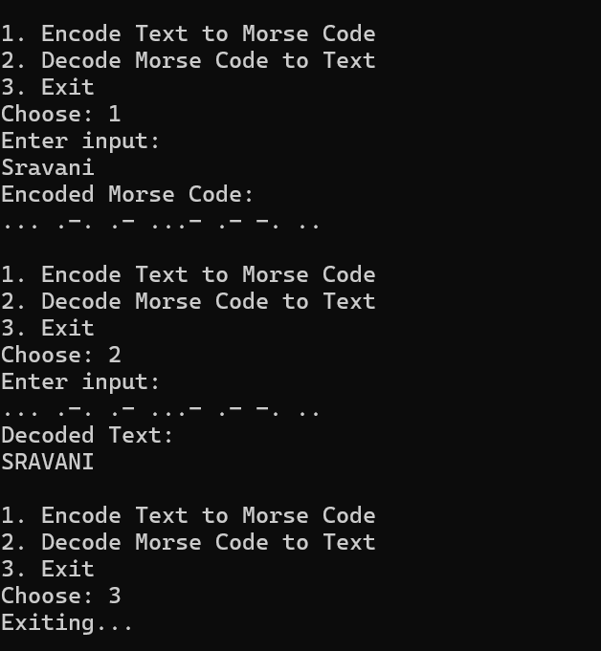

Output Explanation:

During the encoding process, the program takes the user’s input text and converts each character into its corresponding Morse code representation, which consists of sequences of dots and dashes. Each encoded character is separated by spaces for clarity.