James Pindell

1/15/2018

CS 432

Assignment 1

1. 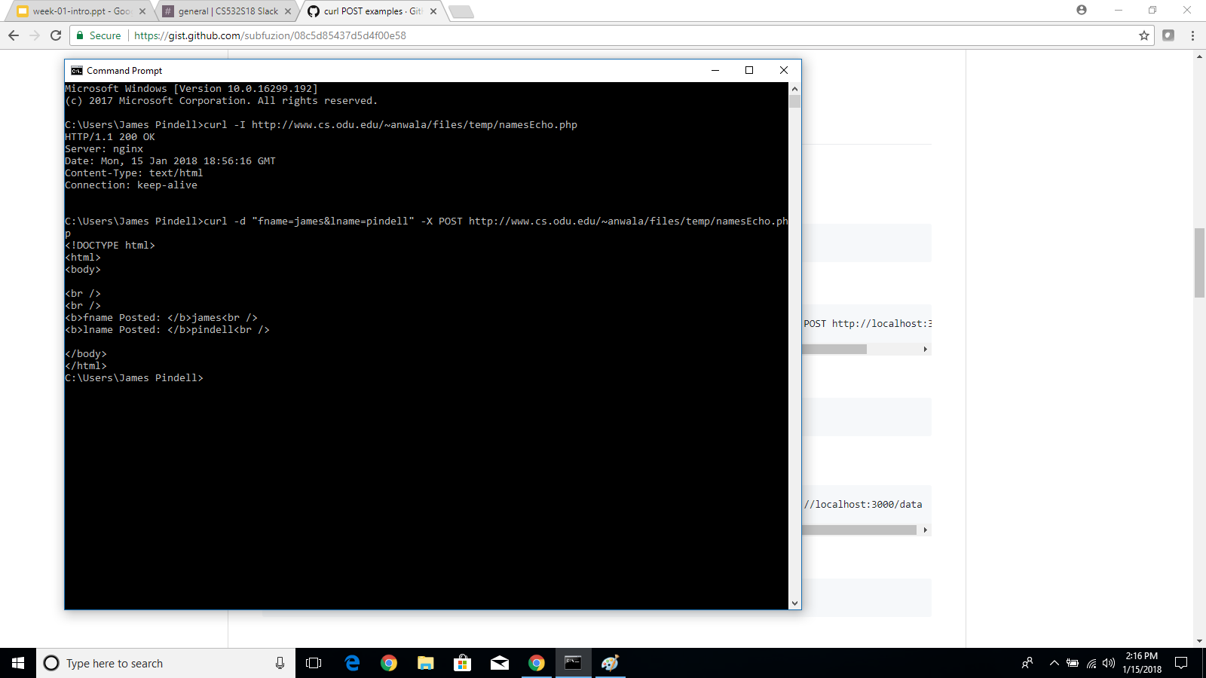
2. 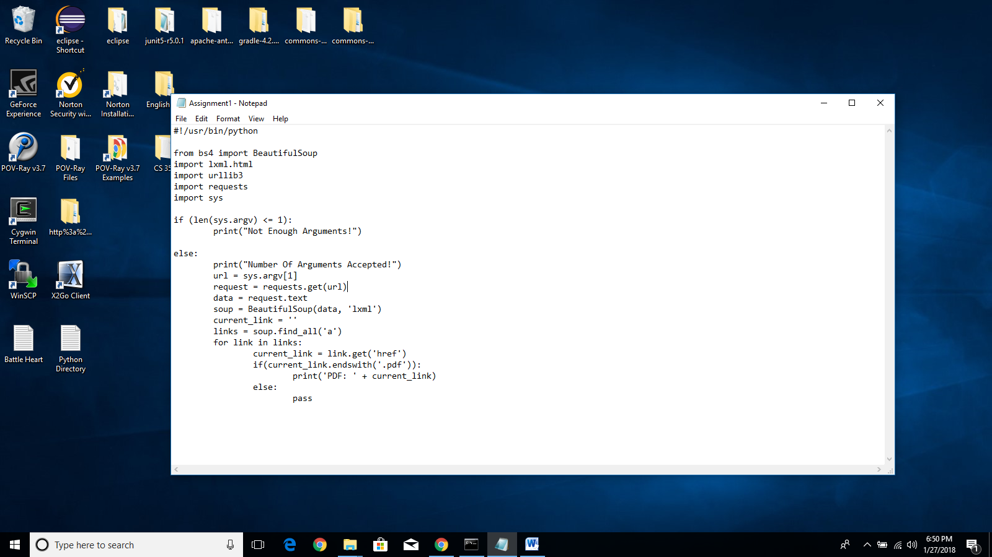 Code:

A. <http://www.cs.odu.edu/~mln/teaching/cs532-s17/test/pdfs.html>

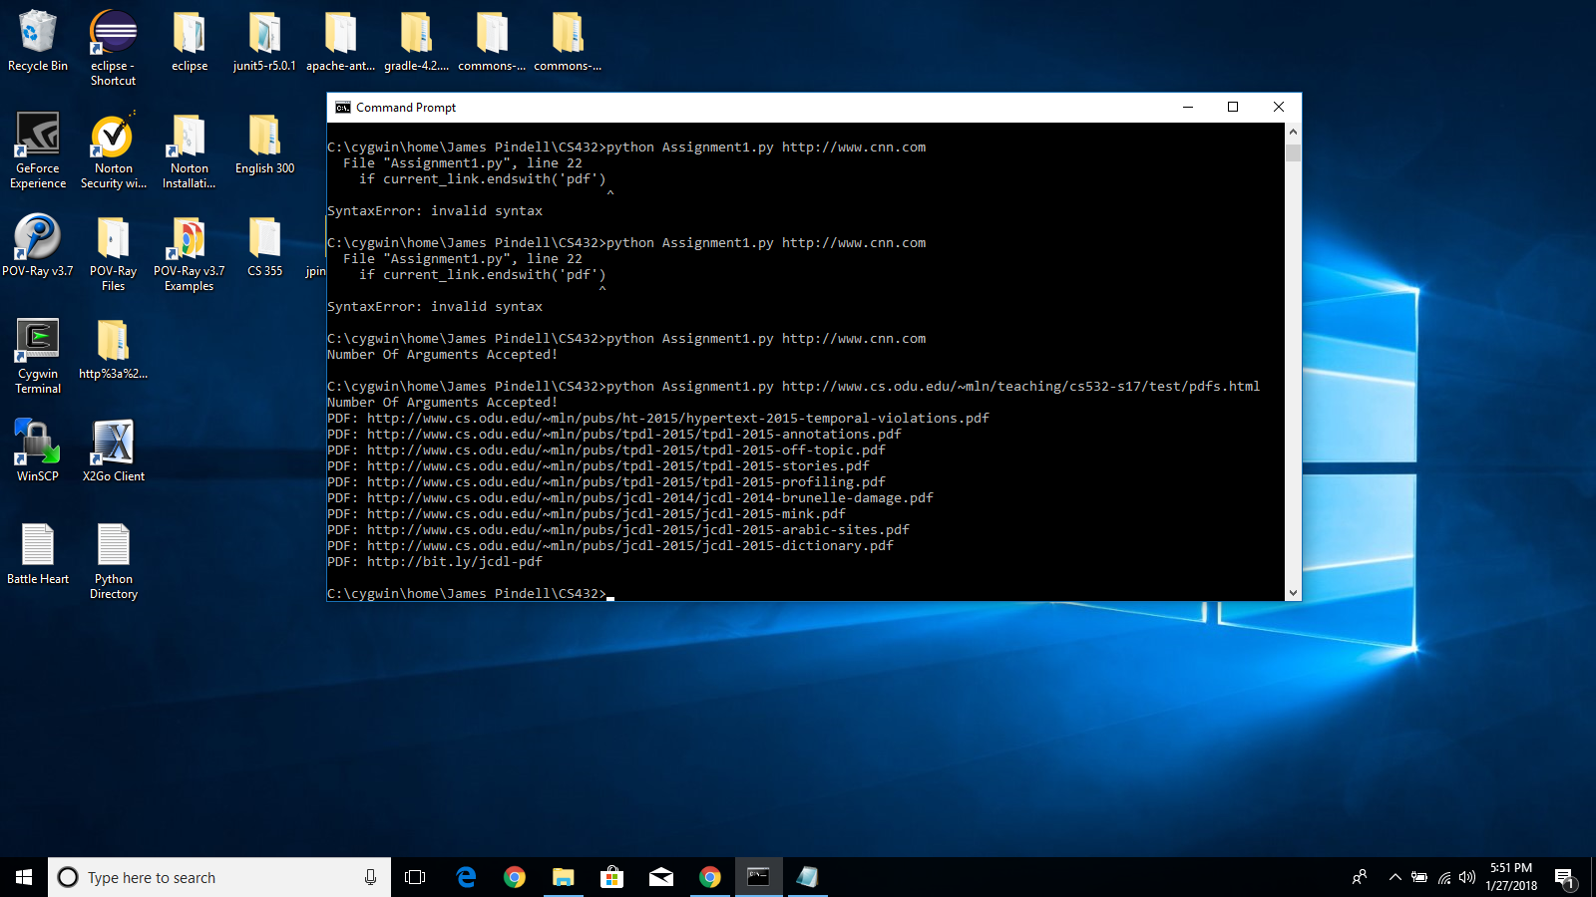

B. <https://gradcollege.okstate.edu>

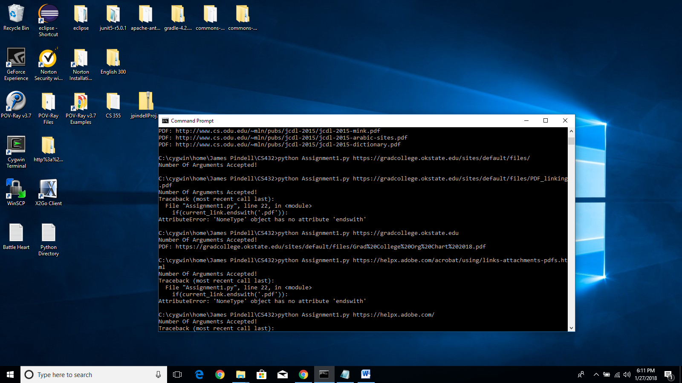

C. <http://www.pdf995.com/samples/>

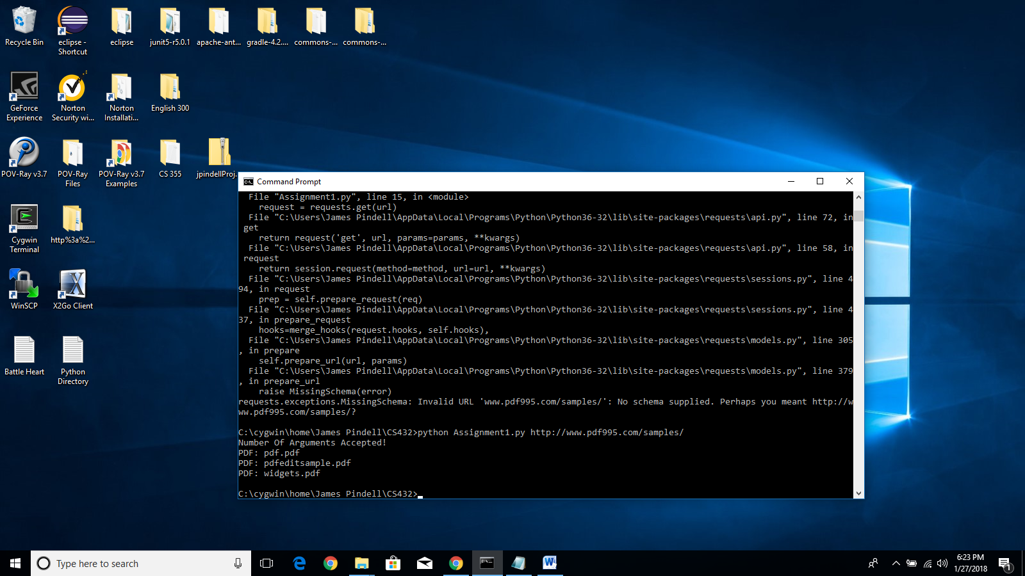

1. 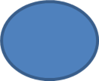

N

L



M



B

A



O

D



P

G

C





I

F

E



H



K

IN: M -> A, O -> A, P -> G

SCC: A -> B, B -> C, C -> A, C -> G, G -> C

OUT: C -> D

TENDRILS: I -> K, I -> H, L -> D

TUBES: M -> N -> D

DISCONNECTED: E -> F