## **Lab Exercises**

### **Exercise 1: Analyzing Wireless Traffic Using Wireshark**

#### **Objective**:  
Learn how to open and analyze pre-captured wireless network traffic.

#### **Steps**:  
1. **Open Wireshark**:  
   - Launch Wireshark on your computer.  
   - Load a pre-captured file (e.g., WPA handshake):  
     - Go to `File` > `Open` > Select the `.pcap` file.

2. **Filter Wireless Traffic**:  
   - Use filters to isolate wireless packets:  
     - For WPA handshake: `eapol`.

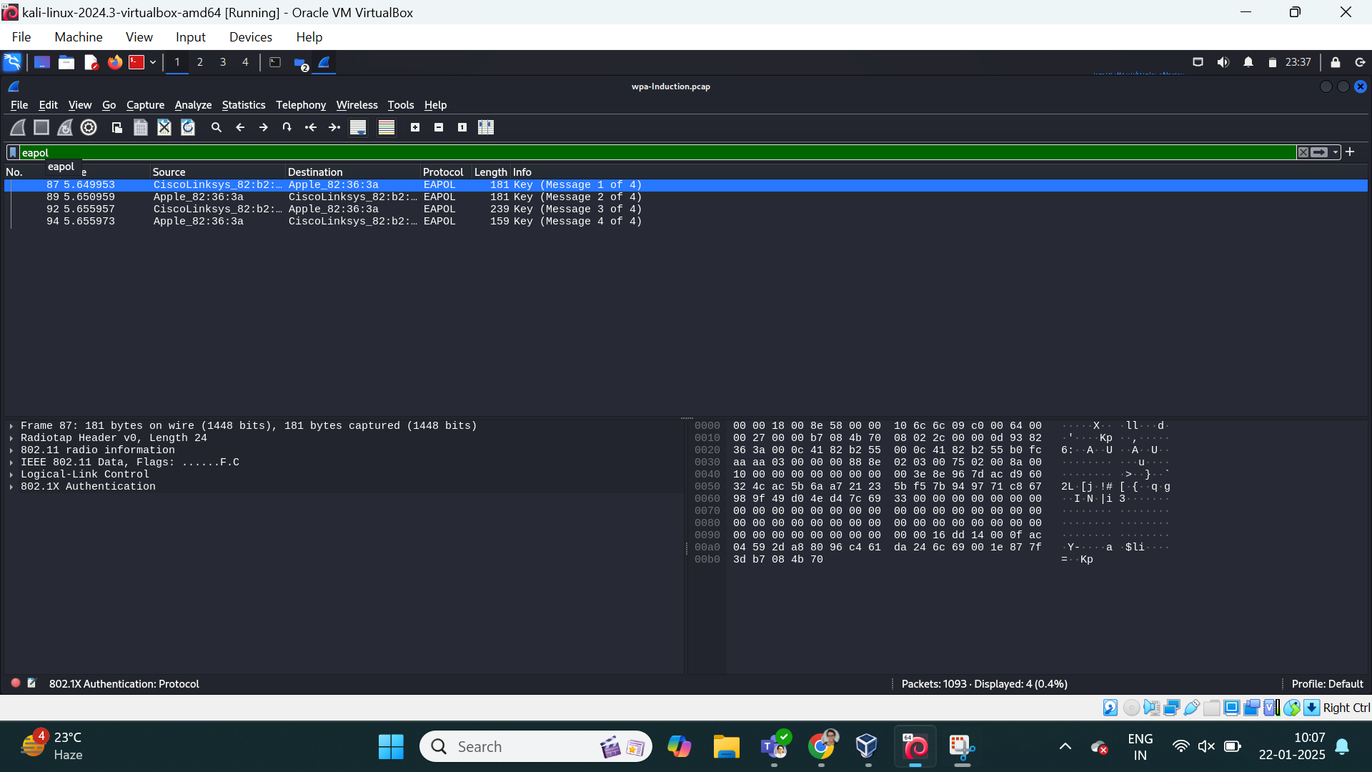

3. **Analyze Packets**:  
   - Identify the following components in the capture:  
     - **SSID**: The network name.

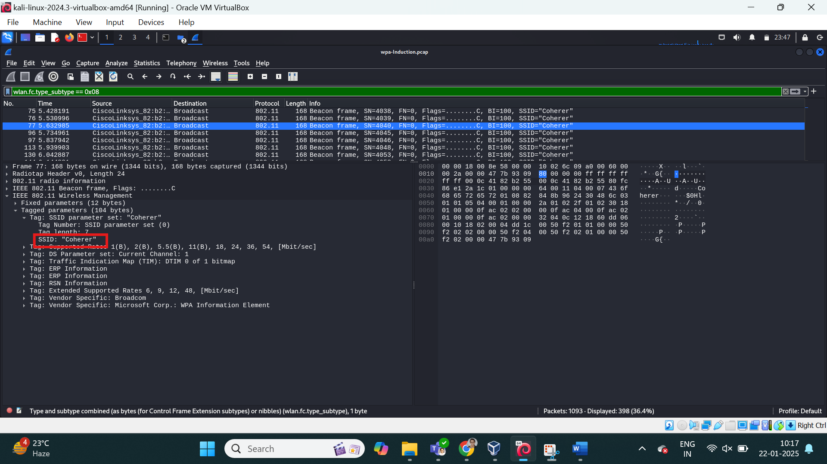  
     - **BSSID**: The MAC address of the access point.

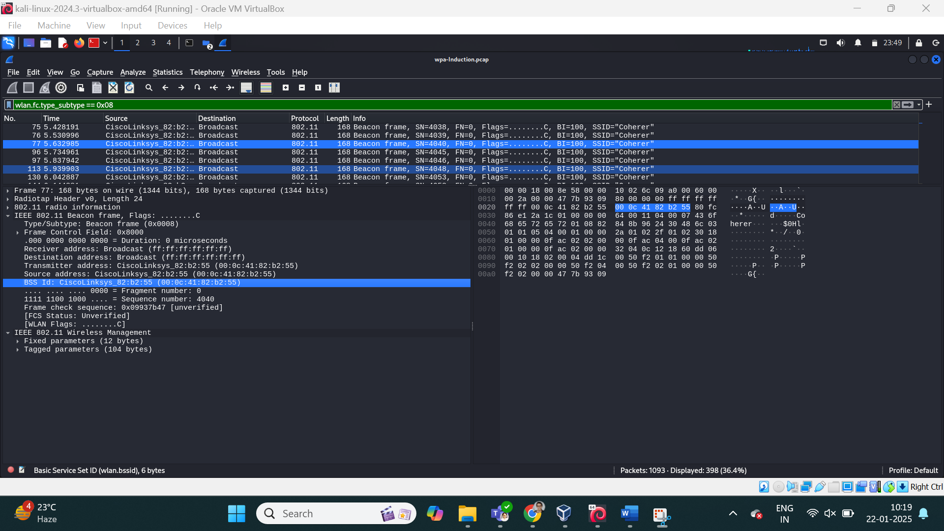  
     - **Handshake Packets**: Look for EAPOL packets.

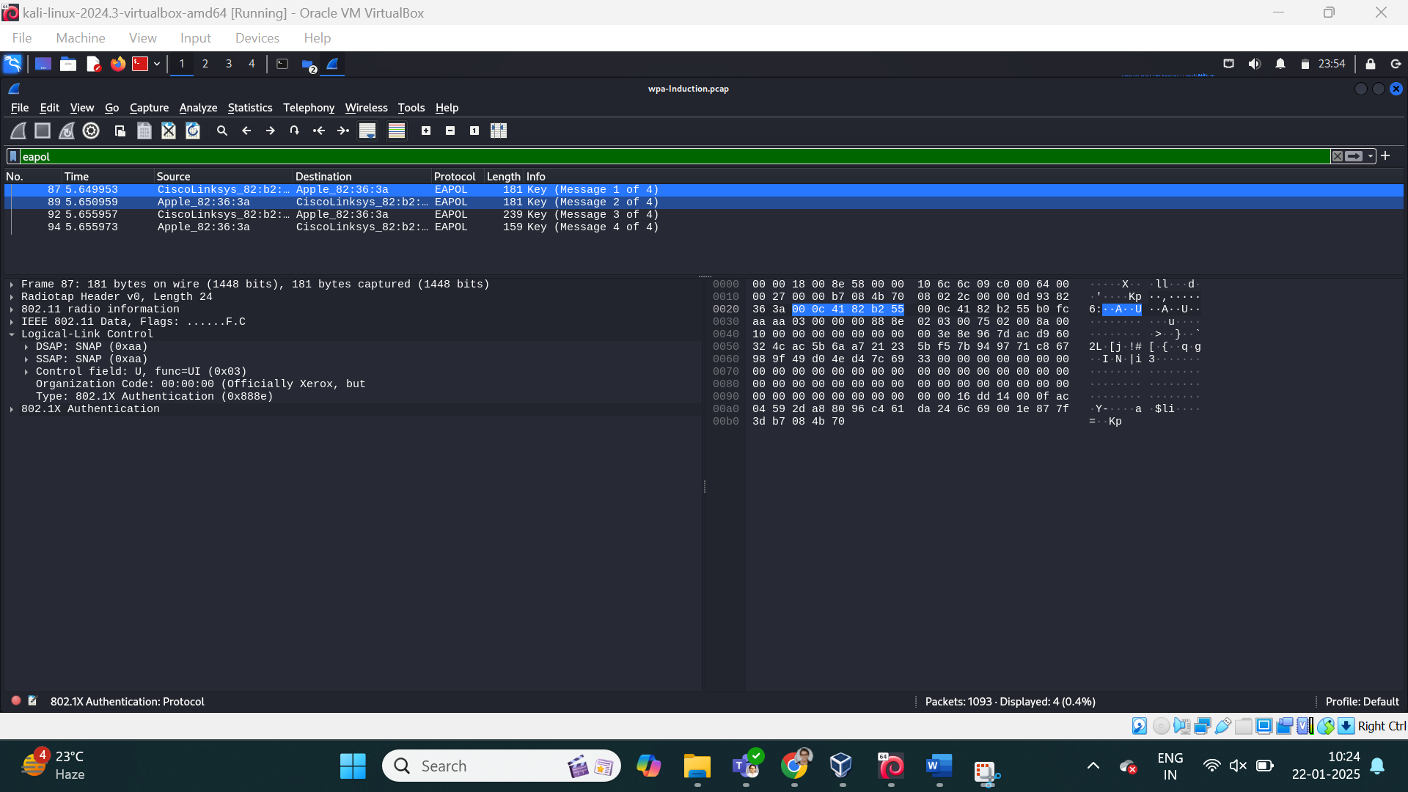

4. **Document Observations**:  
   - Note the time, source, destination, and protocol of key packets.

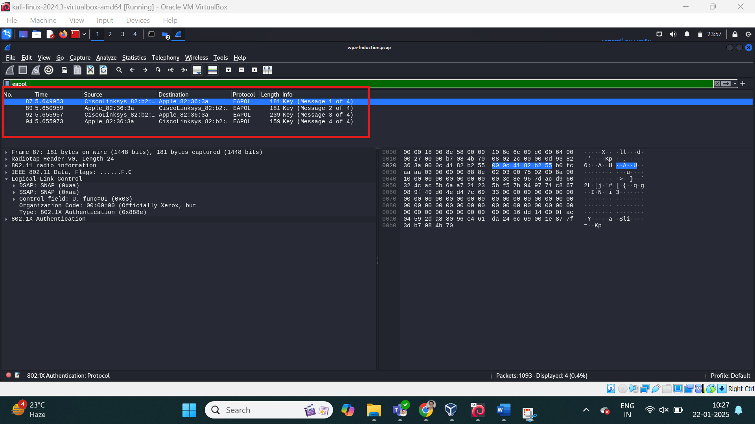

---

### **Exercise 2: Cracking WEP Encryption Using Pre-Captured Files**

#### **Objective**:  
Simulate cracking a WEP-encrypted network using Aircrack-ng.

#### **Steps**:  
1. **Download a WEP Capture File**:  
   - Obtain a `.cap` file containing WEP packets (e.g., from GitHub).

2. **Analyze the Capture**:  
   - Open the file in Wireshark to ensure it contains WEP-encrypted traffic.

3. **Use Aircrack-ng**:  
   - Launch Kali Linux.  
   - Run Aircrack-ng on the capture file:  
     ```bash  
     aircrack-ng -b [BSSID] -w /usr/share/wordlists/rockyou.txt wep_capture.cap  
     ```

4. **Crack the Key**:  
   - If successful, Aircrack-ng will display the WEP key in plaintext.

#### **Expected Outcome**:  
Understand how WEP encryption is vulnerable and why it is deprecated.

---

### **Exercise 3: Cracking WPA/WPA2 Encryption Using a Pre-Captured Handshake**

#### **Objective**:  
Simulate cracking a WPA/WPA2-encrypted network using a captured handshake and dictionary attack.

#### **Steps**:  
1. **Download a WPA Handshake File**:  
   - Obtain a `.cap` file with a valid handshake (e.g., from GitHub).

2. **Verify the Handshake**:  
   - Open the file in Wireshark.  
   - Use the filter `eapol` to ensure handshake packets are present.

3. **Convert the Capture File**:  
   - Use `aircrack-ng` to convert the `.cap` file to `.hccapx` format for Hashcat (optional):  
     ```bash  
     aircrack-ng handshake.cap -J handshake  
     ```

4. **Run Aircrack-ng**:  
   - Attempt to crack the handshake using a dictionary file:  
     ```bash  
     aircrack-ng -w /usr/share/wordlists/rockyou.txt handshake.cap  
     ```

5. **Run Hashcat (Optional)**:  
   - Use GPU acceleration for faster cracking:  
     ```bash  
     hashcat -m 2500 handshake.hccapx /usr/share/wordlists/rockyou.txt  
     ```

#### **Expected Outcome**:  
Understand the importance of strong passwords in securing WPA/WPA2 networks.

---

### **Exercise 4: Simulating an Evil Twin Attack (Theoretical)**

#### **Objective**:  
Understand the concept of a rogue access point and its impact on network security.

#### **Steps**:  
1. **Setup Overview**:  
   - Learn about tools like `Fluxion` or `Airgeddon` for setting up fake APs.  
   - Note: Without Wi-Fi hardware, this exercise remains theoretical.

2. **Captive Portal**:  
   - Understand how users are tricked into providing credentials via a rogue AP.

3. **Defensive Measures**:  
   - Emphasize the importance of HTTPS and VPNs in mitigating Evil Twin attacks.

#### **Expected Outcome**:  
Awareness of social engineering risks associated with rogue access points.

---