Task 2:  
Website Inspected: <https://www.geeksforgeeks.org/html-adding-youtube-videos/>

Metadata

* It is found in the head section.
* Provides metadata about the HTML document
* Ex: documents author, keywords, description, viewport settings

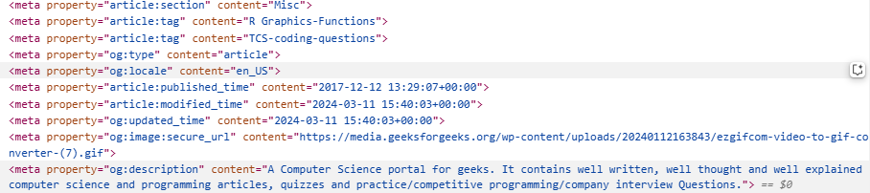

Headings and semantic elements

* The HTML tags used for headings are <h1> to <h6>. <h1> is the largest and <h6> is the tiniest.
* Semantic elements are used to provide meaning to the page structure to improve accessibility.
* Some common semantic elements are <header>, <footer>, <section>, <nav>

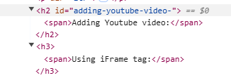

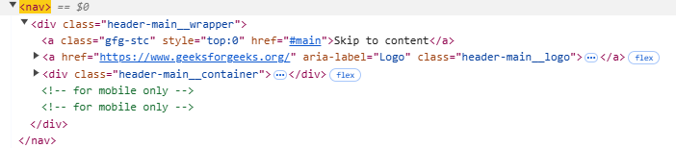



Multimedia

* The HTML tags like <audio>, <video> and <iframe> are used for multimedia content on the HTML document



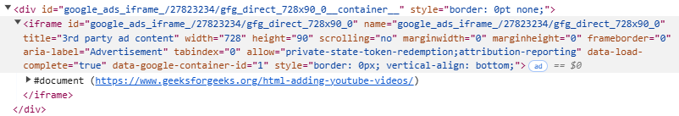

Security Relevant tags:

* CSP: The meta tag or HTTP headers can specify a CSP to restrict the types of content the browser can load
* Sandboxed iframes: An iframe with a sandbox attribute can add extra restrictions to the content it embeds preventing actions like form submissions and popups.

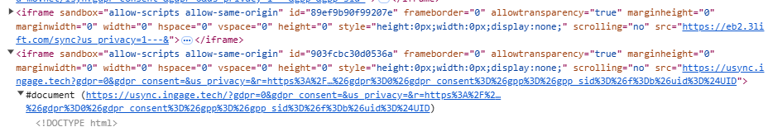

* CORS: Controls whether resources on a page can be accessed from origin. Helps prevent unauthorized requests or malicious cross origin resource sharing.

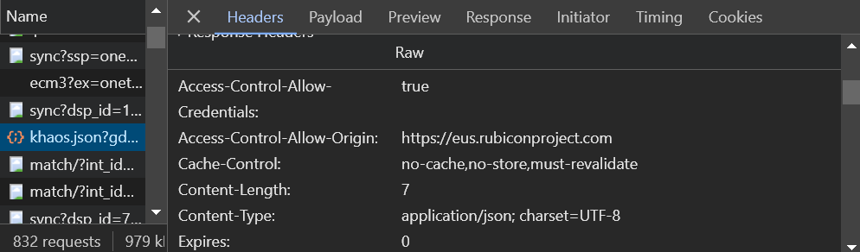

* SRI: Ensures that external resources like scripts or stylesheets is not tampered. Also the hash verifies the content of the resource at the time of loading.

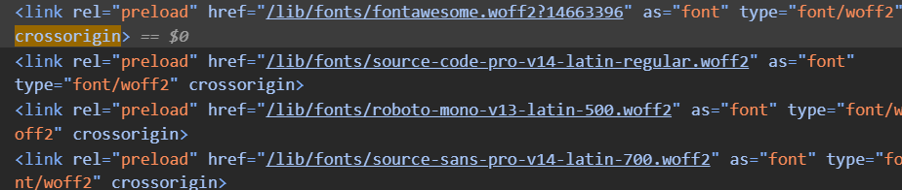

Task 3:

HTML Structure Observations

1. Metadata and Title Usage:
   * The <meta> tags are well-used to specify the character set (UTF-8), author, description, keywords, and viewport settings. This improves accessibility and SEO.
   * The <title> tag effectively names the page.
2. Headings and Content Hierarchy:
   * <h1>, <h2>, and <h3> are appropriately used to structure content hierarchically.
3. Lists (Ordered and Unordered):
   * Both ordered (<ol>) and unordered (<ul>) lists are used correctly to group items.
   * Links in the unordered list (Task 1 and Task 2) are intuitive and align with the page context.
4. Image Inclusion:
   * <img> includes an alt attribute for accessibility, which is commendable.
   * Suggestion: Ensure the alt description matches the context of the image more closely to improve screen reader usability.
5. Tables:
   * A well-structured <table> is used to present data.
6. Multimedia:
   * <iframe> is used to embed videos effectively.
   * Suggestion: Add title attributes to <iframe> elements for improved accessibility and semantics (e.g., title="Video on Application Security").
7. Divisions:
   * <div> tags appropriately group related content.
   * Suggestion: Consider using semantic elements like <section>, <article>, or <aside> to improve the structural meaning of the page.

CSS Usage Observations

1. Inline CSS:
   * The CSS is embedded within a <style> block inside the <head> tag. This approach works but could be improved for maintainability by moving styles to an external stylesheet.
2. Table Styling:
   * The table borders are styled using a single CSS rule
   * Suggestion: Add padding, background colours, or hover effects to improve readability and aesthetics.

Webpage with CSS after Task 4

