Game Design Document

Fill up the following document

1. Write the title of your project.

No Man’s Space

1. What is the goal of the game?

Survive as long as possible

1. Write a brief story of your game.

Since he was a child, Jake always wanted to be an astronaut. He always had a question in his mind, “What is the farthest a man can travel in space”. 20 years later, he decided to find out the answer to the question himself. So, he starts his journey, but there are a lot of astroids in his way. Help him travel as far as possible.

1. Which are the playing characters of this game?

* Playing characters are the ones who respond to the user based on the input from the user.
* Cars, monkeys, dinos, wizards, etc., are the playing characters in the game.

|  |  |  |
| --- | --- | --- |
| Number | Character Name | What can this character do? |
| 1 | Jake | Move to the left and right |
| 2 |  |  |
| 3 |  |  |
| 4 |  |  |
| 5 |  |  |
| 6 |  |  |
| 7 |  |  |
| 8 |  |  |

1. Which are the Non-Playing Characters of this game?

* Non-Playing characters are the ones that don't have an action or behavior when the user interacts with the game.
* Hurdles, stones, bananas, coins, etc., are non-playing characters in the game.

|  |  |  |
| --- | --- | --- |
| Number | Character Name | What can this character do? |
| 1 | Asteroids | Spawn randomly, moving towards the Playing character |
| 2 |  |  |
| 3 |  |  |
| 4 |  |  |
| 5 |  |  |
| 6 |  |  |
| 7 |  |  |
| 8 |  |  |

Draw your imagination of this game. What does this game look like?

* Draw the game either on your computer or on paper.
* Add images of the game scenes to show each of the playing and non-playing characters at least once.

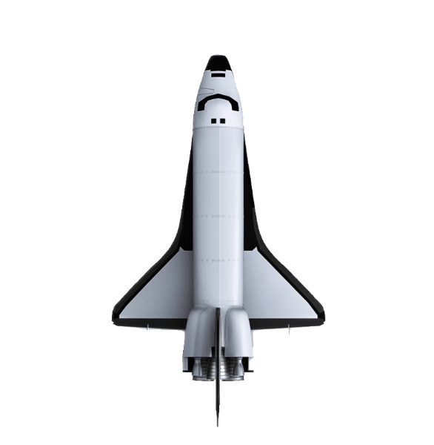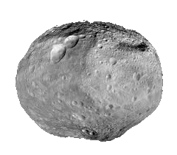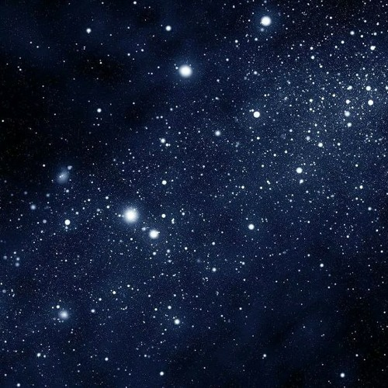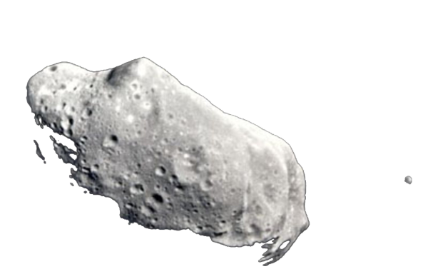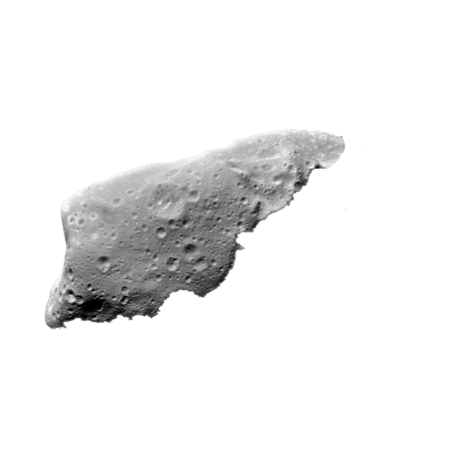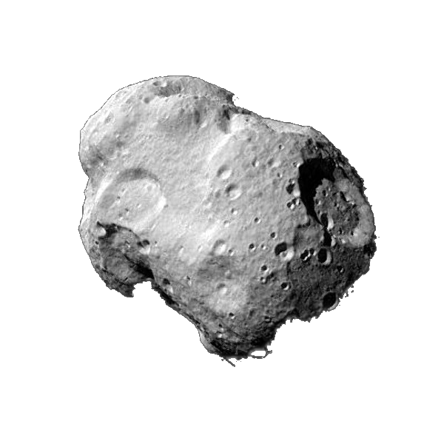

How do you plan to make your game engaging?

More Obstacles will spawn and the speed of the obstacles will increase as u progress through the game, making it harder when your score keeps increasing