Secure Network Messenger Using SSH for Improved
Anonymity

1.Starting the Server:
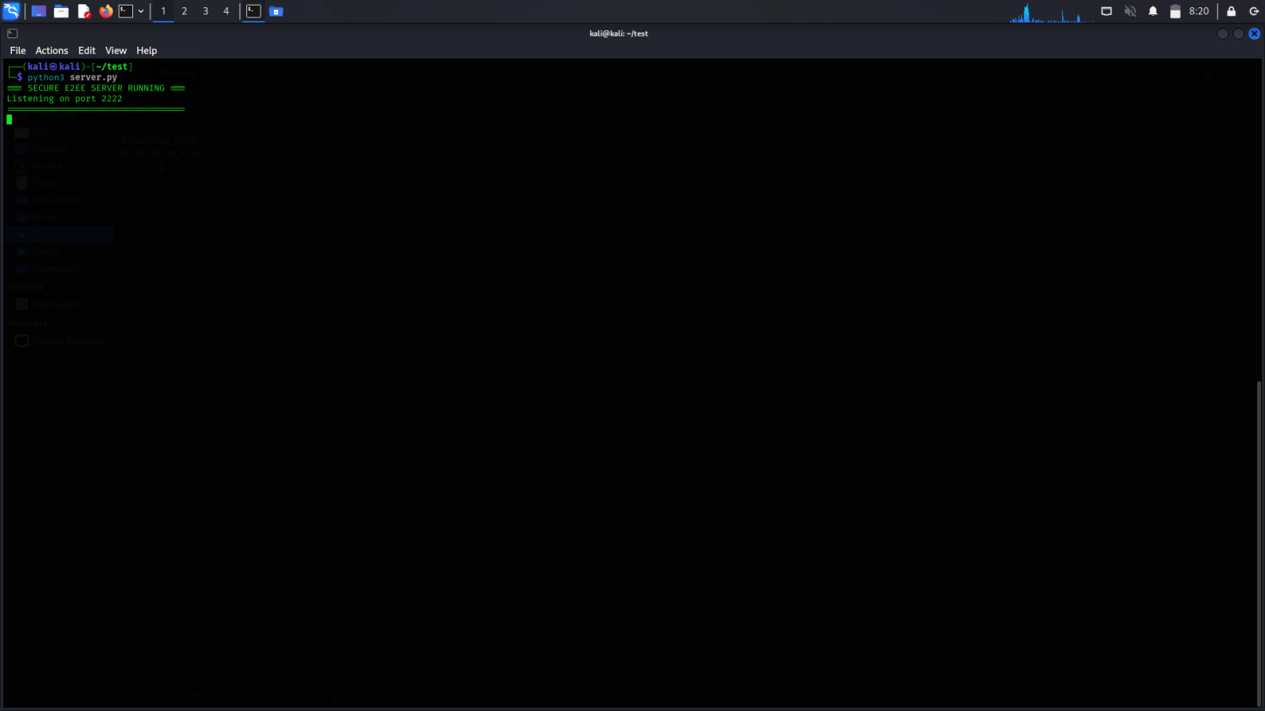

2.Starting the client:
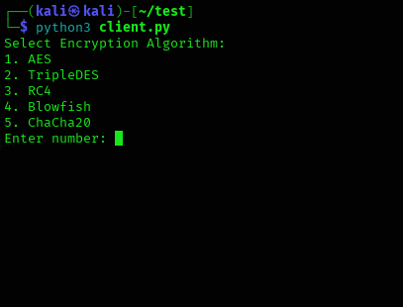

- Client Information Retrieval:

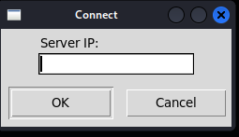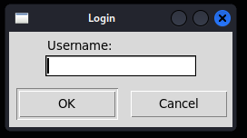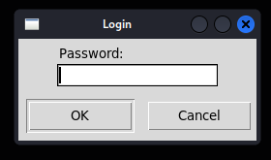

- Server After client logs in:

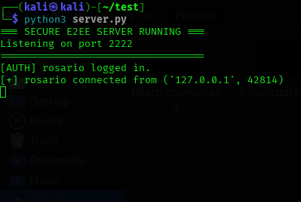

- Client 1 window:

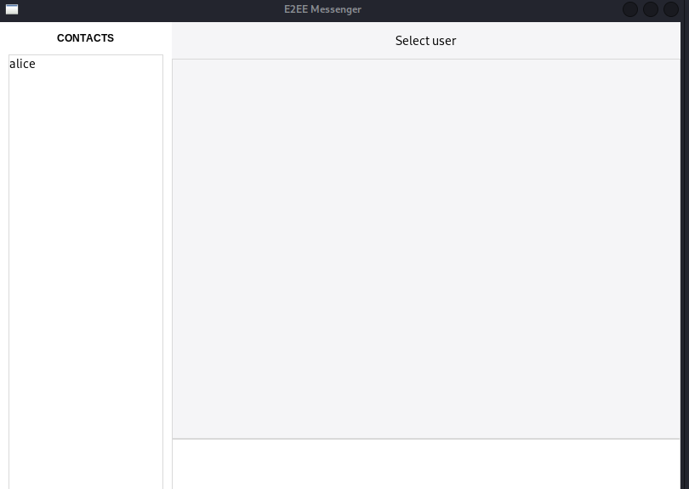
- Client1 mesaging to client 2
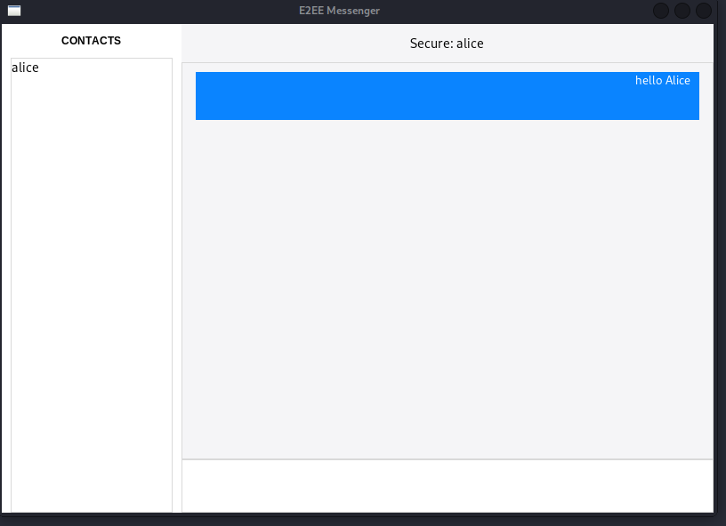

- client1’s data encryption details:
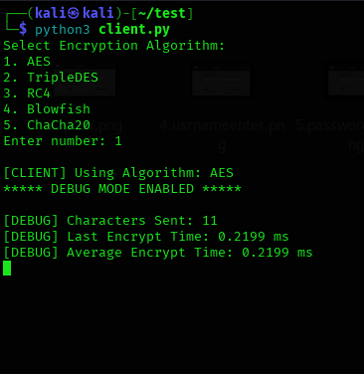
After multiple messages:
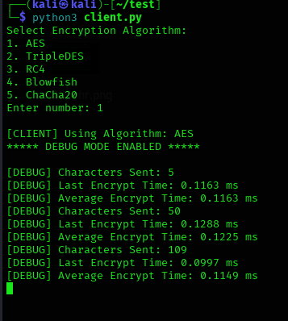

- AES Decryption time output in the debug corner :

Letters:5
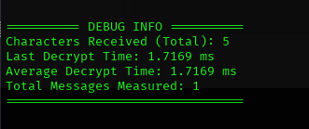

Letters:50

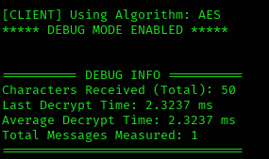

Letters:100

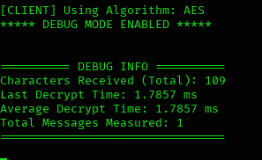

- TripleDES Decryption time Output in the debug corner:

Lettesr:5

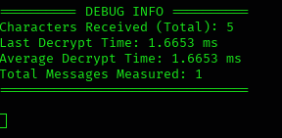

Letters:50
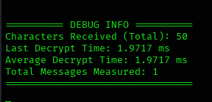

Letters:100
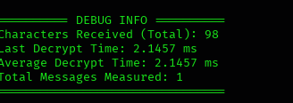

- RC4 Decryption Time in the debug corner

Letters:5

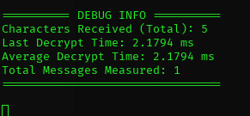

Letters:50

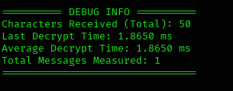

Letters:100

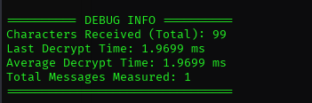

- BlowFish Decryption TIme in the debug corner

Letters:5

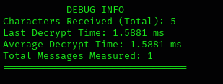

Letters:50

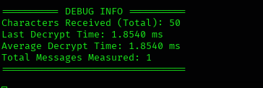

Letters:100

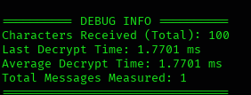

- ChaCha20 Decryption Time in the debug corner

Letters:5

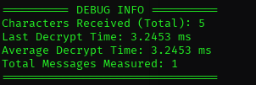

Letters:50

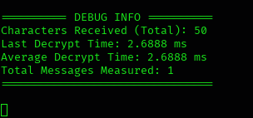

Letters:100

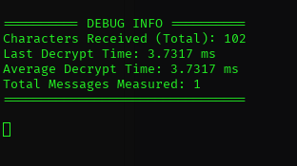

WIRESHARK OVERLOOK ON THE ENCRYPTED DATA

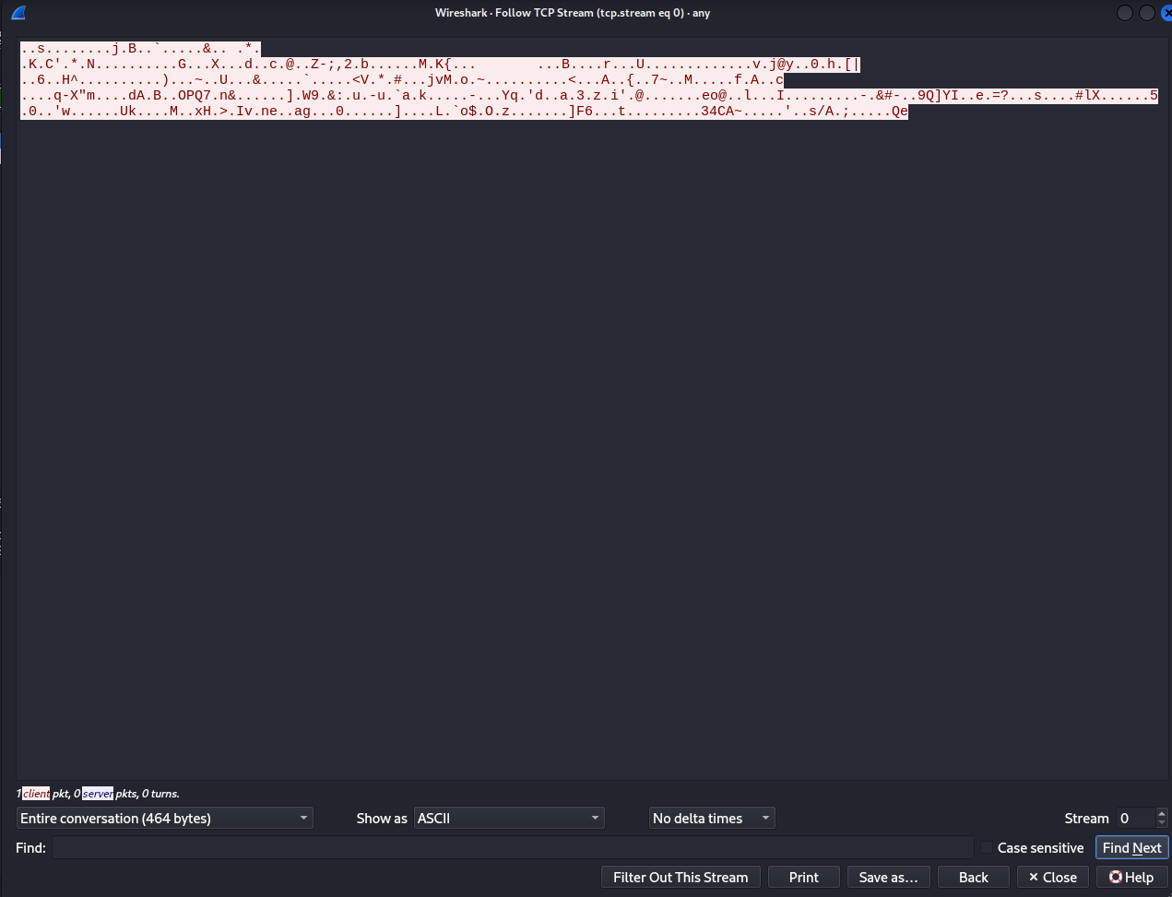
This project presented the design and implementation of a Secure Network Messenger using SSH for improved anonymity and confidentiality. The system combines Secure Shell (SSH) for transport-layer protection with a hybrid cryptographic architecture that utilizes RSA for secure key exchange and multiple symmetric encryption algorithms for message confidentiality. Performance benchmarking was conducted to evaluate encryption and decryption efficiency across different algorithms and message sizes. The results demonstrate that modern symmetric algorithms such as AES and ChaCha20 provide strong security with balanced computational performance, while legacy algorithms exhibit comparatively higher overhead or lower efficiency. Network-level validation using packet analysis confirmed that all transmitted data remains fully encrypted, with no exposure of plaintext content, usernames, or cryptographic material. Overall, the proposed system successfully achieves secure, end-to-end encrypted communication while maintaining practical performance and resistance against packet sniffing and eavesdropping attacks.

