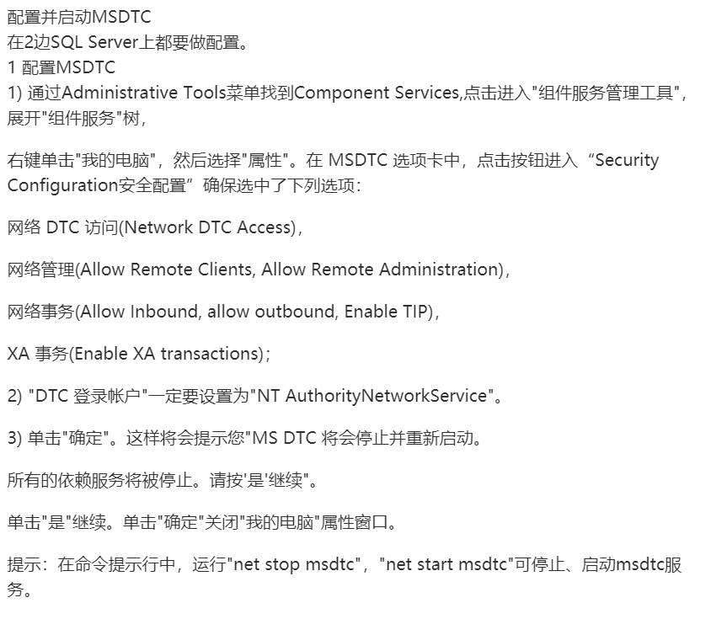

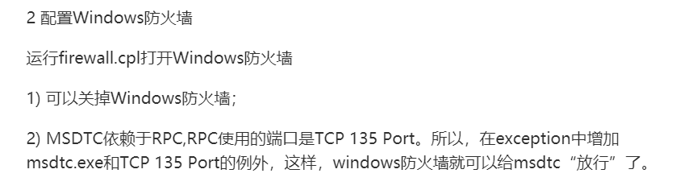

<http://www.360doc.com/content/11/0527/22/45566_119889436.shtml>