Q1)Write a html code to design the 5 rectangle boxes and arrange it horizontal order and keep the gap of 2vw in boxes,
--- Write a html code to design the 5 square boxes and arrange it vertical order and keep the gap of 2vw in boxes,

Ans : <html>
<head>
<title></title>
<style>
.Democontainer
{
display:inline-flex;
border:3px solid black;
padding-top: 4%;
padding-bottom: 3%;
padding-right: 9%;
}

h1{
text-align: center;
}
#boxes1
{
height:110px;
width: 230px;
background-color:skyblue;
margin-left: 8%;

}
.vertical{
margin-top: 5%;
border:5px solid green;
padding-top: 30px;
padding-left: 30px;
padding-bottom: 30px;
}
.boxes2{
height:100px;
width: 200px;
background-color:blue;
margin-top: 3%;
}

</style>
</head>

<body>
<h1>Horizantal boxes</h1>
<div class="Democontainer">

<div id="boxes1">

</div>
<div id="boxes1">

</div>
<div id="boxes1">

</div>
<div id="boxes1">

</div>
<div id="boxes1">

</div>
<div id="box">

</div>
</div>
<!--vertical boxes -->
<div class="vertical">
<h1>Vertical boxes</h1>
<div class="cont">
<div class="boxes2"></div>
<div class="boxes2"></div>
<div class="boxes2"></div>
<div class="boxes2"></div>
<div class="boxes2"></div>
</div>
</div>

</body>
</html>
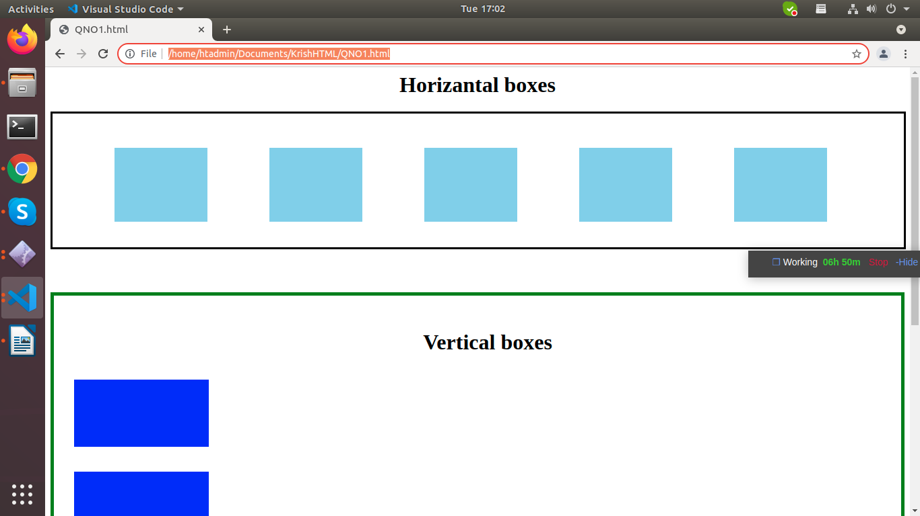

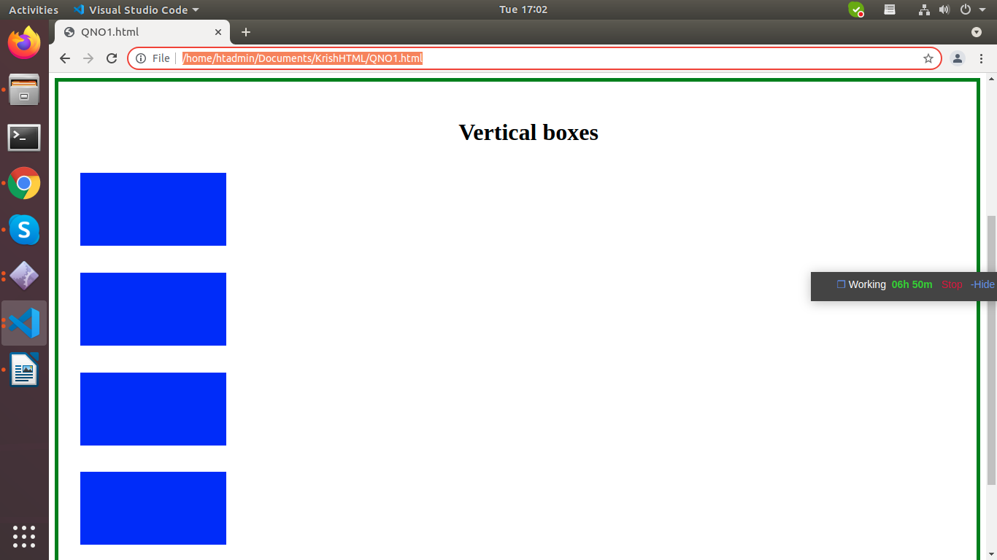

Q 2. Write a html code to design the table with two button,header contains three column, name, age, city etc
- Add row button, which adds a row in new table using javascript
- Add column button,which adds a row in new table using jquery
Ans:

<html>
<head>
<title> </title>

<script>
//javaScript code
function addrow()
{
//get input
var name=document.getElementById('Name1').value;
var age=document.getElementById('age1').value;
var city=document.getElementById('city1').value;
//get html table
var table=document.getElementsByTagName('table')[0];
var newRow = table.insertRow(1);
//addcell
var row = table.insertRow(-1);

var cel1=newRow.insertCell(0);
var cel2=newRow.insertCell(1);
var cel3=newRow.insertCell(2);

cel1.innerHTML=name;
cel2.innerHTML=age;
cel3.innerHTML=city;

}
</script>

<script src="https://ajax.googleapis.com/ajax/libs/jquery/3.2.1/jquery.min.js"></script>
<script>
//Add column button,which adds a row in new table using jquery
$(".addcols").click(function(){
$('#tbl1 tr').append(function(){
$(this).append('<td style="width:70px";></td>');
});
});
</script>
</head>
<body>
Name:<input type="text" placeholder="enter name" name="Name" id="Name1"/><br></br>
Age:<input type="text" placeholder="enter age" name="age" id="age1"/><br></br>
city:<input type="text" placeholder="enter city" name="city" id="city1"/><br></br>

<button onclick="addrow();">Add row</button>
<button class="addcols" onclick="addcols();">Add coloumn</button>
<table id="tbl1" border="1" bgcolor="pink" hight="200px" width="500px" cellspacing="0" cellpadding="20px" >

<caption> Student information </caption>
<tr>
<th> Name </th>
<th> Age </th>
<th> City</th>

</tr>

<tr>
<td> ketan </td>
<td>25 </td>
<td> pune</td>

</tr>

<tr>
<td>mayur </td>
<td> 26</td>
<td> Jalna</td>

</tr>
<tr>
<td>rahul</td>
<td>27</td>
<td>Aurangabad</td>
</tr>

</table>
</body>
</html>

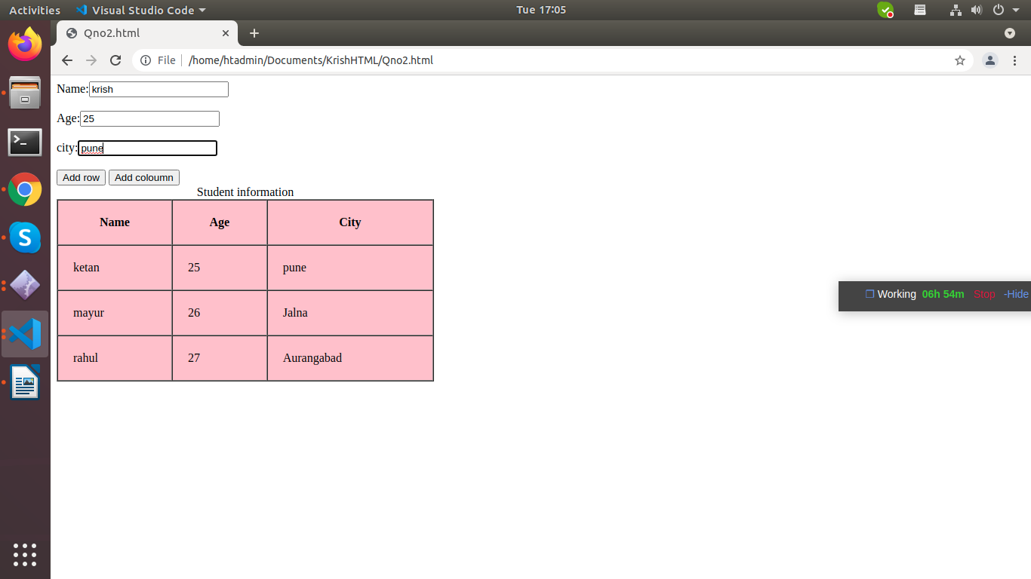

After add row
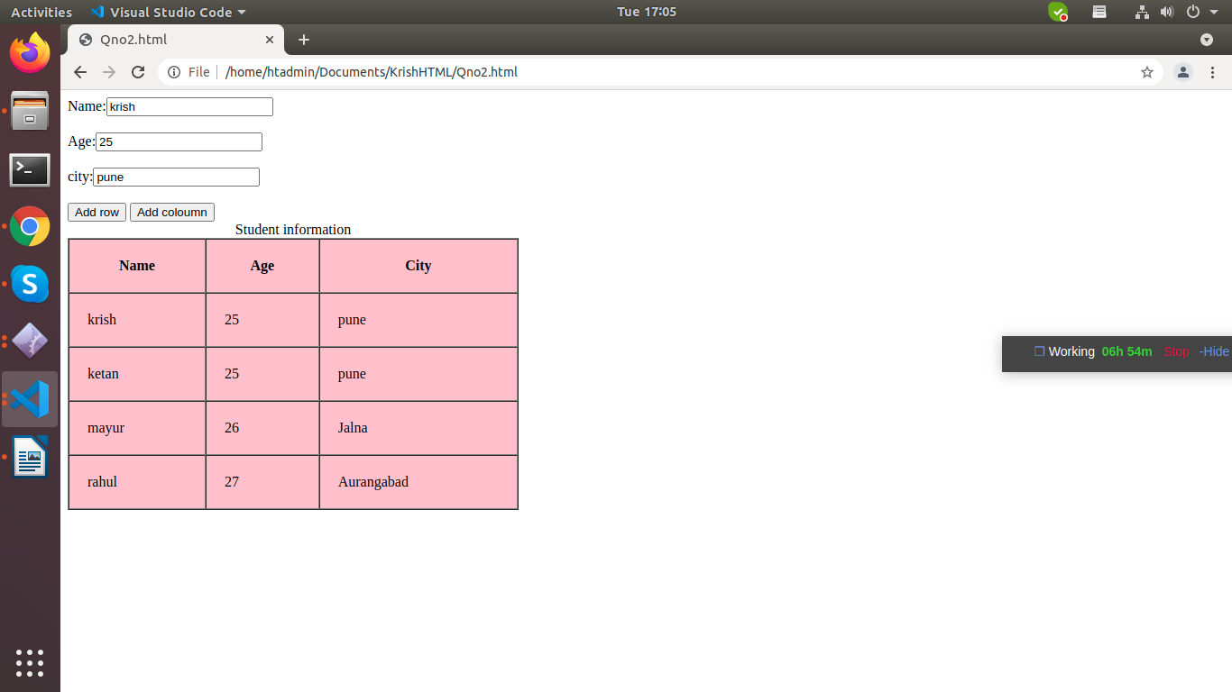

Q3.. Write a jquery click function to perform the some action on the div by click on the given buttons, you can add your own classes and id on the html elements
<div class="animation-div" id="animate-div" style="width:20vw, height=20vh, background-color="red">
</div>

<div style="display:flex">
<button class="fade-out" style="padding:2vw"> // on-click this button, fade out the div in 2 second
<button class="show" style="padding:2vw">// on-click this button, show the div.
<button class="increase-height" style="padding:2vw">// on-click this button, show the div.
<button class="increase-width" style="padding:2vw">// on-click this button, show the div.
<button class="move-right" style="padding:2vw">//// on-click this button, show the div.
</div>
<script>
// Write you code hear
</script>
Ans:
<html>
<title></title>
<head>

<style>
.animation-div{
width: 100px;
height: 100px;
background-color: red;
animation-name: example;
animation-duration: 4s;

}
div.krish1 {
width: 50px;
height: 70px;
float: left;
margin: 5px;
background: rgb(255,140,0);
cursor: pointer;

}

</style>
<script src="https://ajax.googleapis.com/ajax/libs/jquery/3.2.1/jquery.min.js"></script>
<script>

$(function() {
$('.animation-div').addClass('hidden').hide();
$('.fade-out').click(function() {
if ($('.animation-div').hasClass('hidden')) {
$('.animation-div').removeClass('hidden').fadeIn(2000);

}
else {
$('.animation-div').addClass('hidden').fadeOut(2000);
}
});

});

jQuery(document).ready(function(){
jQuery('.krish').on('click', function(event) {
jQuery('.krish').toggle('show');
});
});

</script>
</head>
<body bgcolor="skyblue">
<div class="animation-div" id="animate-div" style="width:20vw, height=20vh, background-color="red">
</div>
<br></br>
<!---click this button, show the -->
<div class="krish">
this is div
</div>
<br></br>
<!--on click button show the div-->
<div class='krish1'>
box

</div>

<input type="button" value="fade-out" class="fade-out" style="padding:1vw"/>
<br></br>
<input type="button" value="Show" class="increase-height" style="padding:1vw"/>
<br></br>
<script>
$( "div.krish1" ).one( "click", function() {
$( this ).height( 100 ).css({
cursor: "auto",
backgroundColor: "green"
});
$( this ).width( 100 ).css({
cursor: "auto",
backgroundColor: "green"
});
$( this ).move-right( 100 ).css({
cursor: "auto",
backgroundColor: "green"
});
});
</script>

</body>
</html>

Before click
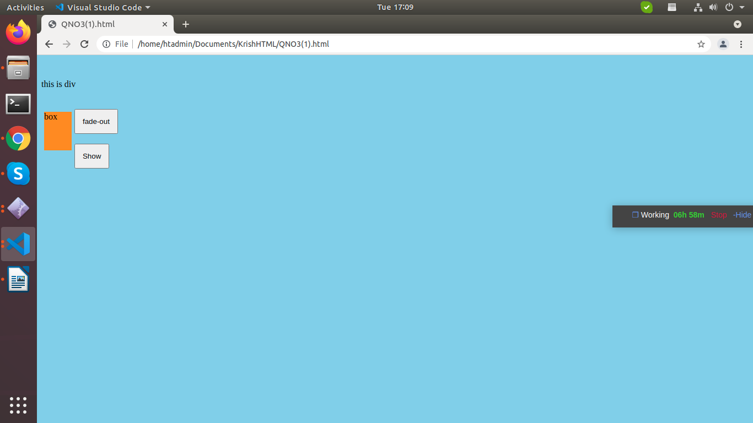

After click
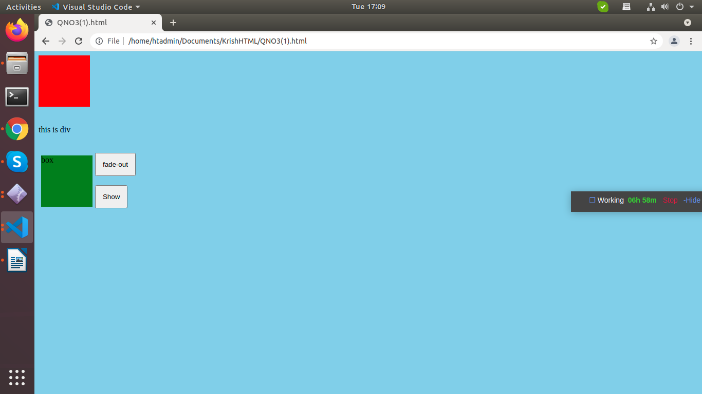

4. What is the correct jQuery code to set the background colour of all p elements to red?
Ans:$(“p”).css(“background-color”,”red”);
5. look at the following selector: $("div.intro"). What does it select?
- It will get all the div with class name intro
- It will get all the div.
Ans:1

6. Design some html with heading and paragraph, add one button which will hide all the paragraph Write a jquery code to hide the all p elements, hide all the paragraphs only not other elements will get hide.
Ans:

<html>
<head>
<script src="https://ajax.googleapis.com/ajax/libs/jquery/3.5.1/jquery.min.js"></script>
<script>
$(document).ready(function(){
$("#button1").click(function(){
$("p").hide();
});
$("#button2").click(function(){
$("p").show();
});
});
</script>
</head>
<body bgcolor="skyblue">

<p>Simply put, a paragraph is a collection of sentences

</p>

<button id="button1">Hide</button>
<button id="button2"> show</button>
</body>
</html>

before click Hide button
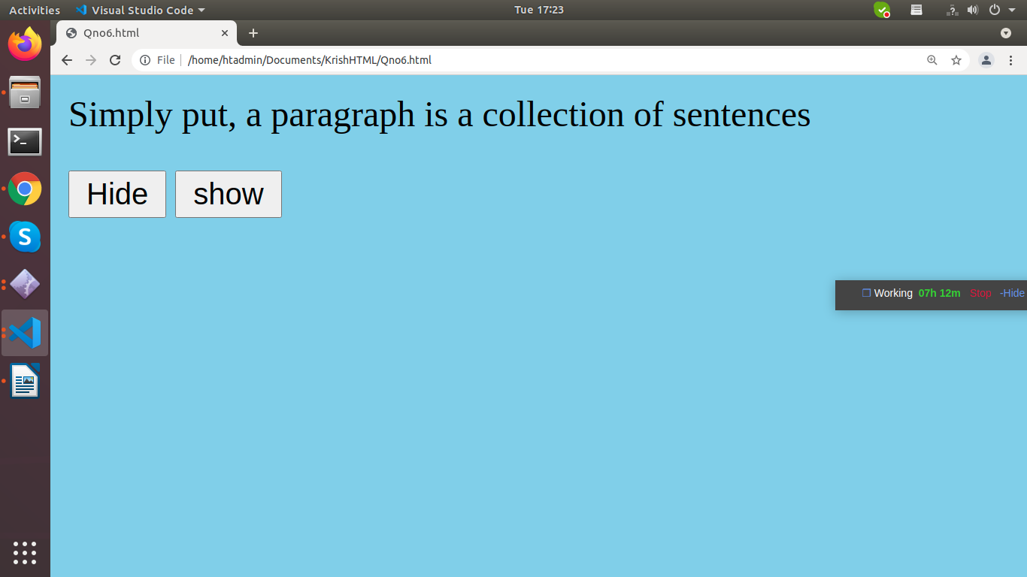

After click hide button

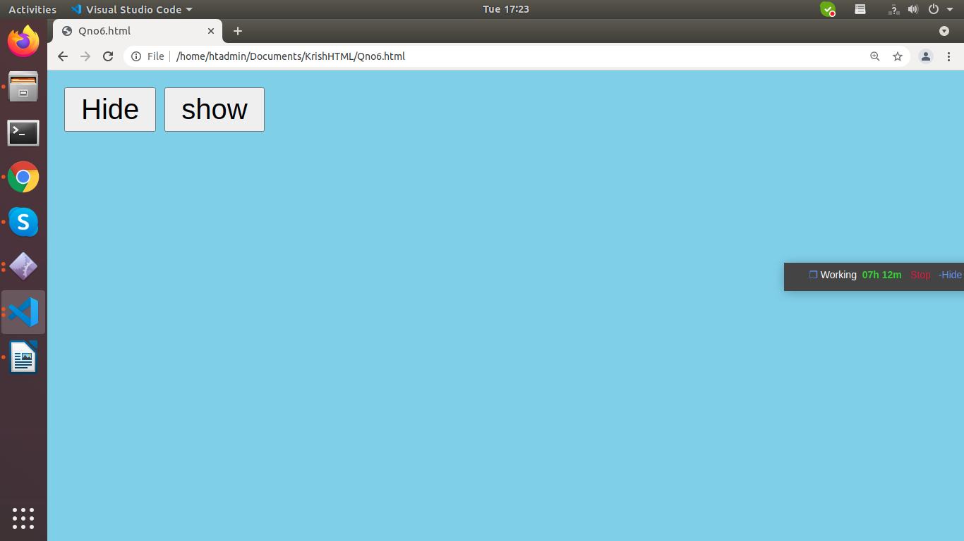

7. Write html code where the one square div is by default hidden with background colour red, Write a javascript code to show this div after 5 seconds when the screens gets load,
Ans:
<html>

<head>

<title>
Demo
</title>

<style>
.Demo {
position: absolute;
background: red;
width: 300px;
height: 250px;
top: 50%;
left: 50%;
transform: translate(-50%, -50%);
}
</style>
</head>

<body>
<div class="Demo"></div>

<script type="text/javascript">
var color = ["red", "yellow"];

document.querySelector("div").addEventListener(
"mouseover", function () {

document.querySelector("div").style.background
= color[Math.floor(Math.random() * color.length)];
})
</script>
</body>

</html>

Before load page
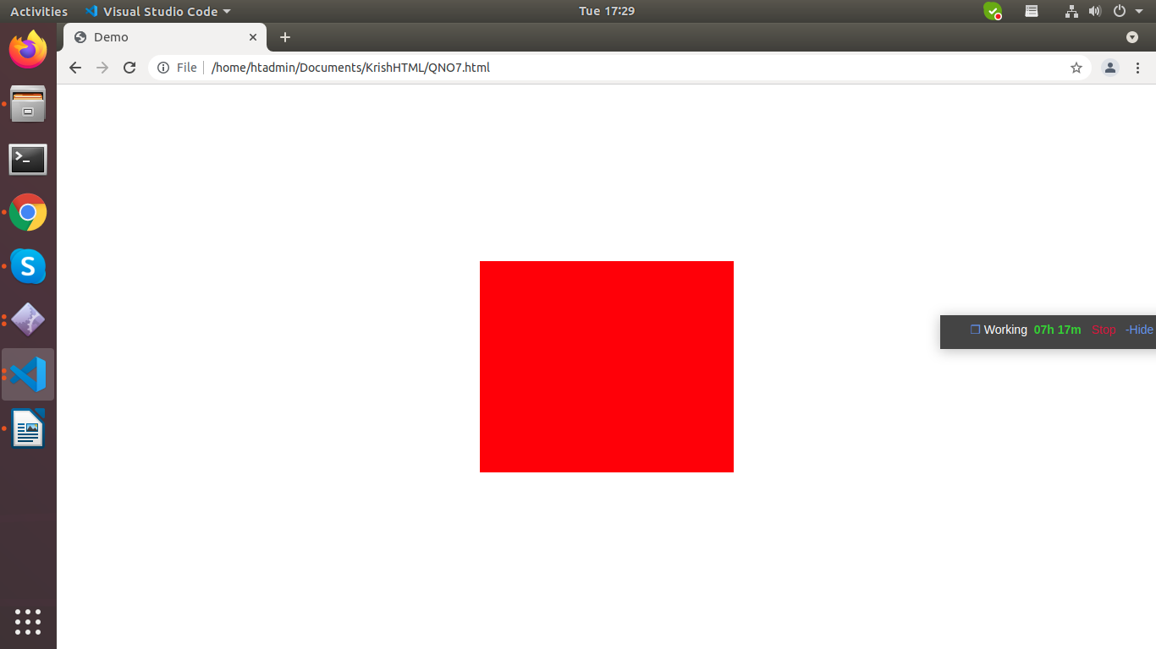

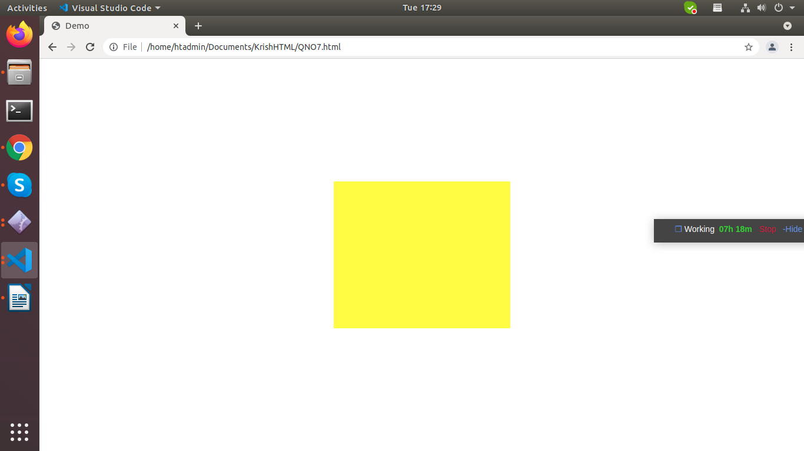
After load page

8. Write html code with one square div with background colour red,Write a javascript code to perform some function after every 5 seconds, break the interval after 20 sec
Ans:

<html>
<head>
<title>Demo</title>
<style>
#squre{
width: 30%;
height: 50%;
background-color: red;
}
</style>

</head>
<body>
<h2>The setInterval() Method</h2>
<div id="Squre">
Hello

</div>
<script>
const element = document.getElementById("Squre");
setInterval(function() {element.innerHTML += "Hello"}, 2000);
</script>
</body>

</html>

Before function after every 5 seconds, break the interval after 20 sec
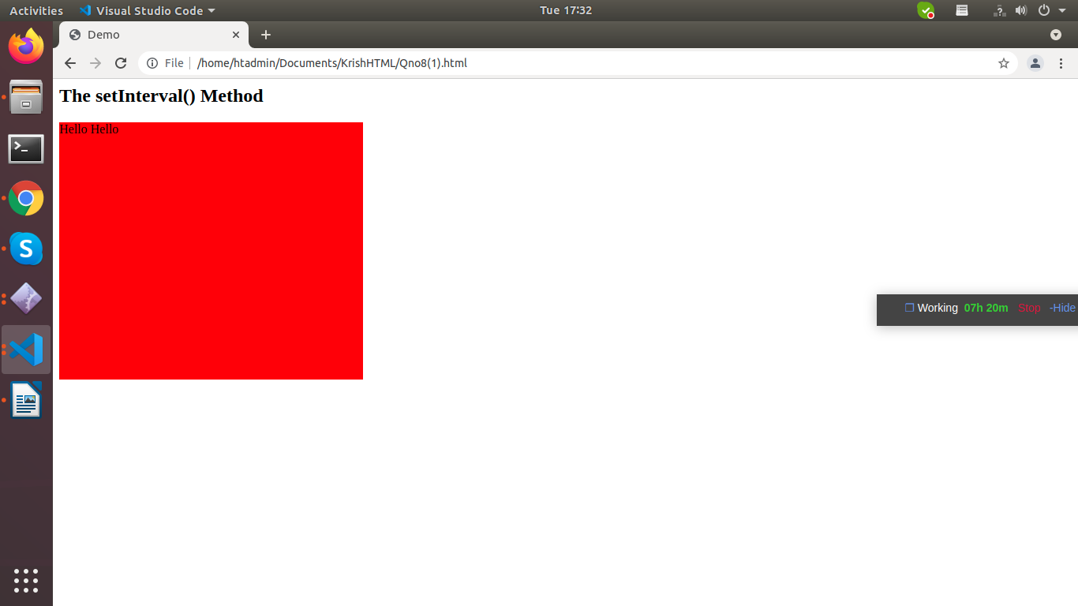

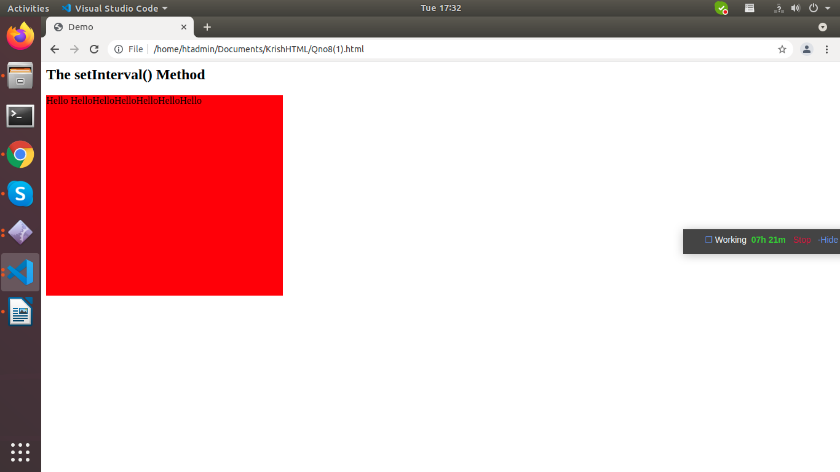
After function after every 5 seconds, break the interval after 20 sec

9. Design HTML code where is one big square div and add more one square div inside the big div with two buttons show button and hide button, Write a javascript code,
– add the event listener on show button, when you click on show button the inner div will be visible,
– add the event listener on show button, when you click on click on hide button the inner div will be hide,
– Write a jquery code to get the parent div of inner div (element traversing)
Ans:

<html>
<head>
<title>Inside div</title>
<style>
#green{

width:300px;
height: 200px;
background-color: green;
}

#blue{

width:300px;
height: 200px;
background-color: blue;
float:left;
}

</style>
<script src="https://ajax.googleapis.com/ajax/libs/jquery/3.5.1/jquery.min.js"></script>

<script>

$(document).ready(function() {
$("#green").click(function(e) {
//document.getElementById('dropdownbutton').style.visibility = 'visible';
$("#button1").show();
});

$(document).mouseup(function(e) {
var container = $("#blue");

if (!container.is(e.target) // if the target of the click isn't the container...
&& container.has(e.target).length === 0) // ... nor a descendant of the container
{
$("#button2").hide();
}
});
});
</script>
</head>
<body>

<input type="button" value="show" id='button1' style="position: absolute;left: 6%;">
<div id="green">

</div>
<input type="button" value="Hide" id='button2' style="position: absolute;left:8%;">
<div id="blue">

</div>

</body>
<script>
document.getElementById('button1').addEventListener("click",function()
{
var box1= document.getElementById("green");
if(box1.style.display=="none")
{
box1.style.display="block"
}
else{
box1.style.display="none";
}
})

document.getElementById('button2').addEventListener("click",function()
{
var box2= document.getElementById("blue");
if(box2.style.display=="none")
{
box2.style.display="block"
}
else{
box2.style.display="none";
}
})
</script>
</html>

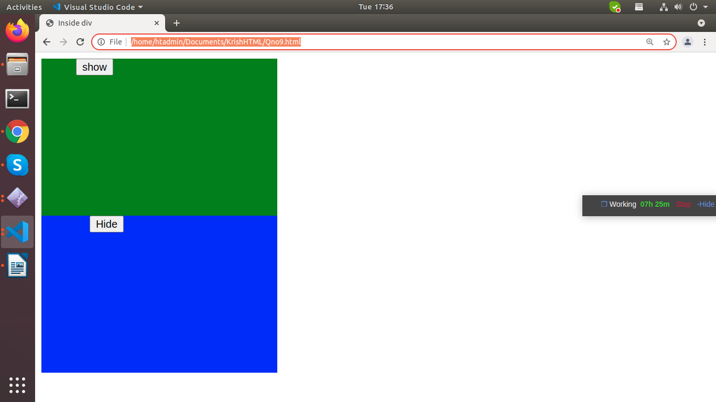

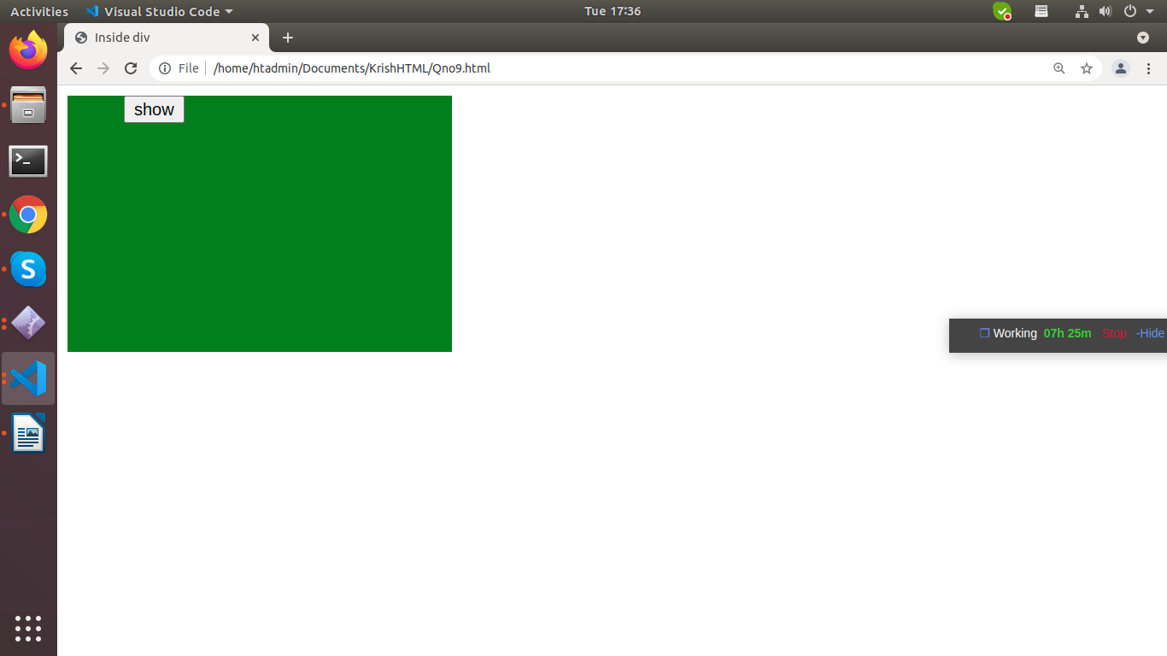

10. Write a jquery code to append and prepend html dynamically following operation
<div class=”main-div”>
<ul class=”ul1”>
</ul>
</div>
— Write a jquery code to append a li element inside the ul
— Write a jquery code to append a new ul inside the div
— Write a jquery code to add new ul at last in the div using siblings of ul
— Insert the title of Ul in the upper side of ul with line-height 6vh
— Add the one button after ul
– For eg: $(selector).append();
Ans:

<html>
<head>

<style>
body{font-family: Arial;}
h1{font-size: 25px;}
.main-div {
background:skyblue;
padding:10px;
border:1px solid #000;
height: 200px;
width: 400px;

}
</style>
</head>
<body>
<h1> Append and prepand</h1>
<div class="main-div">

<ul class=”ul1”>
<li>list1</li>
<li>list2</li>
<li>list3</li>
<li>list4</li>
</ul>

</div>

<br>
<button id="appendBtn" >Append</button>
<button id="prependBtn">Prepend</button>
<script src="https://ajax.googleapis.com/ajax/libs/jquery/3.2.1/jquery.min.js"></script>
<script>
//Append method
$(document).ready(function(){
$("#appendBtn").click(function(){
$('.main-div').append("<li>List5</li>");

});
//prepend method

});
$(document).ready(function(){
$("#prependBtn").click(function(){
$('.main-div').prepend("<li>prependlist</li>");

});
});

</script>
</body>
</html>

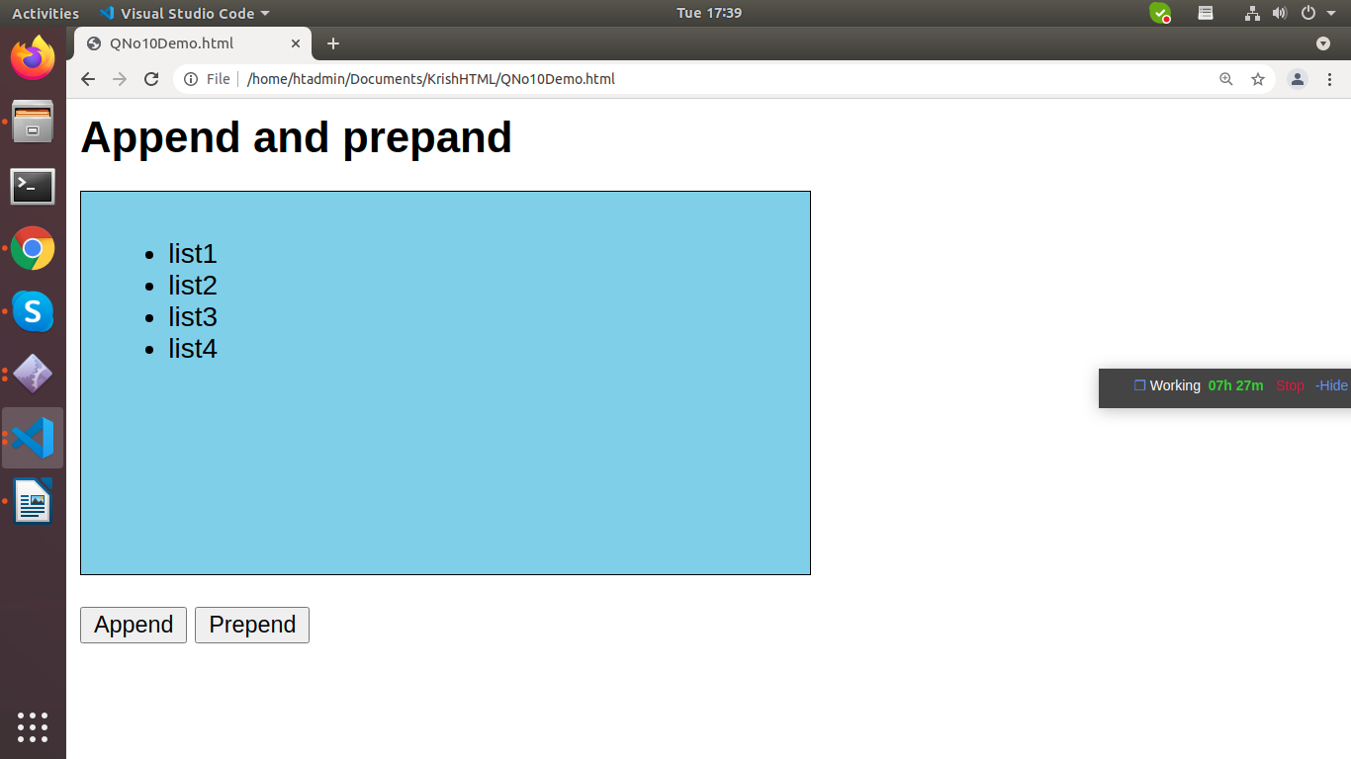

Append:

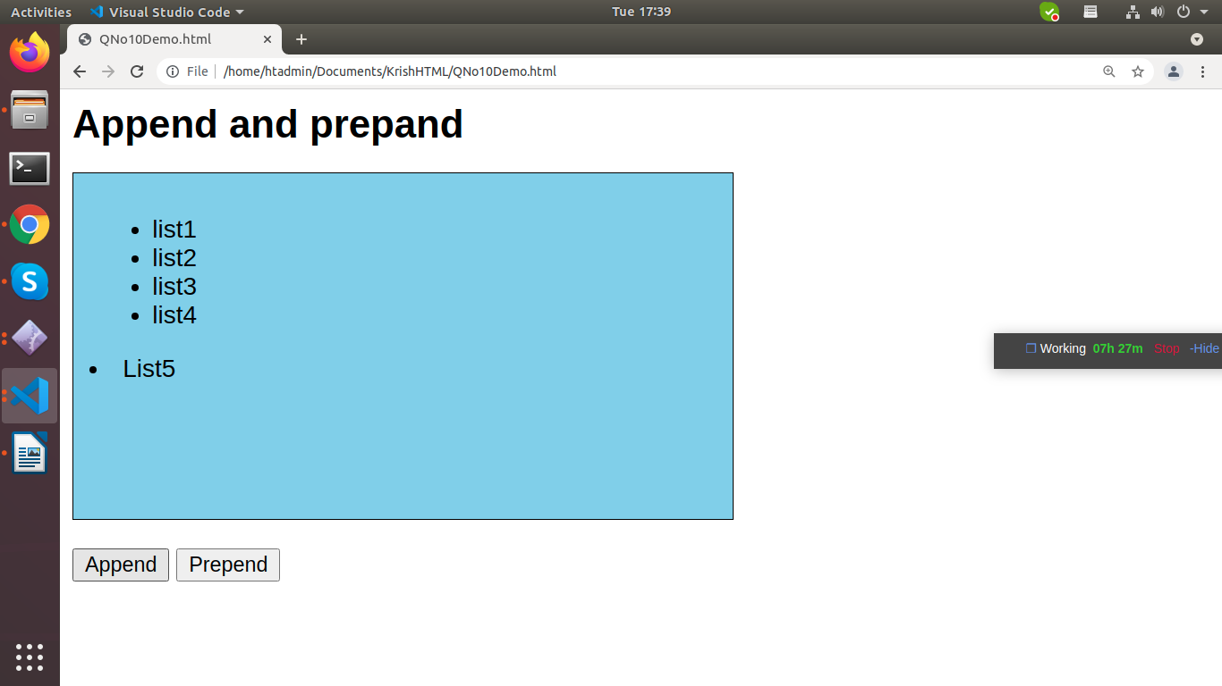

Prepend:

