Journal

# 15/10/12

I attended a planning poker session with my project supervisor and the other students who are using Kinect in their project. This helped a lot with identifying oversights in my user scenarios and in narrowing down time estimates for the user scenarios.

# 18/10/12 & 19/10/12

I set up all of my stories and sub-tasks on Jira. I could not set up a sprint as I do not have administration privileges. I have emailed my supervisor in relation to this but will work around it, for now. I downloaded and installed all the required software for development with the Kinect and Xbox360.

# 20/10/12

I went about setting up my Microsoft account for developing for the Xbox360. I could not register my account due to a glitch in the system. I submitted a support ticket containing all the required details and the reproducible steps I took. I shall develop for Windows until this issue is resolved as I cannot deploy Xbox360 projects without this registration. This has and will cause severe delays, due to the loss of time today and the extra time it will take to port the game to the Xbox360 once this is resolved.

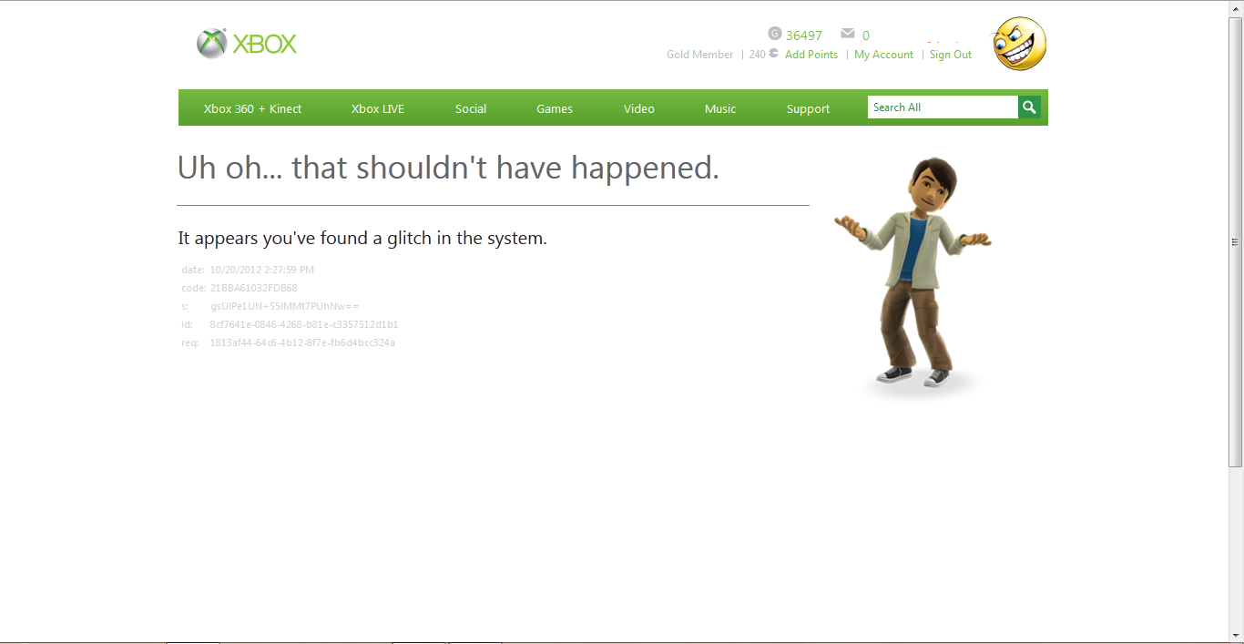

# 21/10/12

I created a Windows game to work on while I’m waiting on a response from the Xbox360 developer support team. I implemented the Farseer physics engine to update on-screen sprites, using keyboard input to apply forces. The engine turned out to be easier to implement than I expected. It contains far more helper functions and classes than the average Box2D port. This has helped recuperate some of the time lost yesterday.



I created the input manager to place a layer of abstraction between the game and the input device. This will allow me to debug while the Kinect is not present/available. This will also make the game easier to port to different platforms, should the opportunity arise. I have skeleton code in place for a number of input types but have only fully implemented keyboard input so far.