Team Proposal: P0_1

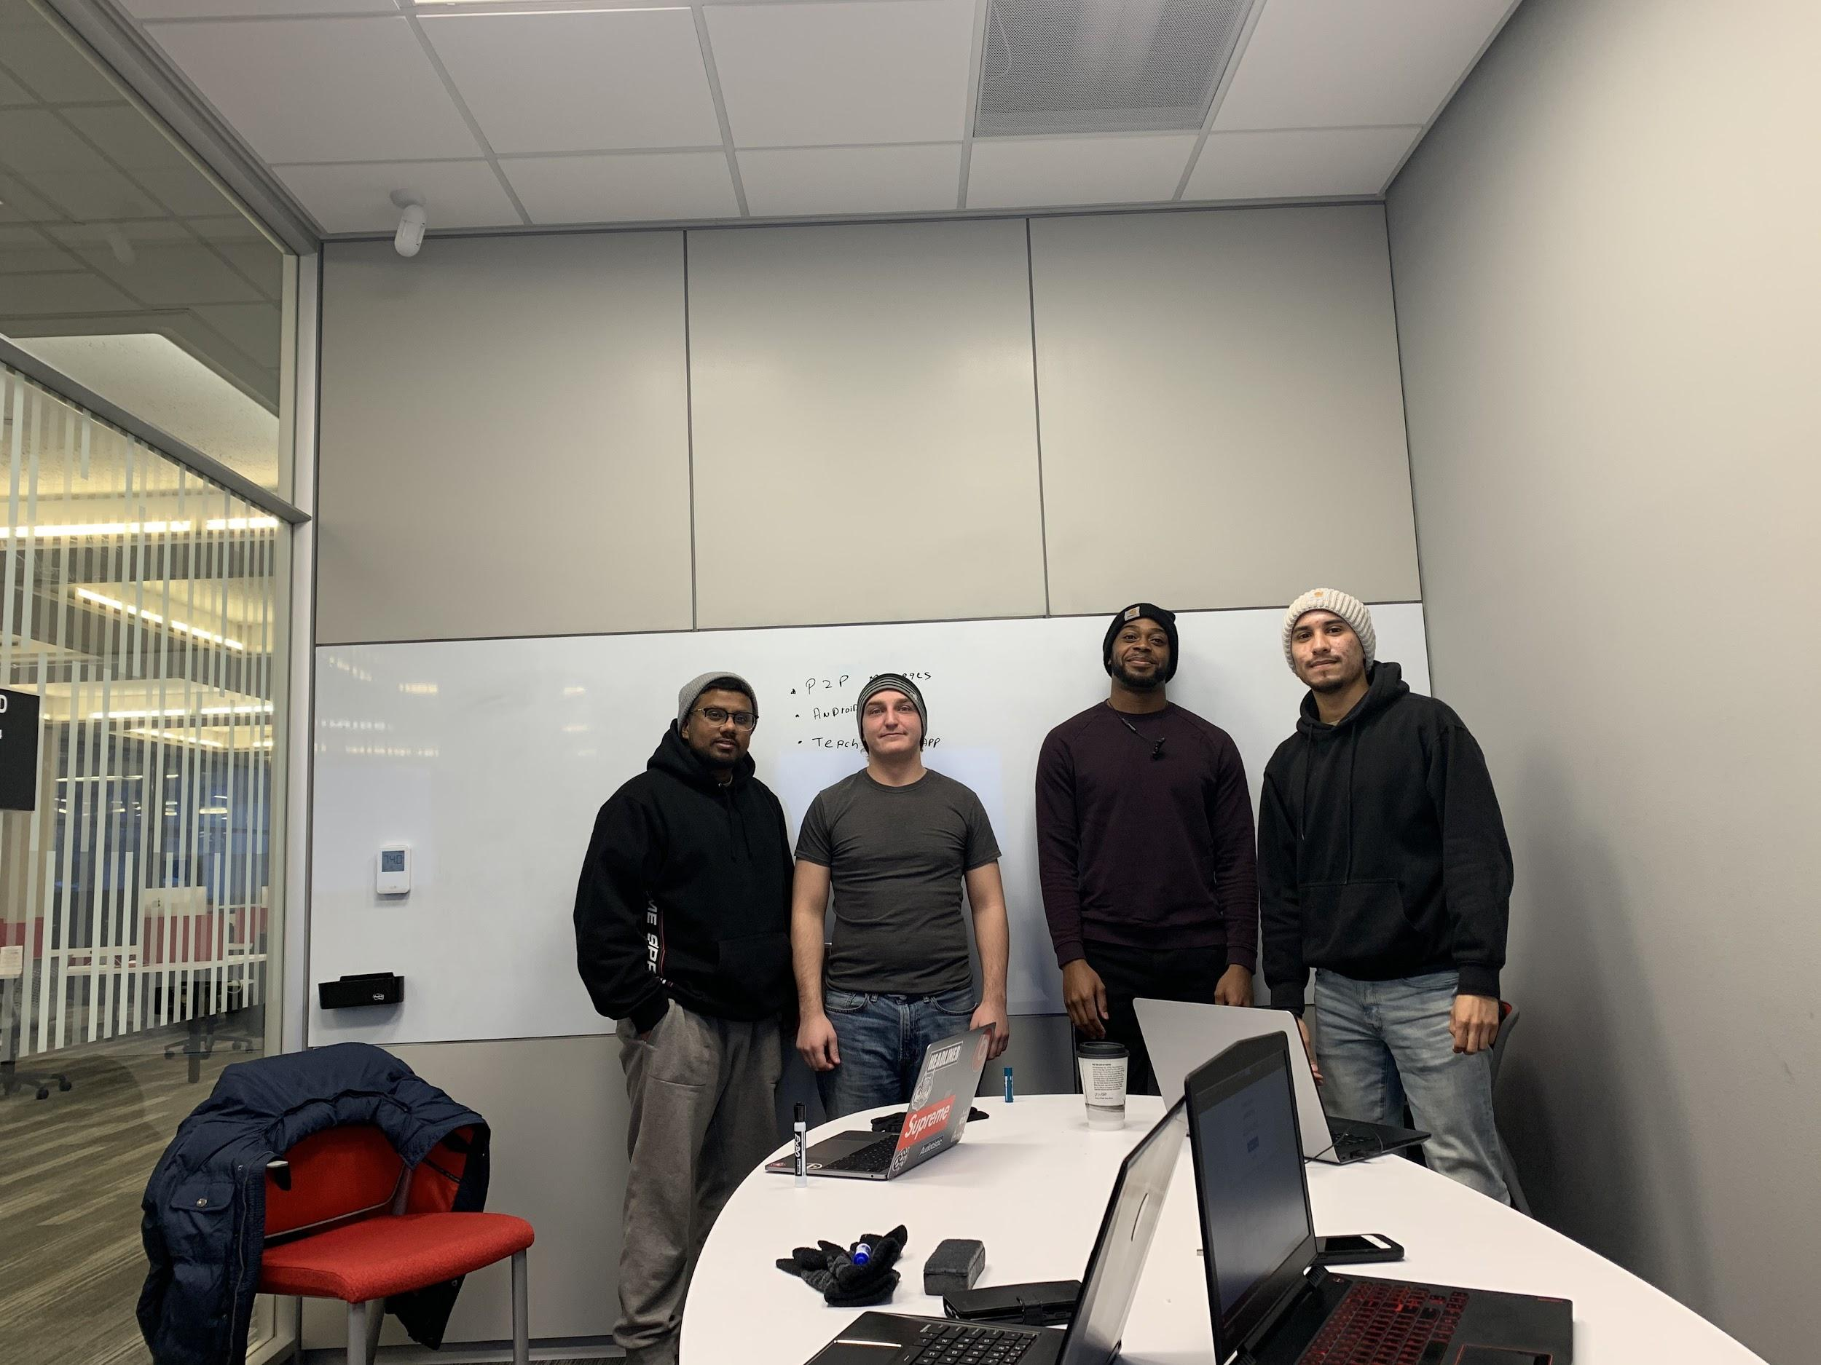

2.

Cody

* Java
* Android studio
* HTML,CSS,
* C
* Python
* <https://www.linkedin.com/in/cody-fredericks-27a8b9140>

Kenyon - Senior

* Java
* C/C++
* mySQL
* SQL
* PHP
* HTML
* CSS
* Javascript
* JQuery & Json
* Python

Courses Taken: CS 227/228, CS 327, CPR E 281, ENG 313, CS 321, CS 352, CS 342

Mohit - Senior

* Java
* C/C++
* HTML
* Python
* Switch
* React

Courses Taken: CS 227, 228, 327, 311, 352, 362, 331, 230, CPRE 430, 281, 321

Ismael - Senior

* Java
* Python
* C/C++
* Javascript

Courses taken: ComS 228 ComS 311, CprE 228, CprE 308

8th Semester in college

3. Project 1

* Name: BUILD - IT.
* Problem being addressed: Connects users looking to complete a project where the required skill set is out of their capacity.
* Description of Project
  + In today’s fast “pop-up shop” style world of Start-ups, there is a need for an app designed at placing exceptional talent within companies that need a slight push towards success. Often times, there are projects that go beyond the scope of one’s abilities and that’s where our app fills the void. By utilizing our app, persons searching for capable and competent workers will be able to collaborate and complete their projects in a timely and stress-free manner.
  + Our app is designed to connect users who need assistance with their projects with people with a specific skill set. This is accomplished by several ways. Initially a user seeking to find help for an upcoming project, posts an advertisement outlining what they need, this includes; Subject, Skills Needed, and Relevant Prior Experience, and Compensation. Users are then allowed to browse and search for jobs with their experience. Once the user that posts the job, and gets requests they will be alerted to those who have an interest in the job and may also suggest the job to people with relevant experience(under review by team). The users then connect via messages,negotiate, and then collaborate.
* Language/Platform/Libraries: Java, Android Studios, Springboot, Thymeleaf
* Large/Complex:
  + People to people messenger
  + Job Posting
  + Database
  + GUI
  + Connection to a server
  + Profiles
  + Server and Client
  + Reviews?