**Assignment: Screen Sketches**

**Team Number:** VB_4

**Team members:**

Ismael Duran

Kenyon Thomas

Mohit Sayore

Cody Federicks

**Project name:** Scout

**Actors and Functionality**

1. System Administrator
   1. This user can access all locations of the application.
   2. Should be able to control everyone's posting
   3. Able to supervise everyone’s account
   4. Be able to block posting
   5. Able to deactivate accounts
2. Job Seeker
   1. User can create a profile and look at job feeds posted by other user/recruiters. User can interact with job posting via commenting or sending a personal message.
   2. This user should be able to view public posting
   3. Should be able to control their own profile for the public to see by allowing editing, adding and deleting
   4. Able to search of posting to filter out uninterested posting
   5. Able to configure setting to their liking
   6. Should be able to view recruiters profiles
3. Job Recruiter
   1. Recruiter can create a profile and posts a job. This actor is looking for an applicant based on the requirements posted on the job description.
   2. Should be able to receive messages from potential clients
   3. Should be able to edit their own posts as well as editing and deleting
   4. Should as well be able to send message
   5. Be able to view seekers profile for recruiting
   6. Allowed to search for job seekers to filter out people with specific skills
   7. Able to configure setting to their liking
   8. Should be able to create their own profile to give credibility to job seekers

**List of NON-Functional requirements**

1. Make the GUI aesthetically good
2. After several attempts of a user password the account gets locked and an email is sent to the account holders email address.
3. Application loads up in less than 3 seconds. While using the app there is very little time it takes to load between different activities

**List tables/fields needed for your project**

User Information

First name, Last name, E-mail, userid, phone number, password, profile picture

* Will upload user file to profile

Posting information

Project name, project description, Needed roles, compensation, pictures

* For every posting all information will be sent to display

Message Table

User1, user2, message history

*possibly add a group chat room

**Screen flow diagram**

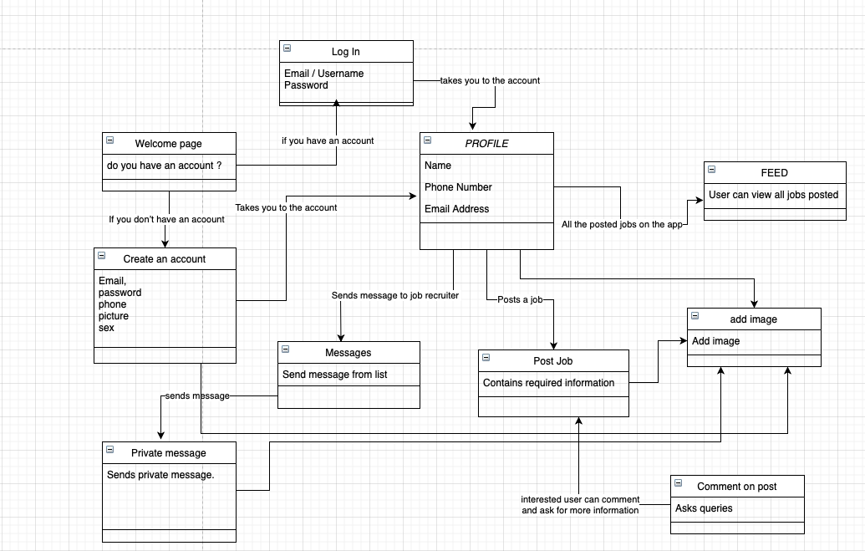

**Screen sketch 1. CJF - Create Account page**

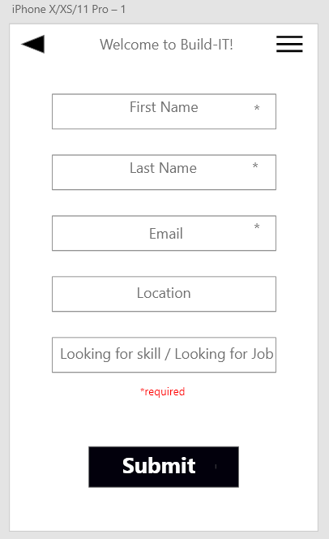

**This is the first screen you see after you select create a account.**

**This is where you will fill out all your basic info to get started.**

**The arrow in the top left is a back arrow, on this page would just exit the app.**

**The 3 lines on the top right is a settings./ menu bar.**

**Screen sketch 2. CJF - Profile page**

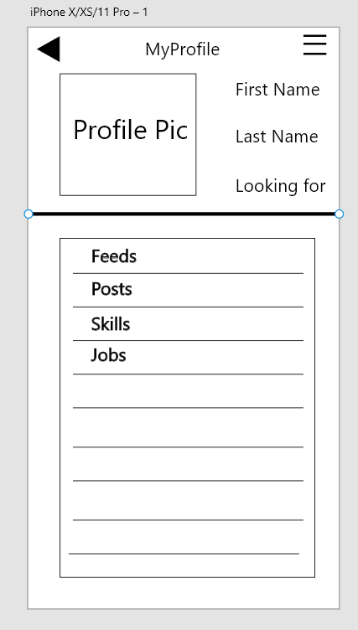

**This is the screen for your profile.**

**The arrow in the top left is a back arrow, on this page would just exit the app.**

**You can put a profile pic here.**

**You can display your name and what you're looking for here.**

**The 3 lines on the top right is a settings./ menu bar.**

**After the balck bar, is where you will see any subscribed feeds, skills you’re looking for job boards and so on.**

**Screen sketch 1. Mohit Job Post**

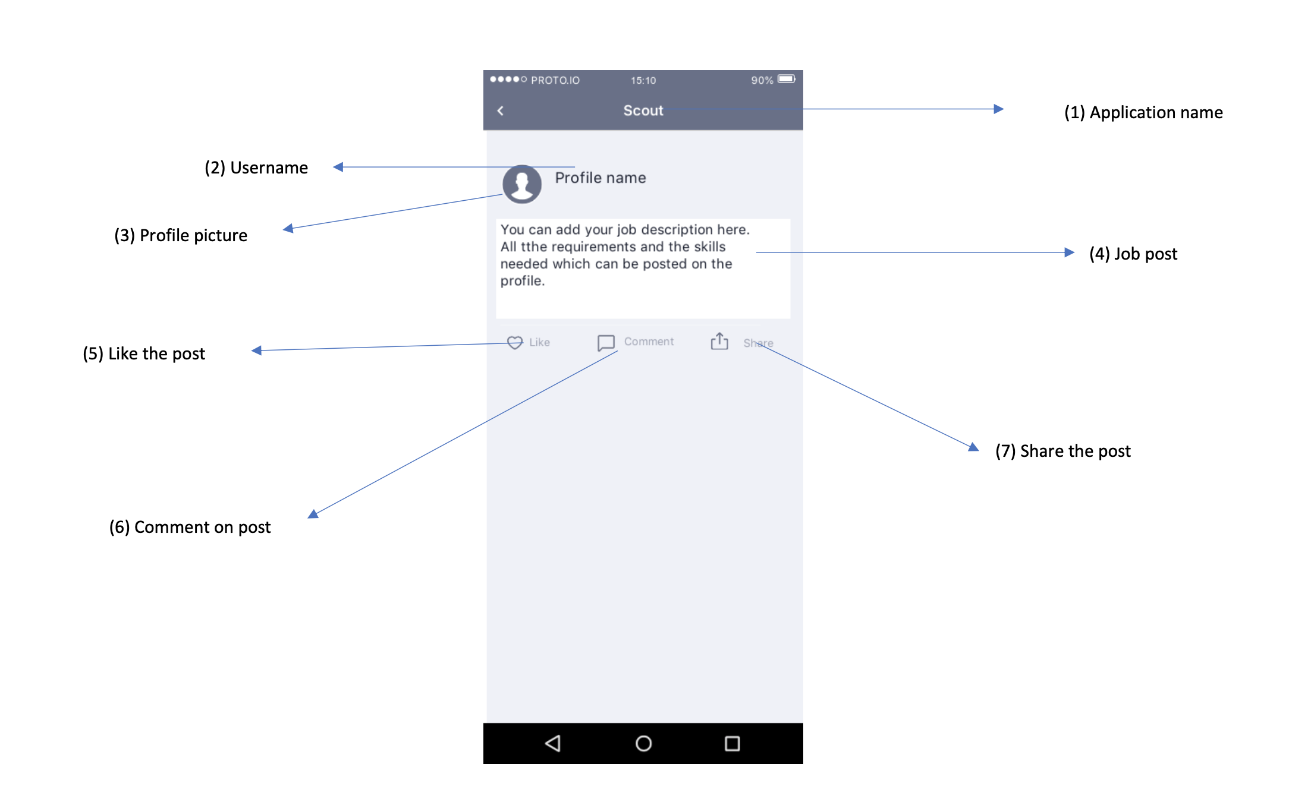

**Screen sketch 2. (Mohit) Comment on a job Post**

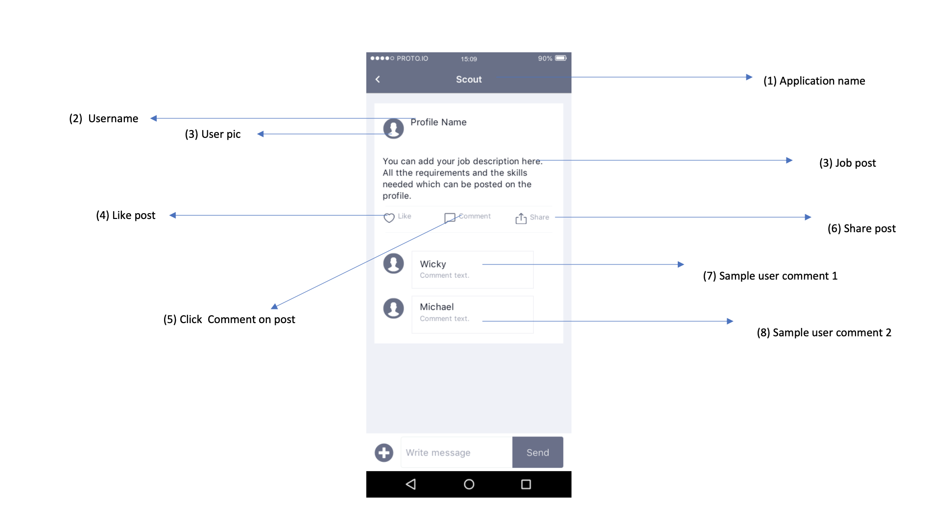

**Login Page (Ismael Duran)**

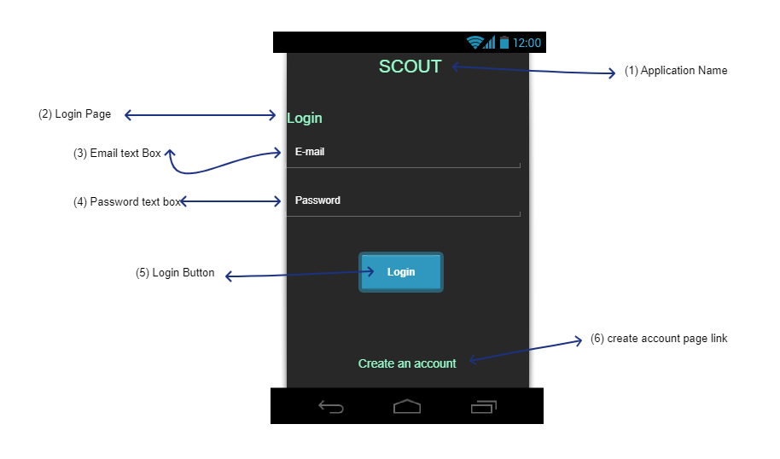

This login screen is the first thing a user will see when they first open the application for the very first time.At the very top of the screen will be the application name or symbol (1) to let the user know what application they opened and for. They will be a Login word art (2) to let the user know what they need to do when on this page.The user will need to put in their email and password that are linked to their account. They will put this information in text box (3) and (4).

(5) is what the user will click on when fill in the (3) and (4) text boxes to be login into their account. If there is a brand new user they will have to create an account. (6) is a button when clicked on they can go the sign up page to create an account.

**Search for post page (Ismael Duran)**

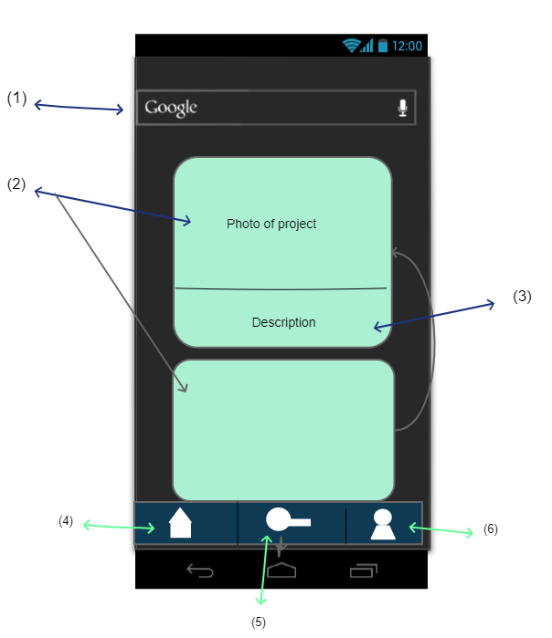

The purpose of this screen it to let the user be able to search for a post. For example, searching for a role in programming. This will allow the users to search for a job more efficiently. A user will search by using the search bar (1). Then post will appear right below it in a structure like the photo. (2) a Photo or a video will on top and right below it will be a description(3) of the project. To see more post user will scroll down this page. At the bottom of the screen will be buttons for the user to go back to home (4) where they can find public post. (5) is a search button which takes you to this screen sketch page and a third option will be the user's profile (6) where they can see their own profile as well as settings.

Messaging (Kenyon Thomas)

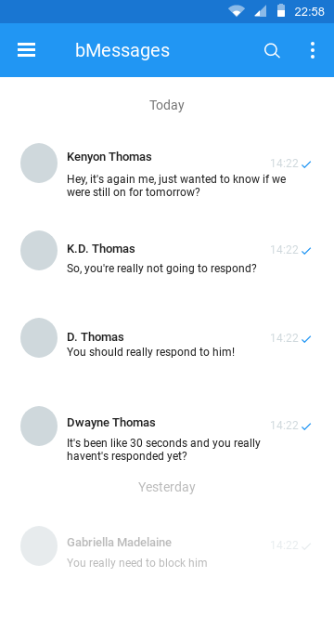

Messaging (Kenyon Thomas)

Here is a prototype for the messaging design. Although, there is time to decide on how it will actually look as I work primarily on the backend, nothing here is set in stone just yet. But, the screen sketch shows what a user would see as they visited their inbox.

Left-side focused, the user is given a profile picture and name, with a short descriptor on the message, that if short enough will be fully displayed.

In the upper-left there will a dropdown button to ease the navigation of the site. The application name will always be displayed. We will try to filter out the message using a search bar, to query the user’s specific messages.

On the upper-right, we standard account settings navigation and log out.

Admin View (Kenyon Thomas)

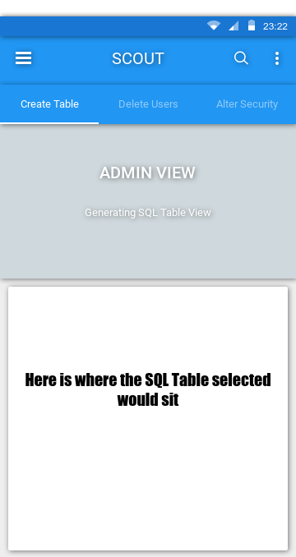

Admin View (Kenyon Thomas)

This screen displays the “Admin View”, specifically used by Admins this is the application’s interface for employees.

Allowing Admins to create, view, and if given upper-level privileges delete tables. Given an assortment of “powers”, the admin maintains proper community guidelines, erasing users who don’t adhere to the established guidelines. The admin can also remove postings deemed irresponsible.

Using similar features as messaging. Admin doesn’t stray too far from other functionality available, other than access to the database and monitoring the website.