Task-2
Adding new columns, new measures, and showing them in Table view and Report view
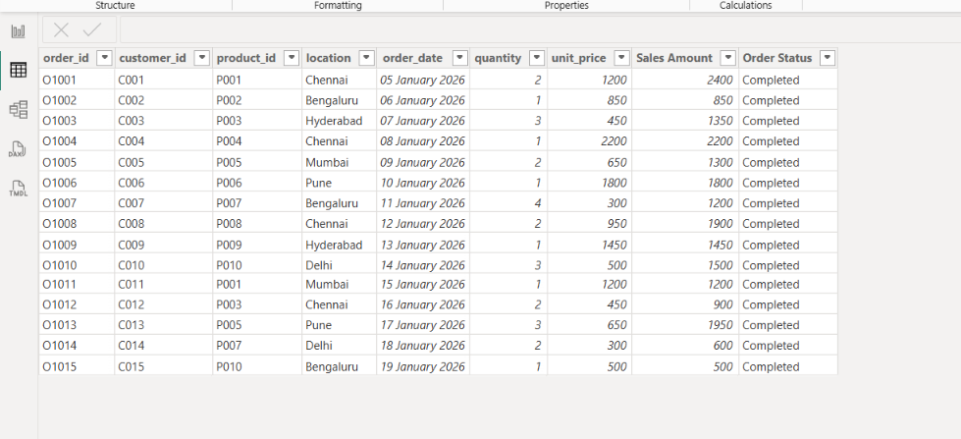
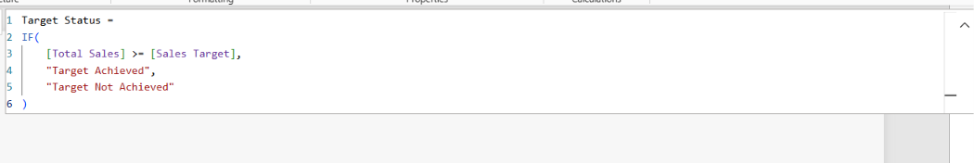

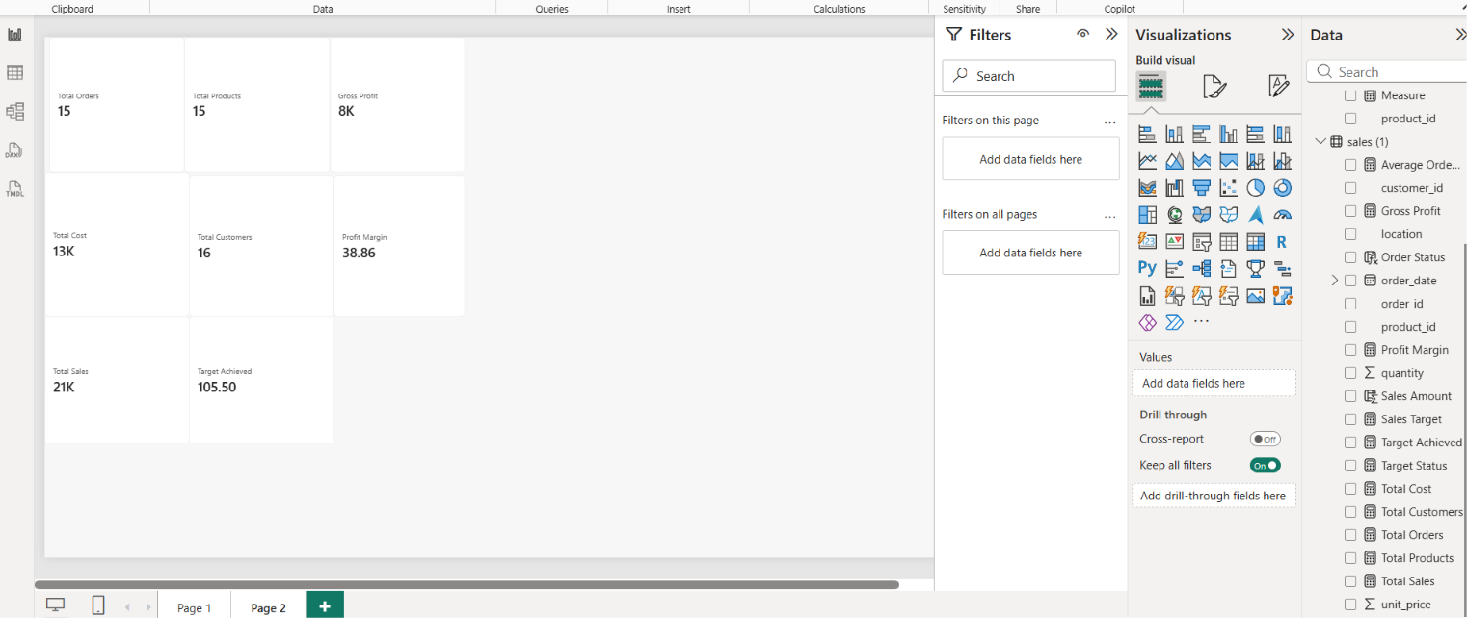
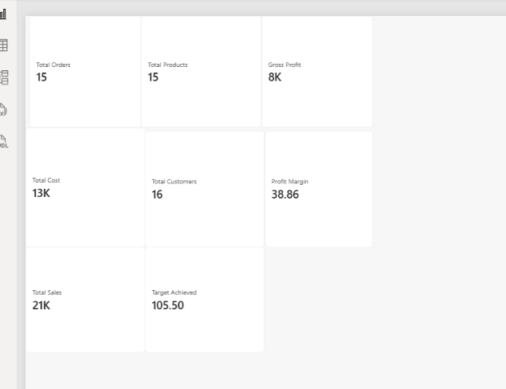
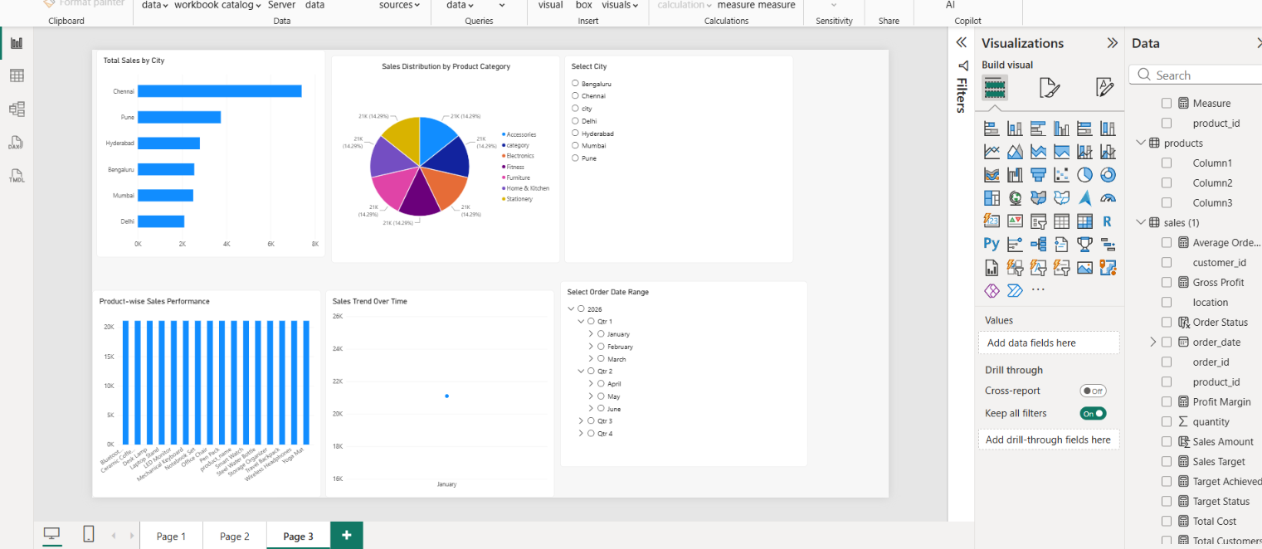
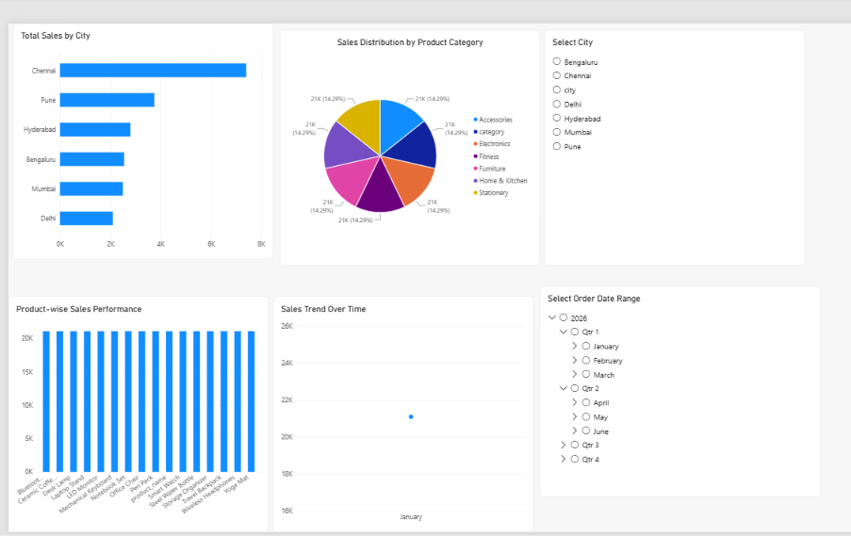

Task-3
Performance Analyzer
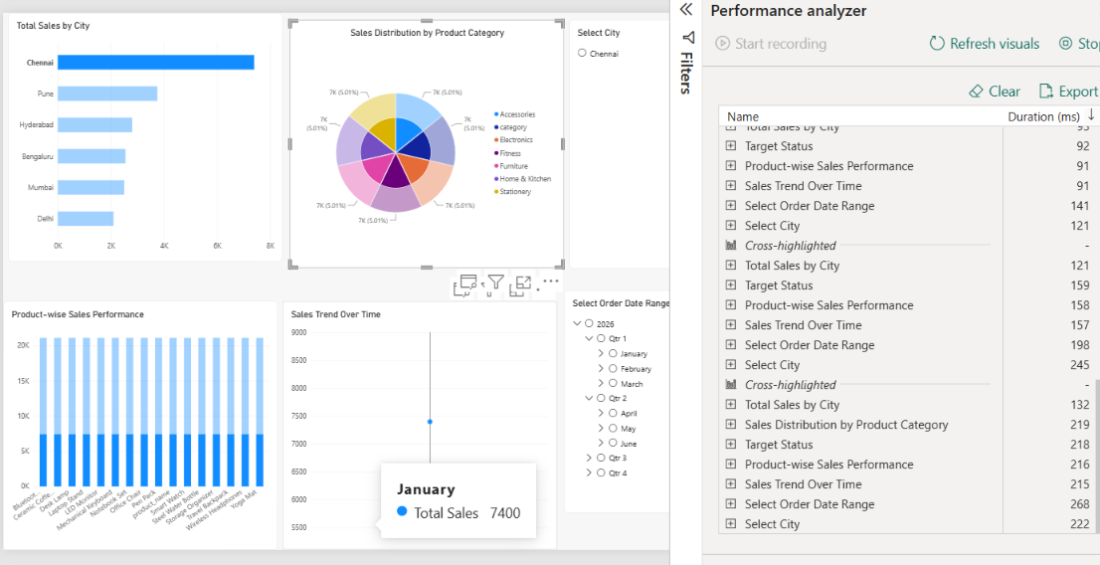

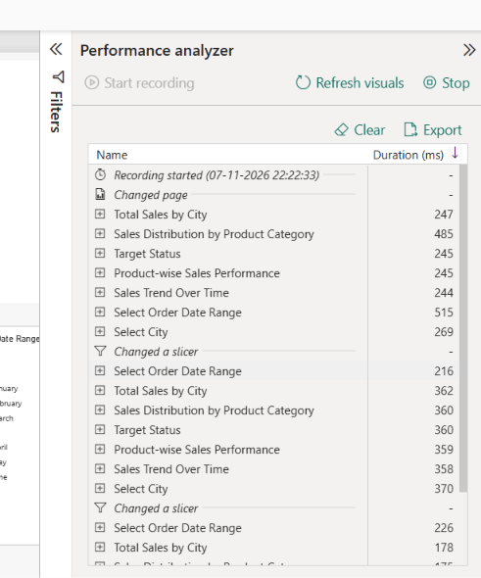

Task-4
Proper Story Telling
No. | Business Insights | Business Interpretation | Business Recommendation
1 | Chennai has the highest sales of ₹3,800, followed by Bengaluru with ₹2,800. | Chennai is the strongest sales location in this dataset. It may have better customer demand or higher order values. | Focus on Chennai customers, maintain sufficient stock and study successful sales strategies to apply in other cities.
2 | Electronics generates the highest category sales of ₹6,850. | Electronics is an important revenue contributor, showing good demand for products such as headphones and speakers. | Expand the electronics product range, offer product bundles and maintain stock of popular products.
3 | The highest individual product sales come from Wireless Headphones, generating ₹3,600. | Wireless Headphones have strong sales value compared with other individual products. | Promote this product through special offers and bundle it with complementary products.
4 | Wholesale and Corporate customers contribute significant sales opportunities. | Different customer types may have different purchasing requirements and order quantities. | Create separate pricing plans, bulk discounts and loyalty offers for Wholesale, Corporate and Retail customers.
5 | Total sales are ₹22,500 against a target of ₹20,000, achieving 112.5%. | The business has exceeded its sample sales target by ₹2,500, indicating positive overall sales performance. | Set a higher target for the next period, monitor monthly performance and identify the factors contributing to sales growth.

