## Study Title: Santee Accord Diadromous Fish Studies

## Period Covered: January 2023—December 2023

**Introduction**

The Santee Basin Cooperative Accord (Accord) is a collaborative approach among the hydroelectric utilities and state and federal resource agencies to address diadromous fish issues within the Santee Basin. Partners include Dominion Power, (formerly known as South Carolina Electric & Gas), Duke Energy, South Carolina Department of Natural Resources (SCDNR), North Carolina Wildlife Resource Department, and US Fish and Wildlife Service (FWS). The Accord allows members to focus efforts on the highest priority areas with the greatest potential for successful results, rather than addressing issues piecemeal based on project relicensing schedules. In exchange for the utilities agreeing to combine and focus efforts by priority sub-basin, the FWS agrees to reserve authority or prescribe phased and or delayed fish passage at lower priority sub-basins. Combining funding and focusing efforts on high priority habitats will produce (1) a collaborative and concentrated response to depressed diadromous fish populations, (2) a program guided by biological responses, and (3) will provide economic assurances to utility companies. This 10-Year Action Plan for the Santee Basin represents the next phase and evolution of the Santee Plan. This Action Plan recognizes the Broad River sub-basin as having the highest priority and potential for successful restoration of diadromous fish, and details in logical steps those activities necessary to rebuild fish populations. The basic tenet of this Action Plan is to rebuild diadromous fish populations in upstream river reaches through enhancement activities and construct permanent passage facilities at dams as stocks rebuild. This plan is to use a combination of enhancement activities including hatchery techniques resulting in fry augmentations, re-locations of pre-spawning adults, and permanent passage facilities as they become warranted. The plan designates 10 task areas for studies, and this report focuses on task 4 in the plan.

*Task 4. Juvenile Shad Monitoring in Nursery Waters and Shad Fin Clip Collection*

Purpose: To collect sufficient young-of-year (YOY) juvenile American shad (AMS) to determine abundance, distribution, size, and out-migration timing. Additionally, collect shad fin clips, for future genetic analyses of the relative contribution of natural versus hatchery produced shad.

**Materials and Methods**

*Sampling Sites*

Sampling occurred at three sites in the Wateree River, three in the Congaree River, four in Lakes Marion and Moultrie, one in the Diversion Canal, and four in the upper Santee River (Figures 1–4). Sampling sites on rivers were selected from satellite imagery based on areas that were presumed to be preferred nursery habitat for YOY AMS. These habitats typically consist of sandbars occurring on the inside bend of rivers, ranging 1–2 meters (m) depth. Sampling sites on lakes were chosen in accordance with juvenile striped bass surveys previously conducted by other SCDNR personnel. These sites also occur over sandbars with a similar depth profile.

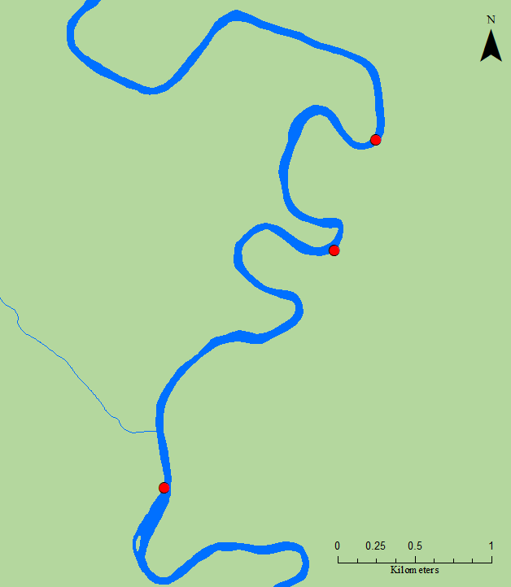

Site #1

Site #3

Site #2

US 378

### Figure 1. Wateree River sampling sites.

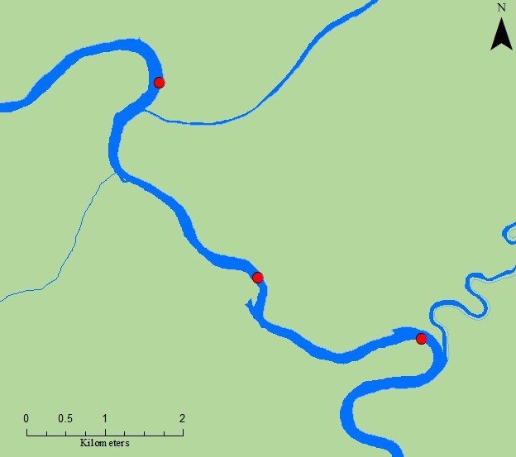

Site #3

Site #2

Site #1

US 601

### Figure 2. Congaree River sampling sites.

### Figure 3. Lakes Marion and Moultrie and Diversion Canal sampling sites.

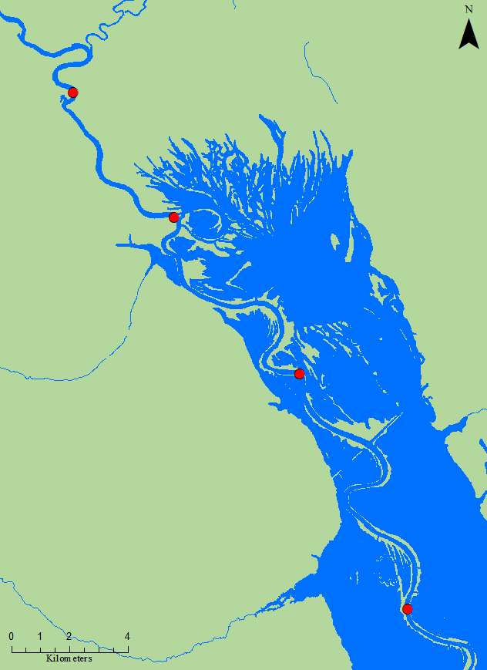

Site #4

Site #3

Site #2

Site #1

### Figure 4. Upper Santee River sampling sites.

*Juvenile AMS Collections*

Electrofishing occurred weekly from June through October (22 weeks). River sites were visited during daylight hours with a goal of three times per month, during which a single 0.25-hr sample per site was conducted. To save financial and personnel resources, sites that typically produce far lower numbers of AMS were only sampled twice per month. Additionally, lake sites were sampled once per month during nighttime hours in September and October. All fish collected were identified to species and total length was recorded to the nearest millimeter (mm). AMS were separated by site, preserved on ice, and later frozen. In past years, after sampling concluded for the season, otoliths were extracted from preserved shad and viewed under a UV fluoroscope to identify fish displaying an oxytetracycline (OTC) mark, thus indicating a fish of hatchery origin. On January 1, 2017, the Food and Drug Administration issued a new rule that all veterinary antibiotics will be accessible only with veterinary oversight. OTC is a veterinary antibiotic and because of the change in the law SCDNR chose to no longer mark AMS using OTC. Consequently, for the 2017 sampling season and thereafter, pectoral fin clips were collected for later analysis for DNA matches with hatchery brood stock, thus indicating fish of hatchery origin.

*Adult American Shad Collections*

During the 2015 Santee Accord board and technical committee meeting, funds were approved to explore the possibility of changing the current study design to collect adult AMS during their spawning run from areas similar to where electrofishing for juvenile shad occurs. This was done to help determine if any AMS return spawners within the Santee River Basin are comprised of hatchery origin fish. A combination of drift-gillnets and electrofishing was used to collect specimens, and pectoral fins of captured adult AMS were clipped for future lab analysis.

*Adult American Shad Collections*

During the 2015 Santee Accord board and technical committee meeting, funds were approved to explore the possibility of changing the current study design to collect adult AMS during their spawning run from areas similar to where electrofishing for juvenile shad occurs. This was done to help determine if any AMS return spawners within the Santee River Basin are comprised of hatchery origin fish. A combination of drift-gillnets and electrofishing was used to collect specimens, and pectoral fins of captured adult AMS were clipped for future lab analysis.

### Table 1. Sampling locations, # of trips, effort, # of juvenile shad collected, and CPUE totals for 2023.

|  |  |  |  |  |
| --- | --- | --- | --- | --- |
| **Sampling Locations** | **# Sampling Trips** | **Total Pedal Time (Seconds)** | **# AMS Captured** | **CPUE (#AMS / minute)** |
| **CONGAREE RIVER** | | | | |
| Bar upstream of HWY 601 | 18 | 16,200 | 155 | 0.57 |
| Bar downstream of HWY 601 | 18 | 16,200 | 140 | 0.52 |
| Congaree/Wateree Confluence | 18 | 16,200 | 160 | 0.59 |
|  | **TOTAL FOR CONGAREE** | **48,600** | **455** | **0.56** |
| **UPPER SANTEE RIVER** | | | | |
| Bar upstream of Trezvants | 18 | 16,200 | 104 | 0.39 |
| Bar upstream of Week's Landing | 18 | 16,200 | 86 | 0.32 |
| Bar upstream of Low Falls RR | 18 | 16,200 | 119 | 0.44 |
| Bar upstream of the Blowout | 18 | 16,200 | 344 | 1.27 |
|  | **TOTAL FOR SANTEE** | **64,800** | **653** | **0.60** |
| **WATEREE RIVER** | | | | |
| 2nd Bar upstream of HWY 378 | 5 | 4,500 | 42 | 0.56 |
| 1st Bar upstream of HWY 378 | 5 | 4,500 | 12 | 0.16 |
| Bar downstream of HWY 378 | 5 | 4,500 | 27 | 0.36 |
|  | **TOTAL FOR WATEREE** | **13,500** | **81** | **0.36** |
| **LAKE MARION** | | | | |
| Harry's Fish Camp | 1 | 1,800 | 15 | 0.5 |
| Big Water | 1 | 1,800 | 147 | 4.9 |
| Indian Bluff | 1 | 1,800 | 98 | 3.27 |
|  | **TOTAL FOR MARION** | **5,400** | **260** | **2.89** |
| **DIVERSION CANAL** | | | | |
| Upstream of HWY 45 Bridge | 11 | 9,900 | 2 | 0.01 |
|  | **TOTAL FOR DIVERSION** | **9,900** | **2** | **0.01** |
| **LAKE MOULTRIE** | | | | |
| Bonneau Beach | 1 | 1,800 | 56 | 1.87 |
|  | **TOTAL FOR MOULTRIE** | **1,800** | **56** | **1.87** |
|  |  |  |  |  |
|  | **2023 TOTALS** | **144,000** | **1,507** | **0.63** |

**Results and Discussion**

*Sampling Results*

Juvenile shad were collected from May 30 to October 26, 2023. In total, 1,507 juvenile AMS were collected in 2023. This total resulted from an effort of 144,000 seconds of electrofishing time with an overall CPUE 0.63 AMS/minute (Table 1). Collected juvenile AMS ranged from 30–201 mm, total length. Individual totals per river per site are listed in Table 1. A subsample of 20 AMS per site were frozen and fin clips will be extracted during upcoming winter months. Electrofishing efforts resulted in collecting a total of 10,278 fish including 51 different species (Figure 5). American shad was the most abundant species in the collection (14%), followed by eastern silvery minnow (13%), coastal shiner (12%), whitefin shiner (11%), bluegill (9%), redear sunfish (7%), and threadfin shad (5%); all other individual species comprised less than 5% of the collection (Figure 5). Observed ranges for water quality parameters during sampling were as follows: temperature, 17.7–30.9°C; dissolved oxygen, 6.28–11.22 mg/L; conductivity, 74.3–125.4 µS; salinity, 0.04–0.06 ppt.

### Figure 5. Percent composition of all species collected. Species without a percentage indicated made up < 5% of the total collection. Fish common names with the three letter abbreviations are provided in Appendix 1.

*Juvenile AMS Catch Rates*

Statistical analysis of data from 2009 to 2016 indicated a general overall trend of increase-peak-decrease in catch rate in most of our sampling years (Post and Holbrook 2016). The increase-peak-decrease trend is most likely a result of a combination of changing environmental and ontogenetic factors as the sampling season progresses. Stokesbury and Dadswell (1989) reported water temperature to be a leading factor for juvenile AMS migration, suggesting that YOY AMS movement was triggered by temperatures ranging from 12–19°C, depending on moon phase. Similarly, 4–6°C was suggested as a lower threshold temperature limit for YOY AMS before emigrating completely from freshwater (Chittenden 1969; Marcy 1976). Another potential cue for outmigration is body size, where larger, typically older, individuals have been found in the downstream portion of rivers earlier than their smaller bodied conspecifics (Limburg 1996). Sampling locations are located near spawning and nursery habitat and, in the fall of the year as water temperatures cool and fish size is larger, we capture fewer AMS most likely because downstream migrations have occurred.

In 2023, catch rate and day of year (DOY) were plotted for juvenile AMS samples collected in the Congaree, Wateree, and Upper Santee Rivers, the Diversion Canal, and Lakes Marion and Moultrie (Figure 6).Data indicates an increase in catch in early summer with a slight peak by mid-July during optimal water temperatures. This was followed by a delay in AMS outmigration as water temperatures remained consistently above 20°C throughout summer months. A drop below 19°C occurred in mid-October and catch rates increased slightly, suggesting the sampling period ended before YOY began to leave the system.Lower than average river levels were a probable factor leading to warmer water temperatures and later outmigration in 2023, and potentially lower catches than in previous years with similar effort (Figure 7).

### Figure 6. Catch rates of juvenile AMS and water temperature throughout the upper Santee River Basin (Congaree, Wateree, and Upper Santee Rivers) in 2023. Catch rate is equal to number of AMS per minute of sampling and DOY is day of calendar year.

### Figure 7. Number of juvenile AMS collected and total sample effort throughout the upper Santee River Basin, the Diversional Canal, and Lakes Marion and Moultrie from 2009 through 2023.

*Adult AMS Catch Rates*

Adult AMS were collected in the Upper Santee River to verify spawning habitat in the Santee Cooper System and establish an annual index of abundance for returning spawners. Data from 2023 spring gillnetting consisted of four trips from January 31 to March 16. A total of 43 adult AMS were collected (Figure 8). Numbers peaked in February during the spawning season and decreased significantly through March.

### Figure 8. Monthly catch rates for adult AMS in the Upper Santee River (2019–2023).

Due to the abundance of debris and submerged trees in the Congaree and Wateree Rivers, gillnet sampling for AMS was problematic, therefore the preferred sampling method was boat electrofishing. This method has proved to be effective in collecting AMS while also being less damaging to equipment. In 2023, electrofishing occurred between March 29 and April 21 on the Congaree (three trips) and Wateree Rivers (three trips). Twenty-three adult AMS were collected in the Congaree River, and 11 adult AMS in the Wateree River (Figure 9).

Number of AMS Caught

### Figure 9. Number of adult AMS caught electrofishing in the Congaree and Wateree rivers from 2023 compared to 2021 and 2022 (No data from 2020 due to Covid-19 restrictions).

A total of 77 adult AMS were collected from the Congaree, Wateree, and Santee Rivers with pectoral fin clips collected from all fish. Tissue samples were preserved in alcohol for future genetic analysis to determine hatchery contribution (Table 2). In September 2023 funding was awarded to the SCDNR Population Genetics Laboratory to assess the restoration effort of AMS in the Santee-Cooper River basin by evaluating hatchery contributions to YOY abundance and returning adults. Results of the study are expected in August 2024 and will inform future decisions regarding continued stocking of AMS in the system.

### Table 2. Number of adult AMS and associated tissue samples collected in 2023.

|  |  |  |
| --- | --- | --- |
| River | Adult AMS Collected | Number of Tissue Samples |
| Upper Santee | 43 | 42 |
| Congaree | 23 | 23 |
| Wateree | 11 | 11 |
| Total | 77 | 76 |

**Recommendations**

Sampling will continue in 2024 but will be conducted by regional SCDNR employees and slight changes in study design may occur. The new genetic analysis study will be used to determine overall hatchery contribution to the system and to evaluate the success of the Santee-Cooper River Basin AMS stocking program as a whole. Data will continue to be used to demonstrate sustainability for the Santee and Cooper Rivers as part of ASMFC’s American Shad Sustainability Plan for South Carolina.

**Literature Cited**

Chittenden, M.E. 1969. Life history and ecology of the American Shad, *Alosa sapidissima*, in the Delaware River. Doctoral dissertation. Rutgers University, New Brunswick, New Jersey.

Limburg, K.E. 1996. Growth and migration of 0-year American Shad (*Alosa sapidissima*) in the Hudson River estuary: Otolith microstructural analysis. Canadian Journal of Fisheries and Aquatic Sciences 53: 220-238.

Marcy, B.C., Jr. 1976. Early life history studies of American Shad in the lower Connecticut River and the effects of the Connecticut Yankee Plant. Pages 141–168 *in* D. Merriman and L.M. Thorpe, editors. The Connecticut River ecology study: The impact of a nuclear power plant. American Fisheries Society Monograph No. 1, Bethesda, Maryland.

Post, B. and Holbrook, C. 2016. Diadromous Fish Project Annual Progress Report, SCR1-39, 244 pp.

Stokesbury, K.D.E., and Dadswell, M.J. 1989. Seaward migration of juveniles of three herring

species, *Alosa*, from an estuary in the Annapolis River, Nova Scotia. The Canadian

Field-Naturalist 103: 388-39.5293685

## Title:

## Fisheries Biologist

## Fisheries Technician

## Prepared By:

## Rickie Guderian

## Lily Graham

### Appendix 1.Common names and abbreviations of fish collected using boat electrofishing equipment.

|  |  |  |  |  |
| --- | --- | --- | --- | --- |
| American Shad | AMS |  | Longnose Gar | LNG |
| Atlantic Needlefish | ANF |  | Mosquito Fish | MSQ |
| Blackbanded Darter | BBD |  | Notchlip Redhorse | NLR |
| Blue Catfish | BCF |  | Quillback | QLB |
| Bowfin | BFN |  | Redbreast Sunfish | RBS |
| Bluefin Killifish | BFK |  | Redear Sunfish | RES |
| Black Crappie | BLC |  | Seminole Killifish | SEK |
| Bluegill | BLG |  | Shorthead Redhorse | SHR |
| Blueback Herring | BLH |  | Smallmouth Buffalo | SLB |
| Brassy Jumprock | BJR |  | Smallmouth Bass | SMB |
| Brook Silverside | BSS |  | Spotted Sunfish | SOS |
| Channel Catfish | CCF |  | Spotted Sucker | SPS |
| Chain Pickerel | CHP |  | Striped Mullet | SRM |
| Common Carp | CRP |  | Striped Bass | STB |
| Coastal Shiner | CSH |  | Spottail Shiner | STS |
| Dollar Sunfish | DSF |  | Tadpole Madtom | TPM |
| Eastern Silvery Minnow | ESM |  | Threadfin Shad | TFS |
| Flathead Catfish | FCF |  | Tessellated Darter | TSD |
| Grass Carp | GCP |  | Warmouth | WAR |
| Golden Shiner | GLS |  | White Catfish | WCF |
| Gizzard Shad | GZS |  | Whitefin Shiner | WFS |
| Highfin Carpsucker | HFC |  | White Perch | WTP |
| Inland Silverside | ILS |  | Yellow Bullhead | YBL |
| Lake Chubsucker | LKC |  | Yellow Perch | YLP |
| Largemouth Bass | LMB |  |  |  |