## **Study Title: Santee Accord Diadromous Fish Studies**

## **Period Covered: January 2025—December 2025**

**Introduction**

The Santee Basin Cooperative Accord (Accord) is a collaborative approach among the hydroelectric utilities and state and federal resource agencies to address diadromous fish issues within the Santee Basin. Partners include Dominion Power, (formerly known as South Carolina Electric & Gas), Duke Energy, South Carolina Department of Natural Resources (SCDNR), North Carolina Wildlife Resource Department, and US Fish and Wildlife Service (FWS). The Accord allows members to focus efforts on the highest priority areas with the greatest potential for successful results, rather than addressing issues piecemeal based on project relicensing schedules. In exchange for the utilities agreeing to combine and focus efforts by priority sub-basin, the FWS agrees to reserve authority or prescribe phased and or delayed fish passage at lower priority sub-basins. Combining funding and focusing efforts on high priority habitats will produce (1) a collaborative and concentrated response to depressed diadromous fish populations, (2) a program guided by biological responses, and (3) will provide economic assurances to utility companies. This 10-Year Action Plan for the Santee Basin represents the next phase and evolution of the Santee Plan. This Action Plan recognizes the Broad River sub-basin as having the highest priority and potential for successful restoration of diadromous fish, and details in logical steps those activities necessary to rebuild fish populations. The basic tenet of this Action Plan is to rebuild diadromous fish populations in upstream river reaches through enhancement activities and construct permanent passage facilities at dams as stocks rebuild. This plan is to use a combination of enhancement activities including hatchery techniques resulting in fry augmentations, re-locations of pre-spawning adults, and permanent passage facilities as they become warranted. The plan designates 10 task areas for studies, and this report focuses on task 4 in the plan.

*Task 4. Juvenile Shad Monitoring in Nursery Waters and Shad Fin Clip Collection*

Purpose: To collect sufficient young-of-year (YOY) juvenile American shad (AMS) to determine abundance, distribution, size, and out-migration timing. Shad fin clips continue to be collected and catalogued for future genetic analyses of natural versus hatchery-reared shad.

**Materials and Methods**

*Sampling Sites*

Due to the loss of dedicated funding and crew (after the 2023 season), sampling in the Santee Basin only occurred at three sites in the Congaree River, and four in the upper Santee River (Figures 1–2). This sampling was conducted by SCDNR WFF Region IV staff, aided by members of the Diadromous section. Sampling sites on rivers were selected from satellite imagery based on areas that were presumed to be preferred nursery habitat for YOY AMS. These habitats typically consist of sandbars occurring on the inside bend of rivers, ranging 1–2 meters (m) depth.

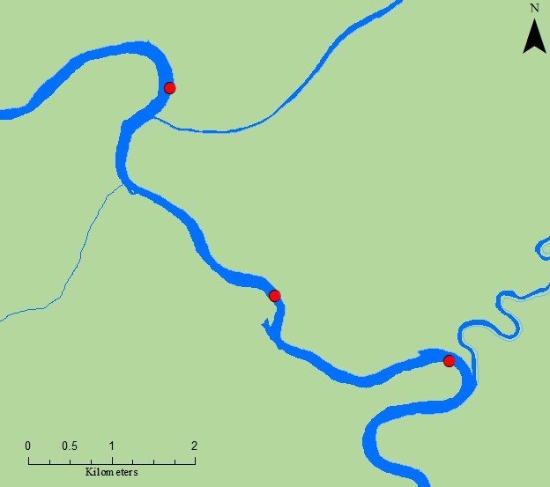

Site #3

Site #2

Site #1

US 601

Figure 1. Congaree River sampling sites

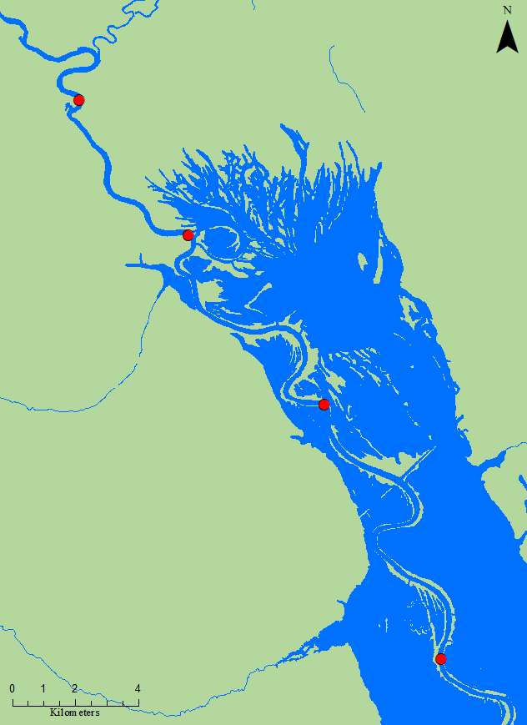

Site #4

Site #3

Site #2

Site #1

Figure 2. Upper Santee River sampling sites.

*Juvenile AMS Collections*

Electrofishing occurred biweekly from early June through October, for a total of 7 sampling trips. River sites were visited during daylight hours, and a single 0.25-hr sampling was conducted per site. All fish collected were identified to species and total length was recorded to the nearest millimeter (mm). Up to twenty American shad (AMS) were collected per site, and preserved on ice (later frozen) for laboratory processing. In past years, after sampling concluded for the season, otoliths were extracted from preserved shad and viewed under a UV fluoroscope to identify fish displaying an oxytetracycline (OTC) mark, thus indicating a fish of hatchery origin. On January 1, 2017, the Food and Drug Administration issued a new rule that all veterinary antibiotics will be accessible only with veterinary oversight. OTC is a veterinary antibiotic and because of the change in the law, SCDNR chose to no longer mark AMS using OTC. Consequently, for the 2017 sampling season and thereafter, pectoral fin clips were collected for later analysis for DNA matches with hatchery brood stock, thus indicating fish of hatchery origin.

*Data Treatment*

Site specific data were pooled to inform catch rates by river, defining within-season rates and allowing annual totals to be calculated. Efforts were summed and paired with the appropriate catch rate to standardize annual rates and demonstrate changes to survey design for the past two years. Standardized annual rates were plotted as individual series to visualize relative abundance trends through time in all rivers, and 25th percentiles were calculated from all available years to act as a baseline to qualify the strength of year classes.

*Adult American Shad Collections*

During the 2015 Santee Accord board and technical committee meeting, funds were approved to explore the possibility of expanding the current study design to collect adult AMS during their spawning run from areas similar to where electrofishing for juvenile shad occurs. This was done to help determine if any AMS return spawners within the Santee River Basin are comprised of hatchery origin fish. A combination of drift-gillnets and electrofishing was used to collect specimens, and pectoral fins of captured adult AMS were clipped for future lab analysis. No adult AMS sampling occurred during the 2024–2025 seasons due to the loss of a dedicated crew and funding, however all previous samples have been retained for later analysis.

**Results and Discussion**

*Sampling Results*

Juvenile shad were collected from June 2 to October 8, 2025. In total, 286 juvenile AMS were collected from 43,967 seconds of electrofishing time, with greater overall catchability from the Santee sites compared to the Congaree sites. Total catch per site and arithmetic mean catch per minute were calculated (Table 1). Additionally, electrofishing efforts resulted in the collection of several non-targeted species. Due to sampling efforts being divided between different crews, species identification of shiners, minnows, and darters was not consistent with prior efforts, and such species were not included in frequency counts. The resulting catch for the most abundant species totaled 2,312 fish (Table 2). Collected juvenile AMS ranged from 31-205 mm (total length), and up to 20 AMS were collected per site for later fin clip extraction. Observed ranges for water quality parameters during sampling were as follows: temperature, 21.5–25.6°C; dissolved oxygen, 3.06*–6.92 mg/L; conductivity, 78–123.1 µS; salinity, 0.00-0.10 ppt. (*Note: the dissolved oxygen probe on the water quality instrument was dying during sampling trips at the start of the season, resulting in very low—and likely inaccurate—dissolved oxygen readings).

|  |  |  |  |  |
| --- | --- | --- | --- | --- |
| **Sampling Location** | **# Sampling Trips** | **Total Pedal Time (s)** | **# AMS** | **CPUE (#AMS/minute)** |
| **Congaree River** |  |  |  |  |
| Bar upstream of HWY 601 (E) | 7 | 6,300 | 14 | 0.13 |
| Bar downstream of HWY 601 (F) | 7 | 6,300 | 20 | 0.19 |
| Congaree/Wateree Confluence (G) | 7 | 6,300 | 28 | 0.27 |
|  | **Congaree Totals** | **18,900** | **62** | **0.20** |
| **Upper Santee River** |  |  |  |  |
| Bar upstream of Trezvants (D) | 7 | 6,300 | 52 | 0.49 |
| Bar upstream of Week's Landing (A) | 7 | 6,167 | 29 | 0.28 |
| Bar upstream of Low Falls RR (B) | 7 | 6,300 | 79 | 0.75 |
| Bar upstream of the Blowout (C) | 7 | 6,300 | 64 | 0.61 |
|  | **Santee Totals** | **25,067** | **224** | **0.54** |

### Table 1. Sampling locations, # of trips, effort, # of juvenile shad collected, and CPUE for 2025.

### Table 2. The most frequently encountered fishes collected from electrofishing efforts in the Santee and Congaree Rivers from 2024–2025. Fish common names with the three letter abbreviations are provided in Appendix 1.

|  |  |  |  |  |  |  |  |  |  |  |
| --- | --- | --- | --- | --- | --- | --- | --- | --- | --- | --- |
| Year | AMS | BLH | BCF | BLG | FCF | GZS | LNG | LMB | TFS | WTP |
| 2024 | 1,567 | 94 | 9 | 371 | 32 | 620 | 85 | 136 | 897 | 106 |
| 2025 | 286 | 89 | 13 | 151 | 15 | 828 | 343 | 124 | 371 | 92 |

*Juvenile AMS Catch Rates*

Statistical analysis of data from 2009 to 2016 indicated an overall trend of increase-peak-decrease in catch rate in this time series (Post and Holbrook 2016). The increase-peak-decrease trend is most likely a result of a combination of changing environmental and ontogenetic factors as the sampling season progresses. Stokesbury and Dadswell (1989) reported water temperature to be a leading factor for juvenile AMS migration, suggesting that YOY AMS movement was triggered by temperatures ranging from 12–19°C, depending on moon phase. Similarly, 4–6°C was suggested as a lower threshold temperature limit for YOY AMS before emigrating completely from freshwater (Chittenden 1969; Marcy 1976). Another potential cue for outmigration is body size, where larger, typically older, individuals have been found in the downstream portion of rivers earlier than their smaller bodied conspecifics (Limburg 1996). Sampling locations are located near spawning and nursery habitat and, in the fall of the year as water temperatures cool and fish continue to grow, fewer AMS tend to be caught, most likely because downstream migrations have already occurred.

In 2025, daily catch rates were plotted for juvenile AMS collected in the Congaree and Upper Santee Rivers (Figure 4). Catch rates peak in early July in both rivers during the highest observed water temperatures, and taper off for the remainder of the summer and into the fall.There were no instances where water temperatures exceeded 26°C or dropped below 20°C, as is common in mid-summer and October, respectfully, in previous years. Catch rates markedly dropped from the early summer peak, declining to near zero by the end of October, suggesting outmigration was complete by the end of the survey. Sampling efforts were lower than prior years (nearing those from 2024) as the sampling responsibility has transitioned from Diadromous staff to regional staff, with the primary goal of maintaining adequate collection for the (historically) most informative sites; those in the Upper Santee and Congaree Rivers. This shift has reduced the number of sampling trips, cutting the overall effort in half, however such effort appears to adequately represent the relative abundance of AMS with respect to the entire series (Figure 5). For example, the 2024 collection was similar to 2023, from roughly 23 hours less sampling effort, suggesting a relatively strong YOY class. While the 2025 catch was the lowest on record, it resulted from a deficit of ~12 sampling hours from 2016, suggesting similar abundance between these years.

Annual geometric means were calculated for AMS catch-per-minute, pooled from all of the river sites sampled throughout project history, and were plotted as river-specific series. The 25th percentile (Q25) was calculated for and plotted along with each series to act as a relative baseline to inform the strength of year classes. Abundance appears either somewhat stationary or increasing slightly for all rivers, aside from the Congaree, which reflects a record low in AMS abundance from the 2025 season. Additionally, all indices appear to oscillate in three-year cycles of low-to-high relative abundance. Data from the Edisto River (2025) was unavailable at the time of this report, however it will be included in the next edition (Figure 6). Often used as a baseline for abundance surveys, Q25 reflects a value that should be met or surpassed with regularity, and surveys that fail to meet Q25 on multiple occasions heighten concern for the species. Particular concern is raised when Q25 is not met for consecutive years, indicating decreasing trends in abundance are likely. In this case, AMS have roughly the same access to Santee and Congaree sites, and it can be difficult to determine the mechanism behind the opposing trends. For example, it is possible that a large proportion of adult AMS spawned downstream of the Congaree sites in 2025 or that progeny were spawned upstream, and high flows may have forced the downstream migration earlier than normal. Alternatively, this abundance trend could be the result of sampling error due to a relatively warm winter, in that a large proportion of YOY AMS may have grown more rapidly and exited the area prior to the start of the 2025 sampling period. When pooled together (not depicted), the Santee and Congaree catch rates generally follow the Santee trend, and perhaps this is a more accurate indicator of abundance (e.g., increased sample sizes) for the Santee Basin.

*Adult AMS Catch Rates*

No Adult AMS sampling occurred in 2024–2025 due to the lack of a dedicated crew and funding, and it is not anticipated this survey will reoccur in subsequent seasons. Relevant data from this survey can be viewed in Post and Waldrop, 2023.

Figure 4. Catch rates of juvenile AMS and water temperature throughout the upper Santee River Basin (Congaree, and Upper Santee Rivers) in 2025.

### Figure 5. Number of juvenile AMS collected and total sample effort throughout the upper Santee River Basin, the Diversional Canal, and Lakes Marion and Moultrie from 2009 through 2023. In 2024–2025, only the Upper Santee and Congaree Rivers were sampled.

Figure 6. Annual geometric means for each surveyed river, plotted with the Q25 (red, dotted line) for each series.

**Recommendations**

Continued sampling remains important to inform trends in early life recruitment for American shad, particularly in systems like the Santee Basin, where fishing effort is persistent and passage concerns exist. While reduced effort has occurred for the past two seasons, it appears the target of biweekly sampling is sufficient to represent annual metrics. Following this sampling protocol is suggested in upcoming seasons to best inform abundance trends, while awaiting genetic analyses to understand parentage and the role of AMS stocking on juvenile catch and adult returns. These data will continue to be used to evaluate annual sustainability compliance to ASMFC, and will be further evaluated to determine the contribution to the American Shad Sustainable Fishing Plan for South Carolina.

**Literature Cited**

Chittenden, M.E. 1969. Life history and ecology of the American Shad, *Alosa sapidissima*, in the Delaware River. Doctoral dissertation. Rutgers University, New Brunswick, New Jersey.

Limburg, K.E. 1996. Growth and migration of 0-year American Shad (*Alosa sapidissima*) in the Hudson River estuary: Otolith microstructural analysis. Canadian Journal of Fisheries and Aquatic Sciences 53: 220-238.

Marcy, B.C., Jr. 1976. Early life history studies of American Shad in the lower Connecticut River and the effects of the Connecticut Yankee Plant. Pages 141–168 *in* D. Merriman and L.M. Thorpe, editors. The Connecticut River ecology study: The impact of a nuclear power plant. American Fisheries Society Monograph No. 1, Bethesda, Maryland.

Post, B. and Holbrook, C. 2016. Diadromous Fish Project Annual Progress Report, SCR1-39, 244 pp.

Stokesbury, K.D.E., and Dadswell, M.J. 1989. Seaward migration of juveniles of three herring

species, *Alosa*, from an estuary in the Annapolis River, Nova Scotia. The Canadian

Field-Naturalist 103: 388-39.5293685

## Title:

## Fisheries Technician

## Fisheries Biologist

## Prepared By:

## Erica Schmidt

## Kyle Hoffman

Appendix 1.Common names and abbreviations of fish collected using boat electrofishing equipment.

|  |  |  |  |  |
| --- | --- | --- | --- | --- |
| American Shad | AMS |  | Longnose Gar | LNG |
| Atlantic Needlefish | ANF |  | Mosquito Fish | MSQ |
| Blackbanded Darter | BBD |  | Notchlip Redhorse | NLR |
| Blue Catfish | BCF |  | Quillback | QLB |
| Bowfin | BFN |  | Redbreast Sunfish | RBS |
| Bluefin Killifish | BFK |  | Redear Sunfish | RES |
| Black Crappie | BLC |  | Seminole Killifish | SEK |
| Bluegill | BLG |  | Shorthead Redhorse | SHR |
| Blueback Herring | BLH |  | Smallmouth Buffalo | SLB |
| Brassy Jumprock | BJR |  | Smallmouth Bass | SMB |
| Brook Silverside | BSS |  | Spotted Sunfish | SOS |
| Channel Catfish | CCF |  | Spotted Sucker | SPS |
| Chain Pickerel | CHP |  | Striped Mullet | SRM |
| Common Carp | CRP |  | Striped Bass | STB |
| Coastal Shiner | CSH |  | Spottail Shiner | STS |
| Dollar Sunfish | DSF |  | Tadpole Madtom | TPM |
| Eastern Silvery Minnow | ESM |  | Threadfin Shad | TFS |
| Flathead Catfish | FCF |  | Tessellated Darter | TSD |
| Grass Carp | GCP |  | Warmouth | WAR |
| Golden Shiner | GLS |  | White Catfish | WCF |
| Gizzard Shad | GZS |  | Whitefin Shiner | WFS |
| Highfin Carpsucker | HFC |  | White Perch | WTP |
| Inland Silverside | ILS |  | Yellow Bullhead | YBL |
| Lake Chubsucker | LKC |  | Yellow Perch | YLP |
| Largemouth Bass | LMB |  |  |  |