|  |
| --- |
|  |
| Report for stochastic methods for material science |
|  |

|  |
| --- |
| Student: Konstantin Ibadullaev;Matric. N : 63072  14.3.2021 |

**List of content**

[**Task 1.** 2](#_Toc66667377)

[**Task 2.** 6](#_Toc66667378)

[**Task 3.** 9](#_Toc66667379)

[**Task 4.** 12](#_Toc66667380)

# **Task 1.**

Comparing two presented random set one can say they have similar or relatively close value of area, although they both have different structures. The smaller size of particles of the 1st is compensated by high density.

|  |  |  |  |
| --- | --- | --- | --- |
| Set | AA | LA | XA |
| img1 | 0.6492861 | 6.8947182 | -12.2461542 |
| img2 | 0.6088781 | 1.6865500 | -0.1306524 |

Table 1. Characteristics of sets.

The 1st set consists of prolonged thin particles of rectangular/cylindrical shape. The number of particles explains the larger perimeter (boundary length) in comparison to the 2nd set, which is formed by particles of bigger size. Since 2nd set has much less “holes” its Euler number has the significantly lower absolute value comparing to chaotically distributed grains of the 1st set. By the following figures one can study the dependence of Minkowski functions on the radius of particles r.

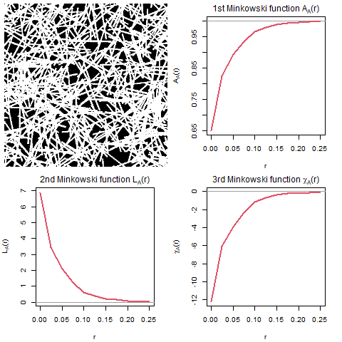

Figure 1.1. Characteristics of the 1st set.

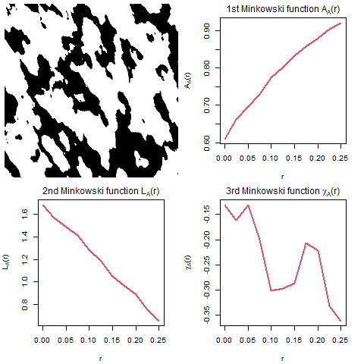

Figure 1.2. Characteristics of the 2nd set.

The figures below expose the trends for each function of each set depending on the increasing of r.

Area is increased (~ exponentially and linearly for 1st and 2nd resp.) since size of grains linearly grows.

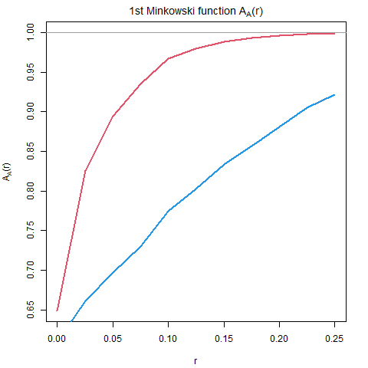

Figure 1.3. The 1st Minkowski functions of both sets.

Boundary length decreases as the grains merge with each other and number of small separate grains is reducing.

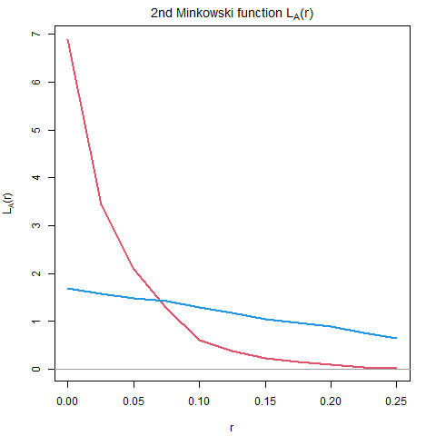

Figure 1.4.The 2nd Minkowski functions of both sets.

The absolute value of Euler number is dramatically reduced for the 1st set as the number of connected elements grows and number of “holes” (discontinuities) decreases due to the growth of radius and the following merge of grains. In the 2nd set the vast of elements is already connected with each other, so it distinguishable in a smaller scale (fig 1.2) but oscillates slightly on the plot below.

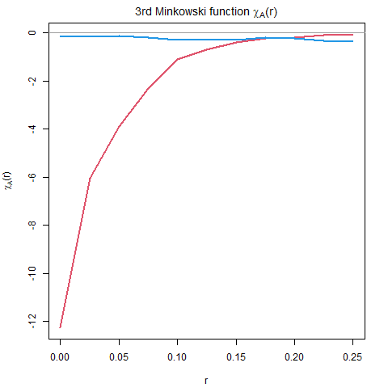

Figure 1.5. The 3rd Minkowski functions of both sets.

# **Task 2.**

For a given model b is assumed to be between 0.10 and 0.11.The best guess is based on a group of several images which are edited(“brushed”) by discs of stepwise increased radius. Therefore, b is 0.1025 mm.

|  |  |
| --- | --- |
| C:\Users\Anaconda\Rscripts\StoMe\project\t2\image1_03.png | C:\Users\Anaconda\Rscripts\StoMe\project\t2\img  0.1025 .png |
| Figure 2.1 The original image and the edited image by means of which approximate value of b  was determined. | |

Two suggested models with parameters Lambda = 4.7, a = 1.71, b = 0.15 (1st model) and Lambda = 5.1, a = 1.98, b = 0.11(2nd model). Firstly, for the 999 realizations of each model 1st Minkowski function was determined by means of Euclidean Distance Transform (EDT) and self-written function 'estALXFct'. They were tested with the global rank envelope test with regard of significance level (alpha) 0.05 to take or reject suggested models. Global rank envelopes (red curves) were determined and presented on figures below as well. Visually one can say that only one out of four images present roughly sufficient (Figure 2.4) as the curve of the chosen functional characteristic (AA estimated by EDT) stays inside of boundaries.

Nevertheless, for the sake of precision it is necessary to determine p values and compare the mean value of p which is smaller than significance level 0.05 in order to reject considerable models. Basing on results presented in the Table 2, one can say that all models should be rejected, as in 77. to 96.1 % p value is smaller than alpha.

|  |  |  |  |  |
| --- | --- | --- | --- | --- |
| alpha=0,05 | 1\_EDT | 2\_EDT | 2\_estALXFct | 1\_estALXFct |
| mean val of p<alpha | 0.775 | 0.785 | 0.961 | 0.934 |
| Table 2. Results of comparing p-values and alpha. | | | | |

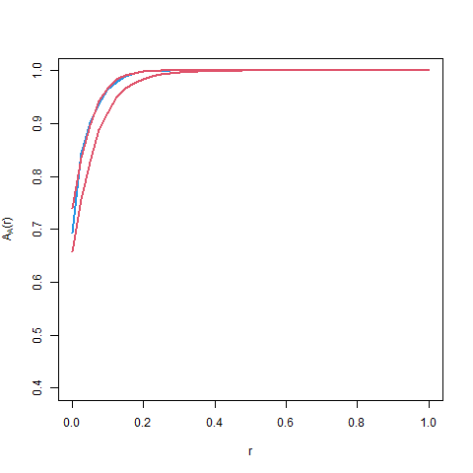

Figure 2.2. Global envelopes for the 1st Minkowski function (AA) of the 1st model.

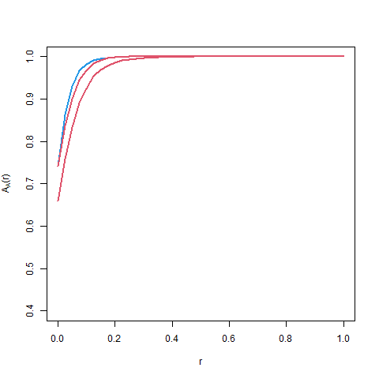

Figure 2.3. Global envelopes for the 1st Minkowski function(AA) of the 2nd model.

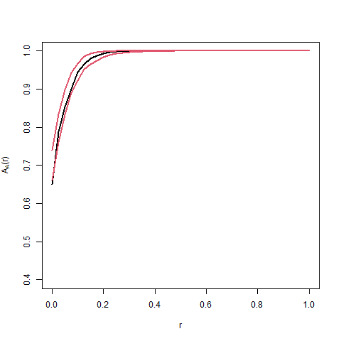

Figure 2.4. Global envelopes for the 1st Minkowski function (AA) estimated by EDT of the 1st model.

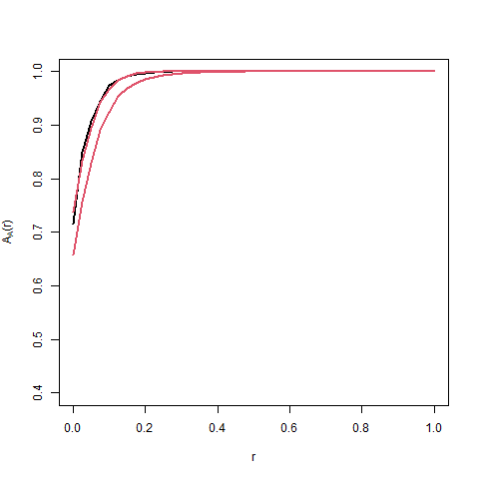

Figure 2.5. Global envelopes for the 1st Minkowski function (AA) estimated by EDT of the 2nd model.

# **Task 3.**

For the random set realization given by the image (1400 x 1400) on the figure 3.1 Vv and Sv were estimated.

|  |  |
| --- | --- |
| Vv | Sv |
| 0.541346 | 37.59791 |
| Table 3.1. Estimates of Vv and Sv | |



Figure 3.1. The original image.

In order to determine diameters of discs and coordinates of their centers by the mean of the segmentation algorithm the original image was labelled. Then idea of minus sampling is implemented. That is, only the discs inside the smaller window 1340 x 1340 are considered.



Figure 3.2. The labelled image.

Calculated properties in 2D presented below in the table 3.2.

|  |  |  |  |  |  |
| --- | --- | --- | --- | --- | --- |
| Discs number | Area(W) | Mean d (mm) | Standard deviation | Λ A | Range (mm) |
| 281 | 1.7956 | 0.0632132720926012 | 0.02495683262675 | 156.493651147249 | 0.00806621189713765-0.10867888641694 |

Table 3.2. Properties in 2D.

For the visual comparison, the histogram of diameters was plotted. One can claim that the most frequent diameters are in interval of 0.06-0.08 mm.

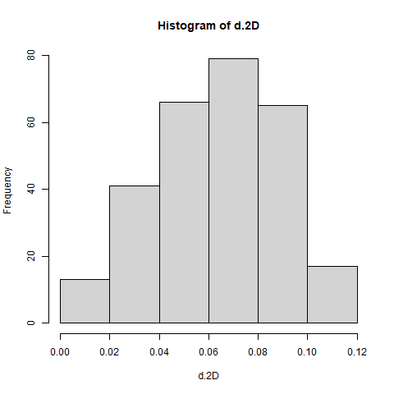

Figure 3.3. Histogram of discs diameters in 2D.

In order to compare frequencies of diameters in 2D and 3D and calculate values of the mean ball diameter and the intensity in 3D Saltykov method is implemented.

|  |  |
| --- | --- |
| Interval (mm) | Absolute frequency |
| 0 - 0,02 | 78.4497518751006 |
| 0,02 - 0,04 | 250.550502380231 |
| 0,04 - 0,06 | 435.480972578868 |
| 0,06 - 0,08 | 585.138883231299 |
| 0,08 - 0,1 | 548.351569428374 |
| 0,1- 0,12 | 142.729250487202 |

Table 3.3 Absolute frequencies of diameters in 3D.

Visually it’s clear that the most frequent diameters are in interval of 0,06 - 0,08 mm in both 2D and 3D case, though the 2nd and 3rd most frequent diameters in 2D and in 3D, are “mirrored” (0,02 - 0,04 and 0,08 - 0,1 , respectively) .

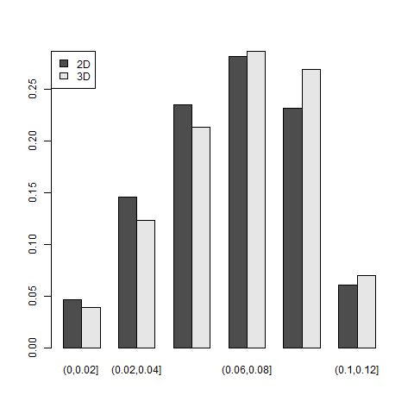

Figure 3.4.

The calculated by two different formulas intensity Λ and the mean ball diameter µv are presented below.

|  |  |  |  |
| --- | --- | --- | --- |
| Λ 1 | µv1 (mm) | Λ2 | µv2 (mm) |
| 2071.15913307945 | 0.0755584873454752 | 2071.15913307945 | 0.0755584873454752 |

Table 3.4 Properties in 3D.

# **Task 4.**

The m = 100 realizations of three different Matern III hard-disc model with parameters Λ =( 5,10,15), radius R = 0.05 and the window 10 x10 were generated in order to estimate 1st , 2nd , 3rd Minkowski functions and their mean values and standard deviations for each model and each of 100 realizations. As the size of table with 100 computed functions is too large, they can be displayed via running the attached Rscript file. Only mean values and standard deviations for each model based on all 100 realizations are presented in the report.

|  |  |  |  |  |  |  |
| --- | --- | --- | --- | --- | --- | --- |
| Model | mean (A) | Std(A) | mean (L) | Std(L) | mean (X) | Std(Χ) |
| Λ = 5 | 0.0363399635872108 | 0.00168108394965952 | 1.44517711061024 | 0.0664006210901827 | 4.53298643989335 | 0.204106220132526 |
| Λ = 10 | 0.0673065257449642 | 0.00206040458345053 | 2.67459016856283 | 0.08151446159372 | 8.29798767736706 | 0.252236180348044 |
| Λ = 15 | 0.094488873257642 | 0.00211213010370391 | 3.75102176513597 | 0.0840416999807063 | 11.4953542130719 | 0.258547297555086 |

Table 4. Mean values and standard deviations of 1st , 2nd , 3rd Minkowski functions for each model.

Calculated results were also visualized with means of boxplot, where coloured lines represent the mean value of Minkowski functions.

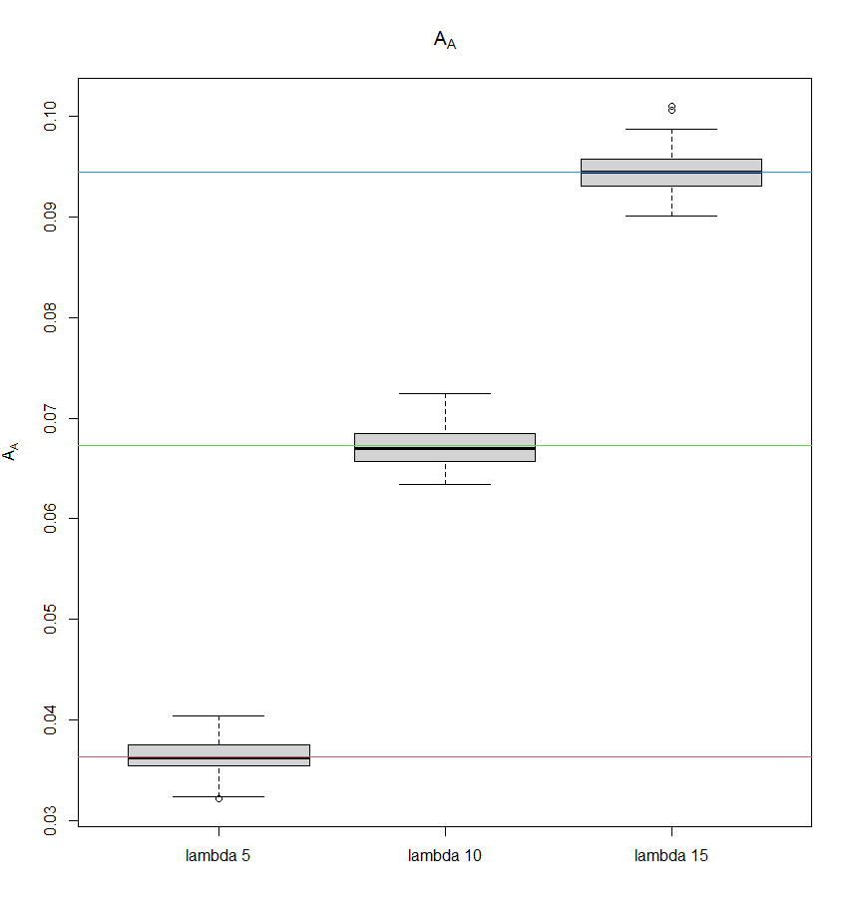

Figure 4.1. The boxplot of the 1st Minkowski function

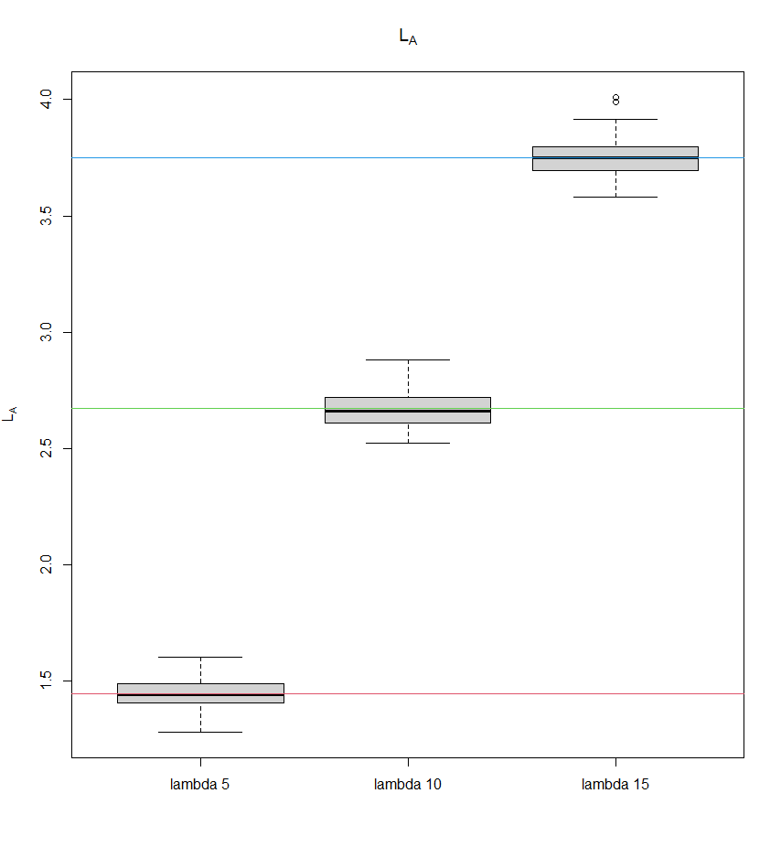

Figure 4.2. The boxplot of the 2nd Minkowski function.

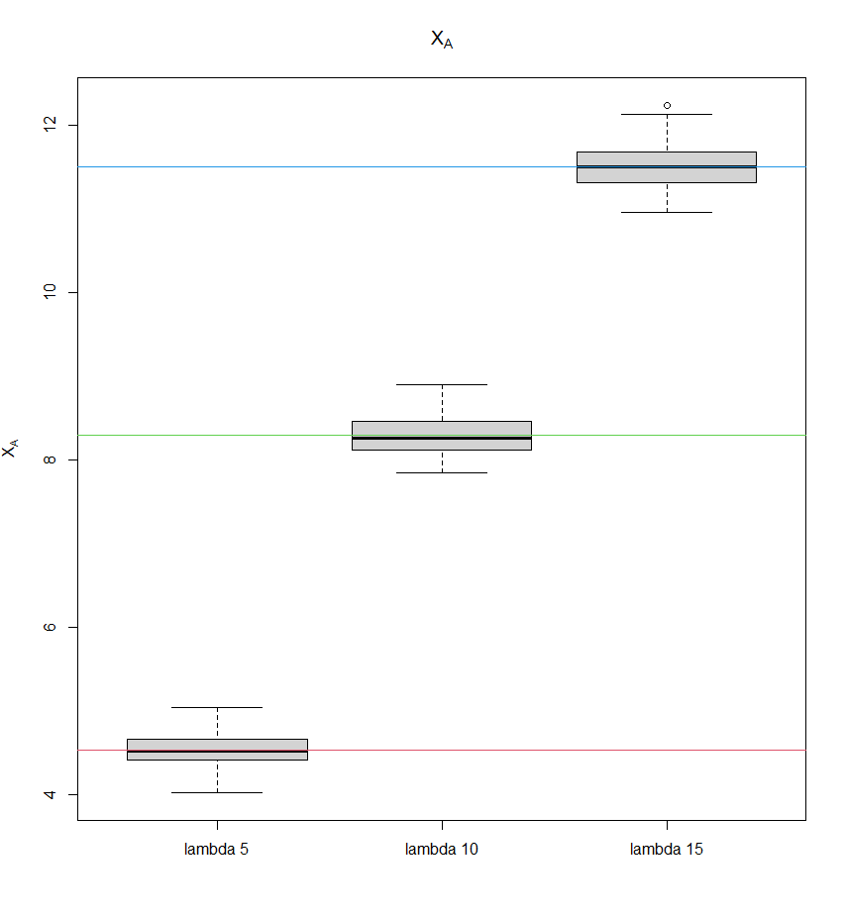

Figure 4.3. The boxplot of the 3rd Minkowski function.