1. Area Graphs:

* An area graph, also known as an area chart, is used to display quantitative data over a continuous interval.
* It is like a line graph, but with the area beneath the line filled with color.
* Area graphs are particularly effective when you want to show the cumulative effect of multiple variables over time or other continuous dimensions.
* They help in visualizing the distribution of a whole and the contributions of individual components.

Line Graphs:

* A line graph, also known as a line chart, is used to display data points connected by straight lines.
* It is commonly used to represent trends over time, relationships between two variables, or comparisons between different categories.
* Line graphs are useful for displaying data with a clear progression or trend.

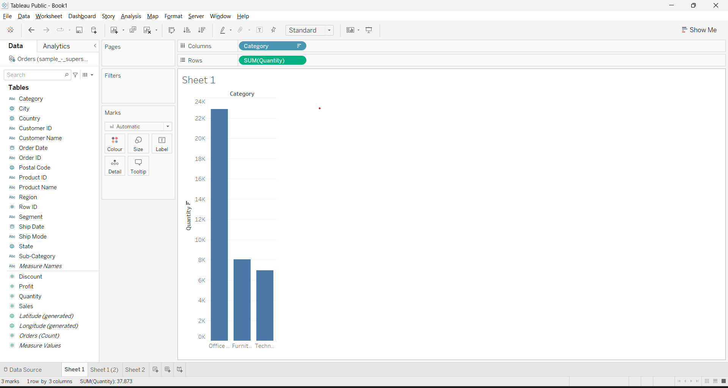

2. In Tableau, grouping fields and combining tables are essential techniques for organizing and analysing data effectively. Grouping fields helps you aggregate data into meaningful categories, and combining tables allows you to bring together data from different sources for more comprehensive analysis.

Let's go through the steps for each process along with an example of creating a grouped field and combining tables in Tableau.

Grouping Fields:

Grouping fields involves categorizing data points based on common characteristics.

This can be helpful when you want to analyse data at a higher level of aggregation. For example, you might want to group sales data by regions or age ranges.

Combining Tables:

Combining tables involves bringing data from multiple data sources into a single view in Tableau. This is useful when you have related data spread across different tables or sources.

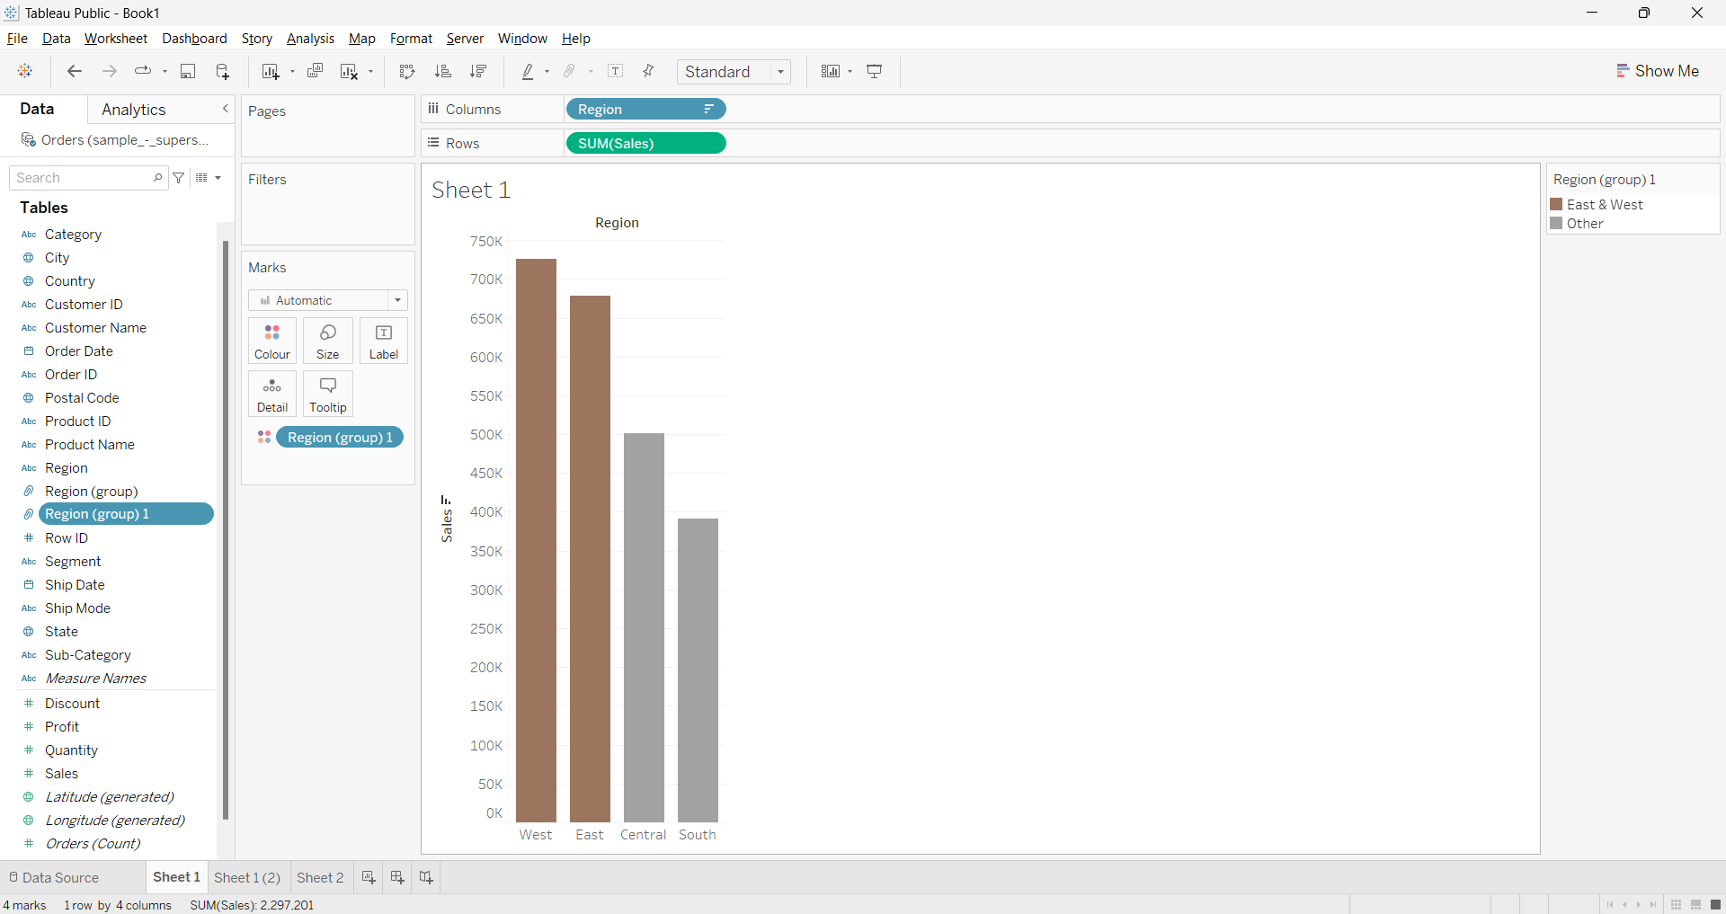

3. In Tableau, the "Marks" card is a crucial feature that allows you to control how your data points (marks) are displayed on the visualization canvas. Within the "Marks" card, you have options to use color and size to encode additional information, making your visualizations more informative and insightful. Let's explore the uses of color and size options in the "Marks" card with the help of an example.

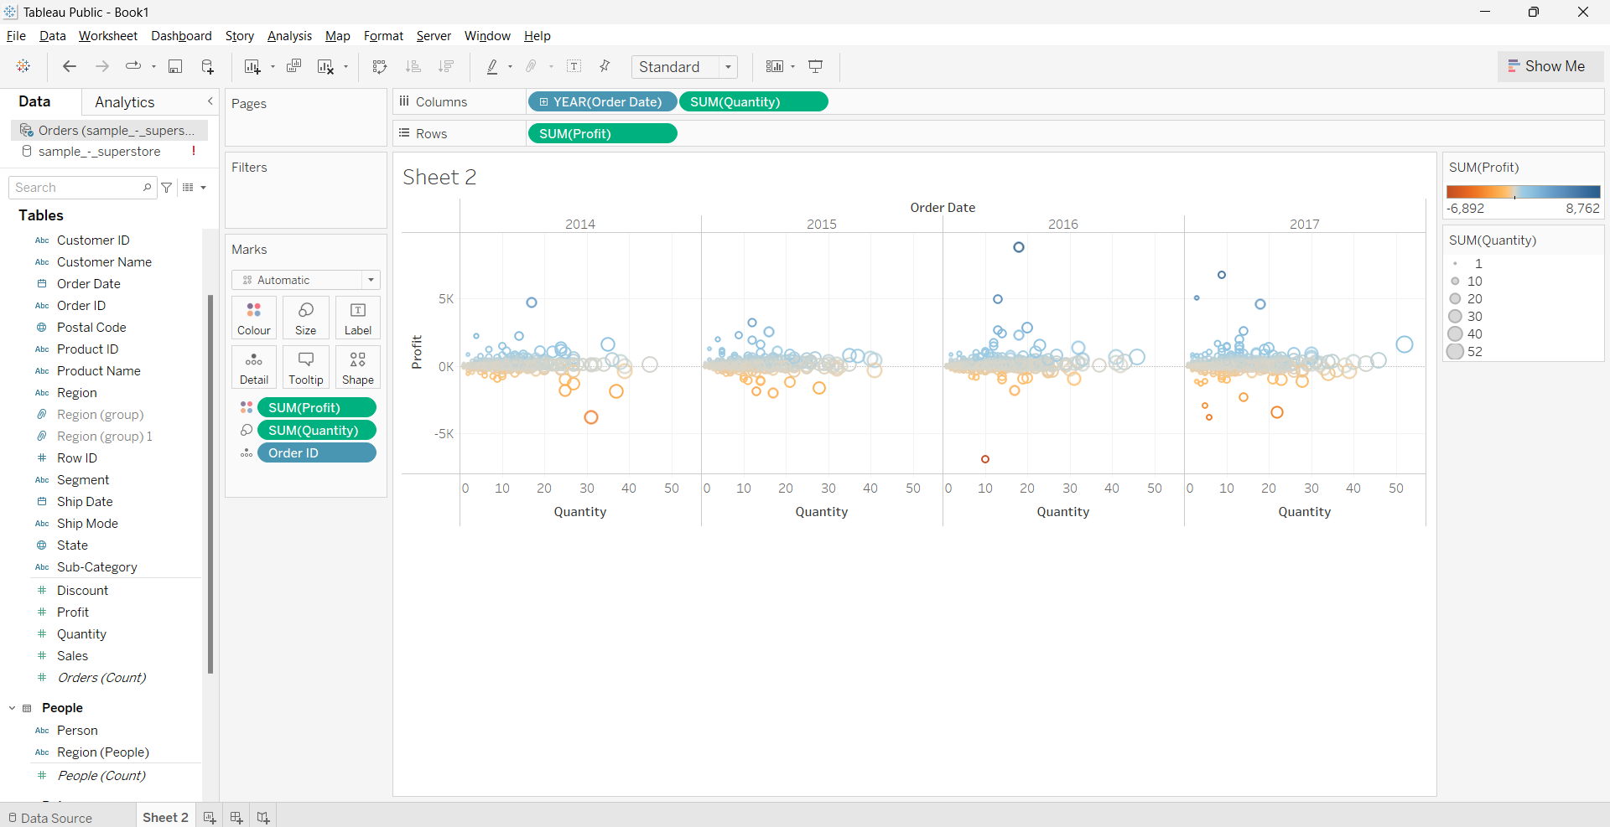

4. Tableau supports various types of joins to combine data from different tables or data sources. The primary join types include Inner Join, Left Join (also known as Left Outer Join), Right Join (also known as Right Outer Join), and Full Outer Join. Each join type determines how the data from the tables are matched and combined.

Inner Join:

Left Join:

Right Join:

Full outer Join:

5.

Creating a dashboard in Tableau allows you to combine multiple visualizations and worksheets into a single interactive and cohesive view. Dashboards are useful for presenting insights, comparisons, and trends to your audience. Let's go through the steps of creating a dashboard in Tableau with an example.

Example: Sales and Profit Dashboard

Suppose you have a dataset that includes sales and profit information for different product categories. You want to create a dashboard that shows the following visualizations:

A bar chart showing sales by product category.

A line chart showing profit trend over time.

A map showing the geographical distribution of sales.

Steps to Create a Dashboard:

1. Connect to Data: Open Tableau and connect to your dataset.
2. Create Worksheets:

Create a bar chart worksheet showing sales by product category.

Create a line chart worksheet showing the profit trend over time.

Create a map worksheet showing the geographical distribution of sales.

1. Arrange and Format Worksheets: Open each worksheet and format them as desired, including axes labels, titles, and colors.
2. Create a Dashboard: Click on the "New Dashboard" button on the bottom of the Tableau window.
3. Add Objects to the Dashboard: Drag the bar chart, line chart, and map worksheets from the "Sheets" section on the left and drop them onto the dashboard canvas.
4. Arrange the worksheets on the canvas to create your desired layout.
5. Size and Position: Adjust the size and position of each worksheet on the dashboard.
   1. You can also add text boxes, images, and other objects to provide context or explanations.
6. Add Interactivity: To add interactivity, you can create actions that allow users to filter or highlight data across multiple visualizations. You can do this by going to the "Dashboard" menu and selecting "Actions."
7. Format and Design: Use the formatting options to customize the appearance of the dashboard, including backgrounds, borders, and fonts.
8. Save and Share: Once you're satisfied with the dashboard, save it. You can publish the dashboard to Tableau Server or Tableau Online for sharing with others.

6.

Heat maps and scatter plots are both powerful visualization techniques in Tableau.

**Heat Maps:**

A heat map is a graphical representation that uses color to display the relationship between two variables. It's particularly useful for visualizing the density or intensity of data points in a 2D space. Heat maps often use color gradients to show areas of high and low density, allowing patterns and trends to be easily identified.

**Creating a Heat Map in Tableau:**

Let's use an example where you have a dataset of customer locations with latitude and longitude information. You want to create a heat map to visualize the concentration of customers' locations.

**Steps:**

1. **Connect to Data:** Open Tableau and connect to your dataset.
2. **Drag Fields:** Drag the "Latitude" field to the Rows shelf and the "Longitude" field to the Columns shelf.
3. **Change Marks Type:** In the "Marks" card, change the default mark type to "Filled Map." Tableau will automatically generate a map based on the latitude and longitude values.
4. **Adjust Color Encoding:** In the "Color" shelf, you can select a color palette or customize the color range. Choose a color encoding that best represents the density of customer locations.
5. **Format and Legend:** Customize the map's appearance, including titles, tooltips, and legends, to make the visualization more informative.

**Scatter Plots**:

A scatter plot is a graphical representation that uses points to show the relationship between two numerical variables. Each point represents an observation in the dataset, and its position on the plot corresponds to the values of the two variables being compared. Scatter plots are great for identifying correlations, clusters, outliers, and trends in data.

**Creating a Scatter Plot in Tableau:**

Let's use an example where you have a dataset of cars with information about their horsepower and miles per gallon (MPG) ratings. You want to create a scatter plot to visualize the relationship between these two variables.

**Steps:**

1. **Connect to Data:** Open Tableau and connect to your dataset.
2. **Drag Fields:** Drag the "Horsepower" field to the Columns shelf and the "MPG" field to the Rows shelf.
3. **Change Marks Type:** In the "Marks" card, select "Circle" as the mark type. This will represent each data point with a circle.
4. **Customize Marks:** Adjust the size and color of the circles based on additional attributes, if desired.
5. **Add Labels and Trendline (Optional):** You can add labels to data points, and if you want to observe a trend, you can add a trendline using the "Analytics" pane.
6. **Format and Axes:** Customize the appearance of the axes, titles, and gridlines to enhance the visualization's clarity.

7.

Table calculations in Tableau allow you to perform calculations on the results of a visualization, which can provide additional insights, comparisons, or aggregations. They enable you to create more complex calculations beyond simple aggregation.

**Example: Running Total in a Line Chart**

Suppose you have a dataset containing monthly sales data for a product. You want to create a line chart that displays both the monthly sales and a running total of sales over time.

**Steps:**

1. **Connect to Data:** Open Tableau and connect to your dataset.
2. **Drag Fields:** Drag the "Month" field to the Columns shelf and the "Sales" field to the Rows shelf.
3. **Create a Line Chart:** Tableau will create a basic line chart showing monthly sales.
4. **Create a Running Total Calculation:**
   1. Right-click on the "Sales" field in the "Rows" shelf and choose "Quick Table Calculation."
   2. Select "Running Total."
5. **Adjust the Calculation:**
   1. A new field named "Running Total of Sales" will be created in the "Rows" shelf.
   2. You can right-click on this field and choose "Edit Table Calculation."
   3. Customize the computation by selecting "Running Total" and choosing "Sum."
6. **Format the Chart:**
   1. You can format the chart by adding labels, adjusting colors, and other formatting options.

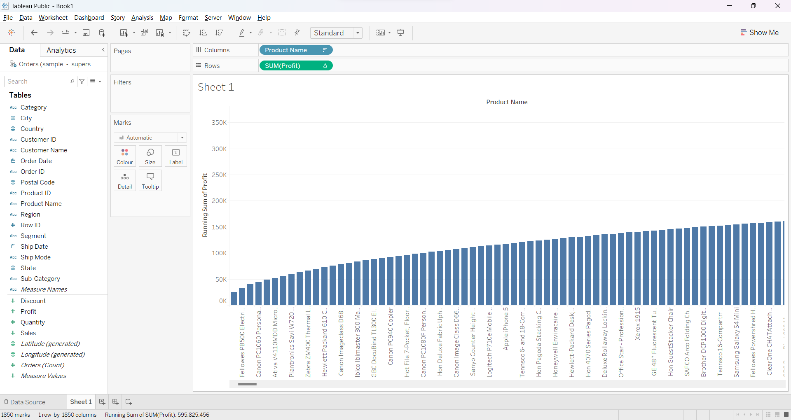

8.

Distribution bands in Tableau, often referred to as reference bands or reference lines, are visual aids that help you highlight specific ranges or values in your visualizations. These bands can be added to a chart or graph to provide context, identify thresholds, or compare data points to predefined benchmarks. They can be horizontal or vertical lines that span across the chart area, indicating specific values or ranges on the axis.

9.

A bar chart is a common visualization that displays data using rectangular bars, where the length of each bar corresponds to the value of a variable. It's effective for comparing values across different categories.

**Steps:**

1. **Connect to Data:** Open Tableau and connect to your dataset.
2. **Drag Fields:** Drag the "Order Date" field to the Columns shelf and the "Sales" field to the Rows shelf.
3. **Choose Visualization Type:** Tableau will automatically create a bar chart with the product categories on the x-axis and sales amounts on the y-axis.
4. **Customize Appearance:** You can format the chart by adding labels, adjusting colors, sorting bars, and other formatting options.
5. **Title and Labels:** Add a title to the chart and provide appropriate labels for the axes.

**Creating a Pie Chart:**

A pie chart is a circular graph that represents data as slices of a whole. Each slice's size is proportional to the value it represents in relation to the total.

**Steps:**

1. **Connect to Data:** Open Tableau and connect to your dataset.
2. **Drag Fields:** Drag the "Order Date" field to the Columns shelf and the "Sales" field to the Rows shelf.
3. **Choose Visualization Type:** Tableau will automatically create a pie chart with slices representing each company's market share.
4. **Customize Appearance:** You can adjust colors, labels, and other formatting options to enhance the clarity of the pie chart.
5. **Tooltip and Labels:** Customize the tooltips to show additional information when users hover over the slices. You can also add a legend to identify each company.

10.

Story points in Tableau allow you to create a sequence of visualizations and annotations to guide viewers through a data-driven narrative. They are an effective way to present insights and tell a story using your data.

