**Test Screenshot**

**Assignment: API Scraping – Jeiya Kumari**

**Task 1: Humorous Flask App**

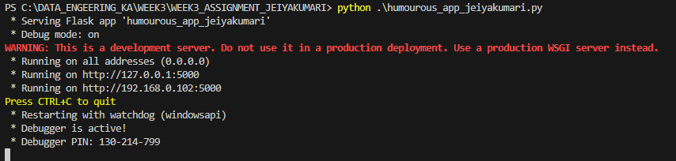

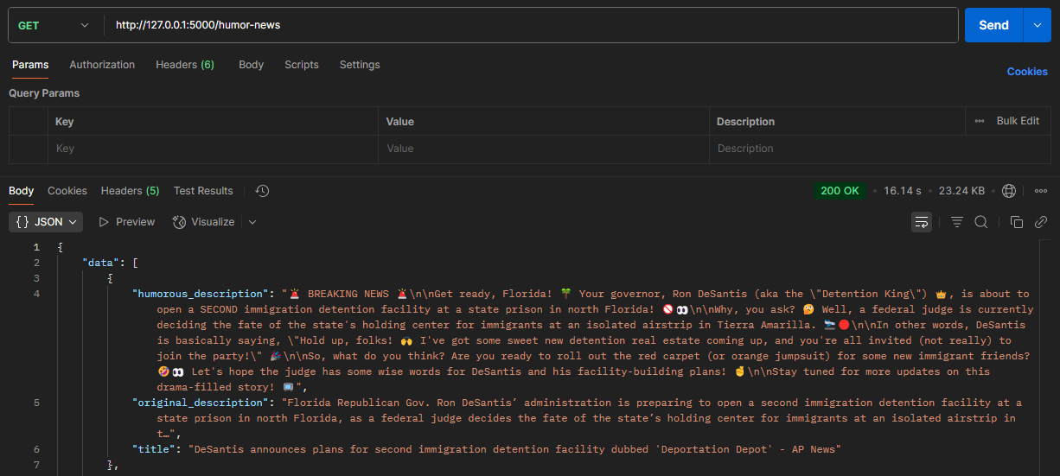

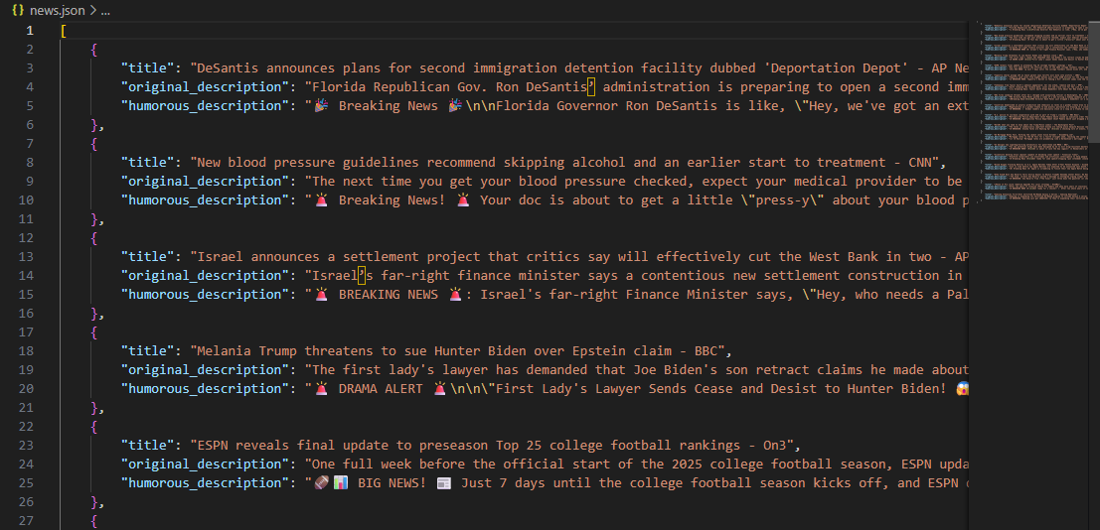

**Task 2: Marham Labs Scraper**

THANK YOU