**ENCRYPTION USING TRANSPOSITION TECHNIQUES**

**RESULT**

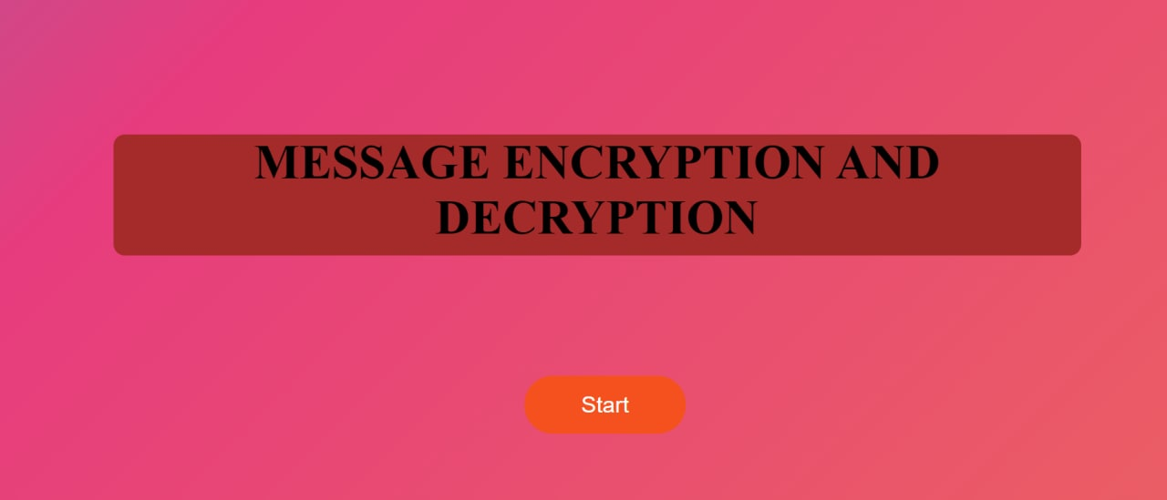

**FIG (10.1)**

**First, user will get welcome page then user will ask to click the submit button**

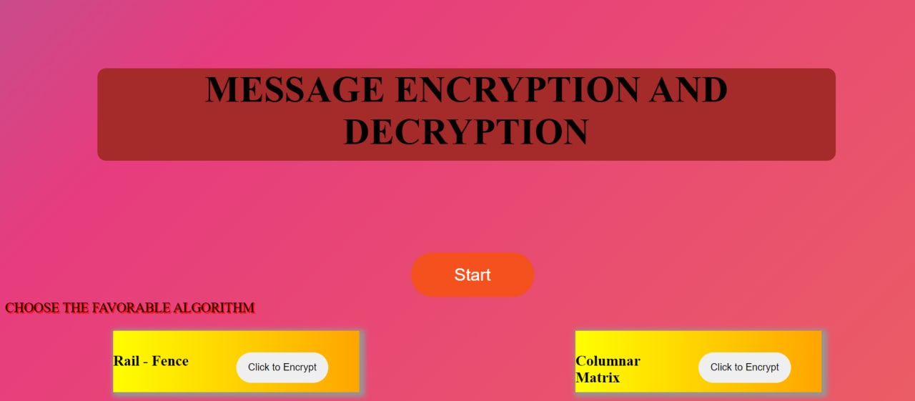

**FIG (10.2)**

**Then user will be redirected to encryption page where user is asked to choose one of the transportation technique to encrypt the msg.**

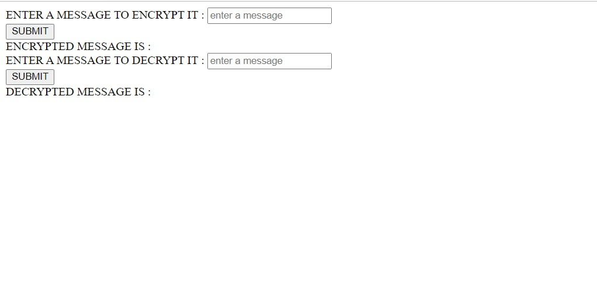

**FIG (10.3)**

**Then user will be redirected to encryption page of user choose encryption transportation technique where user is asked to enter the message then user will get the encrypted cipher by entering the encrypted cipher he can get decrypted cipher nothing but the real message which was given by the user at starting to encrypt .**

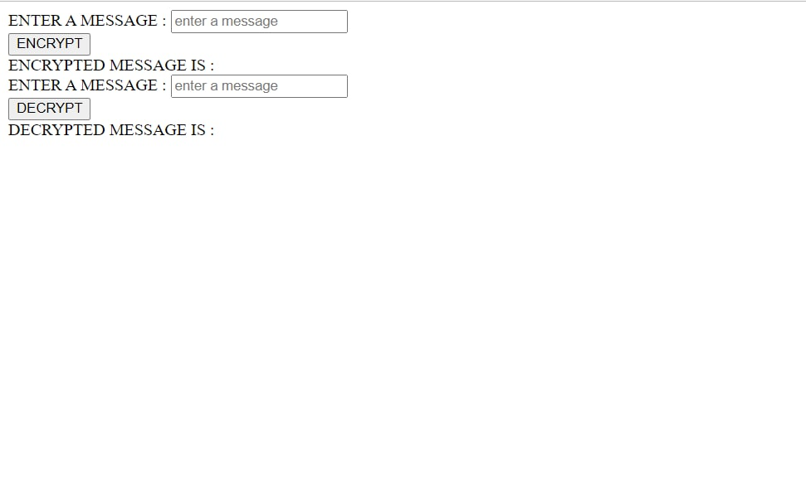

**FIG (10.4)**

**Then user will be redirected to encryption page of user choose encryption transportation technique where user is asked to enter the message then user will get the encrypted cipher by entering the encrypted cipher he can get decrypted cipher nothing but the real message which was given by the user at starting to encrypt**

**TESTING**

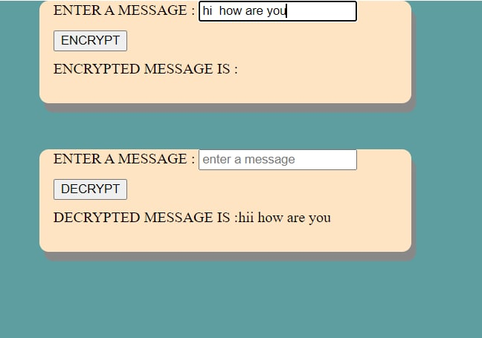

**FIG (9.1)**

**Here we are testing with the input given in the string format so that the encrypted message will be only in string format.**

**Re-entering output as input to Decrypted message to get the Real message:**

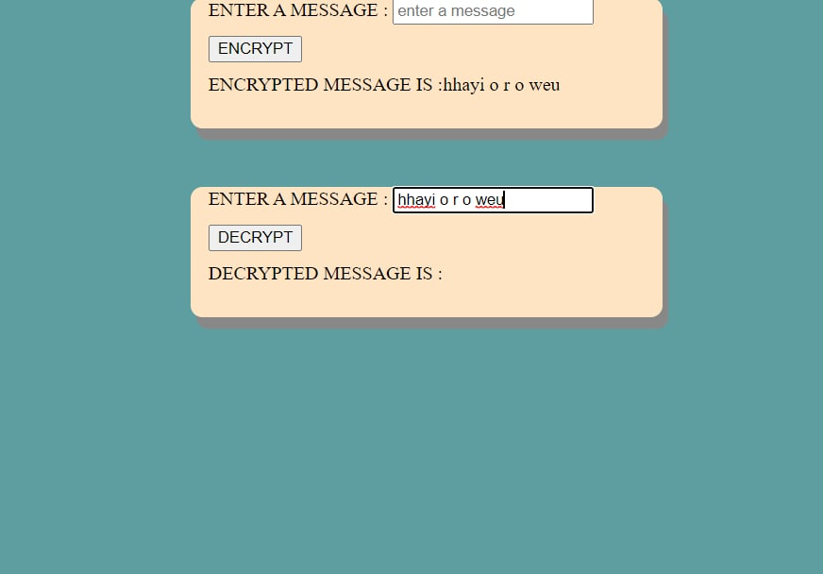

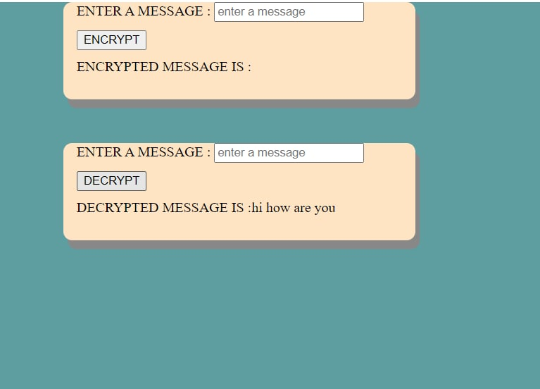

**FIG (9.2)**

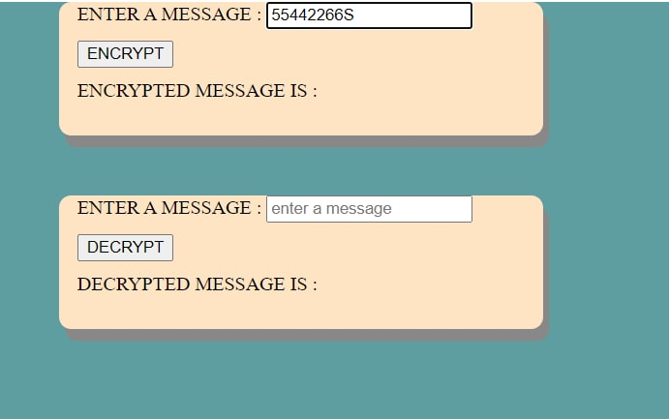

**FIG (9.3)**

**Here we are testing with the input given in in string format so that the encrypted message will be only in string format.**

**Re-entering output as input to Decrypted message to get the Real message:**

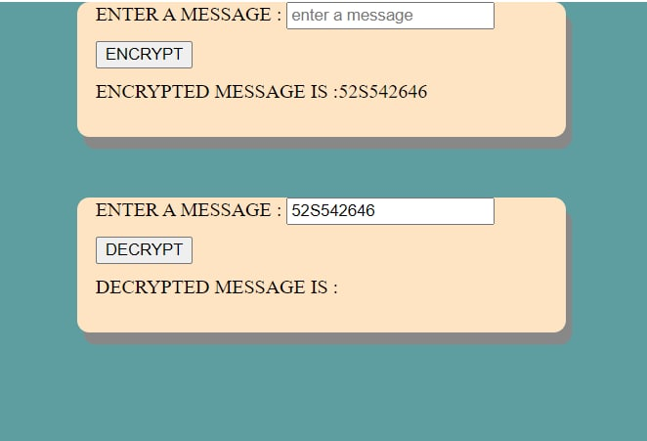

**FIG (9.3)**