**OUPUT :**

**Program 1:**Simple construtor

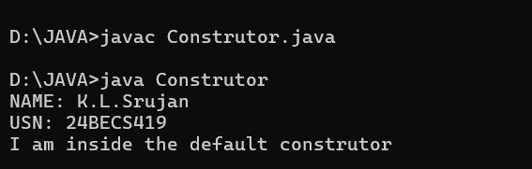

**Program 2:**Parametrized method example program

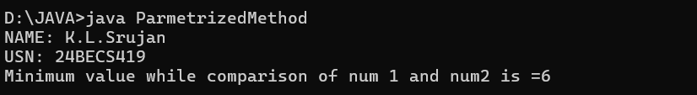

Program 3: Constructor and usage of ‘this’ keyword

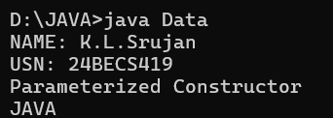

**Program 4:**Constructor Overloading

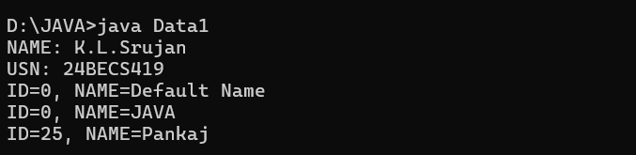

**Program 5:** Method Overloading

