**K L HYDERABAD**

**FRESHMAN ENGINEERING DEPARTMENT**

A Project-Based Lab Report

On

Open Domain Question Answer

**SUBMITTED BY:**

I.D NUMBER NAME

* 2010030168 Tahseen Begum
* 2010030046 E. Pravallika
* 2010030344 N. Sowgna
* 2010030445 Keerthana Pulugam

**UNDER THE ESTEEMED GUIDANCE OF**

**Dr. Arpita Gupta**

**<DESIGNATION>** 

**KONERU LAKSHMAIAH EDUCATION FOUNDATION**

(Deemed to be University)

Moinabad Road, Aziz Nagar, Hyderabad - 500075

**DEPARTMENT OF BASIC ENGINEERING SCIENCES**



**CERTIFICATE**

This is to certify that the project-based laboratory report entitled “Open Domain Question Answer” submitted by Mr./Ms**. Tahseen Begum,** **E.Pravallika,** **N.Sowgna,** **Keerthana Pulugam** bearing Regd. No. 2010030168, 2010030046, 2010030344, 2010030445 to the **Department of Basic Engineering Sciences, KL University** in partial fulfillment of the requirements for the completion of a project in “AI FOR DS”course in II B Tech IV Semester, is a Bonafede record of the work carried out by him/her under my supervision during the academic year 2021-22.

PROJECT SUPERVISOR HEAD OF THE DEPARTMENT

<> <>

**ACKNOWLEDGEMENTS**

It is great pleasure for me to express my gratitude to our honorable President **Sri. Koneru Satyanarayana**, for giving the opportunity and platform with facilities in accomplishing the project-based laboratory report.

I express my sincere gratitude to our Principal **Dr. L. Koteswara Rao** for his administration towards our academic growth.

I express sincere gratitude to our Coordinator for her leadership and constant motivation provided in the successful completion of our academic semester. I record it as my privilege to deeply thank you for providing us with the efficient faculty and facilities to make our ideas into reality.

I express my sincere thanks to our project supervisor Dr. Arpita Gupta for her novel association of ideas, encouragement, appreciation, and intellectual zeal which motivated us to venture into this project successfully.

Finally, it is pleased to acknowledge the indebtedness to all those who devoted themselves directly or indirectly to make this project report success.

Name: Tahseen Begum

Regd. No: 2010030168

Name: E.Pravallika

Regd. No: 2010030046

Name: N.Sowgna

Regd. No: 2010030334

Name: Keerthana Pulugam

Regd. No: 2010030445

**ABSTRACT**

Aiming to answer an open domain question based on knowledge base, we suggest a TANDA algorithm that can automatically extract an adverbial pearl from a simple question and translate it into a KB query. similarity preferences are used to exclude a candidate's start after an easy way to link business. Our method obtained an F1-score of 82.47% in test data. In addition, there is also a series of full bug testing and analysis that can identify features and disabilities of a new data set.

**INDEX**

|  |  |  |
| --- | --- | --- |
| **S.NO** | **TITLE** | **PAGE NO** |
| 1 | Introduction | 05 |
| 2 | Aim of the Project | 06 |
| 2.1 | Advantages & Disadvantages | 06 |
| 2.2 | Future Implementation | 06 |
| 3 | Software & Hardware Details | 07 |
| 4 | Class Diagram | 08 |
| 5 | Implementation | 09-21 |
| 6 | Outputs/Screenshots | 22 |
| 7 | Conclusion | 23 |

**INTRODUCTION**

Questionnaire (QA) is a field of computer science within the fields of information retrieval and natural language processing (NLP), which deals with building programs that automatically answer questions asked by people in the native language. To achieve this, we will use the Python Library and TensorFlow wrapper which enables in-depth learning and AI.

He intends to answer the question in the form of a natural language based on large informal texts.

The purpose of the QA is to produce concise answers to summarized questions asked in the original language. This type of retrieval is required with the growth of digital knowledge. Previously QAS was designed for a specific domain and has limited functionality.

Introduce QAS Target to the types of questions most frequently asked by users, the features of the data source, and the correct answer generated. We aim to build a QA web-scale system

Many QA systems prior to issuing an answer perform quiz settings to predict the type of question response.

**AIM**

It intends to answer the question in the form of a natural language based on large informal texts.

**Advantages: -**

**Disadvantages: -**

**SYSTEM REQUIREMENTS**

1. SOFTWARE REQUIREMENTS:

The major software requirements of the project are as follows:

Language: Python

Operating system: Windows XP or later.

Tools: Google Colab

1. HARDWARE REQUIREMENTS:

The hardware requirements that map towards the software are as follows:

RAM: 1007

Processor: Intel

TRAIN FACE MASK DETECTOR MODEL

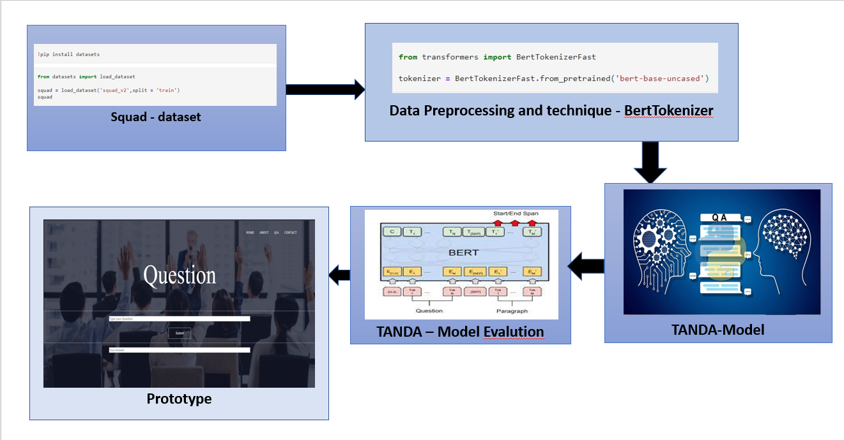

**IMPLEMENTATION**

**DATA SET**

**Techniques:**

**Steps:**

**SOURCE CODE**

**Result And Analysis**

**OUTPUTS**

**CONCLUSION**

**& Future Work**