**CriticareDataAnalysis_Extra**

**1)How can you use a hash function to generate a hash value for a patient id?**

**Query:**

select md5('patient_id') as hashed_value

from baseline;

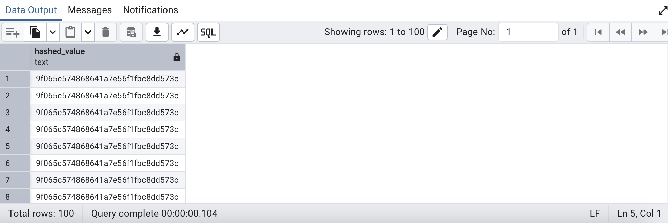

------------------------------------------------------------------------------------------------------------------------

**2)Encrypt, encode, decode, and decrypt patient_id from baseline table for patient details security**

**Query:**

create extension if not exists pgcrypto;

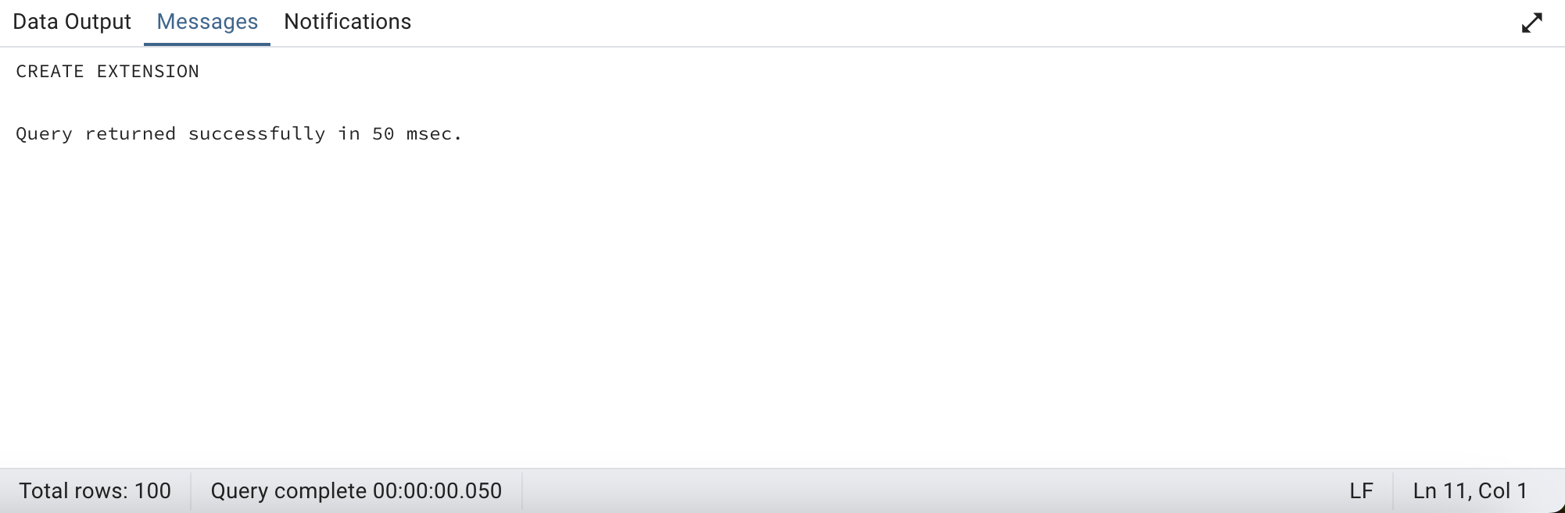

with encrypted_data as (

--encrypt patient_id & encode it as base64 for easy storage

select encode(pgp_sym_encrypt(cast(patient_id as text), 'my_secret_key'), 'base64') as encrypted_value

from baseline

limit 100

)

**--decode and decrypt the encrypted data**

select pgp_sym_decrypt(decode(encrypted_value, 'base64'), 'my_secret_key') as decrypted_value,encrypted_value

from encrypted_data;

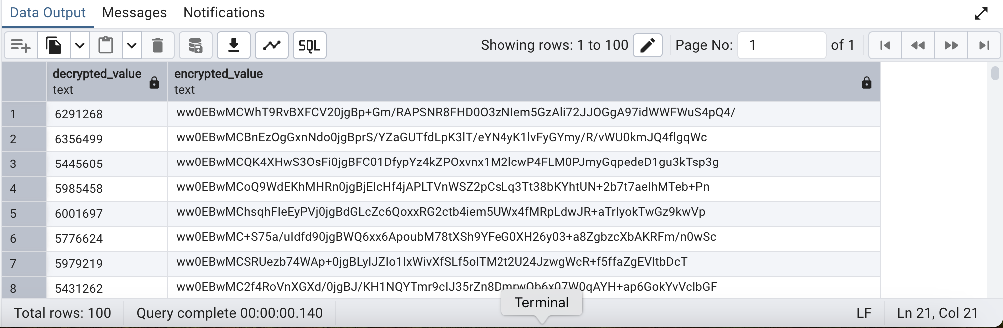

**–drop extension:**

drop extension if exists pgcrypto cascade;

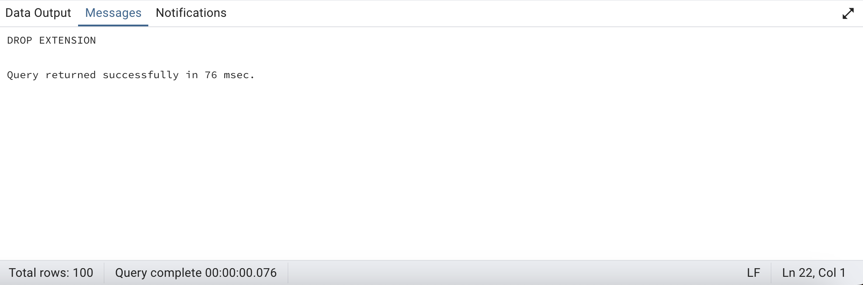

-----------------------------------------------------------------------------------------------------------------

**3) Categorize and count the number of patient transfers based on whether their transfer start time falls in the first half (midnight to noon) or the second half (noon to midnight) of the day using a single bit function?**

**Query:**

with transfers_category as (

select

case

when extract(hour from starttime) < 12 then 0

else 1

end as start_time_bit,

count(*) as patient_cnt

from

transfer

where

date(starttime) = date(stoptime)

group by

case

when extract(hour from starttime) < 12 then 0

else 1

end

)

select

start_time_bit,

patient_cnt,

case

when start_time_bit = 0 then 'AM'

else 'PM'

end as day_half

from

transfers_category

order by

start_time_bit;

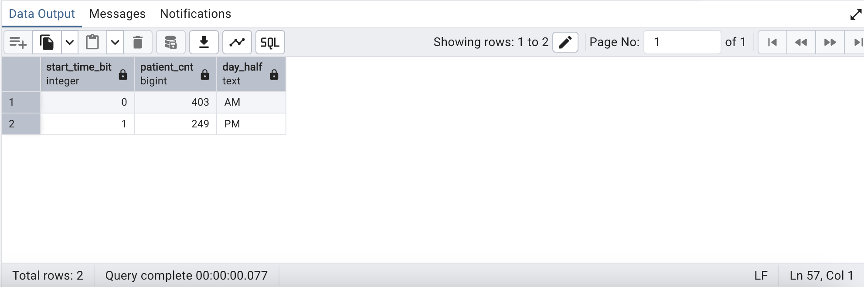

----------------------------------------------------------------------------------------------------------------------

**4)Use XML functions to retrieve the gender of patients along with their admitdept and count & filter the patients based on gender in an XML format**

**Query:**

select

xmlforest(

sex as patient_gender,

admitdept as department_name,

case

when sex = 'Male' then count(*) filter (where sex = 'Male')

else count(*) filter (where sex = 'Female')

end as gender_count

) as patient_outcomes

from

baseline

group by sex,admitdept

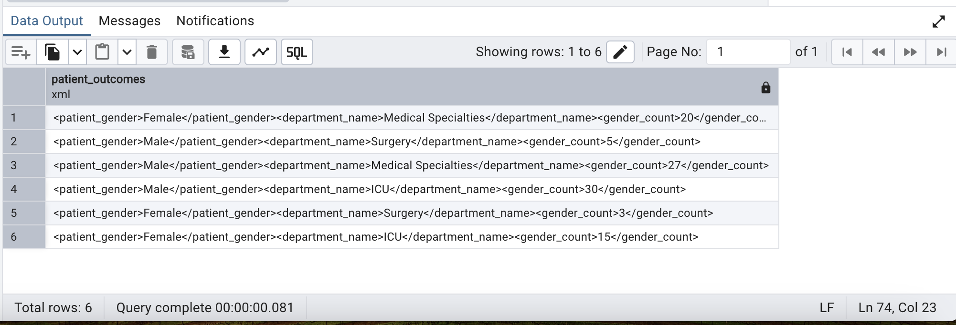

----------------------------------------------------------------------------------------------------------------

**5)create a sequence to generate unique patient IDs, and then create a table that uses this sequence to store patient records? Also set the sequence to a specific value, insert patient data, and retrieve values from the sequence?**

**Query:**

create sequence patient_id_Seq

start with 1000

increment 1;

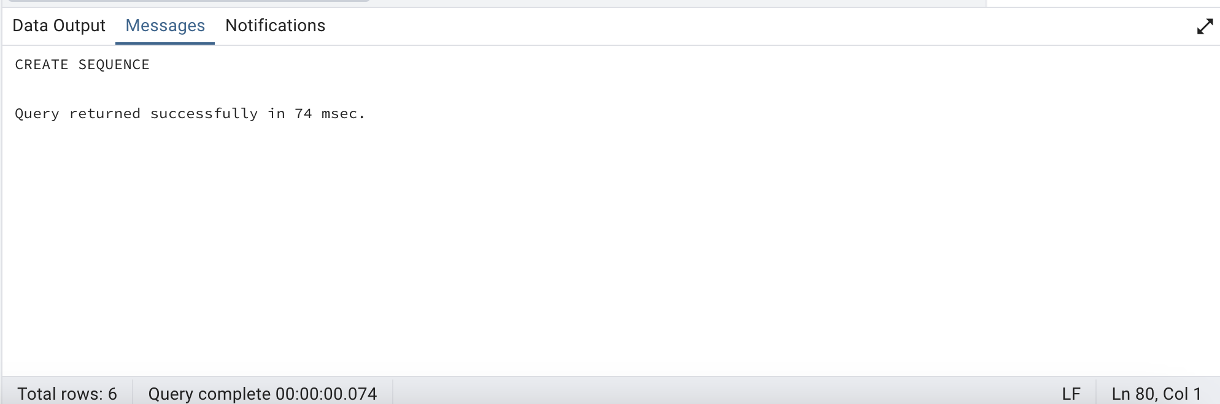

**-- Set the sequence to a specific value**

select setval('patient_id_Seq', 2000 , true) as set_sequence_value;

create table patient_records (

patient_id int default nextval('patient_id_Seq') primary key,

patient_name varchar(100),

admitdept text,

admitdate date

);

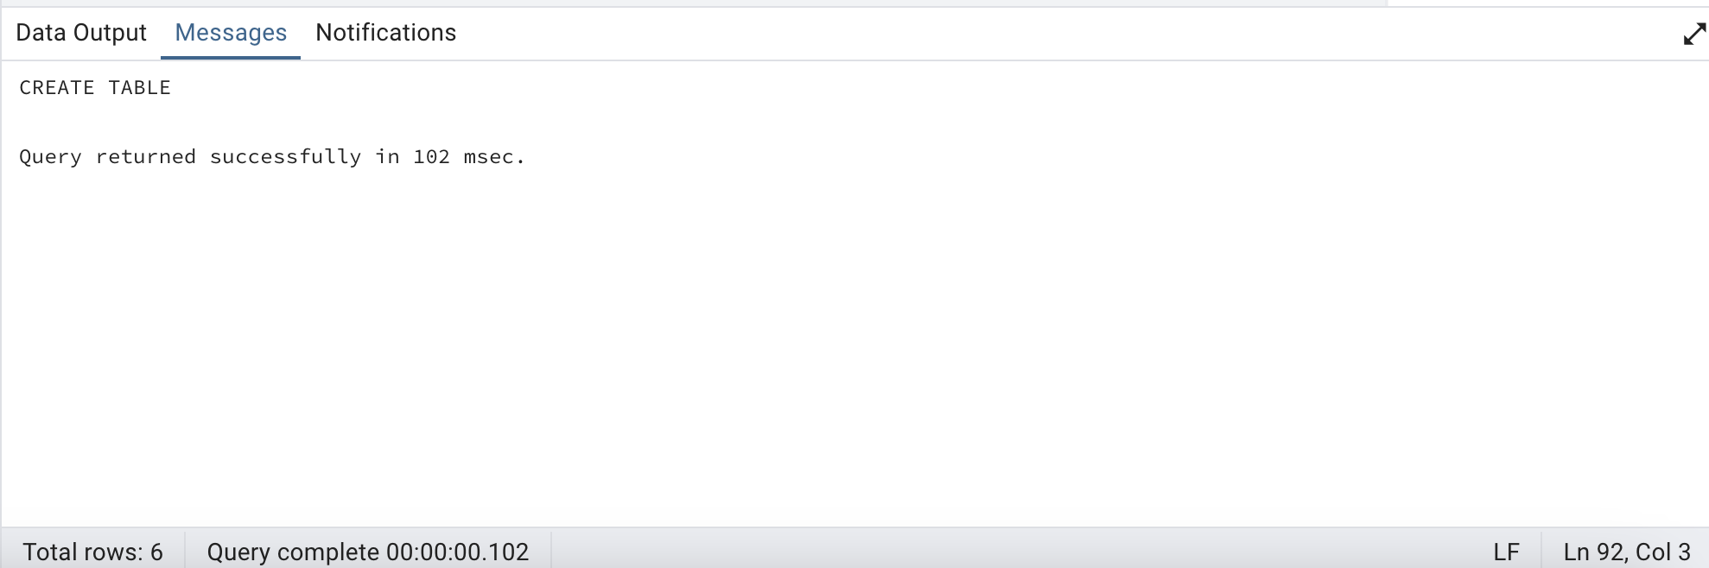

insert into patient_records (patient_name,admitdept,admitdate)

values ('John Doe', 'Laproscopic Surgery', '2019-01-22'),

('Jane Smith', 'Heart Surgery', '2015-08-12'),

('Alice Bob', 'Vascular Surgery', '2017-02-06')

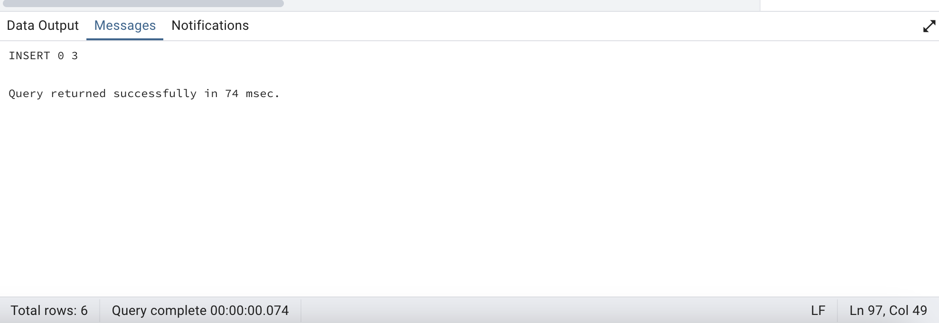

**-- Get the next value in the sequence**

select nextval('patient_id_Seq') as next_value;

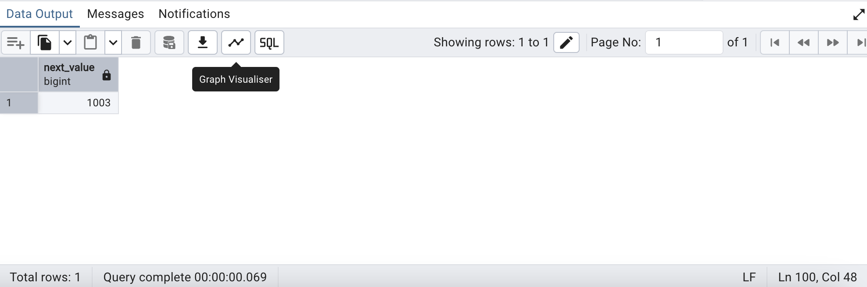

**-- Retrieve the current value of the sequence**

select currval('patient_id_Seq') as current_value;

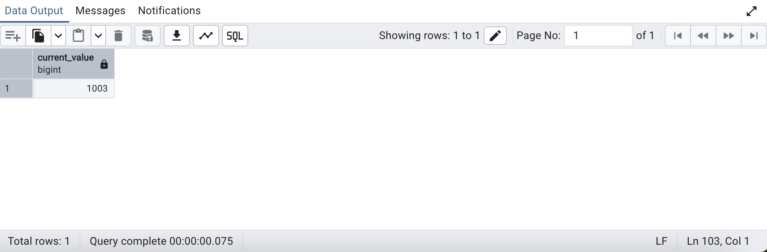

**-- Select all records:**

select * from patient_records;

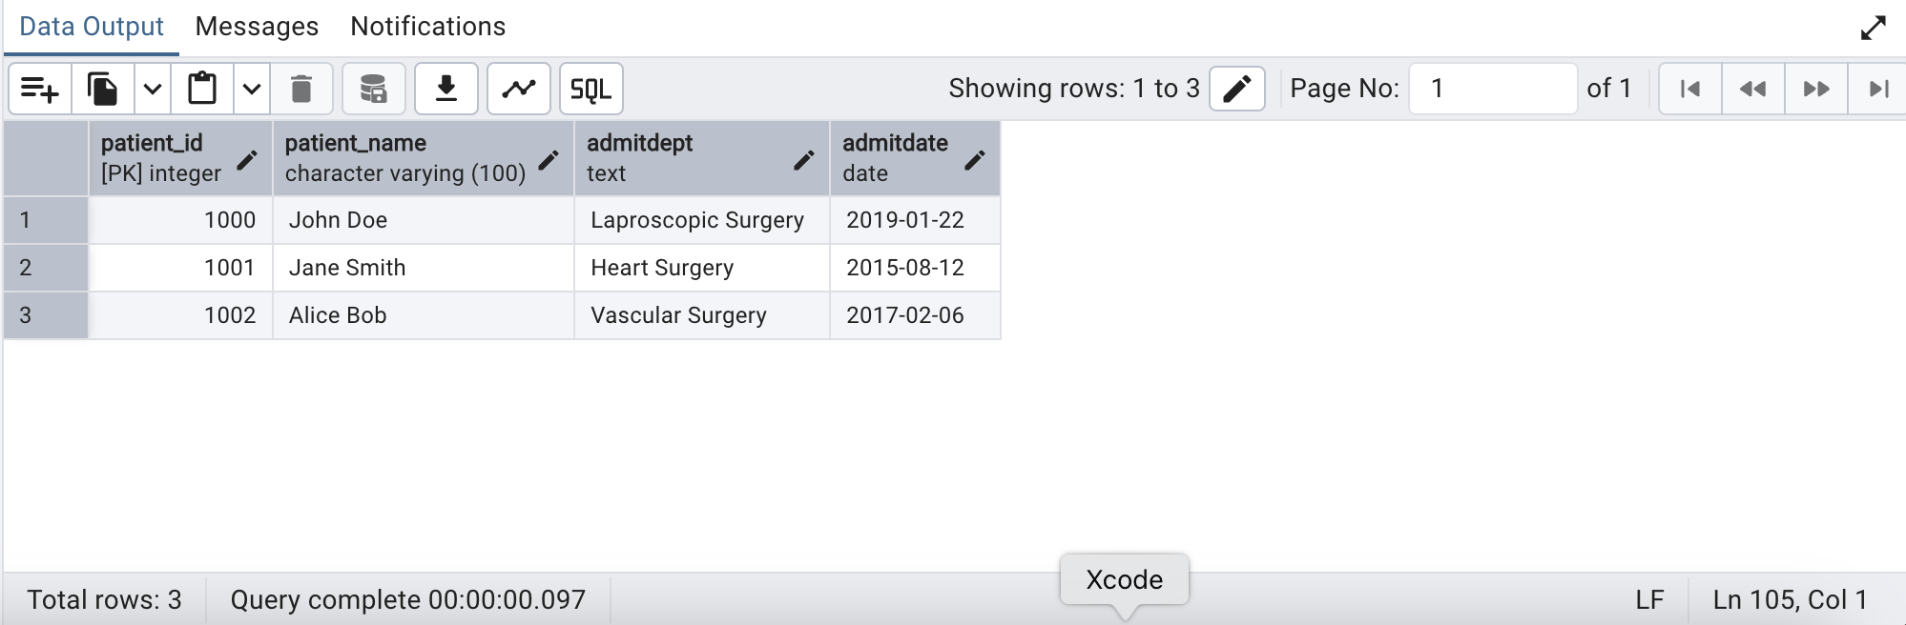

**-- drop records:**

drop table patient_records;

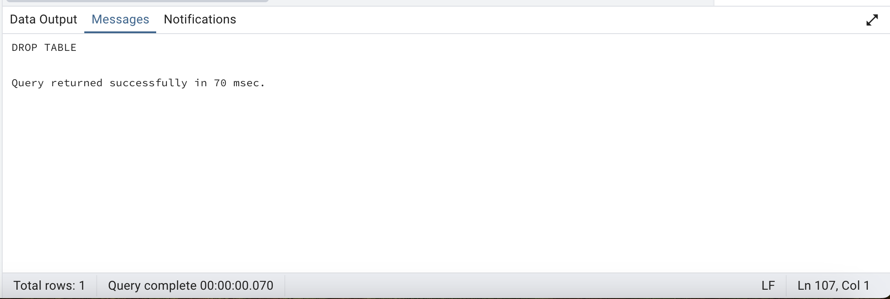

**--optional check**

**-- To Check all sequences in the current schema**

select sequence_name

from information_schema.sequences

where sequence_schema = 'public';

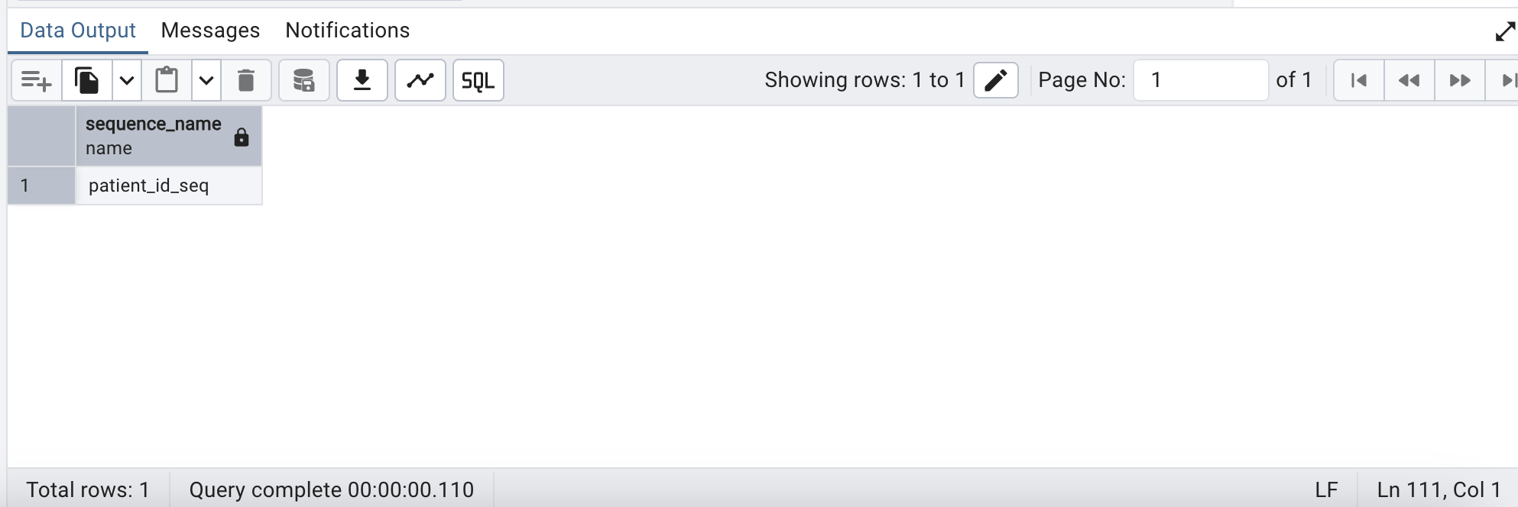

**-- drop sequence:**

drop sequence patient_id_Seq;

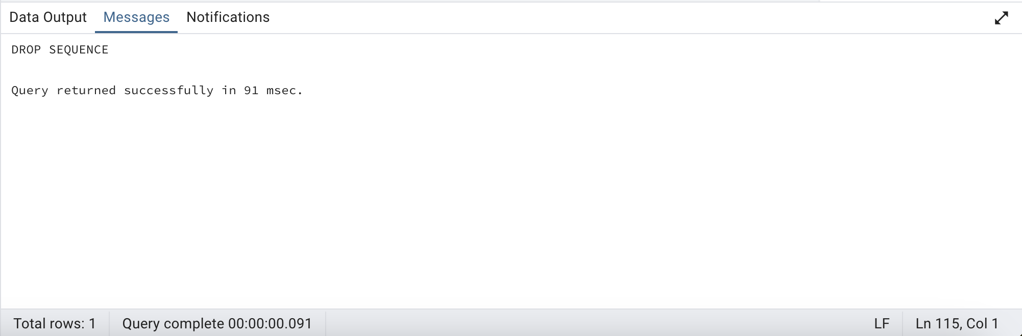

---------------------------------------------------------------------------------------------------------

**6)Create an index on the baseline table and use explain analyze to show differences if any.**

**Query:**

explain analyze

select "patient_id",

"infectionsite",

position('nia' in "infectionsite")

from baseline

order by 3 desc;

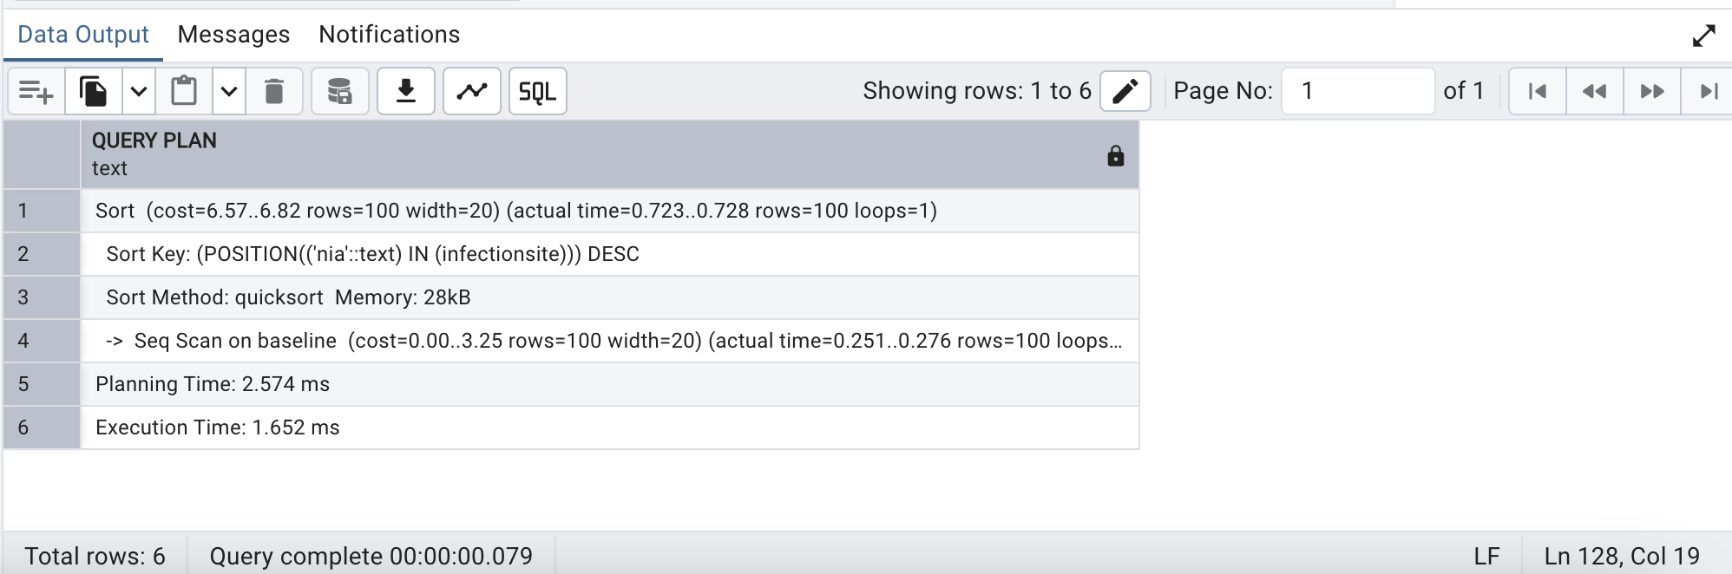

**--Create Index**

create index patient on baseline using btree("patient_id")

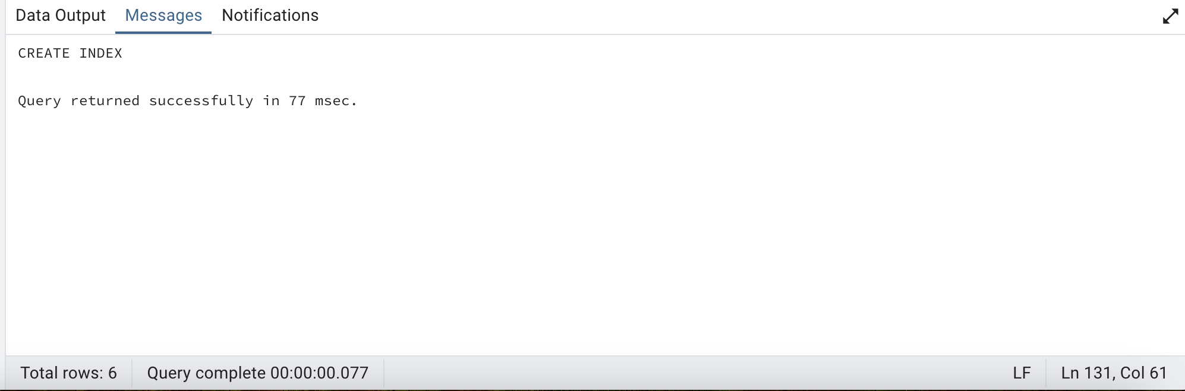

**--After creating Index again Run Explain Analyze**

explain analyze

select "patient_id",

"infectionsite",

position('nia' in "infectionsite")

from baseline

order by 3 desc;

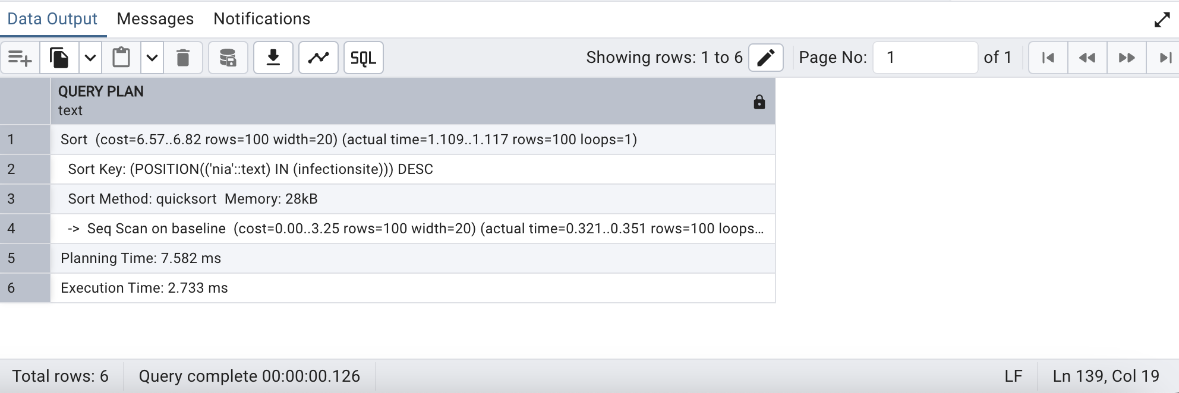

**--drop index patient**

drop index patient

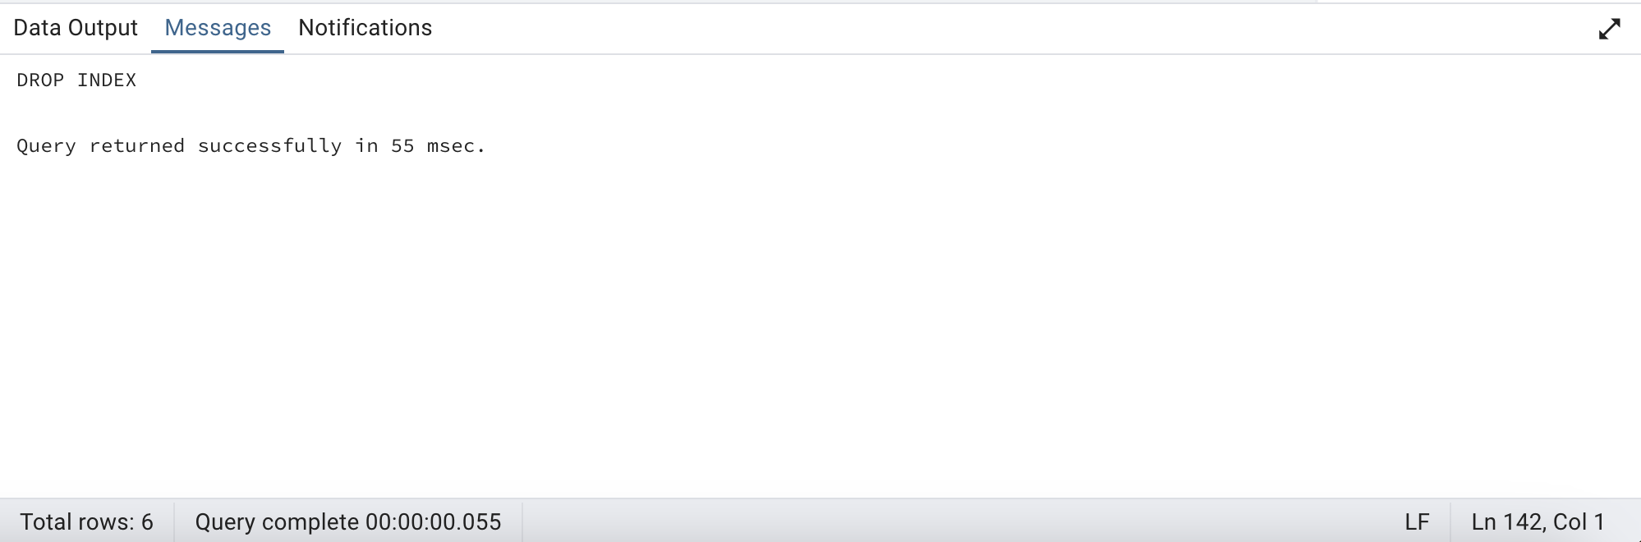

------------------------------------------------------------------------------------------------------------------------

**7)Find patients in the baseline table whose ages are greater than any of the ages listed in a specified array?**

**Query:**

select *

from baseline

where age > any (array[40,50]);

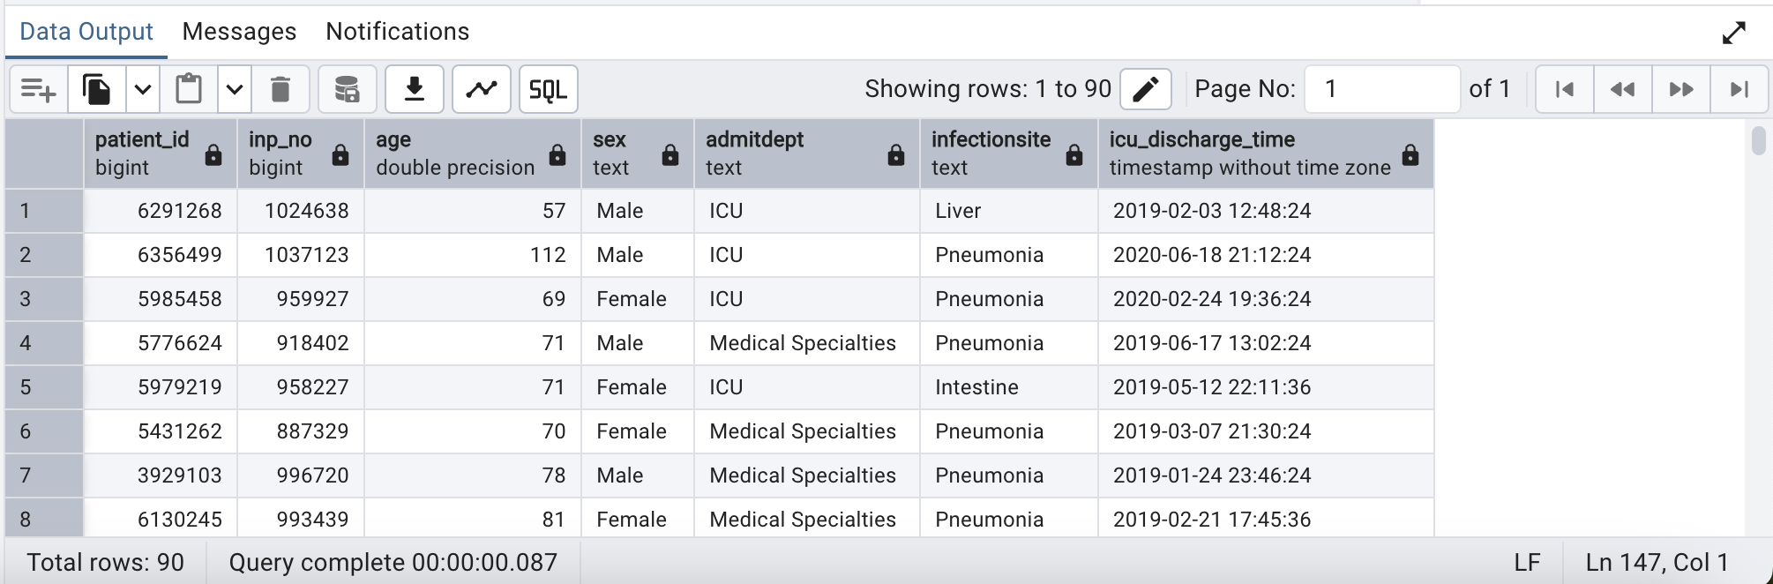

------------------------------------------------------------------------------------------------------------------

**8)Find the cumulative distribution of patients' ages in the baseline table, and identify what percentage of patients are younger than a specific age threshold?**

**Query:**

select

patient_id,

age,

cume_dist() over (order by age) as cumulative_value

from

baseline

where

age is not NULL;

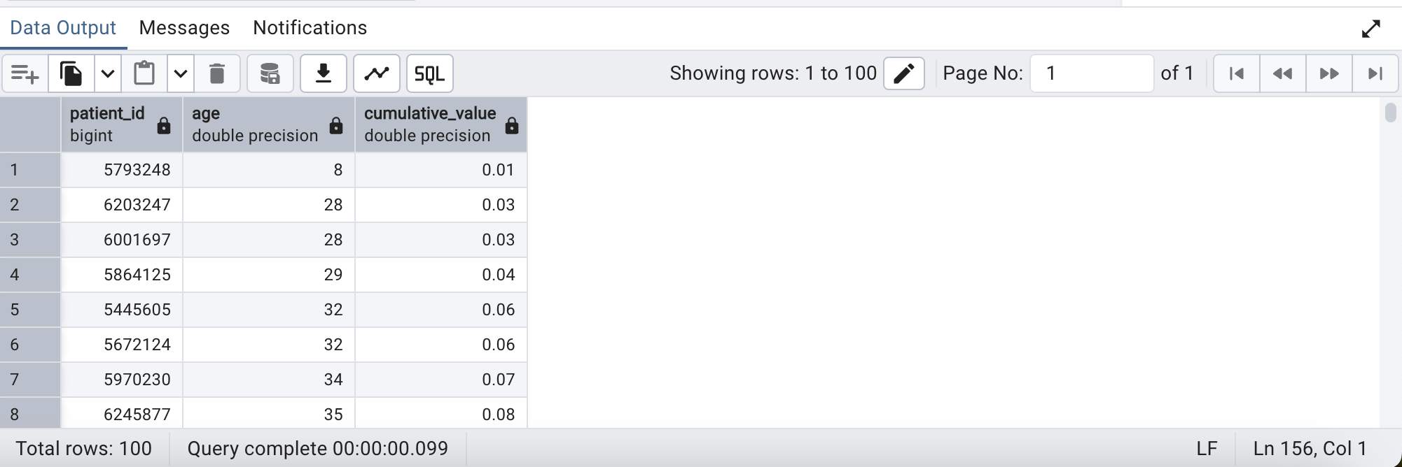

----------------------------------------------------------------------------------------------------------------

**9)Aggregate all inpatient_number values in the baseline table into a comma-separated string format**

**Query:**

select

string_agg(inp_no::text, ', ') AS aggregated_inpatient_numbers

from baseline;

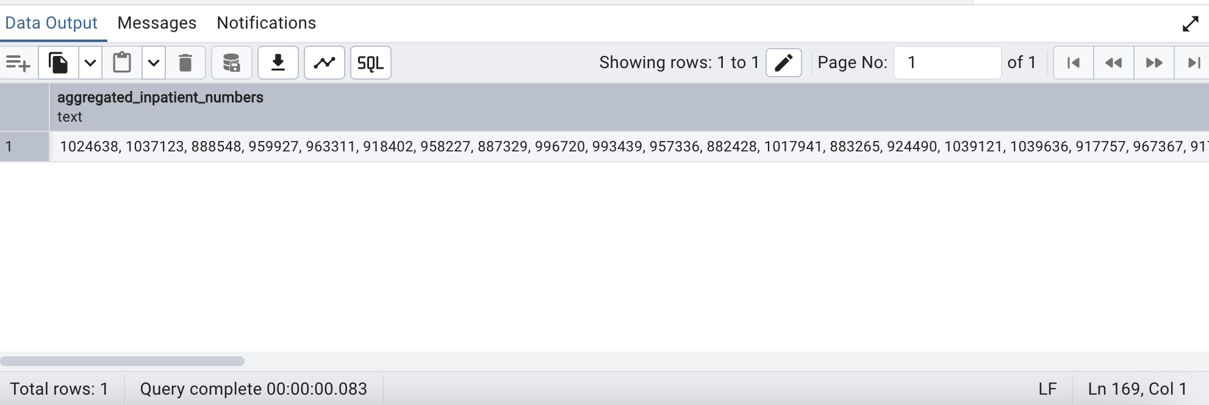

----------------------------------------------------------------------------------------------------------------------------

**10)Categorize patient ages into specific age groups using the width_bucket function in the baseline table**

**Query:**

select width_bucket(age, 0, 100, 5) as age_width_bucket,

count(*) as count_pat

from

baseline

group by

age_width_bucket

order by

age_width_bucket;

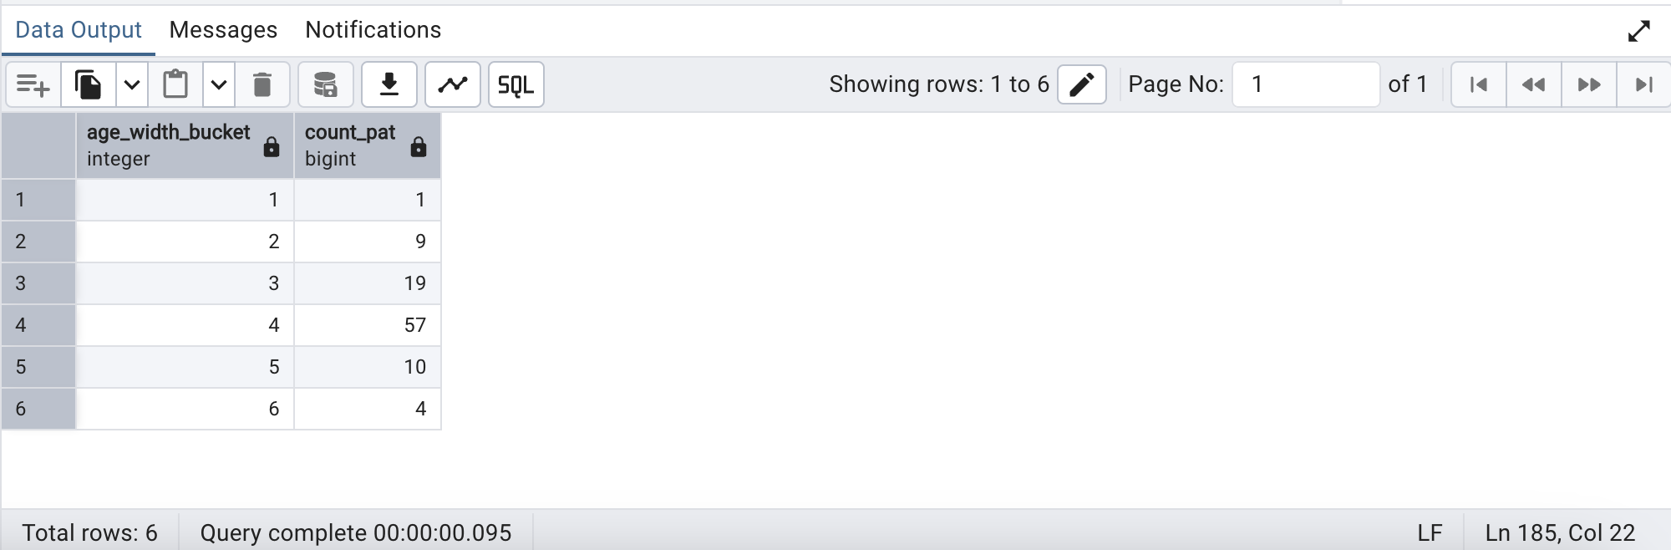

----------------------------------------------------------------------------------------------------------------------------

**11) Retrieve a specific number of records from the baseline using the FETCH clause in SQL**

**Query:**

select *

from baseline

order by age

fetch first 10 rows only;

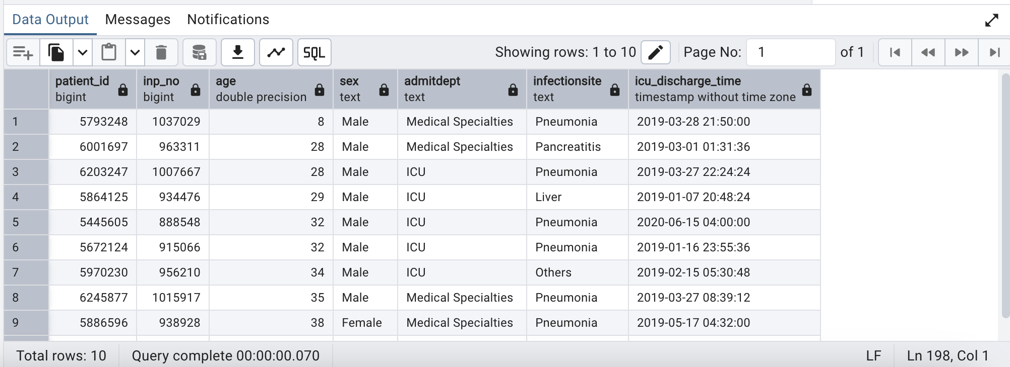

----------------------------------------------------------------------------------------------------------------------------

**12) Retrieve all unique types of icd_code and present them as an array?**

**Query:**

select

array_agg(distinct icd_code) as icd_code_Array

from icd;

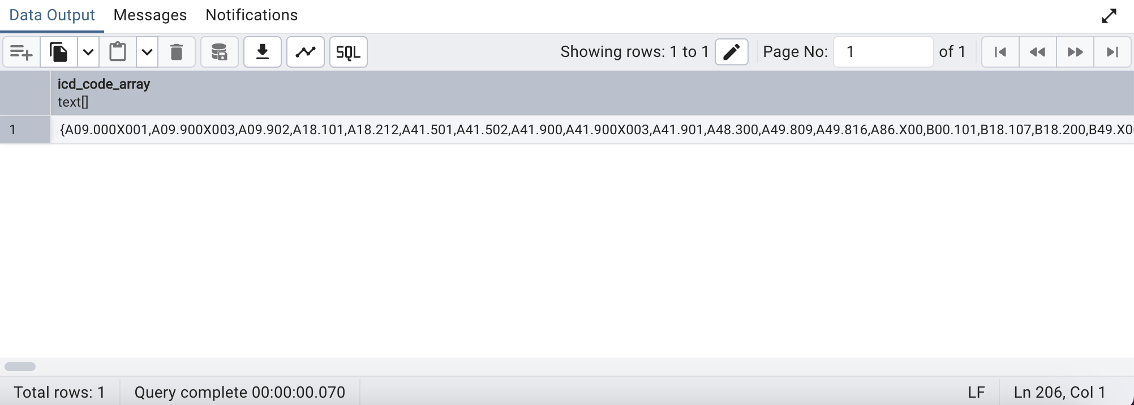

----------------------------------------------------------------------------------------------------------------------------

**13)Write a query using the PERCENT_RANK() window function to find patients in the top 10% of heart rate measurements. Display their patient ID, heart rate, and percentile rank.**

**Query:**

with ranked_heart_rate as (

select

b.patient_id,

n.heart_rate,

percent_rank() over (partition by b.patient_id order by n.heart_rate desc) as heart_rate_percentile

from

baseline b

join

nursingchart n on b.inp_no = n.inp_no

where

n.heart_rate is not null

)

select

patient_id,

heart_rate,

heart_rate_percentile

from

ranked_heart_rate

where

heart_rate_percentile <= 0.1

order by

heart_rate_percentile, heart_rate desc;

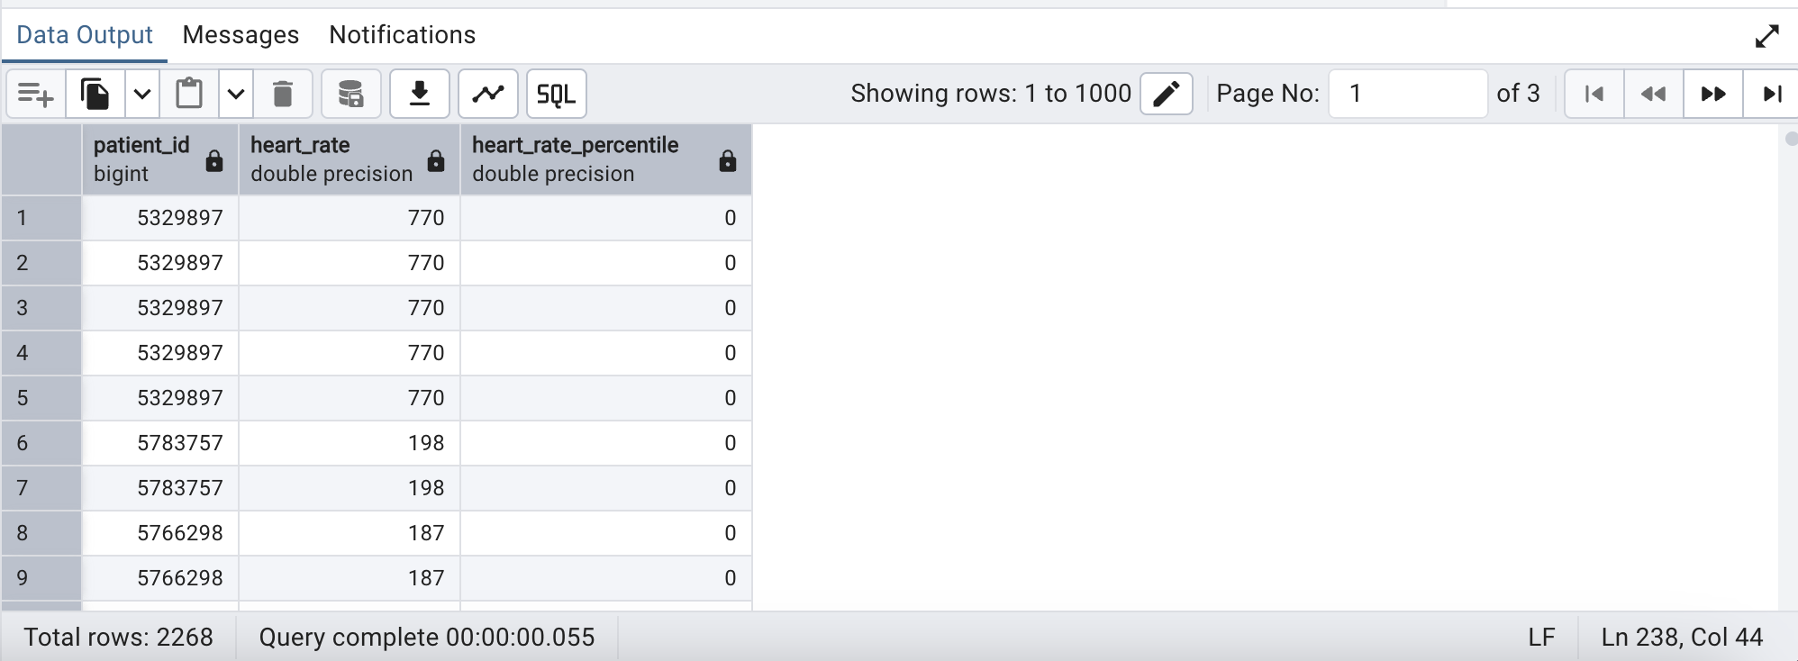

----------------------------------------------------------------------------------------------------------------------------

**14)Find patients whose breathing was in the top 5% during their stay.**

**Query:**

with breathing_ranked as (

select

inp_no,

breathing,

ntile(100) over (order by breathing desc) as percentile_rank

from

nursingchart

where

breathing is not null

)

select

inp_no,

breathing

from

breathing_ranked

where

percentile_rank <= 5

order by

breathing desc;

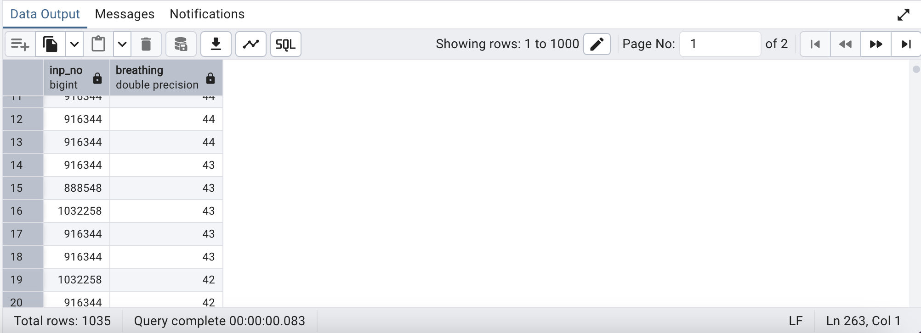

----------------------------------------------------------------------------------------------------------------------------

**15)Using the nursingchart table, identify instances where a patient's heart rate significantly increases compared to the subsequent chart time. Display the patient ID, current heart rate, subsequent heart rate, and the respective chart times.**

**Query:**

with HeartRateComparison as(

select

inp_no,

heart_rate as current_heart_rate,

lead(heart_rate) over (partition by inp_no order by charttime) as subsequent_heart_rate,

charttime as current_chart_time,

lead(charttime) over (partition by inp_no order by charttime) as subsequent_chart_time

from

nursingchart

)

select

inp_no,

current_heart_rate,

subsequent_heart_rate,

current_chart_time,

subsequent_chart_time

from

HeartRateComparison

where

current_heart_rate < subsequent_heart_rate;

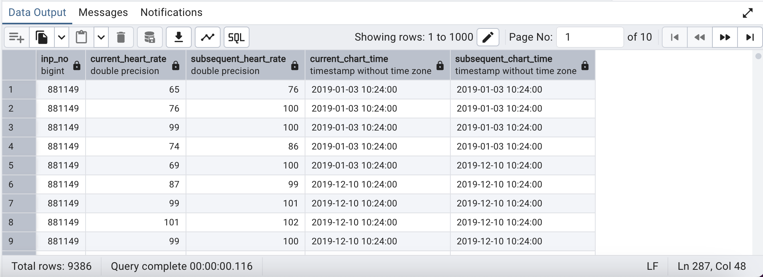

----------------------------------------------------------------------------------------------------------------------------

**16) Select Rows for baseline in a Range of ctid Values between 11 to 20**

**Query:**

SELECT ctid, *

FROM baseline

WHERE ctid BETWEEN '(0,10)' AND '(0,20)';

**Output:**

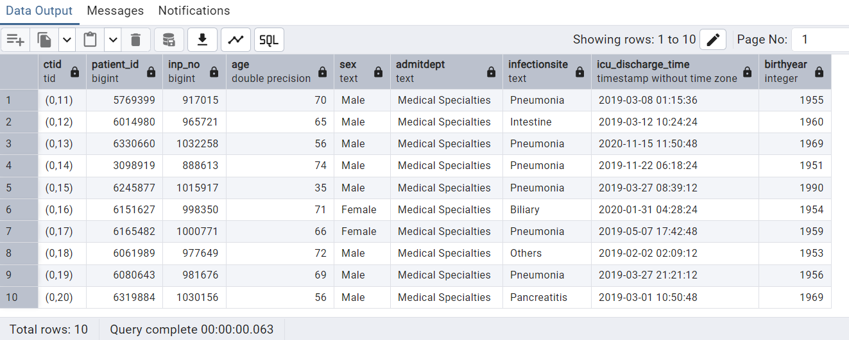

**—----------------------------------------------------------------------------------------------------------------------------**

**Q.17 )Display NTH_VALUE() age function to return all patients with the second most age from table.**

**Query:**

select patient_id,

age,

NTH_VALUE(age, 2)

OVER(

ORDER BY age DESC

RANGE BETWEEN

UNBOUNDED PRECEDING AND

UNBOUNDED FOLLOWING

) FROM baseline;

**Output:**

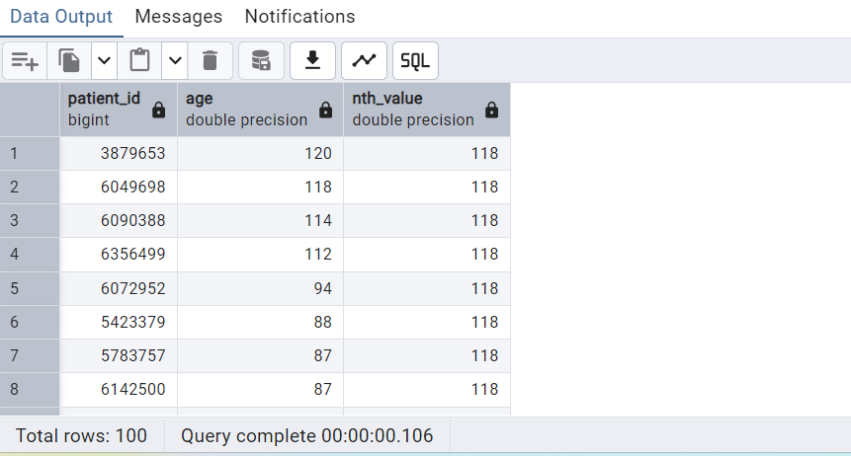

—----------------------------------------------------------------------------------------------------------------------------

**Q.18) Create materialized view with no data, to display no of male and female patients.**

Query:

CREATE MATERIALIZED VIEW patient_gender_count

AS

SELECT sex, COUNT(sex) AS patient_count

FROM baseline

GROUP BY sex

WITH NO DATA;

Output:

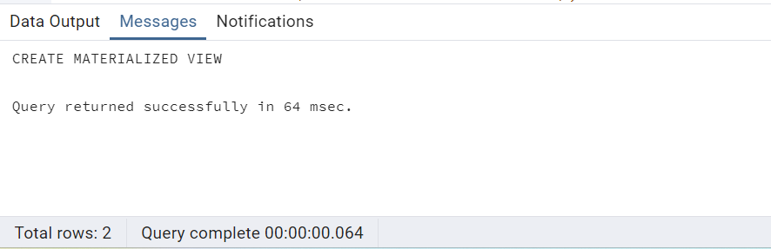

–to refresh materialized view

REFRESH MATERIALIZED VIEW patient_gender_count;

Output:

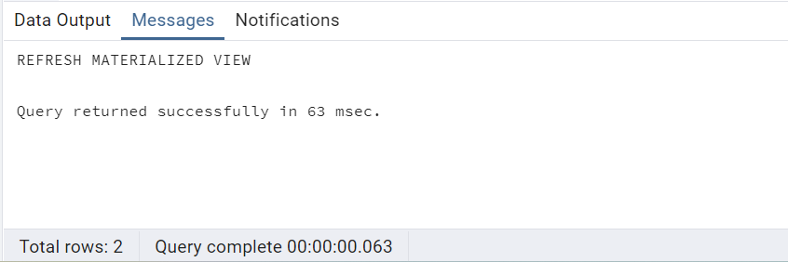

–query to select materialized view

select * from patient_gender_count;

Output:

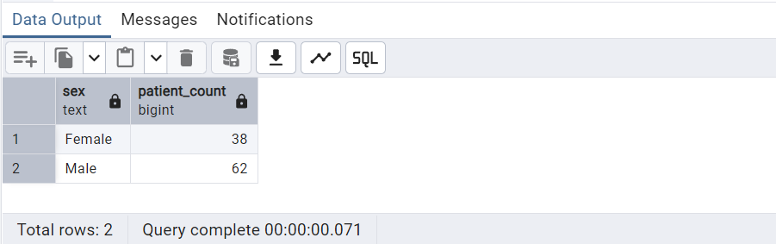

—----------------------------------------------------------------------------------------------------------------------------

**Q. 19) Using implicit cursor write a stored procedure to select the given patient details from the procedure call (patient_id,sex,admit department and drug name).**

**Query:**

CREATE OR REPLACE PROCEDURE patient_information(patient_no int)

LANGUAGE plpgsql

AS

$$

DECLARE

patient_id int;

sex text;

admitdept text;

drug_name text;

is_records Boolean := false;

BEGIN

FOR patient_id , sex,admitdept,drug_name IN

SELECT b.inp_no, b.sex, b.admitdept, dr.drugname AS gender

FROM baseline b JOIN drugs dr ON b.patient_id = dr.patient_id

WHERE b.patient_id = patient_no

LOOP

is_records := true ;

RAISE NOTICE 'Patient ID: %, Patient Gender: %, Admit Department: %, Drug Name: %', patient_no, sex, admitdept,drug_name;

END LOOP;

IF NOT is_records THEN

RAISE NOTICE 'No patients found for Patient ID: %', patient_no;

END IF;

END

$$;

Call the procedure:

--------------------------

CALL patient_information(6356499);

**Output:**

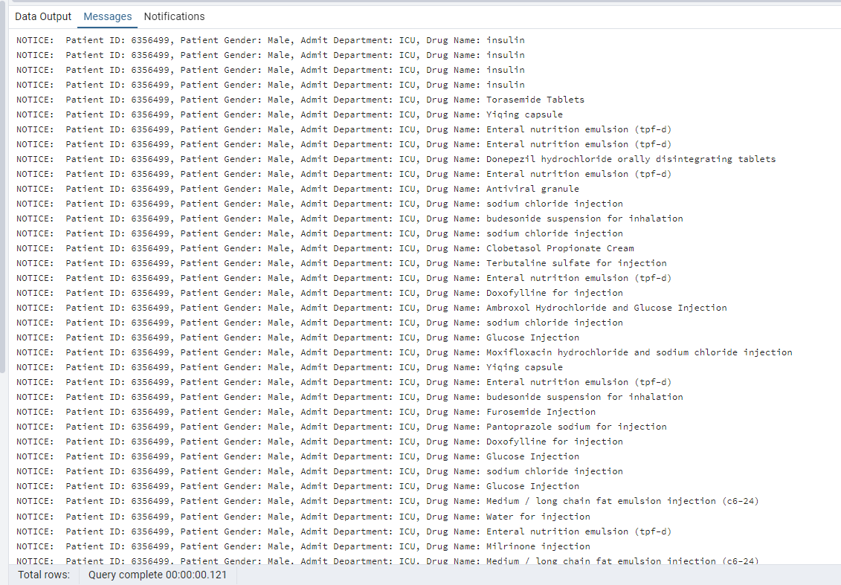

**20) Create a stored procedure to calculate the average heart rate of a given patient. Use IN and OUT parameters**

**Query:**

**Creating the procedure**

**—-----------------------------**

CREATE OR REPLACE PROCEDURE calculate_average_heart_rate(

IN patient_id_input INT, -- IN parameter to filter by patient_id

OUT avg_heart_rate NUMERIC -- OUT parameter to return the average

)

LANGUAGE plpgsql

AS $$

BEGIN

SELECT round(AVG(heart_rate)::numeric,2)

INTO avg_heart_rate

FROM nursingchart

WHERE inp_no = patient_id_input;

IF avg_heart_rate IS NULL THEN

avg_heart_rate := 0;

END IF;

END;

$$;

**Procedure Call for output**

—-------------------------------

DO $$

DECLARE

avg_rate NUMERIC;

BEGIN

CALL calculate_average_heart_rate(974750, avg_rate);

RAISE NOTICE 'Average Heart Rate: %', avg_rate;

END;

$$;

**Output:**

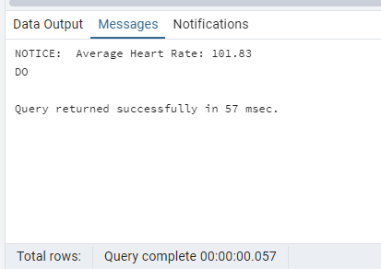

**21) Create a table patients and generate transaction control and error handling with BEGIN, COMMIT, ROLLBACK, and EXCEPTION.**

**Query:**

**—------**

CREATE OR REPLACE PROCEDURE table_manipulation_transaction(

IN p_id INT,

IN p_date VARCHAR,

IN p_name TEXT,

IN inpno REAL

)

LANGUAGE plpgsql

AS $$

BEGIN

INSERT INTO patients(patient_id, entry_date, patient_name, inp_no)

VALUES (p_id, p_date, p_name, inpno);

DELETE FROM patients

WHERE inp_no < inpno;

UPDATE patients

SET inp_no = 4500

WHERE patient_id = p_id;

IF NOT FOUND THEN

RAISE EXCEPTION 'Patient ID % not found for updating inp_no.', p_id;

END IF;

IF p_name IS NULL THEN

RAISE EXCEPTION 'Patient name must be provided.';

END IF;

EXCEPTION

WHEN OTHERS THEN

-- Handle exceptions by reporting an error

RAISE NOTICE 'Transaction rolled back due to an error: %', SQLERRM;

RAISE EXCEPTION 'Error: %', SQLERRM;

END;

$$;

**Procedure Call**

**—-------------------**

CALL table_manipulation_transaction(7, '12-12-2012', 'Rani', 5000);

**Output: 1 (created table)**

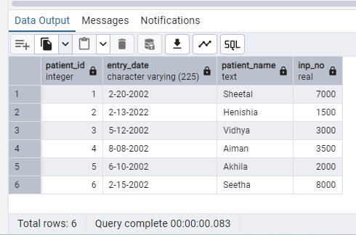

**Output: 2 (code)**

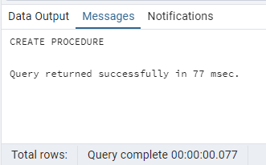

**Output: 3 (Call)**

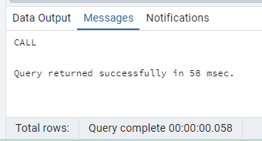

**Output:4 (Updated and deleted rows)**

**(Deleted rows will not be shown as they are already deleted)**

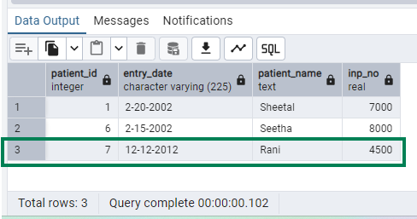

**—----------------------------------------------------------------------------------------------------------------------------**

**22)write a query to repeat transfer department as per patient_id id 5 times whose dept name ='ICU'**

**Query:**

select patient_id, repeat('=>',5),transferdept from transfer

where transferdept = 'ICU'

limit 1;

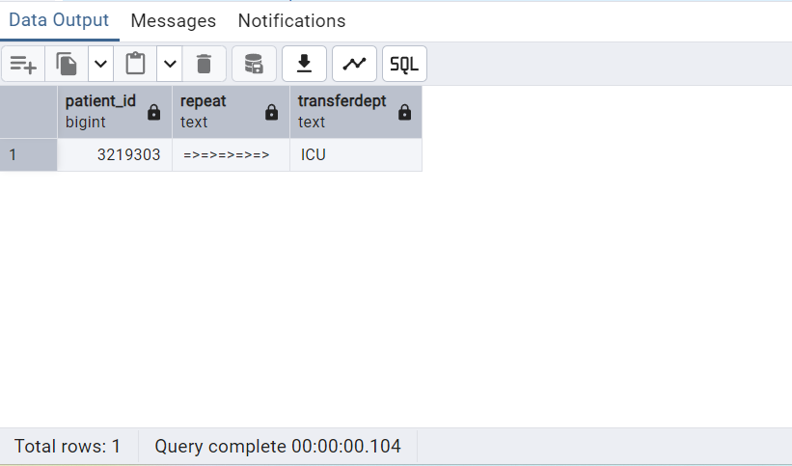

**—----------------------------------------------------------------------------------------------------------------------------**

**23)write a query to find the position of letter a in firstname of patients USING strpos function**

**Query:**

select infectionsite,strpos(infectionsite,'a') as positionofletter_a from baseline

**–selecting table**

select * from baseline;

**Output:**

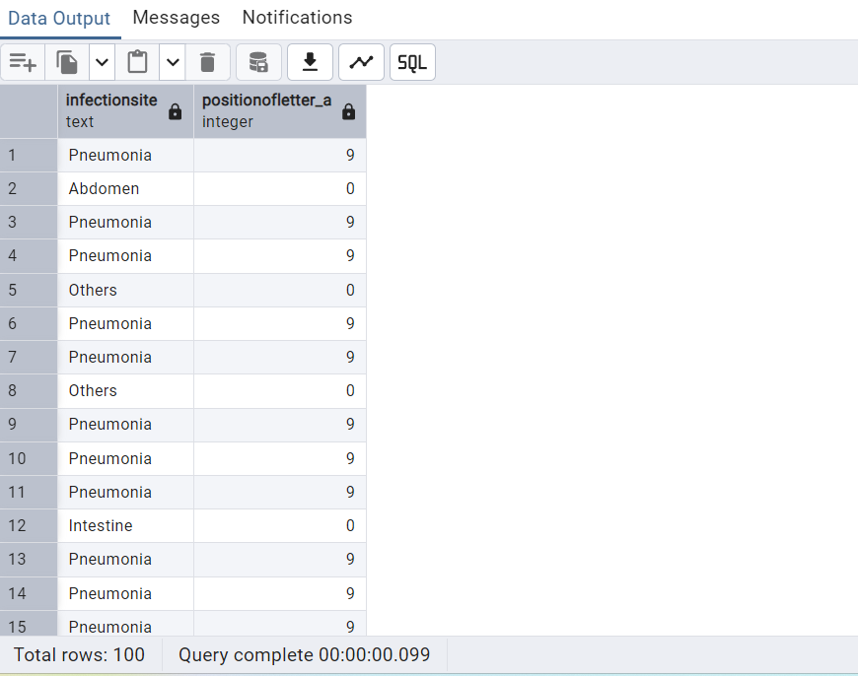

**24)Write a query to lock the table**

**--creates lock**

begin;

lock table baseline IN ACCESS SHARE MODE;

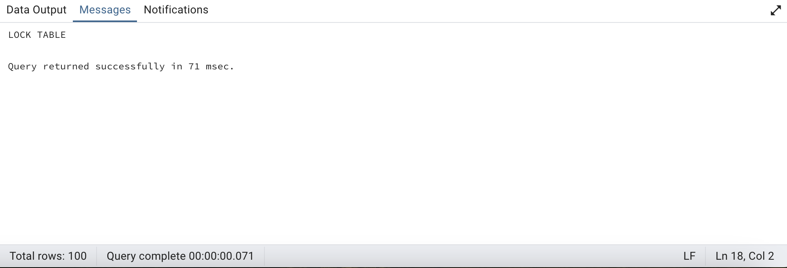

**--validation**

select * from baseline

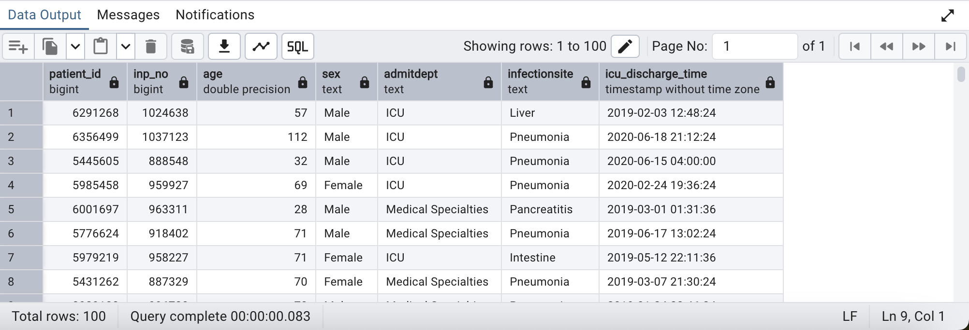

**--To Save**

Commit;

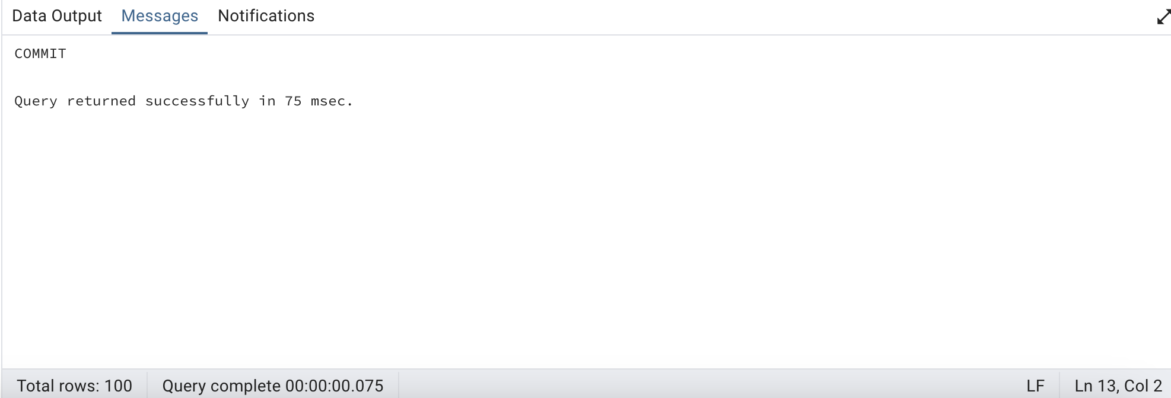

**--To Rollback**

Rollback;

