**SOFTWARE REQUIREMENT SPECIFICATION**

|  |  |
| --- | --- |
| Name | Nithya K |
| Roll No | 7376221CS248 |
| Seat No | 68 |
| Project ID | 28 |
| Problem Statement | Develop a web-based portal to track activities under each Memorandum of Understanding (MOU). This will provide a central hub for monitoring progress, fostering collaboration, and improving transparency for all involved. By streamlining data collection and reporting, the portal aims to enhance decision-making and ensure successful MOU implementation. |

**1. Introduction:**

**1.1.Purpose:**

The aim of this document is to offer a comprehensive overview of the MOU Project. It will detail the project's objectives and features, describe the system interfaces, clarify its functionalities, outline operational limitations, and define how the system will respond to external triggers.

**1.2.Scope of Project:**

The scope of the MOU Project encompasses the development of a web-based portal dedicated to tracking Memoranda of Understanding (MOUs). It involves creating a platform for stakeholders to monitor progress, collaborate, and ensure transparency in MOU implementation. The project will include features such as displaying MOU status, tracking progress, generating reports, and providing administrative functionalities. It's important to note that only administrators will have the ability to create, edit, and delete MOUs. Additionally, expired MOUs will remain on the dashboard for up to 30 days before being automatically deleted.

**2. System Overview:**

**2.1. Users:**

**Students:**

Students can view MOU documents, including ongoing and expired agreements. They can track progress and offers provided by sectors, and download MOU documents as needed.

**Admins:**

Administrators exclusively possess the ability to edit or delete MOU documents. They can create new MOUs by inputting details and uploading necessary documents. Additionally, they have access to track progress and offers from sectors, view and download MOU documents, and renew expired documents within 30 days.

**2.2.Features:**

**1. Login and Registration:**

Students and admins can register for an account or log in with their existing account if the account already exists.

**2. Home:**

Provide a comprehensive description of each Memorandum of Understanding (MOU) to give users insight into its objectives and scope.

**3. MOU:**

Display MOUs in a table format, highlighting their expiry status (visible up to 30 days before expiry) and duration for quick reference.

**4.Progress:**

Visualize sector-wise progress and offers through graphs, enabling stakeholders to track advancements and assess performance effectively.

**5.Activity (Admin Only):**

Empower administrators with the ability to manage MOUs by creating, editing, and deleting them as needed, ensuring efficient governance of the platform.

**6.Report:**

Enable users to view and download MOU documents for detailed analysis and documentation purposes, promoting transparency and accessibility.

**7.Search:**

Users should be able to search for MOU documents by department or purpose, enabling quick and efficient retrieval of relevant documents.

**STUDENT’S INTERFACE**

username

DATABASE

username

Fetch Data- student

user

system

Back to login

Fetch Data

Database of MOU

no

yes

Progress

sectors

offers

Description of the application

Sector

Duration

Department

Purpose

Partner

MOU

logout

Report

MOU

Home

student

password

email

Invalid credentials

login

db

Progress

View

Report

expired

Download

no

Expired> 30 days

Display in dashboard

yes

Delete automatically

**ADMIN’S INTERFACE**

username

DATABASE

username

Fetch Data-admin

system

Back to login

Fetch Data

Database of MOU

no

yes

Progress

sectors

offers

Description of the application

logout

Report

Activity

Progress

MOU

Home

admin

password

email

Invalid credentials

login

db

user

MOU

Create new MOU

Expired MOU

delete

edit

Renewal

Purpose

Partner

edt

Department

report

view

Duration

download

Sector

**ER DIAGRAM**

renewal

Only admin

ongoing

expired

student

status

duration

view

admin

MOU

user

purpose

Only admin

Overview

check

edit

Progress

Activity

Progress

offer

Sector

New MOU

delete

NGO

Internship

placement

Institution

Industry

**3. Functional requirements:**

**User Authentication:**

* The system must authenticate users as either students or administrators upon login.

**MOU Document Management:**

* Users (students and administrators) should be able to view MOU documents, including ongoing and expired agreements.
* Administrators should have the ability to edit, delete, and create new MOU documents, including uploading necessary files.
* Expired MOU documents should be retained on the system for 30 days, after which they are automatically deleted.

**Progress Tracking:**

* Both students and administrators should be able to track progress and offers provided by sectors.

**Download Functionality:**

* Users (students and administrators) should have the ability to download MOU documents as needed.

**Renewal Process:**

* Administrators should be able to renew expired MOU documents within 30 days of expiry.

**Search Feature:**

* Users should be able to search for MOU documents by department or purpose, enabling quick and efficient retrieval of relevant documents.

**4. Non-Functional Requirements:**

**Performance**: The system must respond to user actions within 2 seconds to ensure efficient usability and must handle a concurrent user load of at least 100 users without significant performance degradation.

**Security**: User data must be encrypted during transmission and storage, and access to sensitive functionalities should be restricted to authorized admin users through secure authentication mechanisms.

**Usability**: The user interface should be intuitive and user-friendly, with clear and concise error messages provided to guide users in case of input errors or system failures.

**Reliability**: The system should be available 24/7 with minimal downtime and should have a backup and recovery mechanism in place to prevent data loss in case of system failures or crashes.

**Scalability**: The system should be designed to accommodate an increasing number of users and data volume over time, and it should be scalable to support additional features and functionalities as per future requirements.

**5. Stack:**

|  |  |
| --- | --- |
| Front End | HTML,CSS,JS |
| Back End | Python , Django |
| Database | MySQL |

**6.Back End:**

**Student/ Admin entity:**

|  |  |
| --- | --- |
| name | string |
| email | string |
| password | hash |

**MOU details entity:**

|  |  |
| --- | --- |
| Sector | string |
| First Party | string |
| Second Party | string |
| Purpose | string |
| Duration | integer |
| Department | string |
| Preamble | string |

**7.Prototype of the project:**

**Login page:**

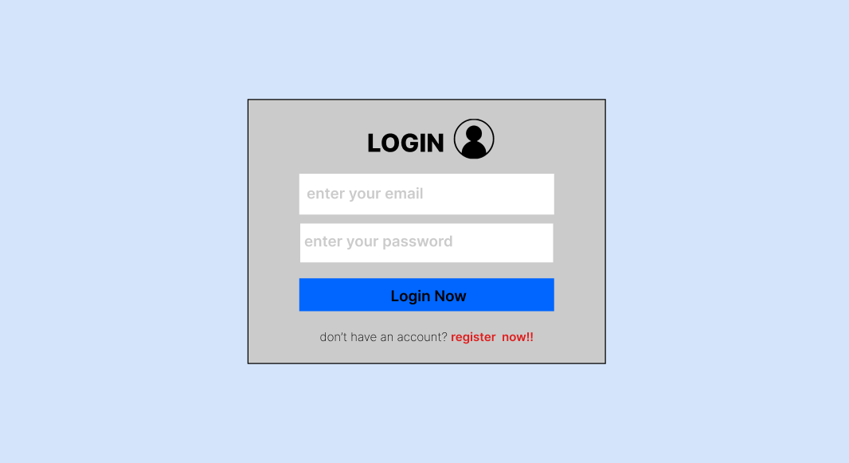

**Register page:**

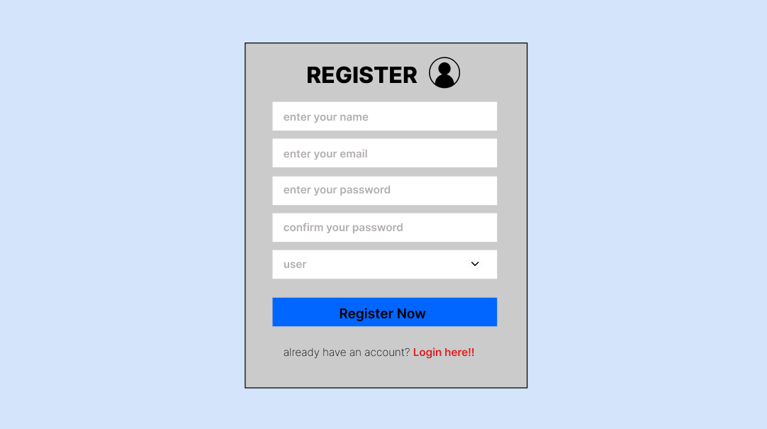

**Admin-HOME page:**

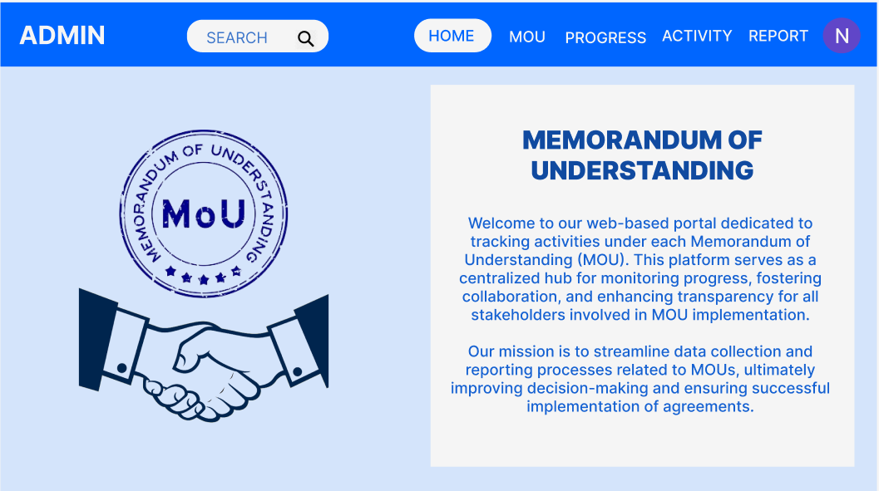

**Admin-MOU:**

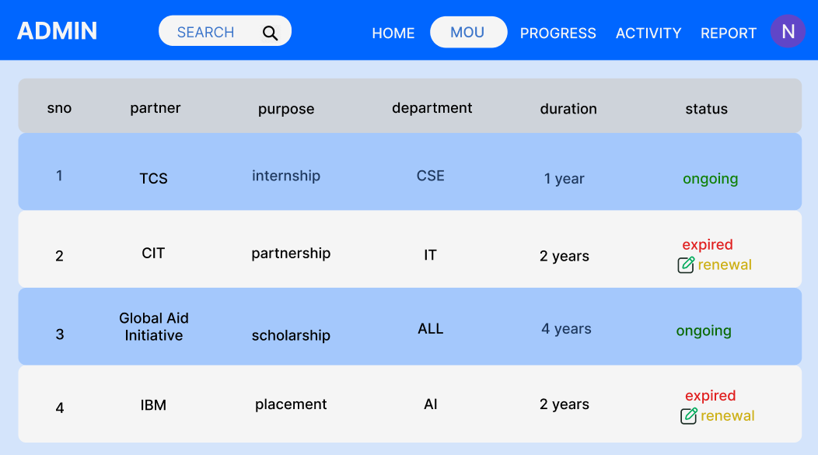

**Admin-PROGRESS:**

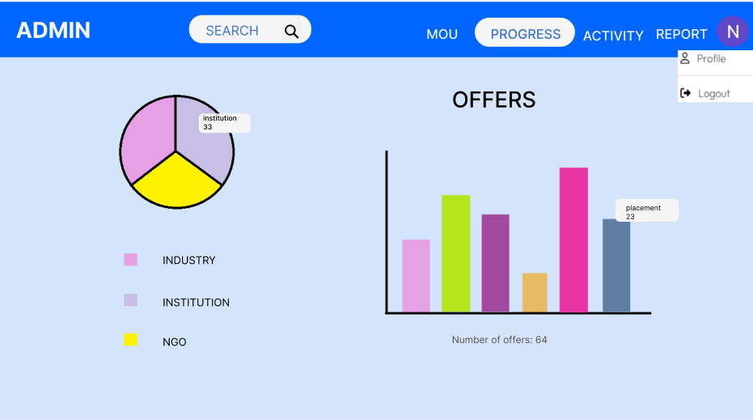

**Admin-ACTIVITY:**

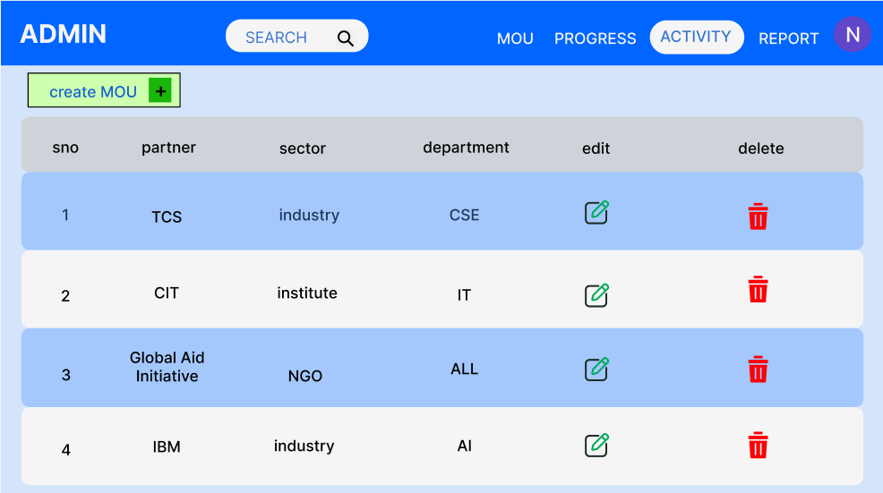

**Admin-creating new MOU:**

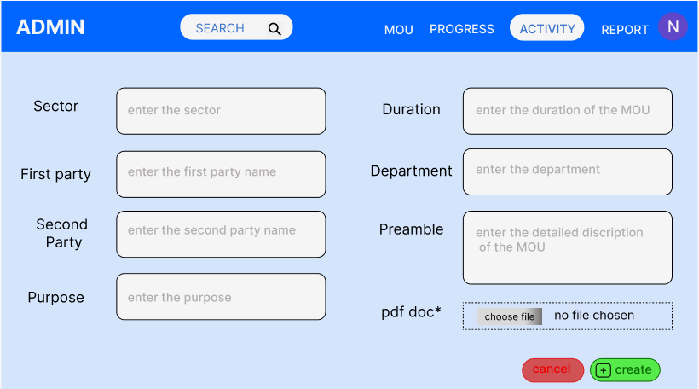

**Admin-REPORT:**

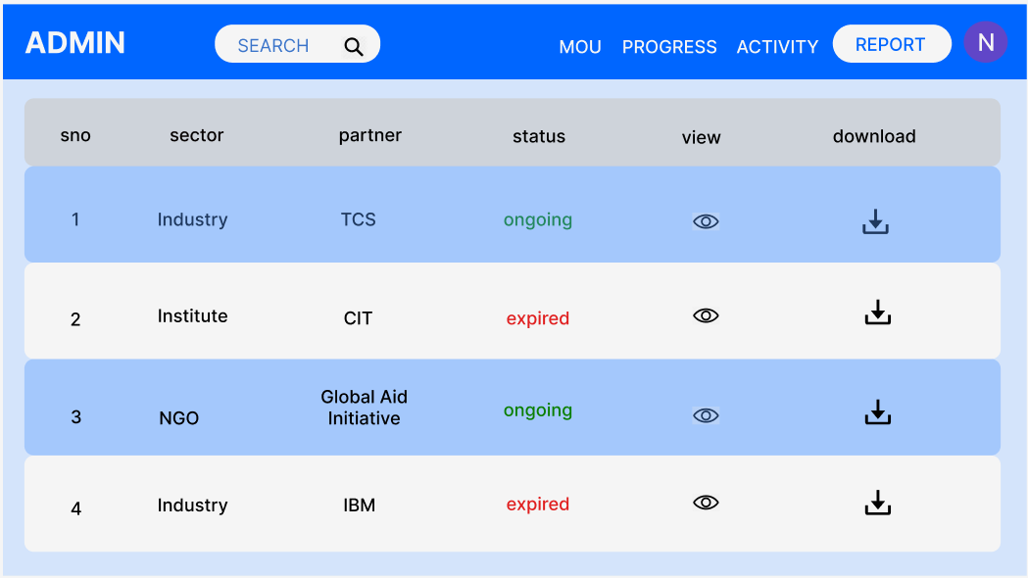

**Student-HOME:**

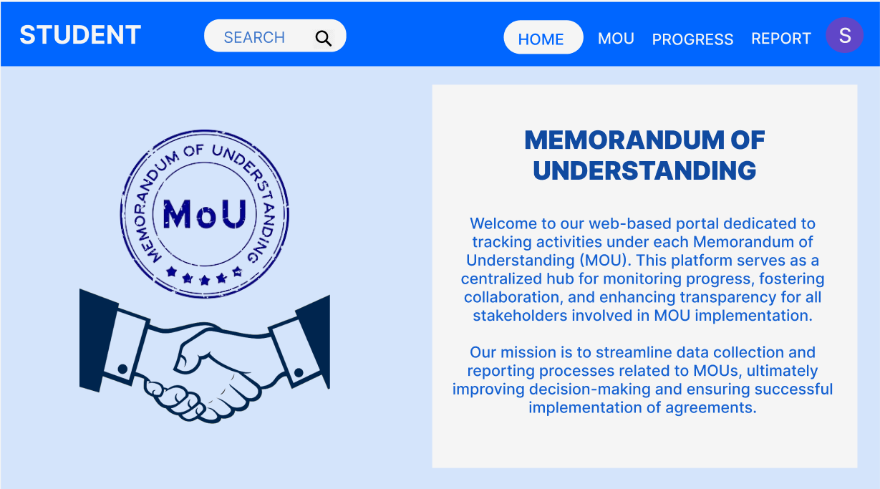

**Student-MOU:**

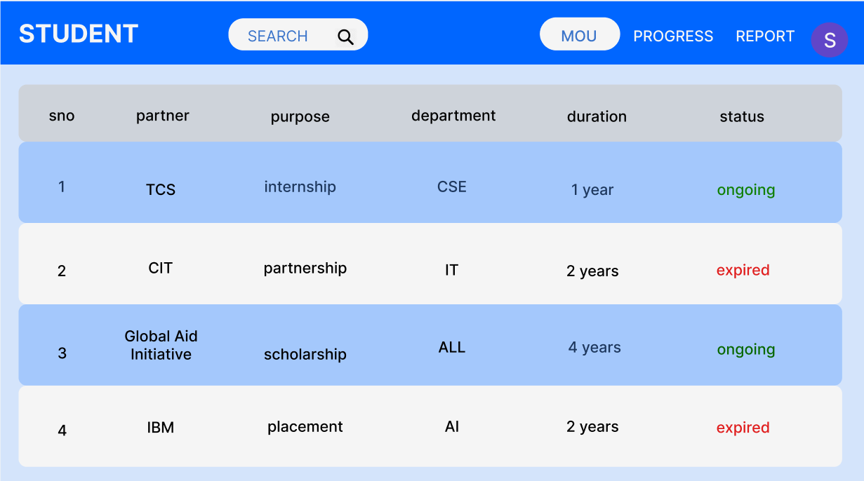

**Student-PROGRESS:**

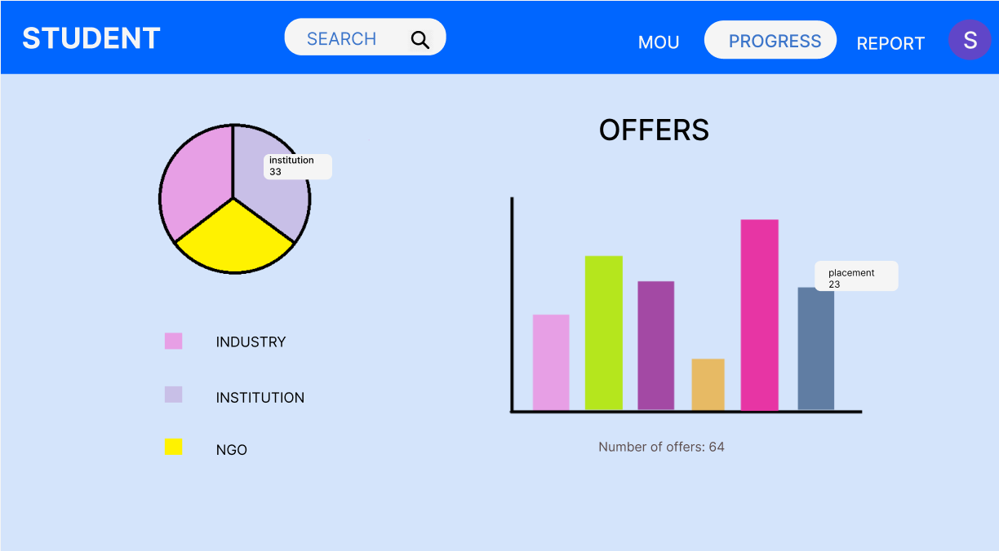

**Student-REPORT:**

