Project – 3

Inventory Management System

Make a folder named inventory_app :

This folder should contain

App.py

Models.py

Two sub folders called:

Static:

Style.css

Templates:

Base

Inventory

Login

Register

…

Folders like:

Instance, __pycache__ and venv will be created automatically by the system when we execute

The code files will be shared

# OUTPUTS:

Register using a username and set a password

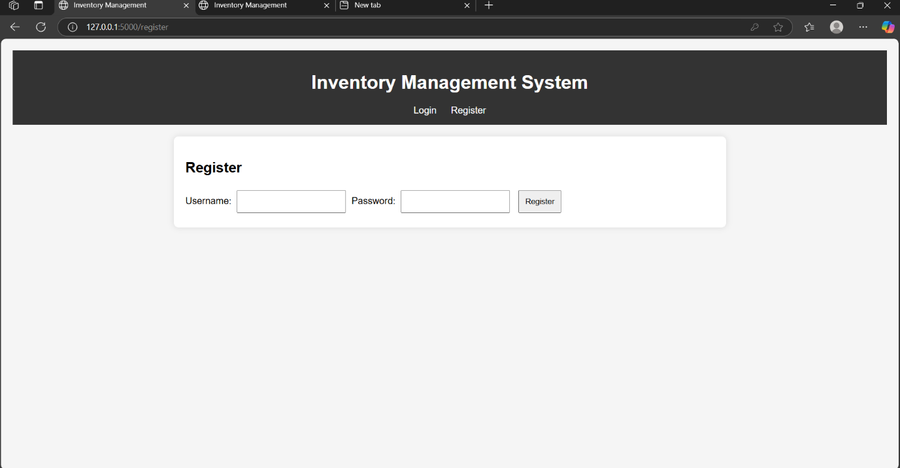

Login in using the username and password that you have created using register

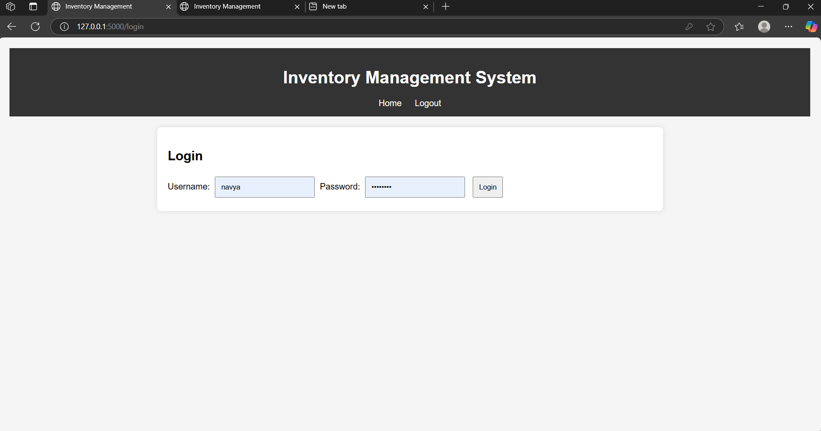

The Inventory Management System is now ready to use

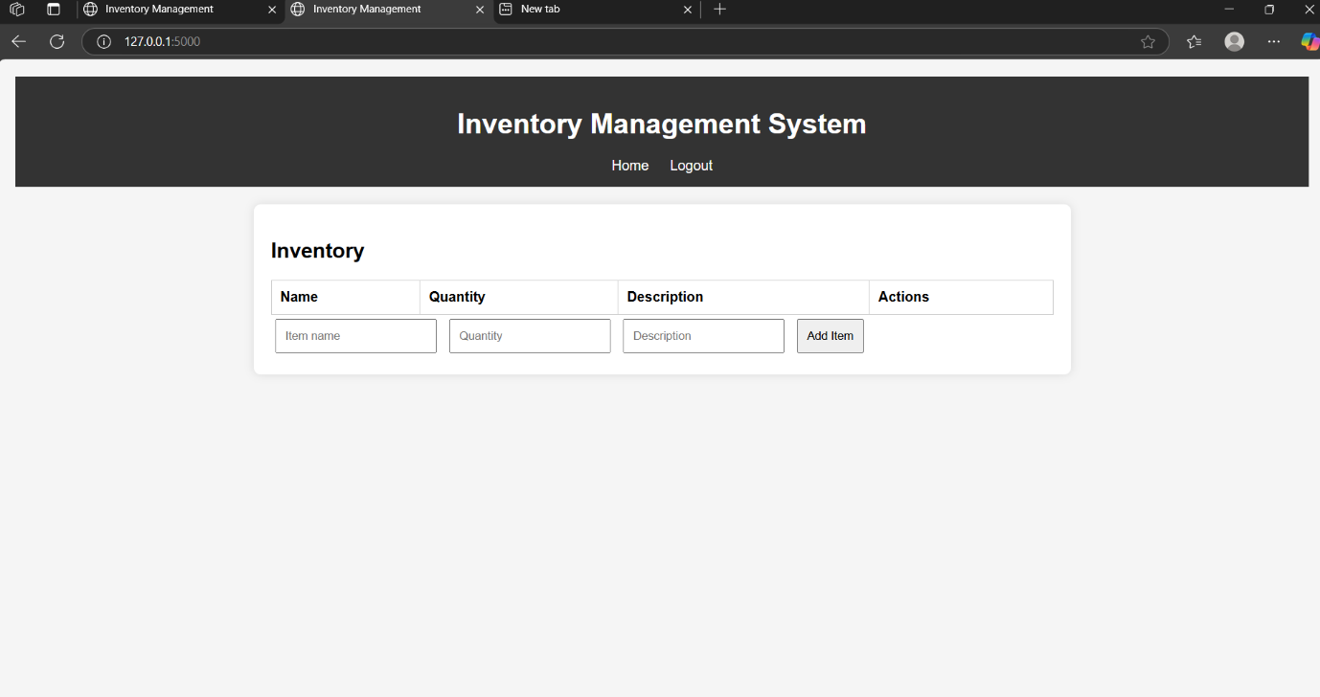

Enter Item name. quantity, description and actions

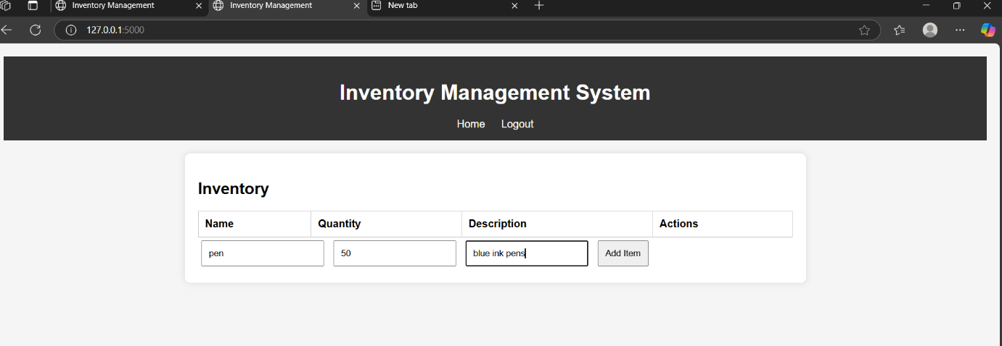

Item is added

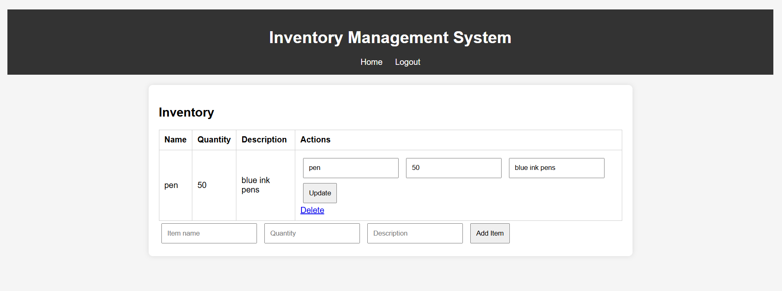

We can update the item



Add another item

The item is added to the Inventory

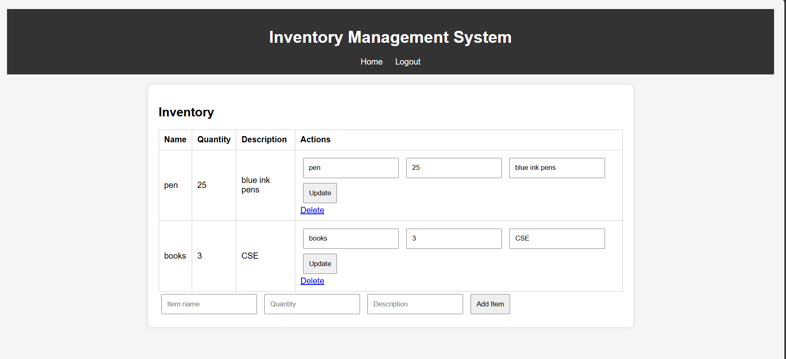

Any item can be removed from the inventory

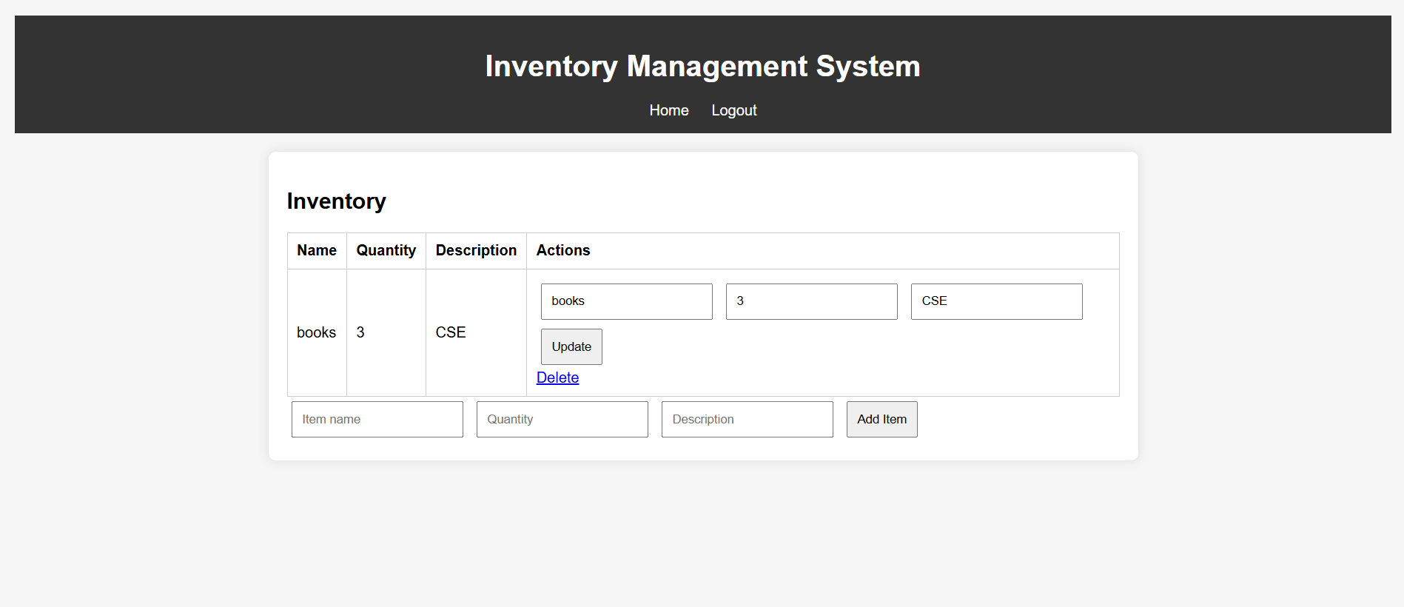

User logs out

