|  |  |
| --- | --- |
| PROJECT – 1  Financial  Planning  Toolkit in PYTHON |  |

# Financial Planning Toolkit in PYTHON

The goal is to create a user-friendly toolkit utilizing python programming that empowers individuals in financial planning. Each calculator should serve a distinct purpose and provide accurate results.

Project Details

1. Mortgage Calculator: - Implement a mortgage calculator in python to assist users in estimating the monthly mortgage payments based on loan amount, interest rate, loan term (In Years).

2. Investment Return Calculator: - Develop a Investment Return Calculator in python that allows users to estimate the future value of an investment based on initial investment, expected rate of return, and investment time horizon.

3. Savings Goal Calculator: - Design a savings goal calculator in python that helps users determine how much they need to invest regularly (monthly) to reach a specific financial goal within a defined time frame. Consider inputs such as savings goal amount, time frame, and expected rate of return.

4. Income Tax Calculator: - Develop a python program for an Income Tax Calculator that calculates estimated tax liability based on annual income, deductions, filing status, and applicable tax credits, considering predefined tax slabs.

5. Handling Bulk Calculations (Optional): - If you wish to improvise further, consider using pandas or PySpark for bulk calculations.

For example

If you have a dataset of thousands of users with different loan amounts, investment details, and tax information, you can use pandas DataFrame or PySpark DataFrame to perform calculations efficiently for all users at once. This approach can demonstrate your ability to handle large-scale financial data processing, making the toolkit capable of providing results for many users in bulk.

CODE:

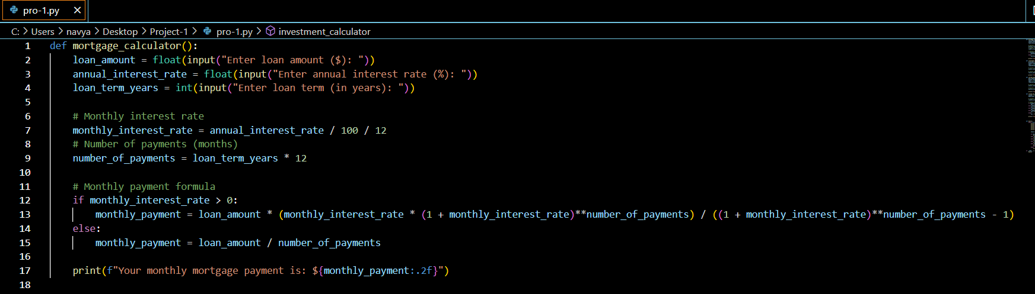

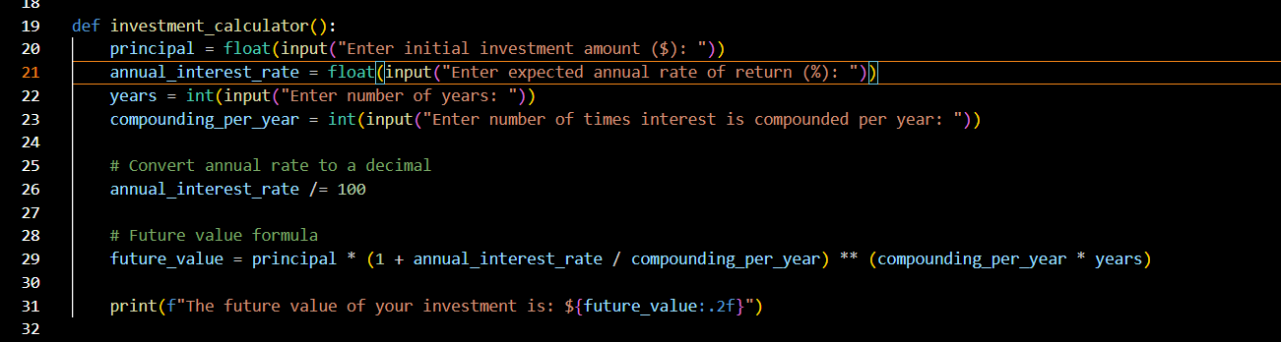

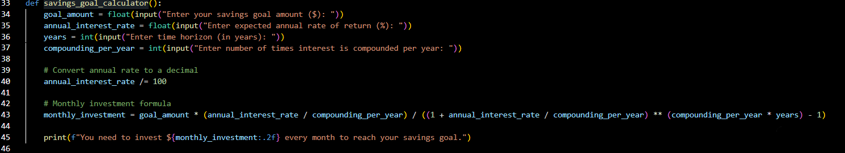

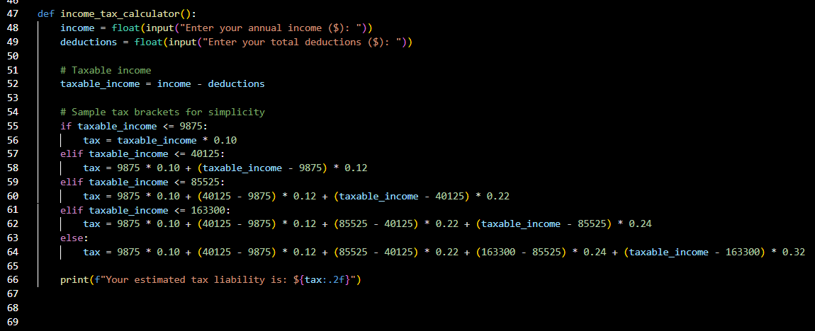

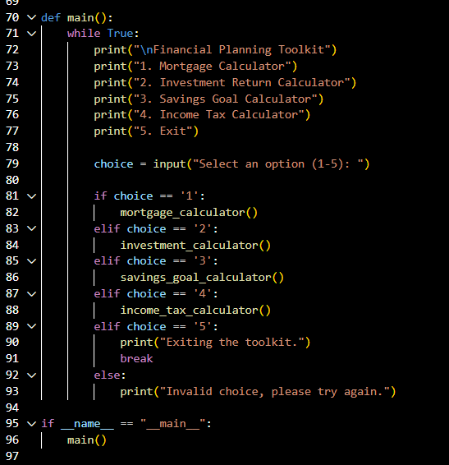

CODE OUTPUT:

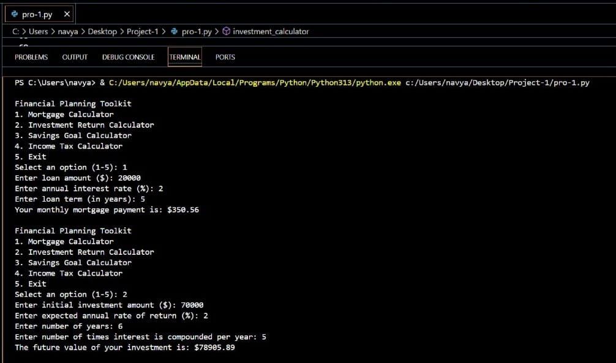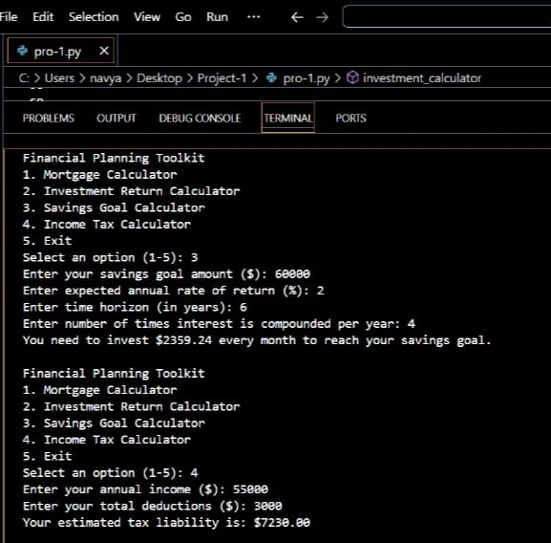

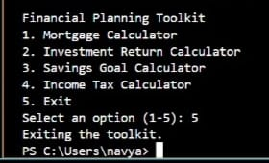

BREAKDOWN

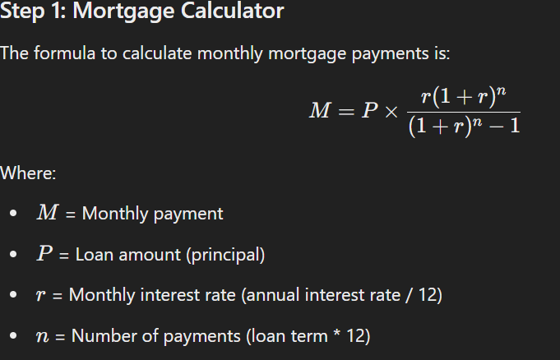

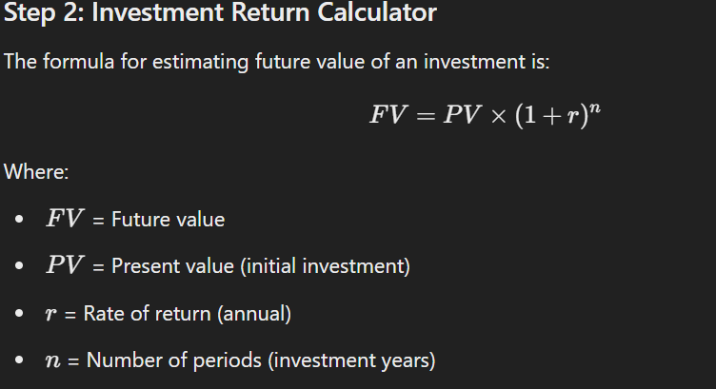

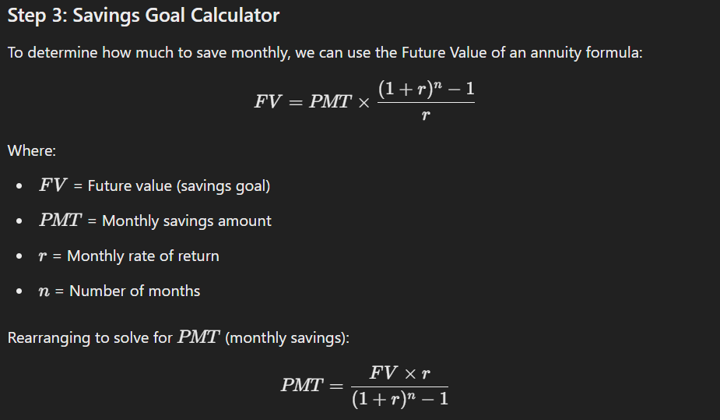

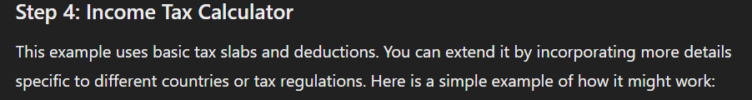

Give ADVANTAGES

**1. Personal Financial Planning**

* **Target Audience**: Individuals looking to plan their finances.
* **Use Case**:
  + Individuals can use the toolkit to assess their financial situation and plan for major life events such as buying a home, saving for retirement, or meeting other financial goals.
  + By using the **Mortgage Calculator**, they can estimate monthly payments on potential home loans.
  + The **Investment Return Calculator** helps individuals project the future value of investments and plan for long-term financial goals like retirement or education.
  + The **Savings Goal Calculator** assists in setting a target for how much to save regularly to meet specific financial goals.
  + The **Income Tax Calculator** helps individuals estimate their annual tax liability, plan for tax payments, and optimize deductions.

**2. Financial Advisors and Consultants**

* **Target Audience**: Financial professionals who provide advisory services to clients.
* **Use Case**:
  + Financial advisors can use this toolkit to provide quick estimates and financial projections for their clients during consultations.
  + It can help clients visualize how different decisions (e.g., saving more money, refinancing a mortgage, or adjusting an investment strategy) will affect their future financial situation.
  + With the **Bulk Calculations** functionality (using pandas or PySpark), financial advisors can analyze data for multiple clients at once, saving time and improving efficiency.

**3. Banking and Mortgage Lenders**

* **Target Audience**: Banks, mortgage lenders, and loan officers.
* **Use Case**:
  + The **Mortgage Calculator** can be embedded into loan application systems to help prospective homebuyers estimate their monthly payments and understand their loan options.
  + The **Income Tax Calculator** can help assess the financial profile of potential borrowers by considering their income and tax liabilities, making it easier to calculate loan eligibility and risk assessments.
  + Lenders can also use this toolkit to run bulk calculations for multiple loan applications and analyze their customer base more effectively.

**4. Retirement and Investment Planning**

* **Target Audience**: Retirement planners and investment firms.
* **Use Case**:
  + This toolkit can help individuals plan their investment strategies, especially for long-term goals like retirement. The **Investment Return Calculator** gives an estimate of how different investments will grow over time, helping users make more informed decisions.
  + The **Savings Goal Calculator** assists in determining how much needs to be saved each month to achieve a specific retirement goal.
  + Investment firms and retirement planners can use this toolkit to evaluate different investment scenarios and help clients achieve financial independence.

**5. Educational Tool for Personal Finance Courses**

* **Target Audience**: Educational institutions, financial literacy programs.
* **Use Case**:
  + Teachers, trainers, or financial literacy programs can use this toolkit to teach students or participants about basic financial planning principles, such as how mortgages work, how to calculate investment returns, and how to save for future goals.
  + Students can use the toolkit as part of assignments or projects to practice using real-world financial formulas and concepts.

**6. Corporate Financial Wellness Programs**

* **Target Audience**: Corporations offering financial wellness programs for employees.
* **Use Case**:
  + Employers can provide this toolkit to their employees as part of a financial wellness program. It could help employees manage their personal finances, estimate mortgage payments, plan for savings, and understand their tax liabilities.
  + Employees could use this toolkit to make decisions about employee benefits, compensation, and retirement planning, leading to better financial decision-making and overall financial health.

**7. Financial Planning Apps and Websites**

* **Target Audience**: Developers and tech startups in the financial services space.
* **Use Case**:
  + This toolkit could be integrated into a personal finance mobile app or website, where users can quickly access mortgage, investment, and tax calculators.
  + With some modifications, it can be turned into a web-based or mobile app tool that users can access anywhere.
  + Developers could add more features such as connecting it with users' bank accounts to automatically track expenses and help with investment allocations.

**8. Small Business and Freelancers**

* **Target Audience**: Small business owners and freelancers.
* **Use Case**:
  + Small business owners and freelancers can use this toolkit to estimate how much they need to save for future business needs or retirement.
  + The **Income Tax Calculator** can help them estimate their tax obligations, taking into account business income and potential deductions.
  + The **Investment Return Calculator** helps in evaluating the potential growth of any funds they invest for business or personal use.

**9. Insurance Companies**

* **Target Audience**: Insurance agents or firms.
* **Use Case**:
  + Insurance companies can use this toolkit to help clients estimate how much they need to save in order to meet financial goals, including retirement planning and estate planning.
  + The toolkit can help customers evaluate the impact of insurance premiums, future payouts, and savings needs over time.

**10. Non-Profits and Charitable Organizations**

* **Target Audience**: Non-profit organizations focusing on financial literacy or helping individuals manage their personal finances.
* **Use Case**:
  + Non-profits can use the toolkit as part of workshops or financial education programs to help people better understand their financial needs and plan for the future.
  + It can be part of community outreach programs aimed at helping low-income individuals or families manage their finances better.

**Summary of Where This Toolkit Can Be Used:**

* **Home/Personal use**: Individuals managing their finances.
* **Financial Advisors**: For consultations and portfolio planning.
* **Banks and Mortgage Lenders**: For assisting clients with loan calculations.
* **Investment Planners and Firms**: For advising on investments and savings.
* **Educational Institutions**: In personal finance courses.
* **Corporate Programs**: For employees’ financial wellness.
* **Web/Mobile Apps**: Financial management applications for a broader audience.
* **Small Business/Insurance Companies**: For better financial planning and estimating taxes or savings.
* **Non-profits**: Financial education and literacy programs.