JENKINS Project

1. Deploy Jenkins on an EC2 Server

1. My Terminal Screenshot

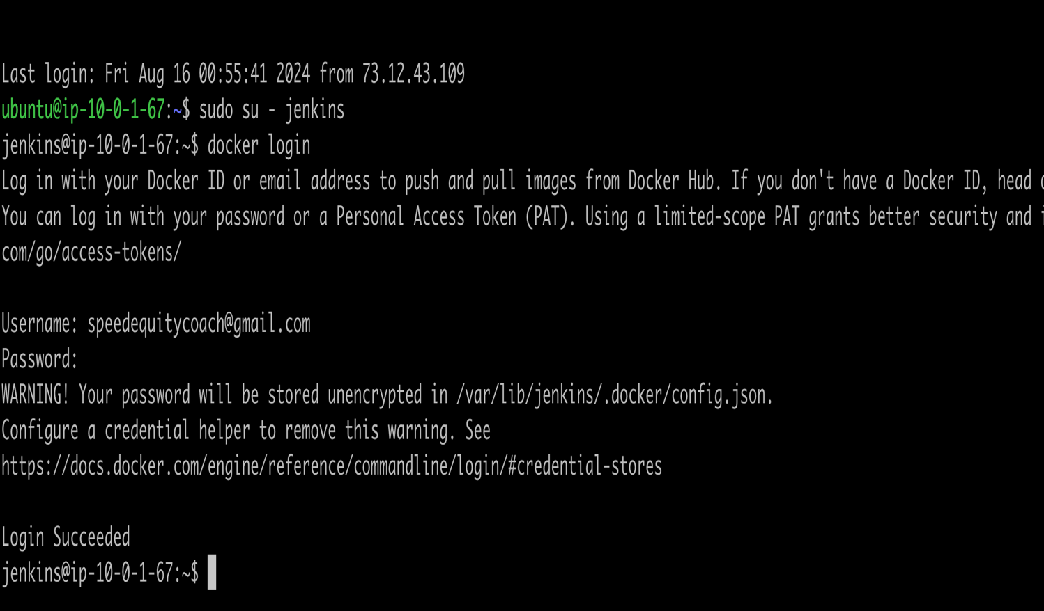

1. Pipeline Console Result
   1. A screenshot of a computer

      Description automatically generated
2. My Dockerhub

