TIMCI Pragmatic Cluster RCT Monitoring Report

Swiss Tropical and Public Health Institute

16 Februar, 2021

# 1. Introduction

This report covers the period from **2021-02-03** to **2021-02-09**.

# 2. Participants

## Number of children

|  |  |  |  |
| --- | --- | --- | --- |
|  | all (N = 14) | 0-2 months (N = 2) | 2-59 months (N = 12) |
| **Age eligibility** |  |  |  |
| 0 - 59 months | 11 (78.57%) | 2 (100.00%) | 9 (75.00%) |
| First day of life | 1 (7.14%) | 1 (50.00%) | 0 (0.00%) |
| **Visit eligibility** |  |  |  |
| Sick child | 7 (50.00%) | 1 (50.00%) | 6 (50.00%) |
| Inpatient admission | 1 (7.14%) | 0 (0.00%) | 1 (8.33%) |
| Trauma | 1 (7.14%) | 0 (0.00%) | 1 (8.33%) |
| Immunisation | 1 (7.14%) | 1 (50.00%) | 0 (0.00%) |
| Monitoring | 1 (7.14%) | 0 (0.00%) | 1 (8.33%) |
| **Multiple enrolments** |  |  |  |
| Previous enrolment | 1 (7.14%) | 0 (0.00%) | 1 (8.33%) |
| Last enrolment < 28 days | 1 (7.14%) | 0 (0.00%) | 1 (8.33%) |
| **Consenting process outcome** |  |  |  |
| Enrolled | 5 (35.71%) | 1 (50.00%) | 4 (33.33%) |

## Number of visits

|  |  |
| --- | --- |
| Visit | N |
| Screening | 14 |
| Baseline visit | 5 |
| Repeat visit | 1 |
| Day 7 phone call | 5 |
| Day 28 phone call | 0 |
| All | 19 |

## Number of participant withdrawn

## Submissions per day

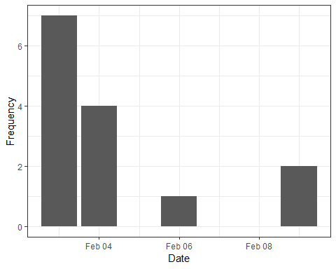

### Enrolment versus global target

### Enrolment versus weekly target

### Enrolment rate

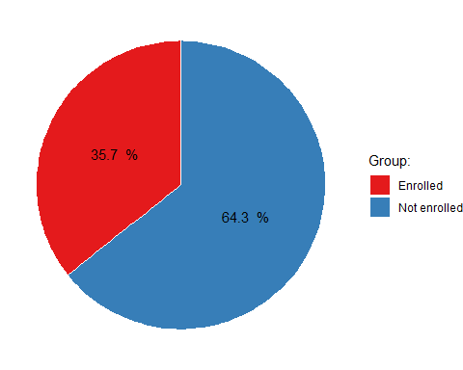

### Non-enrolment causes

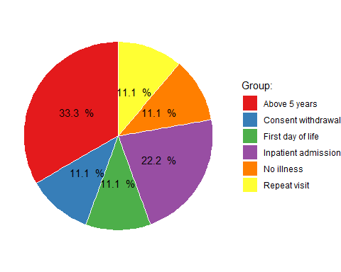

# 3. Baseline visit

## Referrals

|  |  |  |  |
| --- | --- | --- | --- |
|  | all (N = 5) | 0-2 months (N = 1) | 2-59 months (N = 4) |
| **Referral** |  |  |  |
| Caregiver | 2 (40.00%) | 0 (0.00%) | 2 (50.00%) |
| Registry / clinical notes | 2 (40.00%) | 0 (0.00%) | 2 (50.00%) |
| Inpatient admission | 0 (0.00%) | 0 (0.00%) | 0 (0.00%) |

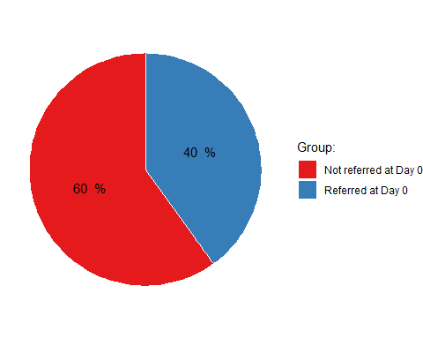

# 4. Day 7 follow-up

|  |  |
| --- | --- |
|  | all (N = 5) |
| **Successful call** |  |
| Successful call | 4 (80.00%) |
| **Child location** |  |
| Home | 1 (20.00%) |
| Hospitalised | 1 (20.00%) |
| Deceased | 1 (20.00%) |
| **Cure** |  |
| Complete recovery | 1 (20.00%) |
| Improving | 1 (20.00%) |
| Same as a week ago | 0 (0.00%) |
| Worse than a week ago | 1 (20.00%) |

# 5. Hospital follow-up

# 6. Day 28 follow-up