LAB 1
Talend Open Studio for Data Integration

Data Integration
Data integration is the process of combining data from several different sources in a unified view, making it more actionable and valuable to those accessing it. Successful data integration combines speed and integrity at scale — so that organizations can meet the demands of their business today, with data they can trust, and keep up with new innovations and the exponential growth in data. There is no universal approach to data integration. However, integration solutions generally involve a few common elements, including a network of data sources, a master server, and clients accessing data from the master server. In a typical data integration process, the client sends a request to the master server for data. The master server then intakes the needed data from internal and external sources. The data is extracted from the sources, then combined in a cohesive, unified form. This is served back to the client

Talend
Talend is an ETL tool for Data Integration. It provides software solutions for data preparation, data quality, data integration, application integration, data management and big data. Talend has a separate product for all these solutions. Data integration and big data products are widely used. This tutorial helps you to learn all the fundamentals of Talend tool for data integration and big data with examples.
ETL
ETL (or Extract, Transform, Load) is a process of data integration that encompasses three steps — extraction, transformation, and loading. In a nutshell, ETL systems take large volumes of raw data from multiple sources, converts it for analysis, and loads that data into your warehouse. Let's cover the three primary ETL steps.

Extraction
In the first step, extracted data sets come from a source (e.g., Salesforce, Google AdWords, etc.) into a staging area. The staging area acts as a buffer between the data warehouse and the source data. Since data may be coming from multiple different sources, it's likely in various formats, and directly transferring the data to the warehouse may result in corrupted data. The staging area is used for data cleansing and organization.
A big challenge during the data extraction process is how your ETL tool handles structured and unstructured data. All of those unstructured items (e.g., emails, web pages, etc.) can be difficult to extract without the right tool, and you may have to create a custom solution to assist you in transferring unstructured data if you chose a tool with poor unstructured data capabilities.

Transformation
The data cleaning and organization stage is the transformation stage. All of that data from multiple source systems will be normalized and converted to a single system format — improving data quality and compliance. ETL yields transformed data through these methods:
- Cleaning
- Filtering
- Joining
- Sorting
- Splitting
- Deduplication
- Summarization

Loading
Finally, data that has been extracted to a staging area and transformed is loaded into your data warehouse. Depending upon your business needs, data can be loaded in batches or all at once. The exact nature of the loading will depend upon the data source, ETL tools, and various other factors.

Working with projects

Creating a project
A project is the highest physical structure for storing all different types of items. Once you launch your Talend Studio and before you start a Business Model, a data integration Job, a Route, or any other tasks, you need first create or import a project.

Creating a project at initial Studio launch

Procedure
1. Launch Talend Studio and connect to a local repository.
2. On the login window, select the Create a new project option and enter a project name in the field.
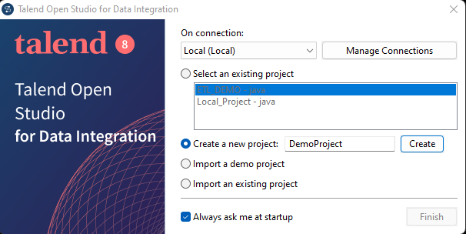
Note:
• A project name is case insensitive
• A project name must start with an English letter and can contain only letters, numbers, the hyphen (-), and the underscore (_)
• The hyphen (-) character is deemed as the underscore (_)
3. Click Finish to create the project and open it in the Studio.

Creating a new project after initial Studio launch
About this task
To create a new local project after the initial startup of the Studio, do the following: Procedure 1. On the login window, select the Create a new project option and enter a project name in the field.
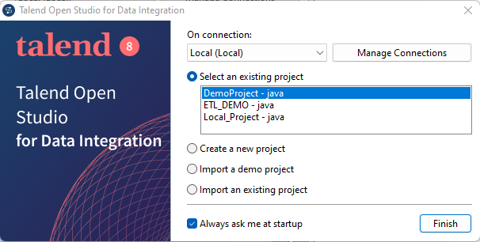
2. Click Create to create the project. The newly created project is displayed on the list of existing projects.
3. Select the project on the list and click Finish to open the project in the Studio. Later, if you want to switch between projects, on the Studio menu bar, use the combination File > Switch Project or Workspace

Designing Jobs
What is a Job design?
A Job Design is the runnable layer of a business model. It is a graphical design, of one or more components connected together, that allows you to set up and run dataflow management processes. A Job Design translates business needs into code, routines and programs, in other words it technically implements your data flow. The Jobs you design can address all of the different sources and targets that you need for data integration processes and any other related process.
When you design a Job in Talend Studio, you can:
• put in place data integration actions using a library of technical components.
• change the default setting of components or create new components or family of components to match your exact needs.
• set connections and relationships between components in order to define the sequence and the
nature of actions.
• access code at any time to edit or document the components in the designed Job.
• create and add items to the repository for reuse and sharing purposes (in other projects or Jobs or
with other users).

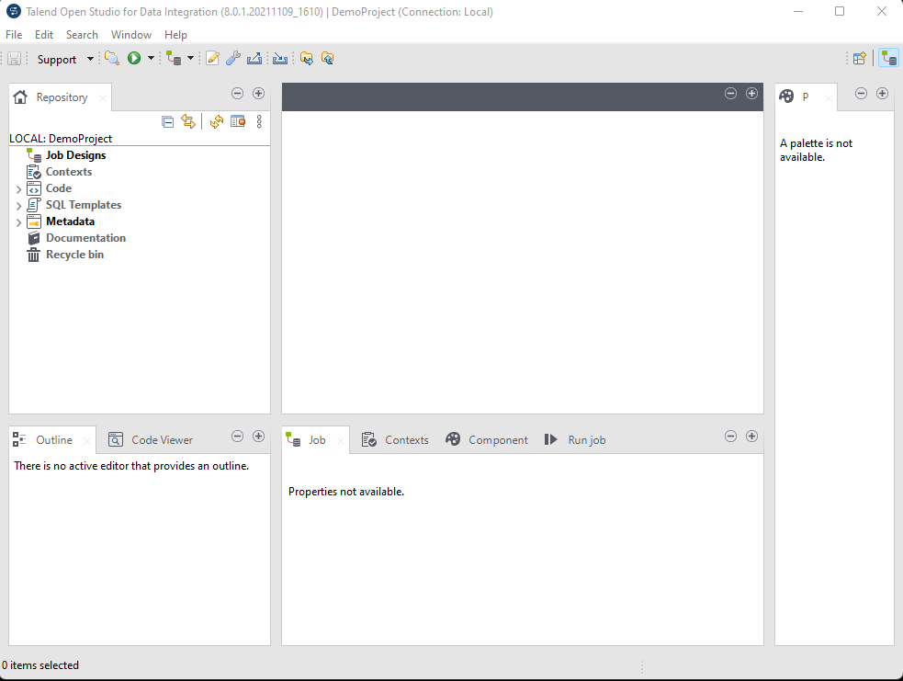

Creating a Job
Talend Studio enables you to create a Job by dropping different technical components from the Palette onto the design workspace and then connecting these components together.

About this task
To create the example Job described in this section, proceed as follows:
Procedure
In the Repository tree view of the Integration perspective, right-click the Job Designs node and select Create job from the contextual menu.
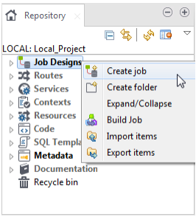

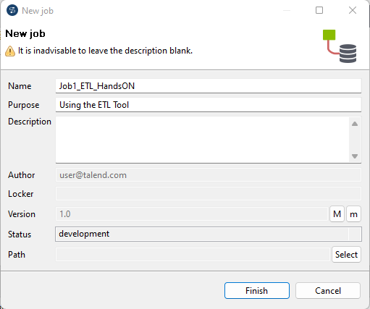
Fill the Job properties as shown in the previous screenshot.
The fields correspond to the following properties:
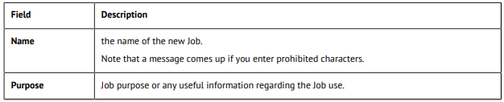
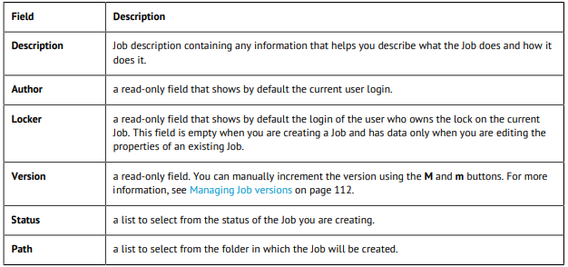
3. An empty design workspace opens up showing the name of the Job as a tab label.
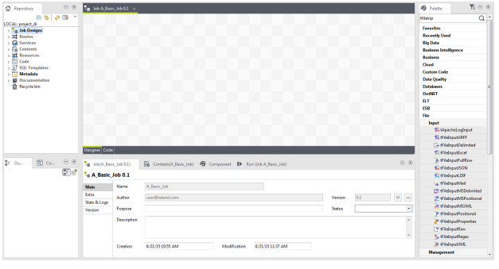

Results
The Job you created is now listed under the Job Designs node in the Repository tree view.
You can open one or more of the created Jobs by simply double-clicking the Job label in the
Repository tree view.

Introduction to Components:

tFileInputDelimited
Reads a delimited file row by row to split them up into fields and then sends the fields as defined in the schema to the next component.

Configuring the components

Procedure
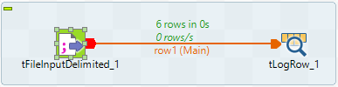
- Select the tFileInputDelimited component again, and define its Basic settings:
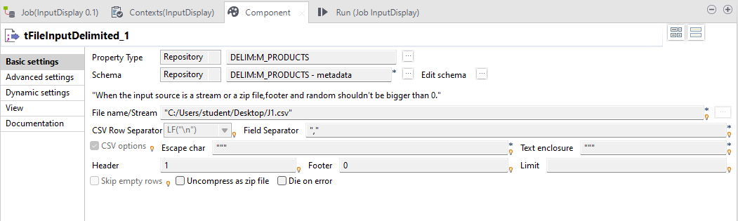
Fill in a path to the file in the File Name field. This field is mandatory.
- Define the Row separator allowing to identify the end of a row. Then define the Field separator used to delimit fields in a row.
- In this scenario, the header and footer limits are not set. And the Limit number of processed rows is set on 50.
- Set the Schema as remotely managed (Repository) to define the data to pass on to the tLogRow component.
- You can load and/or edit the schema via the Edit Schema function.
- Enter the encoding standard the input file is encoded in. This setting is meant to ensure encoding consistency throughout all input and output files.
- Select the tLogRow and define the Field separator to use for the output display.
- Select the Print schema column name in front of each value check box to retrieve the column labels in the output displayed.

Saving and executing the Job

Procedure
- Press Ctrl+S to save your Job.
- Go to Run tab, and click on Run to execute the Job.
The file is read row by row and the extracted fields are displayed on the Run log as defined in both components Basic settings.
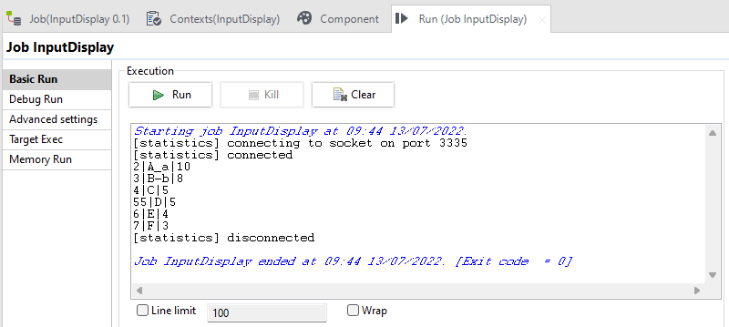

2. tLogRow:
Displays data or results in the Run console to monitor data processed.
3. tFileOutputDelimited, tMap:
Outputs the input data to a delimited file according to the defined schema.

Writing data in a delimited file
This scenario describes a three-component Job that extracts certain data from a file holding information about clients, customers, and then writes the extracted data in a delimited file.
In the following example, we have already stored the input schema under the Metadata node in the Repository tree view.

Procedure
- In the Repository tree view, expand Metadata and File delimited in succession and then browse to your input schema, customers, and drop it on the design workspace. A dialog box displays where you can select the component type you want to use.
- Click tFileInputDelimited and then OK to close the dialog box. A tFileInputDelimited component holding the name of your input schema appears on the design workspace.
- Drop a tMap component and a tFileOutputDelimited component from the Palette to the design workspace.
- Link the components together using Row > Main connections.
- Configure the input component. Refer tInputDelimited.

Configuring the mapping component :
  - In the design workspace, double-click tMap to open its editor.
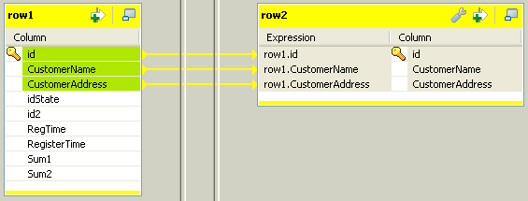
  - In the tMap editor, click on top of the panel to the right to open the Add a new output table dialog box.
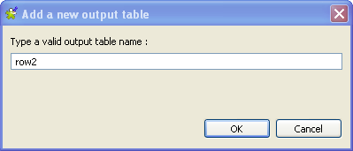
3. Enter a name for the table you want to create, row2 in this example.
4. Click OK to validate your changes and close the dialog box.
5. In the table to the left, row1, select the first three lines (Id, CustomerName and CustomerAddress) and drop them to the table to the right
6. In the Schema editor view situated in the lower left corner of the tMap editor, change the type of RegisterTime to String in the table to the right.
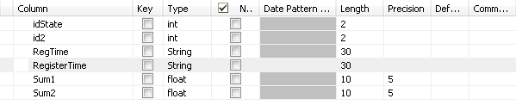
7. Click OK to save your changes and close the editor.

Configuring the output component

Procedure
- In the design workspace, double-click tFileOutputDelimited to open its Basic settings view and define the component properties.
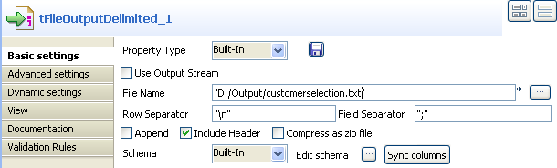
- In the Property Type field, set the type to Built-in and fill in the fields that follow manually.
- Click the [...] button next to the File Name field and browse to the output file you want to write data in, customerselection.txt in this example.
- In the Row Separator and Field Separator fields, set "\n" and ";" respectively as row and field separators.
- Select the Include Header check box if you want to output columns headers as well.
- Click Edit schema to open the schema dialog box and verify if the recuperated schema corresponds to the input schema. If not, click Sync Columns to recuperate the schema from the preceding component.

7. Press Ctrl+S to save your Job, Press F6 or click Run on the Run tab to execute.

4. tFilterRow:

Filtering a list of names through different logical operations
Based on the previous scenario, this scenario further filters the input data so that only those records of people from New York and Chicago are accepted. Without changing the filter settings defined in the previous scenario, advanced conditions are added in this scenario to enable both logical AND and logical OR operations in the same tFilterRow component.

Procedure
- Double-click the tFilterRow component to show its Basic settings view.
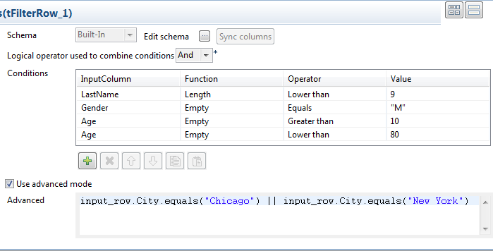

2. Select the Use advanced mode check box, and type in the following expression in the text field:
input_row.City.equals("Chicago") || input_row.City.equals("New York")

This defines two conditions on the City column of the input data to filter records that contain the cities of Chicago and New York, and uses a logical OR to combine the two conditions so that records satisfying either condition will be accepted.

3. Press Ctrl+S to save the Job and press F6 to execute it

5. tAggregateRow, tSortRow:

Aggregating values and sorting data
This example shows you how to use Talend components to aggregate the students'

Creating a Job for aggregating and sorting data

Create a Job to aggregate the students' comprehensive scores using the tAggregateRow component, then sort the aggregated data using the tSortRow component, finally display the aggregated and sorted data on the console.

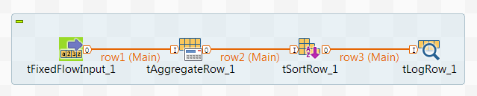Procedure
- Create a new Job and add a tFixedFlowInput component, tAggregateRow component, a tSortRow component, and a tLogRow component by typing their names in the design workspace or dropping them from the Palette.
- Link the tFixedFlowInput component to the tAggregateRow component using a Row > Main connection.
- Do the same to link the tAggregateRow component to the tSortRow component, and the tSortRow component to the tLogRow component.

Configuring the Job for aggregating and sorting data
Configure the Job to aggregate the students' comprehensive scores using the tAggregateRow component and then sort the aggregated data using the tSortRow component.

Procedure
- Double-click the tFixedFlowInput component to open its Basic settings view.
- Click the button next to Edit schema to open the schema dialog box and define the schema by adding two columns, name of String type and score of Double type. When done, click OK to save the changes and close the schema dialog box.
- In the Mode area, select Use Inline Content (delimited file) and in the Content field displayed, enter the following input data:
- Peter;92
- James;93
- Thomas;91
- Peter;94
- James;96
- Thomas;95
- Peter;96
- James;92
- Thomas;98
- Peter;95
- James;96
- Thomas;93
- Peter;98
- James;97
Thomas;95
- Double-click the tAggregateRow component to open its Basic settings view.
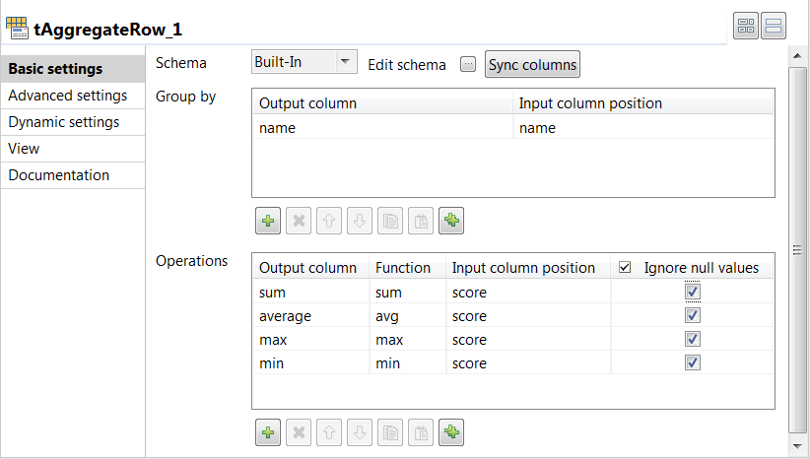
- Click the button next to Edit schema to open the schema dialog box and define the schema by adding five columns, name of String type, and sum, average, max, and min of Double type.
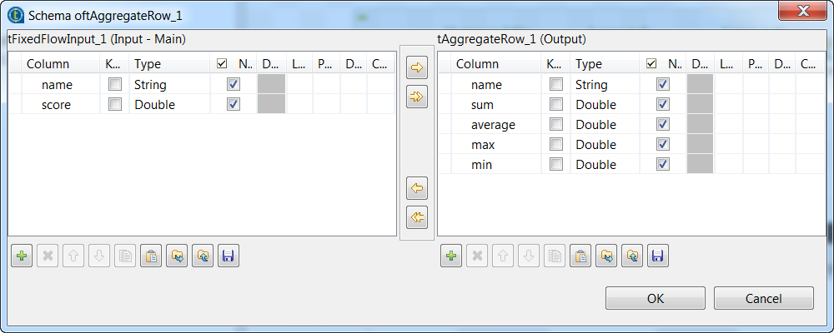
When done, click OK to save the changes and close the schema dialog box.
- Add one row in the Group by table by clicking the button below it, and select name from both the Output column and Input column position column fields to group the input data by the name column.
- Add four rows in the Operations table and define the operations to be carried out. In this example, the operations are sum, average, max, and min. Then select score from all four Input column position column fields to aggregate the input data based on it.
- Double-click the tSortRow component to open its Basic settings view.
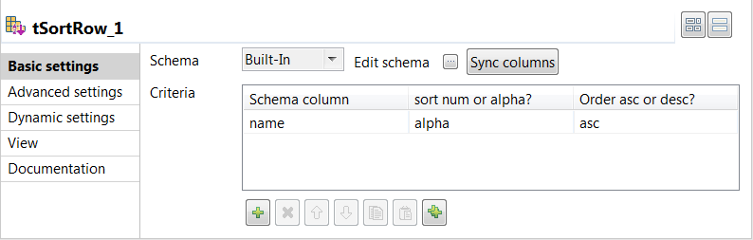
- Add one row in the Criteria table and specify the column based on which the sort operation is performed. In this example, it is the name column. Then select alpha from the sort num or alpha? column field and asc from the Order asc or desc? column field to sort the aggregated data in ascending alphabetical order.
- Double-click the tLogRow component to open its Basic settings view, and then select Table (print values in cells of a table) in the Mode area for better readability of the result.

Executing the Job to aggregate and sort data
After setting up the Job and configuring the components used in the Job for aggregating and sorting data, you can then execute the Job and verify the Job execution result.

Procedure
- Press Ctrl + S to save the Job.
- Press F6 to execute the Job.

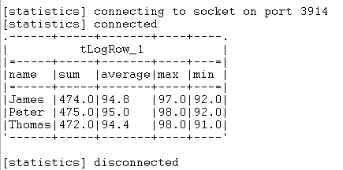

Results
As shown above, the students' comprehensive scores are aggregated and then sorted in ascending alphabetical order based on the student names.
6. tReplace, tFilterColumns:
This Job searches and replaces various typos and defects in a csv file then operates a column filtering before producing a new csv file with the final output.
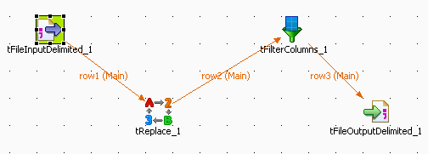
- The File is a simple csv file stored locally. The Row Separator is a carriage return and the Field Separator is a semi-colon. In the Header is the name of the column, and no Footer nor Limit are to be set.
- The file contains characters such as: *t, . or Nikson which we want to turn into Nixon, and streat, which we want to turn into Street.
- 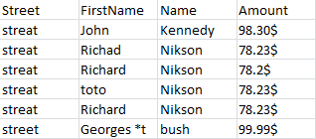
The schema for this file is built in also and made of four columns of various types (string or int).
- Now select the tReplace component to set the search & replace parameters.
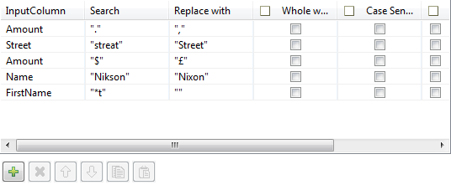
- Select the next component in the Job, tFilterColumn.
- 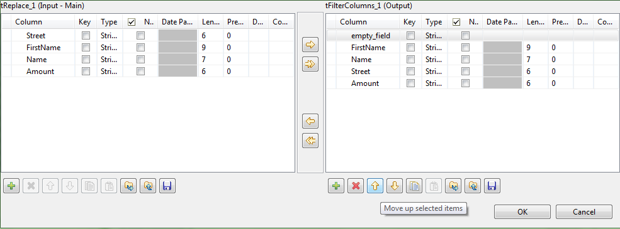
The tFilterColumn component holds a schema editor allowing to build the output schema based on the column names of the input schema. In this use case, add one new column named empty_field and change the order of the input schema columns to obtain a schema as follows: empty_field, Firstname, Name, Street, Amount.
- Click OK to validate.
- 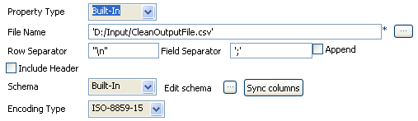
Set the tFileOutputDelimited properties manually.
- The schema is built-in for this scenario, and comes from the preceding component in the Job.
- Save the Job and press F6 to execute it.
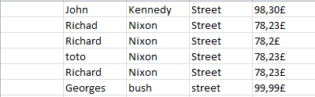
The first column is empty, the rest of the columns have been cleaned up from the parasitical characters, and Nikson was replaced with Nixon. The street column was moved and the decimal delimiter has been changed from a dot to a comma, along with the currency sign.
Lab Exercise:
- Explore and write the uses of the following components used for ETL
  - tFileInputDelimited
  - tLogRow:
  - tFileOutputDelimited
  - tMap:
  - tAggregateRow
  - tSortRow
  - tReplace
  - tFilterColumns
  - tUniqrow
  - tFileExists
  - tReplicate
- Explore the options/components used for ETL in Talend.
LAB2
Executing scenarios using TALEND

Adding components to the Job
Now that the Job is created, components have to be added to the design workspace, a tFileInputDelimited, a tLogRow, and a tFileOutputDelimited in this example.
There are several ways to add a component onto the design workspace. You can:
• find your component on the Palette by typing the search keyword(s) in the search field of the Palette and drop it onto the design workspace.
• add a component by directly typing your search keyword(s) on the design workspace.
• add an output component by dragging from an input component already existing on the design
workspace.
• drag and drop a centralized metadata item from the Metadata node onto the design workspace,
and then select the component of interest from the Components dialog box.

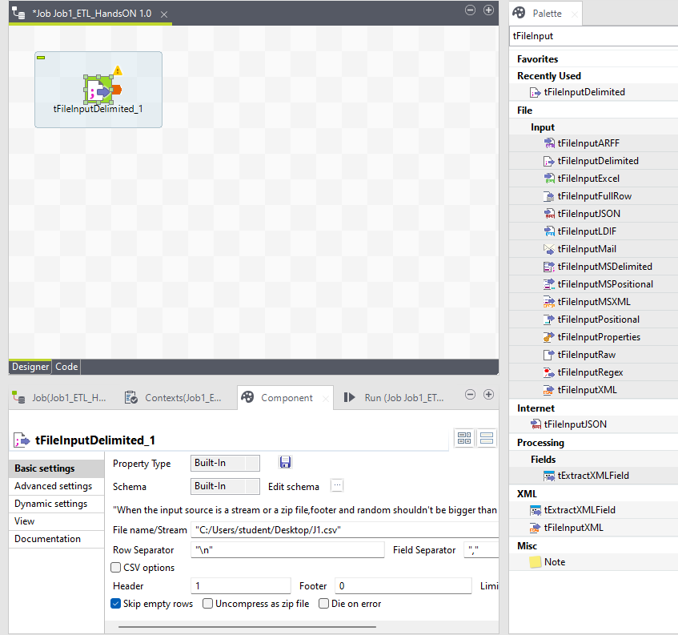

Connecting the components together
Now that the components have been added on the workspace, they have to be connected together. Components connected together form a subJob. Jobs are composed of one or several subJobs carrying out various processes.
In this example, as the tLogRow and tFileOutputDelimited components are already connected, you only need to connect the tFileInputDelimited to the tLogRow component.
To connect the components together, use either of the following methods:
Right-click and click again
Procedure
1. Right-click the source component, tFileInputDelimited in this example.
2. In the contextual menu that opens, select the type of connection you want to use to link the
components, RowMain in this example.
3. Click the target component to create the link, tLogRow in this example.
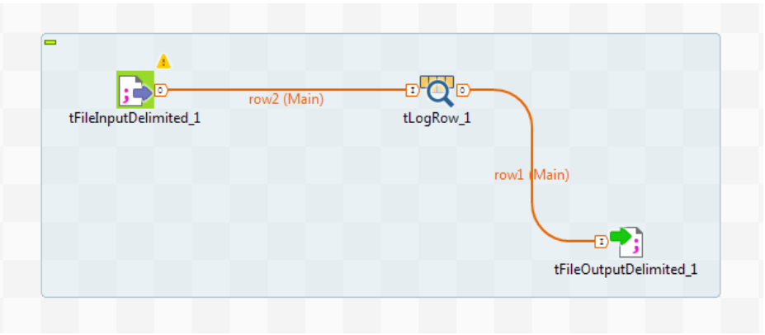

Configuring the components
Now that the components are linked, their properties should be defined.
Configuring the tFileInputDelimited component

Procedure
- Double-click the tFileInputDelimited component to open its Basic settings view
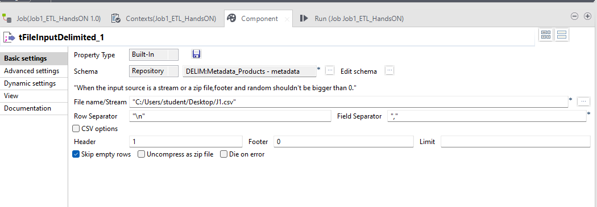
2. Click the [...] button next to the File Name/Stream field.
3. Browse your system or enter the path to the input file, customers.txt in this example.
4. In the Header field, enter 1.
5. Click the [...] button next to Edit schema.
6. In the Schema Editor that opens, click three times the [+] button to add three columns.
7. Name the three columns id, CustomerName and CustomerAddress respectively and click OK to close the editor.
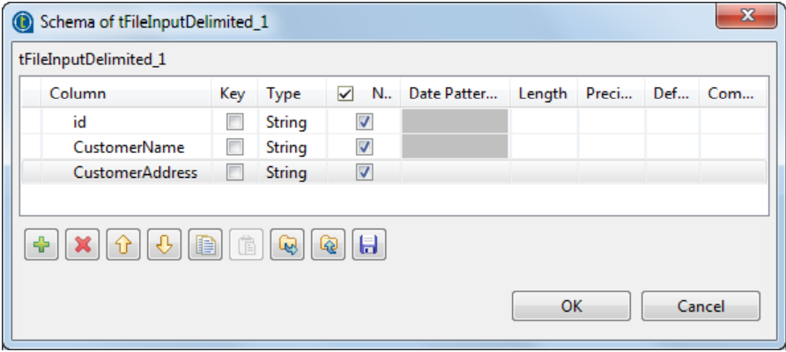
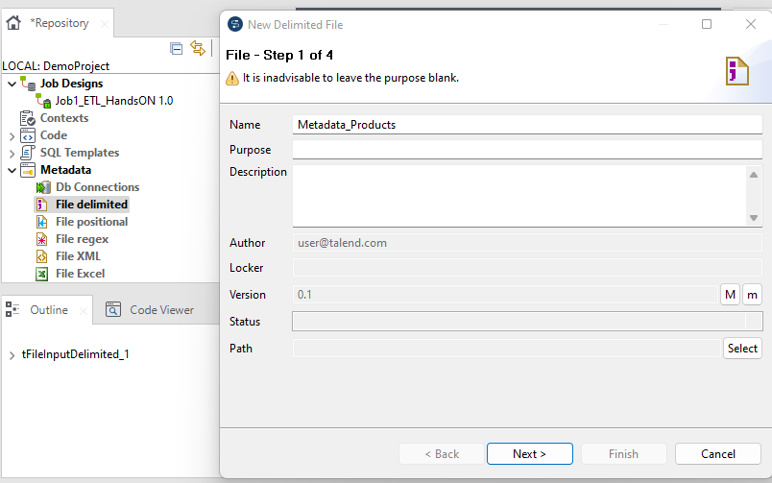
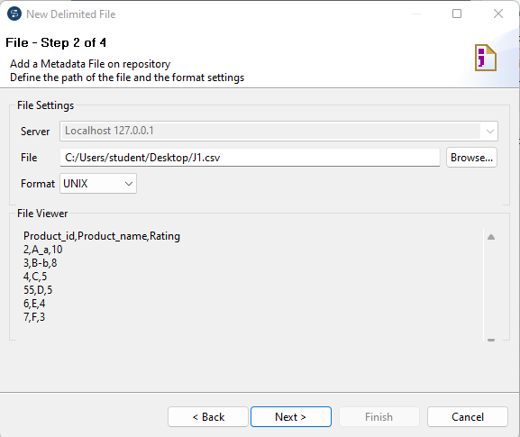
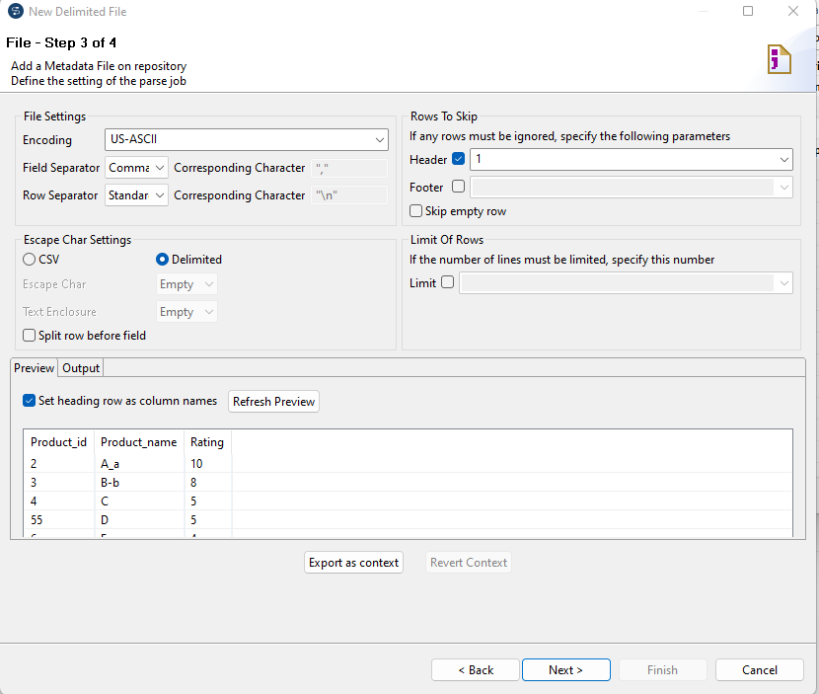

Lab Exercise:
Consider the Schema given below and create job design for each of the following:
Student (Regno, Name, Major, Bdate)
Course (Course_ID, Cname, dept)
Enroll (RegNo, Course_ID, marks)
Book_Adoption (Course_ID, sem, ISBN)
Text (book_ISBN, title, publisher, author)
    - Display the course names taken by students of ICT department.
    - Find whether ICT department has taken up any course which needs books with ISBN=1111.
    - Find names of students who have scored more than 90 in the course of ‘Compilers’
    - Find the departments which provides Major.
    - Find the departments which does not use textbooks of ‘Wiley’ publisher.
    - Display names of the students who have registered for courses for which more than 10 students have registered.
    - Display the departments which uses more than 2 books of author ‘Ken’
    - Find the department which has incorporated textbook by a single publisher.
    - Find course which has maximum number of students.
    - Find the total marks of each student in all courses.

Additional Exercise

Consider the Schema given below and create job design for each of the following:
PERSON (driver _ id , name, address)
CAR (Regno, model, year)
ACCIDENT (report_number, date, location)
OWNS (driver-id, Regno)
PARTICIPATED (driver-id, Regno , report_number, damage)

    - Select registration number of cars which do not come in between the model year 2000 and 2010.
    - Find driver names whose sum of damage amount of all his accidents is less than average
    - damage amount of all accidents in the database.
    - Find driver names whose sum of damage amount of all his accidents is less than average damage amount of all accidents in database.
    - Find driver ids’ who have met with accident more than once but with different cars owned by him and damage amount is greater than Rs.50000.
    - Find driver id of persons with name ‘john’.

