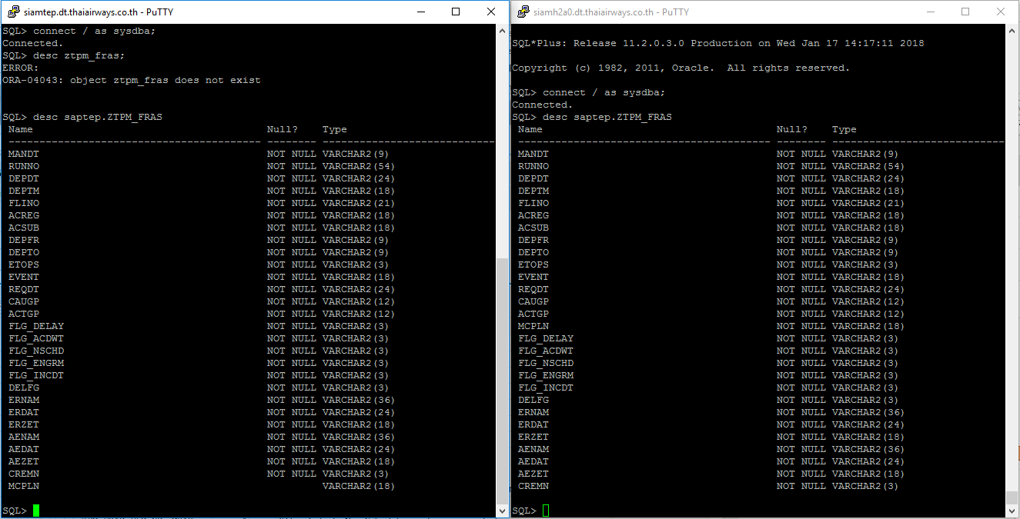

SQL> alter table saptep.ZTPM_FRAS modify (MCPLN NULL);

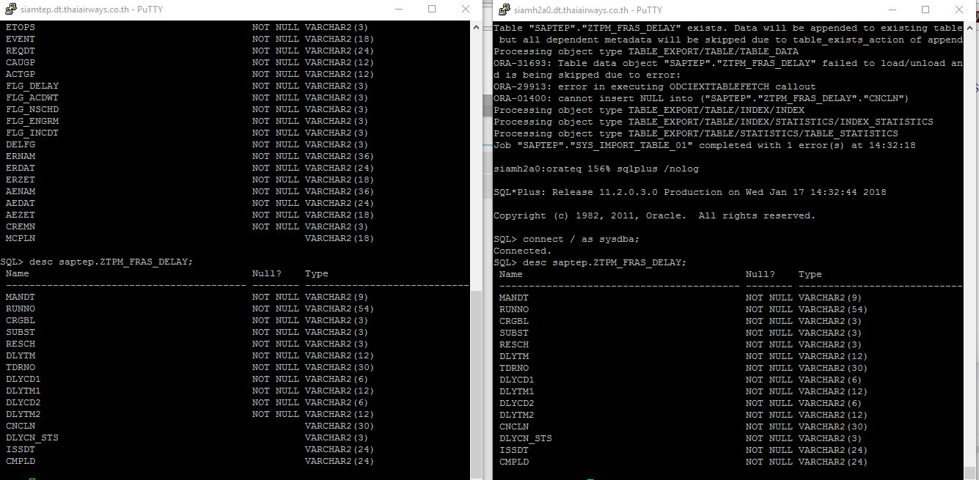

SQL> alter table saptep.ZTPM_FRAS_DELAY

2 modify (CNCLN NULL, DLYCN_STS NULL, ISSDT NULL, CMPLD NULL);

Table altered.

SQL> commit;

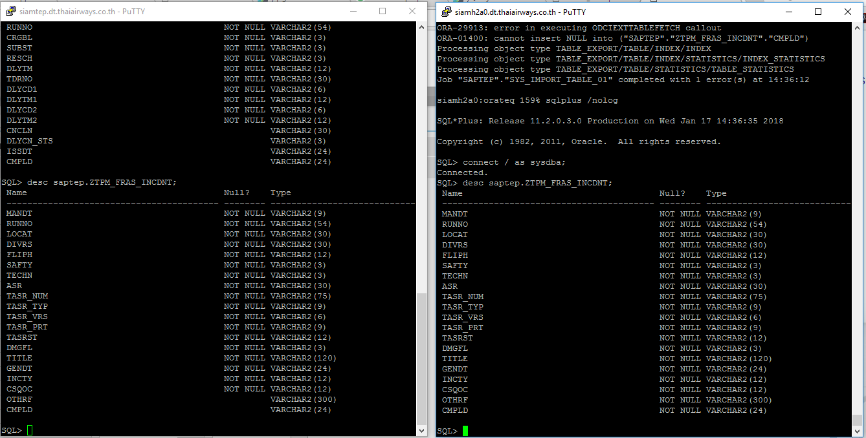

SQL> alter table saptep.ZTPM_FRAS_INCDNT

2 modify (OTHRF NULL, CMPLD NULL);

Table altered.

SQL> commit;

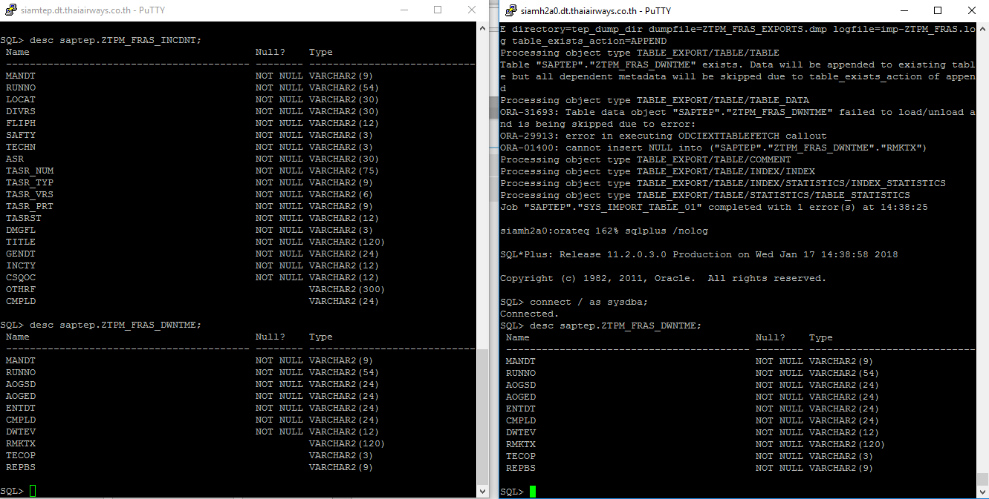

SQL> alter table saptep.ZTPM_FRAS_DWNTME

2 modify (RMKTX NULL,TECOP NULL,REPBS NULL);

Table altered.

SQL> commit;