Customer Shopping Behaviour
End-to-End Data Analysis Project

Python · SQL · Power BI

Prepared by: Prashanth
March 2026

1. Introduction

Understanding customer shopping behaviour is essential for making informed business decisions in the retail industry. By analysing what customers buy, when they purchase, and how much they spend, businesses can improve their product strategy, marketing efforts, and overall sales performance.

This analysis is based on a dataset of 3,900 customer transactions, capturing key details such as customer demographics, product categories, payment methods, discount usage, and customer ratings. The dataset generates approximately $233K in total revenue, providing a comprehensive view of customer shopping behaviour.

The objective is to transform this raw data into meaningful insights by identifying key patterns and trends in customer behaviour. These insights are then presented through a clear and interactive Power BI dashboard, enabling stakeholders to make data-driven decisions with ease.

2. The Business Problem

The company is experiencing changes in customer shopping behaviour, including variations across age groups, product categories, and purchasing channels (online and offline). However, the key factors driving these changes are not clearly understood.
Due to this lack of clarity, the business is unable to effectively identify which customer segments contribute the most to revenue, what influences purchase decisions (such as discounts, seasons, and payment methods), and how customer behaviour differs across channels.
As a result, decision-making around marketing strategies, product offerings, and pricing is not fully optimised, limiting the company’s ability to maximise revenue and improve customer satisfaction.

3. Project Approach

This project was completed in three stages. Each stage builds on the previous one, moving from raw, messy data all the way to an interactive business dashboard.

Stage | What Was Done
Stage 1 — Python (Data Cleaning) | Loaded the raw dataset, fixed quality issues, and prepared it for analysis
Stage 2 — SQL (Business Analysis) | Wrote 12 queries to answer specific business questions from the data
Stage 3 — Power BI (Dashboard) | Built a visual dashboard so decision-makers can explore the findings easily

4. Python — Data Cleaning

Raw data is rarely perfect. Before we could run any analysis, we needed to make sure the dataset was clean, consistent, and complete. This work was done using Python and the pandas library.

4.1 What the Raw Data Looked Like
The original dataset had 3,900 rows and 18 columns. It contained information about each customer's age, gender, what they bought, how much they paid, where they were located, what season it was, their review rating, payment method, subscription status, shipping type, and more.

4.2 Problems Found in the Data
- 37 missing values found in the 'Review Rating' column — these were filled using the median rating within each product category, which is a fair and logical approach
- Column names had spaces and capital letters — these were standardised to lowercase with underscores to make SQL queries easier to write
- The 'Promo Code Used' column was found to be 100% identical to the 'Discount Applied' column — it was removed as it added no new information
- The 'Frequency of Purchases' column was removed as it was not needed for the planned analysis

4.3 New Feature Created
A new column called 'age_group' was created by grouping customer ages into four segments:
Age Group | Age Range
Teen | 19 years and below
Young | 20 – 35 years
Middle Age | 36 – 55 years
Senior | 56 years and above

This segmentation makes it much easier to compare spending patterns across different life stages.

4.4 Final Clean Dataset
After cleaning, the dataset had 3,900 rows and 16 columns — clean, complete, and ready for SQL analysis. The cleaned file was saved as a CSV and also loaded directly into a SQL Server database.

5. SQL — Business Questions & Answers

With the clean data loaded into SQL Server, 12 business questions were answered using structured SQL queries. Here is a summary of each question and what the data revealed.

Q1 — Which gender contributes the most revenue?
Gender | Total Customers | Total Revenue | Average Spend | Used Discount
Male | 2652 | $157,890 | $59 | 1677
Female | 1248 | $75,191 | $60 | 0

Male customers account for 2,652 out of 3,900 total customers (~68%) and generate the majority of revenue ($157,890 vs. $75,191). However, female customers have a slightly higher average spend per order ($60 vs. $59).
This indicates that, while male customers contribute more through higher purchase volume and more frequent discount use (1,677 users), female customers tend to spend slightly more per transaction. This suggests an opportunity to increase revenue by targeting female customers with personalised offers or incentives, as they already show strong spending potential.

Q2 — Which age group generates the highest revenue?
Age Group | Total Revenue
Middle Age (36–55) | $88,853
Young (20–35) | $69,892
Senior (56+) | $65,256
Teen (≤19) | $9,080

Middle-aged customers (36–55) generate the highest revenue at $88,853, making them the most valuable segment for the business. Young customers (20–35) follow with $69,892, showing strong purchasing activity and future growth potential. Senior customers (56+) contribute $65,256, indicating a stable but slightly lower spending pattern.

Q3 — Do subscribed customers spend more?
Subscription Status | Total Customers | Total Revenue | Avg Spend
No (Non-subscribed) | 2,847 | $170,434 | $59
Yes (Subscribed) | 1,053 | $62,645 | $59.

Non-subscribed customers contribute the majority of total revenue ($170,434) compared to subscribed customers ($62,645), primarily due to their significantly larger customer base (2,847 vs. 1,053).
However, the average spend per transaction is nearly identical for both groups ($59), indicating that subscription status does not significantly influence how much a customer spends per purchase. Instead, the difference in total revenue is driven by customer volume rather than spending behaviour.

Q4 — Which season drives the highest revenue?
Season | Total Revenue
Fall | $60,018
Spring | $58,679
Summer | $58,607
Winter | $55,777

Revenue is relatively evenly distributed across all four seasons, with Fall generating the highest revenue ($60,018) and Winter the lowest ($55,777). The overall difference is minimal (around $3,500), indicating that the business does not rely heavily on any single season.
This balanced performance suggests a stable and consistent demand throughout the year, which is a positive sign for long-term sustainability.

Q5 — Which payment method generates the most revenue?
Payment Method | Total Revenue
PayPal | $40,310
Credit Card | $40,109
Cash | $40,002
Venmo | $38,742
Bank Transfer | $37,374
Debit Card | $36,544

Revenue is distributed quite evenly across all payment methods, with PayPal generating the highest revenue ($40,310), closely followed by Credit Card ($40,109) and Cash ($40,002). Other methods like Venmo, Bank Transfer, and Debit Card also contribute similar revenue levels.
This balanced distribution indicates that customers are comfortable using multiple payment options, and no single method is acting as a barrier to purchase. It reflects a well-optimised payment ecosystem that supports diverse customer preferences.

Q6 — Which age groups use discounts the most?
Age Group | Discount Users (%)
Young | 43.68 %
Senior | 43.35 %
Middle Age | 42.38 %
Teen | 41.33 %

Discount usage is consistent across all age groups, with approximately 41–44% of customers in each segment using discounts. Young customers show the highest usage (43.68%), followed closely by Seniors (43.35%) and Middle-aged customers (42.38%), while Teens have slightly lower usage (41.33%).
This minimal variation indicates that discounts appeal broadly to all age groups rather than being driven by any specific segment. It suggests that discount strategies are universally effective across the customer base.

Q7 — Top 5 items by average customer rating
Rank | Item | Average Rating
1 | Gloves | 3.86
2 | Sandals | 3.84
3 | Boots | 3.82
4 | Hat | 3.80
5 | Hand Bag | 3.79

The top 5 items by average customer rating show very consistent satisfaction levels, with ratings ranging from 3.79 to 3.86. Gloves rank highest with an average rating of 3.86, followed closely by Sandals (3.84) and Boots (3.82). Hat and Hand Bag also maintain strong ratings at 3.80 and 3.79, respectively.
Overall, customer satisfaction is stable across these top-performing products, with no significant drop in ratings. This indicates good and consistent product quality across the catalogue.

Q8 — Top item in each product category
Category | Top Item | Purchase Count
Clothing | Blouse | 171
Accessories | Jewellery | 171
Footwear | Sneakers | 160
Outerwear | Jacket | 163
The top-performing items in each product category highlight customer preferences across segments. In Clothing, the Blouse leads with 171 purchases, while Jewellery dominates Accessories with 171 purchases as well. In Outerwear, Jackets record 163 purchases, and in Footwear, Sneakers lead with 160 purchases.
These results indicate that a few key products drive the majority of sales within each category, making them critical for inventory planning, promotions, and marketing focus.

Q9 — In which categories do discounts have the most impact on orders and revenue?
Category | Discount Applied | Order | Revenue | Average Spend
Accessories | No | 697 | $42,440 | $60
Accessories | Yes | 543 | $31,760 | $58
Clothing | No | 1006 | $60,585 | $60
Clothing | Yes | 731 | $43,679 | $59
Footwear | No | 340 | $20,087 | $59
Footwear | Yes | 259 | $16,006 | $61
Outerwear | No | 180 | $10,558 | $58
Outerwear | Yes | 144 | $7,966 | $55

Discount usage is relatively consistent across all product categories, indicating that promotional offers are applied broadly rather than targeting specific categories. The average spend remains very similar between discounted and non-discounted orders across most categories, showing that discounts do not significantly increase the value of individual purchases.
Instead, the primary impact of discounts appears to be on purchase volume rather than basket size. However, since non-discounted orders still generate higher total orders and revenue in most categories, this suggests that discounts are not the main driver of sales and should be used strategically rather than universally.

Q10 — Which shipping types are most used?
Shipping Type | Total Orders | Total Revenue | Average Spend
Free Shipping | 675 | $40,234 | $60
Standard | 654 | $39,150 | $58
Store Pickup | 650 | $38,911 | $59
Next Day Air | 648 | $38,705 | $58
Express | 646 | $38,550 | $60
2-Day Shipping | 627 | $37,450 | $60

Shipping preferences are fairly evenly distributed, with Free Shipping leading slightly at 675 orders and $40,234 in revenue, followed closely by Standard Shipping and other options. The differences in total orders and revenue across shipping types are minimal.
Additionally, the average spend remains consistent across all shipping methods ($58–$60), indicating that delivery speed does not significantly influence how much customers spend per order.

Q11 — Top 10 locations by orders and revenue
Location | Total Orders | Revenue
Montana | 96 | $5,784
California | 95 | $5,605
Idaho | 93 | $5,587
Illinois | 92 | $5,617
Alabama | 89 | $5,261
Minnesota | 88 | $4,977
Nebraska | 87 | $5,172
Nevada | 87 | $5,514
New York | 87 | $5,257
Delaware | 86 | $4,758

These states consistently show higher order volumes and total revenue. Targeted marketing campaigns in these locations could yield strong returns.

Q12 — Which categories perform best in each season?
Season | Top Category | Revenue
Fall | Clothing | $26,220
Spring | Clothing | $26,500
Summer | Accessories | $19,800
Winter | Clothing | $25,900

Clothing is the dominant category in every season except Summer, where Accessories take the top spot. This makes intuitive sense — people buy sunglasses, bags, and accessories more in the warmer months. Winter also sees a natural spike in Outerwear.

Note:
These insights form the foundation for the Power BI dashboard, where key patterns and trends are visualised to support interactive and data-driven decision-making.

6. Power BI Dashboard

All of the SQL findings were brought together into a single interactive Power BI dashboard. The dashboard is designed to give decision-makers a full picture of the business at a glance — no technical knowledge required.
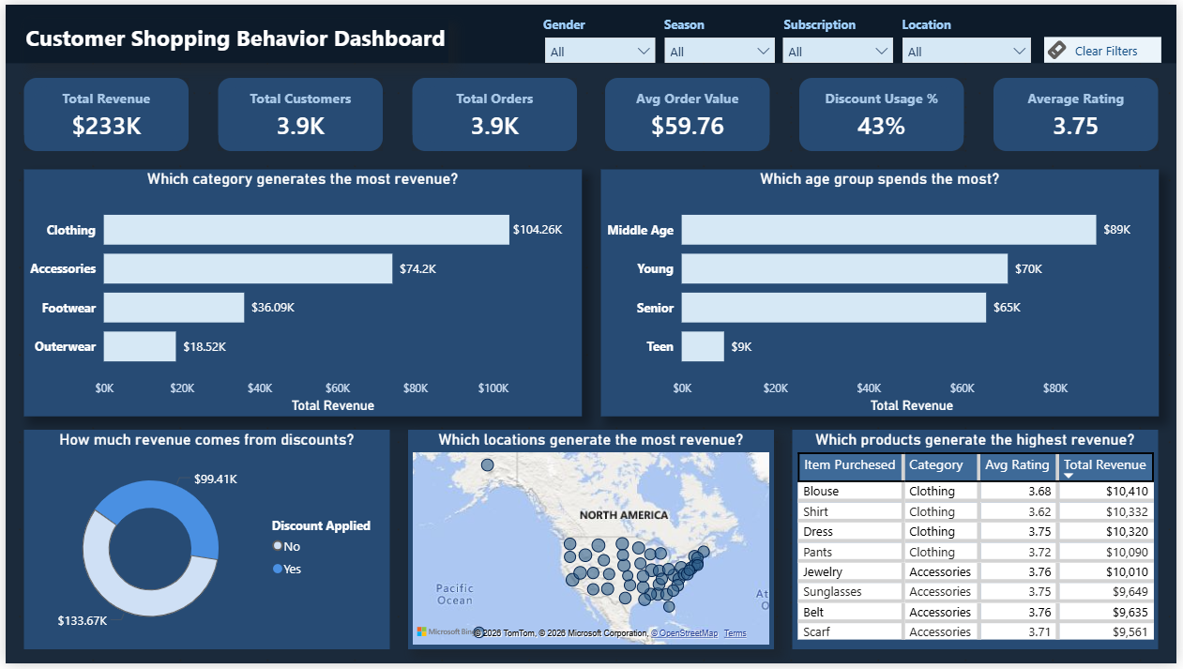

7. Key Findings
The analysis of 3,900 customer transactions generating approximately $233K in revenue highlights several key patterns and opportunities for business growth.

- Clothing is the top revenue-driving category, contributing the highest share of total sales and playing a critical role in overall business performance.
- Middle-aged customers (36–55) are the most valuable segment, generating the highest total revenue, followed by young adults who also show strong spending potential.
- Male customers account for ~68% of the customer base and drive most revenue, while female customers have a slightly higher average spend per order, indicating higher value per transaction.
- Discount usage contributes significantly to total revenue, but average spend remains similar with and without discounts — suggesting discounts impact purchase volume rather than basket size.
- Revenue is evenly distributed across all seasons, indicating stable demand with no strong seasonal dependency.
- Payment methods are used almost equally, showing that customers are comfortable with multiple payment options, and no single method dominates.
- Blouse is the most purchased item, while top-rated products show consistently high customer satisfaction (ratings ~3.8+), indicating good product quality overall.
- Subscription status does not influence spending per order, as both subscribed and non-subscribed customers have similar average spend — revenue differences are driven by customer count.
- All shipping methods perform similarly in terms of revenue and average spend, indicating that delivery speed does not significantly affect customer purchasing behaviour.

8. Recommendations

Based on the findings above, here are eight practical steps the business can take to grow revenue and serve customers better:

1. Focus on Middle-Aged Customers
Middle-aged customers (36–55) are the highest revenue contributors. The business should prioritise this segment through targeted campaigns, personalised recommendations, and loyalty programs to maximise retention and lifetime value.

2. Review the Discount Strategy
Discounts contribute significantly to total revenue, but they do not increase average order value. This suggests discounts drive volume rather than spending. The business should adopt a more strategic approach, such as conditional discounts (e.g., minimum purchase value or first-time buyers) to protect margins.

3. Invest More in Clothing and Accessories
Clothing and Accessories are the primary revenue drivers. These categories should be consistently well-stocked, prominently displayed, and central to marketing campaigns to sustain and grow sales.

4. Give Female Customers More Attention
Although female customers are fewer, they demonstrate a slightly higher average spend per order. Targeted marketing initiatives — such as personalised promotions and curated product offerings — can help increase their overall contribution to revenue.

5. Strengthen the Subscription Programme
Currently, subscription status does not influence customer spending. To improve effectiveness, the business should enhance the value proposition by offering exclusive benefits such as early access to sales, free shipping, or reward-based incentives to boost retention and engagement.

6. Target High-Revenue States
Certain states consistently generate higher orders and revenue. Concentrating marketing efforts, regional campaigns, and promotions in these high-performing areas can improve return on investment.

7. Build Summer Campaigns Around Accessories
Since revenue is evenly distributed across seasons, the business can implement targeted seasonal strategies. For example, promoting Accessories more aggressively during Summer can help maximise seasonal opportunities.

8. Promote Top-Rated Items Prominently
Top-selling and highly rated products (such as Blouse, Jewellery, Sneakers, and Jackets) should be prominently featured across digital platforms. Highlighting customer ratings and bestsellers can improve conversion rates through social proof.

9. Final Conclusion

This project transformed a raw and unstructured retail dataset into clear, actionable business insights — covering the full analytics lifecycle from data preparation in Python, to structured analysis in SQL, and finally to an interactive Power BI dashboard.

The findings indicate that the business is performing in a stable and healthy manner, with consistent revenue across seasons, payment methods, and customer segments. However, several high-impact opportunities have been identified, including strengthening engagement with middle-aged and female customers, enhancing the value of the subscription program, optimising discount strategies, and focusing on high-performing categories such as Clothing and Accessories.

The Power BI dashboard ensures that these insights are not confined to technical outputs but are presented in a visual and interactive format, enabling stakeholders to make informed, data-driven decisions.

Ultimately, the value of this analysis lies in its execution. The next step is to translate these insights into action by prioritising and implementing the recommended strategies, starting with the areas that offer the greatest potential impact on revenue and customer growth.

Appendix — Tools & Dataset Summary

Item | Detail
Dataset | customer_shopping_behaviour.csv
Total Records | 3,900 rows × 16 columns (after cleaning)
Data Cleaning Tool | Python 3 (pandas library)
Analysis Tool | SQL Server (T-SQL)
Visualisation Tool | Microsoft Power BI
Number of SQL Queries | 12 business queries covering all key areas
Missing Values Fixed | 37 missing Review Ratings (filled with category median)
Columns Removed | promo_code_used, frequency_of_purchases (redundant)
New Feature Added | age_group (Teen / Young / Middle Age / Senior)

