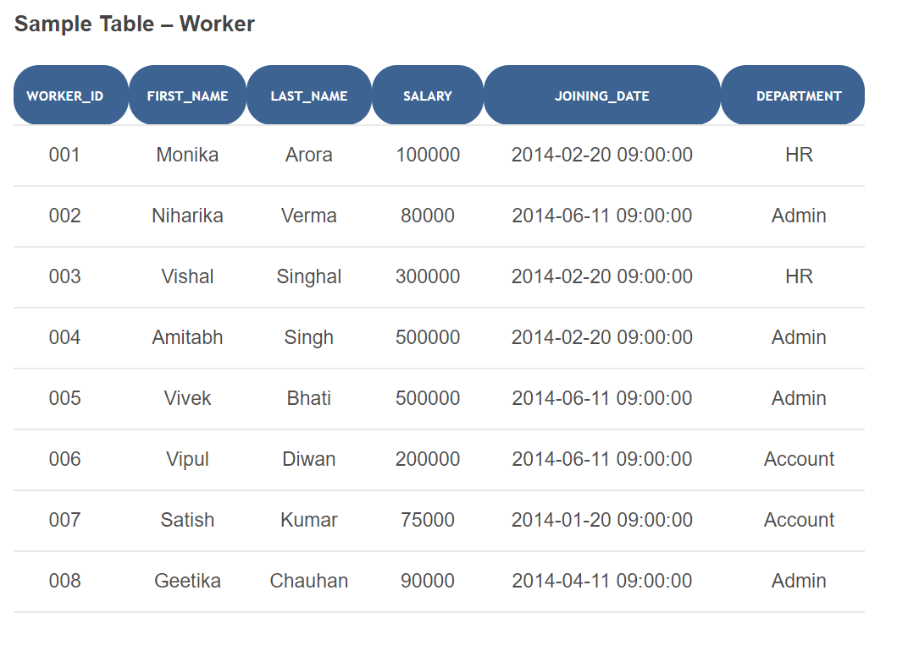

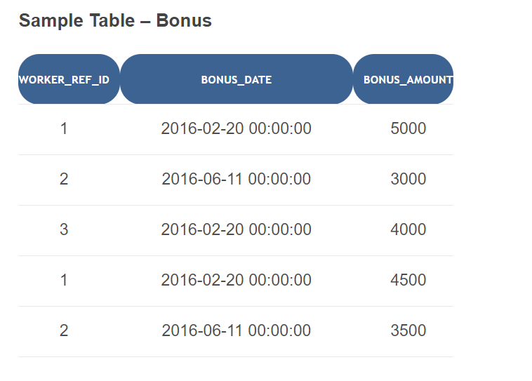

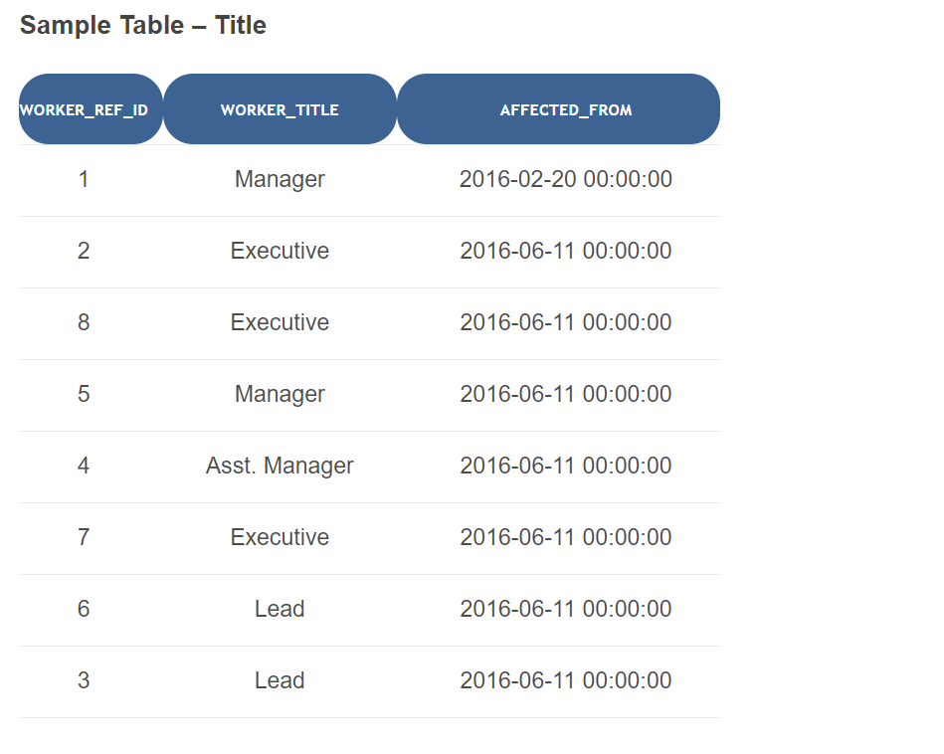

Q-1. Write an SQL query to fetch “FIRST_NAME” from Worker table using the alias name as <WORKER_NAME>.

Q-2. Write an SQL query to fetch “FIRST_NAME” from Worker table in upper case.

Q-3. Write an SQL query to fetch unique values of DEPARTMENT from Worker table.

Q-4. Write an SQL query to find the position of the alphabet (‘a’) in the first name column ‘Amitabh’ from Worker table.

Q-5. Write an SQL query to print the FIRST_NAME from Worker table after removing white spaces from the right side.

Q-6. Write an SQL query that fetches the unique values of DEPARTMENT from Worker table and prints its length.

Q-7. Write an SQL query to print all Worker details from the Worker table order by FIRST_NAME Ascending and DEPARTMENT Descending.

Q-8. Write an SQL query to print details for Workers with the first name as “Vipul” and “Satish” from Worker table.

Q-9. Write an SQL query to print details of Workers with DEPARTMENT name as “Admin”.

Q-10. Write an SQL query to print details of the Workers whose FIRST_NAME contains ‘a’.