Normal Form

Below data is used to describe information of treatment for pets at a pet medical center. Using decomposition technique to model these data into relational model basing normal forms. You should start from 1NF to 3NF.

Ex1: Healthy history report

**Ex2: invoices**

**PET ID PET NAME PET TYPE PET AGE OWNER VISIT DATE PROCEDURE**

246 ROVER DOG 12 SAM COOK JAN 13/2002 01 - RABIES VACCINATION

MAR 27/2002 10 - EXAMINE and TREAT WOUND

APR 02/2002 05 - HEART WORM TEST

298 SPOT DOG 2 TERRY KIM JAN 21/2002 08 - TETANUS VACCINATION

MAR 10/2002 05 - HEART WORM TEST

341 MORRIS CAT 4 SAM COOK JAN 23/2001 01 - RABIES VACCINATION

JAN 13/2002 01 - RABIES VACCINATION

519 TWEEDY BIRD 2 TERRY KIM APR 30/2002 20 - ANNUAL CHECK UP

APR 30/2002 12 - EYE WASH

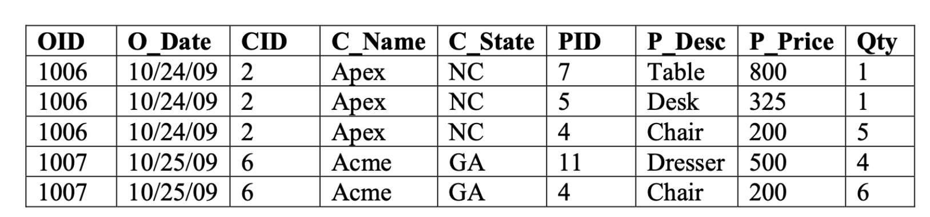

Ex1:

1NF:

|  |  |  |  |  |  |  |
| --- | --- | --- | --- | --- | --- | --- |
| PET ID | PET NAME | PET TYPE | PET AGE | OWNER | VISIT DATE | PROCEDURE |
| 246 | ROVER | DOG | 12 | SAM COOK | JAN 13/2002 | 01 – RABIES VACCINATION |
| 246 | ROVER | DOG | 12 | SAM COOK | MAR 27/2002 | 10 – EXAMINE and TREAT WOUND |
| 246 | ROVER | DOG | 12 | SAM COOK | APR 01/2002 | 05 – HEART WORM TEST |
| 298 | SPOT | DOG | 2 | TERRY KIM | JAN 21/2002 | 08 – TETANUS VACCINATION |
| 298 | SPOT | DOG | 2 | TERRY KIM | MAR 10/2002 | 05 – HEART WORM TEST |
| 341 | MORRIS | CAT | 4 | SAM COOK | JAN 23/2001 | 01 – RABIES VACCINATION |
| 341 | MORRIS | CAT | 4 | SAM COOK | JAN 13/2002 | 01 – RABIES VACCINATION |
| 519 | TWEEDY | BIRD | 2 | TERRY KIM | APR 30/2002 | 20 – ANNUAL CHECK UP |
| 519 | TWEEDY | BIRD | 2 | TERRY KIM | APR 30/2002 | 12 – EYE WASH |

2NF:

|  |  |  |  |  |
| --- | --- | --- | --- | --- |
| PET ID | PET NAME | PET TYPE | PET AGE | OWNER |
| 246 | ROVER | DOG | 12 | SAM COOK |
| 298 | SPOT | DOG | 2 | TERRY KIM |
| 341 | MORRIS | CAT | 4 | SAM COOK |
| 519 | TWEEDY | BIRD | 2 | TERRY KIM |

|  |  |  |
| --- | --- | --- |
| PET ID | VISIT DATE | PROCEDURE |
| 246 | JAN 13/2002 | 01 – RABIES VACCINATION |
| 246 | MAR 27/2002 | 10 – EXAMINE and TREAT WOUND |
| 246 | APR 01/2002 | 05 – HEART WORM TEST |
| 298 | JAN 21/2002 | 08 – TETANUS VACCINATION |
| 298 | MAR 10/2002 | 05 – HEART WORM TEST |
| 341 | JAN 23/2001 | 01 – RABIES VACCINATION |
| 341 | JAN 13/2002 | 01 – RABIES VACCINATION |
| 519 | APR 30/2002 | 20 – ANNUAL CHECK UP |
| 519 | APR 30/2002 | 12 – EYE WASH |