CSD201_CQ192 - You are supplied a project for managing clocks (file Exam2.rar).
This project includes:
(1) I_List.java: Interface for managing a list
(2) I_Menu.java: Interface declared methods for a menu in console application.
(3) Inputter.java: Class that supports data input from users
(4) Item.java: Class represents a item
(5) Menu.java: the Menu class
(6) Clock.java: Class represents a clock
(7) ClockList.java: Class for a list of clocks
(8) ClockListUse.java: Main program.
Describe:
Each clock includes the following information: code (String), make (String), size (int), price (int). The file data-in.txt that stores the clock list initially has the following format:
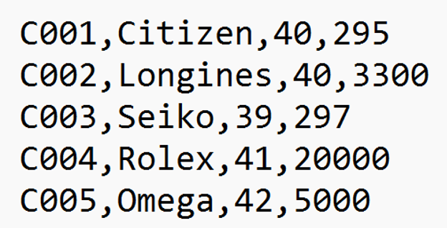
This list is uploaded, processed and then saved to data-out.txt in the following format:
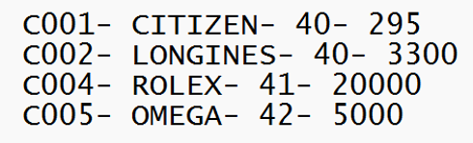
You works:
Implement the class ClockList that extends the class Clock and implements the interface I_List. This class uses HashMap to manage the list (clocks) and implements methods in I_List as below (you can add or modify functions in Clock, ClockList):
- void AddFromFile(String fName): load the list from the file data-in.txt.
- void saveToFile(String fName): save list to the file data-out.txt.
- void add(): add a new clock, with input. Notes: Clock’s code has pattern “Cxxx”, with xxx is three digits, and is not allowed to duplicate.
- void remove(): delete a clock by code, with input.
- void update(): update a clock by code, with input. Notes: If information is blank, the old information will not be changed.
- void print(): print out the list of clocks in ascending order of manufacturer and descending order of price with the format: code - make - size - price.

