CSD201_CQ194 - You are supplied a project for managing cars (file Exam4.rar).
This project includes:
(1) I_List.java: Interface for managing a list
(2) I_Menu.java: Interface declared methods for a menu in console application.
(3) Inputter.java: Class that supports data input from users
(4) Item.java: Class represents a item
(5) Menu.java: the Menu class
(6) Car.java: Class represents a car
(7) CarList.java: Class for a list of cars
(8) CarListUse.java: Main program.
Describe:
Each car includes the following information: code (String), make (String), owner (String), price (double), color (String). The file data-in.txt that stores the car list initially has the following format:
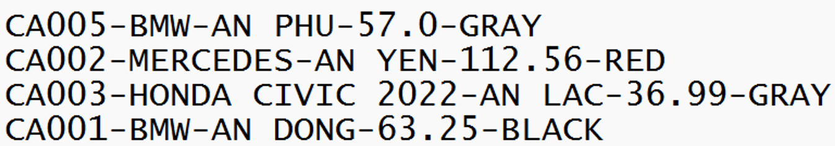
This list is uploaded, processed and then saved to data-out.txt in the following format:
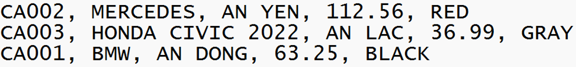
You works:
Implement the class CarList that extends the class Car and implements the interface I_List. This class uses HashMap to manage the list (cars) and implements methods in I_List as below (you can add or modify functions in Car, CarList):
- void AddFromFile(String fName): load the list from the file data-in.txt.
- void saveToFile(String fName): save list to the file data-out.txt.
- void add(): add a new car, with input. Notes: Car’s code has pattern “CAxxx”, with xxx is three digits, and is not allowed to duplicate.
- void remove(): delete a clock by code, with input.
- void update(): update owner and/or price of a Car by code, with input (i.e. if information is blank, the old information will not be changed).
- void print(): print out the list of cars in ascending order of manufacturer and ascending order of price with the format: code, make, owner, price, color.

