 

Q1:

Software Requirements Specification

for

Pet Medical Appointment System

Version 1.0 approved

Prepared by

Nguyen Hoang Dat – SE170330

FU Ho Chi Minh

26/03/2024

Q2:

<Student must replace this line, answer Q2 by drawing 1 context diagram that reflect this exam paper and copy and then paste the image of that context diagram here

Notes:

1. Draw the correct syntax to describe the context diagram (0.3 point)
2. List the name of >= 4 external entities (0.6 point)
3. Draw the data flows described in this exam paper (1.6 points)

>

Q3: 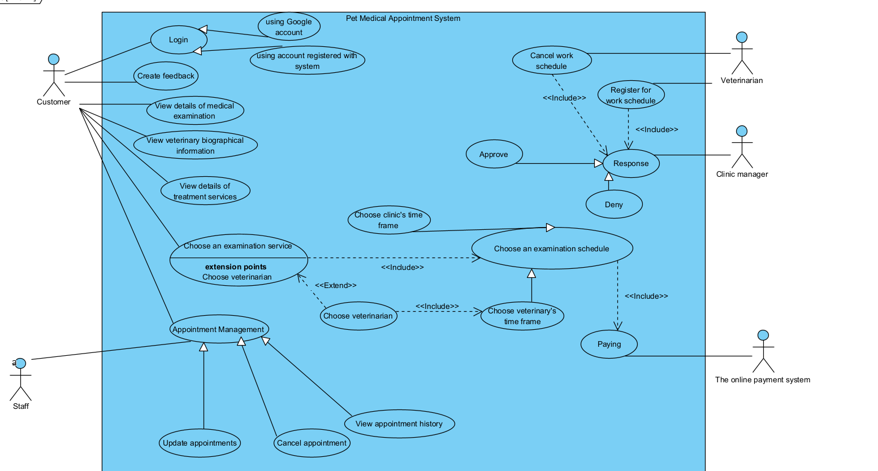

|  |  |  |
| --- | --- | --- |
| **#** | **Actor** | **Description** |
| 01 | Customer | The ones will interact with the system to choose or cancel appointment. |
| 02 | Staff | The ones can update, cancel the appointment. |
| 03 | Veterinarian | The ones work in pet clinic. |
| 04 | Clinic Manager | The ones manage the pet clinic |
| 05 | The online payment system | The ones response with customer payment. |

< Student must replace this line, **briefly describe** the use cases of the diagram by fill the content to below table>

|  |  |  |  |
| --- | --- | --- | --- |
| **#** | **Use Case** | **Actors** | **Description** |
| UC-01 | Login with Google account | Customer | Login to the system with google account |
| UC-02 | Login with registered account | Customer | Login to the system with registered account |
| UC-03 | View details of medical examination | Customer | View the details information of each medical examination |
| UC-04 | View details of treatment services | Customer | View the details information of each treatment service |
| UC-05 | View veterinary biographical information | Customer | Get and view the information of veterinary biographical |
| UC-06 | Update customer registered appointment | Staff | Staff can update the appointment |
| UC-07 | Cancel customer registered appointment | Staff | Staff can cancel the appointment |
| UC-08 | View appointment history | Staff | Staff can view all the registered appointment from all customers. |
| UC-09 | Update customer registered appointment | Customer | Customer can update the appointment |
| UC-10 | Cancel customer registered appointment | Customer | Customer can cancel the appointment |
| UC-11 | View appointment history | Customer | View all customer’s appointment |
| UC-12 | Register an appointment | Customer, The online payment system | Customer can choose an examination service, choose schedule and paying to register new appointment |
| UC-13 | Register for work schedule | Veterinarian | Send request register for work schedule |
| UC-14 | Cancel work schedule | Veterinarian | Send request cancel work schedule |
| UC-15 | Response request | Clinic manager | Send response that approve or deny for request from Veterinarian |
| UC-16 | Send feedback | Customer | Customer can send feedback on the service |

Q4:

< Student must replace this line, answer of Q4 by fill the content to below table that reflect this exam paper

Notes:

1. Describe >= 5 business rules (1.5 point)
2. For each incorrect business rule, 0.3 points will be deducted

>

|  |  |  |
| --- | --- | --- |
| ID | Rule Definition | Use cases |
| BR-01 | The customer receives a 15% discount on medical examination services when making appointments for two or more pets | UC-12 |
| BR-02 | The system will transfer the paid money back to the customer if the customer cancels the appointment 24 hours before the time of examination | UC-07, UC-10 |
| BR-03 | The system only allows the customer to make appointments 24 hours before the time of examination | UC-12 |
| BR-04 | Staff can change or cancel appointments after reaching agreement with the customer. | UC-06, UC-07 |
| BR-05 | Customer allows to send feedback on service after use. | UC-16 |

**Q5:**

* All network transitions that involve financial information or personally identifiable information require 256-bit encryption. Must be 256-bit encryption, do not accept the other.
* The system shall provide a help link from each displayed webpage. This link shall explain how to use that page.