PICKLEBALL LINECALLER
A Two-Camera Computer-Vision System for Automatic Court
Calibration and Ball-Bounce Line Calling
Technical Disclosure & Patent-Styled Research Report
Phase 1 (proof of concept) completed • Phases 2–3 proposed
Version: 1.0
Date: June 2026
Status: Internal — Research Preview
Document type: Invention disclosure + research/technical report
Assignee: [to be assigned]
Inventors / contributors: [to be completed]
CONFIDENTIAL — for internal review and patent-preparation purposes.

Abstract
This document discloses Pickleball Linecaller, a computer-vision system that automatically calibrates a pickleball court from camera video and adjudicates ball-bounce (point-of-pitch) line calls. Phase 1, completed as a proof of concept (POC), establishes fully automatic single-camera court calibration: a YOLOv11m-pose model detects twelve court keypoints, from which a homography to a canonical real-world court model is fitted by RANSAC and the near-half region of interest (ROI) is projected back into the image and locked on within seconds. On a held-out test split of 1,510 frames the keypoint model attains a pose mAP of 99.9% / 99.5%, a mean Object Keypoint Similarity (OKS) of 0.997, and a mean court re-projection error of 2.61 px at lock-on, validating the geometry on real broadcast footage.
Phases 2 and 3 propose the extension to a real-world, two-camera deployment. Two phone cameras placed behind the near-baseline corners each calibrate independently to a single shared court coordinate frame (homography plus Perspective-n-Point, after checkerboard intrinsic calibration), so the two views localize relative to one another and to the court. A guided-placement procedure with audio (beep) feedback ensures each camera is positioned so that all four court corners are visible before calibration. A ball tracker (GridTrackNet, to be fine-tuned from tennis to pickleball) yields per-frame ball positions; at the bounce the ball lies on the playing surface (Z = 0), so each camera's ground-plane homography maps the bounce image point to court coordinates, and the two independent estimates are fused and cross-checked — providing redundancy that resolves close calls that a single camera cannot. Logic distinguishing a bounce from a paddle hit, a two-camera dispute-resolution rule, a low-latency server architecture, a dedicated kitchen (non-volley-zone) camera, and game-rules/scoring integration are also specified. The document concludes with the real-world data-collection methodology that bridges the POC to the next development phase, consolidated experimental results, points of novelty, and patent-styled claims.

Table of Contents
Abstract 2
1. Field of the Disclosure 5
2. Background and Prior Art 5
2.1 The line-calling problem in pickleball 5
2.2 Limitations of single-camera and manual approaches 5
2.3 Relevant prior art 5
2.4 Problems addressed 6
3. Summary of the System 6
3.1 Points of novelty (summary) 6
4. Detailed Description — Phase 1: Single-Camera Court Calibration (completed) 8
4.1 Canonical court model and the 12-keypoint scheme 8
4.2 Dataset and acquisition 9
4.3 Model-assisted annotation 9
4.4 Keypoint model: YOLOv11m-pose 10
4.5 Geometry: homography, RANSAC and line refinement 10
4.6 Near-half ROI construction 10
4.7 Lock-on web application 11
4.8 Results and evaluation 11
5. Detailed Description — Phase 2: Two-Camera Real-World System (proposed) 14
5.1 Rig geometry and camera placement 14
5.2 Camera intrinsic and extrinsic calibration 15
5.3 Inter-camera localization via a shared court frame 15
5.4 Guided camera placement with audio feedback 16
5.5 Ball detection and tracking 16
5.6 Bounce localization by dual ground-plane homography 17
5.7 Discriminating a bounce from a paddle hit 17
5.8 Two-camera dispute resolution 18
5.9 Real-time architecture and latency 19
6. Detailed Description — Phase 3: Extended Scope (proposed) 20
6.1 Kitchen (non-volley-zone) camera and rule monitoring 20
6.2 Kitchen-camera data-collection methodology 20
6.3 Game-rules and scoring integration 21
7. Real-World Data-Collection Methodology 22
7.1 One-time calibration captures 22
7.2 Court coordinate system and synchronization 22
7.3 What to capture 22
7.4 File naming, master log and pitfalls 23
7.5 Capture matrix and shoot plan 23
8. Consolidated Results and Discussion 24
9. Points of Novelty 24
10. Claims (patent-styled) 25
11. Future Work and Roadmap 26
12. References 26
Appendix A — Keypoint index reference 28
Appendix B — Calibration library API (court_calib.py) 28
Appendix C — Training hyperparameters 29
Appendix D — Data-collection log schema and pre-shoot checklist 29
Appendix E — Glossary 29

1. Field of the Disclosure
This disclosure relates to automated officiating and analytics for court sports, and more specifically to computer-vision systems for racquet/paddle sports such as pickleball. It concerns (i) automatic calibration of a camera to a court from detected court-line keypoints, (ii) detection and tracking of the ball, (iii) determination of the ball's point of contact with the playing surface (the bounce or pitch point) and whether that point is inside or outside a boundary line, and (iv) the fusion of information from two or more cameras to produce robust, dispute-resistant line calls in real time.

2. Background and Prior Art

2.1 The line-calling problem in pickleball
Pickleball is played on a court measuring 20 ft wide by 44 ft long, with a non-volley zone (the “kitchen”) extending 7 ft from each side of the net and a net height of 36 in at the sidelines and 34 in at the centre. Whether a ball lands in or out — often by a margin of millimetres, at speed — frequently decides a rally. In recreational and most tournament play, calls are made by the players or by human line judges, which is error-prone, subjective, and a common source of disputes. Professional electronic line-calling (e.g. multi-camera “Hawk-Eye”-style systems) is accurate but expensive, requires fixed installation and professional calibration, and is impractical for the overwhelming majority of courts.

2.2 Limitations of single-camera and manual approaches
A single camera can determine whether a bounce is in or out only when the bounce is unoccluded and the camera-to-court geometry is precisely known. Two failure modes dominate: (a) occlusion, where a player or paddle hides the bounce from the only camera, and (b) calibration drift or manual setup error. Existing automated analytics tools for racquet sports typically assume a fixed, professionally placed broadcast camera and manual or semi-manual court annotation; they neither self-calibrate from arbitrary phone placements nor provide cross-view redundancy for contested calls.

2.3 Relevant prior art
Court keypoint / pose estimation. Modern single-stage detectors such as the Ultralytics YOLO family include a pose variant that regresses a fixed set of named keypoints as a per-instance skeleton, each with a confidence and visibility flag, and are evaluated with Object Keypoint Similarity (OKS), the keypoint analogue of IoU used to compute pose mAP. This disclosure repurposes the “skeleton” as the twelve fixed line-intersections of a court rather than the joints of a person.
Ball tracking. The TrackNet lineage (TrackNet, TrackNetV2) introduced heat-map CNNs for tracking a small, fast ball across multiple consecutive frames in tennis and badminton. GridTrackNet improves this with a grid-based output and an efficient architecture reported to run at ~116 FPS on consumer hardware using five input and five output frames, at higher input resolution, and with improved accuracy over TrackNetV2. This disclosure adopts a GridTrackNet-style tracker and proposes fine-tuning it from tennis to the pickleball ball.
Planar calibration and pose. Estimating a homography between a planar scene and an image, robustly fitting it with RANSAC, recovering camera intrinsics from a checkerboard, and solving the camera pose by Perspective-n-Point (PnP) are well-established techniques in multiple-view geometry. The novelty here is not the individual primitives but their composition into a self-calibrating, two-camera, redundancy-providing line-call pipeline for an arbitrarily, casually placed pair of phones.

2.4 Problems addressed
The system disclosed herein seeks to (i) remove manual court setup by self-calibrating from detected keypoints; (ii) make calibration robust to occluded keypoints via RANSAC and visibility flags; (iii) guide a non-expert user to a valid camera position with simple audio feedback; (iv) localize the bounce point metrically without relying on ill-conditioned wide-baseline stereo; (v) provide a second, independent view so that occluded or borderline calls can be adjudicated; and (vi) do so in real time on commodity phone cameras and a single server.

3. Summary of the System
The system comprises three phases. Phase 1 (built and validated) is single-camera automatic court calibration and near-half ROI extraction. Phase 2 (proposed) extends this to two synchronized cameras that localize to a shared court frame, adds ball tracking and dual-camera bounce localization with dispute resolution, and a guided-placement aid. Phase 3 (proposed, longer-term) adds a kitchen-zone camera for non-volley-zone rule monitoring and integrates the full rules of play and scoring.
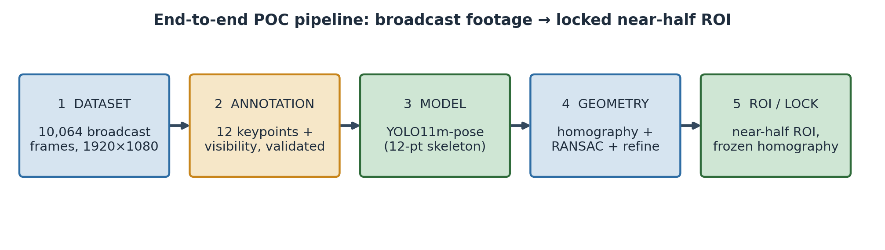
Figure 1. End-to-end Phase-1 pipeline, from raw broadcast footage to a locked near-half region of interest.

3.1 Points of novelty (summary)
- Court-as-skeleton self-calibration: treating the twelve court line-intersections as a single rigid pose “skeleton” detected by one network, then fitting a RANSAC homography to a canonical court model to lock the near-half ROI automatically, with no manual setup.
- Shared-frame inter-camera localization: two casually placed phone cameras each solve a homography (and PnP) to the same canonical court frame, so a single physical court point has identical court coordinates in both views — mutual localization without a precision rig.
- Guided placement by audio feedback: a beep whose cadence encodes “readiness” (all four court corners visible and a valid low-error homography) walks a non-expert user to a correct camera position and signals lock with one long tone.
- Dual ground-plane bounce localization: because the ball is on the surface (Z = 0) at the instant of the bounce, each camera's planar homography fixes the bounce's (X, Y) exactly; the two independent estimates are fused, deliberately avoiding ill-conditioned wide-baseline stereo depth.
- Two-view dispute resolution: when the two cameras' calls disagree on a close bounce, the system adopts the better-supported view (less occluded, lower re-projection error, higher detection confidence), resolving disputes a single camera cannot.

4. Detailed Description — Phase 1: Single-Camera Court Calibration (completed)

4.1 Canonical court model and the 12-keypoint scheme
The court is represented in a canonical, metric coordinate frame in feet. The origin (0, 0) is placed at the far-baseline-left corner; the x-axis runs across the court (0 to 20 ft) and the y-axis runs along the court (0 to 44 ft). The net lies at y = 22 ft, and the two kitchen (non-volley-zone) lines lie at y = 15 ft (far) and y = 29 ft (near). Twelve keypoints are defined at the line intersections, numbered in a fixed “snaking” order that the annotation tool, the model, and the geometry code all share. The four true court corners are keypoints 0, 2, 9 and 11.
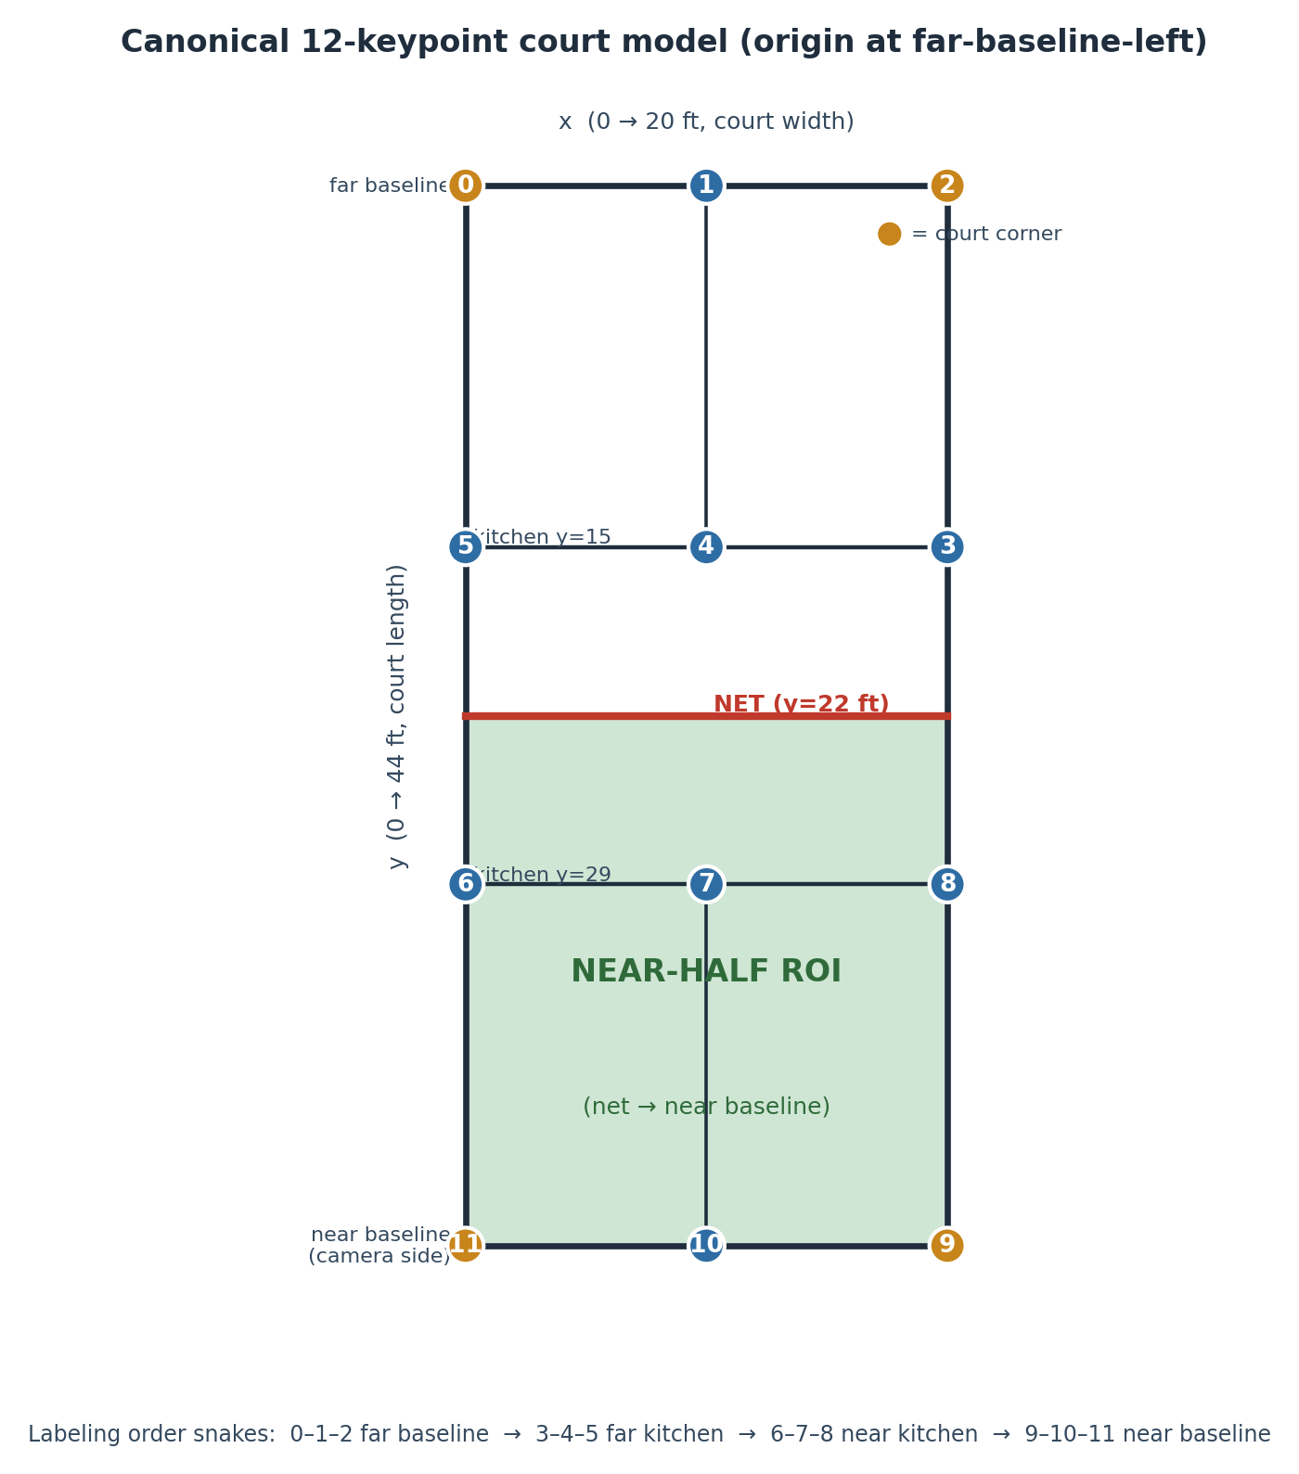
Figure 2. The canonical 12-keypoint court model. Origin at far-baseline-left; the near-half ROI (net → near baseline) is shaded; the four corners are highlighted.
# | Keypoint name | Court coord (ft) | # | Keypoint name | Court coord (ft)
0 | far baseline left | (0, 0) | 6 | near kitchen left | (0, 29)
1 | far baseline mid | (10, 0) | 7 | near kitchen mid | (10, 29)
2 | far baseline right | (20, 0) | 8 | near kitchen right | (20, 29)
3 | far kitchen right | (20, 15) | 9 | near baseline right | (20, 44)
4 | far kitchen mid | (10, 15) | 10 | near baseline mid | (10, 44)
5 | far kitchen left | (0, 15) | 11 | near baseline left | (0, 44)
Table 1. The twelve court keypoints, their canonical metric coordinates, and the fixed index order (matching court_calib.py and the dataset flip map).
Each keypoint carries a visibility flag: 2 = visible, 1 = occluded (position known but hidden by a player or paddle), and 0 = not labeled (not determinable; ignored during training). The flag lets occluded points still contribute their known geometry to calibration while preventing un-locatable points from corrupting the model. A left–right flip map (flip_idx) pairs mirror keypoints (0↔2, 3↔5, 6↔8, 9↔11; the mid points map to themselves) so that horizontal-flip data augmentation remains geometrically correct.

4.2 Dataset and acquisition
The Phase-1 dataset comprises 10,064 frames sampled from online broadcast footage of professional pickleball matches across a variety of courts, all from an elevated baseline view. Frames were sampled from the source clips and standardized (letterboxed, preserving aspect ratio) to 1920 × 1080. The dataset was split into train, validation and test partitions by contiguous frame ranges rather than at random, so that the validation and test partitions are genuinely different segments of footage never seen during training; this range-based (clip-aware) split prevents the leakage that near-duplicate consecutive frames would otherwise cause and that would inflate validation scores.
Split | Frames | Share | Source frame ranges
Train | 7,045 | 70% | img_00001–02500 + img_05520–10064
Validation | 1,509 | 15% | img_02501–04009
Test (held-out) | 1,510 | 15% | img_04010–05519
Total | 10,064 | 100% | range split — no leakage
Table 2. Range-based dataset partition. Validation and test are contiguous, held-out segments of footage.

4.3 Model-assisted annotation
Keypoints were labeled with a purpose-built, browser-based annotation editor developed for this project. To minimize manual effort, a preliminary (bootstrap) keypoint model trained on an initial ~3,000 hand-labeled frames pre-labeled every remaining image; annotators then dragged each point to its correct location and set its visibility flag. Each save wrote both an editable annotations record and a training-ready YOLO-pose label file, allowing work to be paused and resumed. Two annotators completed the corrections over approximately two days. The labeling convention was: mark a point occluded (1) when a player or paddle lies in its line of sight but its position is inferable, and not-labeled (0) when the point is genuinely indeterminable. The bounding box required by the detector is derived automatically to enclose the labeled keypoints, so annotators only ever manipulate the twelve points.

4.4 Keypoint model: YOLOv11m-pose
The deployed detector is a YOLOv11m-pose model (“medium”, ~20M parameters) configured for a single object class (court) and a 12-point, 3-value (x, y, visibility) keypoint skeleton. Rather than predicting a bounding box alone, the network regresses the twelve named court points as one rigid skeleton with per-point confidence. Training used an image size of 1280, the AdamW optimizer, an initial learning rate of 1e-3 with cosine decay, a three-epoch warm-up, weight decay 5e-4, and early-stopping patience of 50 epochs. Horizontal flip augmentation (p = 0.5) was enabled and made geometrically safe by the flip map; mild HSV, rotation (±5°), translation, scale and shear augmentations were used, while mosaic and mixup were disabled because they mangle single-court geometry and keypoints.
Training was performed on a free dual-NVIDIA-T4 cloud GPU session with a 12-hour wall-clock limit; the run reached epoch 65 (approximately 15–20 hours of training) at which point the session limit was hit, and the best checkpoint to that point was retained. The hyperparameters are summarized in Appendix C.

4.5 Geometry: homography, RANSAC and line refinement
Given the detected image keypoints with visibility ≥ 1, a planar homography H maps homogeneous image coordinates to canonical court coordinates: s·[x y 1]ᵀ = H·[u v 1]ᵀ, where (u, v) are image pixels, (x, y) are court feet, and s is a scale. H has eight degrees of freedom and requires at least four point correspondences. Using all available keypoints (visible and occluded), H is fitted by RANSAC with a re-projection threshold of 5 px, which automatically rejects mis-detected or mislabeled points as outliers. The inverse H⁻¹ maps court coordinates back into the image.
Calibration quality is measured by the mean re-projection error: each trusted (inlier) keypoint is mapped to court space and back, and the pixel distance between the original and the round-tripped point is averaged. Formally, error = mean over inliers of ‖ pᵢ − H⁻¹ H pᵢ ‖ (with the analogous distance also reported in feet). An optional line-refinement step can snap the projected net line to the strongest nearby image edge to tighten the fit; it is available in the library but is treated as optional and was not relied upon for the reported results.

4.6 Near-half ROI construction
The region of interest is the near half of the court (court y in [22, 44], i.e. net to near baseline). From the twelve detected points, the system uses the six on the camera's near side — the near kitchen line (6, 7, 8) and the near baseline (9, 10, 11), which are closest to the camera and rarely occluded — and derives three points across the net line (net-left, net-mid, net-right) from the homography. The enclosed quadrilateral, sampled along its edges so that perspective curvature is preserved, is the near-half ROI polygon; it is returned in image coordinates and may be fine-tuned by dragging any point. Figure 5 (right panel) and Figure 1 show the geometry; Figure 4 shows real overlays.
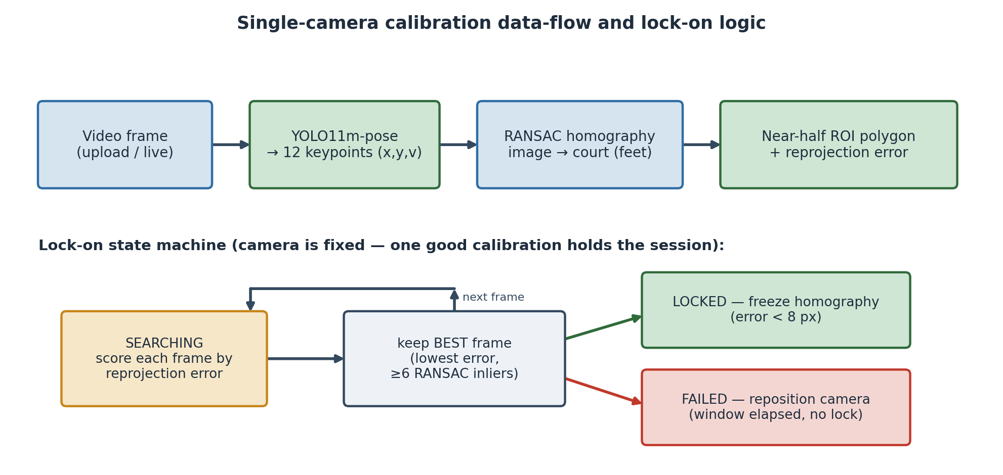
Figure 3. Single-camera calibration data-flow and lock-on logic.

4.7 Lock-on web application
A web application lets a user upload a clip or use a live camera (phone or laptop) and press Start. Because the camera is fixed at a recommended spot, one good calibration holds for the whole session. During a ~10-second search window the server scores every frame by re-projection error and retains the lowest-error frame that has at least six RANSAC inliers. If the best frame beats the lock threshold (default 8 px) the homography is frozen and reused for the rest of the session; if nothing beats the threshold within the window, the app reports failure and asks the user to reposition. The keypoint predictor is the only model-dependent component; the geometry is independent of the model and was developed and tested against ground-truth labels before the model was integrated.

4.8 Results and evaluation
On the held-out test split of 1,510 frames the model never saw during training, detection and keypoint accuracy are effectively saturated, and the geometry reproduces court points to a few pixels. Table 3 summarizes detection and pose metrics; Table 4 reports the keypoint-localization distribution; Table 5 reports calibration re-projection error.
Metric | Value | Notes
Detection rate | 100% (1,510 / 1,510) | every test frame detected
Detection confidence | 100% of preds ≥ 0.85 | high-confidence detections
Pose mAP | 99.5% | @50 and @50–95
Pose mAP (headline) | 99.9% | keypoint accuracy, held-out test
Mean OKS | 0.997 | object keypoint similarity
Bounding-box IoU | 87.4% (median 86.2%) | weakest area — see §8
Table 3. Detection and pose metrics on the 1,510-frame held-out test split.
Keypoint localization | Share of test keypoints | Comment
within 5 px | 9 of 12 keypoints (avg) | 3 near-baseline points: 8.8–12.7 px
within 10 px | 86.2%
within 20 px | 96.3%
within 30 px | 99.3% | only 0.7% beyond 30 px
Table 4. Keypoint-localization accuracy: cumulative share of predicted keypoints within N pixels of ground truth.
Calibration metric | Value | Notes
Mean re-projection error at lock-on (model) | 2.61 px | lowest-error locked frame
Ground-truth label baseline (median) | ~3.19 px | geometry validated on GT labels
Ground-truth baseline (p95) | ~4 px | from batch label validator
RANSAC threshold / min inliers | 5 px / 6 | outlier rejection
Lock window / lock threshold | 10 s / 8 px | freeze best homography
Table 5. Court-calibration re-projection error and lock-on parameters. The trained model at lock-on (2.61 px) matches or beats the ground-truth label baseline because lock-on selects the single best frame.
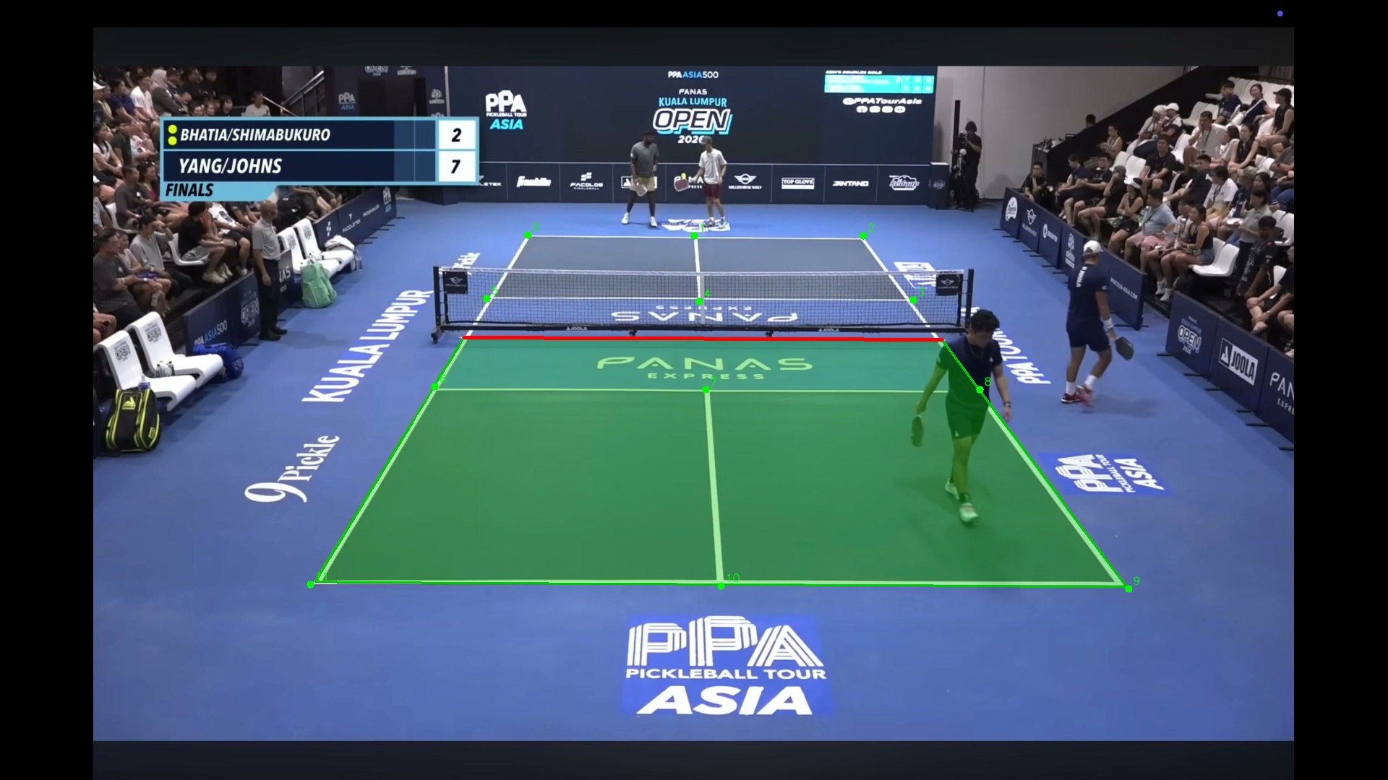
Figure 4. Example automatic near-half ROI overlay on a broadcast frame. The near half is shaded (green), the net line is drawn (red), and detected keypoints are marked; produced fully automatically.
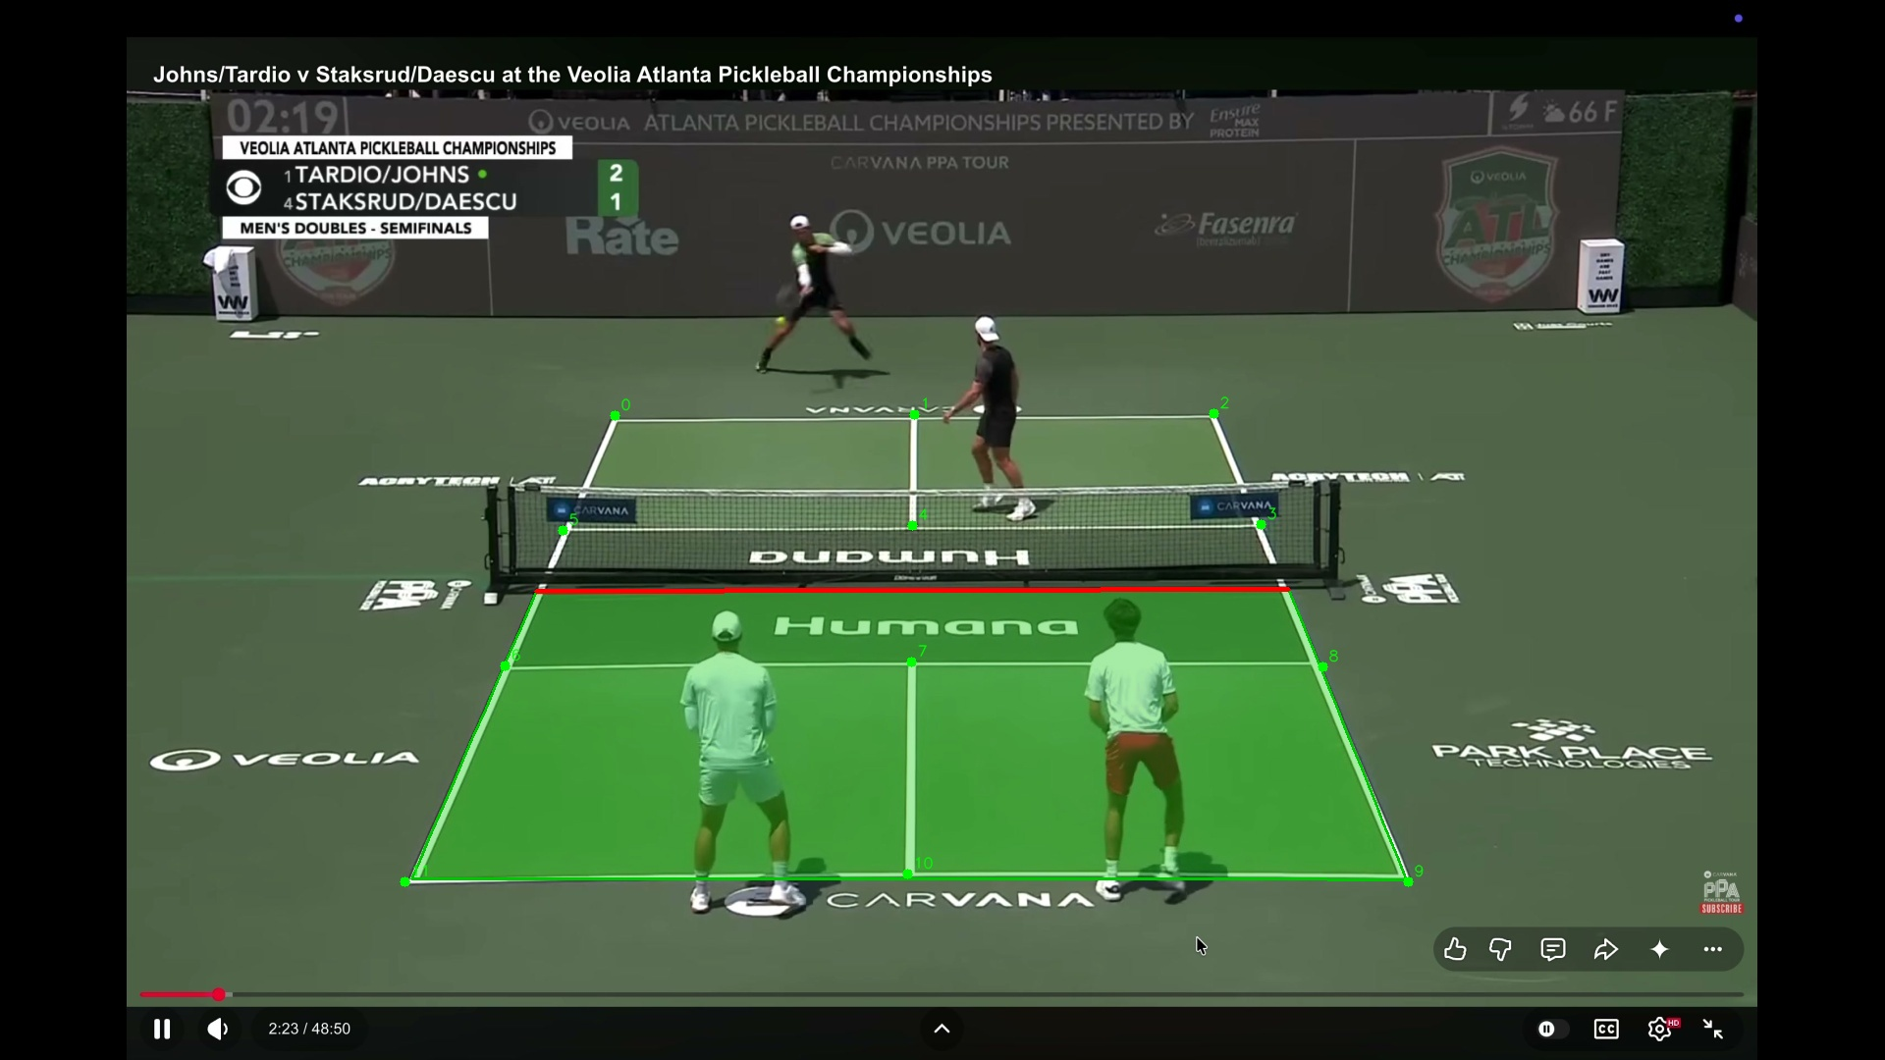
Figure 5. A second automatic ROI overlay, illustrating consistent lock-on across different rallies and camera framings.

5. Detailed Description — Phase 2: Two-Camera Real-World System (proposed)
Phase 2 moves from elevated broadcast footage to a real court observed by two ordinary phone cameras placed behind the near-baseline corners, plus an optional kitchen camera. The objectives are: calibrate each camera to the court exactly as in Phase 1; localize the two cameras relative to one another in a shared court frame; track the ball in each view; localize the bounce point metrically; classify bounce versus paddle hit; and fuse the two cameras' calls, using their redundancy to resolve close or occluded calls.

5.1 Rig geometry and camera placement
Two cameras, A and B, are placed wide apart, each behind (or near) a near-baseline corner, so that the two optical axes converge on the near half from opposite sides. Each camera must independently see the entire near half and all twelve court keypoints; a camera that loses the court lines or corners cannot be calibrated and its data are unusable. An optional kitchen camera K is placed at a net post and aimed along the net across the non-volley zone, as a separate viewer (Phase 3). All cameras roll simultaneously and record a sharp synchronization event (a clap or flash) at the start of each clip.
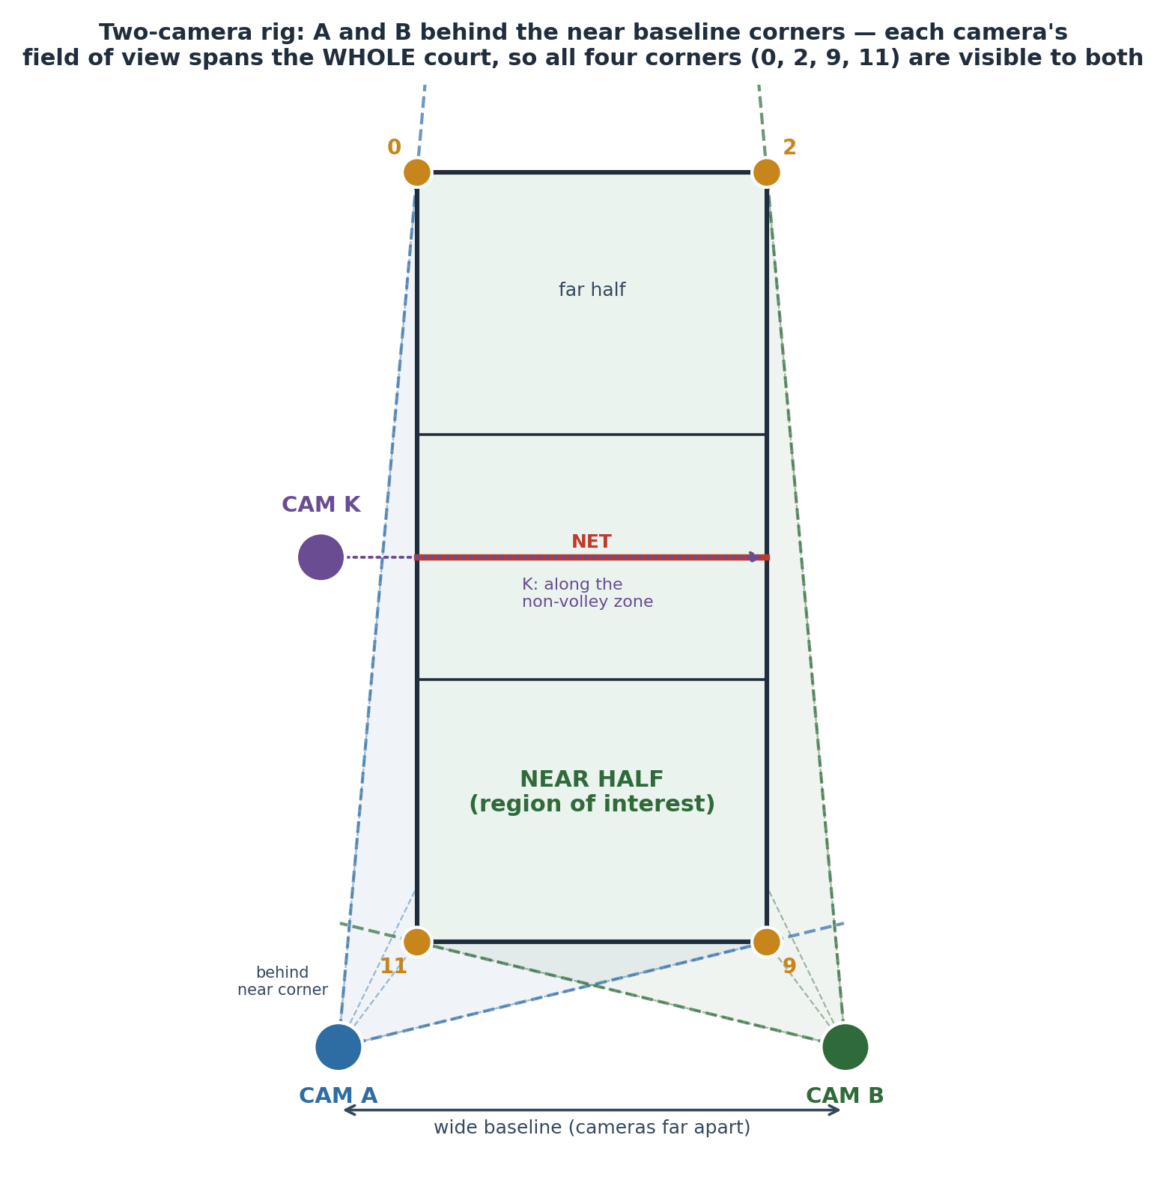
Figure 6. Two-camera rig geometry (top-down). A and B sit behind the near-baseline corners with a wide baseline; each camera's field of view spans the whole court, so all four corners (0, 2, 9, 11) — and thus all twelve keypoints — are visible to both. K observes the non-volley zone.
Capture settings are locked and identical on all cameras and must not change mid-session: 60 fps constant frame rate, 1080p, fixed 1.0× zoom, locked focus and exposure (AE/AF lock), HDR/Dolby Vision off, landscape orientation, clean lens. Changing zoom, focus or exposure voids the calibration; variable frame rate and HDR complicate processing.

5.2 Camera intrinsic and extrinsic calibration
Each camera is intrinsically calibrated once, at the exact settings used for capture, by recording a rigid planar checkerboard (e.g. 9 × 6 inner corners, with the square size measured precisely) moved slowly to cover the whole frame at many orientations and depths. From these views the camera's intrinsic matrix and lens-distortion coefficients are estimated (standard checkerboard calibration), enabling undistortion. Because intrinsics are tied to the exact zoom and resolution, these must be locked before and unchanged after. Each camera's extrinsics (its pose in the court frame) are then recovered by Perspective-n-Point from the twelve detected court keypoints together with their known canonical coordinates, optionally seeded by a coarse measured camera position and height. A few seconds of empty-court reference are recorded per camera for this purpose; if a camera is bumped, its reference is re-shot.

5.3 Inter-camera localization via a shared court frame
The two cameras are tied together not by a precision stereo rig but by the court itself. Each camera independently solves its homography (H_A, H_B) — and, with intrinsics, its PnP pose — to the same canonical court coordinate frame defined in §4.1. Consequently any physical point on the court has the same court coordinates whether computed from camera A or camera B: the two views are mutually localized through the shared frame. This is what allows two points seen in two far-apart cameras to be recognized as the same physical court point, and it is the basis for cross-checking bounce estimates in §5.6.
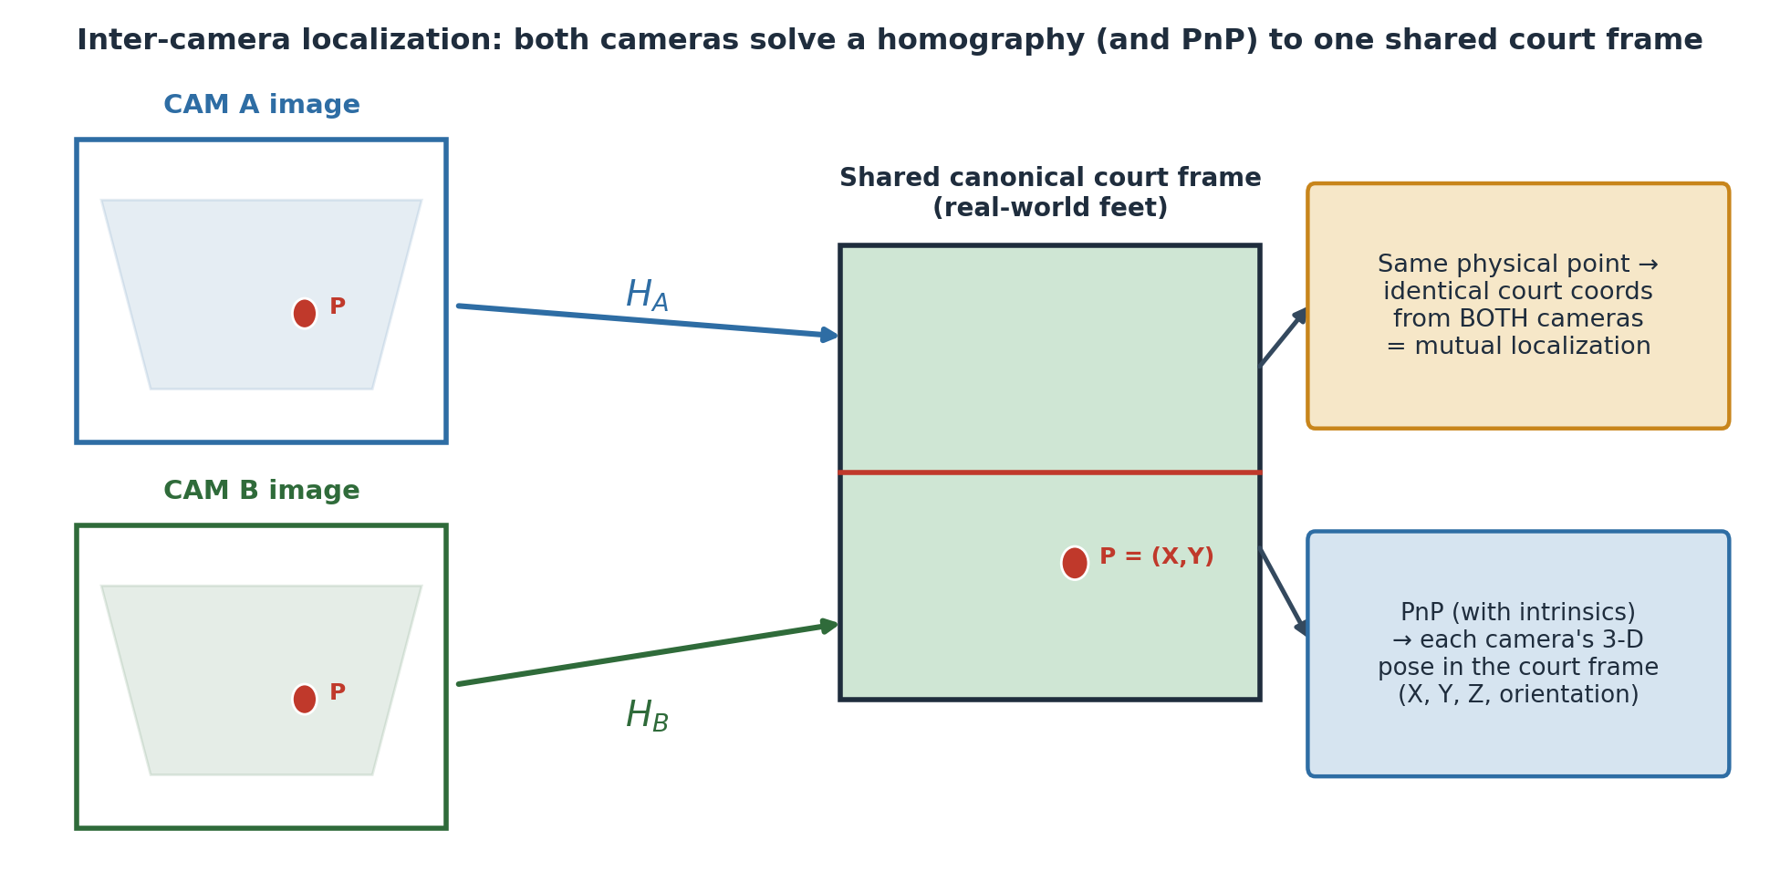
Figure 7. Inter-camera localization through a shared court frame. Both cameras map to one canonical frame; a single physical point yields identical court coordinates from either view. PnP additionally recovers each camera's 3-D pose.

5.4 Guided camera placement with audio feedback
To let a non-expert place each phone correctly, the system provides real-time audio (beep) feedback while the user moves the phone. The correct position is one from which all four court corners (keypoints 0, 2, 9, 11) are visible, which is the precondition for a valid calibration; placement is further refined by requiring all twelve keypoints to be detected and the resulting homography's re-projection error to fall below a threshold and remain stable for a number of frames. A per-frame readiness score is computed (corners detected, keypoint confidence, and re-projection error). The beep cadence encodes readiness: when the phone is far from a valid position the beeping is rapid; as it approaches a valid position the beeping slows; and when a stable, low-error calibration with all four corners is achieved, a single long tone sounds and a message confirms the position is fixed, after which calibration proceeds.
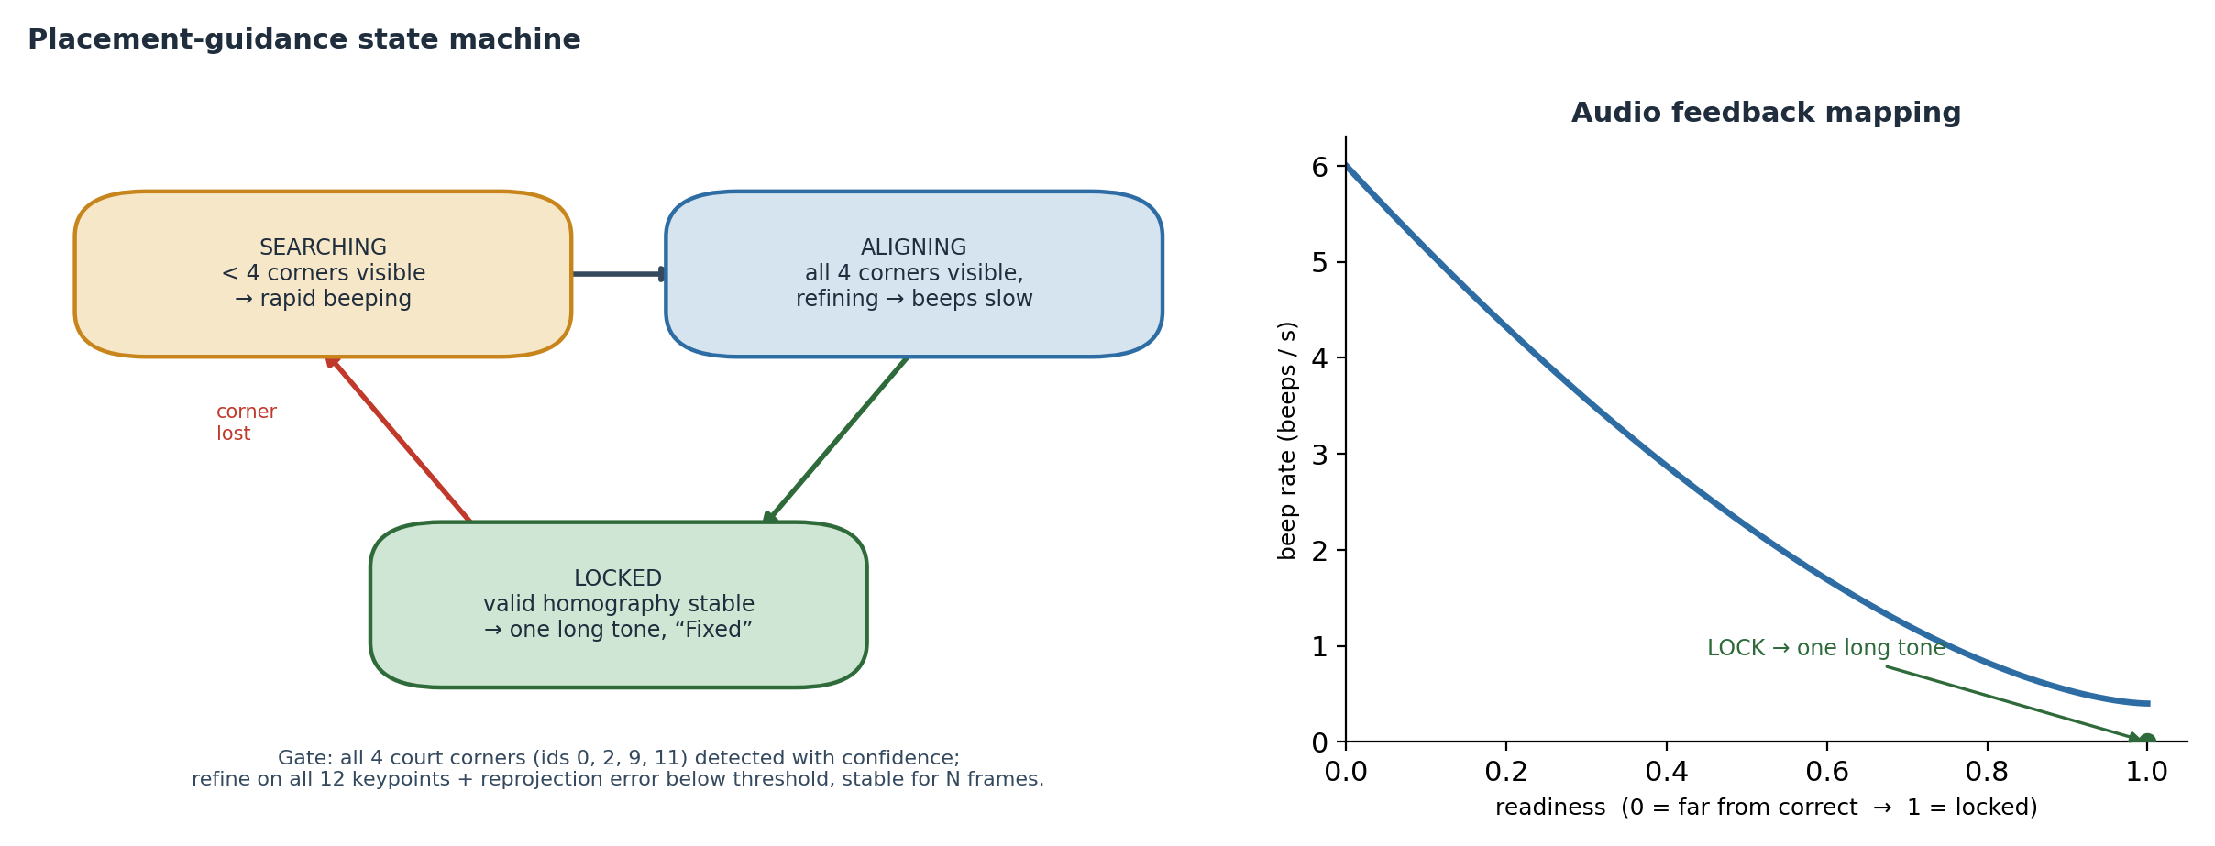
Figure 8. Guided-placement state machine and audio-feedback mapping. Searching (rapid beeps) → Aligning (beeps slow as readiness rises) → Locked (one long tone). The gate is all four corners visible plus a stable low-error homography.
Implementation note
The guided-placement aid is specified here as a proposed algorithm and state machine; it is not yet implemented in the current web application, which presently instructs the user to place the camera at a recommended spot. The readiness function and thresholds above are the intended design and a starting point for tuning.

5.5 Ball detection and tracking
Each camera's video is processed by a ball tracker based on GridTrackNet, a grid-output CNN designed to locate and track a small, fast-moving ball across several consecutive frames in real time (reported ~116 FPS, five input / five output frames, at increased input resolution, improving on TrackNetV2). GridTrackNet is currently trained for the tennis ball; this disclosure proposes fine-tuning it for the pickleball ball using the real-world ball-visible frames gathered during data collection (§7), spanning varied speeds, spins, angles, lighting and, where available, ball colours. The tracker outputs a per-frame ball image position (and a no-ball flag) for each camera, forming the two independent streams of ball evidence.

5.6 Bounce localization by dual ground-plane homography
The bounce (point of pitch) is the instant the ball contacts the surface. At that instant the ball lies on the court plane, Z = 0, so each camera's planar court homography maps the ball's image position directly to court coordinates without any depth estimation. Each camera thus produces an independent estimate of the bounce location in the shared court frame; the two estimates are fused (and cross-checked) to yield the final bounce position and an in/out determination against the relevant line.
Crucially, the system deliberately does not use wide-baseline stereo triangulation to localize the bounce. With two phones placed far apart and at a distance from the court, triangulated depth is numerically ill-conditioned and sensitive to small calibration and detection errors. The planar homography at Z = 0 is, by contrast, well-conditioned and directly yields the only quantity that matters for a line call — the (X, Y) ground coordinate. (Full 3-D trajectory or ball-height reconstruction, which would require tightly synchronized stereo, is reserved as future work; the start-of-clip sync event preserves that option.)
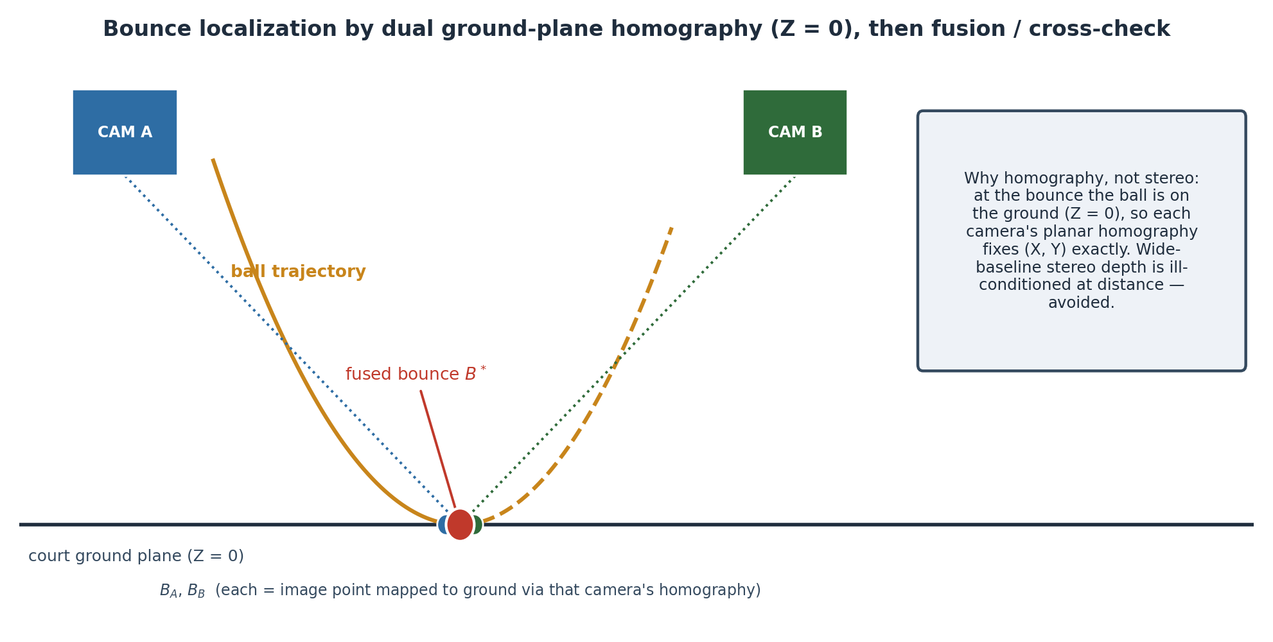
Figure 9. Bounce localization by dual ground-plane homography (Z = 0). Each camera maps the bounce image point to the court plane; the two estimates are fused into B*. Wide-baseline stereo depth is avoided as ill-conditioned.

5.7 Discriminating a bounce from a paddle hit
Only true surface bounces should trigger a line call; paddle (or body) contacts must be excluded. The primary cue is trajectory geometry: a bounce occurs when the ball's height above the court approaches zero and its vertical velocity changes sign at the ground (down then up), whereas a paddle hit is a direction change occurring well above the ground, typically near a player. Because the height/vertical-velocity signal is itself derived per camera, several corroborating cues are proposed to make the decision robust: proximity of the event to the ground plane versus to a detected player/paddle; whether the horizontal velocity is largely preserved (characteristic of a bounce) or reversed/redirected (characteristic of a hit); the residual of a fitted ballistic (parabolic) trajectory model and the point at which that model breaks; and, optionally, an acoustic signature distinguishing ball-on-court from ball-on-paddle. Combining these cues (e.g. by a small rule set or learned classifier over the trajectory window) yields a reliable bounce/no-bounce label.
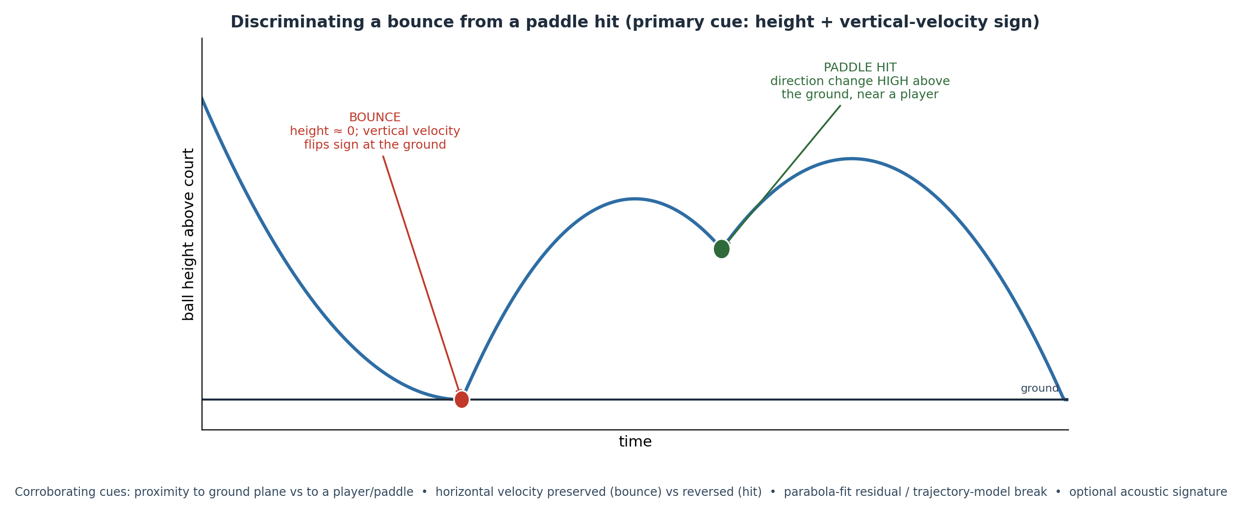
Figure 10. Discriminating a bounce from a paddle hit. A bounce is a height-zero, vertical-velocity sign change at the ground; a paddle hit is a direction change high above the ground near a player.

5.8 Two-camera dispute resolution
Each camera independently issues a call (in/out, with a confidence) for a given bounce. When both calls agree, the result is accepted with high confidence. When they disagree — the situation a single camera cannot resolve — the system compares the supporting evidence and adopts the stronger view: which camera, if any, had the bounce occluded; which produced the lower calibration re-projection error; and which had the higher ball-detection confidence at the bounce frame. The adopted call is returned and flagged as two-view-resolved, preserving an audit trail. This redundancy is the core advantage of the two-camera design: a bounce hidden from one camera by a player or paddle is typically clearly visible to the other.
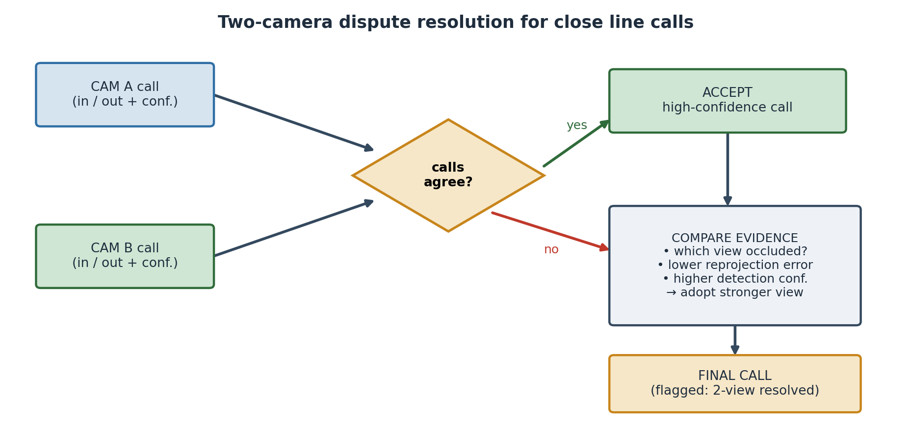
Figure 11. Two-camera dispute-resolution logic for close line calls. Agreement is accepted directly; disagreement is resolved in favour of the better-supported view.

5.9 Real-time architecture and latency
In the intended deployment the cameras stream synchronized video to a server (with a GPU) that runs the models and returns calls instantaneously. The server ingests and time-aligns the streams (using the per-clip sync event), maintains each camera's cached homography/pose, runs the GridTrackNet tracker and the per-camera bounce detector, fuses the per-camera bounce estimates and resolves disputes, and (Phase 3) applies a rules engine; the result is a line call plus an on-screen overlay. The current system implements none of this real-time path yet; it is specified here as the target. To minimize latency, the design favours: tracking on ROI-cropped, optionally down-scaled frames; computing the homography once per camera and caching it (the cameras are fixed); triggering the comparatively expensive fusion only on detected bounce events; and batching the two streams on the GPU.
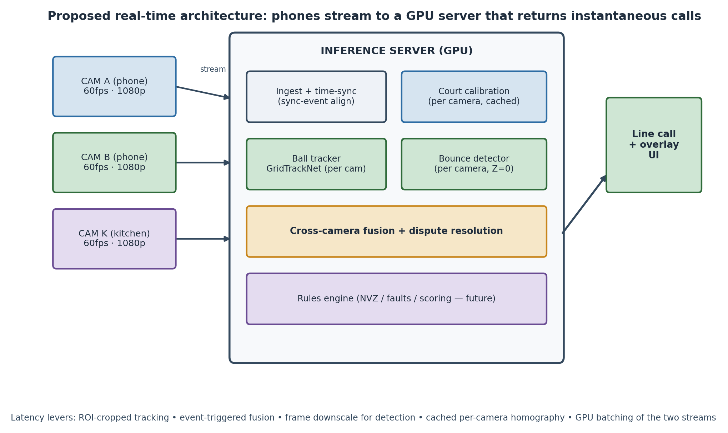
Figure 12. Proposed real-time architecture. Phones stream to a GPU server that calibrates, tracks, detects bounces per camera, fuses and resolves disputes, and returns instantaneous calls.

6. Detailed Description — Phase 3: Extended Scope (proposed)

6.1 Kitchen (non-volley-zone) camera and rule monitoring
A dedicated camera K at the net post, aimed along the net across the non-volley zone, monitors the close-net play that the wide baseline pair covers poorly. The non-volley-zone rules to be enforced include: a player may not volley (strike the ball out of the air) while standing on or touching the kitchen or its line; the line is part of the kitchen, so even a millimetre of contact during a volley is a fault; the rule applies to anything connected to the player (body, paddle, clothing); momentum that carries a player into the kitchen (or onto the line) after a volley is also a fault; and a player may stand in the kitchen at any time provided the ball has bounced before they strike it. Camera K is a pure viewer in this phase — not used for calibration or triangulation — but is recorded and logged like the others to support later kitchen-specific analysis.

6.2 Kitchen-camera data-collection methodology
Although camera K is a pure viewer in this phase, the footage it records must be captured and ground-truthed deliberately so that non-volley-zone (NVZ) rule detection can later be developed and validated. K is placed at a net post, leveled and aimed along the net across the kitchen, with the same locked settings as A and B (60 fps, 1080p, AE/AF lock, fixed 1.0× zoom, HDR off, landscape). Its position and height are measured and logged, and an empty-court reference is recorded so that K can itself be calibrated to the court (a homography from the visible net and kitchen-line keypoints); this lets foot and paddle positions be mapped to court coordinates and contact with the kitchen line be judged metrically. K rolls simultaneously with A and B, shares the per-clip synchronization event, and uses the same clip number.
The capture deliberately stages both legal and faulting non-volley-zone situations — each logged with its intended ground-truth verdict and type — with heavy emphasis on the line-contact edge cases the rule turns on. The kitchen line is, where permitted, marked with high-contrast tape and its measured coordinates recorded, so that foot-on-line judgments are measurable; capture clear, unobstructed views of foot placement relative to the line, varying players, footwear and lighting. Aim for dozens to ~100+ staged NVZ events balanced across the legal and fault classes. The dominant pitfalls are the line being occluded by players or shadows, and K being bumped after its empty-court reference (re-shoot it); as with A and B, an uncalibrated or undocumented K stream is unusable.
NVZ event to stage | Ground-truth verdict | Emphasis / note
Volley with both feet clearly behind the line | legal | baseline negative class
Foot on or over the kitchen line during a volley | fault | primary in/out edge case
Momentum follow-through carries player onto/over line | fault | after a legal volley
Paddle / hat / worn item touches the kitchen on a volley | fault | anything connected to the player
Player in kitchen strikes only after the ball bounces | legal | must NOT be flagged
Table 6. Non-volley-zone events to stage for camera K, with their ground-truth verdicts. The line is part of the kitchen; the fault classes are deliberately line-heavy.

6.3 Game-rules and scoring integration
Longer-term, the in/out bounce calls and the kitchen-violation events feed a rules-and-scoring engine that tracks serves, faults, rally outcomes and the score according to the rules of play. This integration is planned for a later stage and is out of scope for the immediate next development phase.

7. Real-World Data-Collection Methodology
The immediate next task bridging Phase 1 to Phase 2 is collecting real-world, ground-truthed footage formatted so that a subsequent team can use it without the original collector present. The data must enable: calibrating each camera to the court; training/fine-tuning the ball detector; locating the bounce point (each camera maps it via homography, the two cross-checking and covering each other under occlusion); and, optionally, later 3-D triangulation from the synchronized views.

7.1 One-time calibration captures
- Intrinsics (per camera): a ~60-second slow checkerboard sweep covering the whole frame, at the exact capture settings/zoom; record the measured square size.
- Court reference / extrinsics (per camera): a few seconds of the empty near half with all lines and twelve keypoints clearly visible; re-shoot if the camera is bumped.
- Measured camera locations: each camera's position (X, Y from the court origin) and height, plus rough aim; photograph the full setup.

7.2 Court coordinate system and synchronization
Measure the actual court with a tape (baseline width, sideline length, kitchen depth, net height), confirm regulation dimensions (20 × 44 ft; kitchen 7 ft) or note deviations, and state the origin and axes explicitly so they match the model (e.g. near-baseline-left = origin; x along the baseline; y toward the net; z up). Although the cameras are synchronized, record a sharp sync event (clap/flash visible to all cameras) at the start of every clip; loose sync suffices for per-camera bounce redundancy, while the event preserves the option of tight-sync 3-D triangulation later.

7.3 What to capture
Content type | Purpose | Quantity target
Ground-truth bounces | accuracy measurement; line-edge cases | several hundred, line-heavy
Occlusion bounces | the redundancy dataset (one camera blocked) | ~100+, mixed which-camera
Real rallies | ball-detector training; realistic conditions | thousands of ball-visible frames
Variety | lighting, sun angle/shadows, ball colours | more variety > more of same
Table 7. Capture plan and quantity targets for the real-world dataset.
For ground-truth bounces, mark known positions on the near half with tape/cones, record each marker's measured court coordinates, and bounce balls onto/near the markers with heavy emphasis near the lines (in/out edge cases), kitchen line, baseline, sidelines and corners, captured by A and B simultaneously. For occlusion cases, stage bounces where a player or paddle blocks one camera's view while the other sees it clearly, alternating which camera is blocked, and log which camera was occluded each time.

7.4 File naming, master log and pitfalls
Files are named YYYY-MM-DD_S<session>_cam<A|B|K>_clip<NNN>.mov, using the same clip number across cameras for the same moment. A master log (one row per clip) records filename, date, session, camera, fps, resolution, content type, sync event, occluded camera (if any), ground-truth marker presence and coordinates, and notes. A README shipped alongside the footage captures the court origin/axes and measured dimensions, the checkerboard square size, the camera settings, each camera's measured position and height, the sync method, and the marker coordinate list. See Appendix D for the log schema and the pre-shoot checklist.

7.5 Capture matrix and shoot plan
The real-world capture is planned as a structured matrix that maximizes generalization while keeping the shoot tractable. Footage is collected across four distinct courts, at two camera heights, and from three camera positions per camera — each position chosen so that all four court corners are visible to that camera, which is the calibration precondition of §5.1. The two cameras A and B are recorded synchronously throughout (with K rolling alongside), and each individual clip is approximately ten seconds long, which is sufficient for a camera to lock on (§4.7) and to capture several bounce or rally events.
Four courts provide surface-colour, line-contrast and lighting variety; two heights (for example a lower and a higher tripod setting) diversify viewpoint and exercise robustness to mounting; and three valid positions per camera — all satisfying the all-four-corners constraint — both stress the calibration across different baselines and viewing angles and let the system learn placement-invariance rather than overfitting to a single geometry. The configuration count is therefore 4 × 2 × 3 = 24 distinct placements per camera, captured as 24 synchronized A/B setups. At each configuration the standard clip set of §7.3 is recorded (empty-court reference, ground-truth bounces, occlusion bounces, free rallies), each clip approximately ten seconds.
Factor | Levels | Count | Rationale
Courts | 4 distinct courts/venues | 4 | surface, colour, line-contrast, lighting variety
Camera height | 2 (e.g. low / high tripod) | 2 | viewpoint diversity; robustness to mount height
Camera position | 3 per camera, all 4 corners visible | 3 | placement-invariance; varied baseline & angle
Cameras | A + B synchronized (+ K) | 2 | the redundancy pair (K as NVZ viewer)
Clip length | ~10 s per clip | — | enough to lock on and capture events
Placements per camera | 4 × 2 × 3 | 24 | → 24 synchronized A/B setups
Table 8. Real-world capture matrix: 4 courts × 2 heights × 3 valid camera positions, two synchronized cameras, ~10 s clips.
Critical pitfalls that silently ruin the dataset
Changing zoom/focus/exposure mid-session (voids calibration); a camera that cannot see all twelve keypoints (uncalibratable); bumping a camera after its empty-court reference (re-shoot it); no checkerboard (no undistortion/metric ever); no ground-truth markers (accuracy unmeasurable); no occlusion clips (it becomes two single-camera datasets, not a redundancy dataset); unpaired clip numbers (views cannot be matched); HDR or variable frame rate (processing pain); and undocumented clips (unusable to the next team).

8. Consolidated Results and Discussion
Phase 1 demonstrates that automatic, markerless court calibration from a single camera is accurate enough to drive a locked near-half ROI: detection is effectively perfect on the held-out test split, pose mAP is 99.5–99.9% with a mean OKS of 0.997, and the homography reproduces court points to a mean of 2.61 px at lock-on — at or below the ground-truth label baseline. The geometry was validated independently of the model against ground-truth labels, isolating calibration error from detection error.
Two limitations are noted candidly. First, keypoint localization is weakest at the three near-baseline (foreground) points, with average errors of 8.8–12.7 px versus sub-5 px for the other nine; these points are closest to the camera (so a given court distance spans more pixels) and are the most affected by motion blur and player occlusion. Because the near-baseline is exactly where the most consequential line calls occur, improving these points (more near-baseline training data, higher resolution, or temporal smoothing) is a priority for Phase 2. Second, bounding-box regression is the only non-saturated metric (IoU ≥ 0.90 on 40.3% of frames); since the box is auxiliary to keypoint localization and is derived from the points, this has little effect on calibration but is a target for clean-up.

9. Points of Novelty
The following aspects are believed to be novel in combination, and are elaborated as claims in §10:
- Detecting the twelve court line-intersections as a single rigid keypoint “skeleton” with per-point visibility flags, and fitting a RANSAC homography to a canonical metric court model to auto-lock a region of interest with no manual setup.
- Tying two casually placed cameras together through a shared canonical court frame (per-camera homography plus PnP) so that the same physical point yields identical court coordinates in both views, achieving mutual localization without a precision stereo rig.
- Audio-feedback guided placement keyed to corner visibility and homography re-projection error, with a beep cadence that slows as readiness rises and a single long tone at lock.
- Localizing the bounce by dual independent ground-plane (Z = 0) homographies and fusing the two estimates, explicitly in preference to ill-conditioned wide-baseline stereo.
- Resolving disagreements between the two cameras' line calls by adopting the better-supported view (occlusion, re-projection error, detection confidence), turning two views into a dispute-resistant call.

10. Claims (patent-styled)
The following claims are drafted in patent style to delineate the prospective scope of the invention. They are provided for invention-disclosure purposes and are not a substitute for claims prepared by a patent professional.
- A method for automatic line calling in a court sport, comprising: detecting, in an image from a camera viewing a court, a fixed plurality of court keypoints corresponding to predetermined court line-intersections; fitting a homography between the detected keypoints and a canonical metric court model by a robust estimator that rejects outlier keypoints; and projecting, using the homography, a region of interest of the court into the image.
- The method of claim 1, wherein each detected keypoint is associated with a visibility flag indicating visible, occluded-but-known, or not-determinable, and wherein keypoints flagged not-determinable are excluded from the homography fit while occluded-but-known keypoints are included.
- The method of claim 1, wherein the robust estimator is RANSAC, and wherein a calibration is accepted only when at least a threshold number of keypoints are inliers and a mean re-projection error is below a threshold.
- The method of claim 1, further comprising selecting, over a time window, the single frame whose homography yields the lowest re-projection error and freezing that homography for the remainder of a session in which the camera is stationary.
- The method of claim 1, wherein the region of interest is a near half of the court bounded by a net line and a near baseline, and wherein points on the net line are derived from the homography while points on the near side of the court are taken from the detected keypoints.
- A system for line calling using two cameras, comprising: a first and a second camera each arranged to view a court from behind respective near-baseline corners; and a processor configured to compute, for each camera independently, a transformation from that camera's image to a shared canonical court coordinate frame, such that a single physical point on the court is assigned substantially identical court coordinates from either camera.
- The system of claim 6, wherein the transformation for each camera comprises a homography fitted to detected court keypoints and a Perspective-n-Point pose computed using camera intrinsics obtained from a checkerboard calibration.
- The system of claim 6, wherein the processor determines a bounce location by mapping, for each camera, an image position of the ball at an instant of surface contact through that camera's homography to the court plane at zero height, and fusing the two resulting court-plane estimates.
- The system of claim 8, wherein wide-baseline stereo triangulation of ball depth is not used to determine the bounce location.
- The system of claim 8, wherein the processor classifies an event as a surface bounce rather than a paddle or body contact based at least on the ball's height above the court plane approaching zero and a sign change of the ball's vertical velocity at the court plane.
- The system of claim 10, wherein the classification further uses one or more of: proximity of the event to the court plane versus to a detected player; preservation versus reversal of horizontal velocity; a residual of a fitted ballistic trajectory; and an acoustic signature.
- The system of claim 6, wherein each camera independently produces an in/out call for a bounce, and wherein, upon disagreement between the two calls, the processor adopts the call from the camera having one or more of: a less occluded view of the bounce, a lower calibration re-projection error, and a higher ball-detection confidence.
- The system of claim 6, further comprising a guided-placement mode that emits an audio signal whose cadence depends on a readiness measure derived from a count of visible court corners and a homography re-projection error, the cadence slowing as readiness increases and becoming a sustained tone when a stable calibration with all court corners visible is achieved.
- The system of claim 6, further comprising a third camera positioned at a net post and aimed along a non-volley zone, and wherein the processor detects a non-volley-zone rule violation from the third camera's video.
- The method of claim 1, wherein the plurality of court keypoints is twelve, comprising the left, middle and right points of each of a far baseline, a far non-volley-zone line, a near non-volley-zone line, and a near baseline, detected as a single rigid keypoint skeleton by a pose-estimation neural network.

11. Future Work and Roadmap
- Near-term (current intern task): collect and format the real-world two-camera dataset per §7, with ground-truth and occlusion bounces, for hand-off to the next team.
- Calibration robustness: improve the three near-baseline keypoints (data, resolution, temporal smoothing); add per-camera PnP and checkerboard undistortion to the pipeline.
- Ball tracking: fine-tune GridTrackNet from tennis to pickleball on the collected frames; quantify tracking accuracy and dropouts.
- Bounce and fusion: implement dual-homography bounce localization, bounce/paddle classification, and two-camera dispute resolution; measure in/out accuracy against the ground-truth markers.
- Guided placement: implement the audio-feedback placement aid and the lock state machine of §5.4.
- Real-time system: build the streaming server path and characterize end-to-end latency; explore on-device pre-processing.
- Extended scope: kitchen-zone violation detection and full rules/scoring integration; optional tight-sync 3-D trajectory reconstruction.

12. References
- Ultralytics, “Pose Estimation with YOLO11,” Ultralytics Documentation. docs.ultralytics.com/tasks/pose
- Ultralytics, “COCO-Pose Dataset and OKS metric,” Ultralytics Documentation. docs.ultralytics.com/datasets/pose/coco
- V. Korpelshoek, “GridTrackNet: real-time tennis ball tracking via grid outputs,” GitHub. github.com/VKorpelshoek/GridTrackNet
- Y.-C. Huang et al., “TrackNet / TrackNetV2: deep heat-map networks for tracking fast-moving sports balls,” (TrackNet lineage).
- M. A. Fischler and R. C. Bolles, “Random Sample Consensus (RANSAC),” Communications of the ACM, 24(6), 1981.
- R. Hartley and A. Zisserman, Multiple View Geometry in Computer Vision, 2nd ed., Cambridge University Press, 2004 (homography, PnP, triangulation).
- Z. Zhang, “A Flexible New Technique for Camera Calibration,” IEEE TPAMI, 22(11), 2000 (checkerboard intrinsic calibration).
- V. Lepetit, F. Moreno-Noguer, P. Fua, “EPnP: An Accurate O(n) Solution to the PnP Problem,” IJCV, 2009.
- G. Bradski, “The OpenCV Library” (findHomography, solvePnP, calibrateCamera).
- USA Pickleball, “Most Important Rules / Non-Volley Zone,”. usapickleball.org
- Net World Sports, “Pickleball Court Dimensions Guide” (20 × 44 ft; NVZ 7 ft; net 36/34 in). networldsports.com

Appendix A — Keypoint index reference
Canonical order (must match the model and geometry code). bg = far side, fg = near (camera) side.
Index | Name | Court (ft) | Corner?
0 | bg baseline left | (0, 0) | yes
1 | bg baseline mid | (10, 0) | —
2 | bg baseline right | (20, 0) | yes
3 | bg kitchen right | (20, 15) | —
4 | bg kitchen mid | (10, 15) | —
5 | bg kitchen left | (0, 15) | —
6 | fg kitchen left | (0, 29) | —
7 | fg kitchen mid | (10, 29) | —
8 | fg kitchen right | (20, 29) | —
9 | fg baseline right | (20, 44) | yes
10 | fg baseline mid | (10, 44) | —
11 | fg baseline left | (0, 44) | yes

Appendix B — Calibration library API (court_calib.py)
Function | Purpose
compute_homography(keypoints, ransac_thresh_px) | fit image→court homography via RANSAC; returns H, H⁻¹, inlier mask, used indices
reprojection_error(...) | mean/max re-projection error in pixels and feet over inliers
near_half_polygon(H_inv, samples_per_edge) | near-half ROI polygon in image coords (edge-sampled for perspective)
net_line_image(H_inv) | net-line endpoints in image coords
near_half_wireframe(H_inv) | near-half dots/lines (6 measured + 3 derived) in image coords
refine_net_line(image, pL, pR) | optional: snap net line to strongest nearby image edge
draw_near_half(...) / near_half_mask(...) | render overlay / binary ROI mask
load_label_points(...) / model_points_from_result(...) | load 12 (x,y,v) from a YOLO label or a model result

Appendix C — Training hyperparameters
Parameter | Value | Parameter | Value
model | yolo11m-pose (~20M) | optimizer | AdamW
image size | 1280 | lr0 / lrf | 0.001 / 0.01
epochs (configured) | 200 | warmup epochs | 3
epochs (reached) | 65 (session limit) | cosine LR | on
batch | auto | weight decay | 0.0005
keypoints / class | 12 / 1 (court) | patience | 50
fliplr (with flip_idx) | 0.5 | mosaic / mixup | 0 / 0 (off)
hsv h/s/v | 0.015 / 0.7 / 0.4 | degrees / shear | 5 / 2
translate / scale | 0.1 / 0.3 | compute | 2× NVIDIA T4 (cloud)
training time | ~15–20 h | framework | Ultralytics

Appendix D — Data-collection log schema and pre-shoot checklist
Master-log columns (one row per clip): filename, date, session, camera, fps, resolution, content_type (calibration-intrinsics / empty-court / ground-truth-bounce / rally / occlusion), sync_event (y/n), occluded_camera, gt_markers_present (y/n), gt_marker_coords, notes.

Pre-shoot checklist
- All cameras: 60 fps, 1080p, zoom 1.0×, AE/AF locked, HDR off, landscape.
- Intrinsic checkerboard captured for each camera at this session's settings.
- Cameras placed; each sees the full near half + all 12 keypoints (verify on screen).
- Empty-court reference recorded per camera.
- Camera positions + heights measured and logged; setup photographed.
- Court dimensions measured; origin/axes written in the README.
- Ground-truth markers placed and coordinates logged.
- Sync event procedure agreed; performed at the start of every clip.
- Naming scheme + master log open and ready.

Appendix E — Glossary
Term | Meaning
Homography | a projective transform mapping one plane to another (here, image ↔ court plane)
RANSAC | Random Sample Consensus; robust model fitting that rejects outliers
PnP | Perspective-n-Point; recovers camera pose from known 3-D points and their image projections
Intrinsics | a camera's internal parameters (focal length, principal point, distortion)
Re-projection error | pixel distance between a known point and where the model places it
OKS | Object Keypoint Similarity; keypoint analogue of IoU used for pose mAP
ROI | Region of Interest (here, the near half of the court)
NVZ / kitchen | Non-Volley Zone; 7 ft from the net where volleying is prohibited
Point of pitch / bounce | the location where the ball contacts the court surface

