DA 2 Progress Report: 50% Completion
Project: Intelligent Router Path Selection using Machine Learning
Repository: https://github.com/K-RANGARAJAN/smart-path-selector (tag da2)

1. Summary
The data and modelling half of the project is complete. A multi-AS network simulator produces time-varying traffic with congestion episodes. RIP, OSPF and BGP path selection run on the same topology. A 280,000-row dataset has been generated, and a Random Forest predicts next-interval path quality on unseen traffic with R² = 0.897 and MAE = 4.7 quality points (0-100 scale).
Before any ML routing, the baseline analysis already shows the gap this project targets. On unseen traffic the static protocols deliver a mean path quality of 50-90, while the best available path each tick would deliver about 96.

2. Completion status
Component | Status | Notes
Problem definition, architecture | Done | DA 1
Topology (12 routers, 4 ASes, 17 links) | Done | smartpath/topology.py
Traffic and congestion model | Done | smartpath/traffic.py
Link/path metrics and quality score | Done | smartpath/metrics.py
RIP / OSPF / BGP decision logic | Done | smartpath/protocols.py, tested against Dijkstra
Candidate path enumeration | Done | smartpath/paths.py
Dataset generation | Done | python -m smartpath generate
Random Forest training and evaluation | Done | python -m smartpath train
Unit tests | Done (16 passing) | pytest
Recommendation engine | Remaining | Final review
Closed-loop routing evaluation vs protocols | Remaining | Final review
Live dashboard | Remaining | Final review
Packet Tracer validation | Remaining | Final review

3. What was built

3.1 Topology
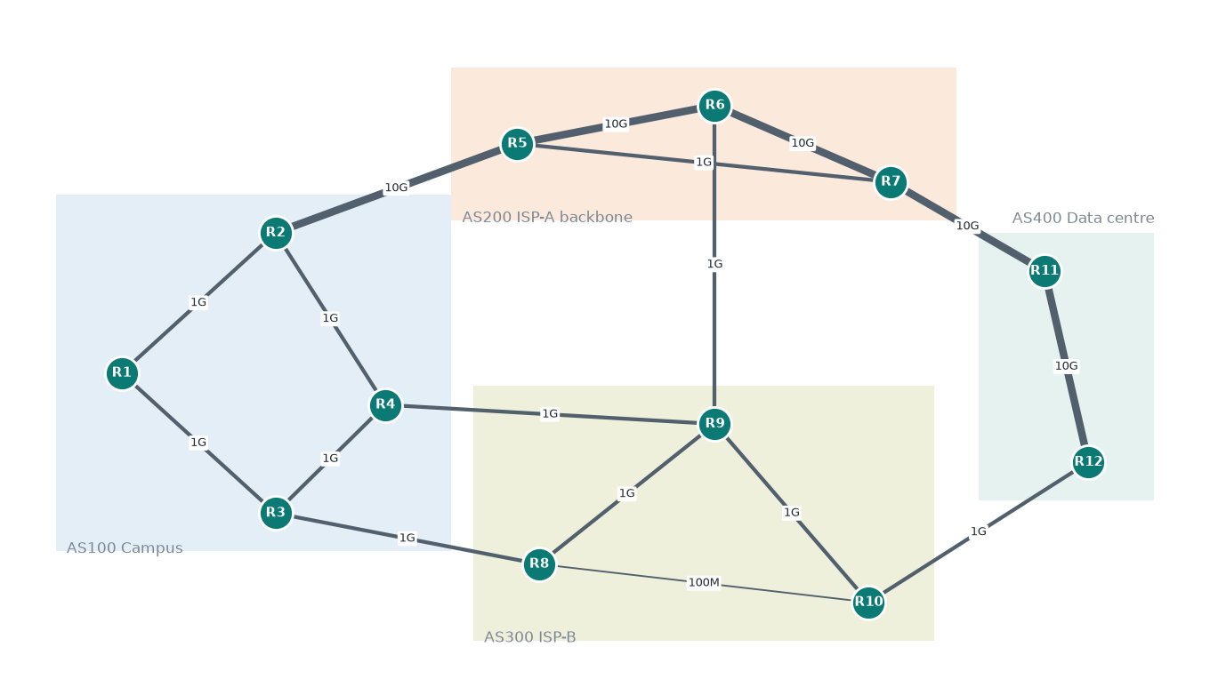
AS | Role | Characteristics
AS100 | Campus (sources R1-R4) | 1 Gbps internal links
AS200 | ISP-A backbone | 10 Gbps, heavily shared, frequent congestion
AS300 | ISP-B | 1 Gbps links plus a 100 Mbps shortcut (R8-R10)
AS400 | Data centre (destinations R11, R12) | 10 Gbps

The topology is built so that each protocol makes a different, defensible choice.
Flow | RIP (hop count) | OSPF (cost) | BGP (policy)
R1→R12 | R1-R3-R8-R10-R12 (4 hops, crosses 100 Mbps) | R1-R2-R5-R6-R7-R11-R12 (cost 15) | R1-R2-R4-R9-R10-R12 (via preferred AS300)
R1→R11 | R1-R2-R5-R7-R11 | R1-R2-R5-R6-R7-R11 | R1-R2-R4-R9-R10-R12-R11
R2→R12 | R2-R4-R9-R10-R12 | R2-R5-R6-R7-R11-R12 | R2-R4-R9-R10-R12
R3→R11 | R3-R8-R10-R12-R11 | R3-R1-R2-R5-R6-R7-R11 | R3-R4-R9-R10-R12-R11

3.2 Traffic model
Each link's utilisation is a mean-reverting AR(1) process around a base load. On top of that sit a daily cycle and randomly arriving congestion episodes (10-60 ticks, +25-60% utilisation, ramping up and fading). Episodes can also be injected by hand for demonstrations.

3.3 Metrics and quality score
Per link, from utilisation u:
- queueing delay ∝ u/(1−u) (M/M/1 shape, capped at 250 ms)
- jitter ∝ queueing delay
- loss: 0.05% floor, rising sharply as the buffer overflows near u ≈ 0.9
- available bandwidth = capacity × (1−u)
Path metrics aggregate across links: latency sums, jitter adds in quadrature, loss compounds, and available bandwidth is the bottleneck.
Quality score (0-100) = simplified ITU-T G.107 E-model R-factor (delay, jitter, loss impairments) × √(bandwidth sufficiency for a 150 Mbps flow).
Routers observe paths through noisy probes: ±8% latency noise, ±25% jitter noise, ±10% bandwidth noise, and loss counted over 100 pings. The model has to predict the true quality in the next tick from these measurements.

3.4 Dataset
 | Train | Test
Traffic seed | 1 | 2 (independent traffic)
Ticks | 6,000 | 2,000
Rows (tick × flow × candidate path) | 210,000 | 70,000
Flows | 4 | 4
Candidate paths per flow | 8-9 | 8-9

Features (9): latency, jitter, packet loss, available bandwidth, hop count, bottleneck capacity, and the change in latency, loss and bandwidth since the previous measurement. Target: realised quality score in the next tick. Mean 73.0, median 96.6. 26.5% of samples are below 60 (visibly degraded).

4. Model results
Random Forest: 150 trees, max depth 16, min 20 samples per leaf, 60% of features per split. Training takes 14 s. Inference is about 0.002 ms per path (batched).

4.1 Accuracy on unseen traffic (test seed)
Predictor | R² | MAE | RMSE
Random Forest | 0.897 | 4.69 | 10.77
Scoring formula on current measurements (no ML) | 0.876 | 5.56 | 11.82
Linear regression | 0.786 | 10.30 | 15.53

4.2 Cross-validation (5 folds, contiguous time blocks)
R² = 0.912 ± 0.009, MAE = 4.50
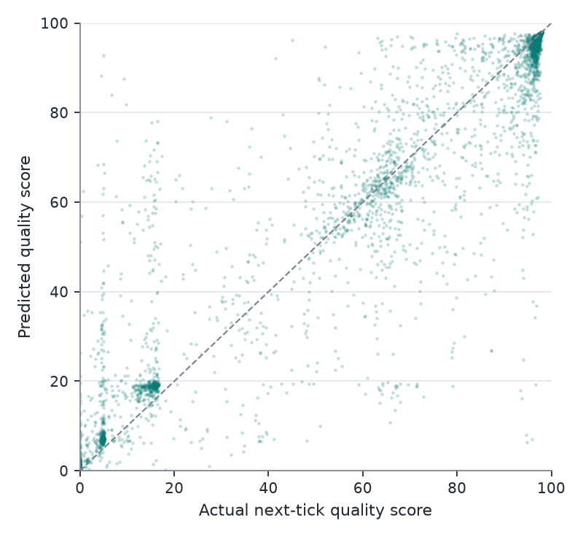
Most predictions sit on the diagonal. The large errors happen when a path's state changes sharply between the measurement and the next tick, for example when a congestion episode starts or ends. The absolute error correlates at r = 0.92 with the size of that change.

4.3 What drives the prediction (permutation importance on test data)
Feature | Drop in R² when shuffled
Latency | 0.275
Available bandwidth | 0.187
Packet loss | 0.061
Jitter | 0.043
Bandwidth trend | 0.009
Bottleneck capacity | 0.005
Latency trend | 0.003
Loss trend | 0.001
Hop count | 0.0001

Hop count, the only metric RIP uses, carries essentially no information about how a path will perform.
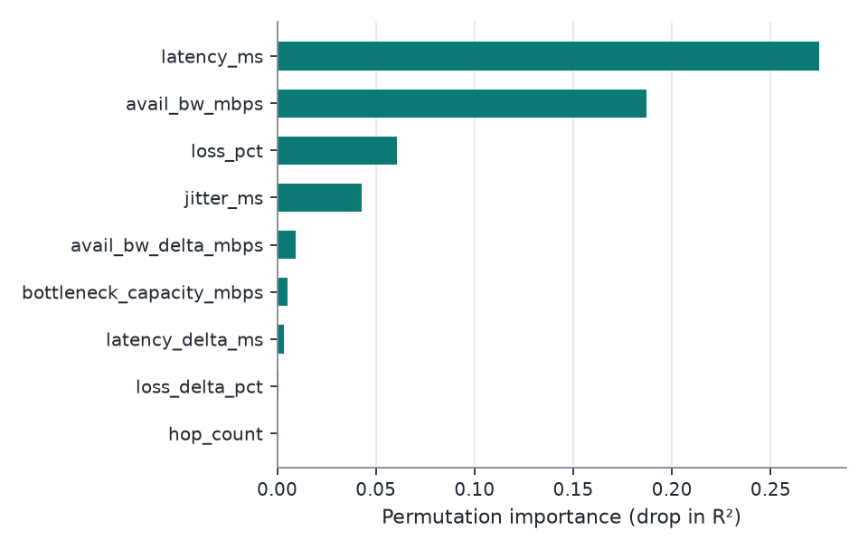

5. Baseline analysis: static protocols on unseen traffic
Mean next-tick quality of each protocol's fixed path, compared with the best fixed path in hindsight and with the per-tick best path (oracle):
Flow | RIP | OSPF | BGP | Best fixed path | Oracle | Best-path changes
R1→R11 | 89.5 | 75.4 | 73.1 | 89.5 | 95.8 | 161
R1→R12 | 50.1 | 74.9 | 73.4 | 89.0 | 96.1 | 177
R2→R12 | 73.8 | 75.5 | 73.8 | 89.6 | 96.0 | 165
R3→R11 | 50.0 | 75.1 | 73.3 | 89.4 | 96.4 | 395

Observations:
- No single fixed path is best. The best path changes 160-400 times in 2,000 ticks. A static protocol cannot follow this, however well it is configured.
- OSPF puts traffic on the 10 Gbps backbone, which is the most congested part of the network.
- RIP's result depends on the topology. For R1→R11 the fewest-hop route avoids the congested backbone and does well (89.5). For R1→R12 and R3→R11 it crosses the 100 Mbps link and scores about 50.
- The gap from the static protocols to the oracle (about 6-46 points) is what the ML engine aims to close.

6. Issues found and how they were resolved
Issue | Resolution
In the first calibration the backbone was congested almost all the time, so one static path was simply best and there was nothing to learn | Retuned base loads so the backbone is usually good but has congestion bursts; the best path now changes regularly
BGP initially chose the same paths as OSPF | Set local preference to favour ISP-B (the cheaper contract), so BGP follows policy rather than speed, which is realistic
First model file was 200 MB | Limited tree depth and leaf size: 16 MB, with slightly better test accuracy (R² 0.896 → 0.897)
The measured-metrics formula is already a strong predictor (R² 0.876) | Kept it as a named baseline so ML gains are reported honestly rather than only against static protocols

7. Remaining work (to final review)
- Recommendation engine: score candidates each tick, add hysteresis against route flapping.
- Closed-loop evaluation: ML, a non-ML adaptive router, RIP, OSPF, BGP and the oracle route the same flows on a fresh traffic seed. Compare quality, latency, loss, time degraded and route changes.
- Live dashboard: topology with link load, candidate path scores and each strategy's choice, with congestion injection for the demo.
- Packet Tracer validation: parse ping/tracert output and score measured paths.

8. Reproducing these results
python -m venv .venv && source .venv/bin/activate
pip install -r requirements.txt
python -m smartpath generate # datasets, topology figure, baseline tables
python -m smartpath train # model, metrics JSON, figures
pytest

