Kubernetes Scheduling Runthrough

This document provides step-by-step execution for each scenario.

Setup

Create namespace:
kubectl create namespace scheduling-demo
Check nodes:
kubectl get nodes
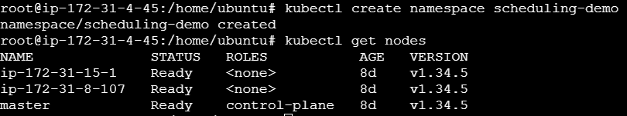

Remove taint in master node (Only if using MASTER-NODE as 3rd node)
kubectl taint nodes master node-role.kubernetes.io/control-plane:NoSchedule-
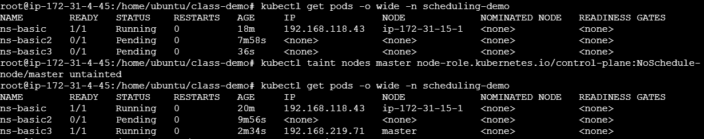

Label Nodes

kubectl label node ip-172-31-15-1 env=prod
kubectl label node ip-172-31-8-107 env=dev
kubectl label node master gpu=true
kubectl label node master disk=ssd
kubectl label node ip-172-31-15-1 generation=3
kubectl label node ip-172-31-8-107 generation=1
Verify:
kubectl get nodes --show-labels
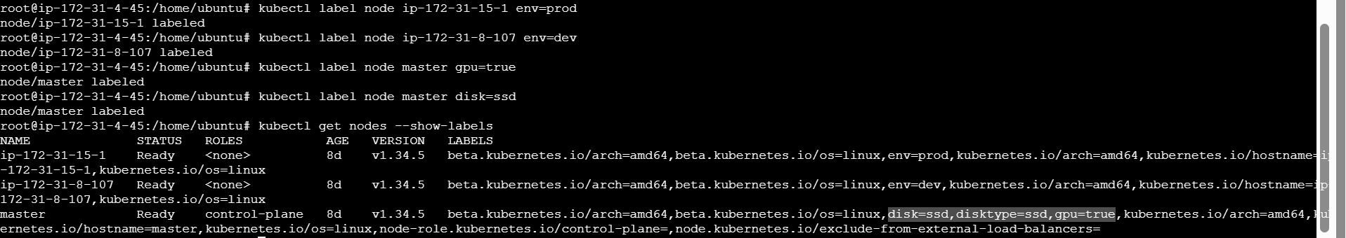

SCENARIO 1: NodeSelector Success

YAML

// ns-basic.yaml
apiVersion: v1
kind: Pod
metadata:
name: ns-basic
namespace: scheduling-demo
spec:
containers:
- name: nginx
image: nginx
nodeSelector:
env: prod

Apply
kubectl apply -f ns-basic.yaml

Verify
kubectl get pods -o wide -n scheduling-demo
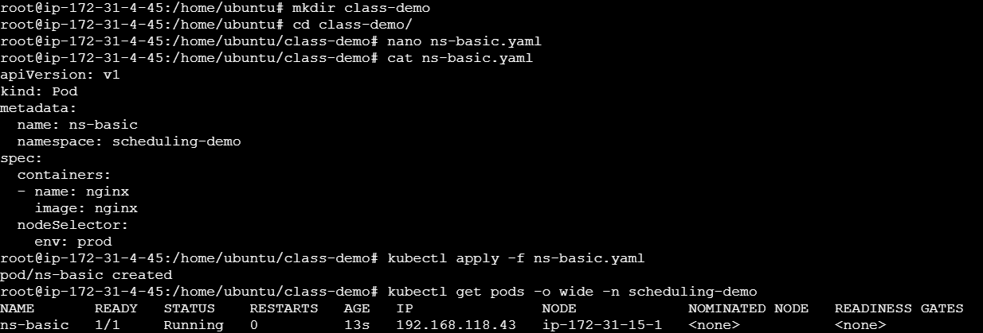

SCENARIO 2: NodeSelector Failure

YAML

// ns-basic2.yaml
apiVersion: v1
kind: Pod
metadata:
name: ns-basic2
namespace: scheduling-demo
spec:
containers:
- name: nginx
image: nginx
nodeSelector:
env: staging

Apply
kubectl apply -f ns-basic2.yaml

Verify
kubectl get pods -o wide -n scheduling-demo
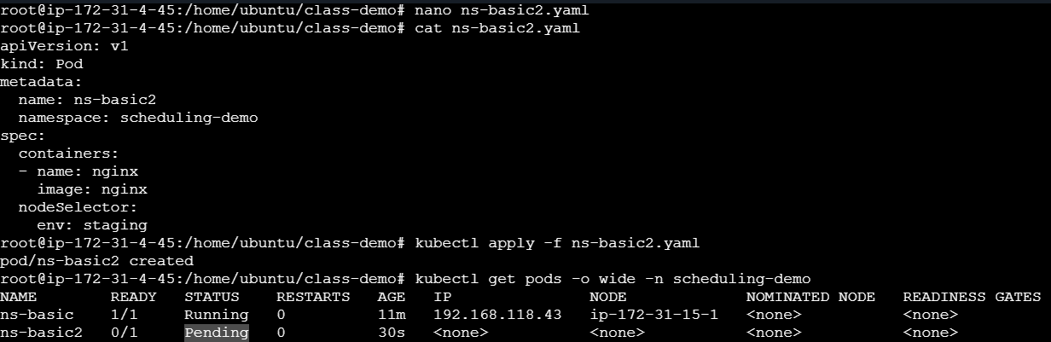
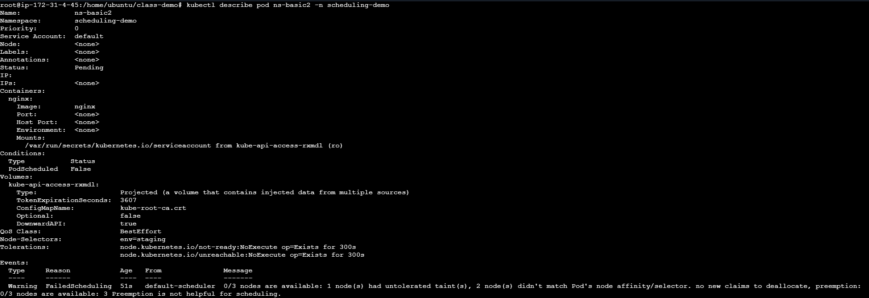

SCENARIO 3: NodeSelector AND

YAML

// ns-basic3.yaml
apiVersion: v1
kind: Pod
metadata:
name: ns-basic3
namespace: scheduling-demo
spec:
containers:
- name: nginx
image: nginx
nodeSelector:
gpu: "true"
disk: ssd

Apply
kubectl apply -f ns-basic3.yaml

Verify
kubectl get pods -o wide -n scheduling-demo
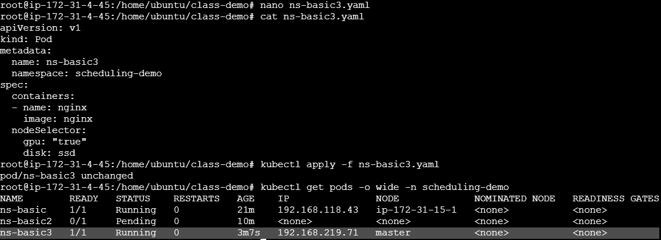

SCENARIO 4: Node Affinity Required

YAML

// affinity-required.yaml
apiVersion: v1
kind: Pod
metadata:
name: affinity-required
namespace: scheduling-demo
spec:
containers:
- name: nginx
image: nginx
affinity:
nodeAffinity:
requiredDuringSchedulingIgnoredDuringExecution:
nodeSelectorTerms:
- matchExpressions:
- key: env
operator: In
values:
- prod

Apply
kubectl apply -f affinity-required.yaml

Verify
kubectl get pods -o wide -n scheduling-demo
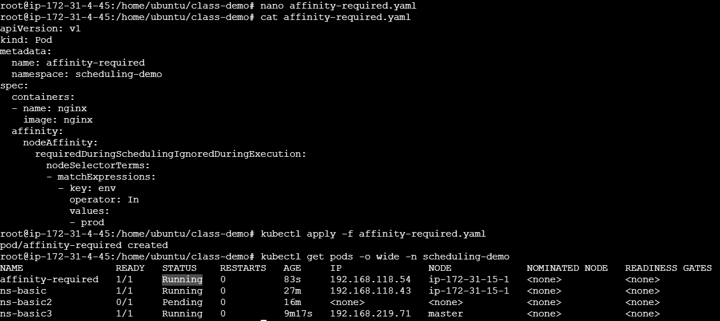

SCENARIO 5: Node Affinity Failure

YAML

// affinity-required2.yaml
apiVersion: v1
kind: Pod
metadata:
name: affinity-required2
namespace: scheduling-demo
spec:
containers:
- name: nginx
image: nginx
affinity:
nodeAffinity:
requiredDuringSchedulingIgnoredDuringExecution:
nodeSelectorTerms:
- matchExpressions:
- key: env
operator: In
values:
- staging

Apply
kubectl apply -f affinity-required2.yaml

Verify
kubectl get pods -o wide -n scheduling-demo
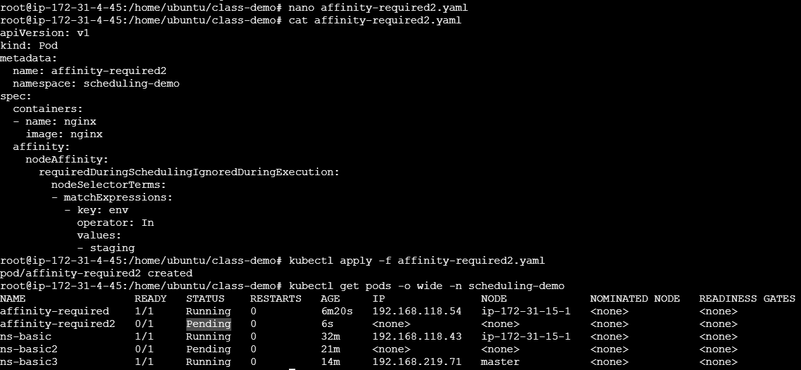

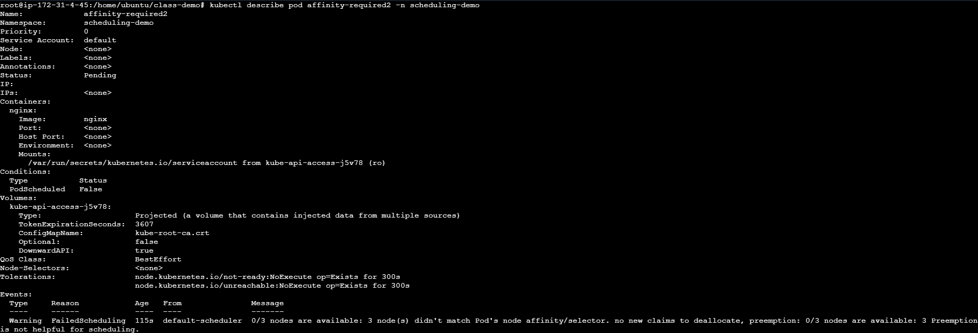

SCENARIO 6: Preferred Affinity

YAML

// affinity-preferred.yaml
apiVersion: v1
kind: Pod
metadata:
name: affinity-preferred
namespace: scheduling-demo
spec:
containers:
- name: nginx
image: nginx
affinity:
nodeAffinity:
preferredDuringSchedulingIgnoredDuringExecution:
- weight: 10
preference:
matchExpressions:
- key: env
operator: In
values:
- prod

Apply
kubectl apply -f affinity-preferred.yaml

Verify
kubectl get pods -o wide -n scheduling-demo
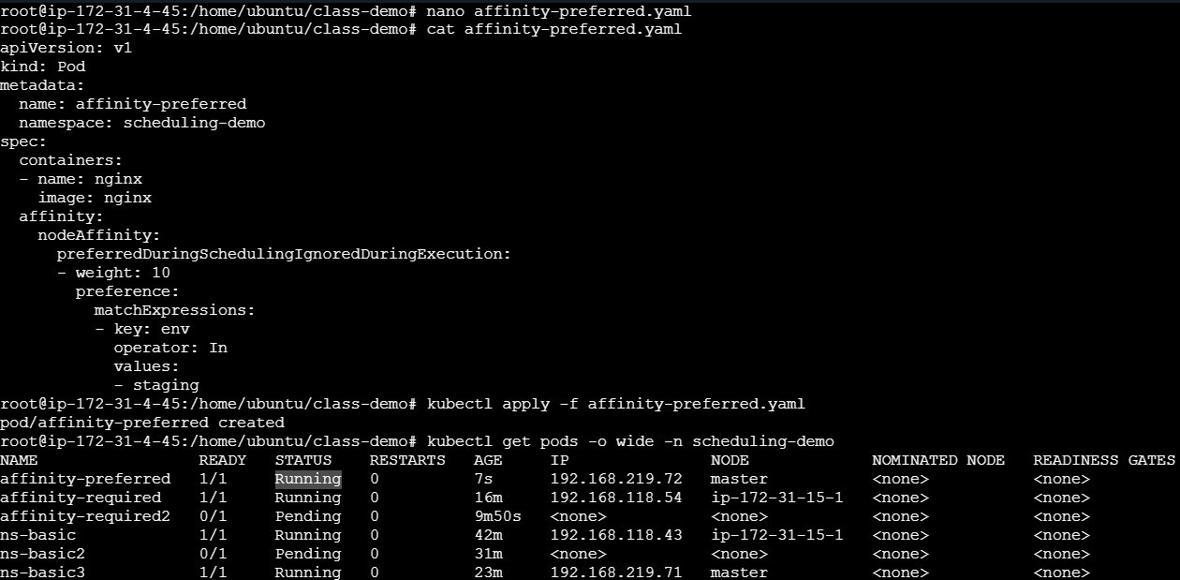

SCENARIO 7: Preferred Multi

YAML

// affinity-preferred-multi.yaml
apiVersion: v1
kind: Pod
metadata:
name: affinity-preferred-multi
namespace: scheduling-demo
spec:
containers:
- name: nginx
image: nginx
affinity:
nodeAffinity:
preferredDuringSchedulingIgnoredDuringExecution:
- weight: 50
preference:
matchExpressions:
- key: env
operator: In
values:
- prod
- weight: 30
preference:
matchExpressions:
- key: disk
operator: In
values:
- ssd
- weight: 20
preference:
matchExpressions:
- key: gpu
operator: In
values:
- "true"

Apply
kubectl apply -f affinity-preferred-multi.yaml

Verify
kubectl get pods -o wide -n scheduling-demo
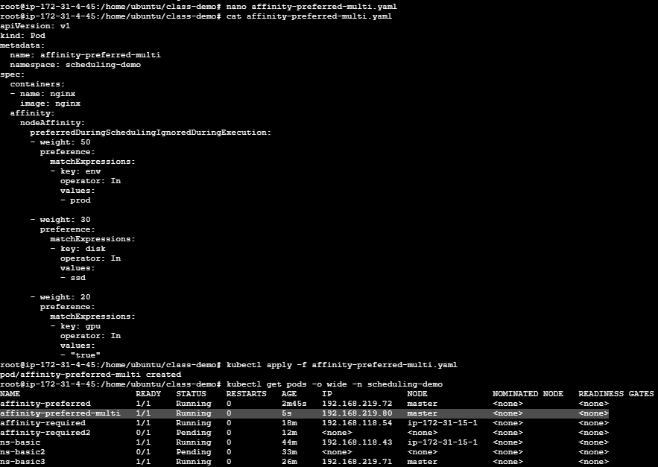

SCENARIO 8: Exists

YAML

// affinity-exists.yaml
apiVersion: v1
kind: Pod
metadata:
name: affinity-exists
namespace: scheduling-demo
spec:
containers:
- name: nginx
image: nginx
affinity:
nodeAffinity:
requiredDuringSchedulingIgnoredDuringExecution:
nodeSelectorTerms:
- matchExpressions:
- key: gpu
operator: Exists

Apply
kubectl apply -f affinity-exists.yaml

Verify
kubectl get pods -o wide -n scheduling-demo
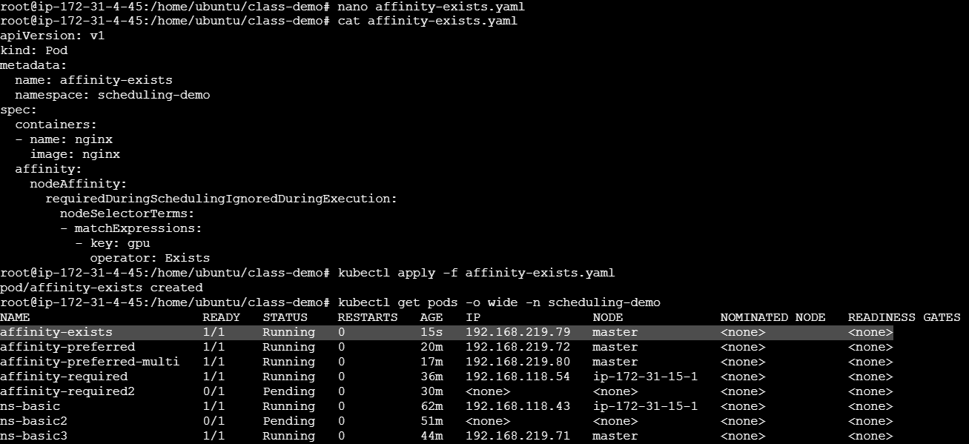

SCENARIO 9: NotIn

YAML

// affinity-notin.yaml
apiVersion: v1
kind: Pod
metadata:
name: affinity-notin
namespace: scheduling-demo
spec:
containers:
- name: nginx
image: nginx
affinity:
nodeAffinity:
requiredDuringSchedulingIgnoredDuringExecution:
nodeSelectorTerms:
- matchExpressions:
- key: env
operator: NotIn
values:
- dev

Apply
kubectl apply -f affinity-notin.yaml

Verify
kubectl get pods -o wide -n scheduling-demo

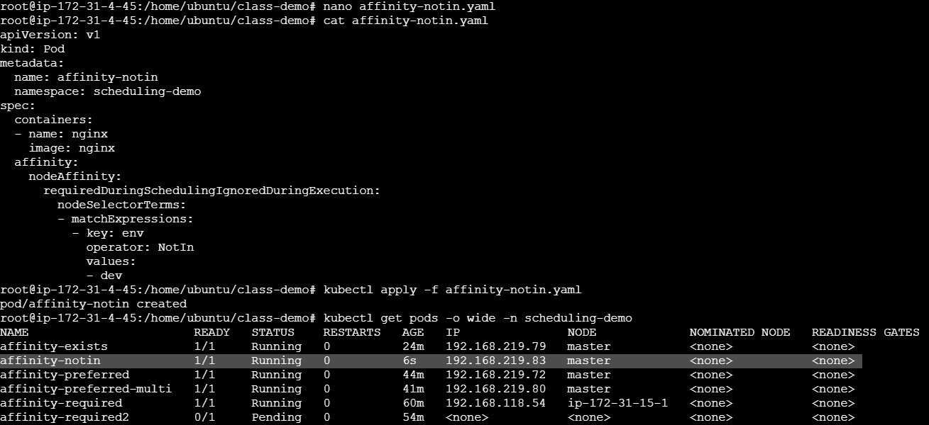

SCENARIO 10: DoesNotExist

YAML
// affinity-doesnotexist.yaml
apiVersion: v1
kind: Pod
metadata:
name: affinity-doesnotexist
namespace: scheduling-demo
spec:
containers:
- name: nginx
image: nginx
affinity:
nodeAffinity:
requiredDuringSchedulingIgnoredDuringExecution:
nodeSelectorTerms:
- matchExpressions:
- key: gpu
operator: DoesNotExist

Apply
kubectl apply -f affinity-doesnotexist.yaml

Verify
kubectl get pods -o wide -n scheduling-demo

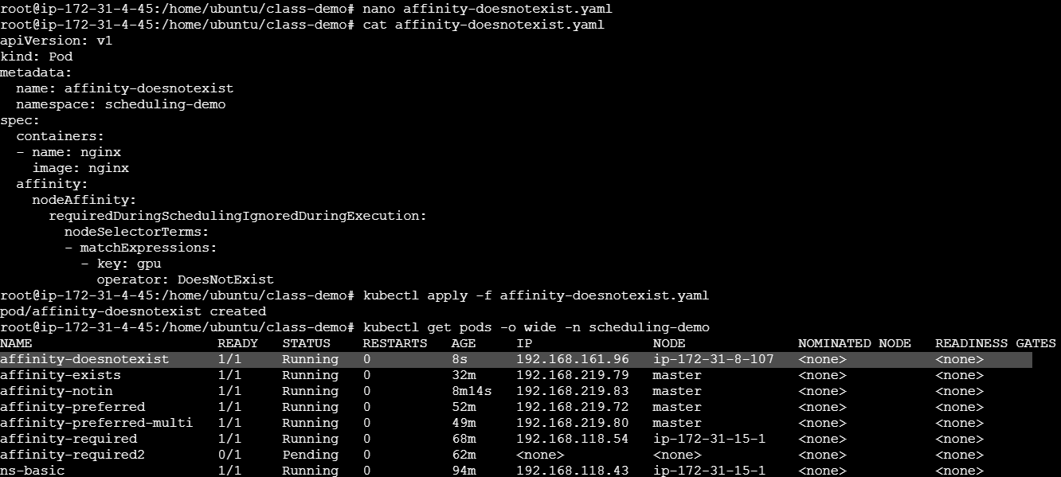

SCENARIO 11: Gt

YAML

// affinity-gt.yaml
apiVersion: v1
kind: Pod
metadata:
name: affinity-gt
namespace: scheduling-demo
spec:
containers:
- name: nginx
image: nginx
affinity:
nodeAffinity:
requiredDuringSchedulingIgnoredDuringExecution:
nodeSelectorTerms:
- matchExpressions:
- key: cpu
operator: Gt
values:
- "2"

Apply
kubectl apply -f affinity-gt.yaml

Verify
kubectl get pods -o wide -n scheduling-demo
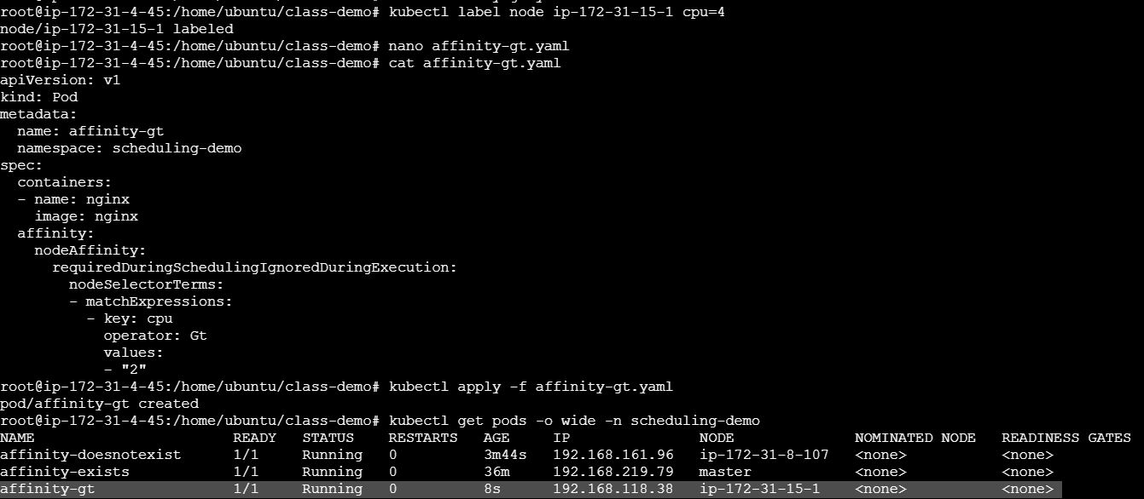

SCENARIO 12: Lt

YAML

// affinity-lt.yaml
apiVersion: v1
kind: Pod
metadata:
name: affinity-lt
namespace: scheduling-demo
spec:
containers:
- name: nginx
image: nginx
affinity:
nodeAffinity:
requiredDuringSchedulingIgnoredDuringExecution:
nodeSelectorTerms:
- matchExpressions:
- key: cpu
operator: Lt
values:
- "10"

Apply
kubectl apply -f affinity-lt.yaml

Verify
kubectl get pods -o wide -n scheduling-demo
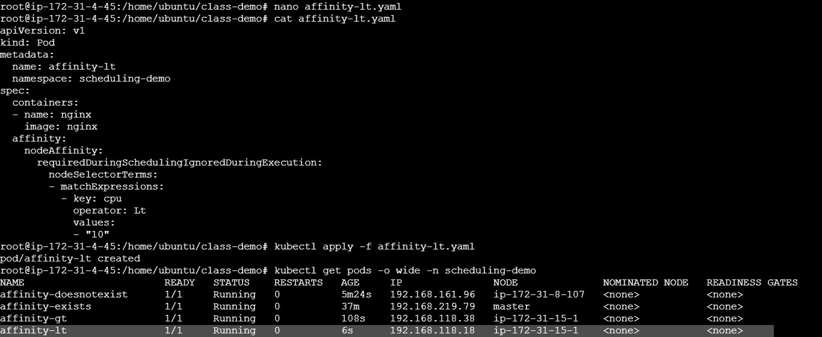

SCENARIO 13: OR Logic

YAML

// affinity-or.yaml
apiVersion: v1
kind: Pod
metadata:
name: affinity-or
namespace: scheduling-demo
spec:
containers:
- name: nginx
image: nginx
affinity:
nodeAffinity:
requiredDuringSchedulingIgnoredDuringExecution:
nodeSelectorTerms:
- matchExpressions:
- key: env
operator: In
values:
- prod
- matchExpressions:
- key: env
operator: In
values:
- dev

Apply
kubectl apply -f affinity-or.yaml

Verify
kubectl get pods -o wide -n scheduling-demo
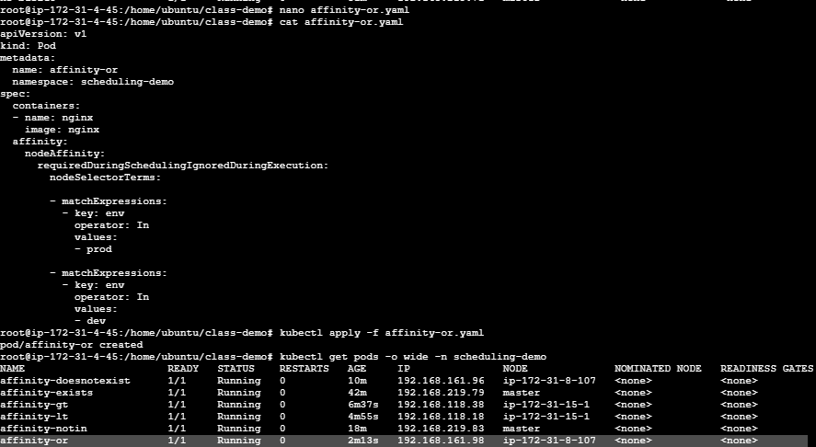

SCENARIO 14: AND Logic

YAML

// affinity-and.yaml
apiVersion: v1
kind: Pod
metadata:
name: affinity-and
namespace: scheduling-demo
spec:
containers:
- name: nginx
image: nginx
affinity:
nodeAffinity:
requiredDuringSchedulingIgnoredDuringExecution:
nodeSelectorTerms:
- matchExpressions:
- key: gpu
operator: Exists
- key: disk
operator: In
values:
- ssd

Apply
kubectl apply -f affinity-and.yaml

Verify
kubectl get pods -o wide -n scheduling-demo

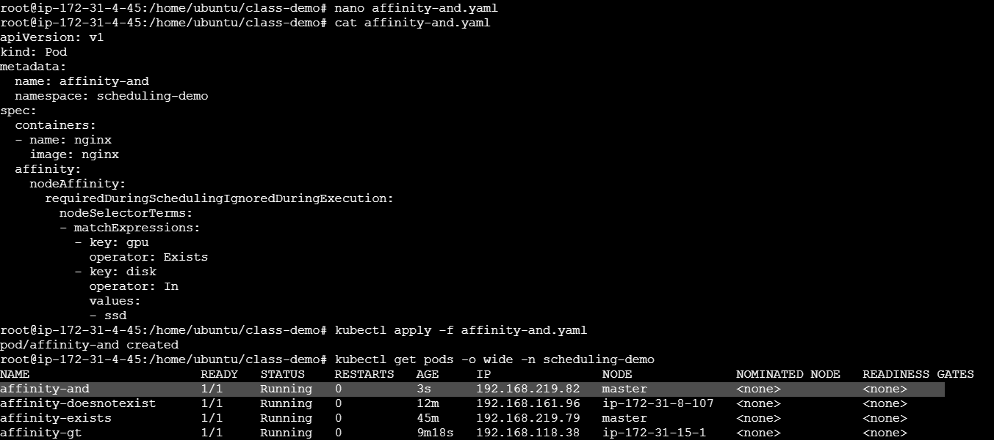

SCENARIO 15: Anti-Affinity Required

YAML

// anti-affinity-demo.yaml
apiVersion: v1
kind: Pod
metadata:
name: anti-affinity-demo
namespace: scheduling-demo
labels:
app: nginx-aa
spec:
containers:
- name: nginx
image: nginx
affinity:
podAntiAffinity:
requiredDuringSchedulingIgnoredDuringExecution:
- labelSelector:
matchLabels:
app: nginx-aa
topologyKey: kubernetes.io/hostname

Apply
kubectl apply -f anti-affinity-demo.yaml

Verify
kubectl get pods -o wide -n scheduling-demo
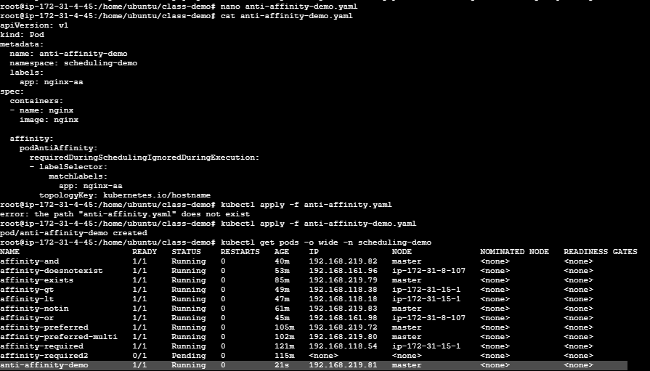

SCENARIO 16: Anti-Affinity Multiple Pods

Repeat with new names:
kubectl apply -f anti-affinity-demo2.yaml
kubectl apply -f anti-affinity-demo3.yaml

Verify
kubectl get pods -o wide -n scheduling-demo
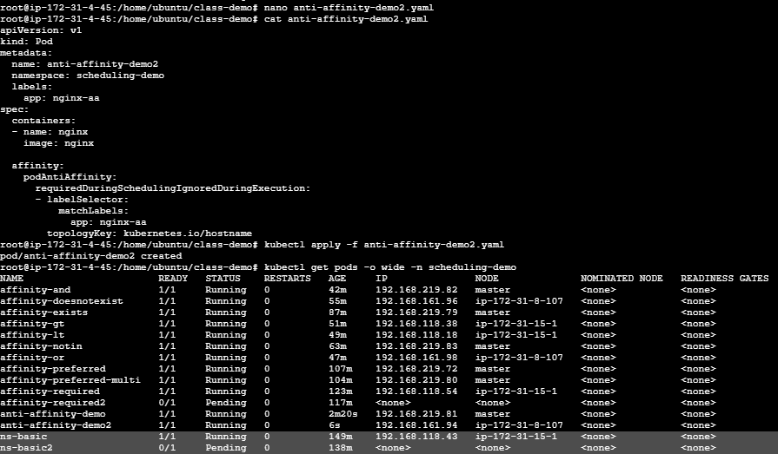
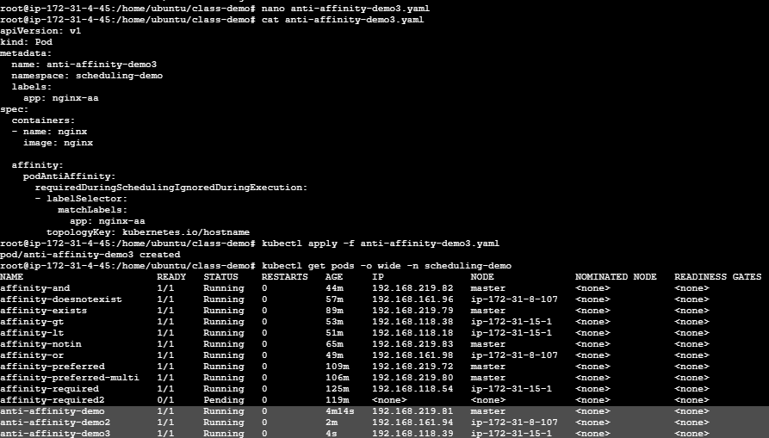

SCENARIO 17: Anti-Affinity Failure

Deploy extra pod:
kubectl apply -f anti-affinity-demo4.yaml

Verify
kubectl get pods -o wide -n scheduling-demo
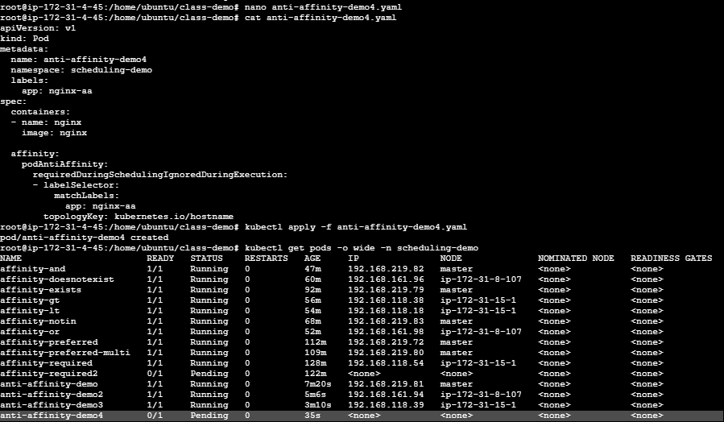

SCENARIO 18: Anti-Affinity Preferred

YAML

// anti-affinity-soft.yaml
apiVersion: v1
kind: Pod
metadata:
name: anti-affinity-soft
namespace: scheduling-demo
labels:
app: nginx-soft
spec:
containers:
- name: nginx
image: nginx
affinity:
podAntiAffinity:
preferredDuringSchedulingIgnoredDuringExecution:
- weight: 100
podAffinityTerm:
labelSelector:
matchLabels:
app: nginx-soft
topologyKey: kubernetes.io/hostname

Apply
kubectl apply -f anti-affinity-soft.yaml

Verify
kubectl get pods -o wide -n scheduling-demo
