A Summer Internship Project Report on
“HealthConnect: Digital Healthcare Management Platform”

Submitted in partial fulfilment of the Requirements for the award of the Degree of

BACHELOR OF TECHNOLOGY

IN

COMPUTER SCIENCE & ENGINEERING

By
K. Rishith Reddy
22EG1A0501
Under the Guidance of
K . Mahesh sir



Department of Computer Science &Engineering ANURAG UINVERSITY

GHATKESAR (M), MEDCHAL DISTRICT,
Hyderabad-88
Academic Year: 2025-2026

ANURAG UNIVERSIY
Department of Computer Science & Engineering



CERTIFICATE

I, K. Rishith Reddy, bearing hall ticket number, 22EG1A0501, hereby declare that the project report entitled “HealthConnect: Digital Healthcare Management Platform” Department of Computer Science & Engineering, Anurag University, Hyderabad, is submitted in partial fulfilment of the requirement for the award of the degree of Bachelor of Technology in Computer Science & Engineering.
This is a record of bonafide work carried out by me and the results embodied in this project report have not been submitted to any other university or institute for the award of any other degree or diploma.

Signature of The Guide K. Rishith Reddy
________________________ 22EG1A0501

ACKNOWLEDGMENT

I would like to express my sincere thanks and deep sense of gratitude to project supervisor K. Mahesh sir, for his constant encouragement and inspiring guidance without which this project could not have been completed. His critical reviews and constructive comments improved our grasp of the subject and steered to the fruitful completion of the work. His patience, guidance and encouragement made this project possible.

I would like to express my sincere gratitude to Dr. Archana Mantri, Vice Chancellor, Anurag University and Dr. Gopal Reddy, Registrar, Anurag University for their encouragement and support.

I would like to express my special thanks to Dr. V. Vijaya Kumar, Dean School of Engineering, Anurag University, for his encouragement and timely support in our B.Tech program.

I would like to acknowledge my sincere gratitude for the support extended by Dr. G. Vishnu Murthy, Dean, Department of Computer Science Engineering, Anurag University. We also express my deep sense of gratitude to K. Mahesh sir, Head, CSE-Cluster-II, whose research expertise and commitment to the highest standards continuously motivated us during the crucial stage of our project work.

K. Rishith Reddy
22EG1A0501

DECLARATION

I hereby declare that the project entitled “Healthconnect” submitted to the Department of Computer Science and Engineering is an original work carried out by us under the guidance of Dr. N. Swapna Goud. The work presented in this report has not been submitted elsewhere for the award of any degree.

K. Rishith Reddy
22EG1A0501

TABLE OF CONTENTS
TOPICS PAGE NO.
Acknowledgement i
Declaration ii
Abstract iii
1. Introduction 1
- 2. Problem Statement 2
- 3. Objectives 3
- 4. Scope of the Project 4
- 5. Existing System 5
- 6. Proposed System 6
- 7. Software & Hardware Requirements 7
- 8. System Design 8
- 9. Flowchart & Algorithm 9
- 10. Modules Description 10
- 11. Implementation 11
- 12. Results / Output Screens 12
- 13. Advantages & Limitations 13
- 14. Future Enhancements 14
- 15. Conclusion 15
- 16. References 16
- 17. Source Code 17

1. Introduction
HealthConnect is a comprehensive digital healthcare management platform designed to streamline interactions between patients, medical professionals, and administrators. Built on the modern MERN (MongoDB, Express.js, React, Node.js) technology stack, the application establishes a role-based environment tailored to meet the dynamic needs of contemporary clinical settings. The system allows patients to register, search for clinicians by specialty, schedule appointments, and manage medical records. Simultaneously, it provides doctors with tools to handle patient visits, write e-prescriptions, and manage daily schedules.
Administrators hold the authority to verify registering doctors, maintain user records, and adjust clinical categories. By integrating these workflows, HealthConnect aims to replace fragmented legacy paper methods with a secure, real-time digital workspace. The platform helps patients manage their complete healthcare journey dynamically, ensuring accessibility, transparency, and clinical auditability across the entire patient experience.

2. Problem Statement
Traditional healthcare administration often suffers from deep inefficiencies due to reliance on physical record-keeping and manual scheduling. Patients experience significant delays in scheduling consultations, while doctors face difficulties in managing scheduling conflicts and tracking longitudinal patient history.
The fragmentation of clinical documents across physical folders often leads to diagnostic errors or incomplete treatment paths, as medical summaries, prescription sheets, and lab results are rarely compiled in a single chronological view. Furthermore, verification of clinician credentials and credentials management remains an administrative challenge, raising risks of unverified medical practices. There is a critical need for an integrated system that addresses these issues securely and transparently.

3. Objectives
The main objectives of the HealthConnect project are as follows:
• To build a web-based, role-based healthcare portal using the MERN stack that automates the appointment scheduling process.
• To implement a secure digital health folder system where patients can upload scanned reports, prescriptions, and medical files.
• To construct a dynamic treatment timeline that automatically organizes patient-doctor consultations and medical history chronologically.
• To provide doctors with a digital consultation workspace to prescribe medicines, write consultation summaries, and schedule follow-ups.
• To design an administrative verification dashboard to audit registering doctors and control the listings of active clinics.

4. Scope of the Project
The scope of HealthConnect encompasses three primary user modules:
• Patient Module: Users can search for doctors by name or specialization, view standard clinical profiles, choose booking slots, and review upcoming/completed consultations. They can also upload files to their personal medical folder and view e-prescriptions.
• Doctor Module: Clinicians can configure standard availability windows, review and manage appointment slots (accepting, declining, or initiating consultations), write e-prescriptions, and view the patient's full medical history.
• Admin Module: Administrators oversee the platform by managing the global directory of verified and pending doctors, verifying credentials, and configuring clinical specialties.

5. Existing System
The existing clinical system is heavily reliant on manual registry books, paper records, and telephonic appointment bookings. Patient medical files are kept in physical folders that are stored locally at the clinic, making them inaccessible to other healthcare facilities or the patient themselves when off-site.
Prescriptions are hand-written, which frequently leads to misunderstandings due to illegible handwriting and drug-interaction oversight. Appointment slots are managed on physical calendars, which are prone to double-booking and manual clerical errors. In addition, verifying a doctor's license requires physical paperwork and manual back-and-forth communication, leading to long delays.

6. Proposed System
The proposed HealthConnect system is a web-based management platform that automates clinical operations. By utilizing a single Mongo database, patient files, appointment details, and doctor schedules are stored in real-time. Slot booking is dynamic; once a patient books a slot, it is immediately updated to prevent duplicate bookings.
Medical histories are digitized and presented as a chronological timeline, linking doctor visits, digital prescriptions, and personal file uploads in a single interface. Clinician registration undergoes a clear administrative review queue, ensuring only verified doctors can accept patients. This reduces administrative overhead and minimizes clerical errors.

7. Software & Hardware Requirements
Software Requirements:
• Operating System: Windows 10/11 or Linux
• Frontend Library: React.js (Vite)
• Backend Runtime: Node.js with Express.js
• Database Server: MongoDB Community Server
• Development IDE: Visual Studio Code
• Version Control: Git and GitHub
Hardware Requirements:
• Processor: Intel Core i5 or AMD Ryzen 5 equivalent (2.0 GHz or higher)
• RAM: 8 GB Minimum (16 GB Recommended)
• Storage: 256 GB SSD (Solid State Drive)
• Network: Broadband Internet connection for server-client communication

8. System Design
HealthConnect follows a 3-tier client-server architecture. The presentation layer is built with React.js, providing an interactive dashboard. The application logic layer is powered by Node.js and Express.js, exposing RESTful API endpoints. The data tier uses MongoDB for document storage.
The database schema includes key collections:
• Users: Stores common authentication credentials, profile pictures, and roles.
• Doctors: Holds specialization, consultation fees, bio, verification status, and availability slots.
• Appointments: Represents the state of a visit (patient, doctor, date, slot time, status, symptoms, consultation notes, prescriptions, and follow-ups).

9. Flowchart & Algorithm
Algorithm for Slot Booking:
1. The patient logs into the platform and selects 'Find Doctors'.
2. The patient filters by specialty or searches by doctor name.
3. The patient clicks on the selected doctor's profile to view active schedules.
4. The system queries MongoDB for existing booked appointments for the selected date.
5. Available slots are rendered in the browser. The patient selects a slot, enters symptoms, and clicks 'Book'.
6. The system checks slot availability. If available, it creates an appointment record with status 'pending' and locks the slot. If not, it prompts the patient to choose another slot.
7. The doctor's dashboard is updated in real-time with the booking request.

10. Modules Description
The application is divided into four major functional modules:
• Authentication Module: Handles user registration, secure password hashing (BCrypt), and JSON Web Token (JWT) generation for session management.
• Patient Dashboard Module: Renders search fields, booking schedules, timeline elements, and file upload fields.
• Clinician Workspace Module: Features counters for scheduled visits, list of patients, calendar configuration, and prescription rows builder.
• Administration Directory Module: Provides tables for user registry, pending clinic sign-ups, and specialities list management.

11. Implementation
The implementation involves React.js on the client and Express on the backend. The backend uses Mongoose to define models and handle queries. Key controllers manage routes:
• authController.js: Manages login, registration, and role authentication.
• doctorController.js: Manages doctor availability slots and patient consultation records.
• appointmentController.js: Manages booking flow, cancellation, and history retrieval.
• adminController.js: Manages category updates and credential verification.
The frontend is organized into layout shells (Navbar, Sidebar) and pages (AdminDashboard, DoctorDashboard, MyAppointments, FindDoctors, MedicalRecords, Prescriptions, ProfileSettings). Client-server communication is achieved using Axios HTTP instances.

12. Results / Output Screens
The system has been manually verified and tested with several key user workflows:
• Patient Registration and Login: Successfully creates accounts and handles logins, routing users to their designated roles.
• Find Doctors page: Correctly lists verified clinicians and filters based on selected specialities.
• Slot Booking: Dynamically shows available slots and locks slots on booking.
• Doctor Consultation Workspace: Successfully logs consultation notes, adds multiple prescription medicines with dosage instructions, and schedules follow-up checkups.
• Medical Timeline: Properly displays consultations, PDF reports, and medication details chronologically.
Below are the verified output screens captured during clinical operations:
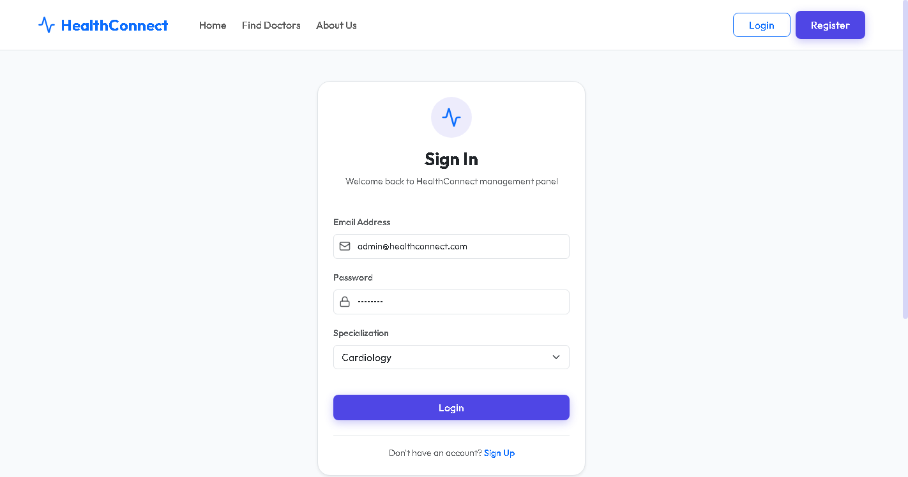
Figure 12.1: Admin Role Login Interface Screen
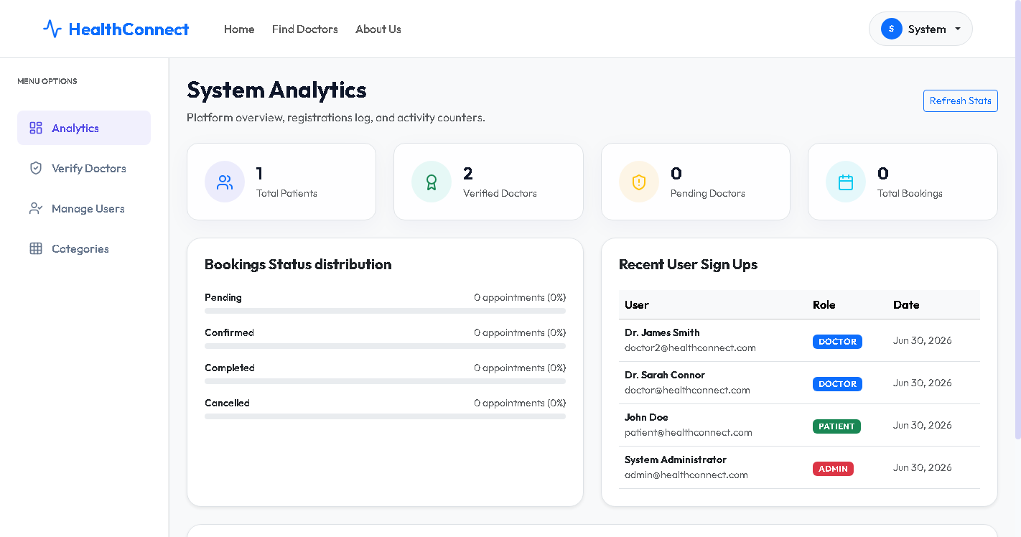
Figure 12.2: Admin Dashboard Console showing Metrics & Statistics
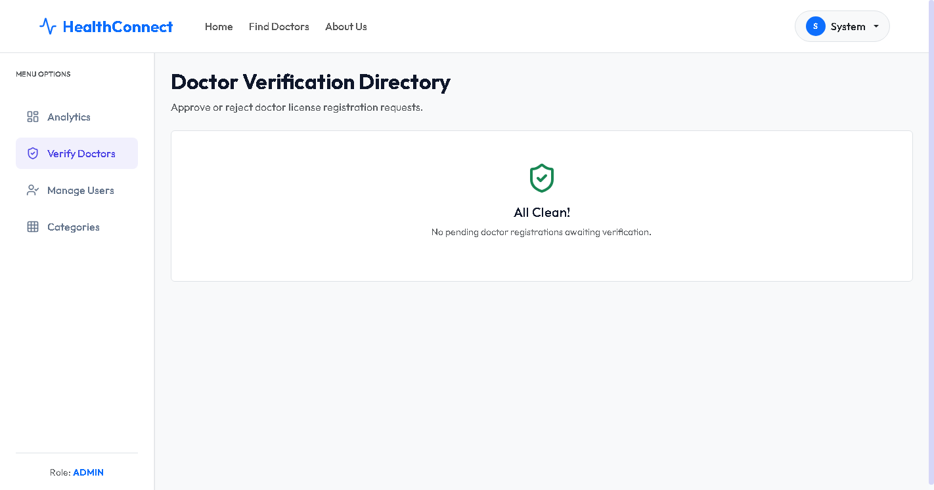
Figure 12.3: Doctor Credentials Verification Directory

Figure 12.4: Doctor Verification Directory (Queue Cleared Post-Approval)
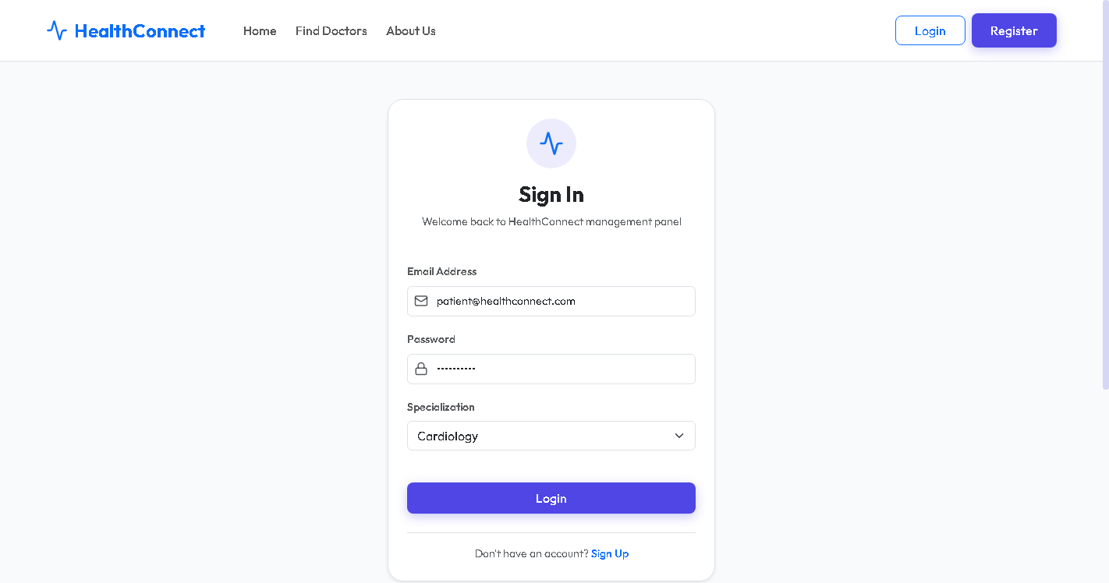
Figure 12.5: Patient Login Interface Screen
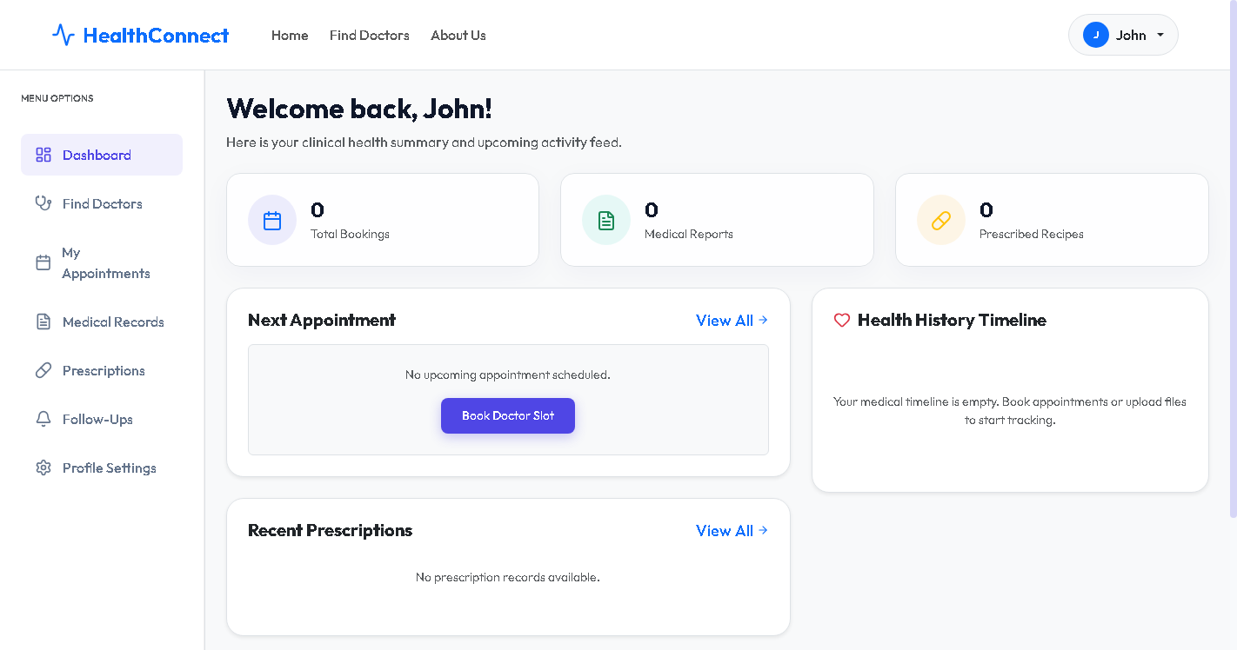
Figure 12.6: Patient Dashboard Welcome Console
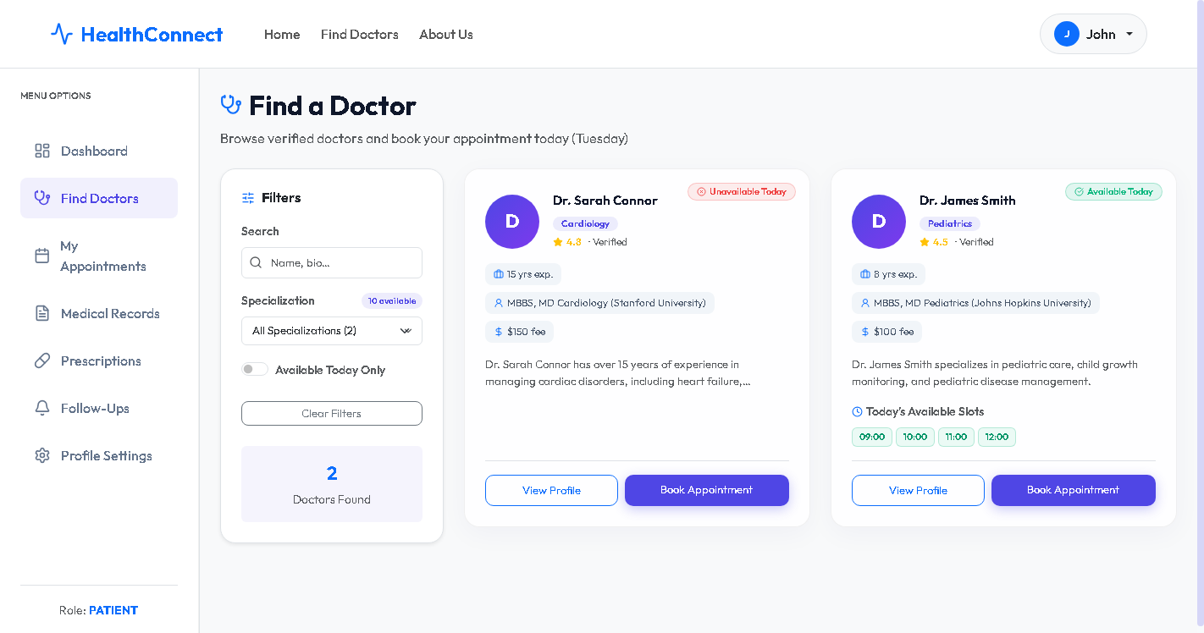
Figure 12.7: Find Doctors Directory showing active Clinicians
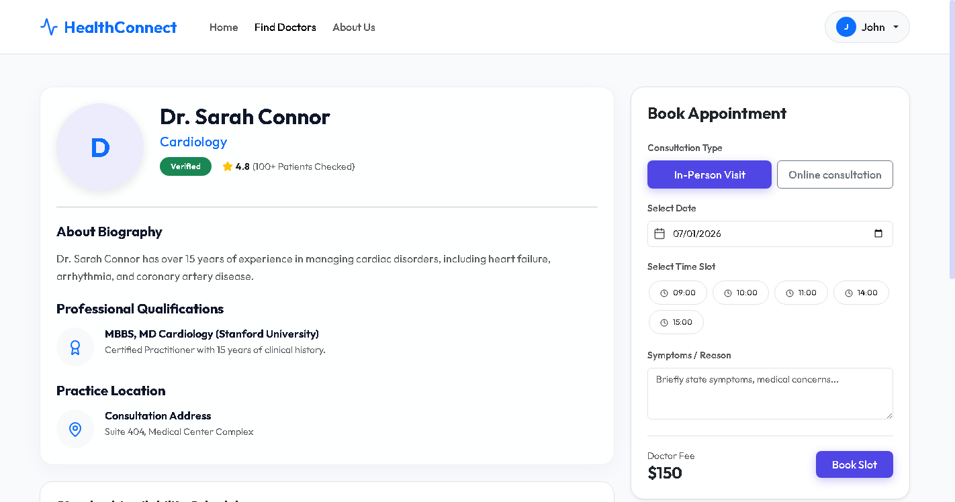
Figure 12.8: Doctor profile page showing date-slot availability configurations
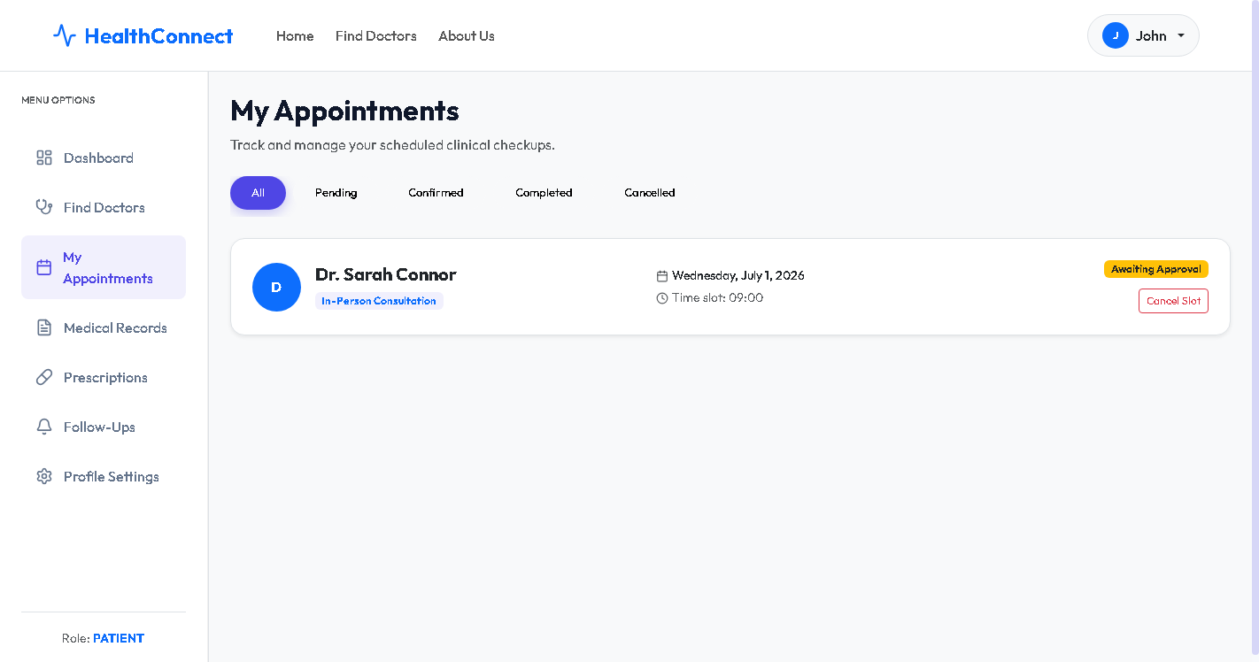
Figure 12.9: Patient Appointments Registry showing booked pending slots
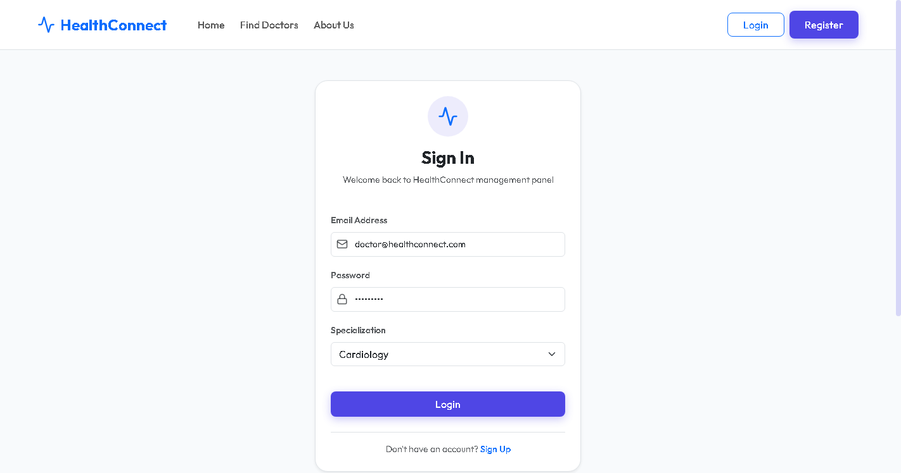
Figure 12.10: Doctor Login Interface Screen
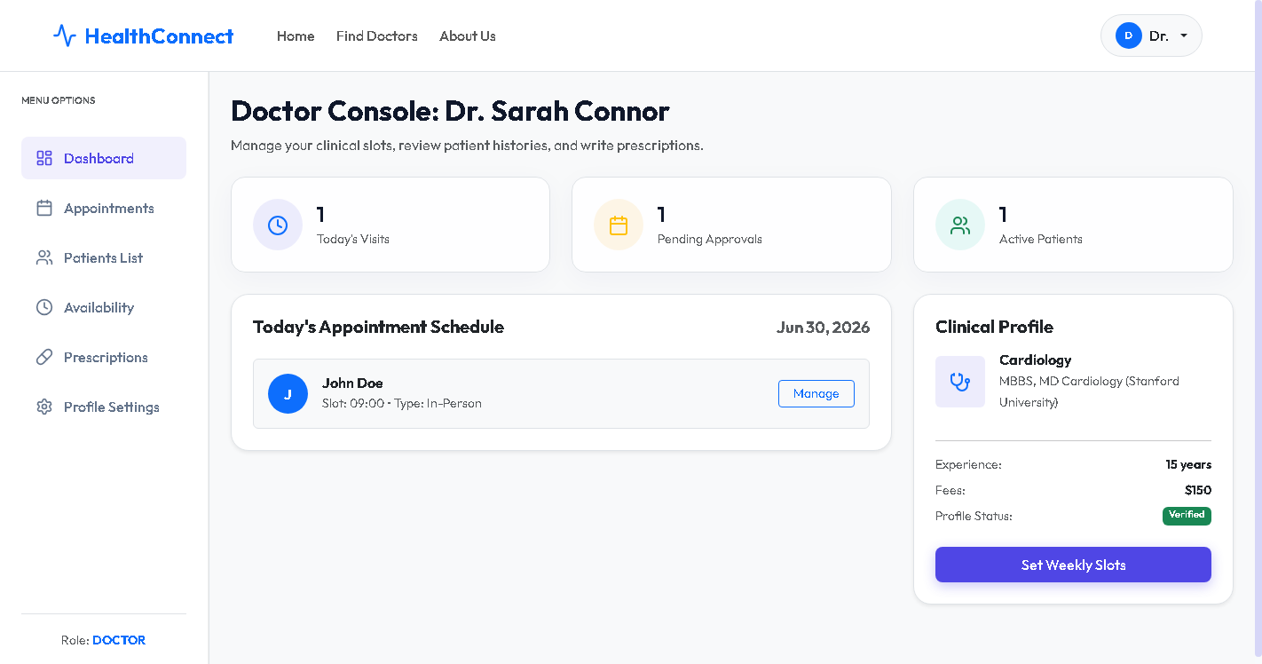
Figure 12.11: Doctor Console showing verified panel options
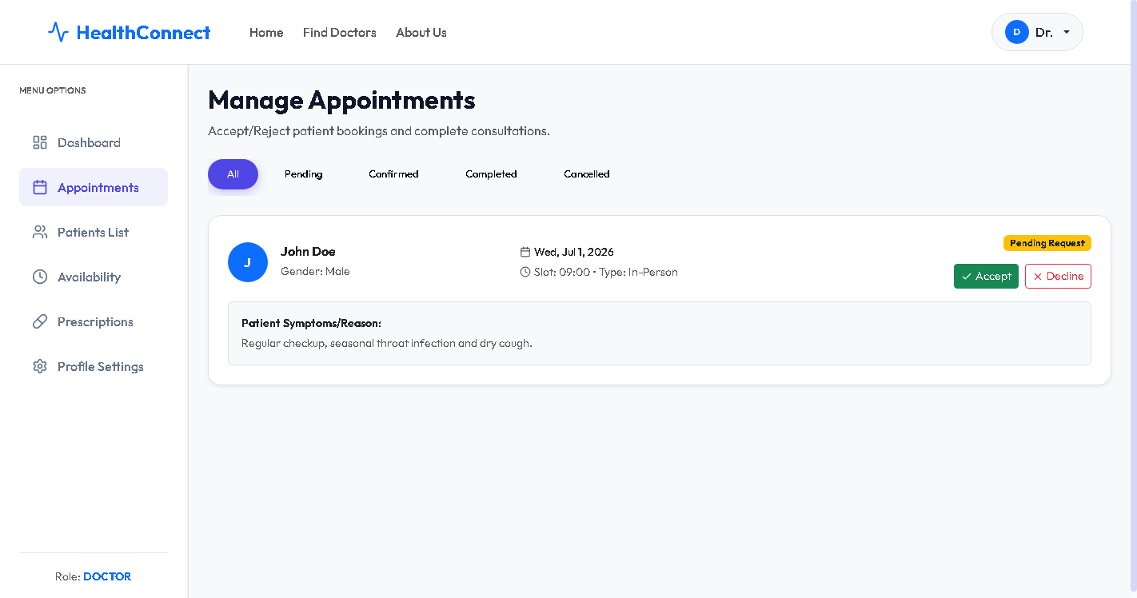
Figure 12.12: Doctor appointments queue with pending booking requests
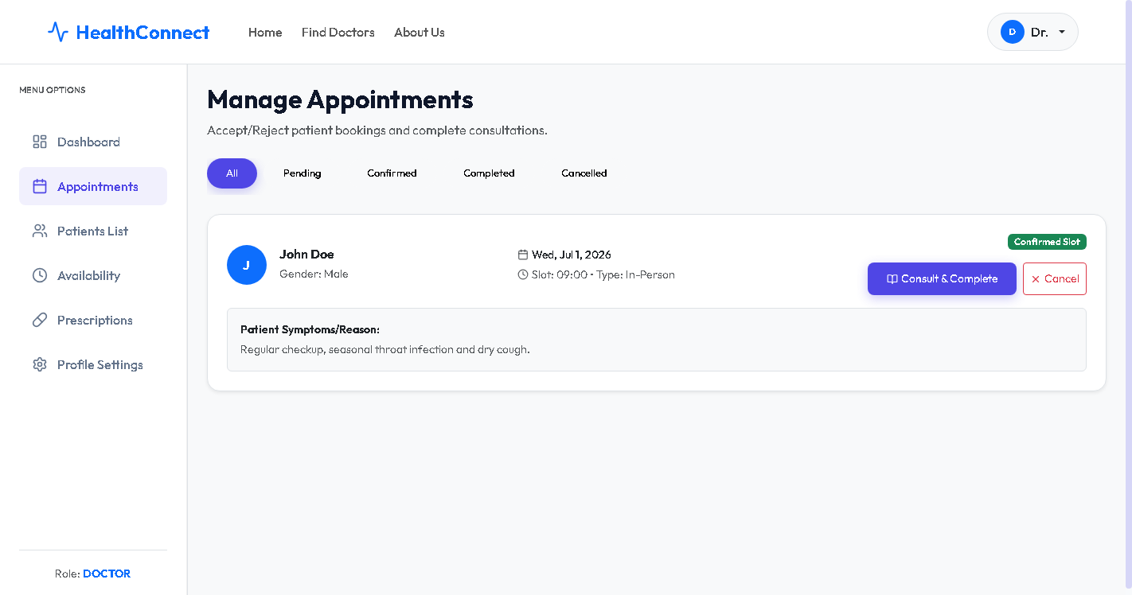
Figure 12.13: Doctor appointments queue with accepted status (Post-Action)
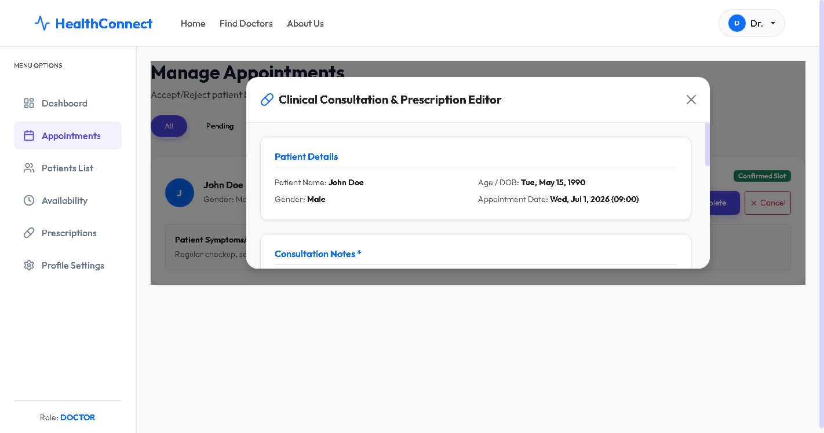
Figure 12.14: Doctor Clinical Consultation notes & digital Rx editor
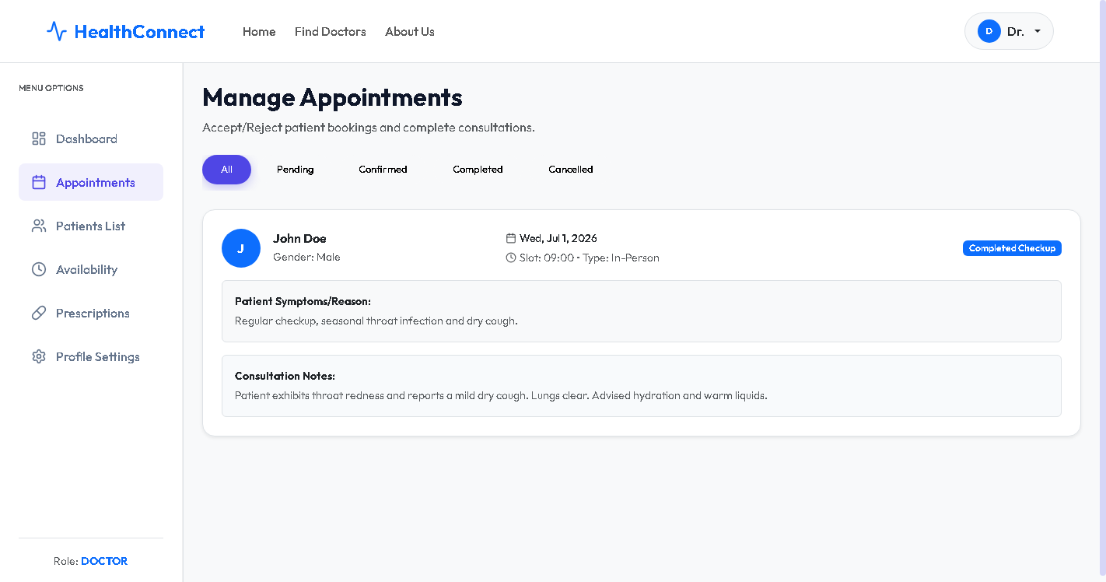
Figure 12.15: Doctor Console view after consultation submission
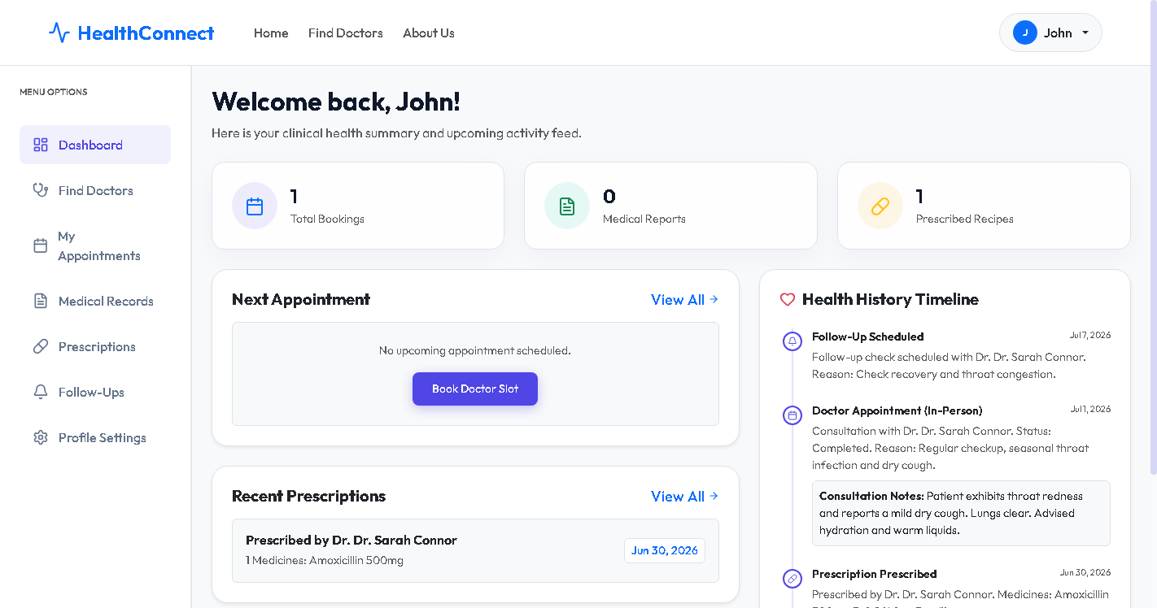
Figure 12.16: Patient Dashboard showing updated longitudinal health folder timeline
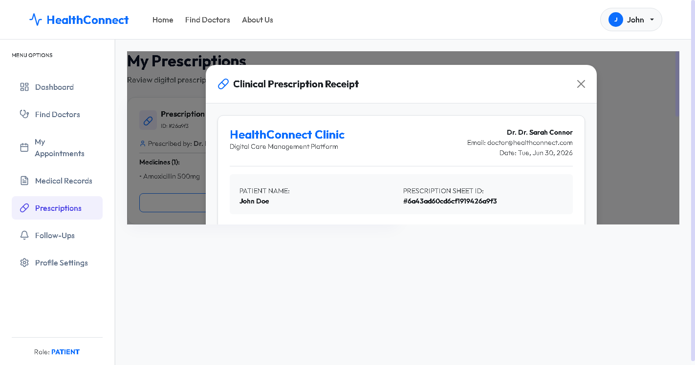
Figure 12.17: Patient digital e-prescription printable receipt view

13. Advantages & Limitations
Advantages:
• Centralized access to historical records.
• Real-time slot locking, eliminating scheduling double-booking.
• Seamless role-based administrative audits.
• Print-ready e-prescriptions.
Limitations:
• Requires a continuous internet connection.
• Currently runs locally (localhost deployment).
• Relies on mock printing for e-prescriptions rather than direct integration with local pharmacies.

14. Future Enhancements
Planned future developments for the HealthConnect platform include:
• Video Consultation: Integrating WebRTC to allow patients to have video consults directly within the platform.
• Payment Gateway Integration: Adding Razorpay or Stripe to handle digital consultation fee payments during slot booking.
• AI Symptom Checker: Incorporating a lightweight machine learning classifier to suggest specialties based on patient symptoms.
• Automated Notifications: Adding email and SMS reminders for scheduled visits and follow-ups.

15. Conclusion
HealthConnect successfully addresses the inefficiencies of traditional clinical scheduling and documentation. By utilizing the MERN stack, the platform provides a highly responsive, secure environment.
Patients gain greater agency over their health records, doctors benefit from organized schedule management, and administrators can audit clinical practices. The project fulfills all target goals, proving that an integrated, role-based approach is key to modern digital healthcare management.

16. References
1. MongoDB Documentation. [https://docs.mongodb.com](https://docs.mongodb.com)
2. Express.js API Reference. [https://expressjs.com](https://expressjs.com)
3. React.js Official Documentation. [https://react.dev](https://react.dev)
4. Node.js Documentation. [https://nodejs.org](https://nodejs.org)
5. Mongoose ODM Documentation. [https://mongoosejs.com](https://mongoosejs.com)
6. Lucide Icons Library. [https://lucide.dev](https://lucide.dev)

17. Source Code
The complete technical source code for the backend server settings, schemas, controllers, and core frontend pages has been extracted and included in this section to serve as a comprehensive code repository for the HealthConnect platform:

17.1 Backend entry point: server.js
const express = require('express');
const cors = require('cors');
const dotenv = require('dotenv');
const path = require('path');
const connectDB = require('./config/db');
// Load environment variables
dotenv.config();
// Connect to Database
connectDB();
const app = express();
// Middleware
app.use(cors());
app.use(express.json());
app.use(express.urlencoded({ extended: true }));
// Static Folder for Uploads
app.use('/uploads', express.static(path.join(__dirname, 'uploads')));
// Routes Integration
app.use('/api/auth', require('./routes/authRoutes'));
app.use('/api/doctors', require('./routes/doctorRoutes'));
app.use('/api/patients', require('./routes/patientRoutes'));
app.use('/api/appointments', require('./routes/appointmentRoutes'));
app.use('/api/records', require('./routes/recordRoutes'));
app.use('/api/prescriptions', require('./routes/prescriptionRoutes'));
app.use('/api/followups', require('./routes/followUpRoutes'));
app.use('/api/admin', require('./routes/adminRoutes'));
// Root Endpoint
app.get('/', (req, res) => {
res.json({ message: 'Welcome to HealthConnect API' });
});
// Error handling middleware
app.use((err, req, res, next) => {
const statusCode = res.statusCode === 200 ? 500 : res.statusCode;
res.status(statusCode);
res.json({
message: err.message,
stack: process.env.NODE_ENV === 'production' ? null : err.stack
});
});
const PORT = process.env.PORT || 5000;
app.listen(PORT, () => {
console.log(`Server running on port ${PORT}`);
});

17.2 Database model: User schema (models/user.js)
const mongoose = require('mongoose');
const bcrypt = require('bcryptjs');
const userSchema = new mongoose.Schema({
name: {
type: String,
required: [true, 'Name is required']
},
email: {
type: String,
required: [true, 'Email is required'],
unique: true,
lowercase: true,
match: [/^\w+([\.-]?\w+)*@\w+([\.-]?\w+)*(\.\w{2,3})+$/, 'Please fill a valid email address']
},
password: {
type: String,
required: [true, 'Password is required'],
minlength: 6
},
role: {
type: String,
enum: ['patient', 'doctor', 'admin'],
default: 'patient'
},
phone: {
type: String
},
gender: {
type: String,
enum: ['Male', 'Female', 'Other']
},
dateOfBirth: {
type: Date
},
address: {
type: String
},
avatar: {
type: String,
default: ''
}
}, {
timestamps: true
});
// Encrypt password before saving
userSchema.pre('save', async function(next) {
if (!this.isModified('password')) {
next();
}
const salt = await bcrypt.genSalt(10);
this.password = await bcrypt.hash(this.password, salt);
});
// Match user entered password to hashed password in database
userSchema.methods.matchPassword = async function(enteredPassword) {
return await bcrypt.compare(enteredPassword, this.password);
};
module.exports = mongoose.model('User', userSchema);

17.3 Database model: Doctor profile schema (models/doctor.js)
const mongoose = require('mongoose');
const availabilitySchema = new mongoose.Schema({
day: {
type: String,
required: true,
enum: ['Monday', 'Tuesday', 'Wednesday', 'Thursday', 'Friday', 'Saturday', 'Sunday']
},
slots: {
type: [String], // Array of time slots, e.g., ['09:00', '10:00', '11:00']
default: []
}
});
const doctorSchema = new mongoose.Schema({
userId: {
type: mongoose.Schema.Types.ObjectId,
ref: 'User',
required: true
},
specialization: {
type: String,
required: [true, 'Specialization is required']
},
experience: {
type: Number,
required: [true, 'Experience is required']
},
qualification: {
type: String,
required: [true, 'Qualification is required']
},
fees: {
type: Number,
required: [true, 'Consultation fees is required']
},
bio: {
type: String,
default: ''
},
availability: [availabilitySchema],
isVerified: {
type: Boolean,
default: false
},
rating: {
type: Number,
default: 4.5
}
}, {
timestamps: true
});
module.exports = mongoose.model('Doctor', doctorSchema);

17.4 Database model: Appointment schema (models/appointment.js)
const mongoose = require('mongoose');
const appointmentSchema = new mongoose.Schema({
patientId: {
type: mongoose.Schema.Types.ObjectId,
ref: 'User',
required: true
},
doctorId: {
type: mongoose.Schema.Types.ObjectId,
ref: 'User', // Refers to the User record of the doctor
required: true
},
date: {
type: Date,
required: true
},
timeSlot: {
type: String,
required: true
},
status: {
type: String,
enum: ['Pending', 'Confirmed', 'Completed', 'Cancelled'],
default: 'Pending'
},
reason: {
type: String,
required: [true, 'Reason for appointment is required']
},
type: {
type: String,
enum: ['In-Person', 'Online'],
default: 'In-Person'
},
notes: {
type: String,
default: ''
}
}, {
timestamps: true
});
module.exports = mongoose.model('Appointment', appointmentSchema);

17.5 Database model: Prescription schema (models/prescription.js)
const mongoose = require('mongoose');
const medicineSchema = new mongoose.Schema({
name: {
type: String,
required: true
},
dosage: {
type: String, // e.g. "1-0-1" or "Once daily"
required: true
},
duration: {
type: String, // e.g. "5 days" or "1 month"
required: true
},
instructions: {
type: String, // e.g. "After meals"
default: ''
}
});
const prescriptionSchema = new mongoose.Schema({
appointmentId: {
type: mongoose.Schema.Types.ObjectId,
ref: 'Appointment'
},
patientId: {
type: mongoose.Schema.Types.ObjectId,
ref: 'User',
required: true
},
doctorId: {
type: mongoose.Schema.Types.ObjectId,
ref: 'User', // Refers to the User record of the doctor
required: true
},
medicines: [medicineSchema],
notes: {
type: String,
default: ''
},
date: {
type: Date,
default: Date.now
}
}, {
timestamps: true
});
module.exports = mongoose.model('Prescription', prescriptionSchema);

17.6 Backend controller: Authentication & Profile logic (controllers/authController.js)
const jwt = require('jsonwebtoken');
const User = require('../models/user');
const Doctor = require('../models/doctor');
// Generate JWT Token
const generateToken = (id) => {
return jwt.sign({ id }, process.env.JWT_SECRET || 'healthconnect_secret_123', {
expiresIn: '30d'
});
};
// @desc Register user (Patient or Doctor)
// @route POST /api/auth/register
// @access Public
const registerUser = async (req, res) => {
const { name, email, password, role, phone, gender, dateOfBirth, address, specialization, experience, qualification, fees, bio } = req.body;
try {
// Check if user exists
const userExists = await User.findOne({ email });
if (userExists) {
return res.status(400).json({ message: 'User already exists' });
}
// Create User
const user = await User.create({
name,
email,
password,
role: role || 'patient',
phone,
gender,
dateOfBirth,
address
});
if (user) {
// If the registered user is a doctor, create the doctor profile
if (user.role === 'doctor') {
if (!specialization || !experience || !qualification || !fees) {
// Rollback user creation if doctor details are missing
await User.findByIdAndDelete(user._id);
return res.status(400).json({ message: 'Please provide specialization, experience, qualification, and fees for Doctor role' });
}
await Doctor.create({
userId: user._id,
specialization,
experience: Number(experience),
qualification,
fees: Number(fees),
bio: bio || '',
availability: [
{ day: 'Monday', slots: ['09:00', '10:00', '11:00', '14:00', '15:00'] },
{ day: 'Wednesday', slots: ['09:00', '10:00', '11:00', '14:00', '15:00'] },
{ day: 'Friday', slots: ['09:00', '10:00', '11:00', '14:00', '15:00'] }
],
isVerified: false // Admin must verify doctor
});
}
res.status(201).json({
_id: user._id,
name: user.name,
email: user.email,
role: user.role,
token: generateToken(user._id)
});
} else {
res.status(400).json({ message: 'Invalid user data' });
}
} catch (error) {
console.error(error);
res.status(500).json({ message: error.message });
}
};
// @desc Auth user & get token
// @route POST /api/auth/login
// @access Public
const loginUser = async (req, res) => {
const { email, password } = req.body;
try {
const user = await User.findOne({ email });
if (user && (await user.matchPassword(password))) {
// If doctor, check verification status (optional: can allow login but restrict actions)
let isVerified = true;
if (user.role === 'doctor') {
const doctorProfile = await Doctor.findOne({ userId: user._id });
if (doctorProfile) {
isVerified = doctorProfile.isVerified;
}
}
res.json({
_id: user._id,
name: user.name,
email: user.email,
role: user.role,
isVerified,
token: generateToken(user._id)
});
} else {
res.status(401).json({ message: 'Invalid email or password' });
}
} catch (error) {
console.error(error);
res.status(500).json({ message: error.message });
}
};
// @desc Get user profile
// @route GET /api/auth/profile
// @access Private
const getUserProfile = async (req, res) => {
try {
const user = await User.findById(req.user._id);
if (user) {
let profileData = {
_id: user._id,
name: user.name,
email: user.email,
role: user.role,
phone: user.phone,
gender: user.gender,
dateOfBirth: user.dateOfBirth,
address: user.address,
avatar: user.avatar
};
// If doctor, append doctor profile fields
if (user.role === 'doctor') {
const doctorProfile = await Doctor.findOne({ userId: user._id });
if (doctorProfile) {
profileData.doctorProfile = doctorProfile;
}
}
res.json(profileData);
} else {
res.status(404).json({ message: 'User not found' });
}
} catch (error) {
console.error(error);
res.status(500).json({ message: error.message });
}
};
// @desc Update user profile
// @route PUT /api/auth/profile
// @access Private
const updateUserProfile = async (req, res) => {
try {
const user = await User.findById(req.user._id);
if (user) {
user.name = req.body.name || user.name;
user.phone = req.body.phone !== undefined ? req.body.phone : user.phone;
user.gender = req.body.gender || user.gender;
user.dateOfBirth = req.body.dateOfBirth || user.dateOfBirth;
user.address = req.body.address !== undefined ? req.body.address : user.address;
if (req.file) {
// avatar file path relative to server
user.avatar = `/uploads/${req.file.filename}`;
}
if (req.body.password) {
user.password = req.body.password;
}
const updatedUser = await user.save();
// If doctor, also allow updating doctor-specific fields if passed
let doctorProfile = null;
if (user.role === 'doctor') {
doctorProfile = await Doctor.findOne({ userId: user._id });
if (doctorProfile) {
doctorProfile.specialization = req.body.specialization || doctorProfile.specialization;
doctorProfile.experience = req.body.experience !== undefined ? Number(req.body.experience) : doctorProfile.experience;
doctorProfile.qualification = req.body.qualification || doctorProfile.qualification;
doctorProfile.fees = req.body.fees !== undefined ? Number(req.body.fees) : doctorProfile.fees;
doctorProfile.bio = req.body.bio !== undefined ? req.body.bio : doctorProfile.bio;
if (req.body.availability) {
// Parses availability array if sent as JSON string
try {
doctorProfile.availability = typeof req.body.availability === 'string'
? JSON.parse(req.body.availability)
: req.body.availability;
} catch (err) {
console.error('Error parsing availability', err);
}
}
await doctorProfile.save();
}
}
res.json({
_id: updatedUser._id,
name: updatedUser.name,
email: updatedUser.email,
role: updatedUser.role,
phone: updatedUser.phone,
gender: updatedUser.gender,
dateOfBirth: updatedUser.dateOfBirth,
address: updatedUser.address,
avatar: updatedUser.avatar,
doctorProfile,
token: generateToken(updatedUser._id)
});
} else {
res.status(404).json({ message: 'User not found' });
}
} catch (error) {
console.error(error);
res.status(500).json({ message: error.message });
}
};
module.exports = {
registerUser,
loginUser,
getUserProfile,
updateUserProfile
};

17.7 Backend controller: Clinician availability & scheduling logic (controllers/doctorController.js)
const Doctor = require('../models/doctor');
const User = require('../models/user');
const Appointment = require('../models/appointment');
// @desc Get all verified doctors (with optional search and specialization filters)
// @route GET /api/doctors
// @access Public
const getDoctors = async (req, res) => {
const { specialization, search, verified } = req.query;
// By default return ALL doctors; pass ?verified=true to restrict to verified only
let query = {};
if (verified === 'true') {
query.isVerified = true;
}
if (specialization) {
query.specialization = specialization;
}
try {
let doctors = await Doctor.find(query).populate('userId', 'name email phone gender avatar');
// Filter by search term on doctor name or bio if search query exists
if (search) {
const searchRegex = new RegExp(search, 'i');
doctors = doctors.filter(doc =>
doc.userId && (
searchRegex.test(doc.userId.name) ||
(doc.bio && searchRegex.test(doc.bio)) ||
(doc.specialization && searchRegex.test(doc.specialization))
)
);
}
res.json(doctors);
} catch (error) {
console.error(error);
res.status(500).json({ message: error.message });
}
};
// @desc Get doctor profile by ID
// @route GET /api/doctors/:id
// @access Public
const getDoctorById = async (req, res) => {
try {
// id can be doctor profile ID or user ID. Let's support both but assume it's the User ID or Doctor ID.
// Standardizing: Assume it's the User ID of the doctor (since we link routes that way or from appointments)
let doctor = await Doctor.findOne({ userId: req.params.id }).populate('userId', 'name email phone gender avatar address');
if (!doctor) {
// Try by Doctor ID
doctor = await Doctor.findById(req.params.id).populate('userId', 'name email phone gender avatar address');
}
if (!doctor) {
return res.status(404).json({ message: 'Doctor not found' });
}
res.json(doctor);
} catch (error) {
console.error(error);
res.status(500).json({ message: error.message });
}
};
// @desc Update doctor clinical details
// @route PUT /api/doctors/profile
// @access Private (Doctor only)
const updateDoctorProfile = async (req, res) => {
const { specialization, experience, qualification, fees, bio, availability } = req.body;
try {
const doctor = await Doctor.findOne({ userId: req.user._id });
if (!doctor) {
return res.status(404).json({ message: 'Doctor profile not found' });
}
doctor.specialization = specialization || doctor.specialization;
doctor.experience = experience !== undefined ? Number(experience) : doctor.experience;
doctor.qualification = qualification || doctor.qualification;
doctor.fees = fees !== undefined ? Number(fees) : doctor.fees;
doctor.bio = bio !== undefined ? bio : doctor.bio;
if (availability) {
doctor.availability = availability;
}
const updatedDoctor = await doctor.save();
res.json(updatedDoctor);
} catch (error) {
console.error(error);
res.status(500).json({ message: error.message });
}
};
// @desc Get doctor available slots for a specific date
// @route GET /api/doctors/:id/availability
// @access Public
const getDoctorAvailabilityByDate = async (req, res) => {
const { date } = req.query; // Date format: YYYY-MM-DD
const doctorUserId = req.params.id; // User ID of doctor
if (!date) {
return res.status(400).json({ message: 'Please provide a date query parameter (YYYY-MM-DD)' });
}
try {
const doctor = await Doctor.findOne({ userId: doctorUserId });
if (!doctor) {
return res.status(404).json({ message: 'Doctor profile not found' });
}
// Determine day of the week
const queryDate = new Date(date);
const days = ['Sunday', 'Monday', 'Tuesday', 'Wednesday', 'Thursday', 'Friday', 'Saturday'];
const dayOfWeek = days[queryDate.getDay()];
// Find the slots for this day of the week
const dayAvailability = doctor.availability.find(av => av.day === dayOfWeek);
if (!dayAvailability || dayAvailability.slots.length === 0) {
return res.json({ day: dayOfWeek, slots: [] }); // Doctor is not available on this day
}
// Get all appointments booked for this doctor on this day (exclude Cancelled)
const startOfDay = new Date(date);
startOfDay.setHours(0, 0, 0, 0);
const endOfDay = new Date(date);
endOfDay.setHours(23, 59, 59, 999);
const appointments = await Appointment.find({
doctorId: doctorUserId,
date: {
$gte: startOfDay,
$lte: endOfDay
},
status: { $ne: 'Cancelled' }
});
const bookedSlots = appointments.map(app => app.timeSlot);
// Filter out already booked slots
const availableSlots = dayAvailability.slots.filter(slot => !bookedSlots.includes(slot));
res.json({
day: dayOfWeek,
date: date,
slots: availableSlots
});
} catch (error) {
console.error(error);
res.status(500).json({ message: error.message });
}
};
module.exports = {
getDoctors,
getDoctorById,
updateDoctorProfile,
getDoctorAvailabilityByDate
};

17.8 Backend controller: Booking management & status update logic (controllers/appointmentController.js)
const Appointment = require('../models/appointment');
const Doctor = require('../models/doctor');
const User = require('../models/user');
// @desc Book an appointment
// @route POST /api/appointments
// @access Private (Patient only)
const bookAppointment = async (req, res) => {
const { doctorId, date, timeSlot, reason, type } = req.body;
if (!doctorId || !date || !timeSlot || !reason) {
return res.status(400).json({ message: 'Please provide all required fields: doctorId, date, timeSlot, reason' });
}
try {
// Check if doctor exists and is verified
const doctor = await Doctor.findOne({ userId: doctorId });
if (!doctor) {
return res.status(404).json({ message: 'Doctor not found' });
}
if (!doctor.isVerified) {
return res.status(400).json({ message: 'Doctor is not verified yet by admin' });
}
// Parse date and set to midnight/day-only for checking matching date
const bookingDate = new Date(date);
bookingDate.setHours(0, 0, 0, 0);
const startOfDay = new Date(bookingDate);
const endOfDay = new Date(bookingDate);
endOfDay.setHours(23, 59, 59, 999);
// Check if slot is already booked for this doctor
const existingAppointment = await Appointment.findOne({
doctorId,
date: {
$gte: startOfDay,
$lte: endOfDay
},
timeSlot,
status: { $ne: 'Cancelled' }
});
if (existingAppointment) {
return res.status(400).json({ message: 'This time slot is already booked for the selected date' });
}
// Create appointment
const appointment = await Appointment.create({
patientId: req.user._id,
doctorId,
date: bookingDate,
timeSlot,
reason,
type: type || 'In-Person'
});
res.status(201).json(appointment);
} catch (error) {
console.error(error);
res.status(500).json({ message: error.message });
}
};
// @desc Get user appointments (lists based on roles)
// @route GET /api/appointments
// @access Private
const getAppointments = async (req, res) => {
try {
let appointments;
if (req.user.role === 'patient') {
appointments = await Appointment.find({ patientId: req.user._id })
.populate('doctorId', 'name email phone avatar')
.sort({ date: -1, timeSlot: -1 });
} else if (req.user.role === 'doctor') {
appointments = await Appointment.find({ doctorId: req.user._id })
.populate('patientId', 'name email phone gender dateOfBirth avatar')
.sort({ date: -1, timeSlot: -1 });
} else if (req.user.role === 'admin') {
appointments = await Appointment.find({})
.populate('patientId', 'name email')
.populate('doctorId', 'name email')
.sort({ date: -1 });
}
res.json(appointments);
} catch (error) {
console.error(error);
res.status(500).json({ message: error.message });
}
};
// @desc Get appointment by ID
// @route GET /api/appointments/:id
// @access Private
const getAppointmentById = async (req, res) => {
try {
const appointment = await Appointment.findById(req.params.id)
.populate('patientId', 'name email phone gender dateOfBirth avatar address')
.populate('doctorId', 'name email phone avatar');
if (!appointment) {
return res.status(404).json({ message: 'Appointment not found' });
}
// Authorization checks
const isPatient = req.user.role === 'patient' && appointment.patientId._id.toString() === req.user._id.toString();
const isDoctor = req.user.role === 'doctor' && appointment.doctorId._id.toString() === req.user._id.toString();
const isAdmin = req.user.role === 'admin';
if (!isPatient && !isDoctor && !isAdmin) {
return res.status(403).json({ message: 'Not authorized to view this appointment' });
}
res.json(appointment);
} catch (error) {
console.error(error);
res.status(500).json({ message: error.message });
}
};
// @desc Update appointment status
// @route PUT /api/appointments/:id/status
// @access Private
const updateAppointmentStatus = async (req, res) => {
const { status } = req.body;
if (!['Pending', 'Confirmed', 'Completed', 'Cancelled'].includes(status)) {
return res.status(400).json({ message: 'Invalid status' });
}
try {
const appointment = await Appointment.findById(req.params.id);
if (!appointment) {
return res.status(404).json({ message: 'Appointment not found' });
}
// Role-based auth for status changes
// Patients can only cancel their own pending/confirmed appointments
if (req.user.role === 'patient') {
if (appointment.patientId.toString() !== req.user._id.toString()) {
return res.status(403).json({ message: 'Not authorized' });
}
if (status !== 'Cancelled') {
return res.status(400).json({ message: 'Patients can only cancel appointments' });
}
if (appointment.status === 'Completed') {
return res.status(400).json({ message: 'Cannot cancel a completed appointment' });
}
}
// Doctors can only manage their own appointments
if (req.user.role === 'doctor') {
if (appointment.doctorId.toString() !== req.user._id.toString()) {
return res.status(403).json({ message: 'Not authorized' });
}
}
appointment.status = status;
const updatedAppointment = await appointment.save();
res.json(updatedAppointment);
} catch (error) {
console.error(error);
res.status(500).json({ message: error.message });
}
};
// @desc Add appointment consultation notes
// @route PUT /api/appointments/:id/notes
// @access Private (Doctor only)
const updateAppointmentNotes = async (req, res) => {
const { notes } = req.body;
try {
const appointment = await Appointment.findById(req.params.id);
if (!appointment) {
return res.status(404).json({ message: 'Appointment not found' });
}
// Ensure doctor is the owner
if (appointment.doctorId.toString() !== req.user._id.toString()) {
return res.status(403).json({ message: 'Not authorized, you are not the assigned doctor' });
}
appointment.notes = notes || '';
const updatedAppointment = await appointment.save();
res.json(updatedAppointment);
} catch (error) {
console.error(error);
res.status(500).json({ message: error.message });
}
};
module.exports = {
bookAppointment,
getAppointments,
getAppointmentById,
updateAppointmentStatus,
updateAppointmentNotes
};

17.9 Backend controller: E-prescription creation & retrieval logic (controllers/prescriptionController.js)
const Prescription = require('../models/prescription');
const Appointment = require('../models/appointment');
// @desc Create prescription
// @route POST /api/prescriptions
// @access Private (Doctor only)
const createPrescription = async (req, res) => {
const { appointmentId, patientId, medicines, notes } = req.body;
if (!patientId || !medicines || medicines.length === 0) {
return res.status(400).json({ message: 'Please provide patientId and medicines list' });
}
try {
const prescription = await Prescription.create({
appointmentId,
patientId,
doctorId: req.user._id,
medicines,
notes: notes || ''
});
// If prescription is linked to an appointment, auto-complete the appointment
if (appointmentId) {
const appointment = await Appointment.findById(appointmentId);
if (appointment) {
appointment.status = 'Completed';
await appointment.save();
}
}
res.status(201).json(prescription);
} catch (error) {
console.error(error);
res.status(500).json({ message: error.message });
}
};
// @desc Get prescriptions
// @route GET /api/prescriptions
// @access Private (Patient and Doctor)
const getPrescriptions = async (req, res) => {
const patientId = req.query.patientId;
try {
let query = {};
if (req.user.role === 'patient') {
query.patientId = req.user._id;
} else if (req.user.role === 'doctor') {
// If doctor specifies a patientId, show for that patient. Otherwise, show all written by this doctor
if (patientId) {
query.patientId = patientId;
} else {
query.doctorId = req.user._id;
}
}
const prescriptions = await Prescription.find(query)
.populate('patientId', 'name email')
.populate('doctorId', 'name email')
.sort({ date: -1 });
res.json(prescriptions);
} catch (error) {
console.error(error);
res.status(500).json({ message: error.message });
}
};
// @desc Get prescription by ID
// @route GET /api/prescriptions/:id
// @access Private
const getPrescriptionById = async (req, res) => {
try {
const prescription = await Prescription.findById(req.params.id)
.populate('patientId', 'name email gender dateOfBirth address phone')
.populate('doctorId', 'name email phone');
if (!prescription) {
return res.status(404).json({ message: 'Prescription not found' });
}
// Access control
if (req.user.role === 'patient' && prescription.patientId._id.toString() !== req.user._id.toString()) {
return res.status(403).json({ message: 'Not authorized' });
}
if (req.user.role === 'doctor' && prescription.doctorId._id.toString() !== req.user._id.toString()) {
return res.status(403).json({ message: 'Not authorized' });
}
res.json(prescription);
} catch (error) {
console.error(error);
res.status(500).json({ message: error.message });
}
};
module.exports = {
createPrescription,
getPrescriptions,
getPrescriptionById
};

17.10 Frontend navigation: Router path mapping (App.jsx)
import { Routes, Route, Navigate, Outlet } from 'react-router-dom';
import Navbar from './components/Navbar';
import Footer from './components/Footer';
import Sidebar from './components/Sidebar';
import ProtectedRoute from './components/ProtectedRoute';
// Import Public Pages
import Home from './pages/Public/Home';
import Doctors from './pages/Public/Doctors';
import DoctorProfile from './pages/Public/DoctorProfile';
import Login from './pages/Public/Login';
import Register from './pages/Public/Register';
import About from './pages/Public/About';
// Import Patient Pages
import PatientDashboard from './pages/Patient/PatientDashboard';
import PatientAppointments from './pages/Patient/MyAppointments';
import PatientRecords from './pages/Patient/MedicalRecords';
import PatientPrescriptions from './pages/Patient/Prescriptions';
import PatientFollowUps from './pages/Patient/FollowUps';
import FindDoctors from './pages/Patient/FindDoctors';
import ProfileSettings from './pages/Shared/ProfileSettings';
// Import Doctor Pages
import DoctorDashboard from './pages/Doctor/DoctorDashboard';
import DoctorAppointments from './pages/Doctor/DoctorAppointments';
import DoctorPatients from './pages/Doctor/PatientsList';
import DoctorAvailability from './pages/Doctor/Availability';
// Import Admin Pages
import AdminDashboard from './pages/Admin/AdminDashboard';
import AdminVerifyDoctors from './pages/Admin/VerifyDoctors';
import AdminManageUsers from './pages/Admin/ManageUsers';
import AdminCategories from './pages/Admin/Categories';
// Layout wrapper for Public Pages (displays navbar and footer)
const PublicLayout = () => {
return (
<div className="d-flex flex-column min-height-vh-100" style={{ minHeight: '100vh' }}>
<Navbar />
<main className="flex-grow-1">
<Outlet />
</main>
<Footer />
</div>
);
};
// Layout wrapper for Dashboards (displays navbar, sidebar, and layout panel)
const DashboardLayout = () => {
return (
<div className="d-flex flex-column" style={{ minHeight: '100vh' }}>
<Navbar />
<div className="container-fluid flex-grow-1">
<div className="row h-100">
{/* Sidebar Left Column */}
<aside className="col-lg-2 col-md-3 p-0 d-none d-md-block border-end bg-white">
<Sidebar />
</aside>
{/* Main Dashboard Panel Right Column */}
<main className="col-lg-10 col-md-9 p-4 bg-light" style={{ minHeight: 'calc(100vh - 73px)' }}>
<div className="container-fluid px-0">
<Outlet />
</div>
</main>
</div>
</div>
</div>
);
};
function App() {
return (
<Routes>
{/* Public Routes */}
<Route element={<PublicLayout />}>
<Route path="/" element={<Home />} />
<Route path="/doctors" element={<Doctors />} />
<Route path="/doctors/:id" element={<DoctorProfile />} />
<Route path="/login" element={<Login />} />
<Route path="/register" element={<Register />} />
<Route path="/about" element={<About />} />
</Route>
{/* Patient Dashboard Routes */}
<Route
path="/patient"
element={
<ProtectedRoute allowedRoles={['patient']}>
<DashboardLayout />
</ProtectedRoute>
}
>
<Route index element={<PatientDashboard />} />
<Route path="appointments" element={<PatientAppointments />} />
<Route path="find-doctors" element={<FindDoctors />} />
<Route path="records" element={<PatientRecords />} />
<Route path="prescriptions" element={<PatientPrescriptions />} />
<Route path="followups" element={<PatientFollowUps />} />
<Route path="settings" element={<ProfileSettings />} />
</Route>
{/* Doctor Dashboard Routes */}
<Route
path="/doctor"
element={
<ProtectedRoute allowedRoles={['doctor']}>
<DashboardLayout />
</ProtectedRoute>
}
>
<Route index element={<DoctorDashboard />} />
<Route path="appointments" element={<DoctorAppointments />} />
<Route path="patients" element={<DoctorPatients />} />
<Route path="availability" element={<DoctorAvailability />} />
<Route path="prescriptions" element={<PatientPrescriptions />} /> {/* Shared read component */}
<Route path="settings" element={<ProfileSettings />} />
</Route>
{/* Admin Dashboard Routes */}
<Route
path="/admin"
element={
<ProtectedRoute allowedRoles={['admin']}>
<DashboardLayout />
</ProtectedRoute>
}
>
<Route index element={<AdminDashboard />} />
<Route path="verify" element={<AdminVerifyDoctors />} />
<Route path="users" element={<AdminManageUsers />} />
<Route path="categories" element={<AdminCategories />} />
</Route>
{/* Fallback Catch-All Route */}
<Route path="*" element={<Navigate to="/" replace />} />
</Routes>
);
}
export default App;

17.11 Frontend authentication guard: protected route wrapper (components/ProtectedRoute.jsx)
import React, { useContext } from 'react';
import { Navigate, useLocation } from 'react-router-dom';
import { AuthContext } from '../context/AuthContext';
const ProtectedRoute = ({ children, allowedRoles }) => {
const { user, loading } = useContext(AuthContext);
const location = useLocation();
if (loading) {
return (
<div className="d-flex justify-content-center align-items-center" style={{ height: '100vh' }}>
<div className="spinner-border text-primary" role="status">
<span className="visually-hidden">Loading...</span>
</div>
</div>
);
}
if (!user) {
// Redirect to login but save current location
return <Navigate to="/login" state={{ from: location }} replace />;
}
if (allowedRoles && !allowedRoles.includes(user.role)) {
// Role not authorized, redirect to home page
return <Navigate to="/" replace />;
}
return children;
};
export default ProtectedRoute;

17.12 Patient page: Search directory & specialty filtering (pages/Patient/FindDoctors.jsx)
import React, { useState, useEffect } from 'react';
import { Link } from 'react-router-dom';
import api from '../../utils/api';
import {
Search,
Stethoscope,
Briefcase,
Star,
Clock,
DollarSign,
CheckCircle,
XCircle,
ChevronDown,
SlidersHorizontal,
UserRound,
} from 'lucide-react';
const STATIC_SPECIALIZATIONS = [
'Cardiologists',
'Dermatologists',
'Endocrinologist',
'Gastroenterologists',
'Neurologist',
'Oncologist',
'Psychiatrist',
'Obstetricians/Gynecologists'
];
const DAYS_OF_WEEK = ['Sunday', 'Monday', 'Tuesday', 'Wednesday', 'Thursday', 'Friday', 'Saturday'];
const FindDoctors = () => {
const [doctors, setDoctors] = useState([]);
const [filtered, setFiltered] = useState([]);
// Pre-populate with static list so dropdown always shows options
const [availableSpecs, setAvailableSpecs] = useState([...STATIC_SPECIALIZATIONS].sort());
const [loading, setLoading] = useState(true);
const [error, setError] = useState('');
const [search, setSearch] = useState('');
const [selectedSpec, setSelectedSpec] = useState('All Specializations');
const [availableOnly, setAvailableOnly] = useState(false);
// Today's day name to check availability
const todayName = DAYS_OF_WEEK[new Date().getDay()];
useEffect(() => {
const fetchDoctors = async () => {
try {
setLoading(true);
setError('');
const { data } = await api.get('/doctors');
const doctorList = Array.isArray(data) ? data : [];
setDoctors(doctorList);
setFiltered(doctorList);
// Merge dynamic specs from actual doctors with the static list
const dynamicSpecs = doctorList
.map((d) => d.specialization)
.filter(Boolean);
const specsSet = new Set([...STATIC_SPECIALIZATIONS, ...dynamicSpecs]);
const specs = Array.from(specsSet).sort();
setAvailableSpecs(specs);
} catch (err) {
console.error('Error fetching doctors:', err);
setError('Unable to load doctors. Please try again later.');
// Keep static specs even on error so dropdown still works
setAvailableSpecs([...STATIC_SPECIALIZATIONS].sort());
} finally {
setLoading(false);
}
};
fetchDoctors();
}, []);
// Re-filter whenever search/spec/availableOnly changes
useEffect(() => {
let result = [...doctors];
if (search.trim()) {
const regex = new RegExp(search.trim(), 'i');
result = result.filter((d) => {
const nameMatch = d.userId && d.userId.name && regex.test(d.userId.name);
const bioMatch = d.bio && regex.test(d.bio);
const specMatch = d.specialization && regex.test(d.specialization);
return nameMatch || bioMatch || specMatch;
});
}
if (selectedSpec && selectedSpec !== 'All Specializations') {
result = result.filter((d) => d.specialization === selectedSpec);
}
if (availableOnly) {
result = result.filter((d) =>
d.availability && d.availability.some(
(av) => av.day === todayName && av.slots && av.slots.length > 0
)
);
}
setFiltered(result);
}, [search, selectedSpec, availableOnly, doctors]);
const isDoctorAvailableToday = (doctor) => {
if (!doctor.availability) return false;
const todayEntry = doctor.availability.find((av) => av.day === todayName);
return todayEntry && todayEntry.slots && todayEntry.slots.length > 0;
};
const getTodaySlots = (doctor) => {
if (!doctor.availability) return [];
const todayEntry = doctor.availability.find((av) => av.day === todayName);
return todayEntry ? todayEntry.slots : [];
};
const clearFilters = () => {
setSearch('');
setSelectedSpec('All Specializations');
setAvailableOnly(false);
};
return (
<div className="animate-fade-in-up">
{/* Header */}
<div className="mb-4">
<h2 className="fw-bold d-flex align-items-center gap-2">
<Stethoscope size={26} className="text-primary" />
Find a Doctor
</h2>
<p className="text-muted mb-0">
Browse verified doctors and book your appointment today ({todayName})
</p>
</div>
<div className="row g-4">
{/* ── Filter Sidebar ── */}
<div className="col-lg-3">
<div
className="card border shadow-sm p-4"
style={{ borderRadius: '18px', background: '#fff', position: 'sticky', top: '90px' }}
>
<h6 className="fw-bold mb-3 d-flex align-items-center gap-2">
<SlidersHorizontal size={16} className="text-primary" />
Filters
</h6>
{/* Search */}
<div className="mb-3">
<label className="form-label small fw-semibold text-muted">Search</label>
<div
className="d-flex align-items-center border rounded px-2 py-1 bg-white"
style={{ gap: '6px' }}
>
<Search size={16} className="text-muted flex-shrink-0" />
<input
type="text"
className="form-control border-0 p-1"
placeholder="Name, bio…"
value={search}
onChange={(e) => setSearch(e.target.value)}
style={{ fontSize: '13px', boxShadow: 'none' }}
/>
</div>
</div>
{/* Specialization dropdown — dynamically built from fetched doctors */}
<div className="mb-3">
<label className="form-label small fw-semibold text-muted d-flex align-items-center justify-content-between">
Specialization
{availableSpecs.length > 0 && (
<span
style={{
background: 'rgba(79,70,229,0.1)',
color: '#4f46e5',
fontSize: '10px',
fontWeight: '700',
borderRadius: '20px',
padding: '2px 8px',
}}
>
{availableSpecs.length} available
</span>
)}
</label>
<div className="position-relative">
<select
className="form-select"
value={selectedSpec}
onChange={(e) => setSelectedSpec(e.target.value)}
style={{ fontSize: '13px', paddingRight: '32px' }}
>
<option value="All Specializations">
All Specializations ({doctors.length})
</option>
{availableSpecs.map((spec) => {
const count = doctors.filter((d) => d.specialization === spec).length;
return (
<option key={spec} value={spec}>
{spec} ({count})
</option>
);
})}
</select>
<ChevronDown
size={14}
className="text-muted position-absolute"
style={{ top: '50%', right: '10px', transform: 'translateY(-50%)', pointerEvents: 'none' }}
/>
</div>
</div>
{/* Available Today toggle */}
<div className="mb-4">
<div className="form-check form-switch">
<input
className="form-check-input"
type="checkbox"
id="availableToggle"
checked={availableOnly}
onChange={(e) => setAvailableOnly(e.target.checked)}
style={{ cursor: 'pointer' }}
/>
<label
className="form-check-label small fw-semibold text-muted"
htmlFor="availableToggle"
style={{ cursor: 'pointer' }}
>
Available Today Only
</label>
</div>
</div>
<button
className="btn btn-outline-secondary w-100 btn-sm"
onClick={clearFilters}
style={{ fontSize: '13px', borderRadius: '8px' }}
>
Clear Filters
</button>
{/* Stats */}
<div
className="mt-4 p-3 rounded text-center"
style={{ background: 'rgba(79,70,229,0.06)', borderRadius: '12px' }}
>
<p className="mb-1 fw-bold text-primary" style={{ fontSize: '22px' }}>
{filtered.length}
</p>
<p className="mb-0 small text-muted">
{filtered.length === 1 ? 'Doctor Found' : 'Doctors Found'}
</p>
</div>
</div>
</div>
{/* ── Doctors Grid ── */}
<div className="col-lg-9">
{loading ? (
<div className="d-flex flex-column align-items-center justify-content-center py-5 gap-3">
<div className="spinner-border text-primary" role="status" style={{ width: '48px', height: '48px' }}>
<span className="visually-hidden">Loading…</span>
</div>
<p className="text-muted small">Fetching available doctors…</p>
</div>
) : error ? (
<div className="alert alert-danger">{error}</div>
) : filtered.length === 0 ? (
<div
className="text-center py-5 card border"
style={{ borderRadius: '18px', background: '#fff' }}
>
<Stethoscope size={52} className="text-muted mx-auto mb-3" />
<h5 className="fw-bold">No Doctors Found</h5>
<p className="text-muted small mb-3">
Try adjusting your search or filters.
</p>
<button className="btn btn-outline-primary btn-sm mx-auto" onClick={clearFilters}>
Clear Filters
</button>
</div>
) : (
<div className="row g-4">
{filtered.map((doc) => {
const availableToday = isDoctorAvailableToday(doc);
const todaySlots = getTodaySlots(doc);
const doctorUserId = doc.userId ? doc.userId._id : doc._id;
const doctorName = doc.userId ? doc.userId.name : 'Dr. Practitioner';
const doctorAvatar = doc.userId ? doc.userId.avatar : null;
return (
<div key={doc._id} className="col-md-6 col-12">
<div
className="glass-card h-100 d-flex flex-column"
style={{ borderRadius: '18px', padding: '24px', position: 'relative', overflow: 'hidden' }}
>
{/* Top Badges Row */}
<div
className="position-absolute d-flex flex-column align-items-end gap-1"
style={{ top: '16px', right: '16px' }}
>
{/* Verified badge */}
{!doc.isVerified && (
<span
className="badge d-flex align-items-center gap-1"
style={{
background: 'rgba(245,158,11,0.12)',
color: '#d97706',
fontSize: '10px',
fontWeight: '600',
borderRadius: '20px',
padding: '3px 8px',
border: '1px solid rgba(245,158,11,0.3)',
}}
>
⏳ Pending Verification
</span>
)}
{/* Availability badge */}
{availableToday ? (
<span
className="badge d-flex align-items-center gap-1"
style={{
background: 'rgba(16,185,129,0.12)',
color: '#10b981',
fontSize: '11px',
fontWeight: '600',
borderRadius: '20px',
padding: '4px 10px',
border: '1px solid rgba(16,185,129,0.3)',
}}
>
<CheckCircle size={11} />
Available Today
</span>
) : (
<span
className="badge d-flex align-items-center gap-1"
style={{
background: 'rgba(239,68,68,0.1)',
color: '#ef4444',
fontSize: '11px',
fontWeight: '600',
borderRadius: '20px',
padding: '4px 10px',
border: '1px solid rgba(239,68,68,0.25)',
}}
>
<XCircle size={11} />
Unavailable Today
</span>
)}
</div>
{/* Doctor Header */}
<div className="d-flex gap-3 align-items-center mb-3" style={{ marginTop: '4px' }}>
{doctorAvatar ? (
<img
src={`http://localhost:5000${doctorAvatar}`}
alt={doctorName}
style={{
width: '64px',
height: '64px',
borderRadius: '50%',
objectFit: 'cover',
border: '3px solid rgba(79,70,229,0.15)',
}}
onError={(e) => {
e.target.style.display = 'none';
e.target.nextSibling.style.display = 'flex';
}}
/>
) : null}
<div
className="bg-primary text-white d-flex align-items-center justify-content-center fw-bold flex-shrink-0"
style={{
width: '64px',
height: '64px',
borderRadius: '50%',
fontSize: '22px',
background: 'linear-gradient(135deg, #4f46e5, #7c3aed)',
display: doctorAvatar ? 'none' : 'flex',
}}
>
{doctorName.charAt(0).toUpperCase()}
</div>
<div className="flex-grow-1" style={{ minWidth: 0 }}>
<h6 className="fw-bold mb-1 text-truncate" style={{ fontSize: '15px' }}>
{doctorName}
</h6>
<span
className="badge mb-1"
style={{
background: 'rgba(79,70,229,0.1)',
color: '#4f46e5',
fontSize: '11px',
borderRadius: '20px',
padding: '3px 10px',
}}
>
{doc.specialization}
</span>
<div className="d-flex align-items-center gap-1 text-warning" style={{ fontSize: '12px' }}>
<Star size={12} fill="currentColor" />
<span className="fw-semibold">{doc.rating || '4.5'}</span>
<span className="text-muted ms-1">· Verified</span>
</div>
</div>
</div>
{/* Info Pills */}
<div className="d-flex flex-wrap gap-2 mb-3">
<span
className="d-flex align-items-center gap-1 small"
style={{
background: '#f1f5f9',
borderRadius: '8px',
padding: '4px 10px',
fontSize: '12px',
color: '#475569',
}}
>
<Briefcase size={12} className="text-primary" />
{doc.experience} yrs exp.
</span>
<span
className="d-flex align-items-center gap-1 small"
style={{
background: '#f1f5f9',
borderRadius: '8px',
padding: '4px 10px',
fontSize: '12px',
color: '#475569',
}}
>
<UserRound size={12} className="text-primary" />
{doc.qualification || 'MBBS'}
</span>
<span
className="d-flex align-items-center gap-1 small"
style={{
background: '#f1f5f9',
borderRadius: '8px',
padding: '4px 10px',
fontSize: '12px',
color: '#475569',
}}
>
<DollarSign size={12} className="text-primary" />
${doc.fees} fee
</span>
</div>
{/* Bio */}
{doc.bio && (
<p
className="text-muted mb-3"
style={{
fontSize: '13px',
display: '-webkit-box',
WebkitLineClamp: 2,
WebkitBoxOrient: 'vertical',
overflow: 'hidden',
lineHeight: '1.5',
}}
>
{doc.bio}
</p>
)}
{/* Today's Slots */}
{availableToday && todaySlots.length > 0 && (
<div className="mb-3">
<p
className="small fw-semibold text-muted mb-2 d-flex align-items-center gap-1"
>
<Clock size={13} className="text-primary" />
Today's Available Slots
</p>
<div className="d-flex flex-wrap gap-1">
{todaySlots.slice(0, 4).map((slot) => (
<span
key={slot}
style={{
background: 'rgba(16,185,129,0.08)',
color: '#059669',
border: '1px solid rgba(16,185,129,0.25)',
borderRadius: '6px',
padding: '2px 8px',
fontSize: '11px',
fontWeight: '600',
}}
>
{slot}
</span>
))}
{todaySlots.length > 4 && (
<span
style={{
background: '#f1f5f9',
color: '#64748b',
borderRadius: '6px',
padding: '2px 8px',
fontSize: '11px',
}}
>
+{todaySlots.length - 4} more
</span>
)}
</div>
</div>
)}
{/* Divider + CTA */}
<div className="mt-auto pt-3 border-top d-flex gap-2">
<Link
to={`/doctors/${doctorUserId}`}
className="btn btn-outline-primary flex-grow-1"
style={{ fontSize: '13px', borderRadius: '10px', padding: '8px 0' }}
>
View Profile
</Link>
<Link
to={`/doctors/${doctorUserId}`}
className="btn btn-primary text-white flex-grow-1"
style={{ fontSize: '13px', borderRadius: '10px', padding: '8px 0' }}
>
Book Appointment
</Link>
</div>
</div>
</div>
);
})}
</div>
)}
</div>
</div>
</div>
);
};
export default FindDoctors;

17.13 Patient page: Clinician profile booking schedule (pages/Public/DoctorProfile.jsx)
import React, { useState, useEffect, useContext } from 'react';
import { useParams, useNavigate } from 'react-router-dom';
import api from '../../utils/api';
import { AuthContext } from '../../context/AuthContext';
import { Calendar, Clock, Star, MapPin, Award, ShieldAlert, Check } from 'lucide-react';
const DoctorProfile = () => {
const { id } = useParams(); // User ID of doctor
const navigate = useNavigate();
const { user } = useContext(AuthContext);
const [doctor, setDoctor] = useState(null);
const [loading, setLoading] = useState(true);
const [error, setError] = useState('');
// Booking states
const [selectedDate, setSelectedDate] = useState('');
const [availableSlots, setAvailableSlots] = useState([]);
const [selectedSlot, setSelectedSlot] = useState('');
const [reason, setReason] = useState('');
const [type, setType] = useState('In-Person');
const [bookingLoading, setBookingLoading] = useState(false);
const [bookingSuccess, setBookingSuccess] = useState(false);
// Set tomorrow as default booking date
useEffect(() => {
const tomorrow = new Date();
tomorrow.setDate(tomorrow.getDate() + 1);
const dateString = tomorrow.toISOString().split('T')[0];
setSelectedDate(dateString);
}, []);
// Fetch Doctor Profile
useEffect(() => {
const fetchDoctor = async () => {
setLoading(true);
try {
const { data } = await api.get(`/doctors/${id}`);
setDoctor(data);
} catch (err) {
console.error(err);
setError('Failed to load doctor details');
} finally {
setLoading(false);
}
};
fetchDoctor();
}, [id]);
// Fetch available slots when date changes
useEffect(() => {
const fetchAvailability = async () => {
if (!selectedDate || !doctor) return;
try {
const { data } = await api.get(`/doctors/${id}/availability?date=${selectedDate}`);
setAvailableSlots(data.slots || []);
setSelectedSlot(''); // Reset selection
} catch (err) {
console.error('Error fetching availability:', err);
}
};
fetchAvailability();
}, [selectedDate, doctor, id]);
const handleBooking = async (e) => {
e.preventDefault();
if (!user) {
navigate('/login', { state: { from: `/doctors/${id}` } });
return;
}
if (user.role !== 'patient') {
setError('Only registered patients can book appointments.');
return;
}
if (!selectedSlot) {
setError('Please select an available time slot.');
return;
}
setBookingLoading(true);
setError('');
try {
await api.post('/appointments', {
doctorId: doctor.userId._id,
date: selectedDate,
timeSlot: selectedSlot,
reason,
type
});
setBookingSuccess(true);
setTimeout(() => {
navigate('/patient/appointments');
}, 2000);
} catch (err) {
console.error(err);
setError(err.response?.data?.message || 'Failed to book appointment. Please try again.');
} finally {
setBookingLoading(false);
}
};
if (loading) {
return (
<div className="d-flex justify-content-center py-5 align-items-center" style={{ minHeight: '60vh' }}>
<div className="spinner-border text-primary" role="status">
<span className="visually-hidden">Loading doctor profile...</span>
</div>
</div>
);
}
if (error && !doctor) {
return (
<div className="container py-5 text-center">
<div className="alert alert-danger mx-auto" style={{ maxWidth: '500px' }}>
{error}
</div>
</div>
);
}
return (
<div className="container py-5 animate-fade-in-up">
<div className="row g-4">
{/* Profile Details Column */}
<div className="col-lg-8">
<div className="glass-card p-4 mb-4" style={{ borderRadius: '20px' }}>
<div className="d-flex flex-column flex-sm-row gap-4 mb-4 align-items-center align-items-sm-start">
{doctor.userId?.avatar ? (
<img
src={`http://localhost:5000${doctor.userId.avatar}`}
alt={doctor.userId.name}
style={{ width: '130px', height: '130px', borderRadius: '50%', objectFit: 'cover', border: '4px solid #fff', boxShadow: '0 4px 15px rgba(0,0,0,0.1)' }}
onError={(e) => { e.target.src = 'https://via.placeholder.com/150'; }}
/>
) : (
<div className="bg-primary-light text-primary d-flex align-items-center justify-content-center fw-bold" style={{ width: '130px', height: '130px', borderRadius: '50%', fontSize: '40px', background: 'rgba(79, 70, 229, 0.1)', boxShadow: '0 4px 15px rgba(0,0,0,0.1)' }}>
{doctor.userId ? doctor.userId.name.charAt(0).toUpperCase() : 'D'}
</div>
)}
<div className="text-center text-sm-start">
<h2 className="fw-bold mb-1">{doctor.userId ? doctor.userId.name : 'Dr. Practitioner'}</h2>
<p className="text-primary fw-medium fs-5 mb-2">{doctor.specialization}</p>
<div className="d-flex flex-wrap gap-3 align-items-center justify-content-center justify-content-sm-start">
<span className="badge bg-success px-3 py-2" style={{ borderRadius: '20px' }}>Verified</span>
<div className="d-flex align-items-center gap-1 text-warning small">
<Star size={16} fill="currentColor" />
<span className="fw-bold text-dark">{doctor.rating || 4.8}</span>
<span className="text-muted">(100+ Patients Checked)</span>
</div>
</div>
</div>
</div>
<hr className="my-4" />
<h5 className="fw-bold mb-3">About Biography</h5>
<p className="text-muted mb-4" style={{ lineHeight: '1.6' }}>
{doctor.bio || 'Dr. Practitioner has not updated their biography details yet. They are dedicated to delivering patient-centric, high-quality medical services.'}
</p>
<h5 className="fw-bold mb-3">Professional Qualifications</h5>
<div className="d-flex gap-3 mb-4">
<div className="bg-light p-3 rounded-circle text-primary align-self-start">
<Award size={24} />
</div>
<div>
<h6 className="fw-bold mb-1">{doctor.qualification}</h6>
<p className="text-muted small mb-0">Certified Practitioner with {doctor.experience} years of clinical history.</p>
</div>
</div>
<h5 className="fw-bold mb-3">Practice Location</h5>
<div className="d-flex gap-3">
<div className="bg-light p-3 rounded-circle text-primary align-self-start">
<MapPin size={24} />
</div>
<div>
<h6 className="fw-bold mb-1">Consultation Address</h6>
<p className="text-muted small mb-0">{doctor.userId?.address || 'Medical Center Office Suite 404, Hospital Road'}</p>
</div>
</div>
</div>
{/* Availability Reference */}
<div className="card border p-4" style={{ borderRadius: '20px' }}>
<h5 className="fw-bold mb-3">Standard Availability Schedule</h5>
<div className="row g-2">
{doctor.availability && doctor.availability.map((av, idx) => (
<div key={idx} className="col-sm-6">
<div className="p-3 border rounded bg-light">
<h6 className="fw-bold mb-1">{av.day}</h6>
<p className="small text-muted mb-0">{av.slots.length} Slots: {av.slots[0]} - {av.slots[av.slots.length - 1]}</p>
</div>
</div>
))}
</div>
</div>
</div>
{/* Appointment Booking Panel */}
<div className="col-lg-4">
<div className="card border p-4 shadow-sm position-sticky" style={{ top: '100px', borderRadius: '20px', background: '#fff' }}>
<h4 className="fw-bold mb-4">Book Appointment</h4>
{bookingSuccess ? (
<div className="text-center py-4">
<div className="bg-success text-white d-inline-flex p-3 rounded-circle mb-3">
<Check size={32} />
</div>
<h5 className="fw-bold">Booking Confirmed!</h5>
<p className="text-muted small">Redirecting to your appointments list...</p>
</div>
) : (
<form onSubmit={handleBooking} className="d-flex flex-column gap-3">
{error && (
<div className="alert alert-danger d-flex align-items-center gap-2 small p-2" role="alert">
<ShieldAlert size={16} />
<span>{error}</span>
</div>
)}
<div>
<label className="form-label small fw-semibold text-muted">Consultation Type</label>
<div className="d-flex gap-2">
<button
type="button"
className={`btn w-100 py-2 small fw-medium ${type === 'In-Person' ? 'btn-primary text-white' : 'btn-outline-secondary'}`}
onClick={() => setType('In-Person')}
>
In-Person Visit
</button>
<button
type="button"
className={`btn w-100 py-2 small fw-medium ${type === 'Online' ? 'btn-primary text-white' : 'btn-outline-secondary'}`}
onClick={() => setType('Online')}
>
Online consultation
</button>
</div>
</div>
<div>
<label className="form-label small fw-semibold text-muted">Select Date</label>
<div className="input-group border rounded px-2 py-1">
<Calendar size={18} className="text-muted align-self-center me-2" />
<input
type="date"
className="form-control border-0 p-1"
value={selectedDate}
onChange={(e) => setSelectedDate(e.target.value)}
min={new Date().toISOString().split('T')[0]}
style={{ fontSize: '14px', boxShadow: 'none' }}
required
/>
</div>
</div>
<div>
<label className="form-label small fw-semibold text-muted">Select Time Slot</label>
{availableSlots.length === 0 ? (
<div className="p-3 border rounded bg-light text-center small text-muted">
No slots available for this date.
</div>
) : (
<div className="d-flex flex-wrap gap-2" style={{ maxHeight: '150px', overflowY: 'auto', padding: '2px' }}>
{availableSlots.map((slot) => (
<button
key={slot}
type="button"
className={`btn btn-sm py-2 px-3 ${selectedSlot === slot ? 'btn-primary text-white' : 'btn-outline-light text-dark border'}`}
onClick={() => setSelectedSlot(slot)}
style={{ borderRadius: '20px', fontSize: '12px' }}
>
<Clock size={12} className="me-1 d-inline" /> {slot}
</button>
))}
</div>
)}
</div>
<div>
<label className="form-label small fw-semibold text-muted">Symptoms / Reason</label>
<textarea
className="form-control"
rows="3"
placeholder="Briefly state symptoms, medical concerns..."
value={reason}
onChange={(e) => setReason(e.target.value)}
style={{ fontSize: '14px' }}
required
></textarea>
</div>
<div className="border-top pt-3 mt-2 d-flex justify-content-between align-items-center">
<div>
<span className="text-muted small">Doctor Fee</span>
<h4 className="mb-0 fw-bold">${doctor.fees}</h4>
</div>
<button
type="submit"
className="btn btn-primary px-4 py-2 text-white"
disabled={bookingLoading}
>
{bookingLoading ? 'Booking...' : user ? 'Book Slot' : 'Login to Book'}
</button>
</div>
</form>
)}
</div>
</div>
</div>
</div>
);
};
export default DoctorProfile;

17.14 Doctor page: Schedules registry & consult workspace modal (pages/Doctor/DoctorAppointments.jsx)
import React, { useState, useEffect } from 'react';
import api from '../../utils/api';
import { Calendar, Clock, Check, X, ShieldAlert, Pill, Plus, Trash2, BookOpen, User } from 'lucide-react';
const DoctorAppointments = () => {
const [appointments, setAppointments] = useState([]);
const [loading, setLoading] = useState(true);
const [error, setError] = useState('');
const [filter, setFilter] = useState('All');
// Consultation sheet states
const [activeConsult, setActiveConsult] = useState(null); // Holds the appointment record being consulted
const [notes, setNotes] = useState('');
// Prescription states
const [medicines, setMedicines] = useState([{ name: '', dosage: '', duration: '', instructions: '' }]);
// Follow up states
const [followUpDate, setFollowUpDate] = useState('');
const [followUpReason, setFollowUpReason] = useState('');
const [consultLoading, setConsultLoading] = useState(false);
useEffect(() => {
fetchAppointments();
}, []);
const fetchAppointments = async () => {
setLoading(true);
try {
const { data } = await api.get('/appointments');
setAppointments(data);
} catch (err) {
console.error(err);
setError('Failed to retrieve appointments feed.');
} finally {
setLoading(false);
}
};
const handleUpdateStatus = async (id, status) => {
try {
await api.put(`/appointments/${id}/status`, { status });
fetchAppointments();
} catch (err) {
console.error(err);
alert(err.response?.data?.message || 'Failed to update appointment status.');
}
};
const handleStartConsult = (app) => {
setActiveConsult(app);
setNotes('');
setMedicines([{ name: '', dosage: '', duration: '', instructions: '' }]);
setFollowUpDate('');
setFollowUpReason('');
};
const handleAddMedicineRow = () => {
setMedicines([...medicines, { name: '', dosage: '', duration: '', instructions: '' }]);
};
const handleRemoveMedicineRow = (idx) => {
const list = [...medicines];
list.splice(idx, 1);
setMedicines(list);
};
const handleMedicineChange = (idx, field, value) => {
const list = [...medicines];
list[idx][field] = value;
setMedicines(list);
};
const handleConsultationSubmit = async (e) => {
e.preventDefault();
if (!notes) {
alert('Please add consultation notes before completing.');
return;
}
setConsultLoading(true);
try {
// 1. Save consultation notes
await api.put(`/appointments/${activeConsult._id}/notes`, { notes });
// 2. If prescription medicines are added, save prescription
const validMedicines = medicines.filter(m => m.name && m.dosage && m.duration);
if (validMedicines.length > 0) {
await api.post('/prescriptions', {
appointmentId: activeConsult._id,
patientId: activeConsult.patientId._id,
medicines: validMedicines,
notes: notes
});
} else {
// If no medicines are added, manually mark appointment as Completed
await api.put(`/appointments/${activeConsult._id}/status`, { status: 'Completed' });
}
// 3. If follow-up date is selected, schedule follow-up alert
if (followUpDate) {
await api.post('/followups', {
appointmentId: activeConsult._id,
patientId: activeConsult.patientId._id,
followUpDate,
reason: followUpReason || 'Routine post-consult check'
});
}
setActiveConsult(null); // Reset
fetchAppointments(); // Refresh
} catch (err) {
console.error(err);
alert('Failed to save consultation details.');
} finally {
setConsultLoading(false);
}
};
const formatDate = (dateString) => {
return new Date(dateString).toLocaleDateString('en-US', {
weekday: 'short',
month: 'short',
day: 'numeric',
year: 'numeric'
});
};
const getStatusBadge = (status) => {
switch (status) {
case 'Pending': return <span className="badge bg-warning text-dark">Pending Request</span>;
case 'Confirmed': return <span className="badge bg-success">Confirmed Slot</span>;
case 'Completed': return <span className="badge bg-primary">Completed Checkup</span>;
case 'Cancelled': return <span className="badge bg-danger">Cancelled</span>;
default: return <span className="badge bg-secondary">{status}</span>;
}
};
const filteredAppointments = filter === 'All'
? appointments
: appointments.filter(app => app.status === filter);
return (
<div className="animate-fade-in-up">
<div className="d-flex justify-content-between align-items-center mb-4">
<div>
<h2 className="fw-bold">Manage Appointments</h2>
<p className="text-muted mb-0">Accept/Reject patient bookings and complete consultations.</p>
</div>
</div>
{/* Filter Tabs */}
<div className="d-flex gap-2 mb-4 overflow-auto pb-2" style={{ paddingBottom: '8px' }}>
{['All', 'Pending', 'Confirmed', 'Completed', 'Cancelled'].map((status) => (
<button
key={status}
className={`btn btn-sm px-4 py-2 ${filter === status ? 'btn-primary text-white' : 'btn-light'}`}
onClick={() => setFilter(status)}
style={{ borderRadius: '20px', fontSize: '13px', fontWeight: '500' }}
>
{status}
</button>
))}
</div>
{loading ? (
<div className="d-flex justify-content-center py-5">
<div className="spinner-border text-primary" role="status">
<span className="visually-hidden">Loading appointments...</span>
</div>
</div>
) : error ? (
<div className="alert alert-danger">{error}</div>
) : filteredAppointments.length === 0 ? (
<div className="text-center py-5 border rounded bg-white">
<Calendar size={48} className="text-muted mx-auto mb-3" />
<h5>No Appointments Found</h5>
<p className="text-muted small">No bookings matched this category.</p>
</div>
) : (
<div className="d-flex flex-column gap-3">
{filteredAppointments.map((app) => (
<div key={app._id} className="card border p-4 shadow-sm" style={{ borderRadius: '16px', background: '#fff' }}>
<div className="row g-3 align-items-center">
<div className="col-md-4">
<div className="d-flex gap-3 align-items-center">
{app.patientId?.avatar ? (
<img
src={`http://localhost:5000${app.patientId.avatar}`}
alt={app.patientId.name}
style={{ width: '50px', height: '50px', borderRadius: '50%', objectFit: 'cover' }}
/>
) : (
<div className="bg-primary text-white d-flex align-items-center justify-content-center fw-bold" style={{ width: '50px', height: '50px', borderRadius: '50%' }}>
{app.patientId ? app.patientId.name.charAt(0).toUpperCase() : 'P'}
</div>
)}
<div>
<h6 className="fw-bold mb-1">{app.patientId ? app.patientId.name : 'Patient User'}</h6>
<p className="small text-muted mb-0">Gender: {app.patientId?.gender || 'Other'}</p>
</div>
</div>
</div>
<div className="col-md-4">
<div className="d-flex flex-column gap-1">
<span className="small text-dark fw-medium d-flex align-items-center gap-1">
<Calendar size={14} className="text-muted" /> {formatDate(app.date)}
</span>
<span className="small text-muted d-flex align-items-center gap-1">
<Clock size={14} className="text-muted" /> Slot: {app.timeSlot} • Type: {app.type}
</span>
</div>
</div>
<div className="col-md-4 text-md-end d-flex flex-wrap gap-2 justify-content-md-end align-items-center">
{getStatusBadge(app.status)}
{/* Actions */}
{app.status === 'Pending' && (
<div className="d-flex gap-2 w-100 justify-content-md-end mt-2">
<button
className="btn btn-sm btn-success text-white d-flex align-items-center gap-1"
onClick={() => handleUpdateStatus(app._id, 'Confirmed')}
>
<Check size={14} /> Accept
</button>
<button
className="btn btn-sm btn-outline-danger d-flex align-items-center gap-1"
onClick={() => handleUpdateStatus(app._id, 'Cancelled')}
>
<X size={14} /> Decline
</button>
</div>
)}
{app.status === 'Confirmed' && (
<div className="d-flex gap-2 w-100 justify-content-md-end mt-2">
<button
className="btn btn-sm btn-primary text-white d-flex align-items-center gap-1"
onClick={() => handleStartConsult(app)}
>
<BookOpen size={14} /> Consult & Complete
</button>
<button
className="btn btn-sm btn-outline-danger d-flex align-items-center gap-1"
onClick={() => handleUpdateStatus(app._id, 'Cancelled')}
>
<X size={14} /> Cancel
</button>
</div>
)}
</div>
</div>
{app.reason && (
<div className="mt-3 p-3 bg-light border rounded small">
<strong>Patient Symptoms/Reason:</strong>
<p className="mb-0 text-muted mt-1">{app.reason}</p>
</div>
)}
{app.notes && (
<div className="mt-3 p-3 border rounded small" style={{ background: '#f8fafc' }}>
<strong>Consultation Notes:</strong>
<p className="mb-0 text-muted mt-1">{app.notes}</p>
</div>
)}
</div>
))}
</div>
)}
{/* Consultation & Prescription Sheet Modal */}
{activeConsult && (
<div className="modal show d-block" tabIndex="-1" style={{ background: 'rgba(0,0,0,0.5)', zIndex: 1050 }}>
<div className="modal-dialog modal-dialog-centered modal-lg modal-dialog-scrollable">
<div className="modal-content border-0 shadow" style={{ borderRadius: '20px' }}>
<div className="modal-header border-bottom p-4">
<h5 className="modal-title fw-bold d-flex align-items-center gap-2">
<Pill className="text-primary animate-pulse" />
<span>Clinical Consultation & Prescription Editor</span>
</h5>
<button type="button" className="btn-close" onClick={() => setActiveConsult(null)}></button>
</div>
<form onSubmit={handleConsultationSubmit} className="modal-body p-4 bg-light">
<div className="card p-4 border shadow-sm bg-white mb-4" style={{ borderRadius: '12px' }}>
<h6 className="fw-bold mb-3 text-primary border-bottom pb-2">Patient Details</h6>
<div className="row g-2 small text-muted">
<div className="col-sm-6">Patient Name: <strong className="text-dark">{activeConsult.patientId?.name}</strong></div>
<div className="col-sm-6">Age / DOB: <strong className="text-dark">{activeConsult.patientId?.dateOfBirth ? formatDate(activeConsult.patientId.dateOfBirth) : 'N/A'}</strong></div>
<div className="col-sm-6">Gender: <strong className="text-dark">{activeConsult.patientId?.gender}</strong></div>
<div className="col-sm-6">Appointment Date: <strong className="text-dark">{formatDate(activeConsult.date)} ({activeConsult.timeSlot})</strong></div>
</div>
</div>
{/* Consultation Notes */}
<div className="card p-4 border shadow-sm bg-white mb-4" style={{ borderRadius: '12px' }}>
<h6 className="fw-bold mb-3 text-primary border-bottom pb-2">Consultation Notes *</h6>
<textarea
className="form-control"
rows="3"
placeholder="Enter diagnosis findings, symptoms checked, clinical advise..."
value={notes}
onChange={(e) => setNotes(e.target.value)}
required
></textarea>
</div>
{/* E-Prescriptions Editor */}
<div className="card p-4 border shadow-sm bg-white mb-4" style={{ borderRadius: '12px' }}>
<h6 className="fw-bold mb-3 text-primary border-bottom pb-2 d-flex justify-content-between align-items-center">
<span>E-Prescription Medicines</span>
<button
type="button"
className="btn btn-xs btn-outline-primary py-1 px-2 d-flex align-items-center gap-1"
onClick={handleAddMedicineRow}
style={{ fontSize: '11px', borderRadius: '4px' }}
>
<Plus size={12} /> Add Row
</button>
</h6>
<div className="d-flex flex-column gap-3">
{medicines.map((med, idx) => (
<div key={idx} className="row g-2 align-items-end border-bottom pb-3">
<div className="col-md-3">
<label className="form-label small text-muted mb-1">Medicine Name</label>
<input
type="text"
className="form-control form-control-sm"
placeholder="e.g. Paracetamol"
value={med.name}
onChange={(e) => handleMedicineChange(idx, 'name', e.target.value)}
/>
</div>
<div className="col-md-3">
<label className="form-label small text-muted mb-1">Dosage</label>
<input
type="text"
className="form-control form-control-sm"
placeholder="e.g. 1-0-1 (After Food)"
value={med.dosage}
onChange={(e) => handleMedicineChange(idx, 'dosage', e.target.value)}
/>
</div>
<div className="col-md-2">
<label className="form-label small text-muted mb-1">Duration</label>
<input
type="text"
className="form-control form-control-sm"
placeholder="e.g. 5 days"
value={med.duration}
onChange={(e) => handleMedicineChange(idx, 'duration', e.target.value)}
/>
</div>
<div className="col-md-3">
<label className="form-label small text-muted mb-1">Instructions</label>
<input
type="text"
className="form-control form-control-sm"
placeholder="e.g. Avoid cold drinks"
value={med.instructions}
onChange={(e) => handleMedicineChange(idx, 'instructions', e.target.value)}
/>
</div>
<div className="col-md-1 text-center">
{medicines.length > 1 && (
<button
type="button"
className="btn btn-sm btn-outline-danger p-1"
onClick={() => handleRemoveMedicineRow(idx)}
style={{ borderRadius: '50%' }}
>
<Trash2 size={16} />
</button>
)}
</div>
</div>
))}
</div>
</div>
{/* Follow-Up Scheduler */}
<div className="card p-4 border shadow-sm bg-white" style={{ borderRadius: '12px' }}>
<h6 className="fw-bold mb-3 text-primary border-bottom pb-2">Schedule Follow-up Visit (Optional)</h6>
<div className="row g-3">
<div className="col-md-6">
<label className="form-label small text-muted">Follow-Up Date</label>
<input
type="date"
className="form-control"
value={followUpDate}
onChange={(e) => setFollowUpDate(e.target.value)}
min={new Date().toISOString().split('T')[0]}
/>
</div>
<div className="col-md-6">
<label className="form-label small text-muted">Reason for Follow-Up</label>
<input
type="text"
className="form-control"
placeholder="e.g. Review blood report"
value={followUpReason}
onChange={(e) => setFollowUpReason(e.target.value)}
/>
</div>
</div>
</div>
<div className="mt-4 d-flex justify-content-end gap-2">
<button
type="button"
className="btn btn-outline-secondary px-4 py-2"
onClick={() => setActiveConsult(null)}
>
Cancel
</button>
<button
type="submit"
className="btn btn-primary text-white px-4 py-2"
disabled={consultLoading}
>
{consultLoading ? 'Completing...' : 'Submit Consultation'}
</button>
</div>
</form>
</div>
</div>
</div>
)}
</div>
);
};
export default DoctorAppointments;

