Name: Kong Sothearith
IDTB110185
CS Department Group 1 SE
Lecturer: Mr. Ngin Kimlong & Ms. Ran Chily

Exercise 2
Well done!
Now your challenge is to convert some vanilla HTML into some React JS code!

Q1 – Research on internet and list down the main differences between HTML and JSX syntax

- Attribute Naming: JSX uses camelCase for almost all attributes to match JavaScript object property naming conventions.
- HTML: class, for, onclick, maxlength.
- JSX: className, htmlFor, onClick, maxLength.
- Closing Tags: In JSX, all elements must be closed while HTML allows tags like <img> or <br>
to stay open. JSX requires them to be self-closed: <br /> or <img />
- Single Root Element: A JSX expression must return a single parent element (or a Fragment <>...</>). HTML allows multiple top-level elements.
- JavaScript Embedding with {}: SX allows you to write any JavaScript expression directly inside your markup by wrapping it in curly braces, such as <h1>{user.name}</h1>. HTML treats everything inside tags as static text unless a separate script is used.

Q2 – The first part is to create an empty React project which display Hello

- Create a new React project using the following command:
npm create vite exercise2 -- --template react

- On the root folder, remove the following useless file:
.eslintrc.cjs README.md
.gitignore

- On /src folder remove, remove the following useless file:
/assets App.css

- Edit the index.css and remove all styles
- Edit the App.jsx and just write a simple code:
function App() { return (
<>
<p>Hello</p>
</>
);
}
export default App;

- From the root folder, launch npm install and npm run dev
- You have now a very simple ReactJS code that displays Hello:



Q3 – On this second part you need to adapt the original HTML code to your new created project:

Your code should be composed of 4 components, as bellow:
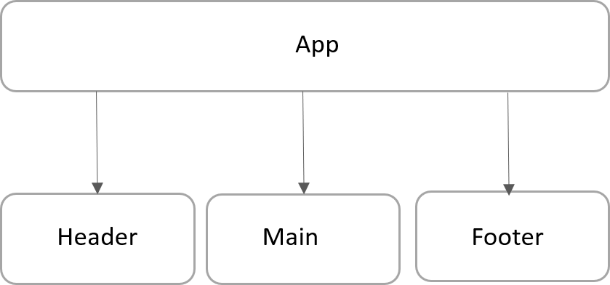

- Create a folder /components
- In this folder create 3 additional JSX files:
  - Header.jsx
  - Main.jsx
  - Footer.jsx

- Adapt the code from the original HTML code to those 4 compomers (App, header, Body and Footer)
  - Do not forget to export your components to use them outside!

- Finally, you can copy the original CSS code to your new project

The finished app could look like this:



Exercise 3
Amazing!

Q1 - Now your challenge is to draw a diagram component from some existing React JS code.
- Read the code
- Identify components
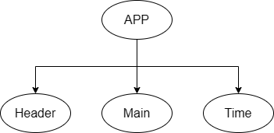
- Draw the diagram component (using power point or another tool)



Q2 – Let’s play with dynamic data:

  - In Header, change the title to: “The amazing atomic clock”

  - In Time component, change the code to display only the time only (not date + time)


