**Industrial Internship Report on**

**”Python URL Shortener”**

**Prepared by**

**K.S.Abhihkeshav**

|  |
| --- |
| *Executive Summary* |
| This report provides details of the Industrial Internship provided by upskill Campus and The IoT Academy in collaboration with Industrial Partner UniConverge Technologies Pvt Ltd (UCT).  This internship was focused on a project/problem statement provided by UCT. We had to finish the project including the report in 6 weeks’ time.  My project was to take a URL for a website as input from the user and create a new shortened URL which can be used in place of the long original URL.  This internship gave me a very good opportunity to get exposure to Industrial problems and design/implement solution for that. It was an overall great experience to have this internship. |

**TABLE OF CONTENTS**

1 Preface 3

2 Introduction 6

2.1 About UniConverge Technologies Pvt Ltd 6

i. UCT IoT Platform……………………………………………………………………………………………………………..6

2.2 About upskill Campus(USC) 11

2.3 The IoT Academy………………………………………………………………………………………………………………………..13

2.4 Objective of this internship program 13

2.5 Reference 13

2.6 Glossary 13

3 Problem Statement 15

4 Existing and Proposed solution 16

4.1 Code submission (Github link)……………………………………………………………………………………….16

4.2 Report submission (Github link)…………………………………………………………………………………….16

5 Proposed Design/ Model 17

6 Performance Test 18

6.1 Test Plan/ Test Cases 18

6.2 Performance Outcome 18

7 My learnings 19

8 Future work scope 20

# Preface

**Summary of the whole 6 weeks’ work:**

* The first week of the internship was spent in exploring problem statements, revising python and exploring many libraries of python to pick the appropriate problem statement for me.
* The second week was spent in the planning and designing algorithm for the chosen problem statement.
* The next 3 weeks were spent on progressing the project and making improvements wherever it was deemed necessary.
* The last week was used to find and rectify any errors found in the project and look for further improvements.

**About need of relevant Internship in career development:**

* Internships are a valuable part of career development, as they provide students and recent graduates with the opportunity to gain real-world experience in their chosen field.
* This experience can be invaluable when it comes to securing future job opportunities, as it allows students to demonstrate their practical skills and knowledge to potential employers.
* It also helps in the growth of an individual by improving and developing professional skills such as communication, teamwork, leadership, time management, etc.
* Internships can also help students build their professional network by interacting with experienced professionals in their field.
* This helps students learn about industry trends, make valuable connections, and get their foot in the door for future job opportunities.

**Brief about Your project/problem statement:**

* The URL shortener is a Python project that converts long URLs into shorter, more manageable links. It takes a long URL as input, generates a unique shortened URL, and redirects users to the original URL when the shortened link is accessed.
* The scope of this project involves the designing of the appropriate UI, creating a database to map between the original and corresponding short URL and also creating functions to generate the short URL.

**Opportunity given by USC/UCT:**

* I sincerely thank USC/UCT for giving me this wonderful opportunity to express myself and my coding skills through this internship.
* This internship has helped me understand and explore the depths of python and the scope of data science.
* It has also helped me explore my interests in the subject and understand the multiple ways this knowledge can be used in practical and real-life scenarios.

**How Program was planned:**

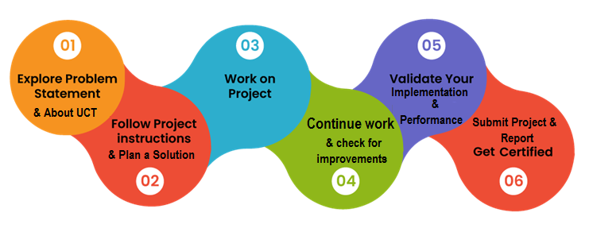

**Learnings and overall experience:**

* I was fortunate to have the opportunity to work on a variety of projects such as the URL shortener.
* I gained a deep understanding of the company's ( UCT ) products and services, as well as the industry as a whole.
* One of the most valuable learnings I had during my internship was the importance of teamwork.
* I learned how to effectively communicate with various people from the internship and effectively work with them.
* I also learned how to manage my time effectively and meet deadlines of each week.
* Overall, the experience of the internship course as well as the help provided by the administrators helped me throughout the journey.

**Acknowledgements**

* I would like to thank Upskill Campus and IOT academy for providing me with this opportunity to take part in this internship course.
* I would like to thank my teammate Naman Mulani to work on this project alongside me.
* I would also like to thank the youtube channel “Codemy” which has helped me learn the uses and implementation of flask effectively.

**Message to my juniors and peers**

* My only advice to my juniors and peers would be that we must not underestimate the importance of time management. Throughout this course time management has been a challenge, which made me realize and plan a schedule for the work to be done.

# Introduction

## About UniConverge Technologies Pvt Ltd

A company established in 2013 and working in Digital Transformation domain and providing Industrial solutions with prime focus on sustainability and RoI.

For developing its products and solutions it is leveraging various**Cutting Edge Technologies e.g. Internet of Things (IoT), Cyber Security, Cloud computing (AWS, Azure), Machine Learning, Communication Technologies (4G/5G/LoRaWAN), Java Full Stack, Python, Front end**etc.

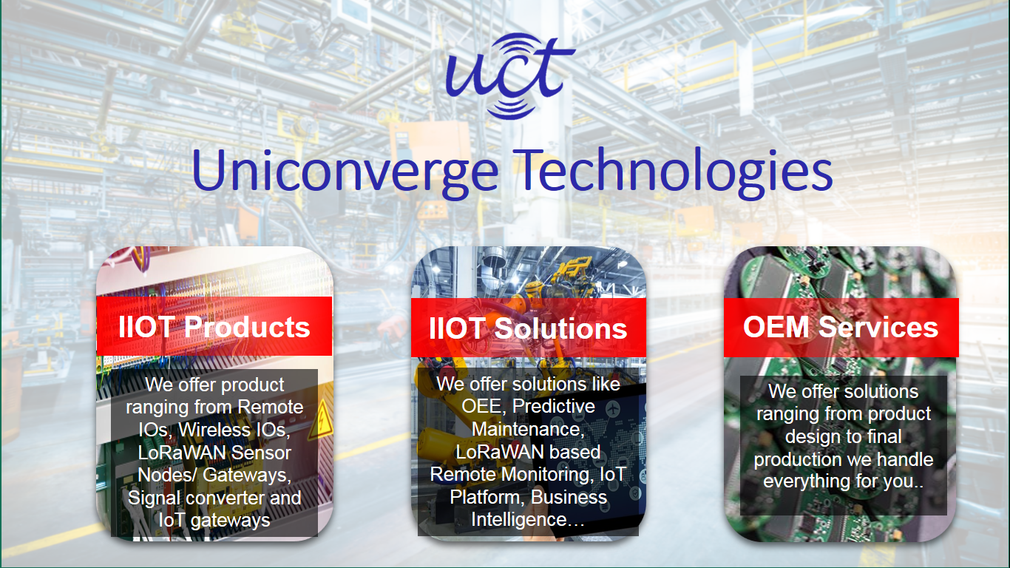

1. UCT IoT Platform **(****)**

**UCT Insight** is an IOT platform designed for quick deployment of IOT applications on the same time providing valuable “insight” for your process/business. It has been built in Java for backend and ReactJS for Front end. It has support for MySQL and various NoSql Databases.

* It enables device connectivity via industry standard IoT protocols - MQTT, CoAP, HTTP, Modbus TCP, OPC UA
* It supports both cloud and on-premises deployments.

It has features to  
• Build Your own dashboard  
• Analytics and Reporting  
• Alert and Notification  
• Integration with third party application(Power BI, SAP, ERP)  
• Rule Engine

 

1. **Smart Factory Platform (****)**

Factory watch is a platform for smart factory needs.

It provides Users/ Factory

* with a scalable solution for their Production and asset monitoring
* OEE and predictive maintenance solution scaling up to digital twin for your assets.
* to unleased the true potential of the data that their machines are generating and helps to identify the KPIs and also improve them.
* A modular architecture that allows users to choose the service that they what to start and then can scale to more complex solutions as per their demands.

Its unique SaaS model helps users to save time, cost and money.

 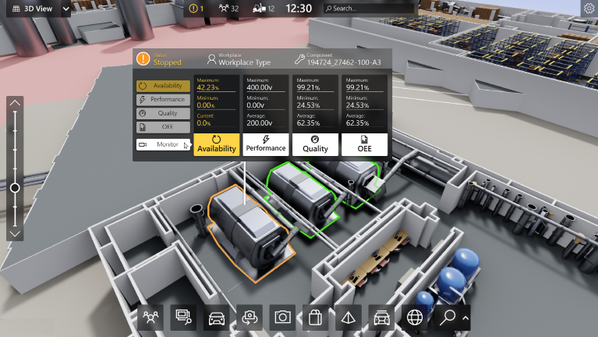

1. 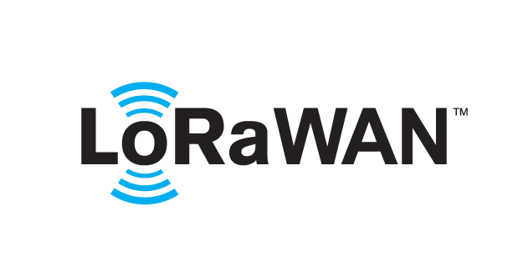 based Solution

UCT is one of the early adopters of LoRAWAN teschnology and providing solution in Agritech, Smart cities, Industrial Monitoring, Smart Street Light, Smart Water/ Gas/ Electricity metering solutions etc.

1. Predictive Maintenance

UCT is providing Industrial Machine health monitoring and Predictive maintenance solution leveraging Embedded system, Industrial IoT and Machine Learning Technologies by finding Remaining useful life time of various Machines used in production process.



## About upskill Campus (USC)

upskill Campus along with The IoT Academy and in association with Uniconverge technologies has facilitated the smooth execution of the complete internship process.

USC is a career development platform that delivers **personalized executive coaching** in a more affordable, scalable and measurable way.



Seeing need of upskilling in self paced manner along-with additional support services e.g. Internship, projects, interaction with Industry experts, Career growth Services

<https://www.upskillcampus.com/>

upSkill Campus aiming to upskill 1 million learners in next 5 year

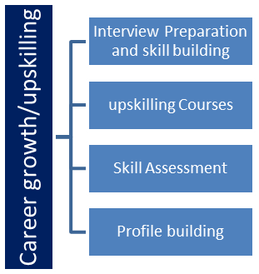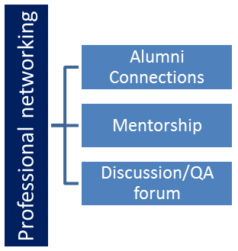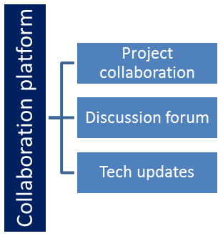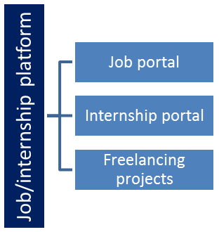

## The IoT Academy

The IoT academy is EdTech Division of UCT that is running long executive certification programs in collaboration with EICT Academy, IITK, IITR and IITG in multiple domains.

## Objectives of this Internship program

The objective for this internship program was to

 ☛ get practical experience of working in the industry.

 ☛ to solve real world problems.

 ☛ to have improved job prospects.

 ☛ to have Improved understanding of our field and its applications.

 ☛ to have Personal growth like better communication and problem solving.

## Reference

[1] YouTube channel “Codemy”

[2] https://www.w3schools.com/

## Glossary

|  |  |
| --- | --- |
| Terms | Acronym |
| LoRaWAN | Long Range Wide Area Network |
| UCT | UniConverge Technologies |
|  |  |
|  |  |
|  |  |

# Problem Statement

In the assigned problem statement we were asked to create a project that would convert long URLs into shorter, more manageable links. It takes a long URL as input, generates a unique shortened URL, and redirects users to the original URL when the shortened link is accessed.

# Existing and Proposed solution

The limitations that other solutions had was that it would either generate a link which would not redirect to the provided url and / or there would be no scope of storing and managing those links . To overcome these draw backs we had picked this project and decided to work on it along with implementing a database to store the mapping between original and shortened URLs.

These would make the user more convenient and more flexible in using the website for better performance and retrieval of shortened links .

## Code submission (Github link)

https://github.com/K-S-Abhihkeshav/URL-Shortener

## Report submission (Github link) :

https://github.com/K-S-Abhihkeshav/URL-Shortener

# Proposed Design/ Model

Given more details about design flow of your solution. This is applicable for all domains. DS/ML Students can cover it after they have their algorithm implementation. There is always a start, intermediate stages and then final outcome.

# Performance Test

We tried our code using links varying drastically in size , the url shortened link is efficient enough to provide a shorter and better link to the long urls and would make sure to redirect them to the right place if used .

We also have a memory usage (database storage ) for only long urls and short-converted urls , our url shortening algorithm proves to be faster in generating the link . (as it is based on random functions ) and are providing better accuracy without collision .

## Test Plan/ Test Cases

By providing out long urls into our code generator we were able to achieve shorter links for it .

## Performance Outcome

The shorting along with the better UI interface would provide the user a better interaction with the website and also with the faster response it seems reasonable to adapt to it.

# My learnings

These 6 weeks were quite good in terms of learning new things and putting them onto work , we learned a lot about different modules , functions . applying them into our project , creating better designs to improve our UI , learning about flask and sqlalchemy and many other things we would not be possible without this course.

# Future work scope

Uploading the website onto the server . creating authentication and authorization and establishing a good cloud server for better retrivel of links shortened in the past.