Q-36. Write an SQL query to show the second highest salary from a table.

SELECT MAX(SALARY) AS SecondHighestSalary

FROM Worker

WHERE SALARY < (SELECT MAX(SALARY) FROM Worker);



Q-37. Write an SQL query to show one row twice in results from a table.

SELECT * FROM Worker WHERE WORKER_ID = 1

UNION ALL

SELECT * FROM Worker WHERE WORKER_ID = 1;

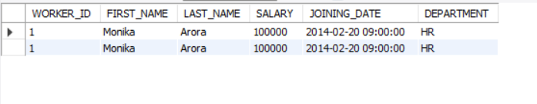

Q-38. Write an SQL query to fetch intersecting records of two tables.

SELECT * FROM Worker

WHERE WORKER_ID IN (SELECT WORKER_REF_ID FROM Bonus);

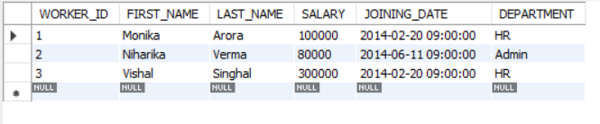

Q-39. Write an SQL query to fetch the first 50% records from a table.

Q-40. Write an SQL query to fetch the departments that have less than five people in it.

SELECT DEPARTMENT

FROM Worker

GROUP BY DEPARTMENT

HAVING COUNT(WORKER_ID) < 5;

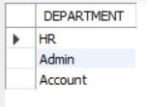

• Q-41. Write an SQL query to show all departments along with the number of people in there.

SELECT DEPARTMENT, COUNT(WORKER_ID) AS NumberOfPeople

FROM Worker

GROUP BY DEPARTMENT;

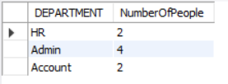

Q-42. Write an SQL query to show the last record from a table.

SELECT * FROM Worker

ORDER BY WORKER_ID DESC

LIMIT 1;

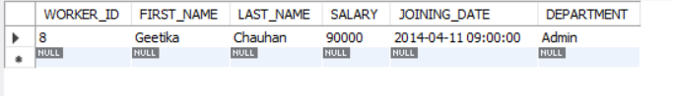

Q-43. Write an SQL query to fetch the first row of a table.

SELECT * FROM Worker

ORDER BY WORKER_ID

LIMIT 1;

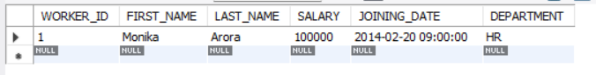

Q-44. Write an SQL query to fetch the last five records from a table.

SELECT * FROM Worker

ORDER BY WORKER_ID DESC

LIMIT 5;

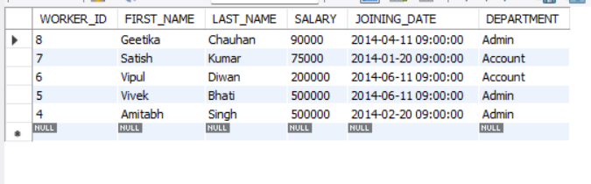

Q-45. Write an SQL query to print the name of employees having the highest salary in each department.

SELECT FIRST_NAME, LAST_NAME, DEPARTMENT, SALARY

FROM Worker

WHERE (DEPARTMENT, SALARY) IN (

SELECT DEPARTMENT, MAX(SALARY)

FROM Worker

GROUP BY DEPARTMENT

);

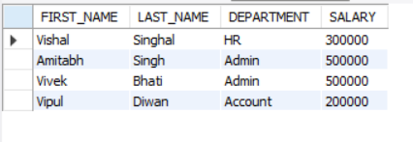

Q-46. Write an SQL query to fetch three max salaries from a table.

SELECT DISTINCT SALARY

FROM Worker

ORDER BY SALARY DESC

LIMIT 3;

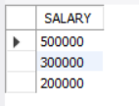

Q-47. Write an SQL query to fetch three min salaries from a table.

SELECT DISTINCT SALARY

FROM Worker

ORDER BY SALARY ASC

LIMIT 3;

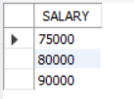

• Q-48. Write an SQL query to fetch nth max salaries from a table.

SELECT DISTINCT SALARY

FROM Worker

ORDER BY SALARY DESC

LIMIT 1 OFFSET 3;



• ⁠Q-49 query to fetch departments along with the total salaries paid

SELECT DEPARTMENT, SUM(SALARY) AS TotalSalariesPaid

FROM Worker

GROUP BY DEPARTMENT;

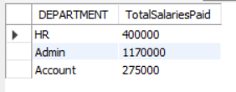

Q-50. Write an SQL query to fetch the names of workers who earn the highest salary.

SELECT FIRST_NAME, LAST_NAME

FROM Worker

WHERE SALARY = (SELECT MAX(SALARY) FROM Worker);

