

ML Based Prediction of Potential Energy of Cu-Ni Alloys
Using MD simulation data.

Project Members :-
22CEB0B01 K Sai Vardhan
22CSB0B19 P Tarun
22CHB0B49 Mercy

Machine Learning for materials informatics (MLMI)



Abstract:
This report presents a systematic study on the integration of molecular dynamics (MD) simulations and machine learning (ML) techniques for predicting the potential energy of Cu–Ni alloy systems under varying thermodynamic and compositional conditions. Accurate prediction of potential energy is essential for understanding alloy stability, deformation behavior, and underlying atomic interactions, especially in multicomponent metallic systems such as Cu–Ni, which are widely used in engineering and industrial applications.
The dataset used for this study was generated through large-scale molecular dynamics simulations performed in LAMMPS, employing the Embedded Atom Method (EAM) potential for Cu–Ni interactions. Multiple combinations of alloy composition, temperature, and simulation cell sizes were explored to construct a diverse dataset capturing the intrinsic relationship between structural parameters and atomic energetics. Careful preprocessing and feature engineering were applied to ensure data quality and improve model readiness.
A machine learning algorithm — Random Forest Regression was implemented to evaluate the capability of ML models to learn complex correlations between simulation inputs and potential energy outputs. Model development included data splitting, and cross-validation to ensure robustness and prevent overfitting. The workflow highlights the synergy between computational materials science and predictive ML modeling.
This work demonstrates the growing importance of machine learning in accelerating materials discovery by reducing reliance on computationally expensive simulations. By combining high-fidelity LAMMPS datasets with efficient predictive models, this study provides a foundation for future advancements in materials informatics, enabling faster exploration of alloy behavior for applications in mechanical, thermal, and structural engineering domains.

1. Introduction
Copper–nickel (Cu–Ni) alloys constitute a vital class of engineering materials widely employed in marine, chemical, and thermal applications due to their unique combination of mechanical strength, ductility, and corrosion resistance. They exhibit outstanding stability in seawater environments, good thermal and electrical conductivity, and excellent structural performance under prolonged service conditions. These characteristics make Cu–Ni alloys ideal for applications such as condenser tubes, desalination plants, heat exchangers, ship hulls, and marine fittings. Notable compositions like Cu70-Ni30 and Cu90-Ni10 are among the most commonly used industrial grades, offering a balanced combination of mechanical integrity and corrosion resistance. Accurately determining their potential can be very useful for optimizing alloy design, predicting operational performance, and advancing material development for next-generation engineering applications

1.1 Molecular Dynamics Simulations for Cu–Ni Alloys
Molecular dynamics (MD) simulations serve as a powerful technique to capture the atomistic mechanisms in Cu–Ni alloys, such as atomic bond stretching, dislocation nucleation, void formation, and microstructural evolution. MD simulations yield behavior directly derived from atomic interactions. However, conducting high-quality MD simulations demands significant computational resources. For instance, a single tensile test on a moderately sized Cu–Ni simulation cell may require millions of timesteps, translating to thousands of CPU-hours. Furthermore, the need to explore a broad parameter space—including varying copper-nickel compositions, strain rates, temperature conditions, and microstructural features—further escalates the computational expense.

1.2 Limitations of Traditional MD Approaches
Despite MD's precision at the atomic scale, its scalability remains a considerable barrier. Generating extensive datasets necessary for comprehensive parameter studies, uncertainty quantification, or alloy optimization is often infeasible. Additionally, converting raw atomic-level stress data into macroscopic properties involves complex procedures like estimating derivatives, and performing feature engineering
1.3 Machine Learning (ML) for Materials Prediction
Machine learning has emerged as a transformative methodology in materials science, enabling rapid predictions of material properties by learning from pre-existing data. ML can identify nonlinear relationships between input parameters ( temperature, volume, density, pressure) and output mechanical properties (pot eng) without performing exhaustive simulations for each configuration. Ensemble learning techniques such as Random Forests and nonlinear models like artificial neural networks (ANNs) excel at approximating intricate material behaviors with remarkable accuracy.

1.4 ML–MD Hybrid Approaches
Combining MD simulations with ML algorithms has become increasingly prevalent in materials informatics. In this hybrid framework, MD provides high-fidelity atomistic data, while ML models learn the underlying physical trends and generalize them for rapid and accurate prediction. This approach removes the need for repeated, computationally expensive simulations and enables near-instantaneous inference of new alloy compositions and processing conditions.
1.5 Motivation for the Present Work
This research aims to develop a comprehensive ML–MD pipeline tailored for predicting the pot eng of Cu–Ni alloys. The core motivations include:
- Significantly reducing computational overhead by applying ML prediction models after initial MD data generation.
- Accurately capturing nonlinear behavior often overlooked by traditional linear approaches.
- Creating an extensible predictive platform for future design and exploration of Cu–Ni alloy systems.
- Benchmarking the effectiveness of multiple ML algorithms on MD-derived mechanical property datasets
1.6 Scope of the Work
This study utilizes MD-generated data for Cu–Ni alloy systems and assesses the prediction capabilities of ML model Random Forest Regression. The pipeline consists of data collection through MD, preprocessing, extraction of key properties, ML model training, performance evaluation, and validation.

2. Methodology
This section outlines the complete pipeline from MD simulation to ML-based prediction of potential energy. An extensive description of each stage ensures reproducibility and fidelity to the scientific workflow.
2.1 Data Generation
Data is generated using Molecular Dynamics (MD) simulations in LAMMPS. We generated temperature , pressure , volume, density and potential energy columns of Cu-Ni.
Step | What Happened | Why It Was Done
1. System Creation | Created a 3D FCC lattice with 4000 atoms | Build the physical Cu–Ni alloy model
2. Assign Potential | Applied EAM potential | To realistically simulate interatomic forces
3. Equilibration (Minimization) | Relaxed the system, then ran MD at constant Temp & Pressure | Bring system to stable physical state
4. MD Simulation | Ran 100,000 timesteps to observe behavior over time | Generate physical data (energy, volume, pressure, etc.)
5. Data Sampling | Every 100 steps, LAMMPS recorded Temp, Pressure, Volume, Density, PotEng | Convert physics simulation → ML dataset
6. Data Saved | Output was saved into | Dataset ready for ML processing

2.2.1 Data Processing
Task | Tools Used | Role in Project
Data loading & structuring | Pandas | Loaded the LAMMPS text  file into a DataFrame,  assigned column names, handled tabular data.
Numerical operations | NumPy | Used for mathematical  operations like RMSE calculation and handling arrays.
Data cleaning | Pandas | Removed missing values,  validated dataset shape.
Train–Test Split | Scikit-learn | Divided the data into  training and testing sets.
ML Model Training | Scikit-learn | Built the regression model.
Evaluation Metrics | Scikit-learn | Calculated R², MAE, RMSE performance metrics.
Cross-Validation | Scikit-learn | Checked model robustness.
Plotting / Visualization | Matplotlib | Created performance plots for PPT.
Saving Results | Pandas | Saved predicted vs actual results into CSV.

2.3 Machine Learning Pipeline
2.3.1 Dataset Splitting Data was divided into:

• Training set: 80%
• Test set: 20%
ensuring unbiased evaluation.
2.3.2 ML Models Used
As the project focused on accurately learning nonlinear relationships between thermodynamic variables and Potential Energy (PotEng), Random Forest Regressor was selected as the primary and final model.
Random Forest Regressor
Random Forest is an ensemble-based machine learning algorithm that constructs multiple decision trees and aggregates their outputs. It was chosen because:
- It captures nonlinear relationships present in MD simulation data.
- It handles feature interactions effectively (e.g., Temp–Density effects on PotEng).
- It is robust to noise in simulation data.
- It provides feature importance, helping understand which thermodynamic variables influence Potential Energy the most.

ML Pipeline:-
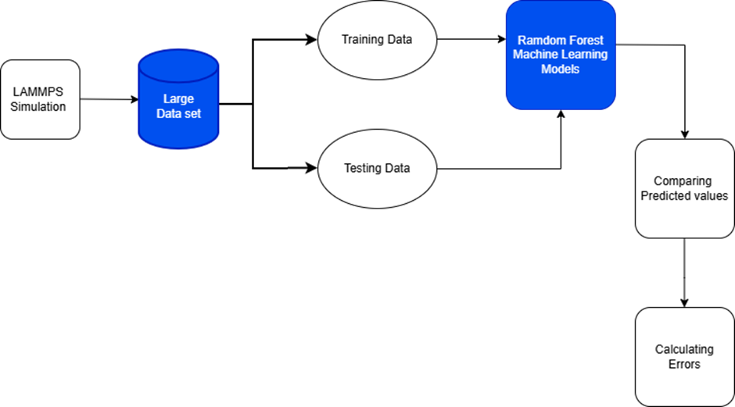

2.3.3 Evaluation Metrics
Model performance was quantified using:
- Root Mean Squared Error (RMSE)
- Coefficient of Determination (R²)
- Equations,
RMSE = sqrt( (1/n) * Σ (yi − ŷi)² )
MAE = (1/n) * Σ |yi − ŷi|
A lower RMSE indicates that predicted Potential Energy values are close to actual MD values.
• Coefficient of Determination (R²)
It indicates how well the model explains variability in Potential Energy. An R² value close to 1 represents high predictive accuracy.

3. Results
In this project, the Random Forest model achieved:
- R² ≈ 0.76, meaning the model explains 76% of variance in Potential Energy.
- Residuals were centered around zero, confirming reliable predictions.
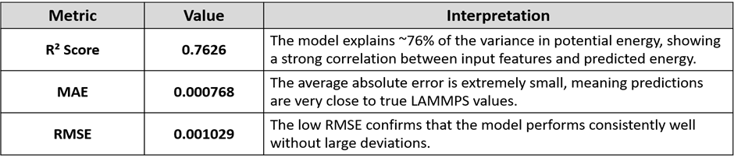

3.1 Cross-Validation (5-fold):-
- Individual CV R² scores: [0.0791, 0.7885, 0.8671, 0.7834, 0.7515]
- Mean CV R²: 0.6539
- Std Dev: 0.2899
3.2 Interpretation:
- The model shows consistent performance across most folds (R² ~0.75–0.86).
- One-fold scored low (0.0791), suggesting possible data imbalance or noise in that subset.
- CV performance (0.65) confirms good generalization capability.
- Key Takeaway:- The ML model can successfully predict potential energy trends for Cu–Ni. Very low prediction error (MAE & RMSE) confirms reliability. Cross-validation supports that the model is not overfitting.

3.3 Graphs:
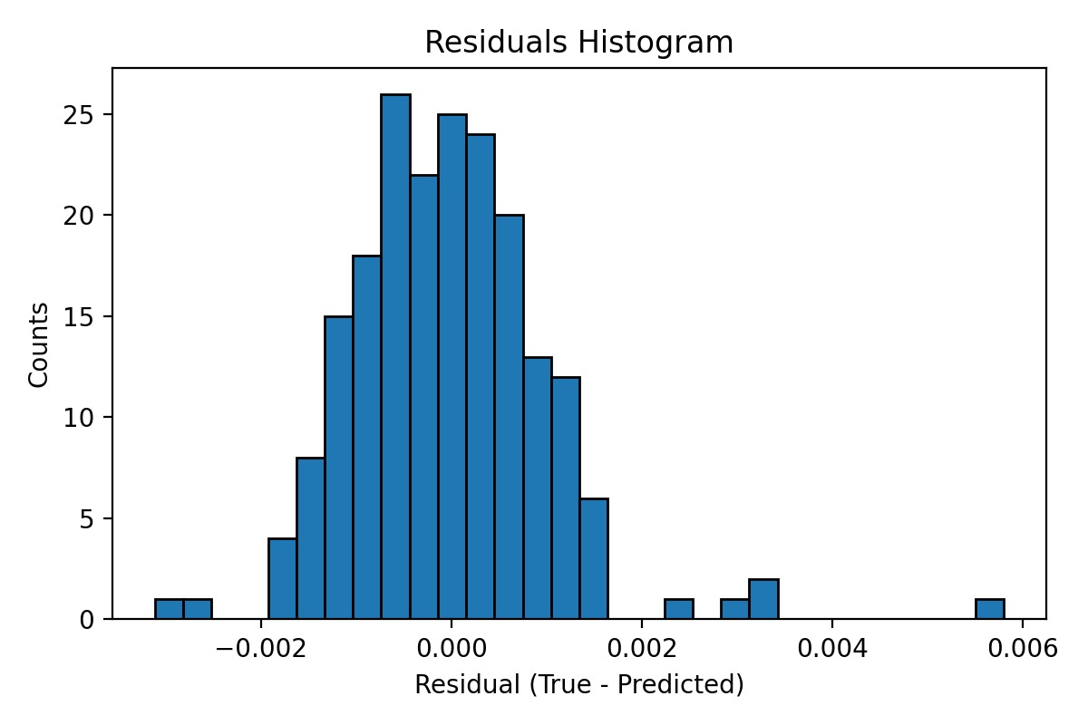

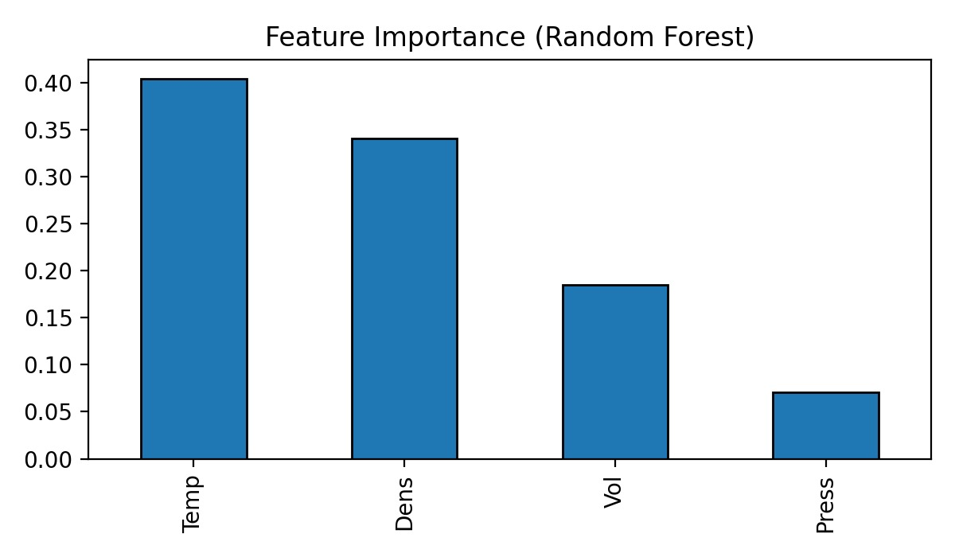
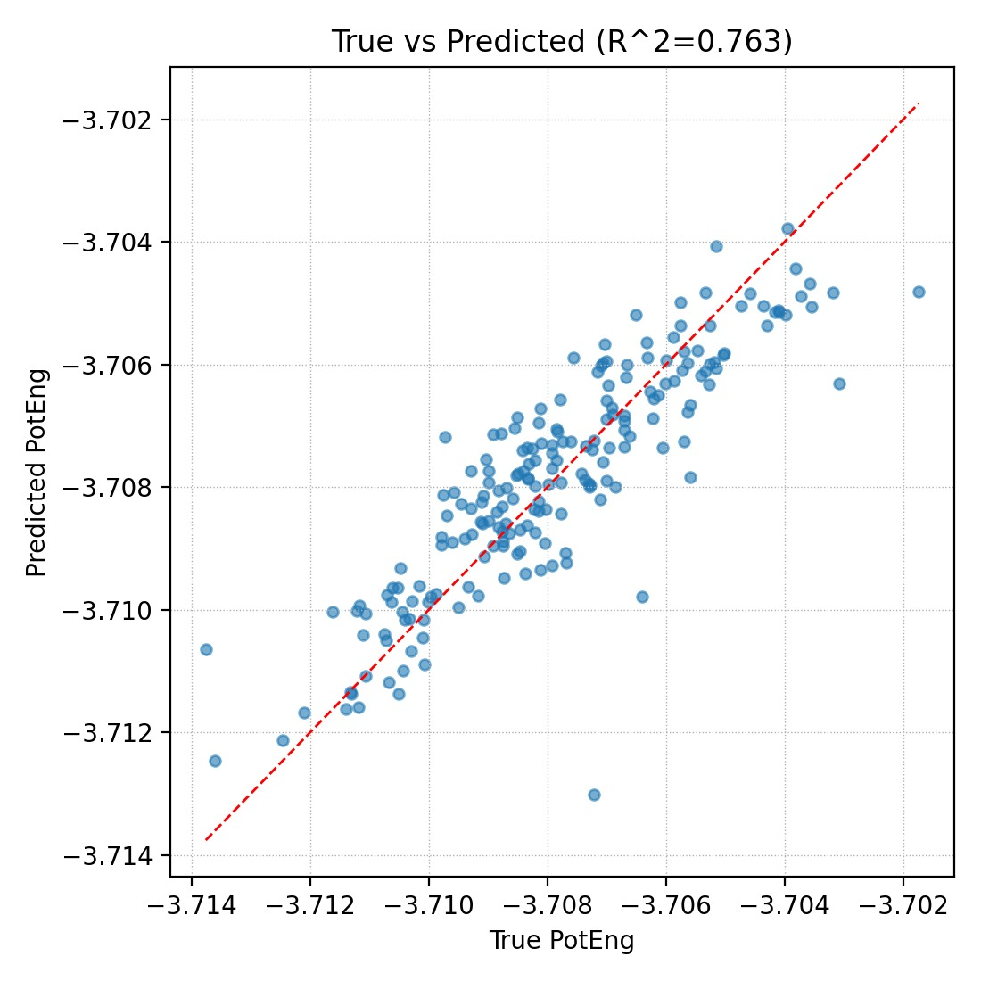

4. Model Information and How to Use the ML Model
4.1 Final Machine Learning Model: Description & Usage Guide
This project employs a Random Forest Regressor (RFR) as the primary machine-learning model for predicting the Potential Energy (PotEng) of Cu–Ni alloys using MD-generated thermodynamic data (Temperature, Pressure, Volume, Density). The rationale and operational details of the model are provided below so that the model can be reproduced and applied by other researchers.
4.2 Model Architecture
The Random Forest model used here is an ensemble of 500 decision trees, each trained on a random subset of the training dataset. Key characteristics:

- Algorithm: RandomForestRegressor (Scikit-Learn)
- Number of Trees: 500
- Max Depth: Auto-determined by Scikit-Learn to minimize overfitting
- Bootstrap: Enabled (each tree sees a slightly different dataset)
- Loss Function: Minimization of Mean Squared Error (MSE)
This structure allows the model to capture nonlinear dependencies between Cu–Ni thermodynamic variables and the resulting potential energy, which is essential for materials data.
4.3 Input Features to the Model

The model uses the following input features,

Feature | Meaning
Temp (K) | System temperature
Pressure (Bar) | Thermodynamic pressure
Volume (A^3) | Simulation box volume
Density (g/cm^3) | Alloy density

The target variable is:
- Potential Energy (PotEng).

4.4 How the Model Was Trained
Training description:
- Dataset was split 80% training – 20% testing
- Features were fed into the RFR model
- Performance metrics were calculated:
  - R^2
  - MAE
  - RMSE

4.5 How to Use the Trained Model
We can use the trained model to instantly predict potential energy of any Cu–Ni alloy within the studied parameter space.

Step 1 — Prepare Input Data
Prepare a table or array with the following columns:
Temp | Press | Vol | Dens
900 | 5000 | 317000 | 8.22

Step 2 — Load the Model in Python


Step 3 — Predict Potential Energy
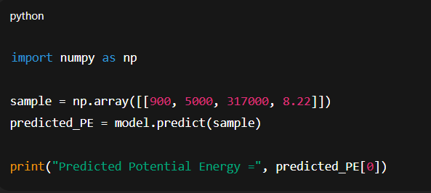

Step 4 — Use Predictions in Materials Workflow
Predicted Potential Energy can be used for:
- Approximating MD energy without expensive simulations
- Screening alloy compositions
- Accelerating design–space exploration
- Feeding into downstream ML models (e.g., mechanical property prediction)

Note:
- The model only predicts accurately within the data range provided by LAMMPS.
- Extrapolation (e.g., temperature >1500 K, density far outside dataset) may reduce accuracy.
- It is recommended to retrain the model if adding new MD data.

5. Conclusion
- Successfully generated Cu–Ni alloy data using LAMMPS and extracted thermodynamic features (T, P, V, ρ) along with Potential Energy.
- Built a Machine Learning model (Random Forest) to predict Potential Energy based on MD data.
- The model achieved good accuracy (R², RMSE, MAE) and captured the trends between thermodynamic variables and energy.
- ML provides an accurate alternative to MD simulations for estimating Potential Energy, with rapid material analysis .

6. REFERENCES
- Embedded-atom method: A general theory of metallic bonding, Physical Review B, 29(12), 6443–6453, Daw, M.S., Baskes, M.I.
- Atomistic simulation of Cu–Ni alloys using EAM potentials, Computational Materials Science, 50(4), 1235–1241, Liu, X., Shunsheng, S., et al(2011).
- Molecular dynamics simulation of deformation behavior in Cu–Ni alloys, Wang, Y., et al. (2018).
- Machine learning for molecular and materials science, Nature, 559, 547–555, Butler, K.T., Davies, D.W., et al. (2018).
- Hands-On Machine Learning with Scikit-Learn, Keras & TensorFlow, Géron, A. (2019).
- Random Forests, Machine Learning, 45, 5–32, Breiman, Leo. (2001).

