VISVESVARAYA TECHNOLOGICAL UNIVERSITY
“JnanaSangama”, Belgaum -590014, Karnataka.


LAB REPORT

On

ANALYSIS AND DESIGN OF ALGORITHMS (23CS4PCADA)

Submitted by

K SANYAM KHAJURIA (1BF24CS130)

in partial fulfillment for the award of the degree of
BACHELOR OF ENGINEERING
in
COMPUTER SCIENCE AND ENGINEERING



B.M.S. COLLEGE OF ENGINEERING
(Autonomous Institution under VTU)
BENGALURU-560019
February to June 2026
CERTIFICATE

B. M. S. College of Engineering,
Bull Temple Road, Bangalore 560019
(Affiliated To Visvesvaraya Technological University, Belgaum)
Department of Computer Science and Engineering



This is to certify that the Lab work entitled “ANALYSIS AND DESIGN OF ALGORITHMS” carried out by K SANYAM KHAJURIA (1BF24CS151), who is bonafide student of B. M. S. College of Engineering. It is in partial fulfillment for the award of Bachelor of Engineering in Computer Science and Engineering of the Visvesvaraya Technological University, Belgaum during the year 2025-26. The Lab report has been approved as it satisfies the academic requirements in respect of Analysis and Design of Algorithms Lab - (23CS4PCADA) work prescribed for the said degree.

Dr.Manjula S Dr. Kavitha Sooda
Assistant Professor Professor and Head
Department of CSE Department of CSE
BMSCE, Bengaluru BMSCE, Bengaluru

Index Sheet
Sl.  No. | Experiment Title | Page No.
1 | Write a program to obtain the Topological ordering of vertices in a given digraph.
2 | Implement Johnson Trotter algorithm to generate permutations.
3 | Sort a given set of N integer elements using Merge Sort technique and compute its time taken. Run the program for different values of N and record the time taken to sort.
4 | Sort a given set of N integer elements using Quick Sort technique and compute its time taken.
5 | Sort a given set of N integer elements using Heap Sort technique and compute its time taken.
6 | Implement 0/1 Knapsack problem using dynamic programming. (5 Marks)
7 | Implement All Pair Shortest paths problem using Floyd’s algorithm.
8 | - Find Minimum Cost Spanning Tree of a given undirected graph using Prim’s algorithm.  - Find Minimum Cost Spanning Tree of a given undirected graph using Kruskal’s algorithm.
9 | Implement Fractional Knapsack using Greedy technique.
10 | From a given vertex in a weighted connected graph, find shortest paths to other vertices using Dijkstra’s algorithm.
11 | Implement “N-Queens Problem” using Backtracking.

Course outcomes:
CO1 | Analyze time complexity of algorithms using asymptotic notations.
CO2 | Apply various algorithm design techniques for the given problem.
CO3 | Evaluate the appropriate algorithm/design technique for solving a given problem.
CO4 | Conduct practical experiments by applying appropriate algorithm design technique to solve problems.

Lab program 1: Topological Sort
CODE:

#include <stdio.h>

#define MAX 100

int adj[MAX][MAX];
int indegree[MAX];
int queue[MAX];
int front = 0, rear = 0;

void topologicalSort(int n)
{
for (int i = 0; i < n; i++)
{
indegree[i] = 0;
for (int j = 0; j < n; j++)
{
if (adj[j][i])
indegree[i]++;
}
}

for (int i = 0; i < n; i++)
{
if (indegree[i] == 0)
queue[rear++] = i;
}

int count = 0;

printf("Topological Order: ");

while (front < rear)
{
int u = queue[front++];
printf("%d ", u);

for (int v = 0; v < n; v++)
{
if (adj[u][v])
{
indegree[v]--;

if (indegree[v] == 0)
queue[rear++] = v;
}
}

count++;
}

if (count != n)
printf("\nGraph contains a cycle.\n");
}

int main()
{
int n, e;

printf("Enter number of vertices: ");
scanf("%d", &n);

printf("Enter number of edges: ");
scanf("%d", &e);

for (int i = 0; i < n; i++)
{
for (int j = 0; j < n; j++)
adj[i][j] = 0;
}

printf("Enter edges (u v) meaning u -> v:\n");

for (int i = 0; i < e; i++)
{
int u, v;
scanf("%d %d", &u, &v);
adj[u][v] = 1;
}

topologicalSort(n);

return 0;
}

OUTPUT:

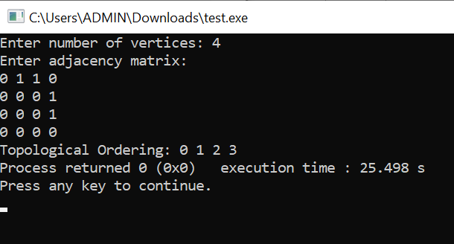

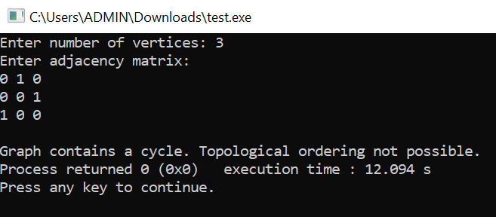

GRAPH:
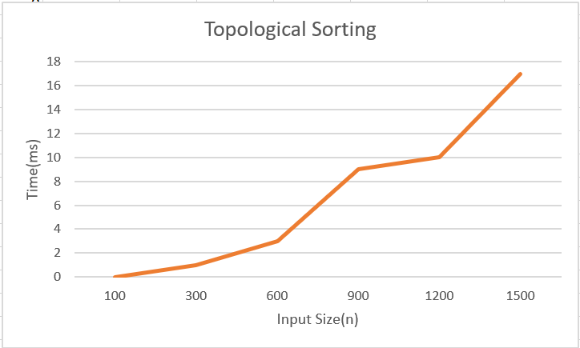

LEETCODE: 207.Course Schedule

CODE:

#include <stdbool.h>
bool canFinish(int numCourses, int** prerequisites, int prerequisitesSize, int* prerequisitesColSize){
int graph[2000][2000] = {0};
int indegree[2000] = {0};
int queue[2000];
int front = 0, rear = 0;
int count = 0;
for(int i = 0; i < prerequisitesSize; i++){
int a = prerequisites[i][0];
int b = prerequisites[i][1];
graph[b][a] = 1;
indegree[a]++;
}
for(int i = 0; i < numCourses; i++){
if(indegree[i] == 0){
queue[rear++] = i;
}
}
while(front < rear){
int node = queue[front++];
count++;
for(int i = 0; i < numCourses; i++){
if(graph[node][i] == 1){
indegree[i]--;
if(indegree[i] == 0){
queue[rear++] = i;
}
}
}
}
return (count == numCourses);
}

OUTPUT:

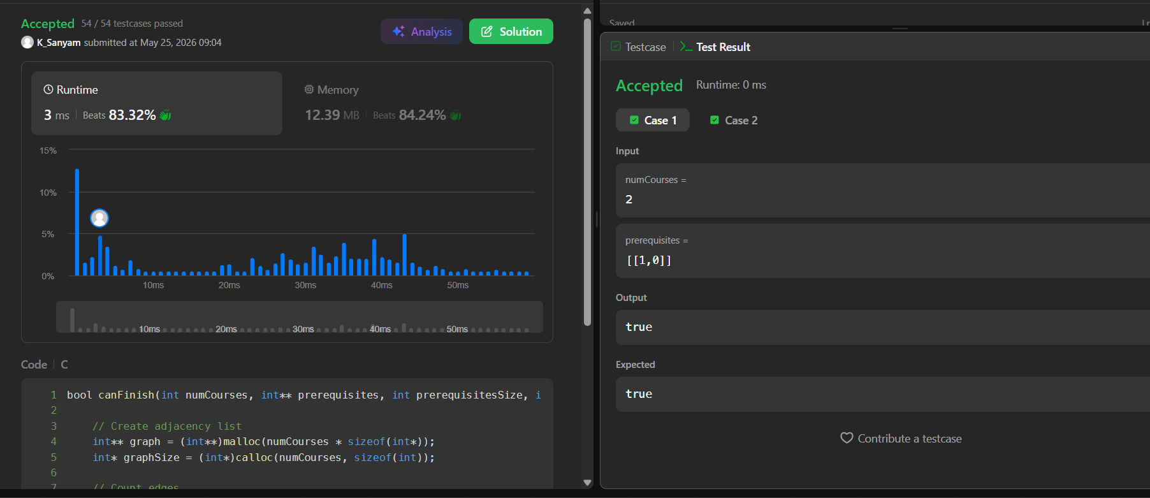

Lab program 2: Johnson Trotter
CODE:

#include <stdio.h>

int mobile(int p[], int d[], int n)
{
int m = 0;

for (int i = 0; i < n; i++)
{
if (d[i] == -1 && i > 0 && p[i] > p[i - 1] && p[i] > m)
{
m = p[i];
}

if (d[i] == 1 && i < n - 1 && p[i] > p[i + 1] && p[i] > m)
{
m = p[i];
}
}

return m;
}

int main()
{
int n;
int p[10], d[10];
int i, m, pos, next, temp;

printf("Enter n: ");
scanf("%d", &n);

/* Initialize permutation and directions */
for (i = 0; i < n; i++)
{
p[i] = i + 1;
d[i] = -1; // All directions initially point left
}

while (1)
{
/* Print directions */
for (i = 0; i < n; i++)
{
printf("%3c", (d[i] == -1) ? '<' : '>');
}
printf("\n");

/* Print permutation */
for (i = 0; i < n; i++)
{
printf("%3d", p[i]);
}
printf("\n\n");

/* Find largest mobile element */
m = mobile(p, d, n);

/* Stop when no mobile element exists */
if (m == 0)
{
break;
}

/* Find position of largest mobile element */
for (i = 0; i < n; i++)
{
if (p[i] == m)
{
pos = i;
break;
}
}

/* Find the adjacent position in its direction */
next = pos + d[pos];

/* Swap numbers */
temp = p[pos];
p[pos] = p[next];
p[next] = temp;

/* Swap directions */
temp = d[pos];
d[pos] = d[next];
d[next] = temp;

/* Reverse directions of all elements larger than m */
for (i = 0; i < n; i++)
{
if (p[i] > m)
{
d[i] = -d[i];
}
}
}

return 0;
}

OUTPUT:

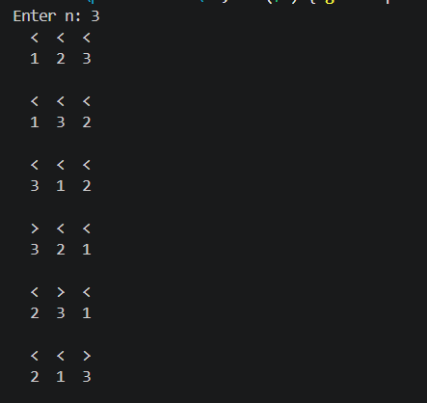

Lab program 3: Merge Sort
CODE:

#include<stdio.h>
void merge(int low,int mid,int high,int arr[]);
void merge_sort(int low,int high,int arr[]){
if(low<high) {
int mid=(low+high)/2;
merge_sort(low,mid,arr);
merge_sort(mid+1,high,arr);
merge(low,mid,high,arr);
}
}

void merge(int low,int mid,int high,int arr[]){
int i=low,j=mid+1,k=low;
int temp[100];

while(i<=mid && j<=high) {
if(arr[i]<arr[j])
temp[k++]=arr[i++];
else
temp[k++]=arr[j++];
}
while(i<=mid)
temp[k++]=arr[i++];

while(j<=high)
temp[k++]=arr[j++];

for(i=low;i<=high;i++)
arr[i]=temp[i];
}

int main(){
int n;
printf("Enter the size of array: ");
scanf("%d",&n);
int arr[n];
printf("Enter elements: ");
for(int i=0;i<n;i++)
scanf("%d",&arr[i]);
merge_sort(0,n-1,arr);
printf("Sorted array: ");
for(int i=0;i<n;i++)
printf("%d ",arr[i]);

return 0;
}

OUTPUT:

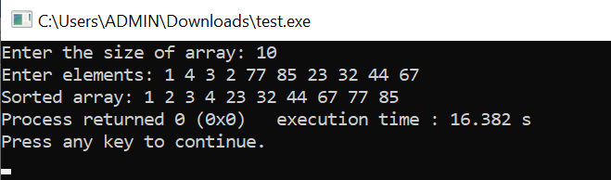

GRAPH:

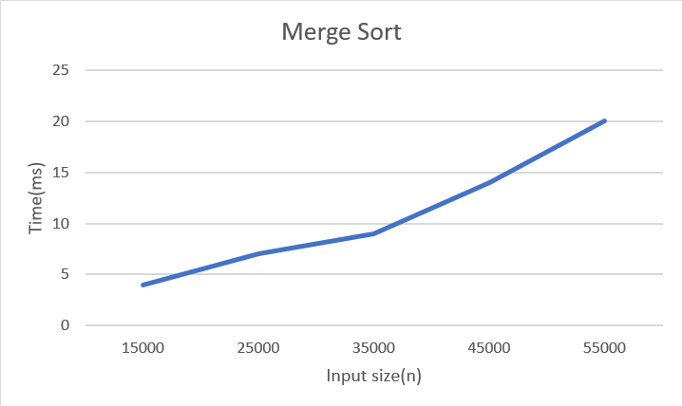

LEETCODE 912.Sort an Array

CODE:

void merge(int arr[], int low, int mid, int high) {
int i = low, j = mid + 1, k = low;
int temp[high + 1];
while (i <= mid && j <= high) {
if (arr[i] <= arr[j])
temp[k++] = arr[i++];
else
temp[k++] = arr[j++];
}
while (i <= mid)
temp[k++] = arr[i++];
while (j <= high)
temp[k++] = arr[j++];
for (int p = low; p <= high; p++)
arr[p] = temp[p];
}
void mergeSort(int arr[], int low, int high) {
if (low < high) {
int mid = (low + high) / 2;
mergeSort(arr, low, mid);
mergeSort(arr, mid + 1, high);
merge(arr, low, mid, high);
}
}
int* sortArray(int* nums, int numsSize, int* returnSize) {
mergeSort(nums, 0, numsSize - 1);
*returnSize = numsSize;
return nums;
}

OUTPUT:

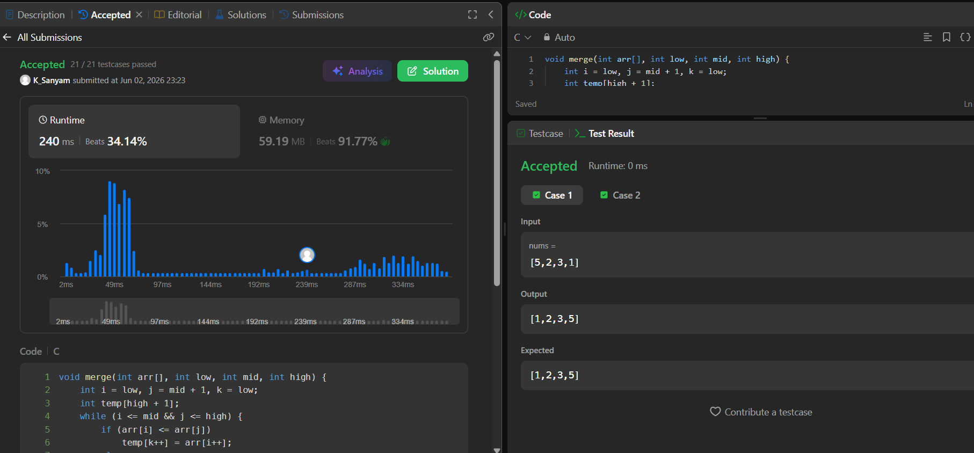

Lab program 4: Quick Sort
CODE:

#include<stdio.h>
#include<stdlib.h>
#include<time.h>
void quickSort(int a[] , int low, int high);
int partition(int a[], int low, int high);
void swap(int *x, int *y);
void quickSort(int a[] , int low, int high){
if(low<high){
int p = partition(a,low,high);
quickSort(a,low,p-1);
quickSort(a,p+1,high);
}
}

int partition(int a[], int low, int high){
int b = a[low];
int i = low+1;
int j = high;
while(1){
while(i<= high && a[i]<= b){
i++;
}
while(a[j] > b){
j--;
}
if(i<j){
swap(&a[i] ,&a[j]);
}
else{
break;
}

}
swap(&a[low] , &a[j]);
return j;
}

void swap(int *x, int *y){
int t = *x;
*x = *y;
*y = t;
}

int main(){
int n , i;
printf("Enter number of elements :");
scanf("%d",&n);
int a[n];
srand(time(NULL));
for ( i=0;i<n;i++){
a[i] = rand() % 100000;
}
clock_t start , end;
start = clock();
quickSort(a,0,n-1);
end = clock();
double time = (double)(end-start)*1000 / CLOCKS_PER_SEC;
printf("\n Sorted Array:");
for(i=0;i<n;i++){
printf("%d", a[i]);
}
printf("\n Time taken : %.3f", time);
return 0;
}

OUTPUT:

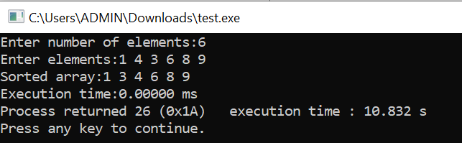

GRAPH:

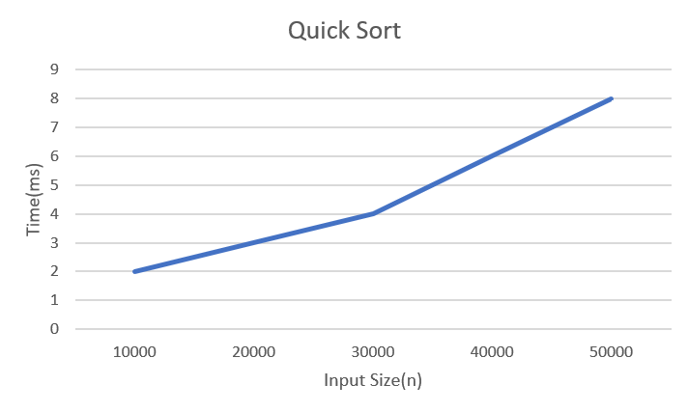

LEETCODE 977.Squares of a Sorted Array

CODE:

#include <stdlib.h>
int* sortedSquares(int* nums, int numsSize, int* returnSize) {
int* res = (int*)malloc(sizeof(int) * numsSize);
int i = 0;
int j = numsSize - 1;
int k = numsSize - 1;
while (i <= j) {
int left = nums[i] * nums[i];
int right = nums[j] * nums[j];
if (left > right) {
res[k--] = left;
i++;
} else {
res[k--] = right;
j--;
}
}
*returnSize = numsSize;
return res;
}

OUTPUT:

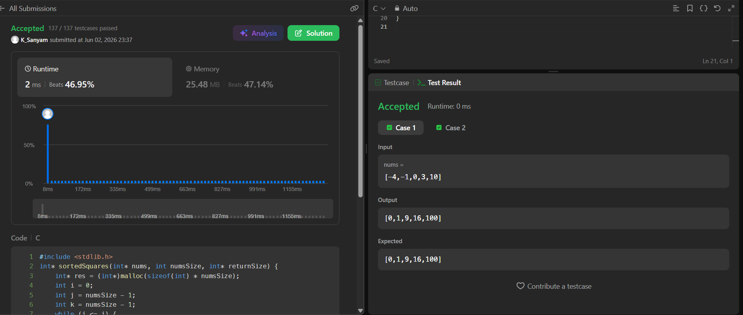

Lab program 5: Heap Sort
CODE:

#include <stdio.h>
#include <time.h>
void heapify(int arr[], int n, int i) {
int largest = i;
int left = 2 * i + 1;
int right = 2 * i + 2;
if (left < n && arr[left] > arr[largest])
largest = left;
if (right < n && arr[right] > arr[largest])
largest = right;
if (largest != i) {
int temp = arr[i];
arr[i] = arr[largest];
arr[largest] = temp;

heapify(arr, n, largest);
}
}
void heapSort(int arr[], int n) {
for (int i = n / 2 - 1; i >= 0; i--)
heapify(arr, n, i);
for (int i = n - 1; i > 0; i--) {
int temp = arr[0];
arr[0] = arr[i];
arr[i] = temp;
heapify(arr, i, 0);
}
}
void printArray(int arr[], int n) {
for (int i = 0; i < n; i++)
printf("%d ", arr[i]);
printf("\n");
}

int main() {
int n;
printf("Enter number of elements: ");
scanf("%d", &n);
int arr[n];
printf("Enter %d integers:\n", n);
for (int i = 0; i < n; i++)
scanf("%d", &arr[i]);
clock_t start = clock();
heapSort(arr, n);
clock_t end = clock();
double time_taken = ((double)(end - start)) / CLOCKS_PER_SEC;
printf("\nSorted array:\n");
printArray(arr, n);
printf("\nTime taken: %f seconds\n", time_taken);
return 0;
}

OUTPUT:

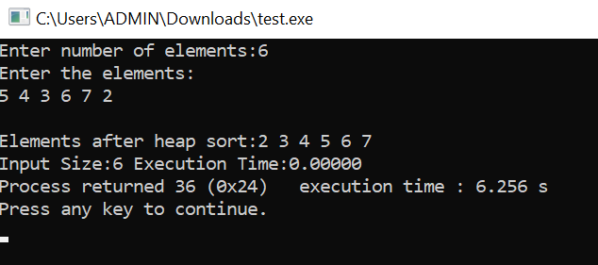

GRAPH:

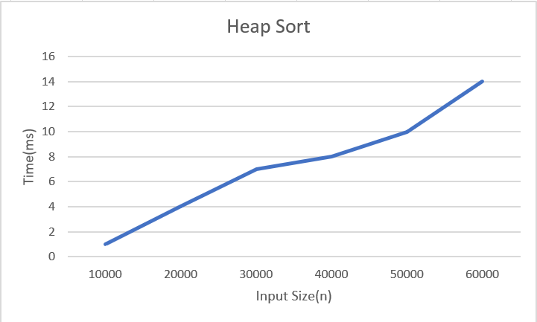

Lab program 6: 0/1 Knapsack
CODE:

#include<stdio.h>
int max (int a , int b){
return (a>b) ? a : b;
}
int knapsack(int W,int wt[], int val[], int n){
int dp[n+1][W+1];
for(int i = 0; i<=n ; i++){
for(int w = 0; w<= W ; w++){
if(w == 0 || i == 0){
dp[i][w] = 0;
}
else if (wt[i-1] <= w){
dp[i][w] = max(val[i-1] + dp[i-1][w-wt[i-1]], dp[i-1][w]);
}
else{
dp[i][w] = dp[i-1][w];
}
}
}
printf("\nDP Matrix:\n");
for(int i = 0; i <= n; i++){
for(int w = 0; w <= W; w++){
printf("%4d", dp[i][w]);
}
printf("\n");
}
return dp[n][W];
}
int main(){
int n , W;

printf("\nEnter no of items : ");
scanf("%d", &n);

int wt[n], val[n];

printf("\nEnter weights : ");
for(int i = 0; i < n; i++){
scanf("%d", &wt[i]);
}

printf("\nEnter values : ");
for(int i = 0; i < n; i++){
scanf("%d", &val[i]);
}
printf("\nEnter capacity : ");
scanf("%d", &W);
int res = knapsack(W, wt, val, n);
printf("\nMaximum value = %d\n", res);
return 0;
}

OUTPUT:

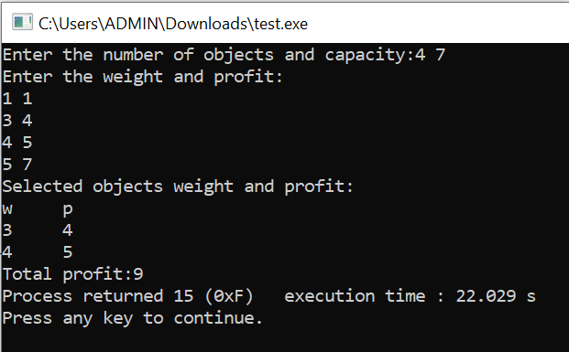

LEETCODE 518.Coin Change II

CODE:

int change(int amount, int* coins, int coinSize) {
unsigned long long dp[amount + 1];
for (int i = 0; i <= amount; i++)
dp[i] = 0;
dp[0] = 1;
for (int i = 0; i < coinSize; i++) {
for (int j = coins[i]; j <= amount; j++) {
dp[j] += dp[j - coins[i]];
}
}
return (int)dp[amount];
}

OUTPUT:

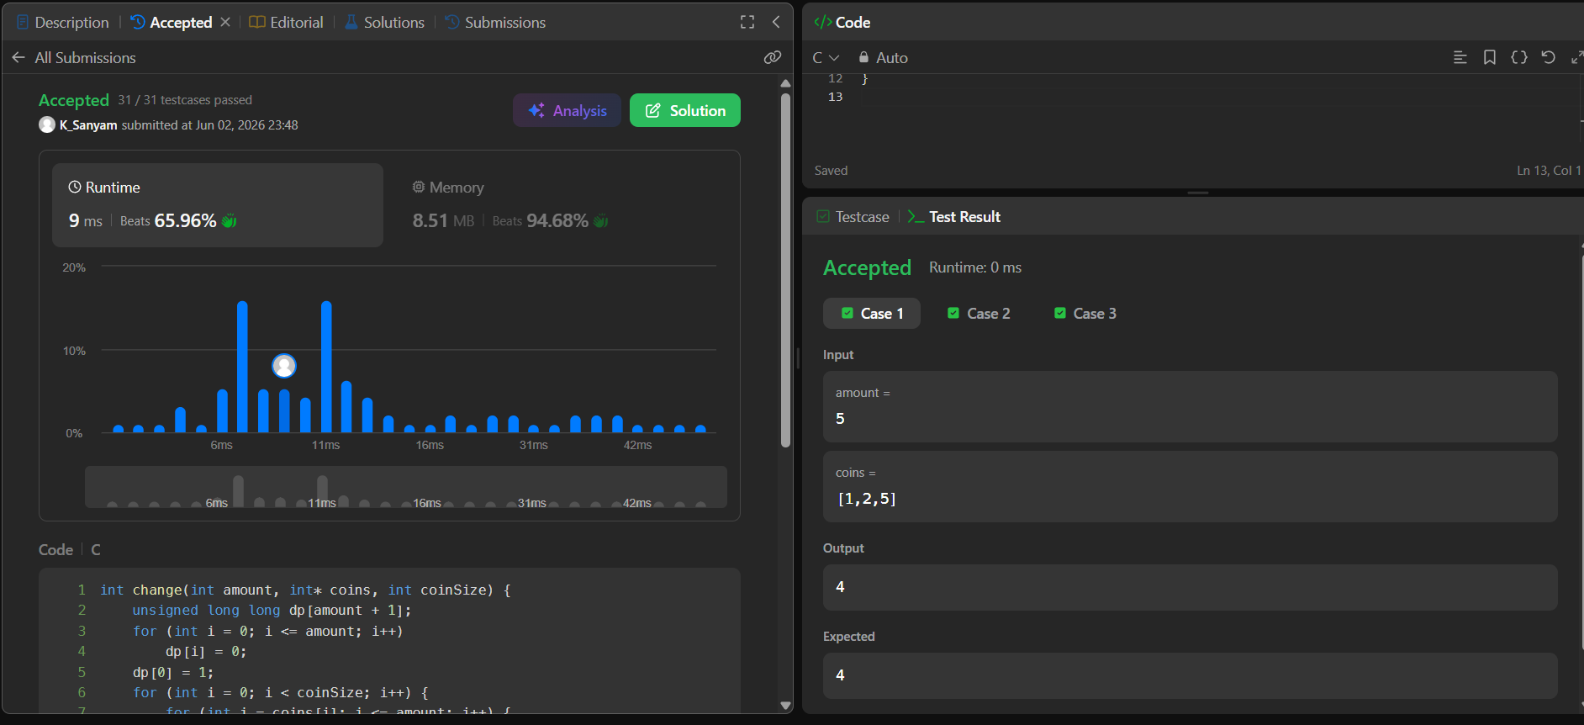

Lab program 7: Floyd’s Algorithm
CODE:

#include<stdio.h>
#include<limits.h>
void main(){
int n;
printf("Enter the number of vertices:");
scanf("%d",&n);
int a[n][n];
printf("Enter the weights and 0 for no edges:\n");
for(int i=0;i<n;i++){
for(int j=0;j<n;j++)
{
scanf("%d",&a[i][j]);
}
}
for(int i=0;i<n;i++){
for(int j=0;j<n;j++){
if(i!=j && a[i][j]==0) a[i][j]=INT_MAX;
}
}
for(int i=0;i<n;i++){
for(int j=0;j<n;j++){
for(int k=0;k<n;k++){
if(a[i][k]!=INT_MAX && a[k][j]!=INT_MAX){
if(a[i][j]>a[i][k]+a[k][j]) a[i][j]=a[i][k]+a[k][j];
}
}
}
}
printf("Shortest pairs:\n");
for(int i=0;i<n;i++){
for(int j=0;j<n;j++){
if(a[i][j]==INT_MAX) printf("Infinity ");
else printf("%d ",a[i][j]);
}
printf("\n");
}
}

OUTPUT:

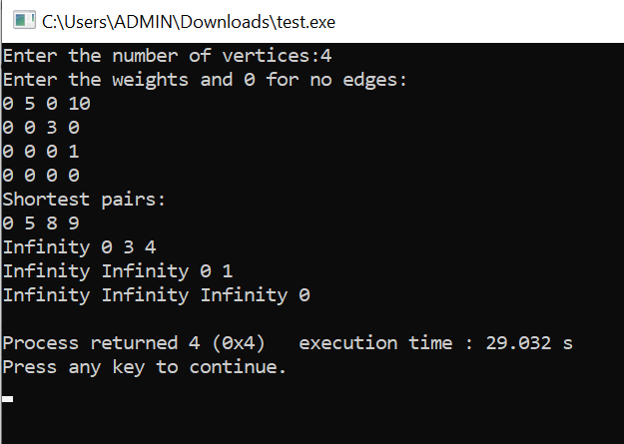

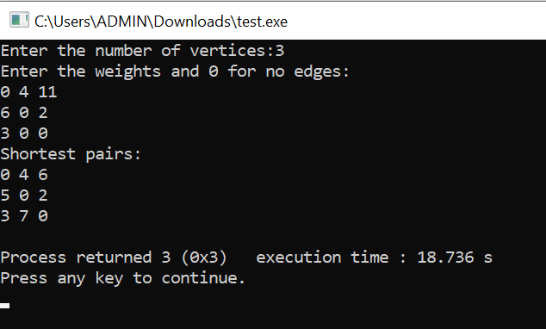

LEETCODE 783.Minimum Distance Between BST Nodes

CODE:

#include<limits.h>
#include<stdlib.h>
int minVal=INT_MAX;
struct TreeNode* prev=NULL;
void inorder(struct TreeNode* root){
if(root!=NULL){
inorder(root->left);
if(prev!=NULL){
int d=abs(root->val-prev->val);
if(d<minVal) minVal=d;
}
prev=root;
inorder(root->right);
}
}
int minDiffInBST(struct TreeNode* root) {
minVal=INT_MAX;
prev=NULL;
inorder(root);
return minVal;
}

OUTPUT:



Lab program 8:
8(a) Prism Algorithm
CODE:

#include <stdio.h>
#define MAX 10
#define INF 99999
int minKey(int key[], int mstSet[], int n)
{
int min = INF, min_index;
for (int v = 0; v < n; v++)
{
if (mstSet[v] == 0 && key[v] < min)
{
min = key[v];
min_index = v;
}
}
return min_index;
}
void printMST(int parent[], int graph[MAX][MAX], int n)
{
int totalCost = 0;

printf("\nEdge \tWeight\n");

for (int i = 1; i < n; i++)
{
printf("%d - %d \t%d\n", parent[i], i, graph[i][parent[i]]);
totalCost += graph[i][parent[i]];
}
printf("\nMinimum Cost = %d\n", totalCost);
}
void primMST(int graph[MAX][MAX], int n)
{
int parent[MAX];
int key[MAX];
int mstSet[MAX];
for (int i = 0; i < n; i++)
{
key[i] = INF;
mstSet[i] = 0;
}
key[0] = 0;
parent[0] = -1;

for (int count = 0; count < n - 1; count++)
{
int u = minKey(key, mstSet, n);

mstSet[u] = 1;

for (int v = 0; v < n; v++)
{
if (graph[u][v] && mstSet[v] == 0 && graph[u][v] < key[v])
{
parent[v] = u;
key[v] = graph[u][v];
}
}
}
printMST(parent, graph, n);
}
int main()
{
int n;
int graph[MAX][MAX];
printf("Enter number of vertices: ");
scanf("%d", &n);
printf("Enter adjacency matrix:\n");
for (int i = 0; i < n; i++)
{
for (int j = 0; j < n; j++)
{
scanf("%d", &graph[i][j]);
}
}
printf("\nPrim's Algorithm - Minimum Cost Spanning Tree\n");
primMST(graph, n);
return 0;
}

OUTPUT:

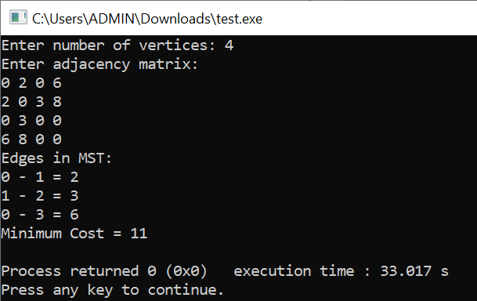
8(b) Kruskal Algorithm
CODE:

#include <stdio.h>
#include <stdlib.h>

struct Edge {
int src, dest, weight;
};

struct Subset {
int parent;
int rank;
};
int find(struct Subset subsets[], int i) {
if (subsets[i].parent != i)
subsets[i].parent = find(subsets, subsets[i].parent);
return subsets[i].parent;
}
void Union(struct Subset subsets[], int x, int y) {
int rootX = find(subsets, x);
int rootY = find(subsets, y);

if (subsets[rootX].rank < subsets[rootY].rank)
subsets[rootX].parent = rootY;
else if (subsets[rootX].rank > subsets[rootY].rank)
subsets[rootY].parent = rootX;
else {
subsets[rootY].parent = rootX;
subsets[rootX].rank++;
}
}

int compare(const void* a, const void* b) {
return ((struct Edge*)a)->weight - ((struct Edge*)b)->weight;
}
void kruskal(struct Edge edges[], int V, int E) {
qsort(edges, E, sizeof(struct Edge), compare);
struct Subset* subsets = (struct Subset*)malloc(V * sizeof(struct Subset));
for (int i = 0; i < V; i++) {
subsets[i].parent = i;
subsets[i].rank = 0;
}
struct Edge result[V];
int e = 0;
int cost = 0;
for (int i = 0; i < E && e < V - 1; i++) {
struct Edge next = edges[i];
int x = find(subsets, next.src);
int y = find(subsets, next.dest);
if (x != y) {
result[e++] = next;
cost += next.weight;
Union(subsets, x, y);
}
}
printf("\nEdges in MST:\n");
for (int i = 0; i < e; i++) {
printf("%d - %d weight = %d\n",
result[i].src,
result[i].dest,
result[i].weight);
}
printf("\nMinimum Cost = %d\n", cost);
free(subsets);
}
int main() {
int V, E;
printf("Enter number of vertices: ");
scanf("%d", &V);
printf("Enter number of edges: ");
scanf("%d", &E);
struct Edge edges[E];
printf("\nEnter edges (src dest weight):\n");
for (int i = 0; i < E; i++) {
scanf("%d %d %d",
&edges[i].src,
&edges[i].dest,
&edges[i].weight);
}
kruskal(edges, V, E);
return 0;
}

OUTPUT:

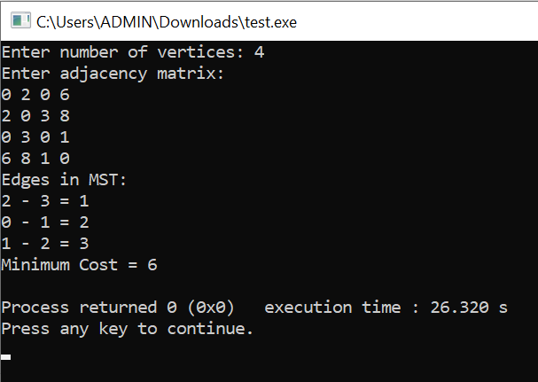
Lab program 9: Fractional Knapsack
CODE:

#include <stdio.h>
struct Item {
int value;
int weight;
float ratio;
};
void sort(struct Item items[], int n) {
int i, j;
struct Item temp;
for (i = 0; i < n - 1; i++) {
for (j = i + 1; j < n; j++) {
if (items[i].ratio < items[j].ratio) {
temp = items[i];
items[i] = items[j];
items[j] = temp;
}
}
}
}
float fractionalKnapsack(struct Item items[], int n, int capacity) {
float totalValue = 0.0;
for (int i = 0; i < n; i++) {
if (capacity >= items[i].weight) {
totalValue += items[i].value;
capacity -= items[i].weight;
} else {
totalValue += items[i].ratio * capacity;
break;
}
}
return totalValue;
}
int main() {
int n, capacity;
printf("Enter no. of items: ");
scanf("%d", &n);
struct Item items[n];
printf("Enter value and weight:\n");
for (int i = 0; i < n; i++) {
scanf("%d %d", &items[i].value, &items[i].weight);
if (items[i].weight != 0){ items[i].ratio = (float)items[i].value / items[i].weight;}
else
items[i].ratio = 0;
}
printf("Enter the capacity: ");
scanf("%d", &capacity);
sort(items, n);
float maxValue = fractionalKnapsack(items, n, capacity);
printf("Maximum profit = %.2f\n", maxValue);
return 0;
}

OUTPUT:

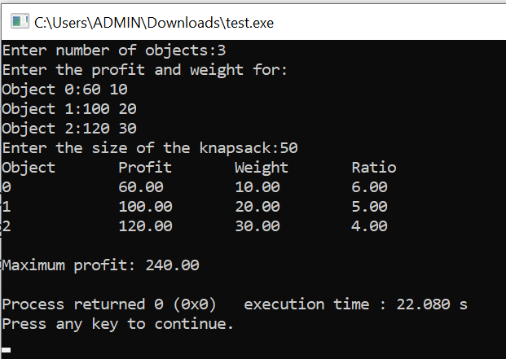

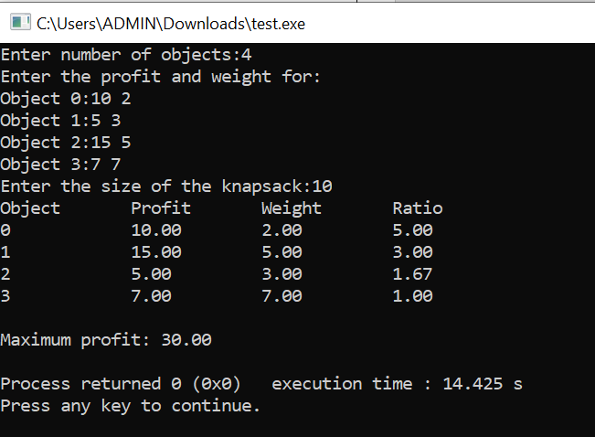

LEETCODE 455.Assign Cookies

CODE:

int cmp(const void* a,const void*b)
{
return (*(int*)a)-(*(int*)b);
}
int findContentChildren(int* g, int gSize, int* s, int sSize) {
int count=0;
qsort(g,gSize,sizeof(int),cmp);
qsort(s,sSize,sizeof(int),cmp);
int i=0,j=0;
while(i<gSize && j<sSize){
if(g[i]<=s[j]){
count++;
i++;
}
j++;
}
return count;
}

OUTPUT:

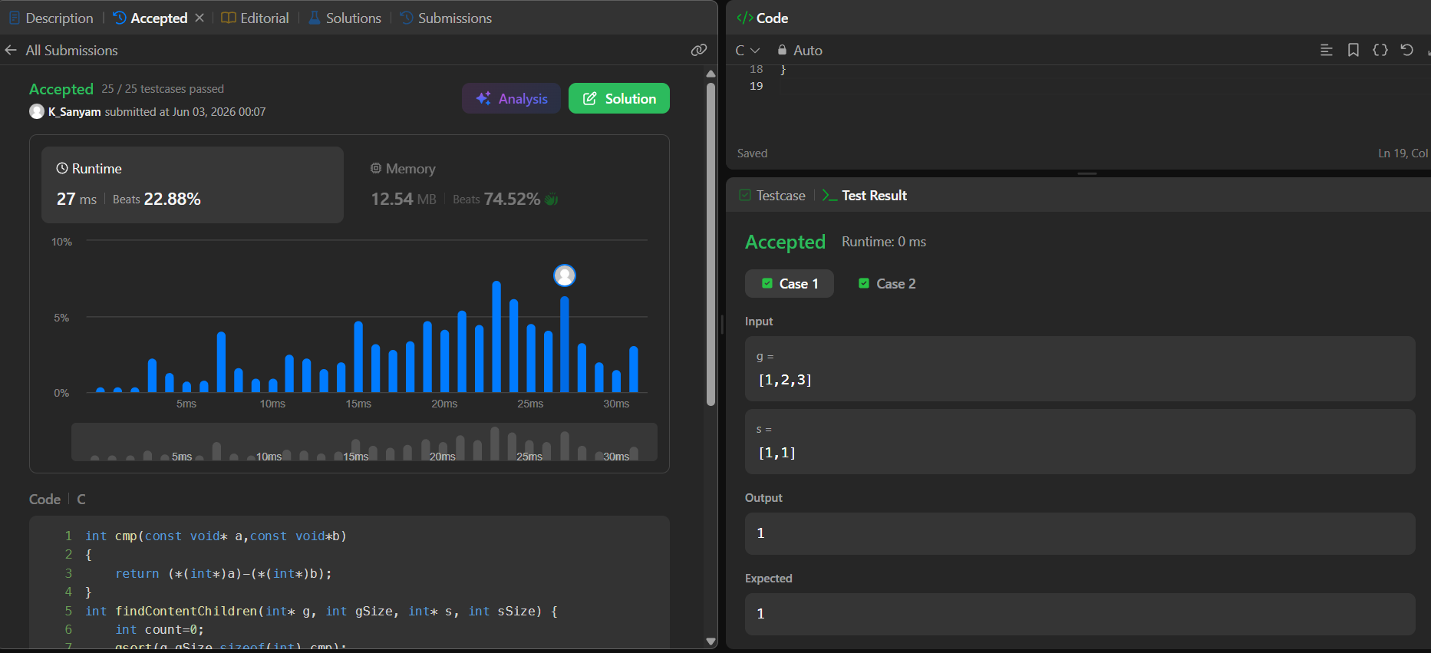

Lab program 10: Dijkstra’s Algorithm
CODE:

#include <stdio.h>
#define MAX 100
#define INF 9999
int minDistance(int dist[], int visited[], int n) {
int min = INF, min_index = -1;
for (int i = 0; i < n; i++) {
if (!visited[i] && dist[i] <= min) {
min = dist[i];
min_index = i;
}
}
return min_index;
}
void printPath(int parent[], int j) {
if (parent[j] == -1) {
printf("%d ", j);
return;
}
printPath(parent, parent[j]);
printf("%d ", j);
}
void dijkstra(int graph[MAX][MAX], int n, int src) {
int dist[MAX], visited[MAX], parent[MAX];
for (int i = 0; i < n; i++) {
dist[i] = INF;
visited[i] = 0;
parent[i] = -1;
}

dist[src] = 0;
for (int count = 0; count < n - 1; count++) {
int u = minDistance(dist, visited, n);
visited[u] = 1;
for (int v = 0; v < n; v++) {
if (!visited[v] &&
graph[u][v] &&
dist[u] != INF &&
dist[u] + graph[u][v] < dist[v]) {

dist[v] = dist[u] + graph[u][v];
parent[v] = u; // store parent
}
}
}
printf("\nVertex\tDistance\tPath\n");
for (int i = 0; i < n; i++) {
printf("%d\t%d\t\t", i, dist[i]);
printPath(parent, i);
printf("\n");
}
}

int main() {
int n, graph[MAX][MAX], src;

printf("Enter number of vertices: ");
scanf("%d", &n);
printf("Enter adjacency matrix (0 if no edge):\n");
for (int i = 0; i < n; i++) {
for (int j = 0; j < n; j++) {
scanf("%d", &graph[i][j]);
}
}
printf("Enter source vertex (0 to %d): ", n - 1);
scanf("%d", &src);
dijkstra(graph, n, src);
return 0;
}

OUTPUT:
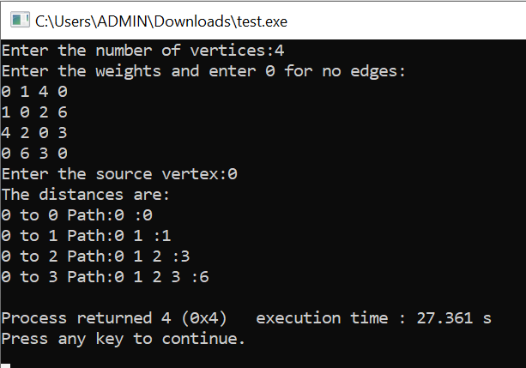

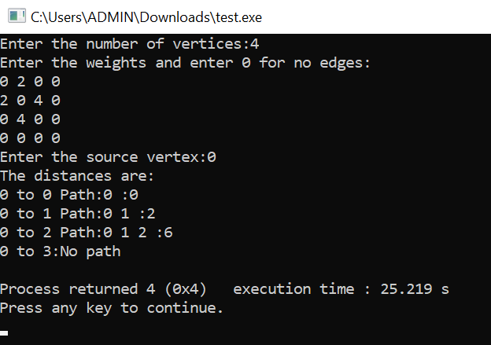

Lab program 11: N-Queens Problem
CODE:
#include <stdio.h>
#include <stdlib.h>
int x[20];
int sol = 0;
int place(int k, int i)
{
for (int j = 1; j < k; j++)
{
if (x[j] == i || abs(j - k) == abs(x[j] - i))
{
return 0;
}
}
return 1;
}
void NQueens(int k, int n)
{
for (int i = 1; i <= n; i++)
{
if (place(k, i))
{
x[k] = i;
if (k == n)
{
sol++;
printf("\nSolution %d:\n", sol);
for (int row = 1; row <= n; row++)
{
for (int col = 1; col <= n; col++)
{
if (x[row] == col)
printf("Q ");
else
printf(". ");
}
printf("\n");
}
}
else
{
NQueens(k + 1, n);
}
}
}
}

int main()
{
int n;
printf("Enter n: ");
scanf("%d", &n);
NQueens(1, n);
printf("\nTotal solutions = %d\n", sol);
return 0;
}

OUTPUT:

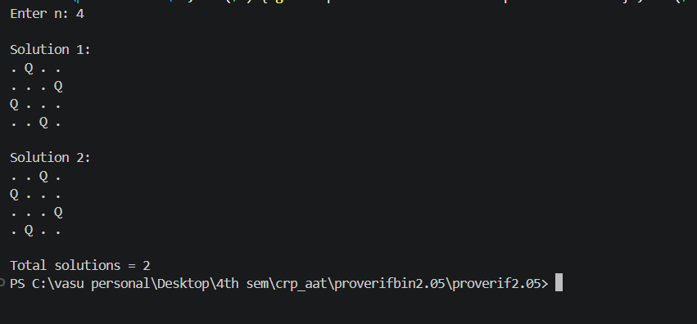

Leet Code :

21. Merge Two Sorted Lists

Code:

struct ListNode* mergeTwoLists(struct ListNode* list1, struct ListNode* list2)
{
struct ListNode dummy;
struct ListNode *tail = &dummy;
dummy.next = NULL;

while (list1 && list2)
{
if (list1->val <= list2->val)
{
tail->next = list1;
list1 = list1->next;
}
else
{
tail->next = list2;
list2 = list2->next;
}
tail = tail->next;
}

if (list1)
tail->next = list1;
else
tail->next = list2;

return dummy.next;
}

Output:

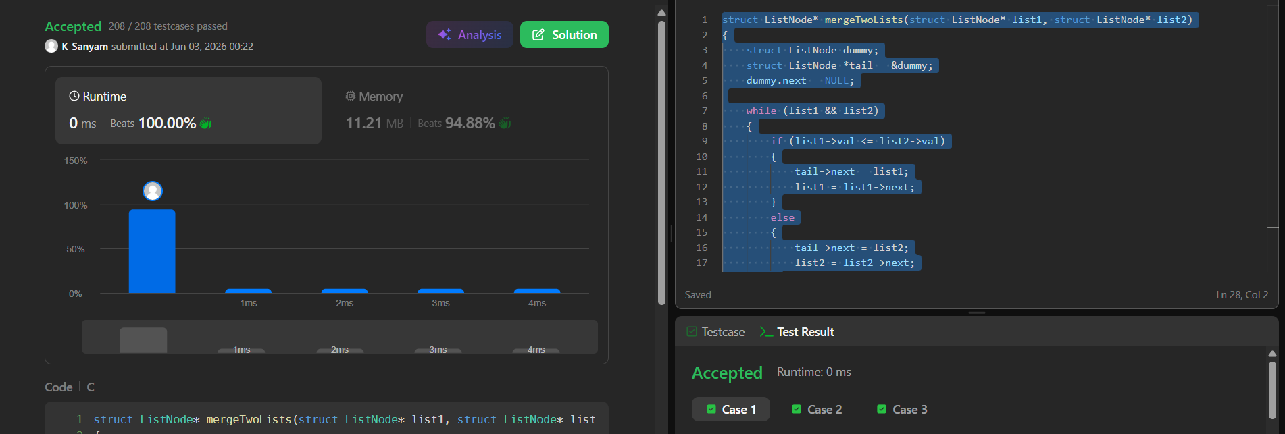

1636. Sort Array by Increasing Frequency:

Code:

#include <stdlib.h>

int* frequencySort(int* nums, int numsSize, int* returnSize) {
*returnSize = numsSize;
int freq[201] = {0};
for (int i = 0; i < numsSize; i++) {
freq[nums[i] + 100]++;
}

int index = 0;
for (int f = 1; f <= numsSize; f++) {
for (int num = 100; num >= -100; num--) {

if (freq[num + 100] == f) {
for (int k = 0; k < f; k++) {
nums[index++] = num;
}
}
}
}
return nums;
}

Output :

