VGG16 FUNDUS lr=0.001

from keras.applications import VGG16, ResNet50, InceptionV3

from keras.models import Sequential

from keras.layers import Dense, Flatten

from keras.preprocessing.image import ImageDataGenerator

from keras.optimizers import Adam

# Set the dimensions of your input images

img_width, img_height = 100, 100

# Specify the pre-trained model you want to use

pretrained_model = VGG16(weights='imagenet', include_top=False, input_shape=(img_width, img_height, 3))

#pretrained_model = ResNet50(weights='imagenet', include_top=False, input_shape=(img_width, img_height, 3))

#pretrained_model = InceptionV3(weights='imagenet', include_top=False, input_shape=(img_width, img_height, 3))

# Freeze the layers of the pre-trained model

for layer in pretrained_model.layers:

    layer.trainable = False

# Build a new model and add the pre-trained model as a layer

model = Sequential()

model.add(pretrained_model)

model.add(Flatten())

model.add(Dense(256, activation='relu'))

model.add(Dense(3, activation='softmax'))

# Compile the model

model.compile(optimizer=Adam(learning_rate=0.001), loss='categorical_crossentropy', metrics=['accuracy'],callbacks=[AccuracyCallback()])

# Specify the directories of your training and validation datasets

train_dir = '/content/drive/MyDrive/Fundus_Split/train'

val_dir = '/content/drive/MyDrive/Fundus_Split/test'

# Set up data generators to automatically preprocess and augment your images

train_datagen = ImageDataGenerator(rescale=1.0/255.0, shear_range=0.2, zoom_range=0.2, horizontal_flip=True)

val_datagen = ImageDataGenerator(rescale=1.0/255.0)

train_generator = train_datagen.flow_from_directory(train_dir, target_size=(img_width, img_height), batch_size=32, class_mode='categorical')

val_generator = val_datagen.flow_from_directory(val_dir, target_size=(img_width, img_height), batch_size=32, class_mode='categorical')

# Train the model

model.fit(train_generator, steps_per_epoch=train_generator.n // train_generator.batch_size, epochs=10, validation_data=val_generator, validation_steps=val_generator.n // val_generator.batch_size)

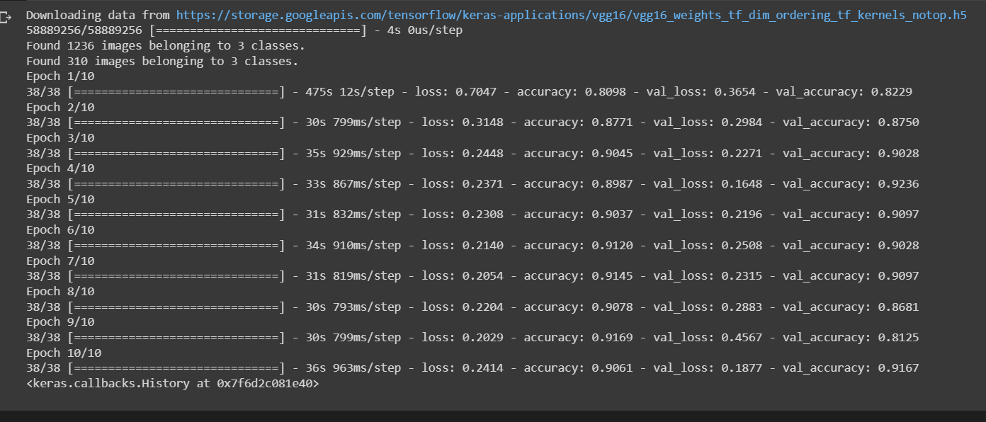

Lr=0.01

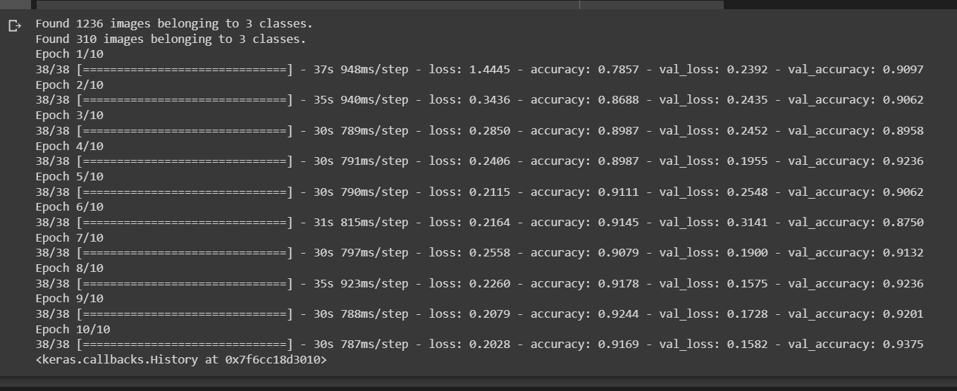

Lr=0.1

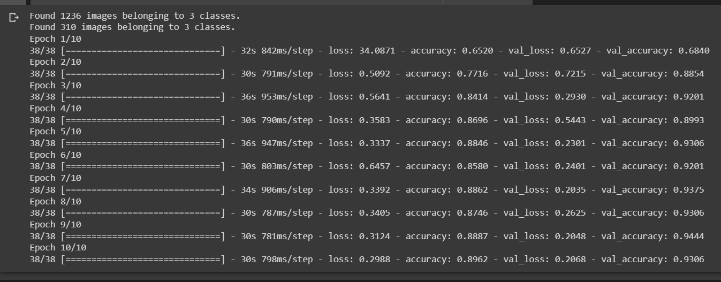  
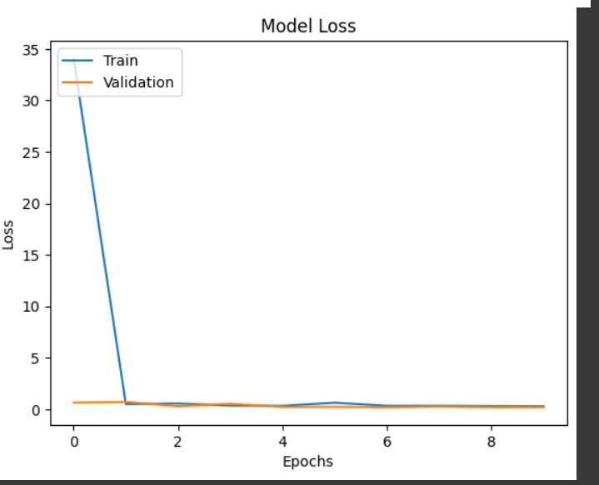

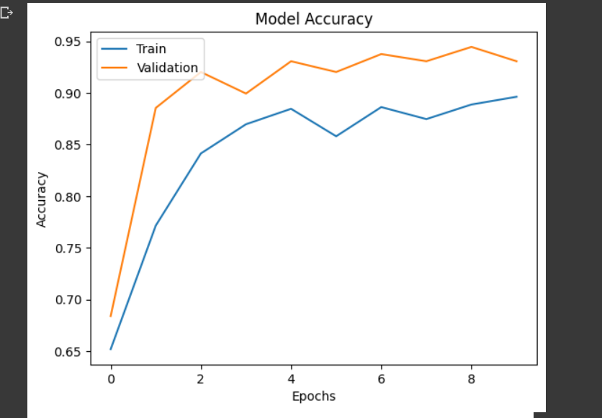

INCEPTIONV3 0.001lr

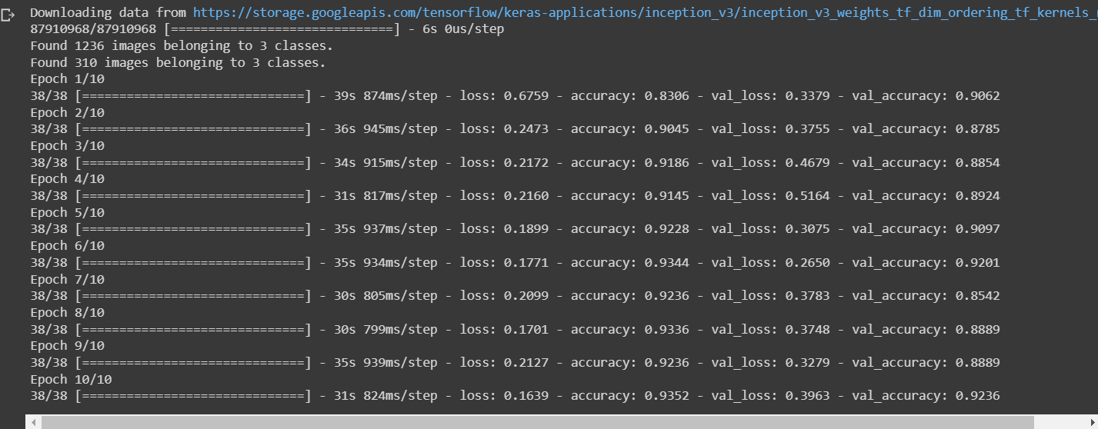

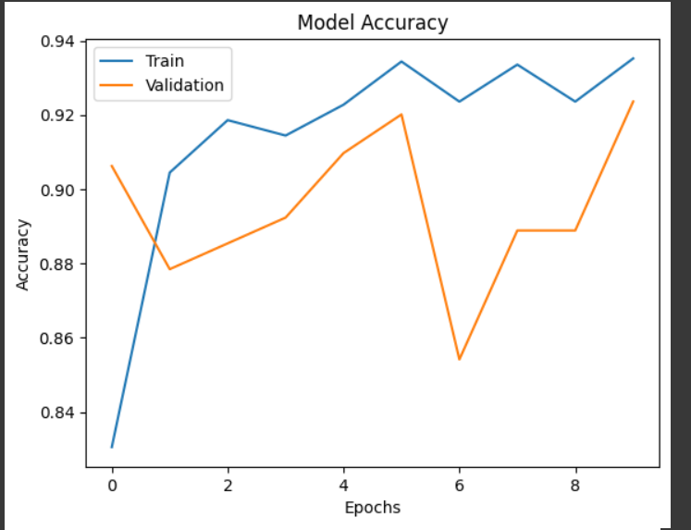

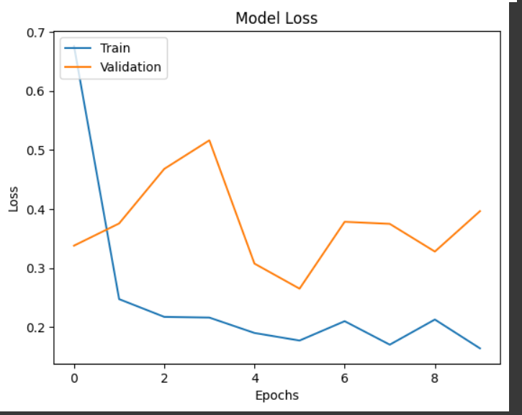

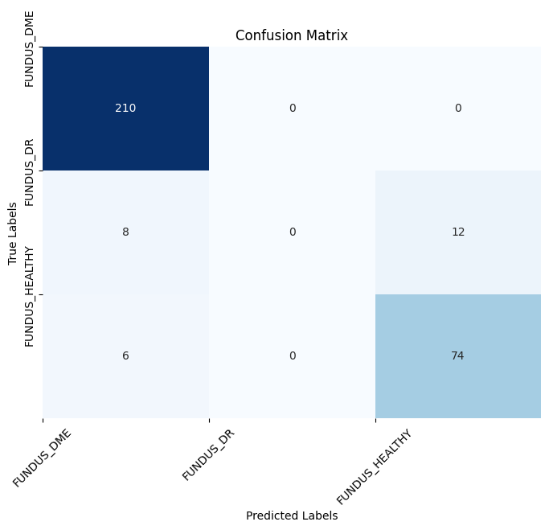

Inception lr=0.01

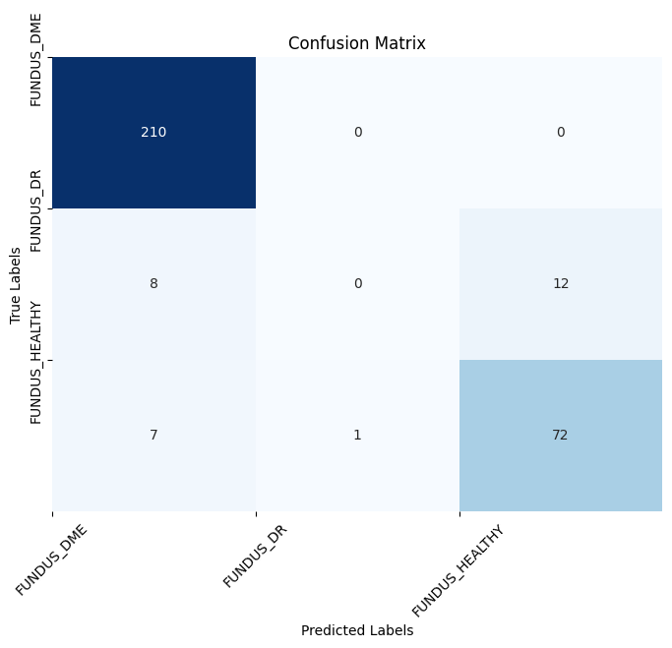

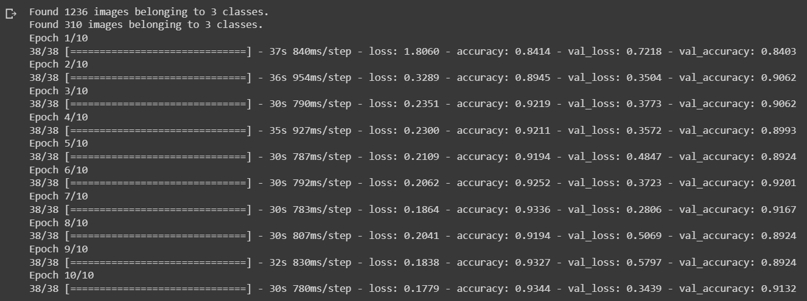

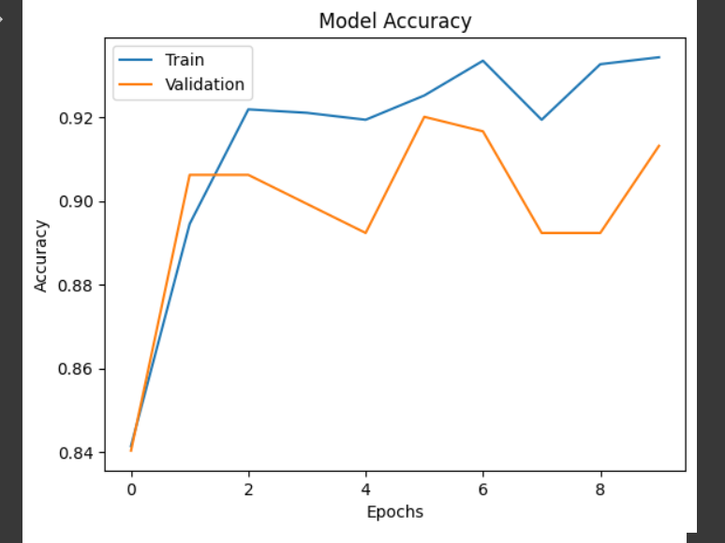

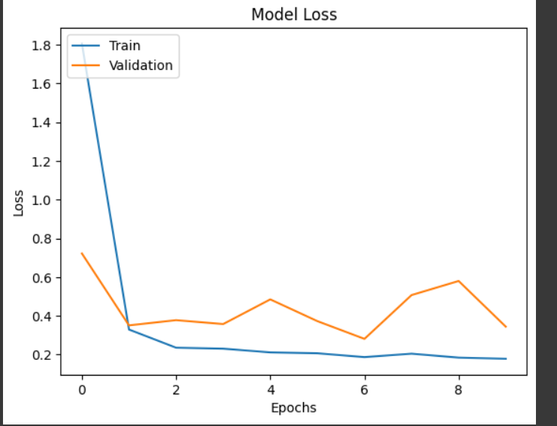

Lr0.1

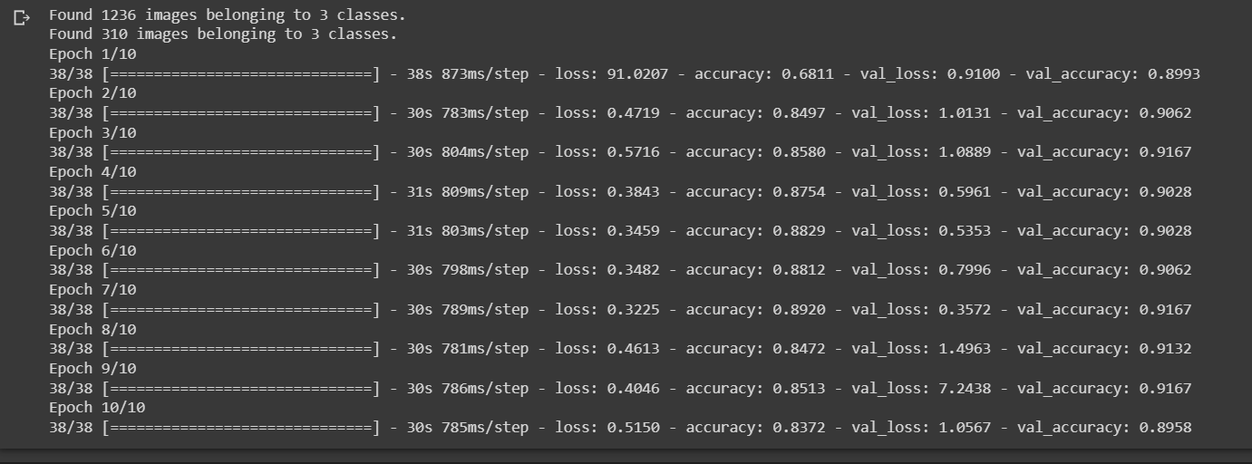

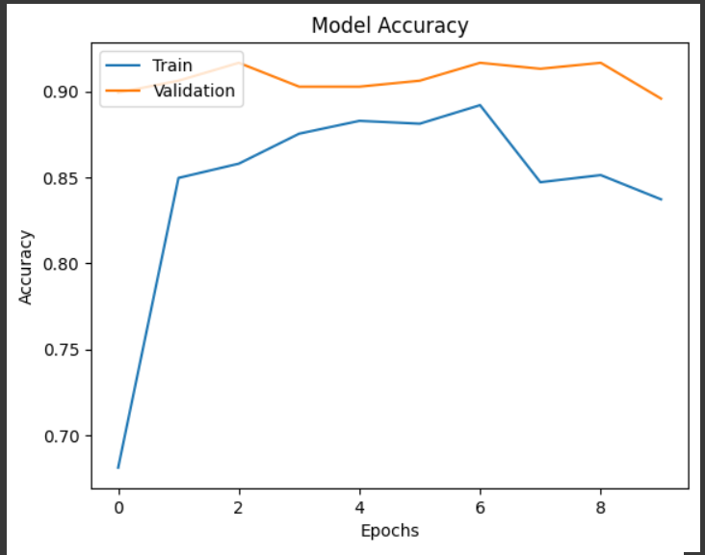

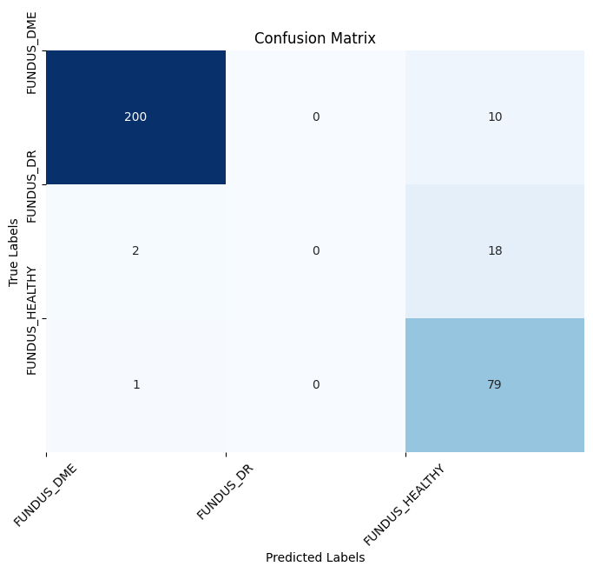

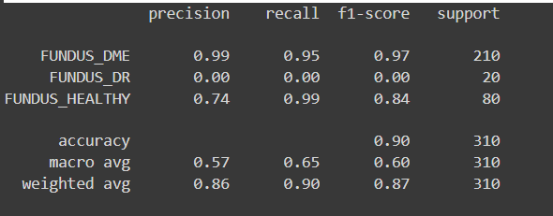

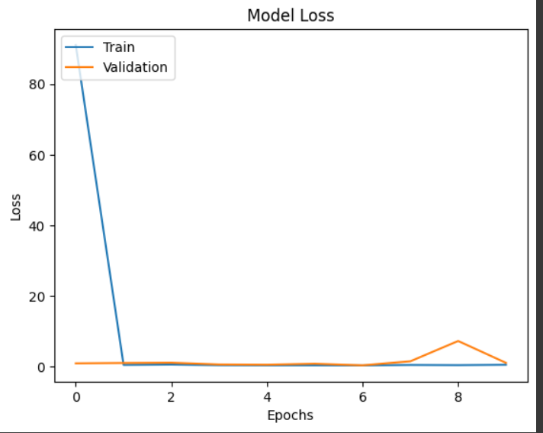  
resnet50 0.001

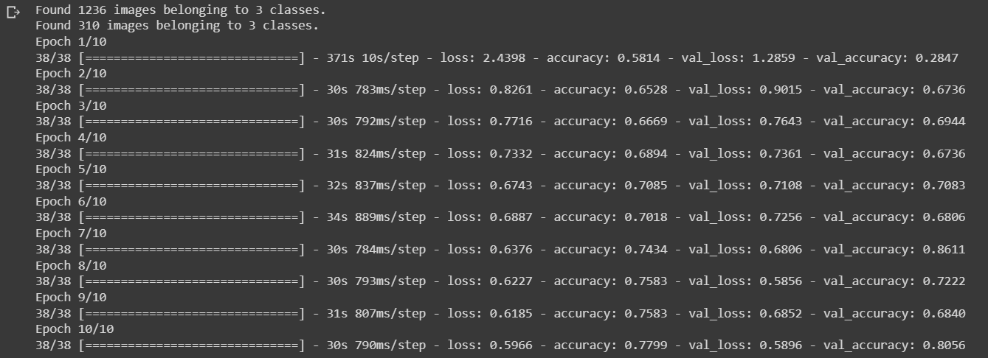

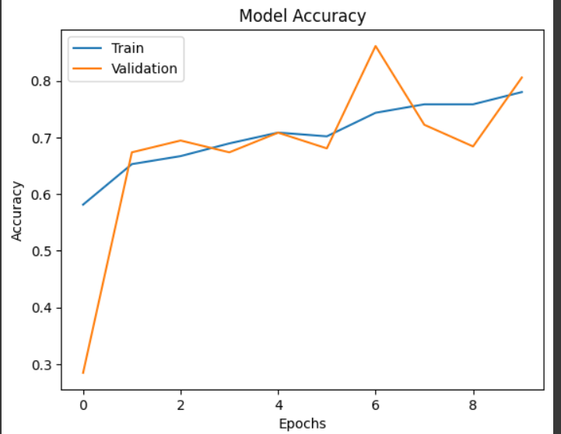

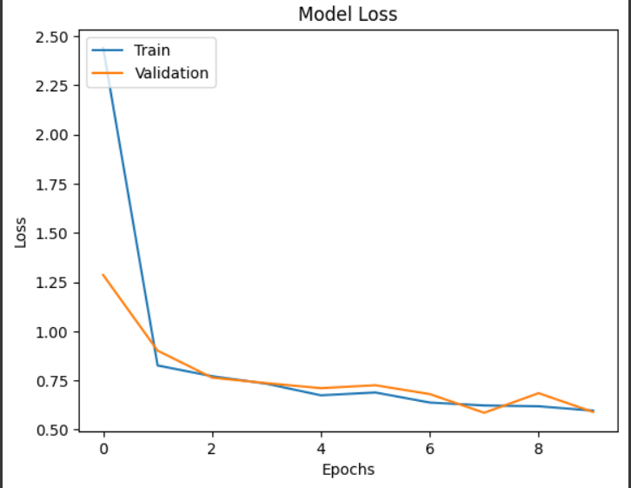

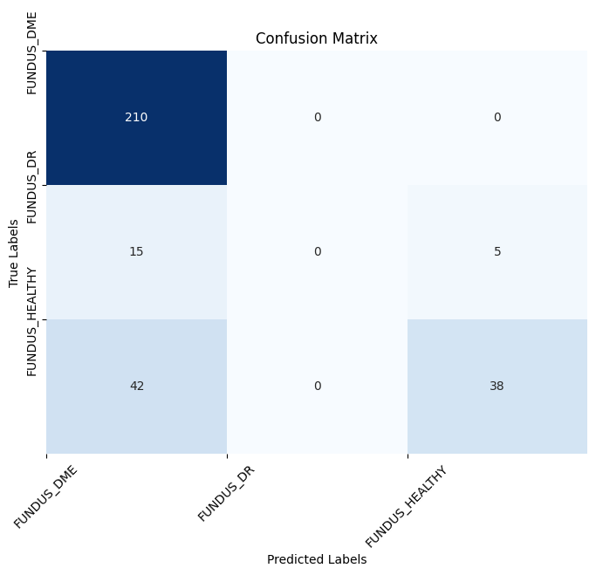

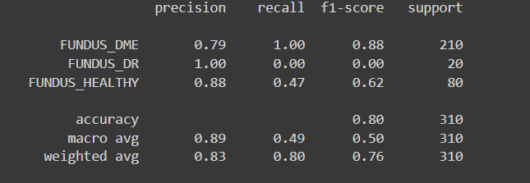

Resnet 0.01

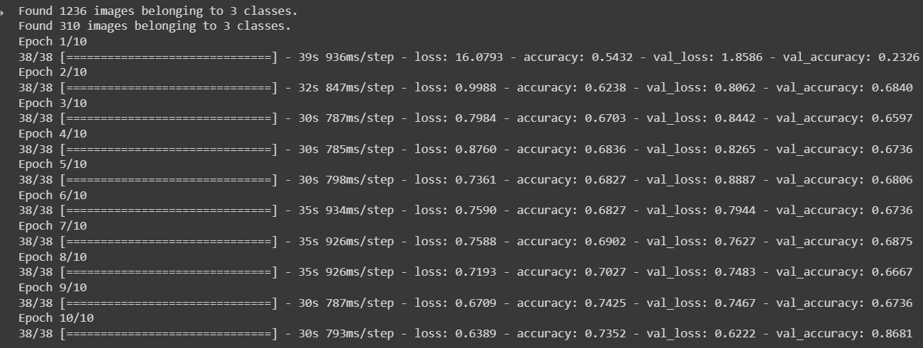

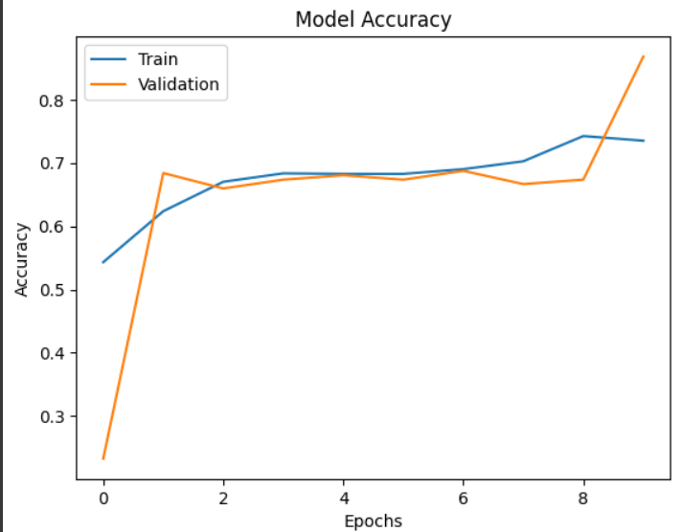

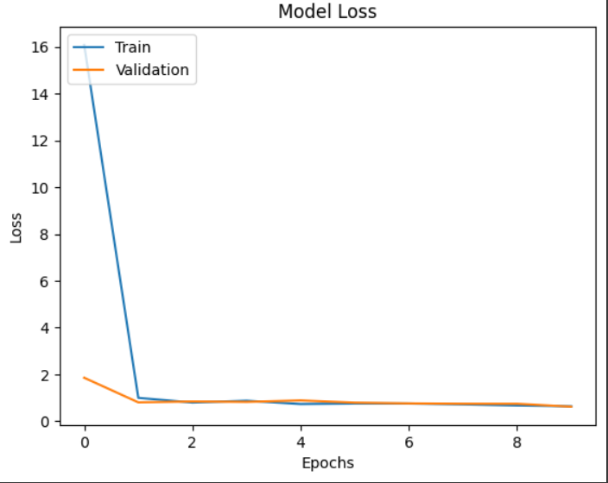

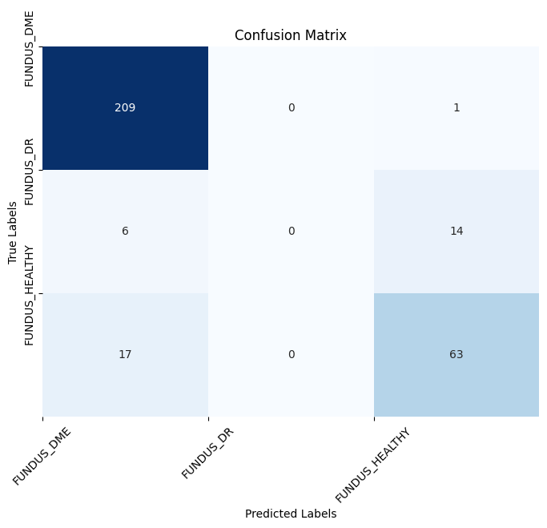

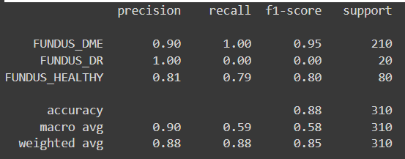

Resnet 0.1

