Analog Circuit Design for ECG Signal Processing
The design aims to:
- Amplify the weak ECG signal (amplitude: 0.5–5 mV).
- Filter out unwanted noise, including:
  - Baseline wander (low-frequency noise below 0.5 Hz).
  - Power-line interference (50 Hz or 60 Hz noise).
  - High-frequency noise (e.g., above 100 Hz).
ECG signal can be represented as a sum of sinusoidal and triangular waveforms. Alternatively, you can use a piecewise linear (PWL) source to approximate the shape of the ECG.

- insert a voltage source
- Right-click the voltage source and set it as PWL under the advanced options.
- for a 60 bpm heart rate (cycle = 1 second), the PQRST components might look like this

PQRST Waveform Values
Time (ms) | Voltage (mV) | Description
0 | 0.0 | Start of baseline
50 | 0.1 | P wave starts
80 | 0.3 | P wave peak
100 | 0.1 | P wave ends
120 | 0.0 | PR segment (baseline)
140 | -0.1 | Q dip
150 | 1.0 | R peak
160 | -0.4 | S dip
200 | 0.0 | End of QRS complex (baseline)
300 | 0.2 | T wave starts
350 | 0.4 | T wave peak
400 | 0.2 | T wave ends
1000 | 0.0 | End of cycle

For 60 bpm
PWL(0m 0 50m 0.1 80m 0.3 100m 0.1 120m 0 140m -0.1 150m 1.0 160m -0.4 200m 0 300m 0.2 350m 0.4 400m 0.2 1000m 0)
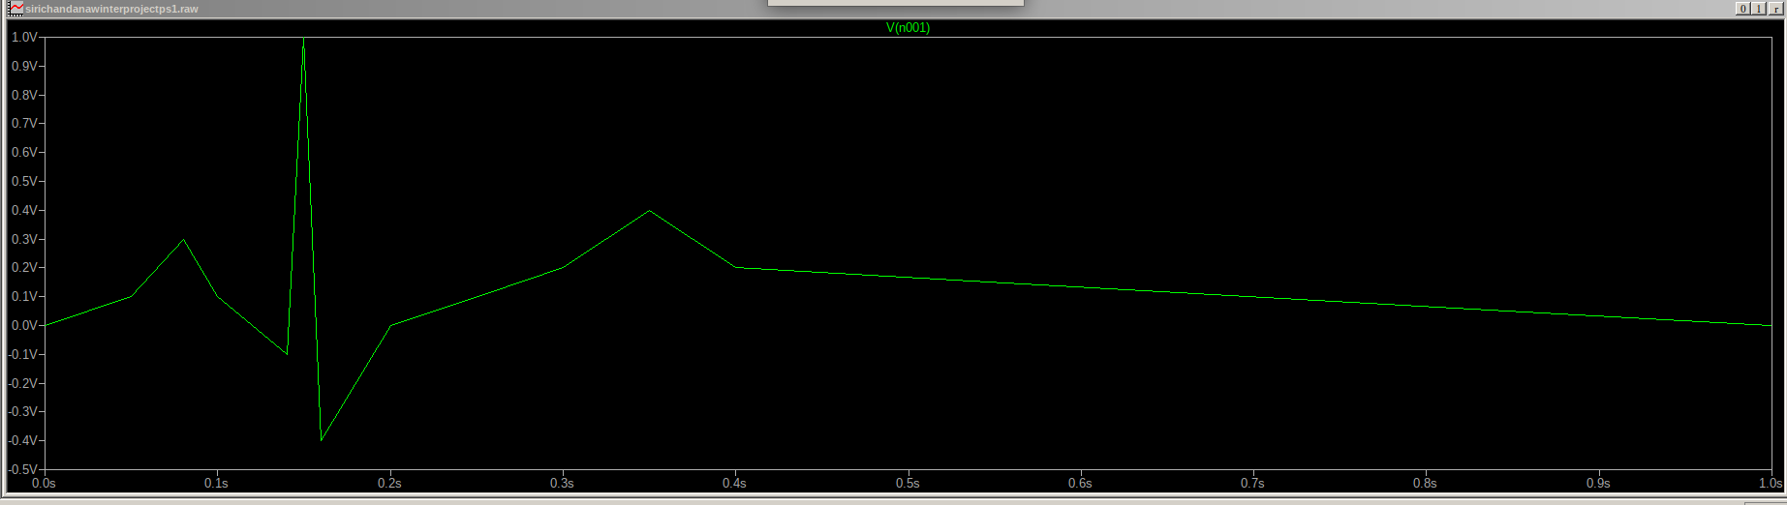

4. Set a transient analysis:
- Go to Simulate > Edit Simulation Cmd.
- Stop time: 2s (for two cycles of a 60 bpm heart rate).
- Time step: 1ms or smaller for high resolution.
5. add resistance/load
Introduction of noise into it

1. 50/60 Hz Power Line Interference.
- Use a sinusoidal voltage source (SINE) with the desired frequency (e.g., 50 Hz or 60 Hz).
- Set an amplitude that corresponds to the level of interference you expect (e.g., 0.01 V or 0.05 V depending on how strong the interference should be).

- SINE(0 0.05 50)
0 → DC offset (centered at 0V).
0.05 → Amplitude (adjust as needed, 50mV peak).
50/60 Hz → Frequency matching power line interference.
to repeat cycle of 1s till 4s(4 cycles)
Periodic Source:
- Ensure that the input source (e.g., pulse or sine wave) is configured to repeat periodically.
- For a PULSE source, set the T (period) parameter to match the time of one cycle.
- For a SIN source, set the frequency (F) to match the desired repetition.
2.Baseline wander (0.1–0.5 Hz.)
SINE(0 0.2 0.1) (offset voltage amplitude frequency)
If you are adding white noise with a BV source:
- Press F2 → Select BV.
- Set the value as:
white(0.01)
Place it near the common node.
- Connect one terminal to the common node and the other to ground.
Voltage source V3 ,V2,B1 are paralleled making an over-defined circuit matrix. You will need to correct the circuit or add some series resistance."
Multiple voltage sources (V3 and B1) are connected in parallel without any series resistance, which creates a conflict in defining the node voltages in the circuit matrix

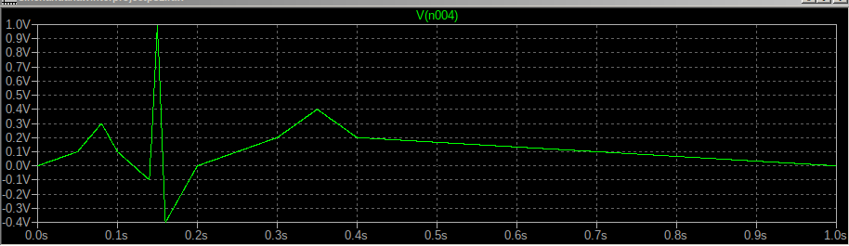
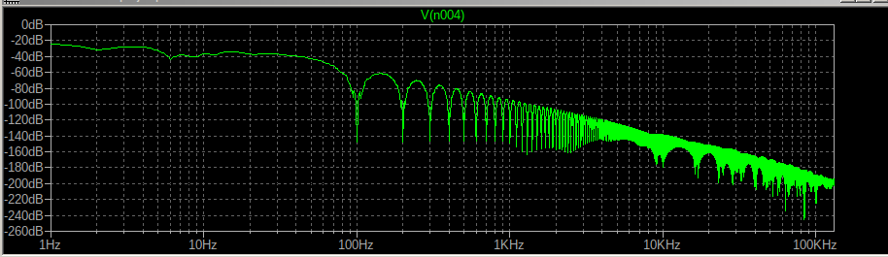

What if Both Sources are Equally Important?
- Run .noise analysis separately for each source:

.noise V(out) V1 dec 10 1 1Meg
.noise V(out) V2 dec 10 1 1Meg

- This will give you the output noise contributions for each source independently.
- Analyze the results:
- Compare the results to understand the relative impact of each source on the circuit's noise performance.
- Combine if Necessary:
- If the sources are independent, the total noise is the square root of the sum of squares (RSS) of individual noise contributions.

.noise V(outputnode) V1 oct 10 10 1Meg

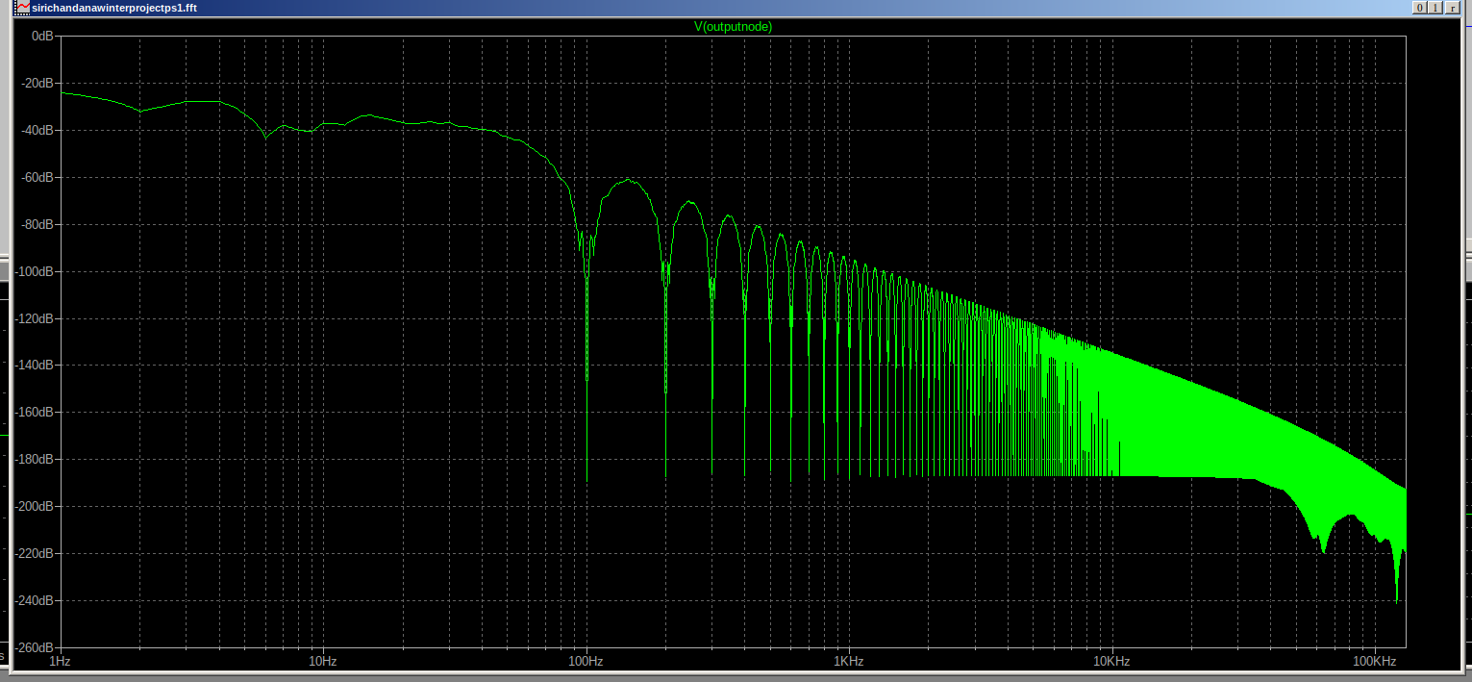

Yes, the circuit introduces noise through the voltage source labeled B1 with the specification v=white(0.1).

Breakdown:

1. B1 Source - The white(0.1) indicates a white noise source with an amplitude of 0.1V (RMS).

2. Effect on Circuit - This will introduce random noise (white noise) into the circuit, which can be used for testing purposes, such as simulating real-world noise effects on the output

Additional Noise Sources:

The other sources (V2 and V3) use sine waves:

V2: SINE(0 0.5 50) — 50 Hz sine wave with 0.5V peak amplitude.

V3: SINE(0 0.5 0.1) — Very low-frequency sine wave (0.1 Hz) with 0.5V peak amplitude.

These do not introduce noise directly but add periodic signals to the circuit.

Conclusion:

The explicit noise introduction is via B1 with the white noise definition. It is likely intended to test the circuit's response to noise conditions.

- Instrumentation amplifiers, like the AD620 or INA128, are designed for low to moderate gains (e.g., 10–100).
- Extremely high gains (e.g., 1000 or more) in a single stage may lead to:
  - Instability due to high-frequency oscillations.
  - Offset errors being amplified, distorting the output signal.
  - Limited bandwidth, which may cause signal attenuation at higher frequencies.
- In noisy environments, a single high-gain stage could cause the output to saturate, especially in the presence of baseline drift and power line interference.
- Distributing the gain across stages prevents early-stage saturation and ensures clean amplification.

-----------------------------------------------------------------------------------------------------------------
- Initial IA Gain (10–20): Ensures the weak signal is raised above noise without distortion.
- Filtering Stage: Removes noise and unwanted signals.
- Second-Stage Amplifier (Gain 100–200): Provides the remaining gain to bring the signal to the desired level (1–5 V).
Using a multi-stage amplifier approach improves performance, stability, and noise rejection.
The IA handles initial gain and noise rejection, while subsequent stages provide filtering and higher amplification without degrading signal quality.
- An IA amplifies common-mode noise and baseline drift along with the signal if no filtering is done beforehand.
- Splitting the amplification into multiple stages allows filtering between stages, improving signal-to-noise ratio (SNR).
---------------------------------------------------------------------------------------------------------------------
PURPOSE OF AMPLIFICATION
Purpose: To enhance weak biological signals for better monitoring, diagnosis, or treatment.
- Application: Medical instruments use amplification to process signals like heartbeats (ECG), brain waves (EEG), or electrical impulses in muscles.
- Examples:
- ECG/EEG Machines: Amplifying weak electrical signals from the heart or brain to create readable data for diagnosis.
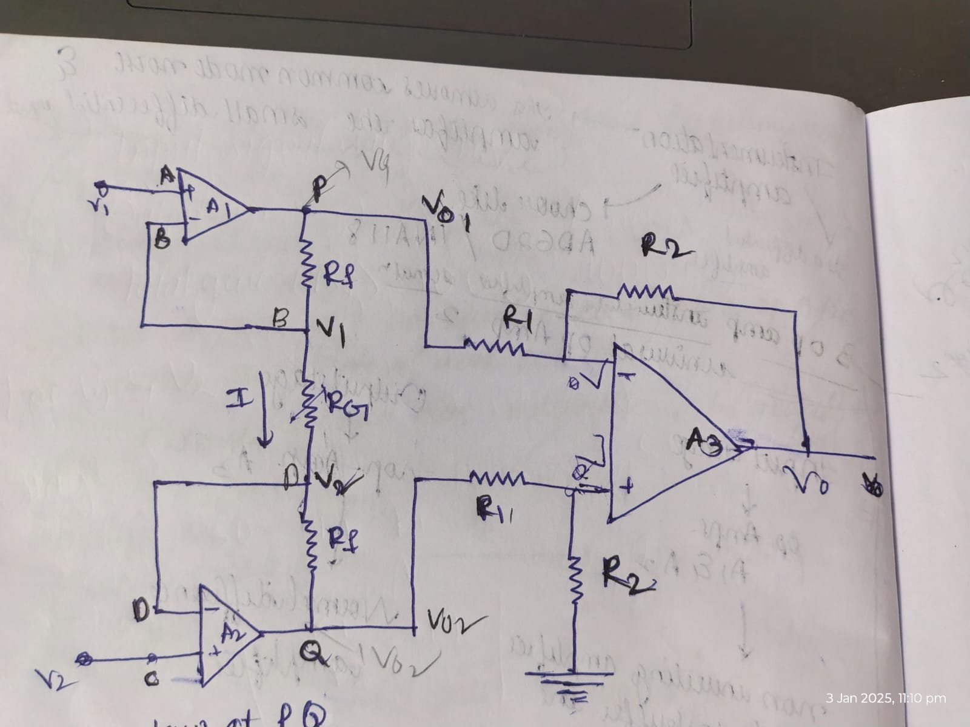
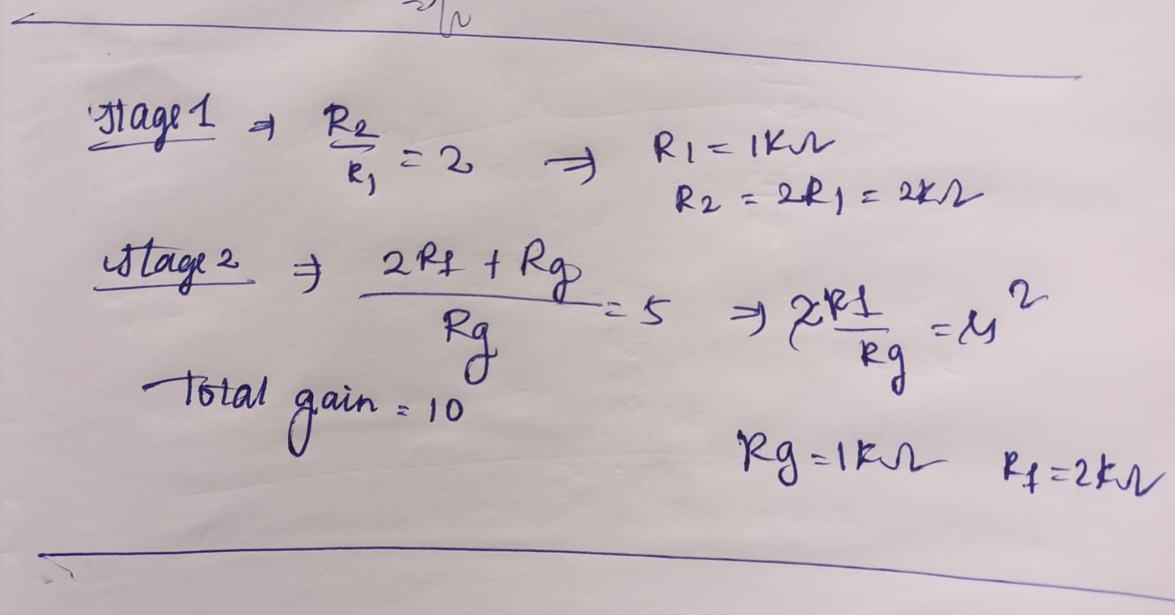

For a gain of 10, the supply voltages ( and ) depend on the input signal range and the desired output range after amplification.
Input Signal
ECG signal: 1–5 mV
Amplified Output Signal
Gain = 10
So, the amplified signal will be in the range: 10–50 mV

1. Dual-Supply Configuration:
V+=5V and V-=-5V
and Suitable for bipolar signals and provides headroom for any DC offset correction.
2.Higher Supplies (Optional):
V+ = 12V and V-=-12V
and can be used if you need more dynamic range for future scaling or filtering stages.

For a gain of 10, the supply voltages ( and ) depend on the input signal range and the desired output range after amplification.

WHAT HAPPENS WHEN MORE VOLTAGE IS SUPPLIED
Recommendation for Your Circuit:

Start with ±5V or 0–5V (single-supply with virtual ground) and ensure the op-amp supports rail-to-rail operation. You can adjust based on testing results.
Supplying more voltage than required to an operational amplifier (op-amp) or any electronic circuit can lead to several potential issues, depending on how much excess voltage is provided and the op-amp's specifications. Here’s what can happen:
1. Damage to the Op-Amp (Overvoltage Damage)
Absolute Maximum Ratings:
Every op-amp has a specified maximum supply voltage (e.g., ±15 V or 36 V for single supply).
Exceeding this value can damage the internal circuitry, causing permanent failure.
Even brief overvoltage conditions can burn out transistors inside the op-amp.
2. Overheating
Higher supply voltages lead to increased power dissipation (heat generation).
If the op-amp cannot effectively dissipate this heat, it may lead to thermal runaway or failure.
This is especially critical in high-gain configurations, where small currents can create large outputs and heat up the device quickly.
3. Output Saturation
Higher supply voltages allow the op-amp to handle larger output swings.
However, if your input signal and gain result in small expected outputs, excessive supply voltage is unnecessary and may cause the output to clip or saturate if the signal exceeds the design range.
For example, amplifying a 1–5 mV ECG signal by 10 yields 10–50 mV, so a ±12 V supply is excessive and could result in noise dominating the signal.
4. Increased Noise and Offset Errors
Operating at unnecessarily high voltages can increase noise levels and offset voltages in sensitive applications like ECG signal processing.
This can degrade the signal-to-noise ratio (SNR) and affect measurement accuracy.

5. Inefficiency
Higher supply voltages waste power, which is problematic in battery-powered or portable medical devices.
It reduces energy efficiency without adding functional benefits.
Best Practice

1. Match Supply Voltage to Application Needs: Use only the voltage required to ensure proper operation and signal amplification.
2. Follow the Datasheet: Stay within recommended operating ranges to avoid failures.
3. Use Rail-to-Rail Op-Amps: If working with low signals, these op-amps allow full-range output swing even with low supply voltages (e.g., 0–5 V).
4. Test with Lower Voltages First: Start with the lowest acceptable supply voltage and increase if needed.

------------------------------------------------------------------------------------------------------------

For your ECG example (1–5 mV signal, gain of 10):

A ±5 V or 0–5 V supply is sufficient.

Avoid using ±12 V unless there’s a specific need for higher output swings or filtering stages

------------------------------------------------------------------------------------------------------------------
In this circuit I used 5v

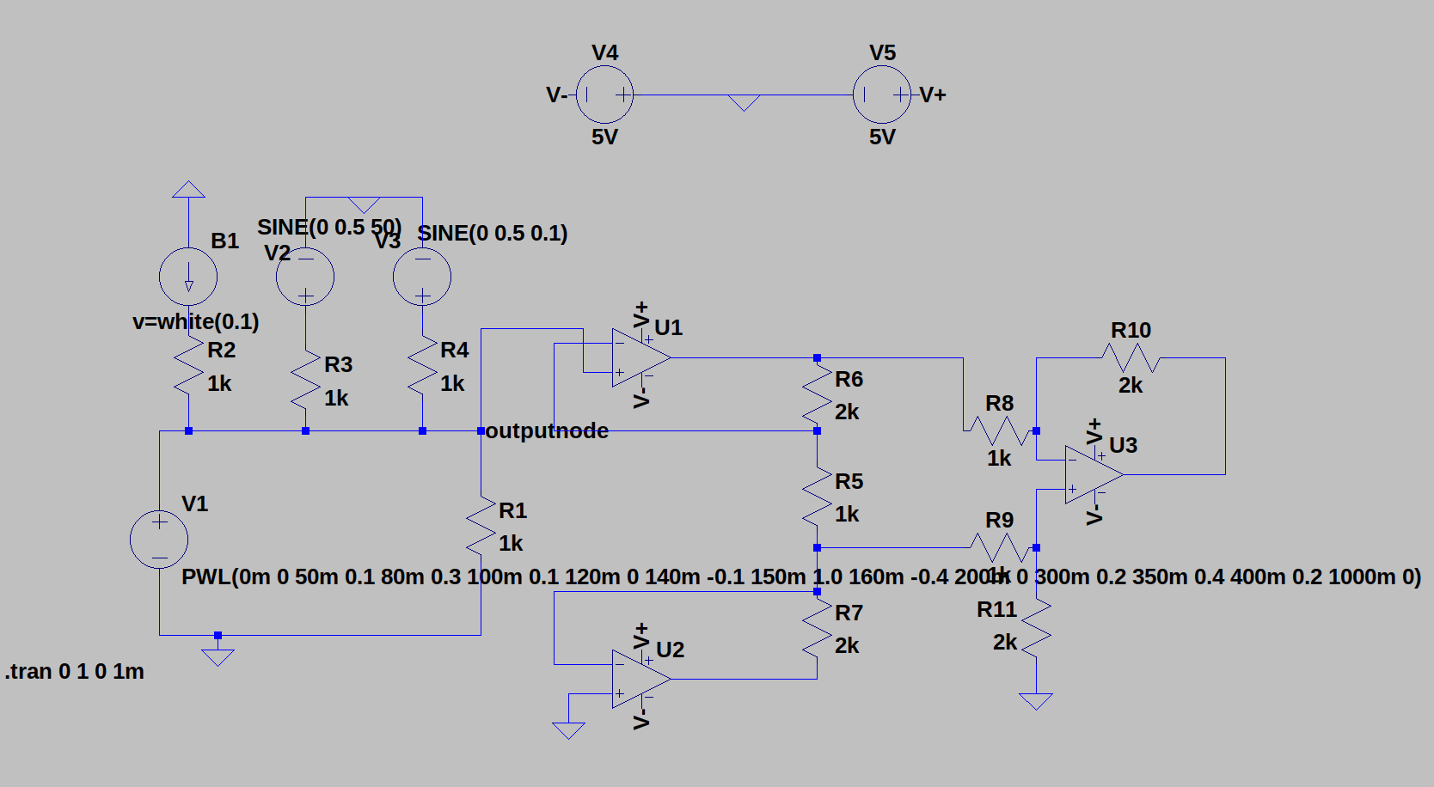
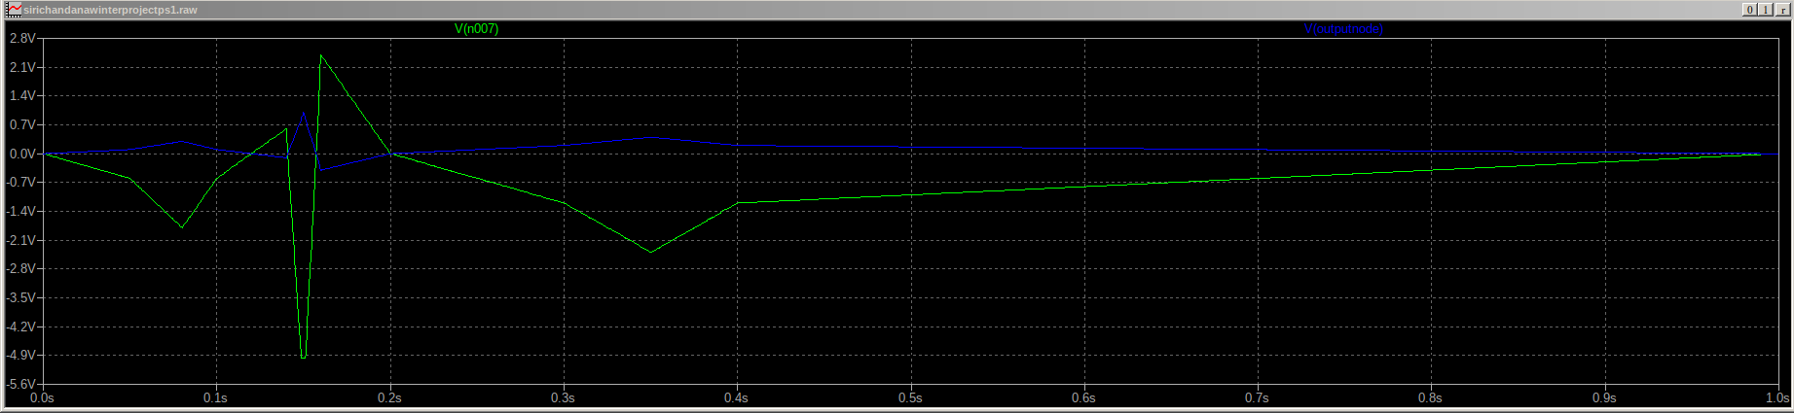
PLOT ANALYSIS(before passing at outputnode and after passing through 3 op amp)
- The signal appears to have higher noise levels spread across a wide frequency range, especially at higher frequencies (>1 kHz).
- The baseline noise floor is higher, suggesting the presence of amplified noise or interference from power line (50/60 Hz) or electronic components.
- Peaks in the high-frequency range may indicate high-frequency noise coupling into the signal.

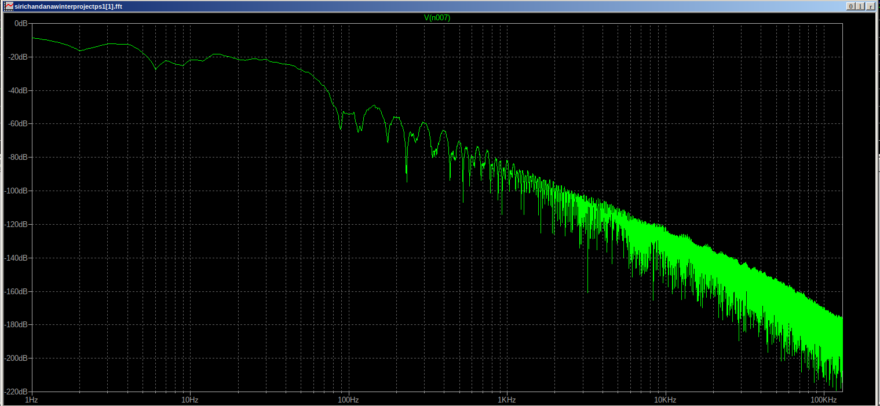
- The noise floor is lower, indicating better noise rejection and filtering effects after amplification.
- The FFT shows a cleaner frequency spectrum, with reduced interference and suppression of unwanted frequency components above the desired range (typical ECG signals have a bandwidth of 0.05–150 Hz).
- High-frequency noise beyond the ECG range (>1 kHz) has been significantly attenuated, suggesting the instrumentation amplifier effectively filtered out noise while amplifying the desired signal
The FFT plot shown in the image represents the frequency response of a signal after passing through a high-pass filter.
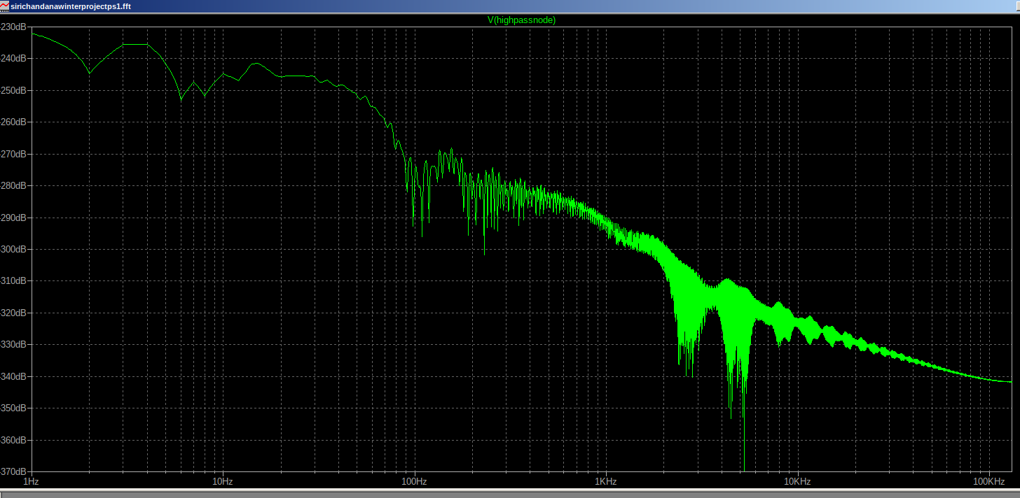
Higher frequencies: Signal magnitude increases slightly, then stabilizes with smaller variations, showing that higher frequencies pass through with less attenuation.

To achieve second-stage amplification with a gain of 100, you can configure the second-stage op-amp as either a non-inverting amplifier or an inverting amplifier. Here's a step-by-step guide for both configurations:

---

1. Non-Inverting Amplifier (Preferred for ECG Signals)
Circuit Configuration:
Gain = 1 + \frac{R_f}{R_g}
Input Signal (Vin): Connect to the non-inverting input (+) of the op-amp.
Feedback Resistor (R_f): Connect between the output (Vout) and the inverting input (-).
Ground Resistor (R_g): Connect between the inverting input (-) and ground.
Gain Calculation:
For Gain = 100:
100 = 1 + \frac{R_f}{R_g}
Simplify:
99 = \frac{R_f}{R_g}
Choose R_g = 1 kΩ → Then, R_f = 99 kΩ
Alternatively, R_g = 10 Ω → Then, R_f = 990 Ω
Advantages:
High Input Impedance: Does not load the previous stage.
Suitable for biomedical signals like ECG, as it avoids phase inversion.
Easy to cascade with instrumentation amplifiers.
2. Inverting Amplifier (Alternative Approach)
Circuit Configuration:Gain = -\frac{R_f}{R_in}
Input Signal (Vin): Connect to the inverting input (-) through a resistor (R_in).
Feedback Resistor (R_f): Connect between the output (Vout) and the inverting input (-).
Non-Inverting Input (+): Connect directly to ground or a reference voltage.
Gain Calculation:
For Gain = 100:
100 = -\frac{R_f}{R_{in}}
Choose R_in = 1 kΩ → Then, R_f = 100 kΩ
Alternatively, R_in = 10 Ω → Then, R_f = 1 kΩ
Disadvantage:
Phase Inversion: Output is inverted compared to the input.
Lower input impedance compared to the non-inverting configuration, which may not be ideal for ECG signals.
3. Additional Considerations:
A. Power Supply:
Use dual supply (+V and -V) or single supply with virtual ground based on your amplifier's requirements.
Ensure that the supply voltage is sufficient to avoid clipping during amplification.
For ECG, a ±5 V or ±12 V supply is often sufficient.
B. Noise Filtering:
Add a low-pass filter at the output with a cutoff frequency around 150 Hz to remove high-frequency noise.
Include decoupling capacitors (0.1 µF and 10 µF) near the power supply pins to suppress supply noise.
C. Cascading Stages:
If the first stage provides a lower gain (e.g., 10), you can cascade the second stage for additional gain.
Ensure the total gain does not saturate the op-amp output (stay within the supply limits).
4. Example LTspice Simulation Settings:
Configure the second stage op-amp in LTspice using the non-inverting topology.
Use VSOURCE for the ECG input signal (~1–5 mV).
Verify output waveform and adjust resistors (R_f and R_g) for precise gain.
Add noise sources (like 50 Hz interference) to test robustness.
Final Notes:
For ECG signals, the non-inverting amplifier is preferred due to its high input impedance and phase-preserving behavior.
Test the circuit in LTspice before implementation to verify signal quality and gain.
Ensure the op-amp bandwidth supports frequencies up to 150 Hz without distortion
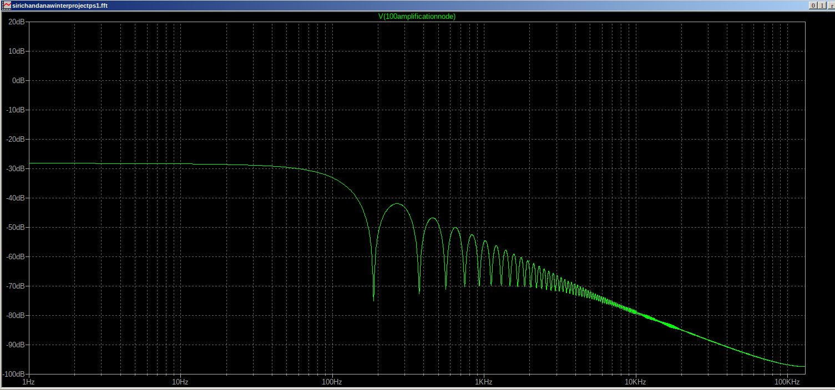

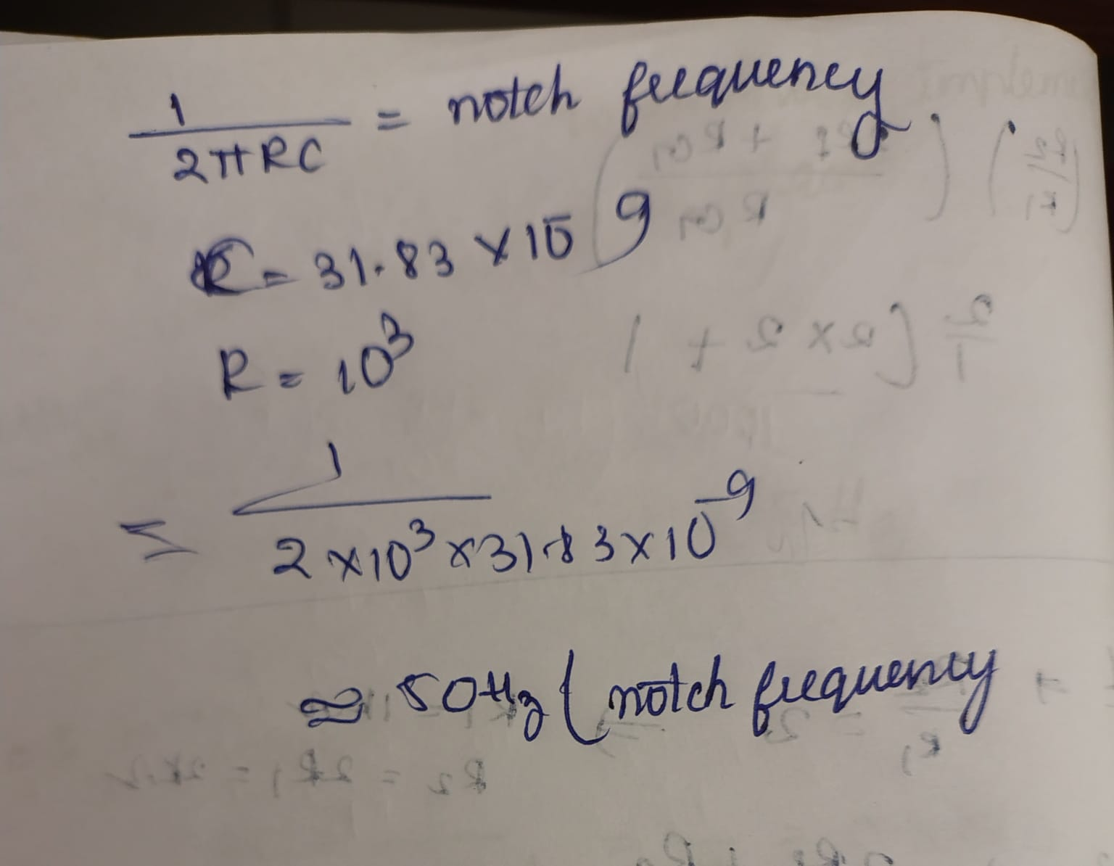

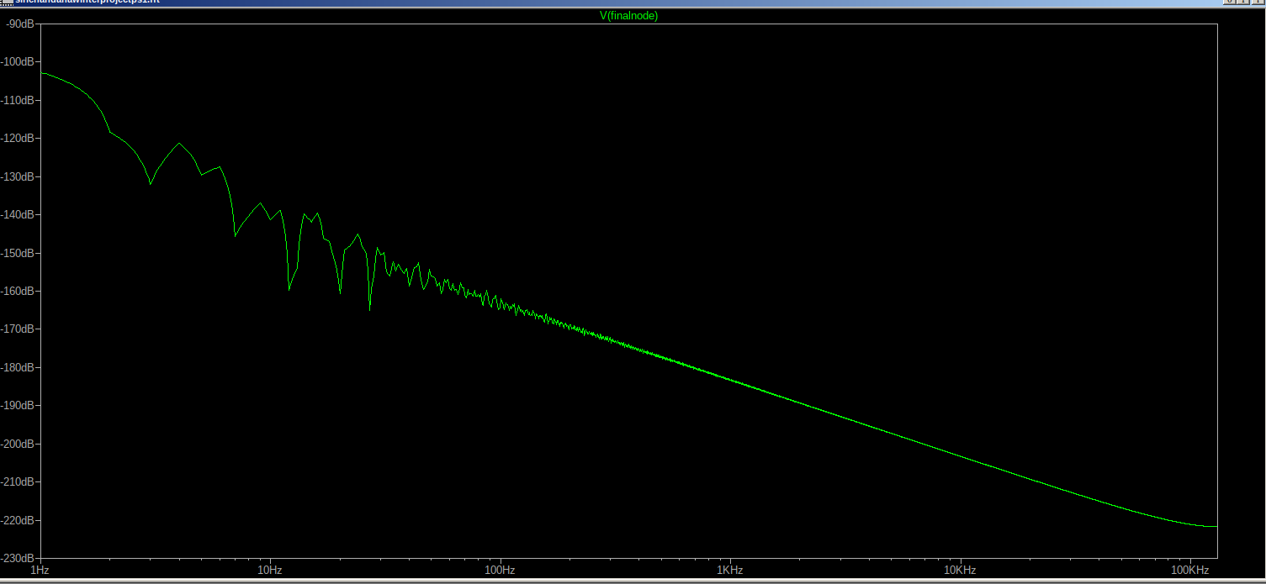

final node

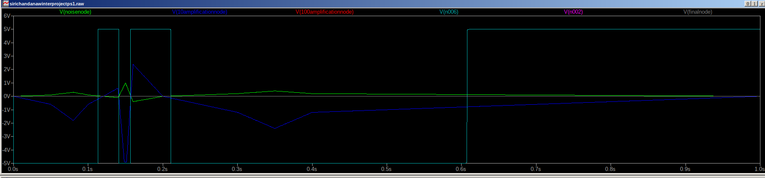
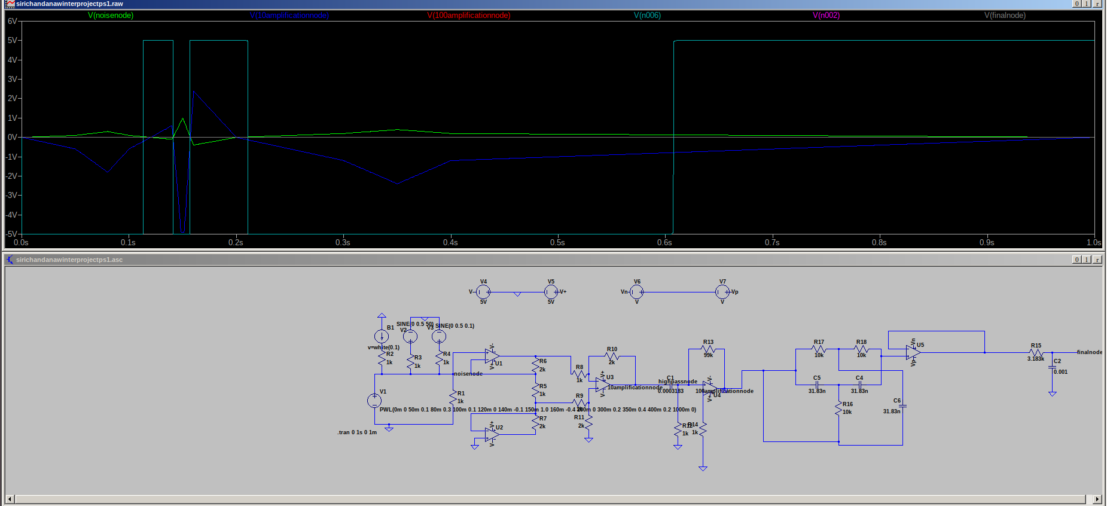
simulations at all specific nodes together

