19BCE1284

KANAKALA TARUN KUMAR

Link

<https://tarun0307.github.io/19BCE1284/>

code:

**Animation :**

Code:

<!DOCTYPE html>

<html>

<head>

<title>assignment</title>

<meta name="viewport" content="width=device-width, initial-scale=1">

<link rel="stylesheet" type="text/css" href="style.css">

</head>

<body>

<div class="topnav">

<a class="active" href="animation.html">Home</a>

<a href="#about">19BCE1284</a>

</div>

<div class="sidemain">

<div class="sidenav">

<a href="animation.html">Animation</a>

<a href="animation_delay.html">-Delay</a>

<a href="animation_direction.html">-Direction</a>

<a href="animation_duration.html">-Duration</a>

<a href="animation_iteration_count.html">-Iteration-Count</a>

<a href="animation_name.html">-Name</a>

<a href="animation_play_state.html">-Play state</a>

<a href="animation_timing_function.html">-timing fucntion</a>

</div>

<div class="main">

<table cellspacing="1" style="border:2px solid black;width:100%;height:400px;"><tr class="1">

<tr>

<th colspan="2"><h3>Animation</h3></th></tr>

<tr><td colspan="2">

<p><pre>Definition and Usage

The animation property is a shorthand property for:

animation-name

animation-duration

animation-timing-function

animation-delay

animation-iteration-count

animation-direction

animation-play-state</pre></p>

</td></tr>

<tr class="in_side"><td class="input_data"><textarea rows="30" cols="70" readonly="readonly">

**<html>**

**<head>**

**<style>**

**body {**

**padding-left:20px;**

**padding-top:20px;**

**color: #fff;**

**background: #1d1f20;**

**}**

**#loading {**

**position: relative;**

**animation-name:my_animation;**

**animation:my_animation 2s linear ;**

**animation-iteration-count: 5;**

**animation-direction: alternate;**

**}**

**@keyframes my_animation{**

**0% { transform: rotate(0deg);**

**left: 0px; top: 0px;}**

**25% {transform: rotate(90deg);**

**left: 200px; top: 0px;}**

**50% {transform: rotate(180deg);**

**left: 200px; top: 200px;}**

**75% { transform: rotate(270deg);**

**left: 0px; top: 200px;}**

**100% { transform: rotate(359deg);**

**left: 0px; top: 0px;}**

**}**

**img{**

**width:50px;**

**height:50px;**

**}**

**</style>**

**</head>**

**<body>**

**<img id="loading" src="http://www.vitorazevedo.net/external_files/loading_small.png">**

**</body>**

**</html>**

</textarea></td><td class="output_data">

<iframe src="alternate.html" name="iframe_a" height="500px" width="100%" title="Iframe Example"></iframe></td></tr></table>

</div>

</div>

</body>

</html>

**In a alternate.html**

Code in between textarea

Output:

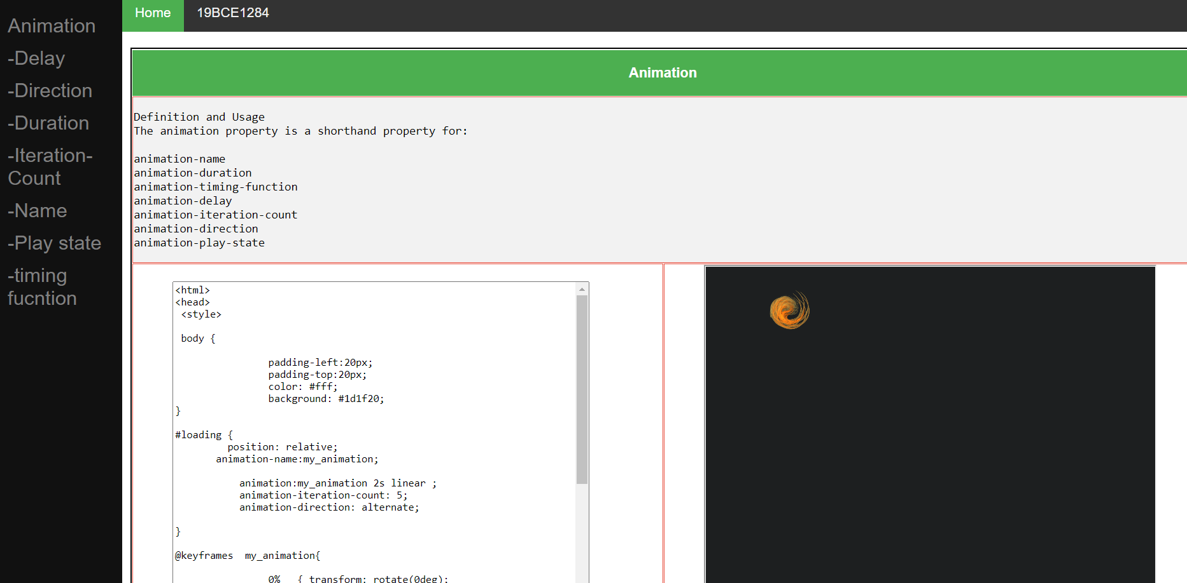

Animation Delay:

Code

<!DOCTYPE html>

<html>

<head>

<title>assignment</title>

<meta name="viewport" content="width=device-width, initial-scale=1">

<link rel="stylesheet" type="text/css" href="style.css">

</head>

<body>

<div class="topnav">

<a class="#about" href="animation.html">Home</a>

<a href="#about">19BCE1284</a>

</div>

<div class="sidemain">

<div class="sidenav">

<a href="animation.html">Animation</a>

<a href="animation_delay.html">-Delay</a>

<a href="animation_direction.html">-Direction</a>

<a href="animation_duration.html">-Duration</a>

<a href="animation_iteration_count.html">-Iteration-Count</a>

<a href="animation_name.html">-Name</a>

<a href="animation_play_state.html">-Play state</a>

<a href="animation_timing_function.html">-timing fucntion</a>

</div>

<div class="main">

<table cellspacing="1" style="border:2px solid black;width:100%;height:400px;"><tr class="1">

<tr>

<th colspan="2"><h3>Delay </h3></th></tr>

<tr> <td colspan="2">

<p>The animation-delay property specifies a delay for the start of an animation.</p>

<p style="font-style:time new roman;">Example</p>

<p><pre style="border-left:5px solid orange;font-size:15px;">div {

animation-delay: 5s;

}</pre></p>

</td></tr>

<tr class="in_side"><td class="input_data"><textarea rows="30" cols="70" readonly="readonly">

**<html>**

**<head>**

**<style>**

**body {**

**padding-left:20px;**

**padding-top:20px;**

**color: #fff;**

**background: #1d1f20;**

**}**

**#loading {**

**position: relative;**

**animation-name:my_animation;**

**animation:my_animation 2s 2 linear ;**

**animation-delay:5s;**

**}**

**@keyframes my_animation{**

**from {**

**transform: rotate(0deg);**

**left:0px;**

**}**

**to {**

**transform: rotate(359deg);**

**left:200px;**

**}**

**}**

**img{**

**width:50px;**

**height:50px;**

**}**

**</style>**

**</head>**

**<body>**

**<img id="loading" src="http://www.vitorazevedo.net/external_files/loading_small.png">**

**</body>**

**</html>**

</textarea></td><td class="output_data">

<iframe src="delay.html" name="iframe_a" height="500px" width="100%" title="Iframe Example"></iframe></td></tr></table>

</div>

</div>

</body>

</html>

**In a delay.html**

Code in between textarea

Output:

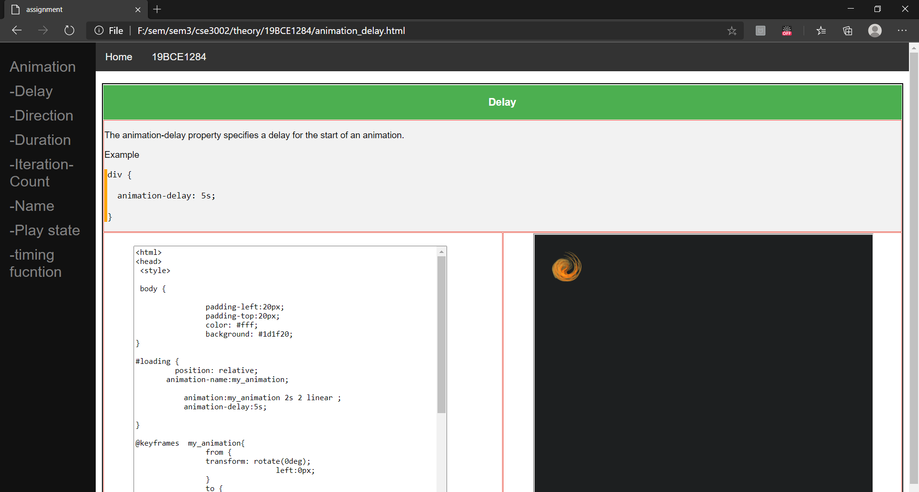

Animation direction

Code:

<!DOCTYPE html>

<html>

<head>

<title>assignment</title>

<meta name="viewport" content="width=device-width, initial-scale=1">

<link rel="stylesheet" type="text/css" href="style.css">

</head>

<body>

<div class="topnav">

<a class="#about" href="animation.html">Home</a>

<a href="#about">19BCE1284</a>

</div>

<div class="sidemain">

<div class="sidenav">

<a href="animation.html">Animation</a>

<a href="animation_delay.html">-Delay</a>

<a href="animation_direction.html">-Direction</a>

<a href="animation_duration.html">-Duration</a>

<a href="animation_iteration_count.html">-Iteration-Count</a>

<a href="animation_name.html">-Name</a>

<a href="animation_play_state.html">-Play state</a>

<a href="animation_timing_function.html">-timing fucntion</a>

</div>

<div class="main">

<table cellspacing="1" style="border:2px solid black;width:100%;height:200px;"><tr class="1">

<th ><h3>Direction</h3></th></tr>

<tr> <td>

<p><pre font-size:20px;>The animation-direction property defines whether an animation should be played forwards, backwards or in alternate cycles.

Property Values

1. Normal

2. Alternate

</pre></p></td></tr></table>

<table cellspacing="1" style="border:2px solid black;width:100%;height:400px;"><tr class="1">

<tr>

<th colspan="2"><h3>Normal</h3></th></tr>

<tr> <td colspan="2">

<p>Default value. The animation is played as normal (forwards)</p>

<p style="font-style:time new roman;">Example</p>

<p><pre style="border-left:5px solid orange;font-size:15px;">div {

animation-direction: normal;

}</pre></p>

</td></tr>

<tr class="in_side"><td class="input_data"><textarea rows="30" cols="70" readonly="readonly">

**<html>**

**<head>**

**<style>**

**body {**

**padding-left:20px;**

**padding-top:20px;**

**color: #fff;**

**background: #1d1f20;**

**}**

**#loading {**

**position: relative;**

**animation-name:my_animation;**

**animation:my_animation 2s linear ;**

**animation-iteration-count: 5;**

**animation-direction: normal;**

**}**

**@keyframes my_animation{**

**0% { transform: rotate(0deg);**

**left: 0px; top: 0px;}**

**25% {transform: rotate(90deg);**

**left: 200px; top: 0px;}**

**50% {transform: rotate(180deg);**

**left: 200px; top: 200px;}**

**75% { transform: rotate(270deg);**

**left: 0px; top: 200px;}**

**100% { transform: rotate(359deg);**

**left: 0px; top: 0px;}**

**}**

**img{**

**width:50px;**

**height:50px;**

**}**

**</style>**

**</head>**

**<body>**

**<img id="loading" src="http://www.vitorazevedo.net/external_files/loading_small.png">**

**</body>**

**</html>**

</textarea></td><td class="output_data">

<iframe src="normal.html" name="iframe_a" height="500px" width="100%" title="Iframe Example"></iframe></td></tr></table>

<table cellspacing="1" style="border:2px solid black;width:100%;height:400px;"><tr class="1">

<th colspan="2"><h3>Alternate</h3></th></tr>

<tr> <td colspan="2">

<p>The animation is played forwards first, then backwards</p>

<p style="font-style:time new roman;">Example</p>

<p><pre style="border-left:5px solid orange;font-size:15px;">div {

animation-direction: alternate;

}</pre></p>

</td></tr>

<tr class="in_side"><td class="input_data"><textarea rows="30" cols="70" readonly="readonly">

**<html>**

**<head>**

**<style>**

**body {**

**padding-left:20px;**

**padding-top:20px;**

**color: #fff;**

**background: #1d1f20;**

**}**

**#loading {**

**position: relative;**

**animation-name:my_animation;**

**animation:my_animation 2s linear ;**

**animation-iteration-count: 5;**

**animation-direction: alternate;**

**}**

**@keyframes my_animation{**

**0% { transform: rotate(0deg);**

**left: 0px; top: 0px;}**

**25% {transform: rotate(90deg);**

**left: 200px; top: 0px;}**

**50% {transform: rotate(180deg);**

**left: 200px; top: 200px;}**

**75% { transform: rotate(270deg);**

**left: 0px; top: 200px;}**

**100% { transform: rotate(359deg);**

**left: 0px; top: 0px;}**

**}**

**img{**

**width:50px;**

**height:50px;**

**}**

**</style>**

**</head>**

**<body>**

**<img id="loading" src="http://www.vitorazevedo.net/external_files/loading_small.png">**

**</body>**

**</html>**

</textarea></td><td class="output_data">

<iframe src="alternate.html" name="iframe_a" height="500px" width="100%" title="Iframe Example"></iframe></td></tr></table>

</div>

</div>

</body>

</html>

**In a normal.html**

Code in between 1st textarea

**In a alternate.html**

Code in between 2nd textarea

Output:

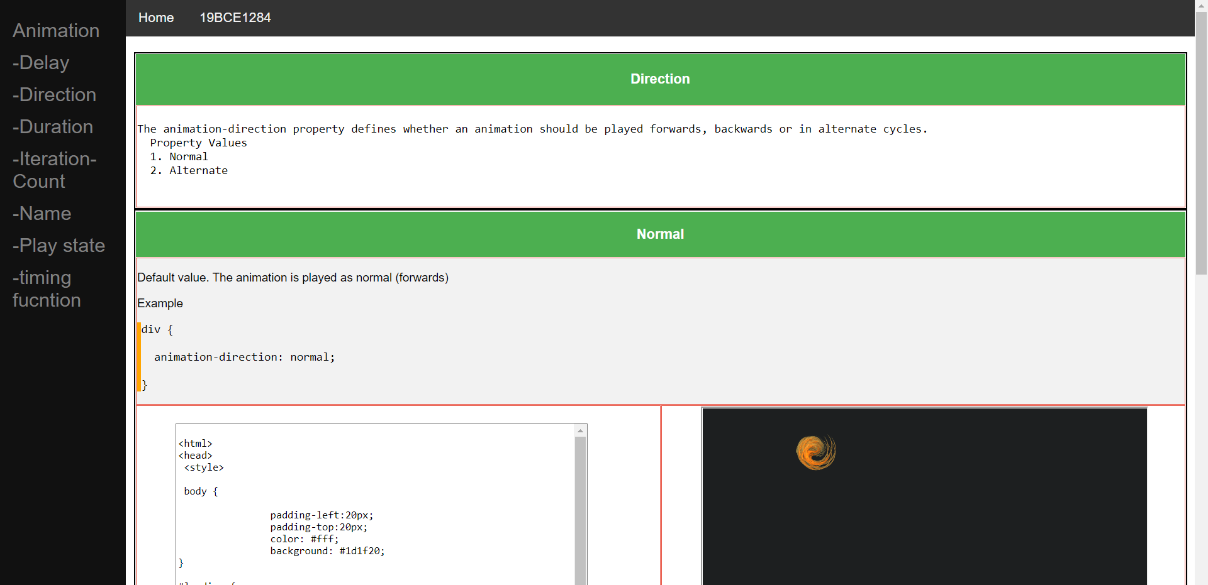

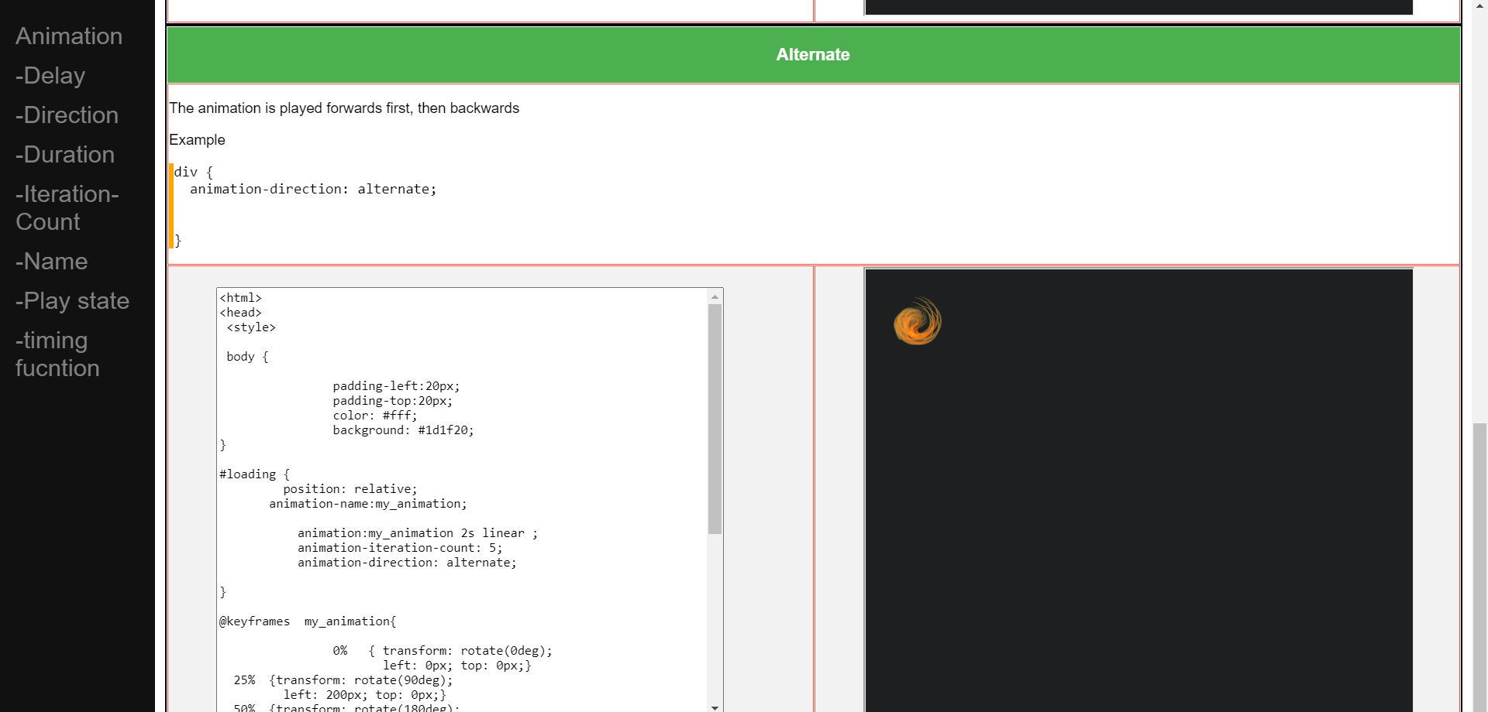

Animation duration:

Code:

<!DOCTYPE html>

<html>

<head>

<title>assignment</title>

<meta name="viewport" content="width=device-width, initial-scale=1">

<link rel="stylesheet" type="text/css" href="style.css">

</head>

<body>

<div class="topnav">

<a class="#about" href="animation.html">Home</a>

<a href="#about">19BCE1284</a>

</div>

<div class="sidemain">

<div class="sidenav">

<a href="animation.html">Animation</a>

<a href="animation_delay.html">-Delay</a>

<a href="animation_direction.html">-Direction</a>

<a href="animation_duration.html">-Duration</a>

<a href="animation_iteration_count.html">-Iteration-Count</a>

<a href="animation_name.html">-Name</a>

<a href="animation_play_state.html">-Play state</a>

<a href="animation_timing_function.html">-timing fucntion</a>

</div>

<div class="main">

<table cellspacing="1" style="border:2px solid black;width:100%;height:400px;"><tr class="1">

<tr>

<th colspan="2"><h3>Duration</h3></th></tr>

<tr><td colspan="2">

<p>The animation-duration property defines how long an animation should take to complete one cycle.</p>

<p style="font-style:time new roman;">Example</p>

<p><pre style="border-left:5px solid orange;font-size:15px;">div {

animation-duration: 5s;

}</pre></p>

</td></tr>

<tr class="in_side"><td class="input_data"><textarea rows="30" cols="70" readonly="readonly">

**<html>**

**<head>**

**<style>**

**body {**

**padding-left:20px;**

**padding-top:20px;**

**color: #fff;**

**background: #1d1f20;**

**}**

**.loading {**

**position: relative;**

**animation-name:my_animation;**

**animation:my_animation 2s linear ;**

**animation-duration:5s;**

**}**

**@keyframes my_animation{**

**from {top: 0px;}**

**to {top: 200px;}**

**}**

**img{**

**width:50px;**

**height:50px;**

**}**

**</style>**

**</head>**

**<body>**

**<img class="loading" src="http://www.vitorazevedo.net/external_files/loading_small.png">**

**</body>**

**</html>**

</textarea></td><td class="output_data">

<iframe src="duration.html" name="iframe_a" height="500px" width="100%" title="Iframe Example"></iframe></td></tr></table>

</div>

</div>

</body>

</html>

**In a duration.html**

Code in between textarea

Output:

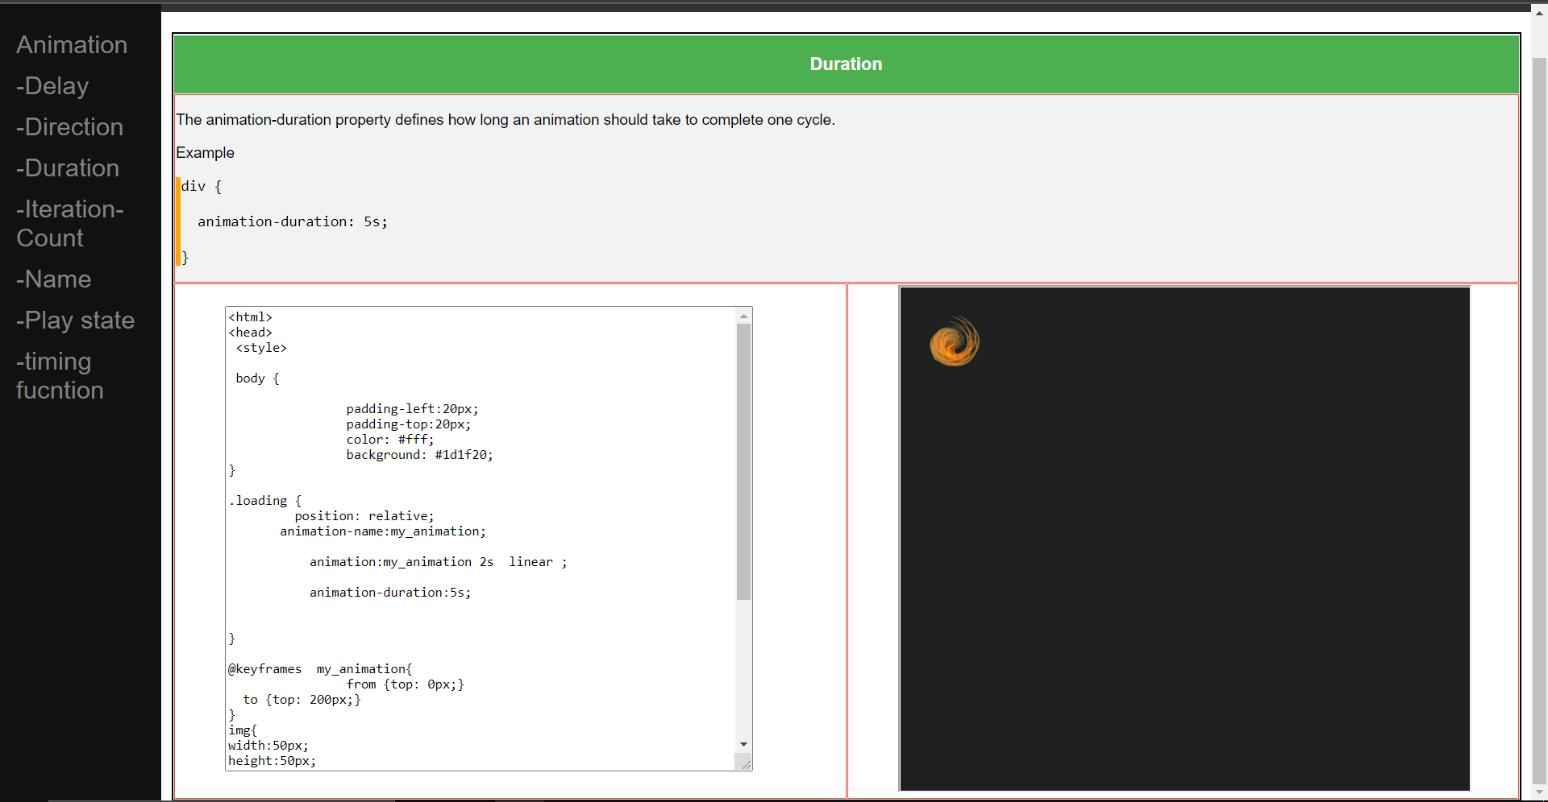

Animation iteration count

Code: <!DOCTYPE html>

<html>

<head>

<title>assignment</title>

<meta name="viewport" content="width=device-width, initial-scale=1">

<link rel="stylesheet" type="text/css" href="style.css">

</head>

<body>

<div class="topnav">

<a class="#about" href="animation.html">Home</a>

<a href="#about">19BCE1284</a>

</div>

<div class="sidemain">

<div class="sidenav">

<a href="animation.html">Animation</a>

<a href="animation_delay.html">-Delay</a>

<a href="animation_direction.html">-Direction</a>

<a href="animation_duration.html">-Duration</a>

<a href="animation_iteration_count.html">-Iteration-Count</a>

<a href="animation_name.html">-Name</a>

<a href="animation_play_state.html">-Play state</a>

<a href="animation_timing_function.html">-timing fucntion</a>

</div>

<div class="main">

<table cellspacing="1" style="border:2px solid black;width:100%;height:200px;"><tr class="1">

<th ><h3>Iteration-Count</h3></th></tr>

<tr> <td>

<p><pre font-size:20px;>The animation-iteration-count property specifies the number of times an animation should be played.

Property Values

1. Number

2. Iherit

</pre></p></td></tr></table>

<table cellspacing="1" style="border:2px solid black;width:100%;height:400px;"><tr class="1">

<tr>

<th colspan="2"><h3>Number</h3></th></tr>

<tr> <td colspan="2">

<p>A number that defines how many times an animation should be played. Default value is 1</p>

<p style="font-style:time new roman;">Example</p>

<p><pre style="border-left:5px solid orange;font-size:15px;">div {

animation--Iteration-Count:4;

}</pre></p>

</td></tr>

<tr class="in_side"><td class="input_data"><textarea rows="30" cols="70" readonly="readonly">

<html>

<head>

<style>

body {

padding-left:20px;

padding-top:20px;

color: #fff;

background: #1d1f20;

}

#loading {

position: relative;

animation-name:my_animation;

animation:my_animation 2s linear ;

animation-iteration-count: 5;

}

@keyframes my_animation{

from {

transform: rotate(0deg);

left:0px;

}

to {

transform: rotate(359deg);

left:200px;

}

}

img{

width:50px;

height:50px;

}

</style>

</head>

<body>

<img id="loading" src="http://www.vitorazevedo.net/external_files/loading_small.png">

</body>

</html>

</textarea></td><td class="output_data">

<iframe src="count_number.html" name="iframe_a" height="500px" width="100%" title="Iframe Example"></iframe></td></tr></table>

<table cellspacing="1" style="border:2px solid black;width:100%;height:400px;"><tr class="1">

<th colspan="2"><h3>Iherit</h3></th></tr>

<tr> <td colspan="2">

<p>Inherits this property from its parent element</p>

<p style="font-style:time new roman;">Example</p>

<p><pre style="border-left:5px solid orange;font-size:15px;">div {

animation-iteration-count: 4;<!-- 4 times -->

animation-iteration-count: 2;<!-- 2 times -->

animation-iteration-count: inherit;<!-- 4 times -->

}</pre></p>

</td></tr>

<tr class="in_side"><td class="input_data"><textarea rows="30" cols="70" readonly="readonly">

<html>

<head>

<style>

body {

padding-left:20px;

padding-top:20px;

color: #fff;

background: #1d1f20;

}

#loading {

position: relative;

animation-name:my_animation;

animation:my_animation 2s linear ;

animation-iteration-count: 4;<!-- 4 times -->

animation-iteration-count: 2;<!-- 2 times -->

animation-iteration-count: inherit;<!-- 4 times -->

}

@keyframes my_animation{

from {

transform: rotate(0deg);

left:0px;

}

to {

transform: rotate(359deg);

left:200px;

}

}

img{

width:50px;

height:50px;

}

</style>

</head>

<body>

<img id="loading" src="http://www.vitorazevedo.net/external_files/loading_small.png">

</body>

</html>

</textarea></td><td class="output_data">

<iframe src="count_inherit.html" name="iframe_a" height="500px" width="100%" title="Iframe Example"></iframe></td></tr></table>

</div>

</div>

</body>

</html>

Output:

