Creating Preconfigured Google Compute VM Instances

1. [Create a Google Cloud Storage Bucket](https://console.cloud.google.com/storage)

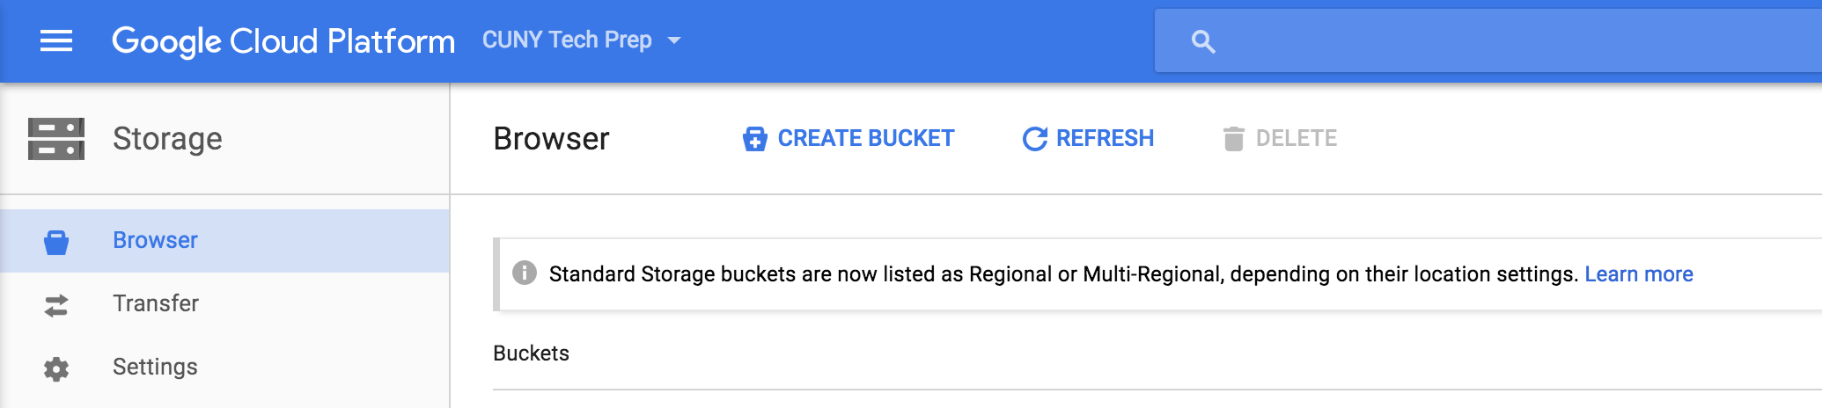

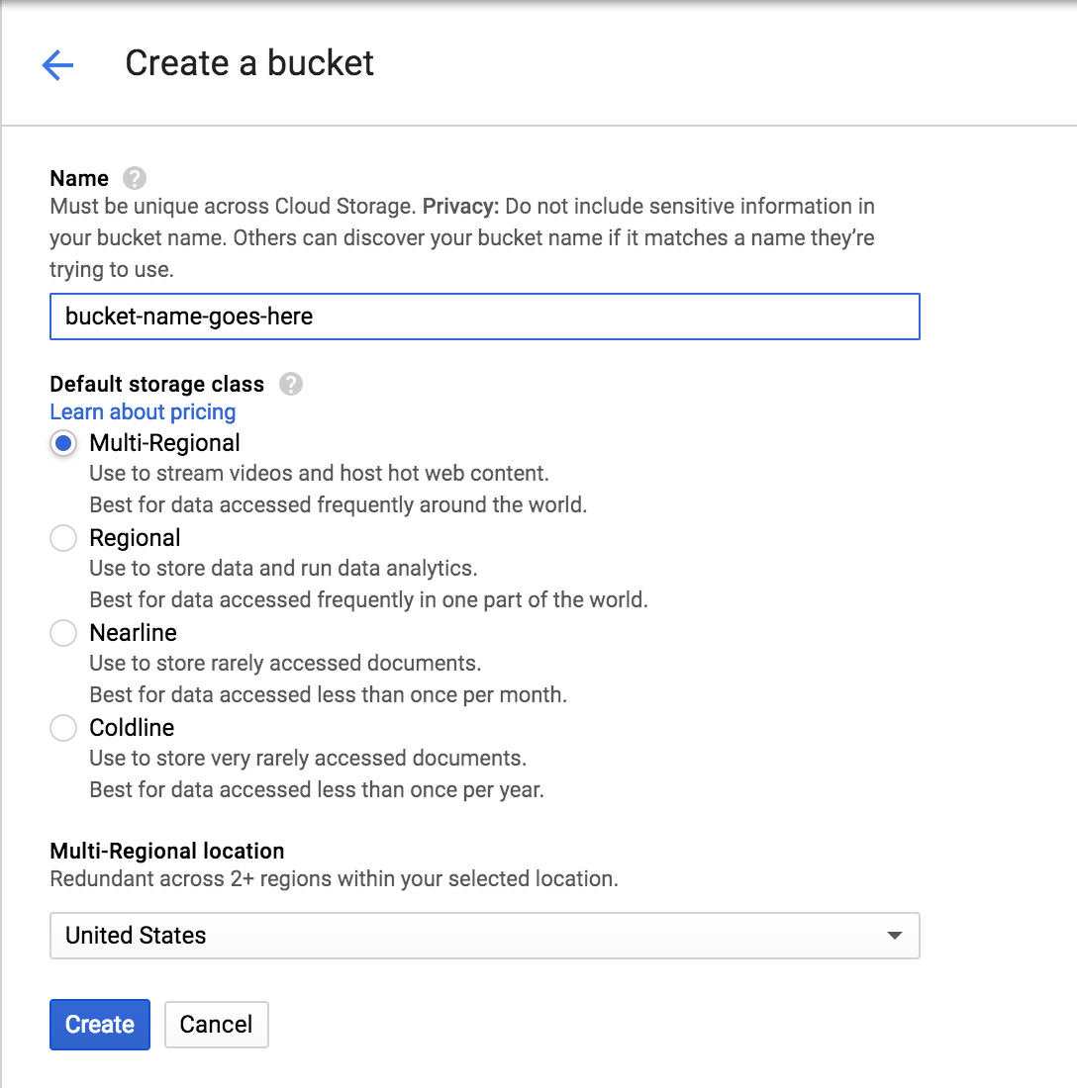

1. [Download the CTP private image tar file](https://storage.googleapis.com/ctp/ctp-base-image.tar.gz)
2. Add the tar file into the bucket created in the first step

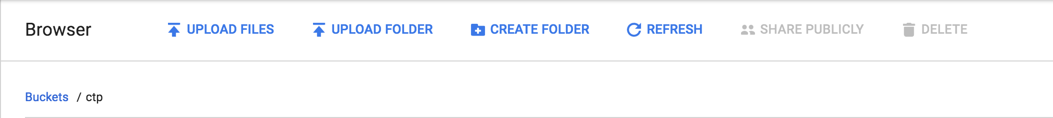

1. [Create a Google Compute Image](https://console.cloud.google.com/compute/images)

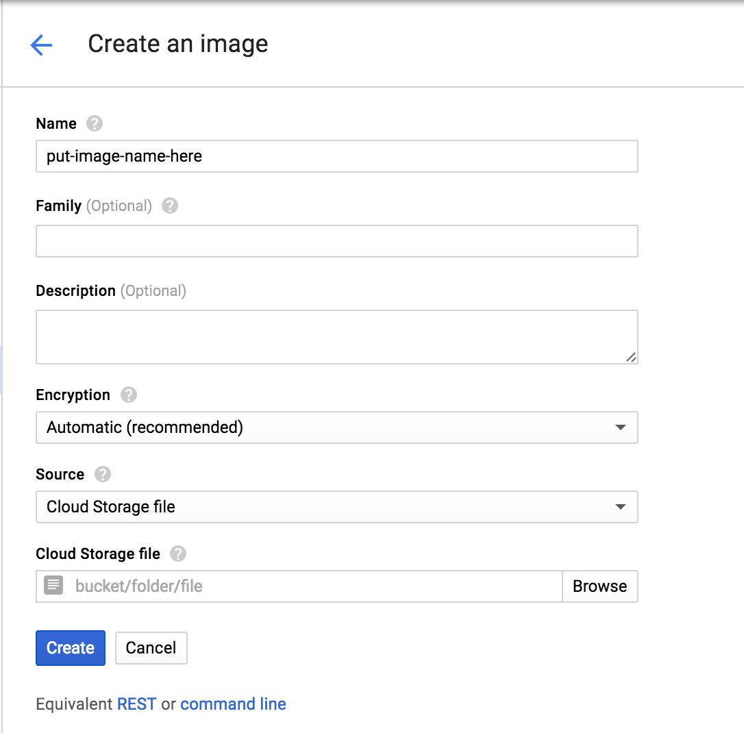

* 1. Source needs to be set to Cloud Storage File
  2. Navigate through your bucket and select the file to you added into the bucket in step 3

1. [Create a Google Compute VM](https://console.cloud.google.com/compute/instances?project=cuny-tech-prep)

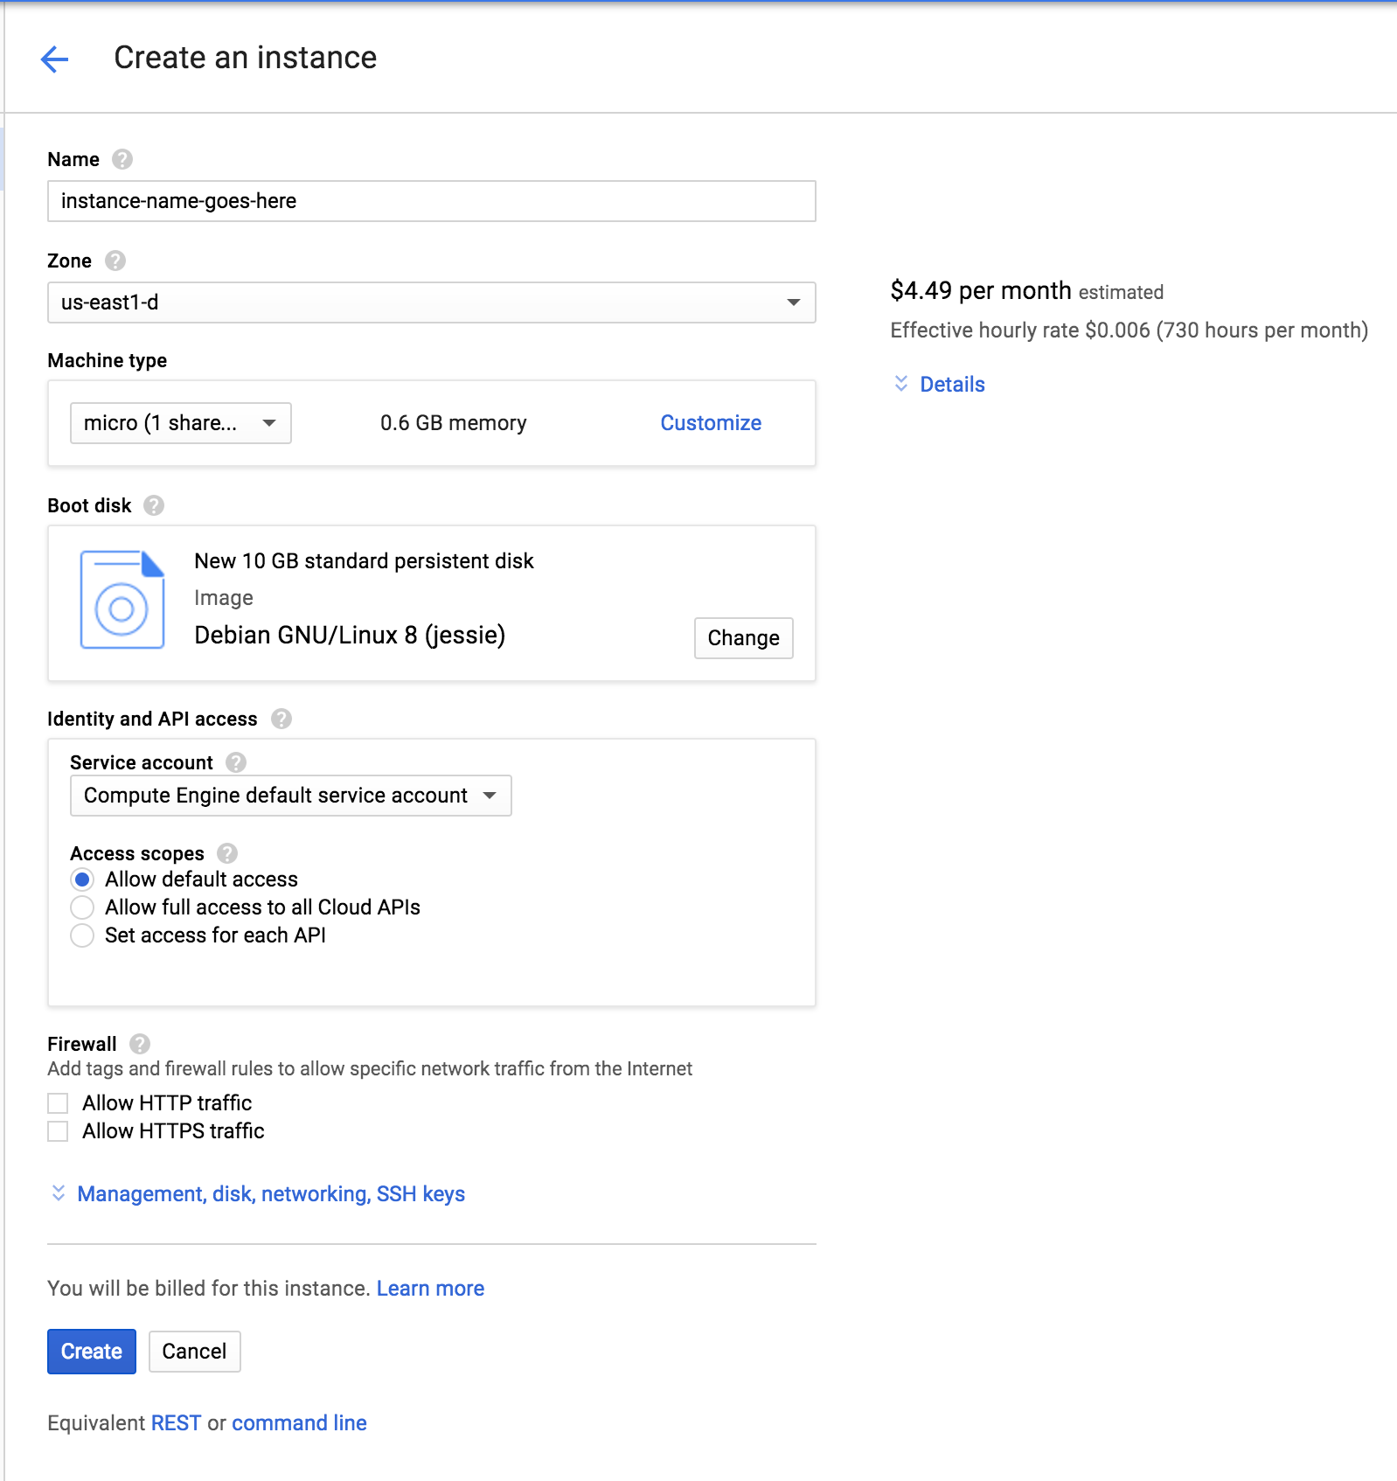

* 1. Go to boot disk
  2. Click on custom images
  3. Select the image you created in step 4
  4. Under **Firewall**, make sure to enable
     1. Allow HTTP traffic
     2. Allow HTTPS traffic

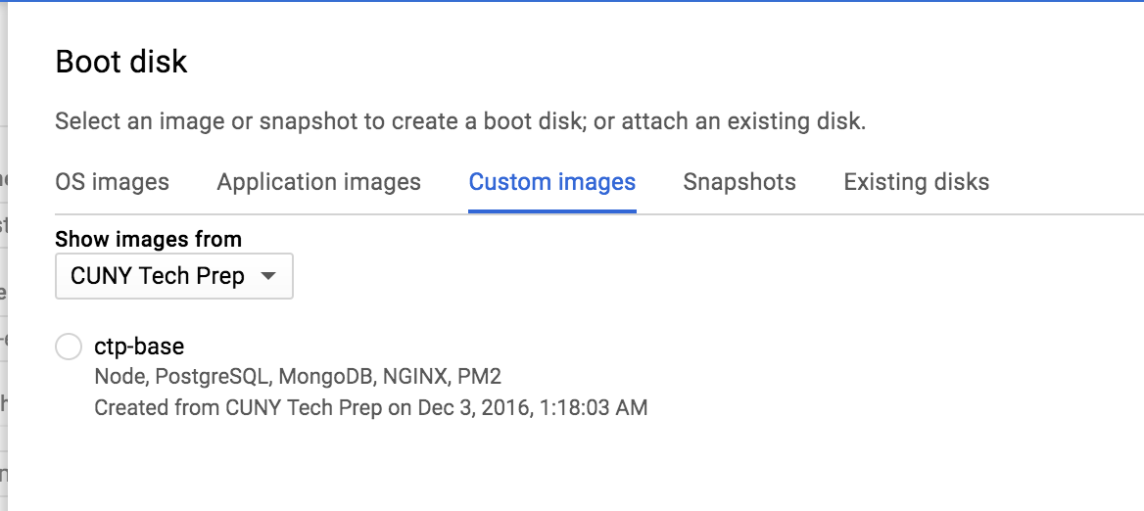

1. SSH into your instance