Proposal
Gulf Rubber

Presented by: Yash
March 30th, 2026

01
Landscape & Objective
We assess your current state, identify pain points, and define clear objectives for your monday.com implementation. This discovery phase ensures we understand your unique challenges and align on success metrics before we begin.

02
Solution Design
Our tailored solution blueprint addresses your specific workflows through board architecture, automation strategies, and integrations. This section details the complete scope of work, phase breakdowns, and deliverables for your implementation.

03
Summary
A transparent breakdown of investment, timelines, and resources required to bring your solution to life. Here you'll find the total engagement hours, costs, and what's included in each implementation phase.

Landscape & Objective Overview
Gulf Rubber is a manufacturing company operating in the rubber products industry. Currently, the organisation is looking to professionalise its sales and relationship management processes by moving away from informal, unstructured methods of tracking contacts, accounts, and commercial opportunities. Patrick, a key stakeholder and decision maker at Gulf Rubber, is leading this initiative to establish a foundational CRM capability for the business.
Gulf Rubber does not currently operate a structured CRM system, with contact management, pipeline tracking, and lead handling likely managed through a combination of email, spreadsheets, and ad hoc communication. The team relies on Microsoft Outlook as a core communication tool, but lacks a centralised platform to capture, organise, and progress sales and relationship data. Gulf Rubber is seeking to onboard onto monday.com CRM Enterprise to establish essential sales operations infrastructure and bring visibility to their commercial pipeline for the first time.
Current Challenges
• No centralised CRM or contact management system — Gulf Rubber has no structured platform for managing contacts and accounts, meaning customer and prospect information is fragmented across individuals and tools with no single source of truth.
• Pipeline visibility is non-existent — Without a defined pipeline management process, the team has no way to track deal stages, forecast revenue, or identify bottlenecks in the sales cycle.
• Lead management is informal and untracked — Inbound and outbound leads are not systematically captured or nurtured, creating a high risk of lost opportunities and inconsistent follow-up.
• Email-based communication operates in isolation — While the team uses Microsoft Outlook for day-to-day correspondence, there is no integration between email activity and a central customer record, limiting context and accountability.
• No documented requirements or internal process definitions — Gulf Rubber has not yet formalised its CRM requirements or documented existing sales workflows, which creates ambiguity around how the system should be configured to match real operational needs.
• Limited internal readiness for platform adoption — As a first-time monday.com implementation, the team will require structured onboarding, training, and change management support to ensure adoption and sustained usage beyond go-live.
• Dependency on timely client engagement — The success of this implementation within the defined 30-hour, four-week timeline is contingent on Gulf Rubber's responsiveness in providing access, documentation, and feedback at key milestones.

The goal is to implement a foundational CRM solution on monday.com CRM Enterprise that gives Gulf Rubber structured, centralised management of contacts, accounts, leads, and pipeline — integrated with Microsoft Outlook to connect email communication directly to customer records. Fruition Services will configure the platform to deliver immediate operational visibility across the sales lifecycle, supported by monday.com Work Management for internal project tracking, and complemented by Monday Vibe and Monday Note Taker to enhance team collaboration. The key outcomes of this engagement are establishing a reliable single source of truth for all commercial relationships, enabling pipeline visibility and lead tracking from day one, and providing Gulf Rubber's team with the training and confidence to manage and evolve the platform independently beyond the initial implementation.

Solution Design
The proposed solution positions monday.com CRM Enterprise as Gulf Rubber's centralised customer relationship management platform — serving as the single source of truth for all contact, account, and sales pipeline activity. This implementation will replace the current unstructured approach with a purpose-built CRM environment, giving Patrick and the team clear visibility over leads, opportunities, and client relationships from one unified workspace.
The solution is built around three core workflow components. First, a Contact and Account Management layer that organises Gulf Rubber's customer and prospect data into structured, searchable records. Second, a Lead Management module that captures and qualifies inbound interest, ensuring no opportunity is missed. Third, a Pipeline Management board that tracks deals through defined sales stages, providing real-time insight into revenue progression and forecast accuracy. Together, these components deliver a streamlined sales workflow tailored to Gulf Rubber's immediate operational needs.
To connect the CRM with Gulf Rubber's existing communication tools, the solution includes a Microsoft Outlook integration enabling seamless email synchronisation between the platform and day-to-day correspondence. This ensures that client communications are automatically logged against the relevant contact or deal record within monday.com, reducing manual data entry and maintaining a complete interaction history. monday.com Work Management will also be leveraged for training boards and the project plan app, supporting internal adoption and ongoing knowledge transfer.

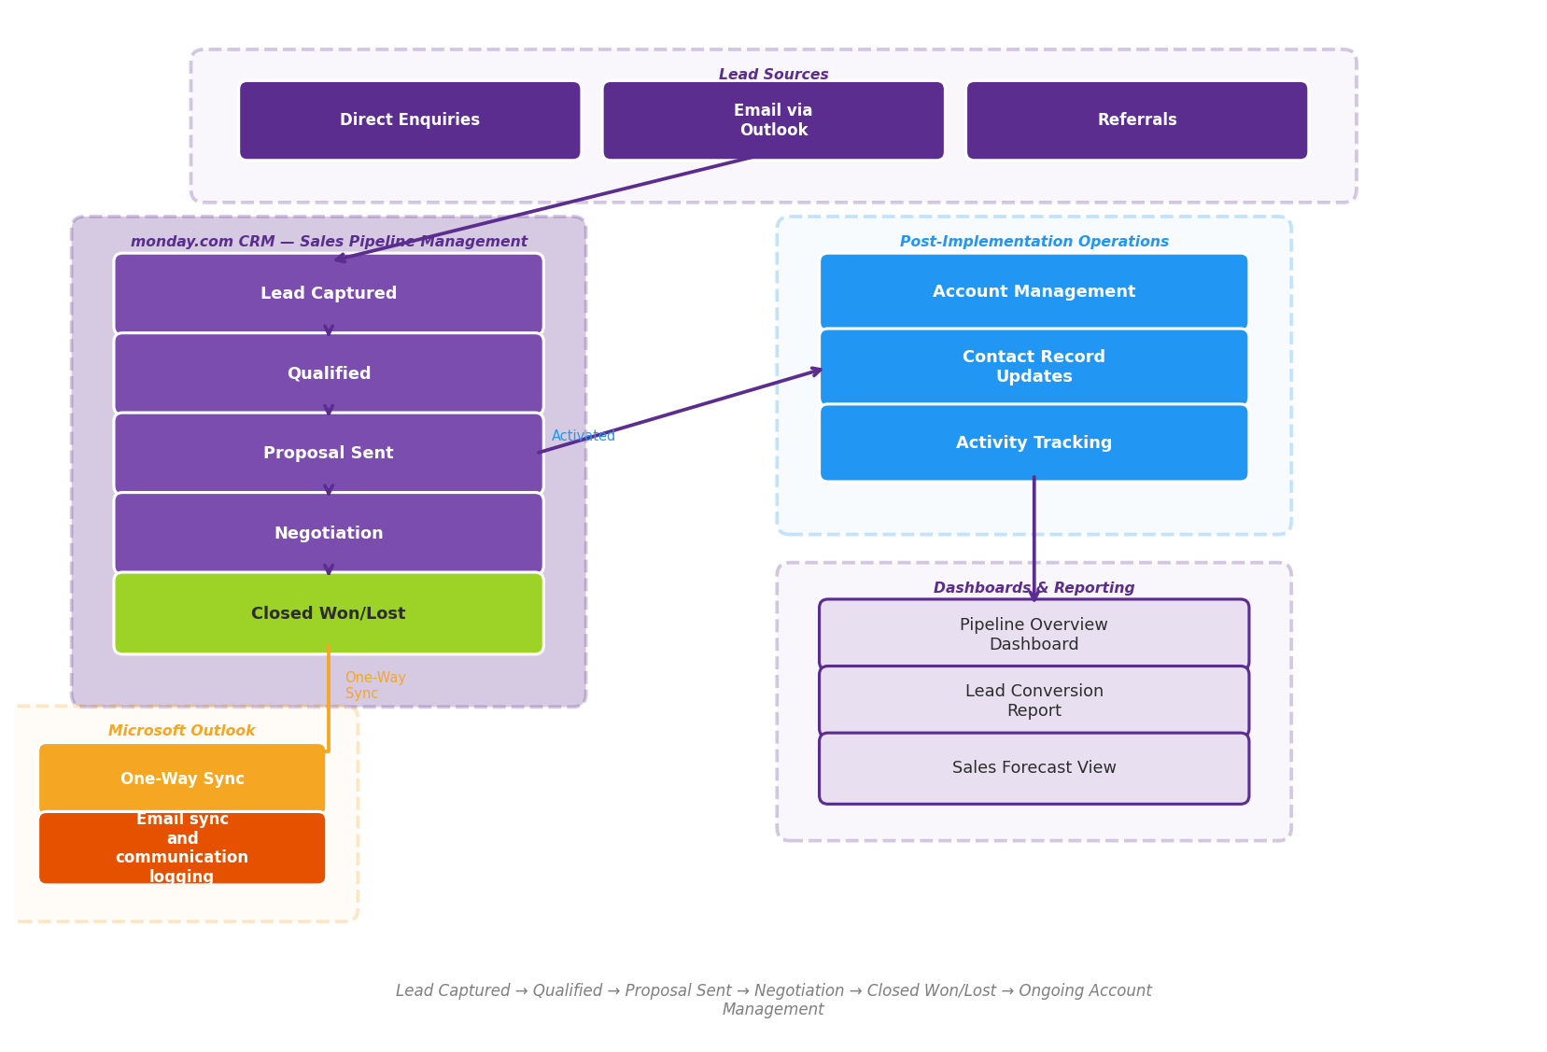
Lead Captured → Qualified → Proposal Sent → Negotiation → Closed Won/Lost → Ongoing Account Management

Phase 1: Discovery & Knowledge Transfer
Hours: 4 Timeline: Weeks 1
Discovery & Knowledge Transfer
This phase establishes a clear understanding of Gulf Rubber's current sales processes, contact management practices, and CRM requirements — ensuring the build phase is grounded in documented, agreed-upon specifications despite the streamlined nature of this engagement.
1. Requirements Gathering & Stakeholder Alignment
• Distribute CRM requirements questionnaire to Patrick — A structured questionnaire will be issued to capture Gulf Rubber's current approach to managing contacts, accounts, leads, and pipeline stages, forming the foundation for all configuration decisions
• Review client-provided documents and meeting transcripts — Nishkarsh Hela will conduct a thorough review of all materials shared by Gulf Rubber, including any existing sales documentation, contact lists, and process notes to identify configuration requirements
• Develop targeted discovery questions — Based on the reviewed materials and questionnaire responses, the Fruition team will prepare focused questions to address gaps and clarify Gulf Rubber's specific CRM workflows during the knowledge transfer session
• Facilitate knowledge transfer session with Patrick — Branson McMahon will lead a scheduled session (Thursday or Friday of Week 1) to walk through Gulf Rubber's sales cycle, lead sources, pipeline stages, and account structures to ensure the CRM build reflects actual business operations
2. Solution Architecture & CRM Blueprint Design
• Map contact and account management structure — Define how Gulf Rubber's contacts and accounts will be organised within monday.com CRM Enterprise, including field definitions, relationship hierarchies, and data categorisation
• Define pipeline stages and lead management workflow — Document the specific stages of Gulf Rubber's sales pipeline and lead qualification process to configure boards that mirror the team's real selling motion
• Scope Microsoft Outlook integration requirements — Identify the specific Outlook integration touchpoints required — such as email logging, contact syncing, and calendar visibility — to ensure seamless connectivity between Gulf Rubber's existing email environment and the CRM
• Establish training board and project plan app framework — Outline the structure for the training board and project plan app to be deployed on Gulf Rubber's monday.com account once access is granted, ensuring the team has clear onboarding resources from day one
3. Agreed Brief & Sign-Off
• Deliver a finalised solution architecture document — Consolidating all discovery outputs into a single reference document covering board designs, field mappings, pipeline configuration, Outlook integration scope, and agreed boundaries for the 30-hour engagement
• Present the brief to Patrick for review and formal approval before proceeding to the CRM Build & Configuration phase, ensuring alignment on deliverables, timeline, and any identified dependencies such as platform access and data availability
• *Phase 1 Summary**
| Detail | Value | |---|---| | Duration | Week 1 | | Allocated Hours | 4 | | Phase Lead | Branson McMahon | | Key Dependency | Timely questionnaire completion and document access from Gulf Rubber |

Phase 2: CRM Build & Configuration
Hours: 20 Timeline: Weeks 2-3
CRM Build & Configuration — Core Sales & Contact Management
This phase delivers the foundational CRM architecture across Gulf Rubber's monday.com environment, establishing structured boards for contact, account, lead, and pipeline management with Outlook integration to support day-to-day sales operations.
1. Lead Management System
• Lead Intake Board — Configure a dedicated Leads board with status stages including New, Contacted, Qualified, Unqualified, and Converted, enabling Gulf Rubber's team to capture and triage inbound interest systematically
• Lead Source Tracking — Set up dropdown and label columns to attribute lead origin (e.g., referral, website, trade show, direct outreach) so Patrick's team can identify which channels drive the most opportunity
• Lead Qualification Fields — Define key data columns including company name, contact person, product interest, estimated value, region, and priority rating to ensure consistent data capture across all users
• Lead-to-Deal Conversion Workflow — Configure a basic automation that moves qualified leads into the Pipeline board upon status change, carrying over core data fields to eliminate manual re-entry
• Outlook Email Integration — Connect Microsoft Outlook to the Leads board so that relevant email correspondence is logged against lead items, giving the team visibility into communication history without leaving monday.com
2. Pipeline Management Board
• Deal Stage Configuration — Build a Pipeline board with clearly defined stages such as Prospecting, Proposal Sent, Negotiation, Won, and Lost, providing Gulf Rubber with a visual sales funnel for tracking active opportunities
• Deal Value & Forecasting Columns — Set up currency columns for deal value, expected close date, and probability fields to enable basic revenue forecasting at a glance
• Stage Movement Notifications — Configure automations to notify assigned team members when a deal moves between stages or when a close date is approaching, keeping follow-ups on track
• Activity Logging — Include a updates/activity log structure within each deal item so notes from calls, meetings, and emails are captured in a single thread per opportunity
3. Contact & Account Management
• Contacts Board — Build a centralised Contacts board with columns for name, title, email, phone, company association, and contact type (e.g., decision maker, influencer, end user) to replace any existing spreadsheet or ad hoc tracking
• Accounts Board — Configure an Accounts board capturing company name, industry segment, account owner, billing region, and relationship status to give Gulf Rubber a structured view of its customer and prospect base
• Board-to-Board Relationships — Establish linked item connections between Contacts and Accounts, and between Accounts and Pipeline deals, so the team can navigate from any record to its related entities in a single click
• Outlook Contact Sync — Leverage the Outlook integration to ensure key contact details remain accessible alongside email workflows, reducing context-switching for the sales team
4. Dashboards & Reporting
• Sales Pipeline Dashboard — Create a primary dashboard for Patrick and the sales team displaying pipeline value by stage, deal count by status, and expected close dates using chart, number, and battery widgets for at-a-glance performance visibility
• Lead Conversion Overview — Build a reporting view showing lead volume by source, conversion rate from lead to qualified opportunity, and average time-in-stage to highlight bottlenecks in the early funnel
• Account & Contact Summary View — Configure a dashboard widget pulling total active accounts, new contacts added, and account owner distribution so management can monitor CRM adoption and data hygiene across the team
• Activity Tracker Widget — Include a widget summarising recent updates and status changes across all CRM boards, giving Patrick a single pane of glass to monitor team activity without drilling into individual items

Phase 3: Testing, Training & Go-Live
Hours: 6 Timeline: Weeks 4
Testing, Training & Go-Live
Phase 3 ensures the monday.com CRM configuration is validated against Gulf Rubber's requirements, the team is trained and confident on the platform, and the system transitions smoothly into daily use.
1. User Acceptance Testing
• Walkthrough sessions — with Patrick to validate all CRM workflows across contacts, accounts, pipeline, and lead management match the agreed requirements documented during Phase 1 discovery
• Integration testing — verify the Microsoft Outlook integration is functioning correctly for email synchronisation and communication tracking within the CRM
• Refinement and adjustments — based on Patrick's feedback, Nishkarsh Hela will action any necessary configuration changes to boards, fields, or views before go-live sign-off
2. Training & Go-Live
• Admin training for Patrick — covering monday.com CRM board management, user permissions, data maintenance, pipeline configuration, and how to modify views and fields as Gulf Rubber's needs evolve
• End-user training for the Gulf Rubber team — focused on daily CRM workflows including adding and managing contacts, updating deal stages in the pipeline, logging leads, and using the Outlook integration for email tracking across up to 5 initial users
• Training boards and resources — dedicated training boards and the project plan app will be configured on Gulf Rubber's account to serve as ongoing reference materials post-implementation
• Go-live support — active monitoring and rapid response from the Fruition team during the first days of live operation to address any immediate issues or user questions
3. Hypercare Period
• 2-week post go-live support — priority access to the Fruition team for bug fixes, minor workflow adjustments, and user queries as Gulf Rubber settles into the platform
• Handover documentation — a system guide covering CRM board structure, pipeline stages, lead management workflows, Outlook integration configuration, and admin procedures to ensure Gulf Rubber can operate independently
• Managed services availability — following the hypercare period, Gulf Rubber can transition to Fruition's ongoing managed services engagement at $500 AUD per month for continued platform support, optimisation, and advisory as CRM adoption matures
• *Phase Duration:** Week 4
• *Estimated Hours:** 6 hours
• *Phase Lead:** Fruition Team (Branson McMahon and Nishkarsh Hela)

Project Deliverables & Timeline
Project Duration: 4 Weeks Total Hours: 30 Hours Initial Users: ~5
Phase | Week | Deliverables | Hours | Responsible
Phase 1: Discovery & Knowledge Transfer | Weeks 1 | Process mapping, board architecture blueprint, agreed brief | 4 | Branson McMahon
Phase 2: CRM Build & Configuration | Weeks 2-3 | Core workflows, automations, integrations, dashboards | 20 | Nishkarsh Hela
Phase 3: Testing, Training & Go-Live | Weeks 4 | UAT, training sessions, go-live support, handover documentation | 6 | Fruition Team
Total | 4 Weeks |  | 30

Investment Summary
Year 1 Investment (AUD)
Item | Cost (AUD) | Notes
monday.com Licensing (5 users) | ~$6,000 | CRM Enterprise license with Monday Vibe and Monday Note Taker included in package
Implementation — Phase 1: Discovery & Knowledge Transfer | $1,000 | 4 hours @ $250/hr
Implementation — Phase 2: CRM Build & Configuration | $5,000 | 20 hours @ $250/hr
Implementation — Phase 3: Testing, Training & Go-Live | $1,500 | 6 hours @ $250/hr
Total Year 1 Investment | ~$13,500 | Licensing + Implementation

Year 2+ Ongoing (AUD)
Item | Cost (AUD) | Notes
monday.com Licensing (ongoing) | ~$6,000 | Annual platform licensing — 5 users
Managed Services (optional) | From $500 / month | Ongoing support, optimisation, new workflows as needed

Notes
• All implementation pricing is based on $250 AUD per hour. This engagement is scoped at 30 hours as part of a preset package, with hours allocated across discovery, build, and training phases.
• Hours are estimated and may vary based on scope refinements during the Discovery & Knowledge Transfer phase. Strict time management will be applied to ensure delivery within the allocated 30-hour budget.
• monday.com licensing — including CRM Enterprise, Monday Vibe, and Monday Note Taker — is billed directly by monday.com and is not included in Fruition's implementation pricing. Licensing costs shown are approximate based on current plan rates; please confirm directly with your monday.com account representative for formal options.
• Any requirements identified during implementation that fall outside the agreed scope — including complex integrations beyond Microsoft Outlook, advanced automations, or custom workflow builds — will be documented and can be addressed through additional engagement or Fruition's Managed Services offering at $500 AUD per month.

Next Steps
1. Proposal Review & Sign-Off — Patrick to review this proposal and confirm the phased approach, scope boundaries, and 30-hour allocation. Written confirmation required before any build work commences.
2. Complete Requirements Questionnaire — Patrick to complete and return the requirements gathering questionnaire provided by Branson McMahon, covering contact management workflows, pipeline stages, lead sources, and account structures currently in use at Gulf Rubber.
3. Schedule Knowledge Transfer Session — Branson McMahon and Patrick to confirm the knowledge transfer meeting for Thursday or Friday of this week. This session is critical to align on CRM requirements and will consume hours from the 4-hour Discovery allocation.
4. Grant Platform Access — Patrick to provide Fruition with administrative access to the Gulf Rubber monday.com workspace so that Nishkarsh Hela can set up the training board and project plan app ahead of the build phase.
5. Prepare Existing Data & Documentation — Patrick to compile any existing contact lists, account records, pipeline data, and lead tracking spreadsheets currently in use at Gulf Rubber. These will inform the CRM board structure and data migration approach during Phase 2.
6. Confirm Microsoft Outlook Integration Requirements — Patrick to identify the Outlook accounts and mailboxes that require integration with monday.com CRM, and confirm IT permissions are in place to enable the connection.
7. Fruition Internal Preparation — Upon sign-off, Nishkarsh Hela will review all client-provided documents, meeting transcripts, and questionnaire responses, then develop the internal solution architecture document for Patrick's approval before build commences in Week 2.

Project Team Contacts
Fruition Services Services | Gulf Rubber
Yash  contact@fruitionservices.io  +1 (555) 000-0000 | Patrick — Key Stakeholder / Decision Maker  Branson McMahon — Project Lead / Solutions Architect  Nishkarsh Hela — Implementation Consultant

Future Phase Opportunities
1. Advanced Sales Automation & Workflows — Introduce automated deal progression, follow-up reminders, and notification triggers within the monday.com CRM to reduce manual pipeline management effort and accelerate Gulf Rubber's sales cycle.
2. Microsoft 365 Ecosystem Deep Integration — Extend beyond the current Outlook integration to connect SharePoint, Teams, and OneDrive with monday.com, giving Patrick's team a unified communication and document management layer across the CRM and Work Management platforms.
3. Manufacturing Order & Quote Management — Build a custom quoting and order tracking workflow within monday.com Work Management that links directly to CRM accounts and deals, enabling Gulf Rubber to manage the full customer lifecycle from lead through to fulfilment.
4. Executive Reporting & Sales Dashboards — Deploy interactive dashboards tailored for Gulf Rubber's leadership team, providing real-time visibility into pipeline health, conversion rates, and revenue forecasting without reliance on manual reporting.
5. AI-Powered Lead Scoring & Prioritisation — Leverage monday.com's AI capabilities to automatically score and rank incoming leads based on engagement history and account attributes, helping the sales team focus effort on Gulf Rubber's highest-value opportunities.
6. Multi-Site & Regional Expansion Rollout — Scale the CRM and Work Management configuration across additional Gulf Rubber locations or business units, with role-based permissions and region-specific pipelines to support operational growth.
7. Ongoing Managed Services & Optimisation Programme — Engage Fruition's managed services retainer to provide continuous platform health checks, user support, and iterative enhancements, ensuring Gulf Rubber's monday.com environment evolves with the business beyond initial go-live.

FRUITION INTRODUCTION
monday.com Advanced Implementation and Integration Partner. Trusted by 600+ Private and Public organisations globally.
As a certified monday.com partner, we bring deep expertise to every implementation. We begin by listening carefully to understand your unique needs and objectives, then collaborate with you to design solutions that fit seamlessly into your workflows.
Our experienced team guides you through each phase, maintaining clear communication and delivering on time and within budget. Beyond implementation, we provide ongoing support to ensure your continued success.
At Fruition, we measure our success by yours — building lasting partnerships that help your business thrive.

