$oft ₵orp

ICU Patient Management System

Project Report
For The Development Of A
Critical Care Software

CIS 4374-19257
Professor Dobretsberger
Kevin Zavala
05/01/2026
$oft ₵orp
Proposal for Standalone Hospital ICU

Table of Contents
Project Kickoff 4
Research: 4
Market Research: 5
Project Acquisition 6
Project Overview: 6
Software Requirements Specifications (SRS) 7
Introduction 7
Overall Description 7
Functional Requirements 7
Non-Functional Requirements 9
Use Case 10
User Story 11
WBS & Schedule 14
WBS for ICU patient management system 14
Timeline 17
GANTT Chart 19
Backlog & Sprints 21
Identify and List Risks – 24
Technical: 24
Schedule: 24
Financial: 24
People: 25
Risk Register 26
Communication Plan 28
Resource & Cost Management 30
Roles & Resources: 30
Resource & Cost Plan 32
Resource Plan 32
Cost Plan (Bottom-up) 33
RACI matrix 34
Cashflow Table 35
Stakeholder Analysis 36
Project Charter 37
Team Charter 38
Closure Report & Maintenance Proposal 39
Proposal for Maintenance Contract 41
Reference Page 42

Project Kickoff
Project: ICU Patient Management System
Company - $oft ₵orp
02/05/2026

Research:
From what can currently be found on the ‘what already exists’ standpoint is that there are about three different categorized types of software that are/could be used in ICU patient management systems.
- Hospital-Wide EHRs
  - These types of systems are a singular software that is used throughout the entire hospital, ensures seamless data sharing and stability.
  - Uses modular parts for specific usages within the hospital, so the ICU use their own module which will contain a more specific setup for their patient management system.
  - Examples: Epic (have been told this is like the Cadillac of EHRs), Orcale Health
- Specialized ICU Systems
  - These systems are fully built revolving the needs and wants of complex protocols/high-stake environments revolving the ICU department.
  - Requires bridging to the rest of the current hospital systems so that data may be shared to other departments of the hospital, so a need for compatibility with potentially older hardware and software systems.
  - Examples: iMDsoft (MetaVision), Philips (ICCA)
- Generic/Legacy Systems
  - These types of systems are out of date for modern medium-to-large hospitals and are essentially reliant on constant monitoring and manual data input from nurses. These systems are more likely to be found in very small hospitals that have low funding.
  - Only hold records that must be manually input so no automatic vital monitoring occurs, which is crucial for an ICU patient management system.
  - Examples: Meditech (older versions), SimplePractice.
Looking through case studies and research with conducted surveys, many systems still feel very clunky, overwhelming, are manual input reliant, and require too much navigating to see necessary vitals. Using survey studies that have been conducted in the last couple of years to catch issues and complaints with current patient monitoring systems and using current technology advancements, $oft ₵orp will develop an in-house system built truly for an ICU workflow while still integrating with current EHRs. This new system will have close to real-time updates on all vitals (from ICU devices that can port raw data) onto a dashboard screen with alerts and trends, visual and audible alerts using intelligent communication technology, unit level configuration, and an optimized UX.

Market Research:
Our system will be better as it is completely catered to the wants and needs of the hospital while still providing a combination of the best (and most needed) aspects of other software systems, such as real-time data streams for patient vitals, unique configuration of ICU dashboards while maintaining essential vitals on-screen, zero-downtime, an optimized UX to combat alert fatigue, integration with current medical devices and hospitals current EHR, customizable and configurable protocols, remote monitoring, and many more smaller features that helps bring together a precise and intuitive system to a critical setting.
Major ICU Software Systems –
iMDsoft MetaVision | A patient data management system for ICUs that generates minute-by-minute EMRs. Works with integrating with hospital information systems and medical devices.
Picis Critical Care Manager | An ICU system that automates workflows for ICUs. Captures near real-time data, offers customizable protocols, and is capable of records integration.
Philips eCareManager | An eICU enterprise solution to support and monitor 50-500 remote ICU beds. Uses AI algorithms to predict patient deterioration and provides actionable insights for care.
Ambient Clinical Solutions | Offers Software as a Medical Device for remote patient monitoring and virtual ICUs. Real time point-of-care data visualization and supports clinical decisions.

Project Acquisition
$oft ₵orp acquired an RFP from a medium sized hospital after talks and initiations began at a regional medical-tech convention, they approached us at the team’s booth that was set up presenting ICU/EHR workflow prototypes and the hospitals team were interested since they have an outdated and fragmented system. At $oft ₵orp we specialize in working with clinical information systems that are specifically designed based on the needs and wants of clients (hospitals, clinics, healthcare) while also implementing ideas from case studies with conducted surveys and research from around the world. Our teams are filled with experts that have diverse knowledge and experience working with and supporting complex data environments. Our goal is to always create a more intuitive streamline workflow allowing close to real-time data being always available and to help enhance decision making for care teams through monitoring solutions, device integration, UX and clinical dashboards.

Project Overview:
Goal - Deliver an ICU patient management system for a single standalone hospital ICU that will unify ICU device data into a platform that will present alerts and trends, integrate data with the rest of hospital systems, improving efficiency in the workflow while reducing manual transcriptions.
Scope Outline
- ICU monitoring system not EHR replacement
- ICU device integration ~ device raw data to readable to hub
- Data integration to rest of hospital EHR systems – read only EHR
- Big data for alerts and trends – potential use for Intelligent Technology
- ICU vital reports
- Web-based ~ Intranet

Software Requirements Specifications (SRS)
Project: ICU Patient Management System
Version: 1.0
Date: 02/05/2026

Introduction
Purpose: This document defines the requirements for the ICU Patient Management System that will be developed, by $oft ₵orp, for a standalone hospital’s ICU. This system will be created to cater to the ICU care team after surveying and interviewing is done, ultimately providing a unified real time view of patient vitals (through integrating data streams from ICU devices) which will have triggers on alerts and trends within those vitals. This new system is intended to enhance ICU response times, decision making, reduce manual transcriptions, and of course improving patient safety.
Scope: The system will allow doctors and nurses to monitor, capture, enter, and evaluate vital patient data ensuring patient safety. Improving on the outdated system, the new system will provide visual and audible alerts, trend analysis, and daily ICU vitals reports as well as integrating with the rest of the current hospital information systems.

Overall Description
  - Users: ICU doctors, ICU nurses, hospital IT, MTAs, ICU Control Center
  - System Environment: Web-based application based on the hospitals intranet, will be supported by nursing terminals and tablets.
  - Constraints: Must be compatible with older hardware and work with current implemented software, must have high availability.
  - Assumptions: Hospital will have network access (and intranet), device integration endpoints are available, hospital has backup power supply available.

Functional Requirements
- FR1: System shall support secure authentication for ICU staff and enforce role-based access control.
- FR2: The system shall allow users to add patients.
- FR3: The system shall display live vital updates for ICU patients through a middleware integration layer.
- FR4: The system shall generate a daily vitals report.
- FR5: The system will provide visual and audible alerting with severity levels and configurable thresholds for trends and vital changes.
- FR6: The system will display real-time visualization and patient history views for configurable time ranges.
- FR7: The system will give visual and audible alerts for trends and severe vital changes.
- FR8: ICU control center can configure dashboards/thresholds
- FR9: The system will show trend visualization and have access to patient-level history views.
- FR10: The system will allow manual entry override.
- FR11: The system will allow users (nurses) to personalize their dashboard widget vital order (per patient), while some defined ICU policy (vitals cannot be deleted, etc.).
- FR12: The system shall display device connectivity status and indicates when device streams are interrupted.
- FR13: The system shall generate daily ICU vital reports and support exports to PDF or CSV format.
- FR 14: The system shall display a unit-wide overview dashboard showing all ICU beds and patient status indicators.
- FR 15: The system shall allow ICU Control Center administrators to assign and reassign patients to nurses based on shift schedules
- FR16: System shall support ICU bed management including registering beds and associating devices with each bed.
- FR17: The system shall allow authorized staff to acknowledge alerts and record the responding user and timestamp.
- FR18: the system will require confirmation that a patient is assigned to a bed before device vitals begin streaming.
- FR19: The system shall generate a ‘Shift handoff report’ that aggregates critical vitals and nurse notes from the previous 12 hours to facilitate safe bedside transitions.
- FR20: The system shall provide a hands-free interface for nurses or doctors to record bedside observations directly into the patient record using secure speech-to-text APIs.
- The system shall detect cloud connectivity interruptions and automatically switch to the Local Edge Server to maintain continuous monitoring without user intervention needed.
- The system shall support tiered administrative access (will be assigned per employee access) for maintenance staff to access architecture diagrams, runbooks and audit logs.
- The system shall provide a read-only view of patient information from outside the ICU ward via the EHR bridge for historical context.
- The system will collect and report real-time telemetry on feature usage and system health to identify performance bottlenecks.
- The system will include an interactive ‘onboarding wizard’ for new clinical staff to reduce the manual training burden on the project team.
- The system shall support a continuous update model to deploy security patches improvements without a full system restart.
- The system shall provide a self-service knowledge base for clinicians to troubleshoot common UI issues and ‘Alert Fatigue’ settings independently.
- The system shall provide authorized support staff with access to digitized ‘Runbooks’ for step-by-step remediations of known technical issues.

Non-Functional Requirements
- NFR1: The system shall provide 99.99% uptime.
- NFR2: The system shall support at least 1,000 concurrent users.
- NFR3: The system shall update certain values (vitals) within 1 second.
- NFR4: Alerting will be configured to minimize noise pollution but still preserving critical alerts.
- NRR5: All patient data transmitted between devices, servers, and user interfaces shall be encrypted using industry standard protocols.
- NFR6: Data will be stored in short-term, then moved to summarized long-term archives.
- NFR7: The system shall comply with HIPAA regulations for the protection of patient health information.
- NFR8: The system shall support multi-factor authentication using hospital badge authentication and passkey verification.
- NFR9: All user actions involving data access, configuration changes, or alerts shall be logged for auditing purposes.
- NFR10: The system shall support disaster recovery and restore operations through batteries until hospital generators maintain power.
- The architecture shall support a minimum of 50 concurrent tablet connections per local ward without degrading vital refresh rates.
- The system will remain operational via hardware UPS (batteries that must be maintained once at a 6-month period) and hospital generators during a total facility blackout.
- Short term high-resolution data must be stored for 72 hours before being moved to a summarized long-term archive for audit purposes.
- The system shall adhere to a contractual Service Level Agreement of 99.9% availability for the primary monitoring dashboard.
- The system will detect and log critical hardware disconnects or data interruptions within 60 seconds.
- The system architecture will use a microservices approach to allow scaling to other hospital departments without impacting ICU performance.
- The system will automatically generate a detailed ‘Incident Log’ for every critical failure to support the creation of blameless reports.

Use Case
Title: Configuring ICU alert threshold
Actor: ICU Control Center Admin
Precondition: User is authenticated for configuration privileges
Steps:
- Admin opens the ICU configuration panel.
- Admin selects a vital to configurate (preset of vitals allowed will be shown).
- Admin defines the threshold ranges for the severity levels (green, light orange, dark orange, red).
- Admin can configure alert escalation rules (only a visual for a warning like green to light orange or light orange to red and audible cue for critical).
- Admin confirms and saves the configuration.
- System validates the configuration and applies to all active ICU dashboards.

Postcondition: The new thresholds and alert rules are active for the ICU unit. Vitals will now be evaluated against the updated thresholds. Changes made will be logged for audit.

User Story
- “As a nurse, I want to see all my assigned patients’ vitals selectable on one screen to quickly view vitals.”
Acceptance Criteria: Unified dashboard will show assigned patients, clicking one will show live vitals within 2 seconds.
- “As a physician, I want to view trends over time to assess improvements or if health has been deteriorating.”
Acceptance Criteria: Trend charts show last 24 hours to 72 hours, will be configurable.
- “As an ICU Control Center admin, I want to assign and reassign patients to nurses by shift, so match staffing changes made”.
Acceptance Criteria: Elevated privileged users (admin) have the authority to create/edit assigned nurses with start/end times, and changes will appear immediately on nurses’ dashboards.
- “As a nurse, I want to view all key vitals for a selected patient in on one dashboard to monitor deterioration for specific vitals.”
Acceptance Criteria: Dashboard updates within the defined performance target
- “As an ICU Control Center Admin, I want an overview display that can monitor ICU status across multiple beds”
Acceptance Criteria: Overview option shows all ICU beds with severity indicators and highlights any critical alerts
- “As a nurse, I want to confirm that a patient is linked to the correct bed before vitals stream so I can prevent wrong or no data being sent to the system”
Acceptance Criteria: Bed shows inactive status until confirmation of a patient to selected bed.
- “As a hospital IT, I want to register ICU beds and device identifiers so that data streams appear as inactive until a patient is assigned”.
Acceptance Criteria: Beds will be connected to devices, system will validate devices, bed with devices will appear and can be configured to a number (bed #1, etc.).
- “As a control center admin, I want to see device connection status, so I know whether vitals are current.”
Acceptance Criteria: Dashboard will show connected/inactive/interrupted status as visible indicators. Patients will have to be confirmed onto beds or discharged otherwise interrupted will appear.
- “As a nurse I want visual and audible alerts based on severity so I can respond appropriately”.
Acceptance Criteria: The system will show alerts for a ‘warning’ with optional soft cues, and urgent alerts with an urgent tone. This will be configurable dependent on Hospital ICU policy.
- “As an ICU control center admin, I want to configure thresholds and escalation rules, so alerts match the ICU protocols.”
Acceptance Criteria: Admin once logged in, has authority to set thresholds per vital and define which severities cause visual and audible triggers. Will be logged.
- “As a nurse, I want to acknowledge an alert, so the care team knows someone is responding”
Acceptance Criteria: Nurse on their device will be able to acknowledge alerts occurring and will be received to Control Center with user and time.
- “As a doctor, I want to view the vital trends that have occurred over the last two days to evaluate effectiveness of medicine”.
Acceptance Criteria: There will be a specific are to access trends on the system with time frames, for doctors or nurses once logged in, that are configurable to a certain extent – short term records so there is not an overwhelming amount of data being stored at once for many different patients.
- “As a nurse, I want to manually enter a vital because a device is unavailable but patient monitoring needs to continue.”
Acceptance Criteria: The user can manually enter/override any specific vita through the system, but entries are marked and timestamped to that specific user with original values preserved.
- “As a doctor I want to see key patient information from the hospitals system”. (data from potentially the ER before transfer or follow up on another floor)
Acceptance Criteria: User may find specific patient data with a name, can be filtered further by date of birth.
- “As an ICU nurse lead, I want a daily vitals report so that I can review patient status and how a unit is performing.”
Acceptance Criteria: User (maybe with authorization needed) may be able to generate reports per patient or per unit and exported to PDF/CSV.

- “As a nurse I want to reorder and pin vitals widgets to prioritize the most critical information per that patient” (A patient is experiencing low blood pressure, wants to prioritize that in view)
Acceptance Criteria: User will be able to move around vital widgets with a drag and drop method to reorder per patient, there will be an ICU policy where some vitals must remain in a most obvious spot still.
- “As hospital IT staff, I want to configure ICU beds and connected devices so that the monitoring system reflects the real ICU layout.”
Acceptance Criteria: Beds and devices can be registered and mapped.
- “As a control center admin, I want to be notified when a device stops sending data so that technical staff can respond quickly.”
Acceptance Criteria: System displays device disconnect alerts and timestamps the interruption.
- “As an ICU doctor, I want to view key patient information from the hospital EHR so that I can understand the patient's history and treatment context.”
AC: Systems retrieves read-only patient information from the hospital EHR.
- “As hospital IT staff, I want the monitoring system to remain operational even during network disruptions so that ICU staff can continue monitoring patients.”
AC: System maintains a local cache for recent vitals, which can also be accessed if the network temporarily fails.
- “As an ICU Control Center Admin, I want a wall-display mode that aggregates all bed statuses on a single screen so I can triage emergencies across the entire unit”
- “As a Maintenance Specialist, I want access to system ‘Runbooks’ in the dashboard so I can follow a step-by-step procedures during a technical incident.
- “As an ICU Physician, I want to use the “Heartbeat Service” to set a custom alert threshold for specific patients so I am only notified for clinically relevant changes.
- “As a Support Developer, I want a blameless report generated after any system outage to identify the root cause and prevent recurrence.”
- “As an ICU nurse lead, I want to review Service Level Indicators for the Heartbeat Service so I can verify the system is meeting its performance targets during my shift.”
- “As a UX Designer, I want to analyze telemetry data to see which dashboard widgets are ignored by nurses, so I can refine the UI to prevent Alert Fatigue.”
- “As a Hospital Executive, I want quarterly reports on the ROI and system adoption metrics to justify the long-term maintenance budget.”
- “As a support specialist, I want a centralized status page to monitor the health of the EHR Bridge so I can proactively alert the dev team before clinicians notice a sync delay.”

WBS & Schedule
Create WBS for ICU App & Draft timeline w/ Gantt Chart

WBS for ICU patient management system
The extra details are meant to gain a broader understanding of what task is required.
- Frontend
  - ICU Dashboard
    - Unit overview dashboard as default (shows all beds, active or inactive – can view any patient from this view as well)
    - “My Patients” view – based on nurse role and shows their assigned patients, can view all patients assigned or not in the default overview (1.1.1)
    - Patient detail dashboard – will show live vitals for selected patient and can add/edit/view notes, all shown in one dashboard.
    - Control Center management panel – elevated role access required, where patients are assigned and configuration can occur.
  - Visualization UX
    - Severity indicators – color & icons levels
    - Trend visualization – time ranges set for trends available
    - Dashboard personalization – in dashboard default (1.1.1) can view ‘all active’ or ‘all inactive’, and patient details (1.1.3) can reorder/pin vitals (some cannot be moved *or will always be in plain sight* that are deemed to be too important to move according to hospital policy).
    - Wall display mode
  - Reporting UI
    - Daily clinical summary view – per patient, this will typically be an overnight report showing progress and delivered as a morning report to doctors/nurses.
    - Shift handoff report view – and important notes and vitals to note as shift changes
    - ICU unit operations report view – report over the whole ICU
    - Inter-unit summary view – report for patient information outside the ICU
    - Export Controls – format of reports received (PDF/CSV/ etc.,)
  - Patient & Device Management UI
    - Add/Search patients – admit new patients to ICU/link to existing, additional notes can be added here.
    - Patient Reassignment – if patient needs to move to another bed
    - Add/Register new devices to beds
    - Patient-bed confirmation UI (activate/deactivate device data streams)
  - Authentication UI (Login Screen)
    - Login Screen – requires username and passkey
    - To confirm passkey required hospital Badge Tap – 2FA
    - 2FA error handling
- Backend
  - Authentication & Access Control
    - Secure login – Badge Tap + Passkey
    - Session management – if no activity for a set amount of time, re-login is required
    - Role-based access control – specific access depending on the users
    - Access logging and audit trails
    - 2FA verification service – badge tap + passkey
  - Patient & Shift Management
    - Patient search and lookup services
    - Add/link patients to ICU beds
    - Shift-based assigning management – create/edit assignments
  - Device Integration & Streaming
    - Bed/Device Registry
    - Patient-bed confirmation workflow – data is flowing
    - Real-time vitals integration, normalization, validation
    - Device connectivity status and data interruption detection
  - Alerts & Rules
    - Threshold configuration (elevated access role required)
    - Alert evaluation – severity levels
    - Audible/visual escalation rules
    - Alert acknowledgement tracking – alert must be confirmed
  - Hospital System Integration
    - Patient context – EHR information
    - Near real-time refresh handling for EHR updates
    - Data mapping and validation
  - Reporting & Data Management
    - Daily report generation services
    - Event summaries – will contain trends, alerts, acknowledgements
    - Data retention – temperature summaries
  - Data Layer (Databases) – Some will be combined into the same server
    - Vitals time series storage
    - Device registry and bed mapping
    - Alerts, events and audit logs
    - Reporting storage
    - Patient Information
    - Login Verification Credentials
- Post-Implementation & Operations
  - Support Model & Tiered Access
    - Tier 0 Setup: Creation of self-service knowledge base and “Onboarding Wizard” for clinical staff.
    - Tier 1-2 Helpdesk Integration: Training hospital IT staff on basic troubleshooting and dashboard navigation.
    - Tier 3 Developer On-Call: Establishing the rotation schedule for senior developers to handle critical failures.
  - Maintenance & Security Management
    - Implement a continuous update model to deploy security patches without system downtime.
    - Scheduling quarterly penetration tests and HIPAA compliance reviews.
    - Setting up configuration management to allow for rapid server recovery in case of a disaster.
  - Observability & Incident Response
    - Monitoring system health, SLIs, and user engagement to identify problematic UI elements.
    - Digitizing step-by-step procedures for common technical incidents.
    - Formalizing a root cause analysis procedure for any system-wide outages.

Timeline
Story Points Method
Phase 1: Foundation – Identity, Security, & Data
WBS # | Task Name | Start | End | Duration
2.7.1 - 2.7.6 | Data Layer (All Databases) | Week 1 | Week 5 | 5 Weeks
2.1.1 – 2.1.3 | Secure Login | Week 3 | Week 8 | 5 Weeks
1.5.1 | Login Screen UI | Week 5 | Week 7 | 2 Weeks
2.1.5 | 2FA Verification | Week 6 | Week 9 | 3 Weeks
1.5.2 – 1.5.3 | Badge Tap & 2FA UI | Week 7 | Week 10 | 3 Week
2.5.1, 2.5.3 | EHR & Data Mapping | Week 4 | Week 11 | 7 Weeks
Quality Assurance - 1 | Testing - Security | Week 11 | Week 12 | 2 Week

Phase 2: Core Engine & Data Streaming
WBS # | Task Name | Start | End | Duration
2.3.1 – 2.3.2 | Bed/Device Registry | Week 13 | Week 15 | 2 Weeks
2.3.3 – 2.3.4 | Vitals Integration | Week 14 | Week 20 | 6 Weeks
1.1.1, 1.1.3 | Unit Overview & Patient Dashboard | Week 16 | Week 22 | 6 Weeks
1.1.4 | Control Center UI | Week 19 | Week 22 | 3 Weeks
1.4.3 – 1.4.4 | Device Registration & Bed Confirmation UI | Week 17 | Week 21 | 4 Weeks
QA - 2 | Stress Test | Week 22 | Week 24 | 2 Weeks

Phase 3: Clinical Logic & Operations
WBS # | Task Name | Start | End | Duration
2.4.1 – 2.4.4 | Alerts & Rules Engine | Week 25 | Week 30 | 5 Weeks
2.2.1 – 2.2.2 | Patient Search & Linking Service | Week 25 | Week 28 | 3 Weeks
1.2.1 – 1.2.4 | Visualization UX | Week 26 | Week 32 | 6 Weeks
1.4.1 – 1.4.4 | Patient & Device Management UI | Week 27 | Week 30 | 3 Weeks
2.2.3 | Shift Assignment Logic | Week 29 | Week 32 | 3 Weeks
1.1.2 | “My Patients” View | Week 31 | Week 34 | 3 Weeks
QA – 3 | Clinical Logic Validation | Week 34 | Week 36 | 2 Weeks

Phase 4: Reporting
WBS # | Task Name | Start | End | Duration
2.6.1 – 2.6.3 | Reporting Services | Week 37 | Week 42 | 5 Weeks
2.5.2 | Refresh Handling | Week 38 | Week 41 | 3 Weeks
1.3.1 – 1.3.5 | Reports UI | Week 40 | Week 44 | 4 Weeks
2.1.4 | Access Logging & Audit | Week 42 | Week 44 | 2 Week
 | User Acceptance Testing | Week 44 | Week 47 | 4 Weeks
 | Soft Launch | Week 48 |  | Potential Final

Phase 5: Maintenance
WBS # | Task Name | Start | End
3.1 – 3.3 | Support Model Setup | Week 49 | Week 53
3.2.1, 3.2.3 | Maintenance & Security | Week 53 | Week 104
3.2.2 | Quarterly HIPAA Compliance Reviews | ~ | ~
3.3.1 | Constant Monitoring | Week 53 | Week 104
3.3.2, 3.3.3 | Incident Response | Week 51 | Week 54

GANTT Chart
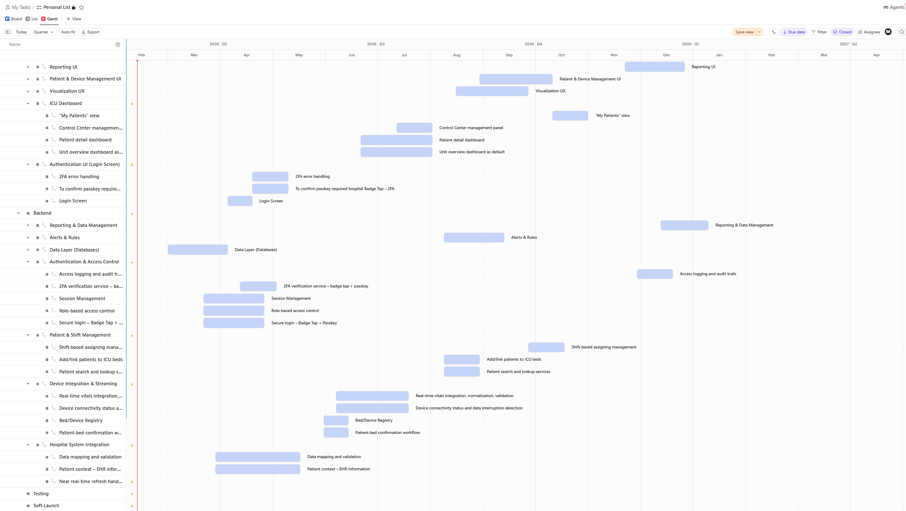
Without Proposed Maintenance After Deployment

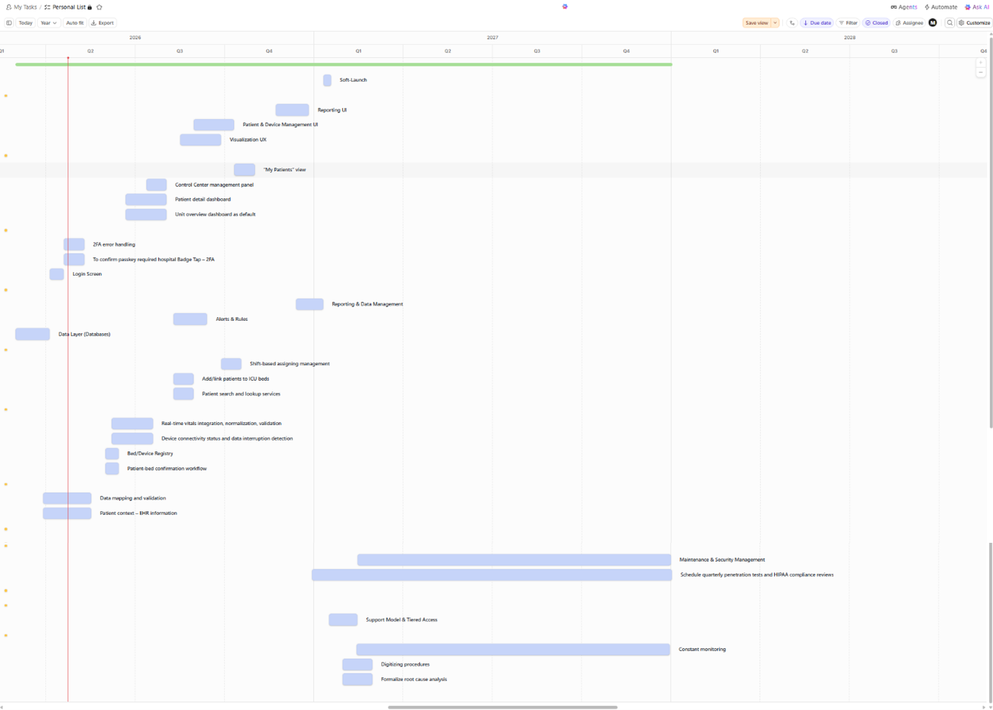
With Proposed Maintenance After Deployment

Backlog & Sprints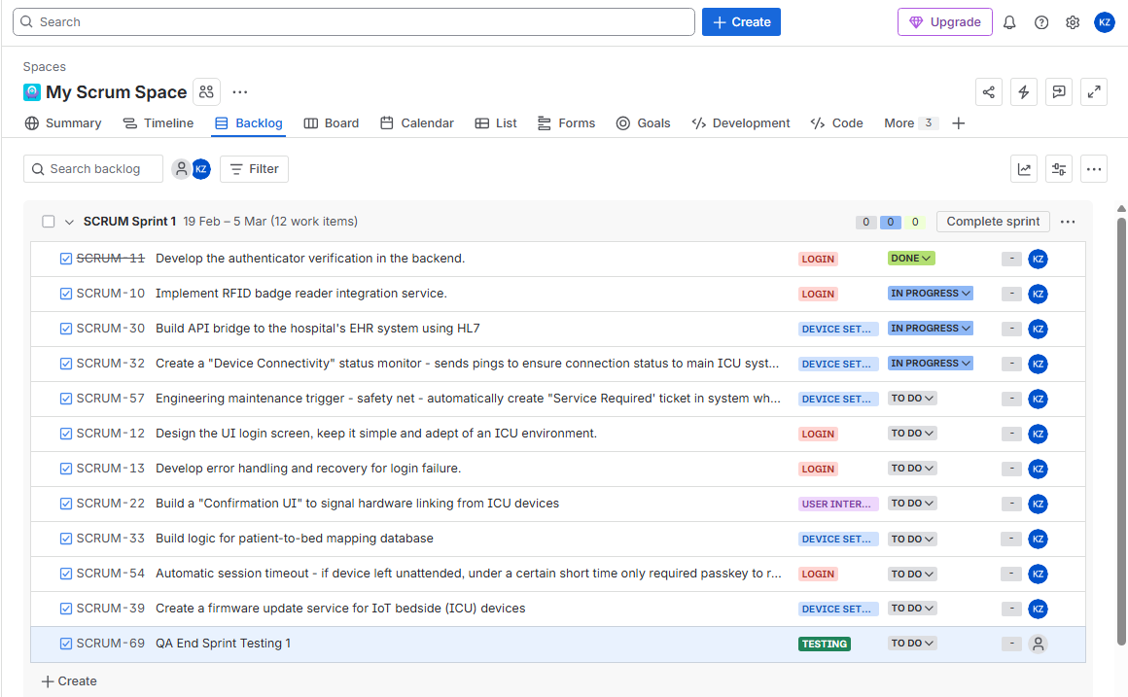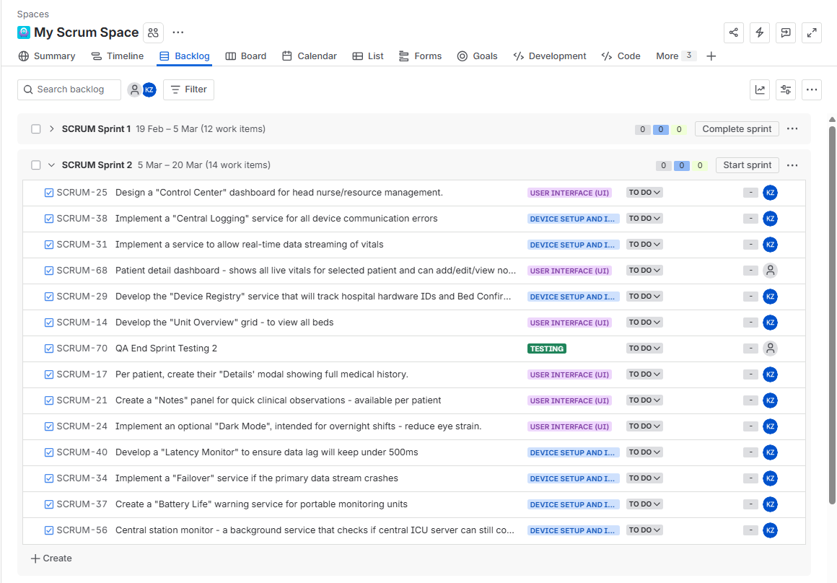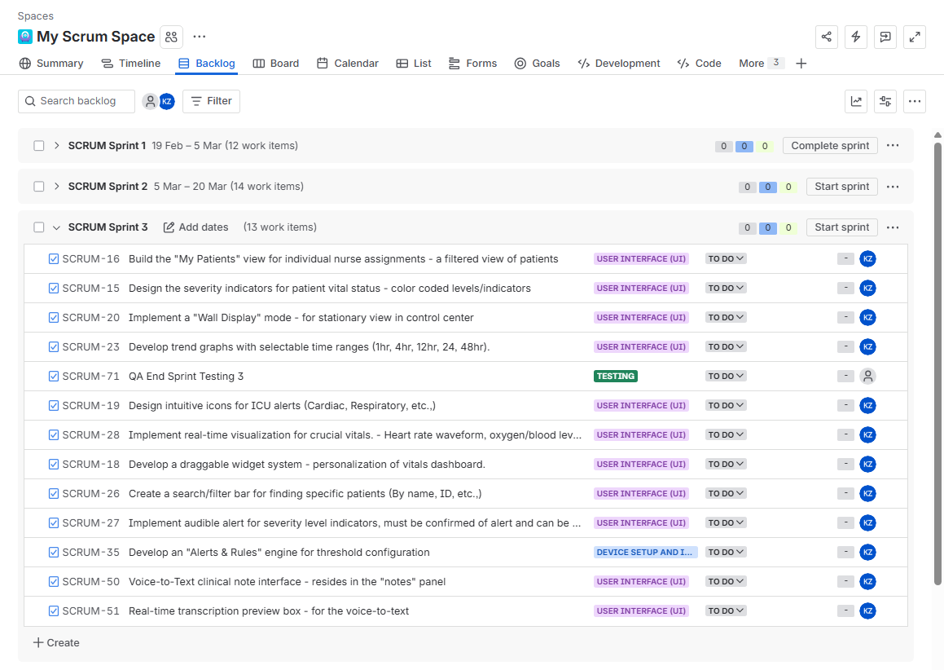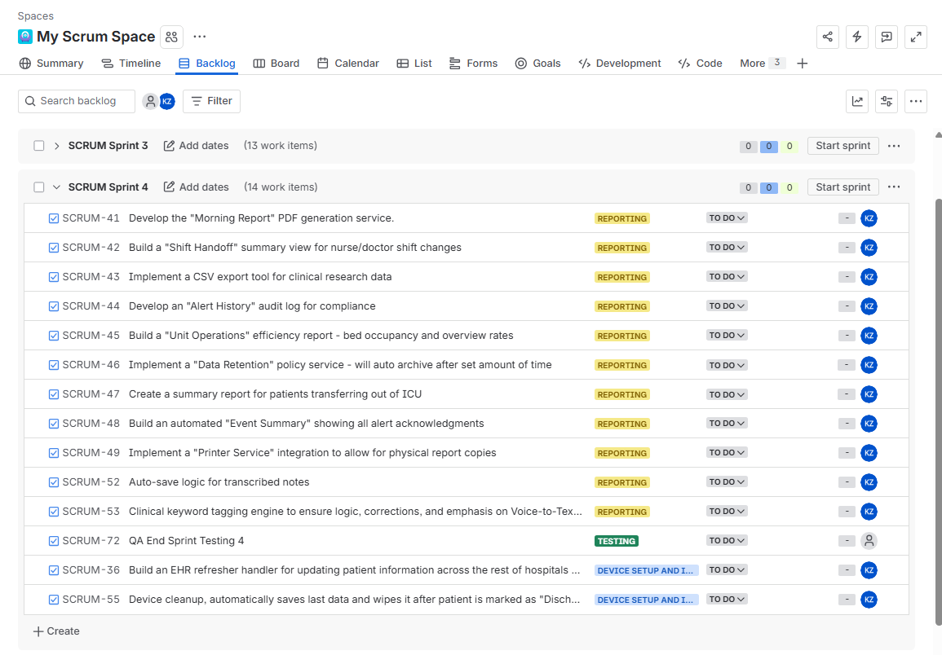
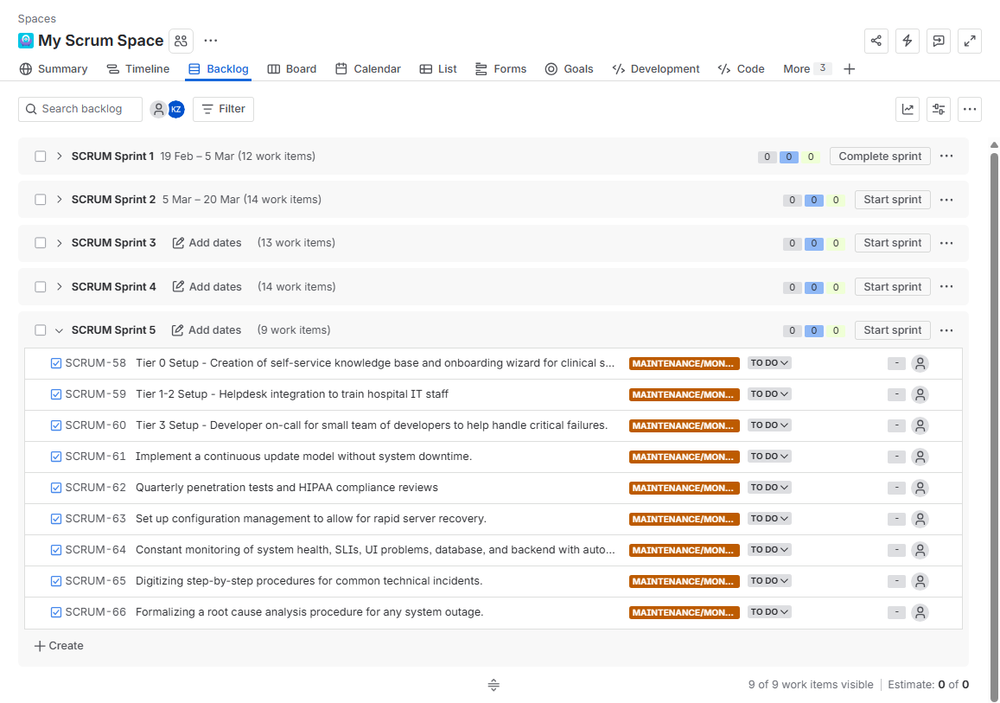
Risk Management & Communication

Identify and List Risks –

Technical:
1. Vitals Data Latency – ensure data from ICU devices are streaming vitals correctly and without a certain latency limit.
2. Legacy API Incompatibility – Hospital updates EHRs could pose potential problems with our systems integration.
3. Ghost Data – ICU devices could fail to disconnect and restart vitals, leaving previous patients vitals still visible.
4. Patch Deployment Regression – Automated security patches could potentially break clinical logic leading to ‘silent failures’ in monitoring.
5. Observability Blind Spots – If not configured correctly, the support team might miss ‘intermittent’ data issues until a clinician reports them manually.

Schedule:
1. Hardware Shipping – Specialized ICU-grade devices that are required can take time to be gathered and shipped which can cause delays especially for the ‘Device Setup’ phase (one of the early phases for the project).
2. High-Priority Bugs - throughout the whole development, different bugs have the potential of arising which will cause delays especially on how complex they can be requiring too much time – this will halt other developments until this can be resolved.
3. Scope Creep – The hospital (nurses/clinicians) request some major changes could cause scheduling issues through discussions, more meetings, and implementing changes.
4. Incident Response Lag – Outdated or overly complex ‘runbooks’ could result in a Mean Time to Repair that exceeds targeted time.
5. Audit Bottlenecks – Delays in the first quarter HIPAA review could halt feature updates or patching cycles until compliance is re-verified.

Financial:
1. Cloud Storage Budget – a potential risk is the expensive of using cloud storage to store high-resolution vitals data for a medium sized ICU which can exceed the monthly budget if too much data occurred too quickly.
2. Hardware Procurement Spike – An unforeseen global supply chain issue or shortages on technology/hardware that is used for ICU devices could cause a significant margin in increased prices.
3. Licensing Fees – Trough third party providers for certain services being used can potentially increase their prices mid-project which will need reallocation of the budget, which can hinder the needs of other components.
4. Technical Debt – a high-velocity sprint or attempting to develop too quickly can potentially cause a spiral of mistakes which will cost more time and money.
5. Maintenance overrun – unexpected third-party API price hikes or high cloud data costs during the maintenance year could exhaust operating budget.
6. Contractual penalties – failing to meet the 99.9% uptime SLA could trigger financial penalties defined in the hospital’s maintenance contract.

People:
1. Communication Silos – the culture of the current hospital or the project team members can be a very isolated type causing a lack of coordination which can cause a breakdown of communication channels, which can cause major issues with the development of the project.
2. Team Turnover – team members leaving during the project can result in a loss of system knowledge especially if they were leads responsible for critical systems, this can also cause a gap in skills.
3. Stakeholder Conflict – Two different audiences have and want different needs. While a doctor might want every single data point on the screen, the UI designer suggests a clean and minimal UI to avoid fatigue since they have more experience to suggest that it can occur.
4. Alert Fatigue – on the more clinical-technical side, must make sure that alarms are not overwhelming/too sensitive or people in the ICU can begin to ‘ignore’ alerts.
5. Support knowledge loss – the transition to a smaller support squad from the original development team could lead to a loss of specialized knowledge about the system.
6. Onboarding wizard – clinicians might not take the self-service training serious and overwhelm the support team with basic UI questions and issues.

Risk Register
Risk ID | Description | Prob/Imp | Score | Owner | Response Strategy | Status/Notes
RSK-1 | Vitals Data Latency | 3/5 | 15 | Lead Dev | Mitigate: Use WebSockets and data compression. | Active / Testing SCRUM-47 connectivity monitor.
RSK-2 | Nurse “Alert Fatigue” | 4/4 | 16 | Prod Owner | Avoid: Clinical focus group to rank. alarm/alert priority. | Active: Focus group scheduled for Sprint 3.
RSK-3 | Legacy Code Bug | 2/5 | 10 | Lead Dev | Avoid: Mandatory peer reviews and code purges. | Mitigated: Added to “Definition of Done” for all tasks.
RSK-4 | EHR API Integration Failure | 3/5 | 15 | Lead Dev | Mitigate: Build a local cache for offline data. | Active: SCRUM-25 HER Bridge in Sprint 1.
RSK-5 | HIPPA Data Breach: Unauthorized access to patient vitals in the cloud | 2/5 | 10 | Lead Dev | Avoid: Implement end-to-end encryption through all data travels and MFA for all logins. | Active: Security audit of the Cloud Storage API is ongoing and engage in penetration testing to ensure security.
RSK-6 | Ghost Data | 2/5 | 10 | Lead Dev | Avoid: Force “Hard Reset” on device disconnect. | Identified: The logic being drafted for Sprint 2.
RSK-7 | Cloud Storage Over Budget | 3/2 | 6 | Project Mang | Accept: Monitor billing | Watching: First billing report due at end of month.
RSK-8 | Key Developer Turnover | 2/4 | 8 | Scrum Master | Transfer: Crosstrain team on the Rules Engine | Identified: Documentation started in
RSK-9 | Hardware Theft | 2/2 | 4 | Project Mang | Accept: Use physical locks and remote wipes | Active: Adding locks to order and Identify best methods to lock devices.
RSK-10 | WiFi Signal Interference: Medical devices lose connection to dead zones or high-interference zones | 3/5 | 15 | Lead Dev | Mitigate: Deploy redundant Wi-Fi access points and use Wired Ethernet for critical beds | Identified:  WiFi heatmap of the ICU ward is scheduled
RSK-11 | Legacy API Incompatibility: A hospital EHR update makes the current data bridge non-functional | 4/5 | 20 | Lead Dev | Mitigate:  Build an abstraction layer to decouple our system from the legacy EHR version | Active:  Design the data translation layer to handle multiple API versions.
RSK-12 | Cloud Server Failure: The cloud storage server or internet access is down and crucial data cannot be accessed | 3/5 | 15 | Lead Dev | Mitigate: Deploy a Local Server in the hospital to host the active 24h vitals dashboard locally | Active: Designing the sync logic between local buffer and cloud storage
RSK-13 | Total Facility Blackout/Power Failure:  Natural disaster or grid failure cuts all hospital power | 1/5 | 5 | Project Mgr | Mitigate: Utilize hardware UPS (batteries) and hospital backup generators | Watching: Verify UPS battery life for bedside tablets and devices/should have routine checkups
RSK-15 | System uptime falls below the 99.9% contract target. | 2/5 | 10 | Arch | 24/7 automated telemetry and SLO alerting with 60s detection | New: Added for Maintenance Phase.
RSK-16 | Security patch causes problems with vital alerting logic. | 2/4 | 8 | Dev | Mitigate: Staged rollout model with 1-click rollback. | New: Added for maintenance phase.
RSK-17 | Loss of system context and knowledge during handover to maintenance squad. | ¾ | 12 | Project Mgr | Centralized repository and digitized ‘Runbooks’ | New: Added for maintenance phase.
RSK-18 | Frequent change requests form clinical staff extend the 12-month timeline. | 4/3 | 12 | Project Mgr | Transference: Use formal Change Control Board for all SME feedback. | Ongoing: Managed via Jira.
RSK-19 | Technical Debt Spike – high velocity sprints lead to unrefined code and bugs | 3/3 | 9 | QA/PM | Mitigation: Mandatory testing and peer PR reviews in Github | Active: Quality control measure

Communication Plan
Meeting Cadence
Meeting Type | Frequency | Stakeholder Responsibility | Purpose | Reporting Method
Daily stand-up | Daily ~15min | Dev Team: Current development progress, ID blockers Scrum Master: Facilitate flow | Tracking on-going progress with the current backlog items and identifying potential immediate blockers – making sure everyone is on the same page for the day. | Will be tracked through Jira Dashboard – needs to be updated daily and require notes to be taken / Should also be recorded to be viewable at any point in time. Will also be summarized by Co-pilot and sent to the PM.
Sprint Review | Bi-Weekly | Dev Team: Setup the current developed software Product Owner (Nurses/MDs): Provide Feedback and potentially be allowed to test the demo | At the end of the sprints (two-week-lock) perform a demonstration of working software. | The demo is recorded, and a transcript is created – all saved to a shared drive.
Weekly Progress Meeting | Weekly ~ 30 min | Project Manager: Monitor scores and status Risk Owners: Updates on status | Updating on the weeks status and notes in the Risk Register – especially with on-going sprint. | Updates through a collaborative tool that can summarize meetings and show changes to the Risk Register and Backlogs.
Sprint Overview | Bi-Weekly | Full team: Identify processes, improvements, and conflicts | Paired with sprint review but acknowledges the whole team on the dynamics and any conflicts – goal is to improve QA processes. | This will also be recorded along with the ‘Sprint Review’, will be summarized as well through co-pilot for a quick outline. – all saved to a shared drive.
Monthly Steering Meeting | Monthly | Project Manager: Report milestones and any current issues/potential issues Executives stakeholders: Review budget/progress | High-level reporting on budget, the timeline, and major catastrophic risks – big overview on the progress of the project. | Executive Status PDF will be created along with the report of the meeting/transcript. Will also contain a Powerpoint slide – all should be recorded as well for archive purposes.
Incident Alert | Immediate | Automated System: Alerts automatically through a monitoring system  Hospital IT & Maintenance Team: View issue and fix. | Provide real-time notification of monitoring failures that need to be addressed. | Real-time Status Page and notification. Report of problem and fix will be created and added to a central repository.
Maintenance Performance Review | Monthly | Hospital IT & Maintenance Team: Report overall performance and any issues/fixes that have occurred. | Verify compliance with SLA and MTTR metrics, ensuring proper workflow and agreements. | Reports throughout the month compiled into PDF and going over with the team to understand trends, can be over Microsoft teams meeting.
Root Cause Analysis | Ad-Hoc | Lead Dev & Hospital IT | Conduct root cause analysis and follow any critical system-wide outages and create reports to be shared. | RCA report created by maintenance team showing problem and fix to be shared through repository shared with Hospital IT.

Resource & Cost Management

Roles & Resources:
Name | Role(s) | FTE % | Assumption
Kevin | PM/PO/SME | 1.0 | Responsible for the project until the end, creating all the documentation and must learn a significant amount of how the ICU works/needs.
Steve | Lead Software Design (Architect) / Lead DevOps | 0.6 / 0.4 | Owns SDLC and employing automation
Sarah | UX / UI | 0.7 / 0.3 | Focus on user experience to help with UI design to ensure usability for ICU conditions.
Jordan | UI / UX | 0.7 / 0.3 | Focuses on creating the UI that will be used and seen by the faculty. Will also need to take part with UX.
John | BA | 1.0 | Ensure standardized rules and compliances are being followed throughout the whole design and building of this project.
Alex | Senior Dev/ DevOps/ QA | 0.5 / 0.3 / 0.2 | Focus on leading team of developers and back-end development
Nadia | Senior Dev/ QA | 0.8 / 0.2 | Front-end developer – Preforms testing at end of week.
David | Dev / QA | 0.8 / 0.2 | Front-end developer - Preforms testing at end of week.
James | Junior Dev / QA | 0.8 / 0.2 | Front-end developer - Preforms testing at end of week.
Megan | Junior Dev / QA | 0.8 / 0.2 | Front-end/Back-end developer (used as a support role) - Preforms testing at end of week.
Lindsey | Junior Dev / QA | 0.8 / 0.2 | Back-end developer - Preforms testing at end of week.
Parker | Dev / QA | 0.8 / 0.2 | Back-end developer - Preforms testing at end of week.
Chris | Lead QA | 1.0 | Accountable for the overall system testing strategy and safety audits.
Dr. Khan | SME | 0.2 | Part-time ~ helps provide input and validation during end of sprint reviews. May be called to help throughout the process of the project.
ICU Nurse Brenda | SME | 0.2 | Part-time ~ helps provide input and validation during end of sprint reviews. May be called to help throughout the process of the project.

Resource & Cost Plan

The project is projected to span 12-months and 40-hour work weeks, considering holidays and potential personal days ~ going to use 1600-hours as a productive year.

Resource Plan
Name | Role(s) | FTE % | Estimated Hours | Hourly Rate | Cost
Kevin | PM/PO/SME | 1.0 | 1600 | $50 | $80,000
Steve | Lead Software Design (Architect) / Lead DevOps | 0.6 / 0.4 | 1600 | $80 | $128,000
Sarah | UX / UI | 0.7 / 0.3 | 1600 | $60 | $96,000
Jordan | UI / UX | 0.7 / 0.3 | 1600 | $60 | $96,000
John | BA | 1.0 | 1600 | $50 | $80,000
Alex | Senior Dev/ DevOps/ QA | 0.5 / 0.3 / 0.2 | 1600 | $85 | $136,000
Nadia | Senior Dev/ QA | 0.8 / 0.2 | 1600 | $85 | $136,000
David | Dev / QA | 0.8 / 0.2 | 1600 | $70 | $112,000
James | Junior Dev / QA | 0.8 / 0.2 | 1600 | $45 | $72,000
Megan | Junior Dev / QA | 0.8 / 0.2 | 1600 | $45 | $72,000
Lindsey | Junior Dev / QA | 0.8 / 0.2 | 1600 | $45 | $72,000
Parker | Dev / QA | 0.8 / 0.2 | 1600 | $70 | $112,000
Chris | Lead QA | 1.0 | 1600 | $55 | $88,000
Dr. Khan | SME | 0.2 | 320 | $100 | $32,000
ICU Nurse Brenda | SME | 0.2 | 320 | $35 | $11,200
TOTAL |  |  | 21,440 | $935 | $1,323,200

Cost Plan (Bottom-up)
Item | Category | Qty/Months | Unit Cost | Duration (months) | Total | Notes
Direct labor | Labor | 21,400 hrs | $45/50/55/  60/70//80/85  hourly | 12 | $1,236,800 | Total for 13-person team
Consultation | Labor/  Contract | 640 | $35/$100 hourly | 12 | $86,400 | 2 consultants
Compliance Audit | Legal | One-off | $50,000 | N/A | $30,000 | HIPAA/FDA audits and certifications
Bedside Tablets | Hardware | ~40 units | $500/unit | N/A | $20,000 | Clinical-grade tablets
Cloud Hosting | Infra | 11 Months | $2500/month | 11 | $30,000 | High availability hosting multiple needed services
Overhead & Benefits | Overhead | 20% of dev labor | N/A | 12 | $247,364.4 | For long term team members our business
Voice-to-text API | Infra | 10m Calls | $0.001/call | 11 | $10,000
Contingency | Reserve | 10% | Applied to total before maintenance cost | N/A | $166,056.44 | Backup funds until release
Maintenance Team Cost | Labor | 232 hrs/  monthly | $33,100/  Monthly | 12 | $397,200 | 5 person support team
Overhead & Benefits of support team | Overhead | 20% of dev labor | N/A | 12 | $79,440 | Bonuses and benefits for supporting team.
Maintenance Contingency | Reserve | 10% | Applied to total of contract year | N/A | $47,664 | Backup funds for maintenance team

The total estimated budget is $1,826,620.84 for the 12-month timeline, the total with the proposed maintenance contract for a year $2,350,942.84

RACI matrix
Task/role | Dev | PM | QA | UX/UI | DevOps | PO | BA | SME
Requirements | C | A | I | C | I | R | R | R
Architecture | R | C | I | I | A | C | C | I
Implementation | A | C | I | R | R | I | I | I
System Testing | R | I | A/R | I | I | I | C | C
Release | I | A | C | I | R | I | I | I
Maintenance | R | I | C | ~ | ~ | ~ | ~ | ~

R = Responsible
A = Accountable
C = Consulted
I = Informed

Cashflow Table
Month(s) | Labor & Overhead | Infra | Tools & API | One-off | Contingency  (10%) | Total
Month 1 | 130,880.37 | N/A | N/A | 2500 (tablets) | 13,838 | 147,218
Per-Month  2-8 | 130,880.37 | 2,727 | 909 | 0 | 13,838 | 148,354
Month 9 | 130,880.37 | 2,727 | 909 | 17,500  (tablets) | 13,838 | 175,354
Month 10 | 130,880.37 | 2,727 | 909 | 50,000  (Compliance) | 13,838 | 198,345
Month 11 | 130,880.37 | 2,727 | 909 | 0 | 13,838 | 148,354
Month 12 | 130,880.37 | 2,727 | 909 | 0 | 13,838 | 148,345
Total | $1,570,564 | $30,000 | $10,000 | $70,000 | $166,052 | $1,826,620

Maintenance Cashflow Table –
Cost of tools/APIs/Infra would be taken under the hospital directly with transfer
Month(s) | Labor & Overhead | Infra | Tools & API | One-Off | Contingency (10%) | Total
12 Months | $476,640 | ~ | ~ | ~ | $47,664 | $524,304

Stakeholder Analysis
01 – High Power / High Interest | 02 – High Power / Low Interest | 03 – Low Power / High Interest | 04 – Low Power / Low Power
- Hospital Executive Sponsor / Admin  - ICU Nurse Lead  - ICU Physician Lead  - Project Manager  - Hospital IT | - Compliance / Legal Stakeholder  - Finance / Procurement Approvers | - ICU Control Center  - ICU Nurses (end users)  - Development Team (QA, UX, Dev)  - Hospital IT Analysts | - Device Vendors / Middleware Vendors  - Patients
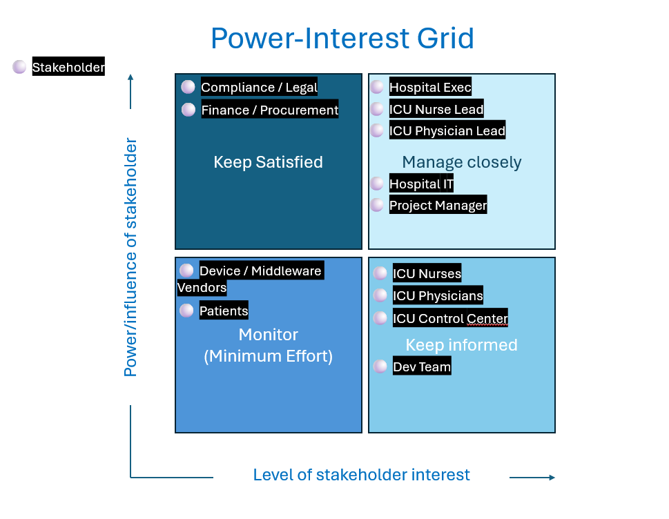

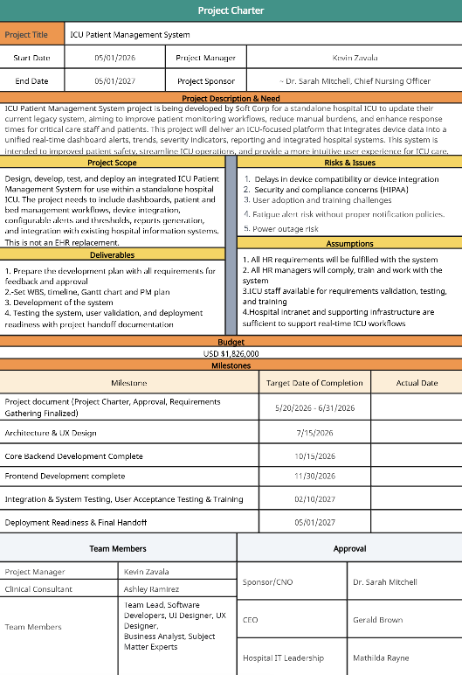
Project Charter

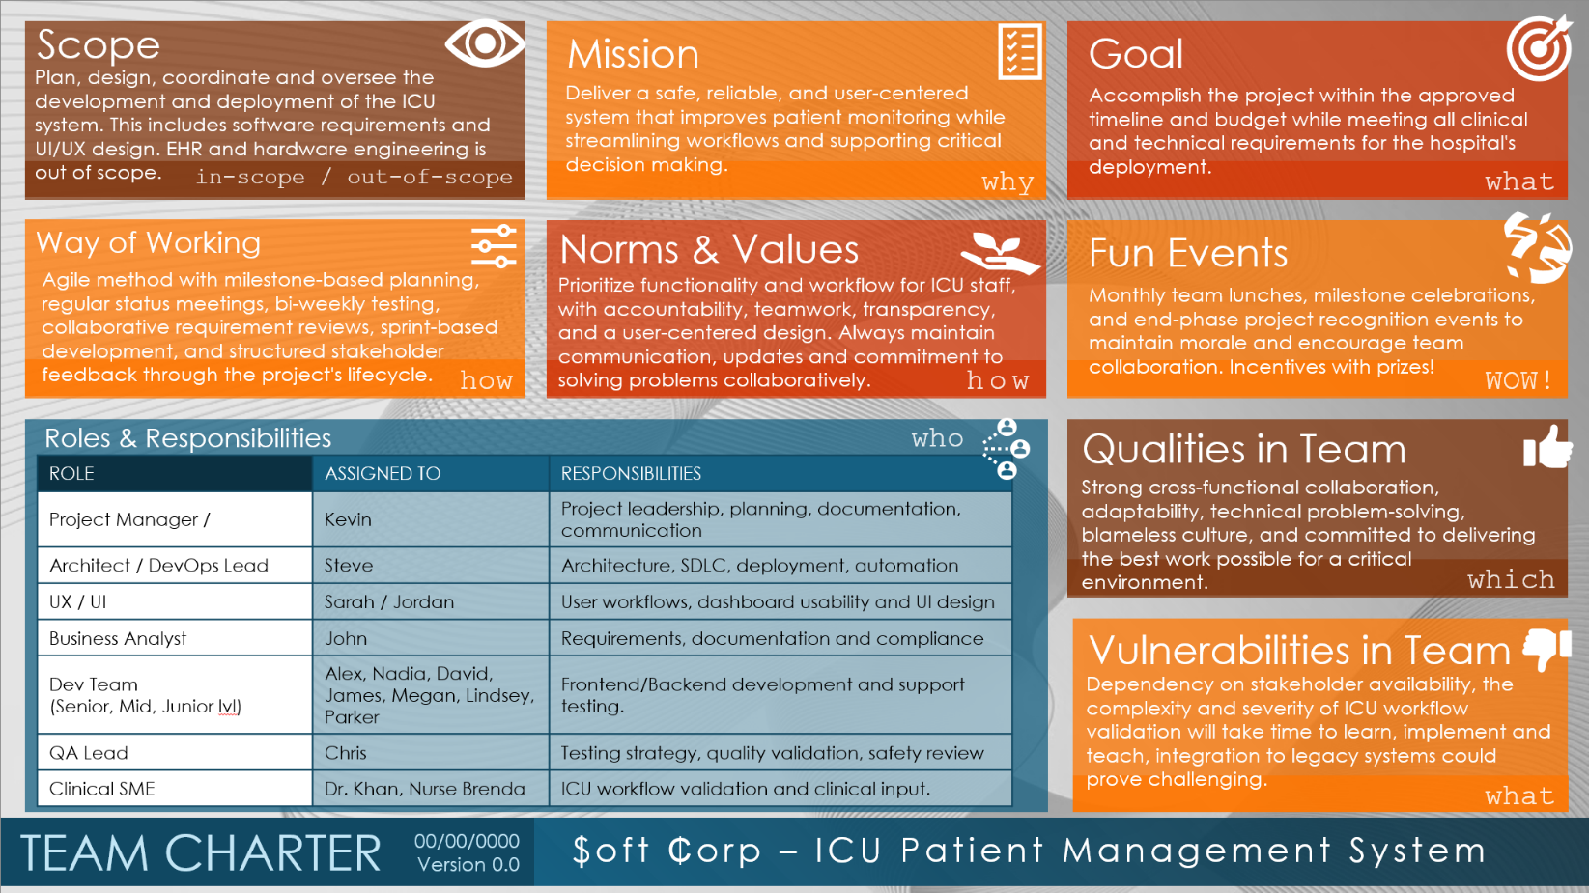
Team Charter

Closure Report & Maintenance Proposal
Executive Summary
This ICU Patient Management System project was catered and proposed by $oft ₵orp to fit the high-stakes standards of an ICU critical environment for a standalone hospital ICU. This system will successfully deliver a high and constant availability monitoring suite through a 12 month development period and a 15 person team, featuring live readings of critical vitals through device integration into our system, a bridge from this system to their current EHR system, configurable dashboard/ dashboard alerts, and a Local Edge Server to maintain live readings in case of server/outage failures. At an estimated cost of $1.87 million, this system will be built to the exact preferences/needs of clinical workers through constant clinical input throughout the whole project and will maintain an operational state with a 99.99% uptime achievement.
Achievements and Shortfalls
Achievements:
- High Performance: Achieved the required 99.99% uptime and met target of <1 second end-to-end vital refresh latency.
- Clinical Safety: Successfully integrated the Local Edge Server to ensure zero monitoring downtime, tested through simulated outages.
- 2FA Login Success: Achieved secure login for Badge Tap + Passkey security protocol.
- Voice-to-Text Accuracy: Final testing showed a 97% accuracy rate through a noise environment.
Shortfalls:
- Initial Alert Fatigue: Early testing showed high noise pollution ~ two weeks of unscheduled fine tuning with Nurse Brenda to refine thresholds.
- Training Bottleneck: Clinical system onboarding took much longer than expected, particularly due to staff rotation schedules dealing with a system.
- Initial Communication Silos: A lack of coordination between the UX/UI team and the Back-end developers led to redundant dashboard widget designs, was resolved early on.
- AI use: Failed to implement potential AI use, having acting as a constant overwatch for patient vitals. Too new in development (could prove unready and waste of time) and was not necessarily in scope, would have also taken more time to develop which time frame was to keep within near a year.
Lessons Learned
- RACI: Having a single lead for system testing helped to prevent the blame game, during high priority bug fixes.
- Testing: Having mandatory weekly peer reviews significantly reduced technical debt while also providing more collaboration, felt more effective than monthly testing phases.
- SME Input: Frequent bi-weekly demos with Dr. Khan and Nurse Brenda helped to prevent scope creep by aligning UX with more realistic clinical needs and preferences, better to gain preference from actual workers paired with research.
- Communication: Teams should be mandated to meet frequently to quickly brief with on-going phases and attack plans to ensure no confusion within sprints, since communication silos began to form in the beginning before corrected.
Recommendations for future projects
- Scaling: Should budget for potential future ward expansions including a trained maintenance team to handle ongoing security patches and updates.
- Automated Training: Implement an interactive ‘onboarding wizard’ to reduce manual training burden on the projects team.
- Manage Technical Backlog: Formalize a sprint specifically to address any shortfalls that are identified through phases.
- Continuous Security Auditing: Rather than the ‘one off’ phase, ensure quarterly penetration testing and HIPAA compliance review cycles into development.

Proposal for Maintenance Contract
Overview – With the successful release of the ICU Patient Management System, $oft ₵orp proposes that with the deployment of this project it would greatly improve this system to be followed by a 12-month Operational Maintenance Contract to ensure the continued stability, security, and performance of the clinical software. This contract will cover the SLAs through constant monitoring and reports, with scheduled meetings and training sessions with the hospital’s support team (IT and lead nurses with elevated access).
$oft ₵orp commits to following Service Level Objectives to maintain the clinical safety standards and the integrity of the system.
- System Availability: 99.9% uptime for the primary monitoring dashboard and vitals streaming service.
- A Mean Time to Repair of less than 4 hours for system-wide outages if the safety net fails to take over.
- Continuous monitoring to ensure vital refresh rates remain under 1-second threshold.
The system will be supported by a 4-tier structure to maximize efficiency.
- Tier 0: Access to Onboarding Wizard for clinical training and a Knowledge Base for immediate UI troubleshooting.
- Tier 1: Initial triage by hospital IT staff by establishing a helpdesk.
- Tier 2: $oft ₵orp technical specialists for sync issues and dashboard configuration.
- Tier 3: Developers retained for critical bug fixes and infrastructure failures.
There will be on-going maintenance & security operations to ensure long-term system health.
- Constant Monitoring: 24/7 automated tracking system
- Monthly Patching: Implementation of continuous update model for security patches via the CI/CD pipeline.
- Quarterly Audits: HIPAA compliance reviews and penetration testing conducted by security lead.
- Runbook maintenance: Continuous updates to technical recovery procedures based on issues that occur.
In the maintenance phase $oft ₵orp will utilize a lean ‘Support Squad’ of 5 core team members to reduce percentage allocations while providing expert oversight and maintaining cost-efficiency.

Reference Page

Mao, Z., Liu, C., Li, Q., Cui, Y., & Zhou, F. (2023, May 16). Intelligent Intensive Care Unit: Current and future trends. Intensive care research. https://pmc.ncbi.nlm.nih.gov/articles/PMC10186295/

Poncette1, A.-S., Spies1, C., Mosch1, L., Schieler1, M., Weber-Carstens1, S., Krampe1, H., Balzer1, F., 1Department of Anesthesiology and Intensive Care Medicine, & Balzer, C. A. (2019, April 30). Clinical requirements of future patient monitoring in the intensive care unit: Qualitative study. JMIR Medical Informatics. https://medinform.jmir.org/2019/2/e13064/

Rayan, A., Al-Ghabeesh, S. H., Fawaz, M., Behar, A., & Toumi, A. (2024, February 19). Experiences, barriers and expectations regarding current patient monitoring systems among ICU nurses in a University Hospital in Lebanon: A qualitative study. Frontiers in digital health. https://pmc.ncbi.nlm.nih.gov/articles/PMC10910027/

Poncette, A.-S., Mosch, L., Spies, C., Schmieding, M., Schiefenhövel, F., Krampe, H., & Balzer, F. (2020a, June 19). Improvements in patient monitoring in the intensive care unit: Survey study. Journal of medical Internet research. https://pmc.ncbi.nlm.nih.gov/articles/PMC7307326/
https://www.picis.com/solution/clinical-information-system-suite/critical-care-manager/
https://imd-soft.com/metavision/icu/
https://www.draeger.com/en_seeur/Hospital/Clinical-IT-Collaboration/PDMS

GeminiAI was used to identify topics for user stories, help answer intricacies of healthcare technology (how they should work, make more sense of the technology being used), medical terminology and definitions.
Have a familiar who works in the medical field as a registered medical assistant has helped answer questions as well about the processes that go into monitoring vitals and EHRs
Using ChatGPT as an agent, a senior software developer/engineer, to help me understand and plan out what components will be necessary for building this device, and approximately (with leniency) will it take for those components.
To create GANTT chart: https://clickup.com/
Suleski, T., Ahmed, M., Yang, W., & Wang, E. (2023, May 22). A review of multi-factor authentication in the internet of healthcare things. Digital health. https://pmc.ncbi.nlm.nih.gov/articles/PMC10214092/
Project Charter - https://creately.com/
Team Charter - https://www.smartsheet.com/content/team-charter-templates
Power-grid - https://simplystakeholders.com/stakeholder-mapping-template/

